PHYS 1901A Ch. 3: Light and Atoms Sept.24th,2013

Radiation – energy transmitted through space to one point to another without need for any physical connection btwn two locations.

Electromagnetic – energy carried in form of rapidly fluctuating electric & magnetic fields.

Visible Light – type of electromagnetic radiation which can be detected by human eyes.

Invisible Electromagnetic Radiation – unnoticed by eyes; radio, infrared, ultraviolet, X-rays, and gamma rays.

Light,rays,radiation, and waves refer all to same thing.

Disturbance – (like stone thrown in pond) occurs in a distinctive repeating pattern. Stone creates up and down motions of the water, creating waves.

Wave’s Period – number of seconds needed for wave to repeat itself at any given point in space.

Wave Length – number of meters needed for wave to repeat itself at a given moment in time. Measured as distance btwn two adjacent wave crests, two adjacent wave troughs.

Amplitude – maximum departure of wave from undisturbed state – still air, flat pond surface – called amplitude.

Frequency – number of wave crests passing any given point per unit time. Many crests pass per second = high f. F of wave is reciprocal of wave’s period:
Frequency = 1
Period
- Expressed in hertz (Hz) = Heinrich Hertz.
- Wave with a period of 5 seconds (5 s) has frequency of (1/5) cycles/s = 0.2 Hz, meaning one wave crest passes a given point in space every 5 seconds.

Wave Velocity: Velocity = wave length
Period
Since period is reciprocal of frequency, we can write this relationship as velocity = wavelength X frequency.
- Wavelength of 0.5 m, velocity would be (0.5 m)/(5s) or (0.5 m ) X (0.2 Hz) = 0.1 m/s.
- In this case of electromagnetic radiation, velocity is the speed of light.

Visible Spectrum - white light separating into rainbow while passing through prism (Isaac Newton).
- Frequency determines color of beam of light (its wavelength)
- Prism splits beam of light into separate colours bc light rays of different frequencies are bent, or refracted, slightly differently as they pass through prism – red light the least, violet light the most.
- 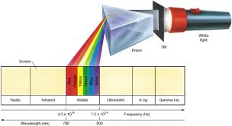Visible Spectrum
- Wavelength of light expressed in nanometer (nm). 10^9 nanometers in 1 meter.
- Angstrom (1 Å = 10⁻¹⁰m = 0.1 nm) Anders Ångstrom.
- Visible spectrum covers range of wavelengths from 400 nm to 700 nm (4000Å to 7000Å)
- Radiation to our eyes most sensitive wavelength near middle at 550 nm (5500$Å$)

Radiation vs Wavelengths: Wavelengths travel through a material medium; whereas, radiation needs no medium (travels through virtual vacuum of space).

Sound waves require air or medium, otherwise cannot travel.

Gravitational Force – attractive.
Electrical Forces – attractive or repulsive.
- Particles with like charges (both negative/both positive) (2 electrons, or two protons) repel one another.
- Particles with unlike charges (opposite signs) (electron and proton) attract one another.

Electric Field – determines electrical force exerted by particle on all other charged particles in universe.
- Strength of electric field decreases with increasing distance from charge according to an inverse square law.

Magnetic Field – govern influence of magnetized objects on one another.
- Needle on compass points North result of interaction btwn magnetized needle and Earth’s magnetic field.
- Also exerts forces on moving electric charges (electric current).
- Moving charges create magnetic fields (electromagnets).
- Electric and magnetic fields are linked to one another: change in either on necessarily creates the other.
- Fields are always oriented perpendicular to one another and to direction in which wave is travelling.
- 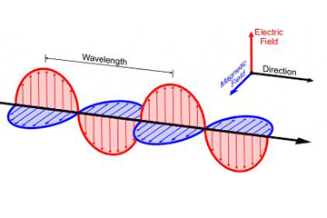
- Single physical phenomenon: electromagnetism – wave carries energy and information from one part of universe to another.
- Electromagnetic waves move at speed of light © = 299,792.458 km/s in a vacuum; rounds to c = 3.00 x 10⁵ km/s.

Wave Theory of Radiation – 1800s nature of light was thought as a wave phenomenon (electromagnetism unknown at time.

Electromagnetic Spectrum:
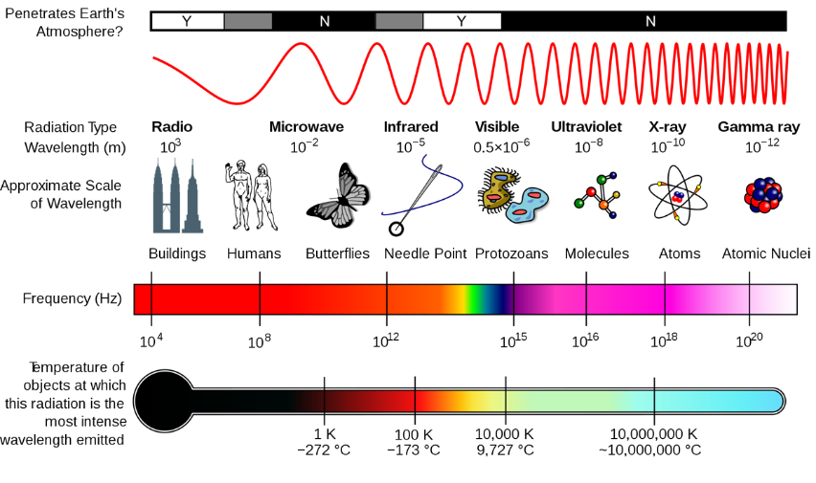
** all move at speed of light ( C ).
- Logarithmic Scale: Values marked by factors of 10; Each is 10 times greater than its neighbor.

Atmosphere Opacity – opacity is extent to which radiation is blocked by the material through which it is passing (air). Opposite of transparent.

Spectral Windows – locations in the electromagnetic spectrum where Earth’s atmosphere is transparent.

Atmosphere is Opaque to: Ultraviolet, X-ray, and gamma-ray observations can be made from above atmosphere from orbiting satellites.

Wave Nature of Radiation:
Particle Theory - particle, or corpuscular, theory by Isaac Newton = light consisted of tiny particles moving in straight lines.
Wave Theory – Christian Huygens = light as a wave phenomenon in which colour was determined by frequency, or wavelength.

Two Key Wave Properties:
Diffraction – deflection, or “bending” or a wave as it passes a corner or moves through a narrow gap.
- Longer the wavelength or smaller the gap, the greater is the angle through which the wave is diffracted.
- More noticeable for sound waves: ability to hear ppl around corner.
Interference – ability of two or more waves to reinforce or diminish each other.
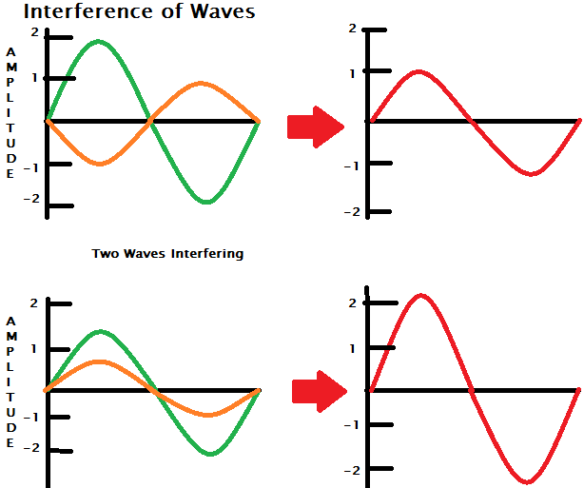 Resulting Waves for each scenario.
- Destructive Interference - Figure shows the green wavelength has twice amplitude in opposite direction to orange one. The net effect is that the two wave motions interfere with each other, resulting in the wave at the right.
- Constructive Interference – when waves reinforce each other instead, as in the lower frames, the effect results in constructive interference.
- Thomas Young 1805, wave nature of radiation: characteristic interference pattern – two identical light sources are placed side by side; light and dark bands are formed by constructive and destructive interference of the beams from the two sources.

Ionosphere – interaction btwn Sun’s ultraviolet radiation and upper atmosphere produces thin, electrically conducting layer at an altitude of 100 km. Reflects long-wavelength radio waves as well as a mirror reflects visible light.

Thermal Radiation – All macroscopic objects - fire, ice cubes, people, stars - emit radiation at all times, regardless of size, shape, or chemical composition.
- Radiate bc microscopic charged particles they are made up of are in constantly varying random motion, and whenever charges interact (collide) and change their state of motion, electromagnetic radiation is emitted.
- Temperature – of object is direct measure of amount of microscopic motion within them. Hotter the object – higher its temperature – the faster its component particles move, the more violent are their collisions, and more energy they radiate.

Black Body Spectrum:
Intensity – amount or strength of radiation at any point in space; basic property of radiation.
Blackbody – radiation distribution curve for mathematical idealization as black body – an object that absorbs all radiation falling on it.
- In steady state, blackbody must reemit same amount of energy it absorbs.
- Blackbody curve – describes distribution of that reemitted radiation (curve also known as Planck curve after Max Planck).
- Blackbody curve shifts toward higher frequencies (shorter wavelengths) and greater intensities as an object’s temperature increases. Even so, shape of curve remains same.
- Obtain simple connection btwn wavelength at which most radiation is emitted and the absolute temperature (measured in Kelvins) of the emitting object:
- Wavelength of peak emission $∝$ 1
Temperature
- $∝$ means proportional to.
- This relationship is Wien’s law, after Wilhelm Wien, who formulated the equation in 1897.

Wien’s Law – hotter the object, the bluer is its radiation.
- I.e. Temp of 6000 K emits most of its energy in visible part of the spectrum, with a peak wavelength of 480 nm. At 600 K, the object’s emission would peak at a wavelength of 4800 nm, well into the infrared portion of the spectrum. At Temp 60,000 K, the peak would move through visible spectrum to a wavelength of 48 nm, in ultraviolet range.
- Temperature of object increases, total amount of energy it radiates (summed over all frequencies) increases rapidly.
- Total amount of energy radiated per unit time is actually proportional to the fourth power of the object temperature:
Total energy emission $∝$ temperature⁴
- This equation is Stefan’s Law, after Josef Stefan: energy emitted by a body rises dramatically as its temperature increases. Doubling temperature causes the total energy radiated to increase by a factor of 2⁴ = 16; tripling temp increases the emission by 3⁴ = 81.

The Kelvin Temperature Scale:
Thermal Energy - The atoms and molecules that make up matter are in constant random motion; this motion in form of energy (thermal energy), or heat.

Temperature – direct measure of object’s internal motion; higher temp = faster random motion of particles.
- Temp below freezing point of water known as absolute zero = -273.15˚
- Absolute Zero – temp in which all thermal atomic and molecular motion ceases.
- Kelvin Scale – takes absolute zero as starting point. Named after Lord Kelvin; Kelvin scale differs from Celsius scale by 273.15˚.
- Kelvins = degrees Celsius + 273
- Thus, all thermal motion ceases at 0 kelvins ( 0 K); water freezes at 273 kelvins (K); water boils at 373 kelvins (K).
- Occasionally, term degrees absolute used instead of ˚K (unit K: not degree for kelvins).

The Doppler Effect: Waves caused by a moving object cause a doppler effect. Doppler effect is a change in frequency and wavelength of a wave.
- It is caused by the change in distance between the thing creating the wave (causer) and whatever is measuring (watcher or observer), seeing or hearing the wave.
- Another word for "causer" is "sender". Another word for "change in distance" is "speed" or "relative velocity". A common example is sitting in a car while another car goes by the watcher. The watcher will hear a change in pitch, while the sender will not.
Effects of changes in distance [change]: If observer and creator of the wave get closer, the frequency is higher and the wavelength is shorter.
- For light, this causes a shift in colour towards the blue end of the spectrum called a blueshift.
- For sound, this causes the sound to become higher in pitch
If the distance between the observer and creator gets longer, the frequency is lower and the wavelength is longer.
- For light, this causes a shift towards the red end of the spectrum called a redshift, the faster something is moving away, the greater the redshift.
- For sound, this causes the sound to become lower in pitch.
Blueshift – shorter wavelength. Any shift towards shorter wavelength = blueshift.
Redshift – longer wavelength. Any shift towards longer wavelengths = redshift.

Net velocity of recession btwn source and observer, the apparent wavelength and frequency (measured by observer) are related to the true quantitites (emitted by the source) as:

Apparent wavelength = true frequency
True wavelength apparent frequency

Recession frequency
= 1 + wave speed
Radial Motion – only motion along the line joining source and observer appears in foregoing equation.
- Motion that is transverse (perpendicular) to the line of sight has no significant effect.
- Doppler Effect depends only on relative motion btwn source and observer.

Relative motion – if object moves at 10 km/h, observer sees it move at that speed. If object and observer move at 10km/h, object appears to be standing still to observer. If object travels 10km/h and observer at 5km/h, object appears to move at 5 km/h (difference btwn speed of object and observer).

