Chapter One - Information Systems and Business Strategy
  - : Information Systems in Business

Information Systems (IS)-
- Computer based tool that people use to work with information
- Supports information and information processing needs of an organization
- It does not represent a business’s success and innovation**
Information Technology (IT)-
- Acquisition (Gaining), processing, storage, and dissemination (distributing) of vocal, pictorial, textual, and numerical information by a microeconomics based combination of computing and telecommunications.
- Deals with the use of computers and telecommunications to retrieve, store and transmit information
Management Information Systems (MIS)-
- Another business function similar to marketing, finance, operations and human resources management
- MIS plans for, develops, implements, and maintains the hard/software and applications in IT
- In order to perform MIS effectively, most organizations have an internal IS department which is the IS, IT, AND MIS
Data-
Ex: date, item number, item description, customer name, shipping details
Information-
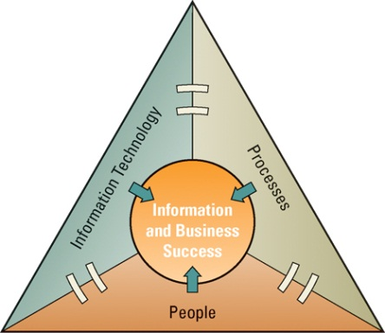
- Data that is converted into a useful and meaningful context
Ex: best/worst selling items, best/worst customers
Knowledge-
- When information can be acted upon it becomes knowledge
*People use information systems to transform data into information and information into knowledge
*People, information, and information systems (in that order of priority) are inseparably linked
What is one of the most important assets in an organization?
- Information is one of the most important assets in an organization, and the primary way that people get information is through information technology
Without databases and spreadsheets how would managers gather, correlate, and analyze information?
- Manually
- Performing these tasks manually, or by hand, is extremely time consuming
Functional Organization (6)
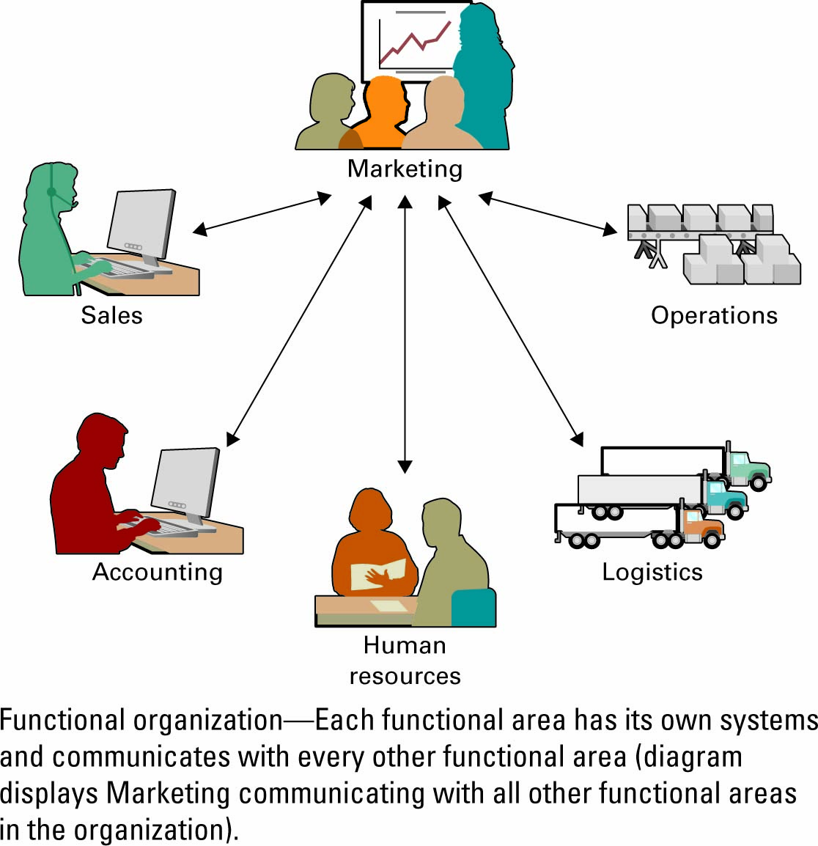
- Each functional area has its own systems and communicates with every other functional area
- Functional organizations are interdependent

Ex: Marketing can be linked with:
- Sales and Marketing – forecasting, segmentation, advertising, promotions
- Operations and Logistics – purchasing, supplying, receiving, transportation
- Accounting and finance – accounting, planning, budgeting, tax, costs
- Human resources – hiring, training, benefits, and payroll

Why are functional areas interdependent?
- Departments cannot operate in isolation; they require information from around the organization to operate
Why must sales and marketing work with operations?
- To know what is available for sale including overstocked items and under stocked items

Different information cultures found in organizations
Information-Functional Culture
- When employee use information as a means of exercising influence or power over others.
Ex: Sales manager refuses to share information with marketing
- Will cause marketing to need the sales manager’s input each time a new sales strategy is developed
Information- Sharing Culture
- When employees across all departments trust each other to use information to improve performances
Information- Inquiring Culture
- When employees across all departments search of information that will help them understand the future and allow themselves to be up to date with the current trends.
Information- Discovery Culture `
- When employees are open to information about crisis and radical changes
- They are able to seek ways to create competitive advantages
Some of the positions in IS are: (An individual can have more than one position)

CEO – Chief executive officer CIO- Chief information officer
CFO – Chief financial officer CTO- Chief technology officer
COO- Chief Operations officer CSO- Chief security officer
CPO- Chief privacy officer CKO- Chief Knowledge Officer

Chief Information Officer
- Has an executive-level position,
- CIO reports to the CEO
- Must have strong business and IT skills
- Responsible for overseeing all uses of information systems and ensuring the strategic alignment of IS with business goals and objectives
- Must have a deep understanding of both information systems and business
- Enhancing customer satisfaction is the number one concern for many CIOs
- CIO’s play a key role in the executive suite:
- Manager – ensure that delivery of all IS products are done on time and within budget
- Leader – ensure that the strategic vision of IS is in line with the strategic vision of the organization
- Communicator – they have to advocate and communicate the IS strategy in order to maintain and build a strong executive relationship

Chief Technology Officer
- Responsible for ensuring throughput, speed, accuracy, availability and reliability of IT

Chief Security Officer
- Is responsible for ensuring that the information systems, developing strategies and technical safe guards are safe from hackers and viruses

Chief Privacy Officer
- Is responsible for ensuring the ethical and legal use of information in an organization
- Many CPO’s are lawyers

Chief Knowledge Officer
- Is responsible for collecting, maintaining, and distributing an organization’s knowledge

Business personnel & IS Personnel
- Business personnel possess expertise in functional areas such as marketing, accounting, and sales.
- IS personnel have the technological expertise.
- This typically causes a communications gap between the business personnel and IS personnel.
- For both sides to have effective communications, the business personnel must seek to achieve an increased level of understanding of IS, and the IS personnel must seek to achieve an increased level of understanding of the business (**They must be able to understand each other completely for effective communication)
Common departments in an organization
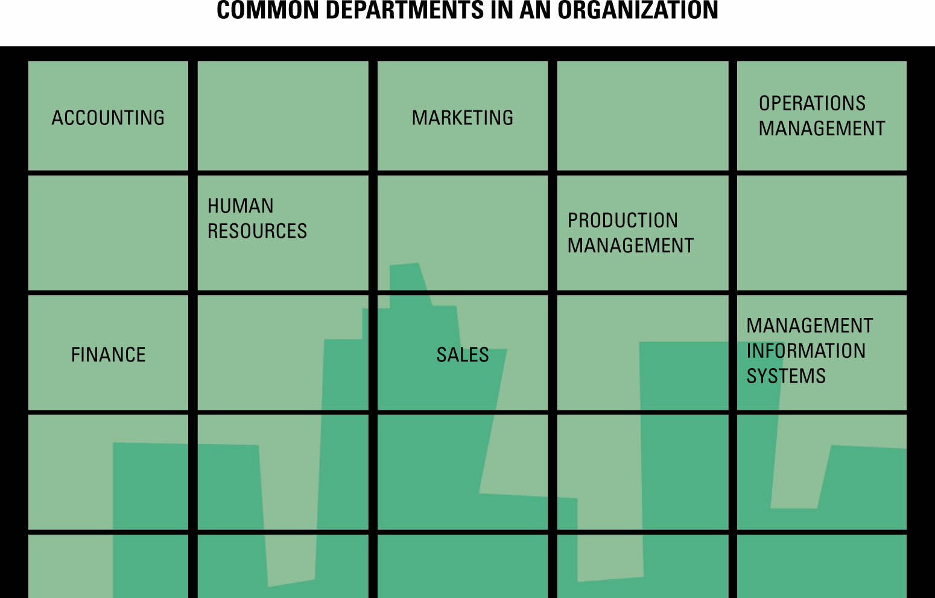
- Accounting provides quantitative information about the finances of the business including recording, measuring, and describing financial information
- Finance deals with the strategic financial issues associated with increasing the value of the business, while observing applicable laws and social responsibilities
- Human resources includes the policies, plans, and procedures for the effective management of employees (human resources)
- Sales is the function of selling a good or service and focuses on increasing customer sales, which increases company revenues
- Marketing is the process associated with promoting the sale of goods or services. The marketing department supports the sales department by creating promotions that help sell the company’s products
- Operations management (aka production management ) includes the methods, tasks, and techniques organizations use to produce goods and services. Transportation (also called logistics) is part of operations management.
- Management information systems (MIS) is the function that plans for, develops, implements, and maintains IS hardware, software, and the portfolio of applications that people use to support the goals of an organization

Skills required by IT executives & meanings

Communications – be able to communicate and influence at all levels

Business Knowledge – be able to understand, focus, and help a business grow instead of only cutting costs and helping an organization into being more efficient

Innovation/ Creativity- The vision that differentiates a CIO from a more traditional IT director – innovation, creativity, flair, and an entrepreneurial spirit. * da fukk ?

Leadership- Good leaders will inspire and motivate teams and help achieve things

Domain Knowledge- practical understanding of technology fundamentals in order to make the right strategic calls about the deployment and exploitation of IT.

1.2 :Business Strategy

Competitive Advantage
- A product or service that an organizations customers place a greater value on that similar offerings from a competitor
- These are temporary because competitors are quick to copy competitive advantages
First-mover advantage
- occurs when an organization can significantly impact its market share by being first to market with a competitive advantage
Environmental Scanning
- the acquisition (gaining) and analysis of events and trends in the environment external to an organization
Three common tools for analyzing/developing competitive advantage:
Organizations use three common tools to analyze and develop competitive advantages:
- Porters Five Forces Model
- Porters Three generic strategies
- Value Chain Analysis

Porters fives forces model – (Evaluating business segments)
- Michael Porter’s created the five forces model
- Useful tool to aid organizations facing the challenge of entering a new industry or industry segment
- Helps determine the relative attractiveness of an industry and includes:
- Buyer power – high when buyers have many choices of whom to buy from and low when their choices are few
- Supplier power – high when buyers have few choices of whom to buy from and low when their choices are many
- Threat of substitute products or services – high when there are many alternatives to a product or service and low when there are few alternatives from which to choose
- Threat of new entrants – high when it is easy for new competitors to enter a market and low when there are significant entry barriers to entering a market
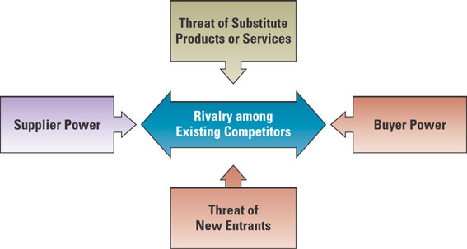
- Rivalry among existing competitors – high when competition is fierce in a market and low when competition is more complacent

- Buyer power (aka customer power)
- The ability of buyers to affect the price of an item
- Organizers need to be concerned about buyer power when:
- In their relationships with customers
- In their relationships with suppliers
Relationship with customers
- Organizations function as suppliers and prefer to reduce the buyer power of customers (to create a competitive advantage)
- An organization must make its products more attractive for customers to buy from it instead of its competitions
Relationship with suppliers
- Organizations function as buyers and prefer to increase their own buyer power with suppliers (and create competitive advantage)
- Organizers want to work with a large pool of suppliers to potentially supply the desired good or service.

Loyalty Programs
- Reward customers based on the amount of business they do with a particular organization
- Loyalty programs can use IS to reduce buyer power; customers are more loyal to or give most of their business to a single organization
Switching cost
- Manipulating costs that make customers reluctant to switch to another product

- Supplier power
- Low when buyers have few choices to buy from and low when they have many choices
- It is the converse of buyer power
- Two situations in the supply chain when organizations need to be concerned:
- In their relationship with customers
  - Organizations function as suppliers and want supplier power to be high
- In their relationship with suppliers
  - Organizations function as buyers and therefore want supplier power to be low

Business to Business marketplace (B2B)
- an Internet-based service that brings together many buyers and sellers
- Organizations can create a competitive advantage by locating alternative supply sources (decreasing supplier power) through B2B marketplaces
Two types of business-to-business (B2B) marketplaces:
- Private exchange
- a single buyer posts its needs and then opens the bidding to any supplier who would care to bid
- Reverse auction
- an auction format in which increasingly lower bids are solicited (asked) from organizations willing to supply the desired product or service at an increasingly lower price. Internet based
What effect does this have on supplier power?
- It reduces supplier power and creates a competitive advantage for the buyer organization since it is paying the lowest possible price for its goods and services
- Threat to substitute products or services
- High when there are alternatives to a product or service and low when there are a few alternatives from which to choose
- an organization wants to be in a market in which there are few substitutes for its products or service
- difficult to achieve, and most organizations create a competitive advantage through switching costs - the more painful it is for a customer to switch suppliers, the less likely they are to switch
- threat can be reduced if switching cost is HIGH
Switching costs
- are costs that can be make customers reluctant to switch to another product or service

Organization within the Supply Chain

Supply chain
- consists of all parties involved in the finding of a product or raw material
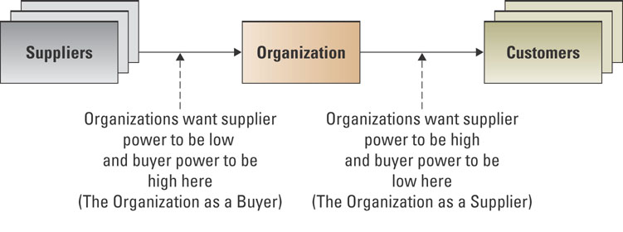

- Threat of New Entrants
- High when it is easy for new competitors to enter a market and low when there are significant entry barriers

Entry Barrier
- A feature of a product or service that customers have come to expect and entering competitors must offer the same for survival

What is an industry that has a high entry barrier?
- Energy – the organization has to have the infrastructure to support energy
- Telecommunications – the organization has to invest in a telecommunications infrastructure prior to offering services
- Banking – the bank must offer its customers an array of IT-enabled services including ATMs and online account services

What is an industry that has a low entry barrier?
- Restaurants – simply lease a space, obtain a license, and you can sell food
- Catering – simply offer food and deliver
- Movie rental – simply buy the movies, pay the licensing fee, and offer the movies for rental

- Rivalry Among Existing Competitors
- High when competition is fierce in a market and low when competitors are more self-satisfied

Product differentiation
- Occurs when a company develops unique differences in its products or services with the intent to influence demand
What are a few industries where competition is high?
- Restaurants, products, telecommunications, banking
What are a few industries where competition is low?
- This is typically highly regulated industries such as energy markets and stock exchanges

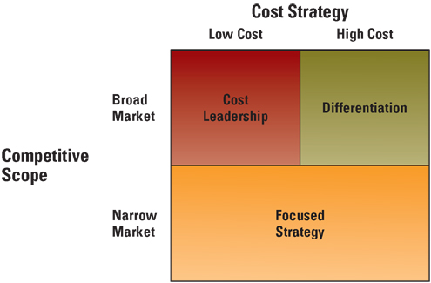
Three generic strategies – creating a business focus
Organizations typically follow one of Porter’s three generic strategies when entering a new market
  - Broad cost leadership
  - Broad differentiation
  - Focused strategy

Value Chain Analysis- targeting business processes
- Views a firm as a series of business processes that each add value to the product or service

Value Chain
- views an organization as a series of processes, each of which adds value to the product or service for each customer
Value Chain Groups
- Within a company separate the company’s activities into two categories:
1) primary value activities
2) support value activities
Business process
- A standardized set of activities that accomplish a specific task
Ex: processing a customer’s orders
The competitive advantage is to:
  - Target high value-adding activities to further enhance their value
  - Target low value-adding activities to increase their value
  - Perform some combination of the two
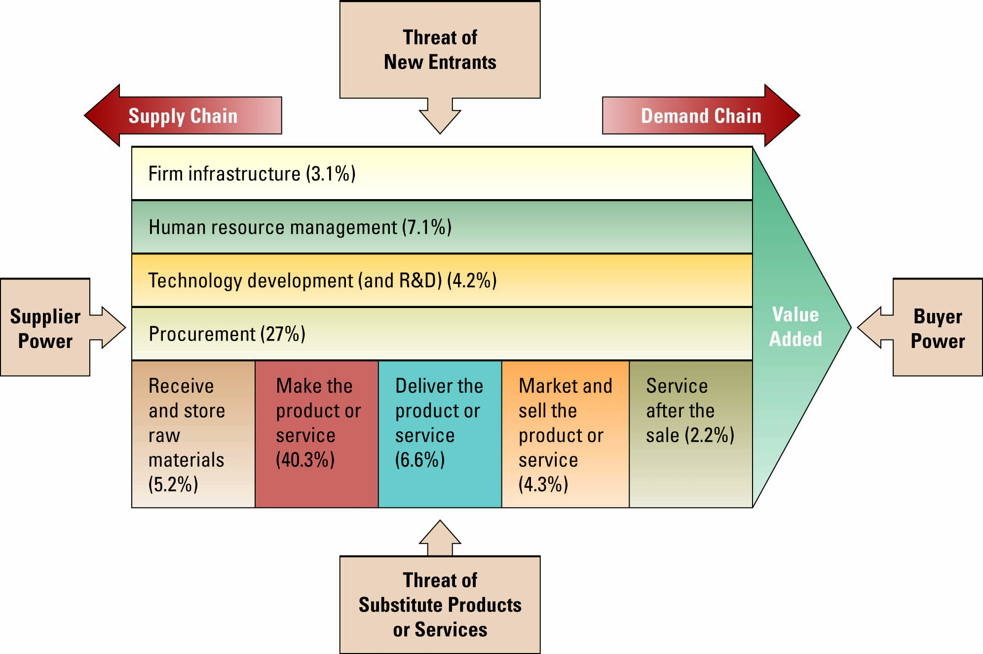
Value Chain and Porter’s Five Forces

Business Driven information system & Business strategy
- Systems that are implemented to support a company’s competitive business strategy
- The Five Forces Model, Three Generic Strategies and Value Chain allow business to assess competitive advantage.
- Information Systems collect the data from the business process activities and provide analysis to give organizations insight into ways to behave more competitively.
- Information Systems are not used on their own. They are driven by the need of business for fast, accurate and insightful information.

Chapter Two – Decision Making and Business Processes
  - : Decision making and information systems

Reasons for growth of decision-making information systems
- People need to analyze large amounts of information
- People must make decisions quickly
- People must apply sophisticated analy`sis techniques, such as modeling and forecasting, to make good decisions

Managerial Decision making challenges are:
- Analyze large amounts of information
- Apply sophisticated analysis techniques
- Make decisions quickly

Common Company Structure:
- Operational decision-making
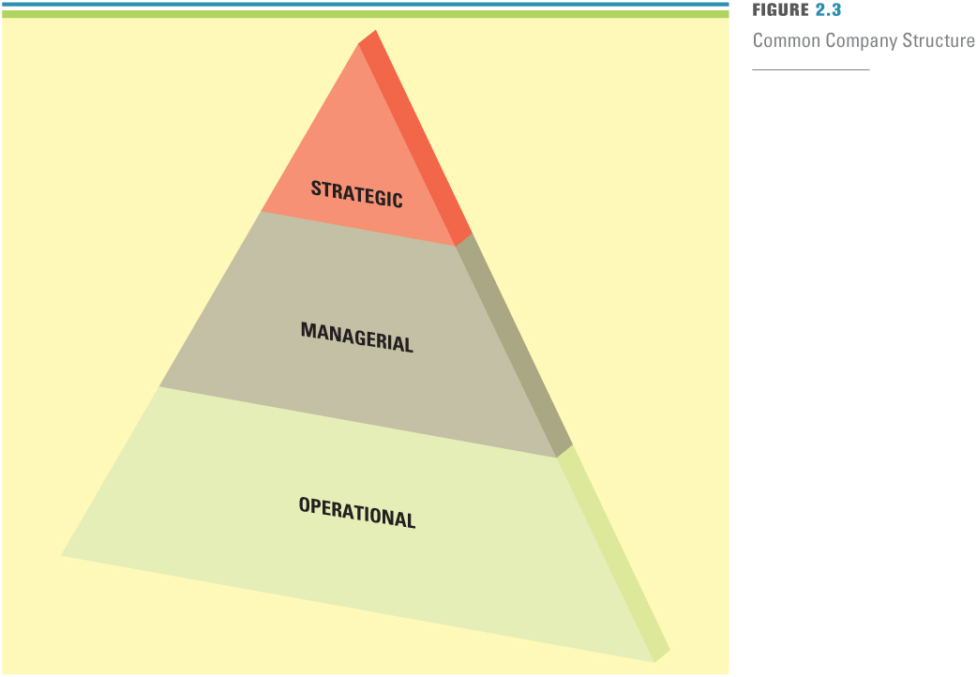
- Employees develop, control, and maintain core business activities required to run the day-to-day operations (DCM)

Structured decisions
- Operational decisions are considered structured
decisions
- Situations where established processes offer potential solutions

- Managerial decision making
- Employees evaluate company operations to identify, adapt to, and leverage change (IAL)

Semi-structured decisions
- Occur in situations in which a few established processes help to evaluate potential solutions, but not enough to lead to a definite recommended decision

- Strategic decision making
- Managers develop overall strategies, goals, and objectives (SGO)

Unstructured decisions
- Occurs in situations in which no procedures or rules exist to guide decision makers toward the correct choice

Transactional Data
- Encompasses all raw facts contained within a single business process or unit of work
- Primary purpose is to support performing daily operational tasks

Analytical Data
- Encompasses all summarized transactional data
- Primary purpose is to support performing analysis tasks
- Also include external information such as info obtained from outside market and industry sources.

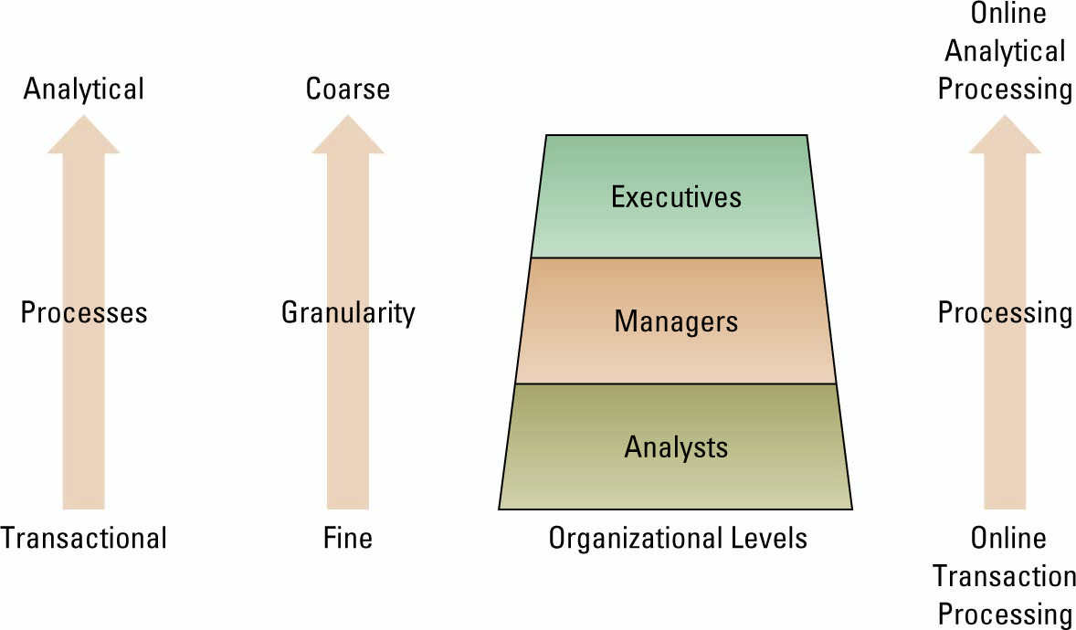
* Moving up through the organizational pyramid, users move from requiring transactional information to analytical information

Metrics
- Measurements that evaluate results to determine whether a project is meeting its goals

Common types of metrics are:
- KPIs – Key Performance Indicators
- Efficiency and Effectiveness

Key Performance Indicators
- Measures that are tied to business drivers

Efficiency IS metrics
- Measures the performance of the information system itself such as speed and availability

Effectiveness IS metrics
- Focuses on how well a firm is achieving its goals and objectives
- Doing the right things – setting the right goals and objectives and ensuring they are accomplished

Benchmarks
- Baseline values the system seeks to attain

Benchmarking
- Process of continuously measuring system results, comparing those results to benchmark values, and identifying steps and procedures to improve system performance

Common types of Efficiency IS metrics:
- Throughput
Amount of information that can travel through a system at any point in time
- Transactional Speed
Amount of time a system takes to perform a transaction
- System Availability
Number of hours a system is available to users
- Web Traffic
Includes a host of benchmarks such as the number of page views. Number of unique visitors etc.
- Response Time
Time it takes to respond to user interactions such as mouse clicks

Common types of Effectiveness IS metrics:
- Usability
- Customer satisfaction
- Conversation rates
- Financial

*Information to make decisions and measure performances come from:
- Transaction Processing System (TPS)
- Basic business system that serves the operational level and assists in making structured decisions

- Online transaction processing (OLTP)
- capturing of transaction and event information using technology to process, store, and update.

- Source Documents
- Using systems thinking, the inputs for a TPS or the original transaction record.

- Decision Support System (DSS)
- Models information to support managers and business professionals during the decision-making process
Three quantitative models used by DSS include:
  - What-if analysis – the study of the impact of a change in an assumption on the proposed solution
  - Sensitivity analysis – the study of the impact that changes in one (or more) parts of the model have on other parts of the model
  - Goal-seeking analysis – finds the inputs necessary to achieve a goal such as a desired level of output

Online analytical processing (OLAP)
- Manipulation of information to create business intelligence in support of strategic decision making

Interaction between TPS & DSS (pg.36)
- The TPS supplies transaction-based data to the DSS
- The DSS summarizes and aggregates the information from the many different TPS systems, which assists managers in making informed decisions.

Executive Information System
- A specialized DSS that supports senior level executives within the organization
- Contains information from external sources as well as information from internal data sources

Why would you need interaction between a TPS and EIS? (pg.37-chart)
  - The EIS needs information from the TPS to help executives make decisions
  - Without knowing order information, inventory information, and shipping information from the TPSs, it would be very difficult for the CEO to make strategic decisions for the organization

Artificial Intelligence (AI)
- Stimulates human intelligence, such as the ability to reason and learn

Intelligent Systems
- Various commercial applications of artificial intelligence
  - :Business Processes
Business Process
- A standardized set of activities that accomplish a specific task
Ex: processing a customer’s order

Customer facing processes
- Results in a product or service that is received by an organization’s external customer’s

Business-facing Processes
- Is essential to the effective management of the business and includes goal setting, day to day planning, performance feedback, and rewards

The order to delivery process
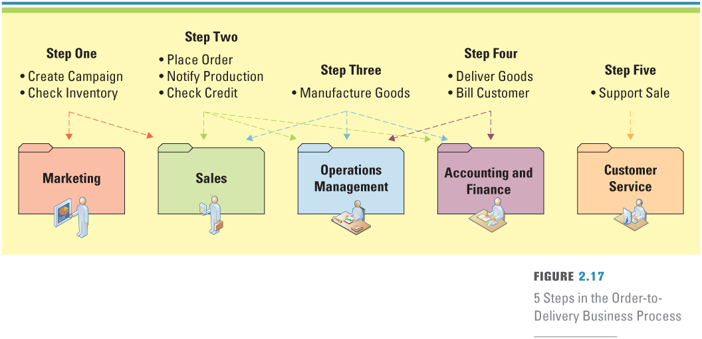
Business process improvement
- Attempts to understand and measure the current process and make performance improvements accordingly
- A cyclical activity
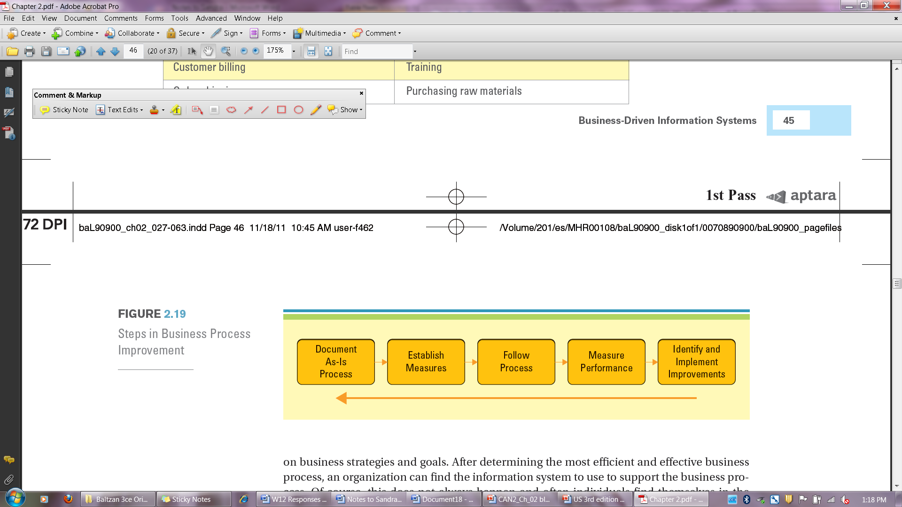

Business Process Re-engineering (BPR)
- The analysis and redesign of workflow within and between enterprises

Business Process Modelling (or mapping)
- The activity of creating a detailed flow chart or process map of a work process showing its inputs, tasks, and activities in a structured sequences
- Process of how the work was done

Business Process Model
- A graphic description of a process, showing the sequences of tasks that complete the process from a selected viewpoint

Why is it important to diagram the As-Is process prior to diagramming the To-Be process?
- It is important to understand the entire process from end-to-end before determining how to fix the process

What is the difference between the As-Is and To-Be process (pg.49-50 diagram as example)
- As-Is process model - represents the current state of the operation that has been mapped, without any specific improvements or changes to existing processes
- To-Be process model - shows the results of applying change improvement opportunities to the current (As-Is) process model

Business Process Management (BPM)
- Integrates all of the organizations business processes to make individual processes more efficient

LOOK AT BUSINESS PROCESSING MODELING EXAMPLES – pg. 53&54

Chapter Three – The Internet and E-Business
  - : Business and the Internet

E-business
- The conducting of business on the internet
- Not only buying and selling but also serving customers and collaborating with business partners

Digital Darwinism
Implies that organizations that cannot adapt to the new demands placed on them for surviving in the information age are doomed to extinction
- Those who are no able to adapt to the new demands for survival will not succeed in the future

Disruptive Technology
- A new way of doing things that open new markets and destroys the old ones
- A new way of doing things that does not meet the needs of existing customers

Sustaining Technology
- Produces improvements to products that customers are eager to buy

The internet – Business disruption
- One of the biggest forces changing business is the internet
- Organizations must be able to transform as markets, economic environment and technology changes
- Focusing on the unexpected allows an organization to capitalize on the opportunity for new business growth from a disruptive technology

Evolution of the Internet
- Began as an emergency military communication system
- Operated by the U.S department of defence
- Gradually moved from a military pipeline to a communication tool for scientists to businesses

Internet
- Is a global public network for computer networks that pass information from one to another using common computer protocols

Protocols
- Are standards that specify the format of data as well as the rules to be followed during transmission

World Wide Web (WWW)
- A global hypertext system that uses the internet as its transport mechanism

Hypertext transport protocol (HTTP)
- The internet standard that supports the exchange of information on the WWW.

Are the Internet and the WWW synonymous?
- People often interchange the terms Internet and the World Wide Web, but these terms are not synonymous
- The Internet is a global public network of computer networks that pass information from one to another using common computer protocols
- The World Wide Web is a global hypertext system that uses the Internet as its transport mechanism
- The World Wide Web operates on the Internet

Reasons for WWW growth
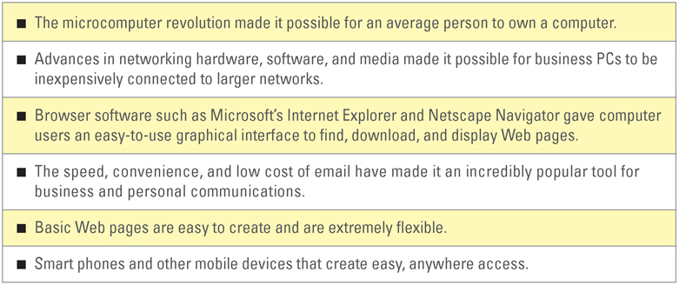

What are the two primary reasons for growth of the WWW?
- Two events changed the history of the Internet
  - On August 6, 1991 Tim Berners-Lee built the first Web site
  - Marc Andreesen built and distributed Mosaic

The internets impact on information
Easy to compile
- Searching for information on products, prices, customers, suppliers, and partners is

Increased richness
- refers to the depth and of information transferred between customers and business.
- Businesses and customers can collect and track more detailed information when using the Internet.

Increased reach
- refers to the number of people a business can communicate with, on a global basis.
- Businesses can share information with numerous customers all over the world.
Improved content
- A key element of the Internet is its ability to provide dynamic relevant content.
- Buyers need good content descriptions to make informed purchases, and sellers use content to properly market and differentiate themselves from the competition.
- Content and product description establish the common understanding between both parties to the transaction. As a result, the reach and richness of that content directly affects the transaction.
What is the difference between information richness and information reach?
- Information richness refers to the depth and breadth of information transferred between customers and business
Ex: Instead of a company catalogue with a simple text box and perhaps a small photo, the Web allows companies to post 3-dimensional photos, video, customer reviews, newspaper and magazine articles, product comparisons including price, etc.

- Information reach refers to the number of people a business can communicate with, on a global basis
Ex: Companies can now reach customers around the world, not just customers who can physically travel to their store
Digital Divide
- Occurs when those with access to technology have great advantages over those who without access to technology

Web 2.0
- A set of economic, social, and technology trends that collectively form the basis for the next generation of the internet

Web Mash-up
- A website or web application that uses content from more than one source to create a completely new product or service

Application programming interface (API)
- A set of routines, protocols, and tools for building software applications.

Mashup editor
- WYSIWYGs or What You See Is What You Get tools
- They provide a visual interface to build a mashup, often allowing the user to drag and drop data points into a Web application
Web 3.0
- A term that has been coined in different meanings to describe the evolution of web usage and interaction among several separate paths
- Transforming the Web into a database.
- Making content accessible by multiple non-browser applications.
- Leveraging AI (artificial intelligence0 technologies.
- The semantic Web and service-oriented architecture.
- Evolution to 3D.
Semantic Web
- Structuring data so web pages describe things in a way that computers can understand and find, share and integrate ideas more effectively to people

Four common tools used for accessing internet information:
Intranet
- Internalized portion of the internet, protected from outside access
- Allows an organization to provide access to information and application software to only its employees
- student or faculty and staff sites such as Blackboard or WebCT

Extranet
- An intranet that is available to strategic allies
Ex: customers, suppliers, partners
- for potential students and partners

Portal
- A website that offers a broad array of resources and services
Ex: Email, online discussion groups, search engines, online shopping malls
- a place where students or faculty and staff can access all of their applications such as registration, billing, grades, Blackboard or WebCT, and e-mail

Kiosk
- Publicly accessible computer system that has been set up to allow interactive information browsing
- places around the campus where students can logon to the Internet

Three common forms of service providers:
Internet service provider (ISP)
- provides individuals and other companies access to the Internet
Online service provider (OSP)
- offers an extensive array of unique Web services
Application service provider (ASP)
- offers access over the Internet to systems and related services that would otherwise have to be located in organizational computers

Service Level agreements (SLAs)
- defines the specific responsibilities of the service provider and sets the customer expectations

  - :E-Business
E-commerce
- the buying and selling of goods and services over the Internet

E-business
- the conducting of business on the Internet including not only buying and selling, but also serving customers and collaborating with business partners
- Because E-businesses are not limited by shelf space, they can offer a far wider selection of products that may suit only a few customers

Mass customization
- The ability of an organization to tailor its products or services to the customers’ specifications

Personalization
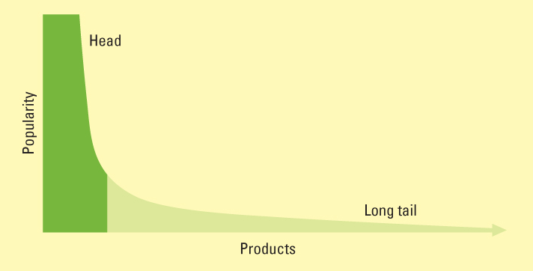
- Occurs when a company knows enough about a customer’s likes and dislikes that it can fashion offers more likely to appeal to that person

The Long Tail
- Refers to the tail of a typically sales curve

Intermediary
- Agents, software, or businesses that provide a trading infrastructure to bring buyers and sellers together

Disintermediation
- Occurs when a business sells directly to the customer online and cuts out the intermediary
Ex: Buying a computer from Dell’s website cuts out the electronics retailer.

Reintermediation
- Steps are added to the value chain as new players find ways to add value to the business process.

Cybermediation
- Refers to the creation of new kinds of intermediaries that simply could not have existed before the advent of ebusiness.
Ex: Netflix is an example.

Reducing Costs
- Business processes that take less time and human effort.

Improving Operations
- Communications customized to meet consumer needs and available 24/7.

Improving Effectiveness
- Web sites must increase revenue and new customers and reduce service calls

Interactivity metrics
- measure E-business success: number of repeat visits, times spent on site and number of pages viewed among other activities.

Measuring Website success:
Stickiness—visit duration time.
Raw Visit Depth—total Web page exposures per session.
Unidentified visitor—no information about visitor is available.
Unique visitor—recognized and counted once in a period of time.
Identified visitor—can be tracked across multiple web visits.
Hits—A single request made by a visitor to view a web page.

E-Business Models:
B2B (Business to business)
- Applies to businesses buying from and selling to each other over the Internet.

B2C (Business to customer)
- Applies to any business that sells its products or services to consumers over the Internet.

C2B (Customer to business)
- Applies to any consumer that sells a product or service to a business over the Internet
Ex: eBay, Kijiji

C2C (Customer to customer)
- applies to any consumer that sells a product or service to other consumers, eBay, Kijiji
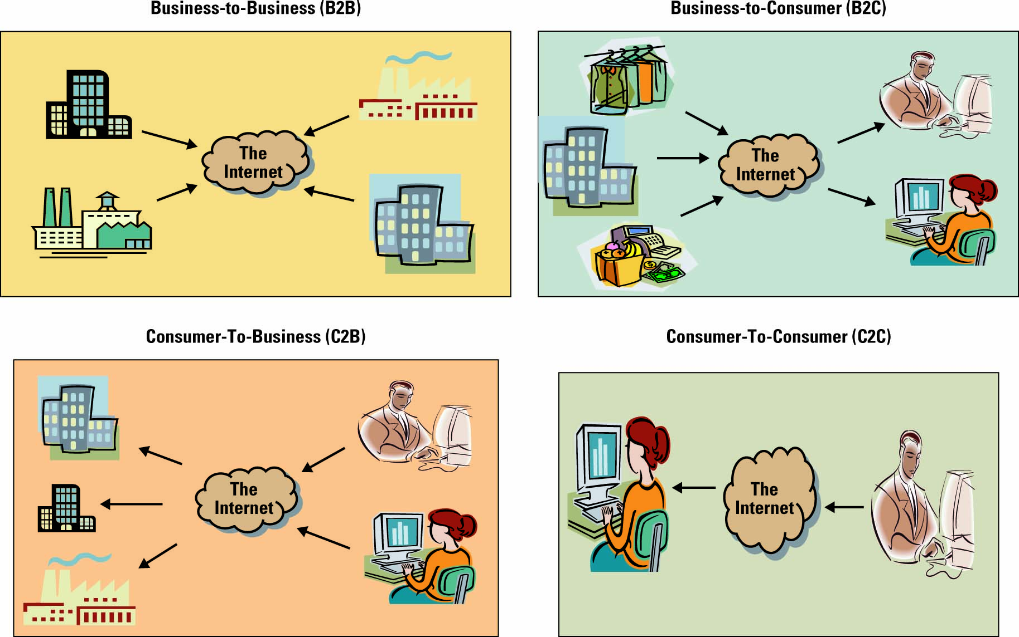
One of the most successful C2C business model is C2C Communities which are sometimes used for consumer to consumer financial transactions.

Types of C2C Communities:
Communities of interest
- People interact with each other on specific topics, such as golfing and stamp collecting
Communities of relations
- People come together to share certain life experiences, such as cancer patients, senior citizens, and car enthusiasts
Communities of fantasy
- People participate in imaginary environments, such as fantasy football teams and playing one-on-one with Michael Jordan

Types of Businesses:
Brick and Mortar
- Physical store, no Web site.
Pure-play (virtual) business
- Web site only.
Click and Mortor
- Physical store and Web site.

E-auctions
- are a successful E-business model.

Forward Auctions
- Seller offers to many buyers who bid and the highest bid wins.

Reverse Auction
- Buyer specifies product or service and lowest seller bid wins contract.

Electronic marketplace (e-marketplace)
- interactive business communities providing a central market where multiple buyers and sellers can engage in e-business activities
- Their primary goal is to increase market efficiency by tightening and automating the relationship between buyers and sellers
Common B2C e-business models include:
e-shop (aka e-store/ e-tailing)
- a version of a retail store where customers can shop any time without leaving their home
e-mall
- consists of a number of e-shops; it serves as a gateway through which a visitor can access other e-shops
Online Consumer Payments:
Financial cybermediary
- an Internet-based company that facilitates payments over the Internet.
Ex: PayPal

Electronic cheque
- a mechanism for sending a payment from a chequing or savings account.

Electronic bill presentment and payment (EBPP)
- a system that sends bills over the Internet and provides an easy-to-use mechanism to pay the bill.
Ex: EBPP systems are available through local banks or online services such as Checkfree and Quicken.

Digital wallet
- both software and information—the software provides security for the transaction and the information includes payment and delivery information
Ex: the credit card number and expiration date

Online business payments include:
Electronic data interchange (EDI)
- a standard format for exchanging business data.
- One way an organization can use EDI is through a value-added network.

Value-added network (VAN)
- a private network, provided by a third party, for exchanging information through a high-capacity connection.
- VANs support electronic catalogues (from which orders are placed), EDI-based transactions (the actual orders), security measures such as encryption, and EDI mailboxes.

Financial EDI (financial electronic data interchange)
- is a standard electronic process for B2B market purchase payments.

Why do businesses use different forms of online payments than consumers?
- Business payments are typically much larger than consumer payments and need additional security
- With supply chain management systems online business payments are automated using EDI

Maintenance, repair, and operations (MRO) materials (aka indirect materials)
- materials necessary for running an organization but do not relate to the company’s primary business activities

E-procurement
- the B2B purchase and sale of supplies and services over the Internet

Electronic catalogue
- presents customers with information about goods and services offered for sale, bid, or auction on the Internet

E-business Security methods
Encryption
- scrambles information into an alternative form that requires a key or password to decrypt.
- Encryption is achieved by scrambling letters, replacing letters, replacing letters with numbers, and other ways.

Secure socket layer (SSL)
- (1) creates a secure and private connection between a client and server computer
- (2) encrypts the information,
- (3) sends the information over the Internet. SSL is identified by a Web site address that includes an “s” at the end—https.

Secure electronic transaction (SET)
- a transmission security method that ensures transactions are secure and legitimate.
- encrypts information before sending it over the Internet.
- SET enables customer authentication for credit card transaction.

E-Business Challenges:
Protecting consumers
- Against unsolicited, illegal or harmful goods, invasion of privacy, cyber fraud
Leveraging existing systems
- Effectively integrating innovative systems with existing systems.
Increasing liability
- Identity theft, privacy, and the Internet’s global reach means dealing with laws of many countries.
Providing security
- Protection of consumer and business information and data assets.
Taxation Rules
- Adhering to often new rules

E-Business Benefits:
Highly Accessible
- Businesses can operate 24 hours a day, 7 days a week, 365 days a year
Increased Customer Loyalty
- Additional channels to contact, respond to, and access customers helps contribute to customer loyalty
Improved Information Content
- In the past, customers had to order catalogues or travel to a physical facility before they could compare price and product attributes. Electronic catalogues and Web pages present customers with updated information in real-time about goods, services, and prices
Increased Convenience
- E-business automates and improves many of the activities that make up a buying experience
Increased Global Reach
- Businesses, both small and large, can reach new markets
Decreased Cost
- The cost of conducting business on the Internet is substantially smaller than traditional forms of business communication
E-government
- Involves the use of strategies and technologies improve the delivery of services and enhance the quality of interaction between the citizen-consumer within all branches of government.

Mobile commerce
- the ability to purchase goods and services through a wireless Internet-enabled device

Chapter Four – Enterprise Computing challenges and Enterprise Resource Planning
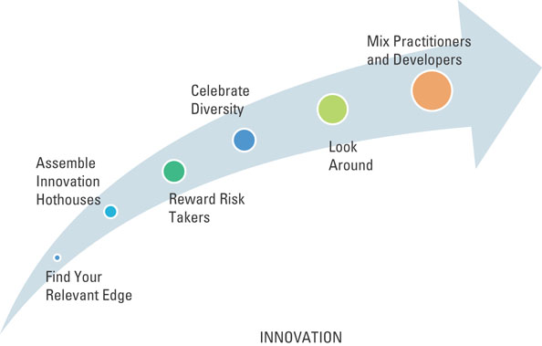
4.1: Enterprise Computing Challenges
What are the 6 best practices of Innovation?
- Find your relevant edge
- Assemble innovation hothouses
- Reward risk takers
- Celebrate diversity
- Look around
- Mix practitioners and developers

Innovation
- The introduction of new equipment’s and methods

Social Entrepreneurship:
Social Responsibility
- implies that an organization has a responsibility to society.

Corporate Policy
- reflects the position a company takes on social and political issues.

Sustainable or “Green”
- describes systems that minimize damage to the environment

Ewaste
- Refers to discarded, obsolete or broken electronic devices

Sustainable IT disposal
- Refers to the safe disposal of MIS assets at the end of their life cycle

Electronic Product Stewardship Canada (EPSC)
- an industry association that educates and encourages e-waste control
- Recent International laws restrict the use of hazardous materials.

Organization Social Networking:
Passive Search
- Finding people for new jobs who are happy and productive where they through business networking sites.

Boomerangs
- Former employees returning to old jobs.

Marketing Networks
- Using business networks for marketing and events
Virtual World
- An Internet resource which presents a 3D virtual community.

Virtual Organizations
- interactive web presence for businesses and their customers.

Virtual Workforce
- working from home…or anywhere via the Internet.

Mobile commerce (m-commerce)
- ability to purchase goods and services through a mobile device.

Telematics
- The blending of wired and wireless technologies for efficient electronic communication.

Electronic tagging
- the use of RFID (radio frequency identification) and other systems to identify and tracking digital assets.

4.2: Enterprise Resource Planning
Enterprise resource planning (ERP)
- integrates all departments and functions throughout an organization into a single IT system)
- so that employees can make enterprise-wide decisions by viewing enterprise-wide information on all business operations
ERP is:
- Solution to incompatible applications.
- Addresses the need for global information sharing.
- Avoids the expense of fixing legacy systems.

Legacy Systems
- are older computer technology still in use.
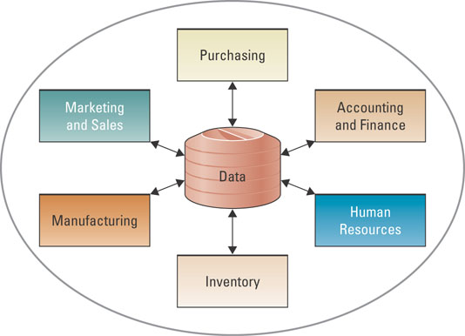
Functional Systems
- serve single business departments or units.

ERP Integration Data Flow
- At the heart of all ERP systems is a database; when a user enters or updates information in one module, it is immediately and automatically updated throughout the entire system

Core ERP components
- traditional components included in most ERP systems and they primarily focus on internal operations

Extended ERP components
- extra components that meet the organizational needs not covered by the core components and primarily focus on external operations

Core ERP components
- traditional components included in most ERP systems and they primarily focus on internal operations

Extended ERP components
- extra components that meets the organizational needs not covered by the core components and primarily focus on external operations

Core ERP component
- traditional components included in most ERP systems and they primarily focus on internal operations

Extended ERP component
- extra components that meet the organizational needs not covered by the core components and primarily focus on external operations

Three most common core ERP components:
Accounting and finance components
- manage accounting data and financial processes within the enterprise with functions
Ex: general ledger, accounts payable, accounts receivable, budgeting, and asset management

Production and materials management components
- handle the various aspects of production planning and execution such as demand forecasting, production scheduling, job cost accounting, and quality control

Human resource components
- track employee information including payroll, benefits, compensation, performance assessment, and assumes compliance with the legal requirements of multiple jurisdictions and tax authorities

Accounting and finance ERP component
- manages accounting data and financial processes within the enterprise with functions such as general ledger, accounts payable, accounts receivable, budgeting, and asset management

Production and materials management ERP component
- handles the various aspects of production planning and execution such as demand forecasting, production scheduling, job cost accounting, and quality control

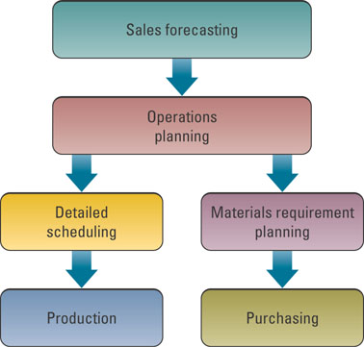
The production planning Process:

- This figure displays the typical ERP production planning process.
- The process begins with forecasting sales in order to plan operations.
- A detailed production schedule is developed if the product is produced, and a materials requirement plan is completed in the product is purchased.

Human resource ERP component
- tracks employee information including payroll, benefits, compensation, performance assessment, and assumes agreement with the legal requirements of multiple jurisdictions and tax authorities

Extended ERP components include:
Business intelligence
- describes information that people use to support their decision-making efforts
Customer relationship management (CRM)
- involves managing all aspects of a customer’s relationships with an organization to increase customer loyalty and retention and an organization's profitability
Supply chain management (SCM)
- involves the management of information flows between and among stages in a supply chain to maximize total supply chain effectiveness and profitability
E-business
- means conducting business on the Internet, not only buying and selling, but also serving customers and collaborating with business partners

Primary Users and Business Benefits of Enterprise Applications:

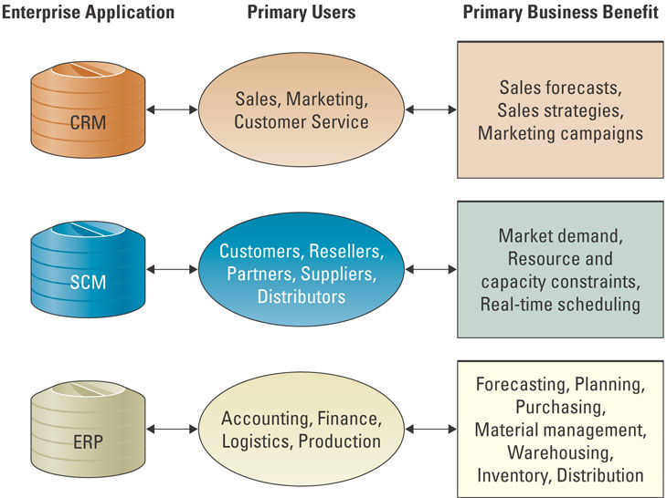

E-logistics
- manages the transportation and storage of goods

E-procurements
- the business to business (B2B) purchase and sale of supplies and services over the internet

Integration tools:
- Integrations are achieved by using middleware
- Middleware translates information between disparate systems
Middleware
- Several different types of software that sit between and provide connectivity for two or more software applications

Enterprise application integration middleware (EAI)
- Takes a new approach to middleware by packaging commonly used applications together, reducing the time needed to integrate applications from multiple vendors
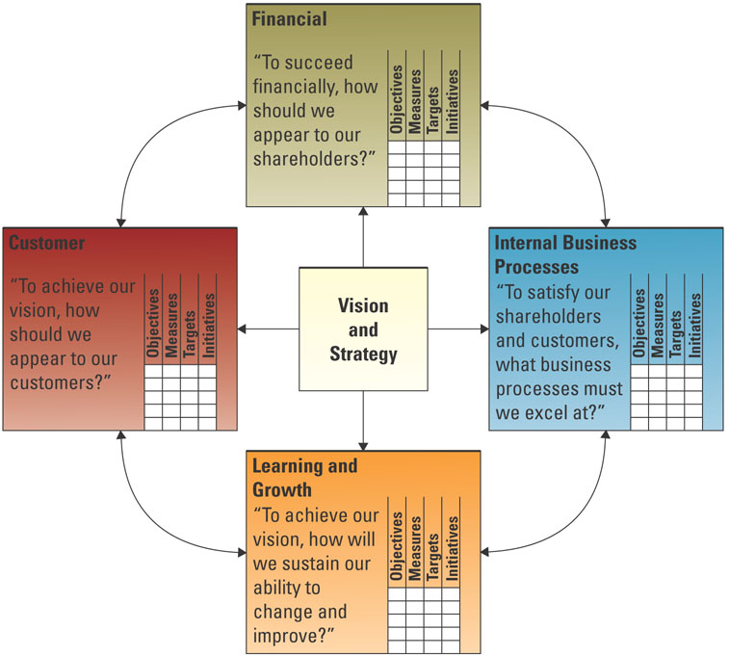
The Four Primary Perspectives of the Balanced Scorecard:

- Customer—”To achieve our vision, how should we appear to our customer.
- Financial –”To succeed financially, how should we be appearing to our shareholders?”
- Internal Business Process—”To satisfy our shareholders and customers, what business processes must we excel at?”
- Learning and Growing—”To achieve our vision, how will we sustain our ability to change and improve?”

Successful ERP projects share 3 attributes:
Overall fit
- This refers to the degree of gaps that exist between the system and the business process.
- A well-fitting ERP has no major process gaps and very few minor ones

Proper business analysis
- The best way to determine which fit strategy is right is to conduct a thorough business analysis.
- A proper analysis must result in a documented list of the business processes at work within the company.
- This will provide a basic tool that can measure vendor capability.

Solid implementation plans
- As with the installation of any successful process or machinery, a plan is needed to monitor the quality, objectives, and timelines.
- The plan will also employ processes such as workflow analysis and job combination to harvest savings.
- A thorough implementation will transfer knowledge to system users.
- When the project is complete, employees must be capable of using the tools the new system provides.
- The users must also know what to do in cases when the process fluctuates.
- Most failed systems result from poor quality implementation

Which of the three basic attributes is most important when considering an ERP purchase?
  - All are important; depending on the project, the level of importance might change

Chapter Five – Operations Management & Supply Chain Management
5.1: Operations Management

Production management
- describes all the activities managers do to help companies create goods.

Operations management (OM)
- is the management of systems or processes that convert or transform resources (including human resources) into goods and services.

Transformation process
- is often referred to as the technical core, especially in manufacturing organizations, and is the actual conversion of inputs to outputs.

Value-added
- The term used to describe the difference between the cost of inputs and the price value of outputs
- Has an ability to increase value added during the transformation process

OM in a business:
Forecasting: Estimating demand for a product/service

Capacity Planning- Determining the amount of space, equipment and throughput is needed to achieve the production targets.

Scheduling- Determining when the production will occur.

Managing inventory- Ensuring raw materials will be available on time and in place and that work in progress and finished goods have storage.

Assuring quality- Ensuring standards are met through sampling inputs, in process work and outputs.

Motivating and training employees- Appropriate pay, benefits, scheduling, and direction, supervision and instructions.

Locating Facilities- Determining where to put production facilities and the cost effectiveness of near major markets or away from markets and close to transportation routes.

SBU Strategic Business Unit
- is a stand-alone business under a corporate umbrella
Strategic Planning
- are the collection of decisions focus in doing the right things over a longer period of time
MPR Systems
- use sales forecast to make sure parts and materials are available
Global Inventory Management Systems (GIMS)
- locate, track and predict materials and components by installing GPS in transportation vehicles
Operational Planning and Control (OP&C)
- deals with day-to-day operations.

Inventory management and Control systems
- provides control and visibility to the status of individual items maintained in inventory

Transportation planning systems
- tracks and analyzes the movement of materials and products to ensure the delivery of materials and finished goods at the right time, to the right place, and at the lowest cost

Distribution management systems
- coordinates the process of transportation materials from a manufacturer to distribution centers to the final customers

Five key competitive priorities that can add value for customers:
- Cost—key determinant in a customer purchase decision
- Quality—Product quality should reflect the exact requirements of a customer
- Delivery—fast and reliable
- Flexibility—offering a wide variety of products to customers. Offering a choice of environmentally friendly products and services.
- Service—New products revert to being commodities quickly. Often the distinguishing factor is the service provided by the supplier.

Supply chain
- consists of all parties involved, directly or indirectly, in the procurement of a product or raw material

Supply chain management (SCM)
- involves the management of information flows between and among stages in a supply chain to maximize total effectiveness and profitability.
- Supply chain management improves ways for companies to find the raw components they need to make a product or service, manufacture that product or service, and deliver it to customers
The four basic components of Supply chain management (SCM) are:
Supply Chain Strategy
- A company must have a plan for managing all the resources that go toward meeting customer demand for products or services.
Supply Chain Partners
- Companies chosen to deliver finished products, raw materials and services.
Supply Chain Operations
- Scheduling production activities, including testing, packaging, and preparing for delivery.
Supply Chain Logistics
- product delivery process and elements including orders, warehouses, carriers, defective product returns and invoicing.

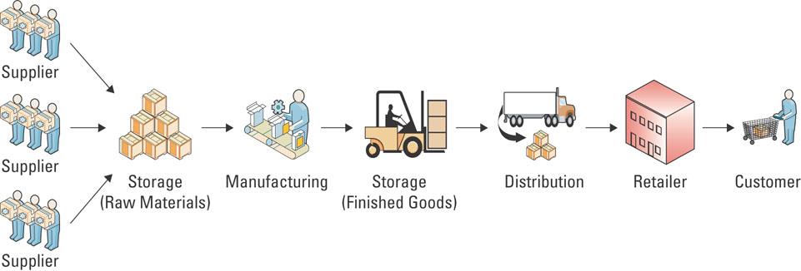
A typical manufacturing supply chain:
Example:
- Customer places an order for a Cervello bike with a store.
- Store (such as a local bike shop, or local sporting goods store) receives the order.
- Store receives the payment from the customer.
- Store orders the bike from Cervello.
- Store sends payment to Cervello.
- Cervello orders materials from its suppliers, such as packaging material, metal, and accessories.
- Cervello sends payments to suppliers.
- Cervello receives materials from suppliers.
- Cervello assembles the bike.
- Cervello ships the bike to the store.
- Customer picks up the Cervello bike from the store.

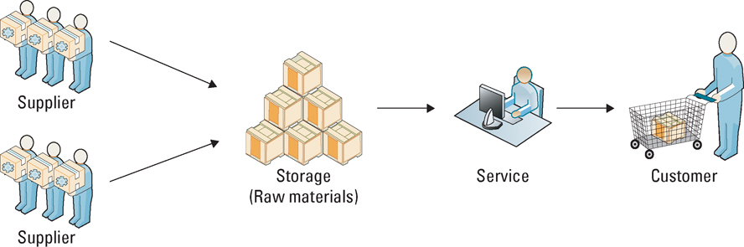
A typical service supply chain:

Impact of Efficient & Effective Supply Chain Management on Porter’s Five Forces
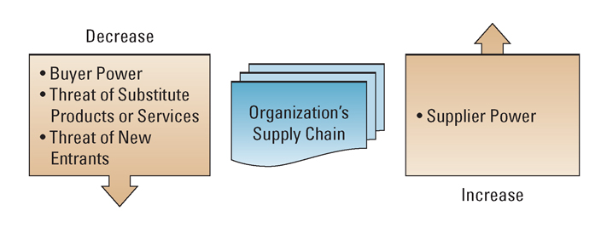
Effective and efficient SCM systems can enable an organization to
  - Decrease the power of its buyers
  - Increase its own supplier power
  - Increase switching costs to reduce the threat of substitute products or services
  - Create entry barriers thereby reducing the threat of new entrants
  - Increase efficiencies while seeking a competitive advantage through cost leadership
5.2: Supply Chain fundamentals

The supply chain has three main links:
  - Materials flow from suppliers and their “upstream” suppliers at all levels
  - Transformation of materials into semi-finished and finished products through the organization’s own production process
  - Distribution of products to customers and their “downstream” customers at all levels

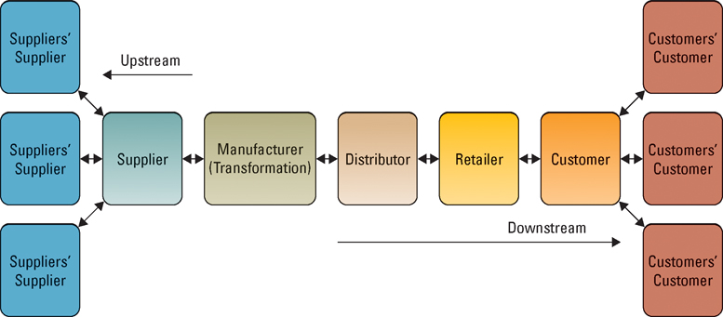
A Typical Supply Chain for a Manufacturer

The five basic supply chain management components:
Plan
- This is the strategic portion of supply chain management.
- A company must have a plan for managing all the resources that go toward meeting customer demand for products or services.
- A big piece of planning is developing a set of metrics to monitor the supply chain so that it is efficient, costs less, and delivers high quality and value to customers.
Source
- Companies must carefully choose reliable suppliers that will deliver goods and services required for making products.
- Companies must also develop a set of pricing, delivery, and payment processes with suppliers and create metrics for monitoring and improving the relationships.
Make
- This is the step where companies manufacture their products or services.
- This can include scheduling the activities necessary for production, testing, packaging, and preparing for delivery.
- This is by far the most metric-intensive portion of the supply chain, measuring quality levels, production output, and worker productivity.

Deliver
- This step is commonly referred to as logistics.
- During this step, companies must be able to receive orders from customers, fulfill the orders via a network of warehouses, pick transportation companies to deliver the products, and implement a billing and invoicing system to facilitate payments.
Return
- This is typically the most problematic step in the supply chain. Companies must create a network for receiving defective and excess products and support customers who have problems with delivered products.

Logistics
- is the set of processes that plans for and controls the efficient and effective transportation and storage of supplies from suppliers to customers.

Supply Chain Visibility
- is the ability to view all areas up and down the supply chain

Bullwhip effect
- means that disruptions upstream at supply source increase in impact as they move downstream to the consumer.

Demand Planning systems
- create forecasts using statistical tools and techniques so that customers can respond faster to consumer demands, reducing inventory and improving delivery time.

Supply Chain Planning Systems (SCP)
- process correct and timely information with Mathematical algorithms to improve the flow of input materials and final product outputs through the supply chain.

Supply Chain Execution (SCE)
- automates steps in the supply chain such as order, shipment and payment.
- A blanket PO (purchase order) sits in the suppliers’ computers and the use of the purchasers’ products are tracked.
- When the purchasers’ inventory falls to a specified level an automatic shipment is triggered and payment is done through automatic bank withdrawal.
- The most common system is EDI (Electronic Data Interchange).

Supply Chain Execution
- applications remove the need for paper flow and allow for continuous materials and product flow, speed is increased.
- Increasing speed and capacity of servers and telecommunications has improved supply chain speed dramatically.

Why is information speed critical in a supply chain?
- If the information arrives three dates late, chances are high that managers have already made decisions based on current information that might have been inaccurate
- Information timeliness is critical
- IT is an enabler of information timeliness

Common supply chain metrics include:
- Back order
- Inventory cycle time
- Customer order cycle time
- Inventory turnover

Seven principles of SCM:
- Segment customers’ needs by service needs, regardless of industry, and then tailor services to those particular segments
- Customize the logistics networks and focus intensively on the service requirements and on the profitability of the pre-identified customer segments
- Listen to signals of market demand and plan accordingly. Planning must span the entire chain to detect signals of changing demand
- Differentiate products closer to the customer, since companies can no longer afford to hold inventory to compensate for poor demand forecasting
- Strategically manage sources of supply, by working with key suppliers to reduce overall costs of owning materials and services
- Develop a supply chain information technology strategy that supports different levels of decision making and provides a clear view (visibility) of the flow of products, services and information’s
- Adopt performance evaluation measures that apply to every link in the supply chain and measure true profitability at every stage

SCM industry best practices include:
- Make the sale to suppliers.
- Wean employees off traditional business practices.
- Ensure the SCM system supports the organizational goals.
- Deploy in incremental phases and measure and communicate success.
- Be future oriented

Instrumentation
- Data will be increasingly machine-generated. GIS and RFID-enabled devices, meters and actuators.

Interconnectedness
- Every component from customer back to materials source and every element in between such as vehicles, containers and products will be identified and can be tracked.

Intelligence
- Data received from the smart objects in the supply chain will be processed with smart analytics which will create better models to support improved decisions in an increasingly complex world.

Chapter six – Customer relationship management
6.1 :CRM Fundamentals

Customer relationship management (CRM)
- Involves managing all aspects of a customer’s relationship with an organization to increase customer loyalty and retention and an organization's profitability

CRM enables an organization to:
- Provide better customer service
- Make call centres more efficient
- Cross-sell products more effectively
- Help sales staff close deals faster
- Simplify marketing and sales processes
- Discover new customers
- Increase customer revenues

Organizations can find their most valuable customers through “RFM”
- Recency, Frequency, and Monetary value
- How recently a customer purchased items
- How frequently a customer purchased items
- The monetary value of each customer purchase

Three phases in the evolution of CRM include reporting, analyzing, and predicting.
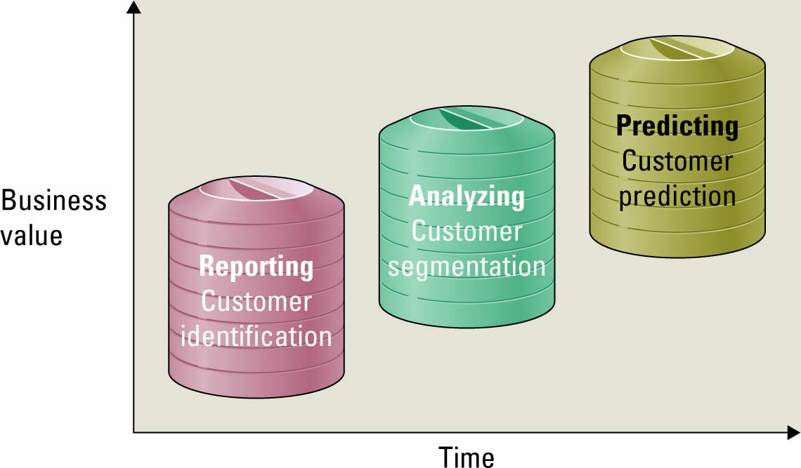
Reporting—Asking What Happened?
- What is the total revenue by customer?
- How many units did we manufacture?
- Where did we sell the most product?
- How many customers did we serve?
- What are our inventory level?
Analyzing
- Why did sales not meet forecast?
- Why was production so low?
- Why did we not sell as many units as last year?
- Who are our customers?
- Why was customer revenue so high?
- Why are inventory levels so low?
Predicting
- What customers are at risk of leaving?
- What products will the customer buy?
- Who are the best candidates for mailing?
- What is the best way to reach the customer?
- What is the lifetime profitability of a customer?
- What transactions might be fraudulent?

Operational CRM
- supports traditional transactional processing for day-to-day front-office operations or systems that deal directly with the customers.

Analytical CRM
- supports back-office operations and strategic analysis and includes all systems that do not deal directly with the customers.

Three primary operational CRM systems Marketing can use to increase customer satisfaction:
List Generators
- compile customer data from a variety of sources and segment the data for different marketing campaigns.

Campaign Management Systems
- guide campaign planners through key tasks, can calculate campaign ROI and track results for future fine tuning.

Cross-selling and Up-selling Strategies
- identify customers that would have interest in additional, related products or might respond to increasing the value of their purchase.

Sales force automation (SFA)
- a system that automatically tracks all of the steps in the sales process.

Sales and operational CRM technologies
- Sales management CRM system
- automates each phase of the sales process, helping individual sales representatives coordinate and organize all of their accounts
- Contact management CRM system
- maintains customer contact information and identifies prospective customers for future sales
- Opportunity management CRM system
- targets sales opportunities by finding new customers or companies for future sales

Pointers for gaining Prospective Customers:

1. Get their attention If you have a good prospect, chances are that he or she receives dozens of offers from similar companies. Be sure your first contact is professional and gets your customer’s attention.

2. Value their time When you ask for a meeting, you are asking for the most valuable thing a busy person has— time. Many companies have had great success by offering high-value gifts in exchange for a meeting with a representative. Just be careful because some organizations frown on expensive gifts. Instead, offer these prospective customers a report that can help them perform their jobs more effectively.

3. Overdeliver If your letter offered a free DVD in exchange for a meeting, bring a box of microwave popcorn along with the movie. Little gestures like these tell customers that you not only keep your word, but also can be counted on to overdeliver.

4. Contact frequently Find new and creative ways to contact your prospective customers frequently. Starting a newsletter and sending out a series of industry updates are excellent ways to keep in contact and provide value.

5. Generate a trustworthy mailing list If you are buying a mailing list from a third party be sure that the contacts are genuine prospects, especially if you are offering an expensive gift. Be sure that the people you are meeting have the power to authorize a sale.

6. Follow up One of the most powerful prospecting tools is a simple thank-you note. Letting people know that their time was appreciated may even lead to additional referrals.

Three customer service operational CRM technologies:
- Contact centre (call centre)
- where CSRs answer customer inquiries and respond to problems through different touchpoints

- Web-based self-service system
- allow customers to use the Web to find answers to their questions or solutions to their problems
Click-to-talk
- customers click on a button and talk with a CSR via the Internet

- Call scripting system
- access organizational databases that track similar issues or questions and automatically generate the details to the CSR who can then relay them to the customer

Analytical CRM
- Digs deep into the company’s historical customer data to expose patterns of customer behaviour on which a company can capitalize.
- Has ability to provide an organization with information about their customers that was previously impossible to locate, and the resulting payback can be tremendous.
- relies heavily on data warehousing technologies and business intelligence to glean insights into customer behaviour.
- These systems quickly aggregate, analyze, and disseminate customer information throughout an organization.
Personalization
- when a Web site knows enough about a person’s likes and dislikes that it can fashion offers that are more likely to appeal to that person

6.2: CRM Best practices and trends

CRM industry best practices include:
- Clearly communicate the CRM strategy.
- Define data needs and flows.
- Build an integrated view of the customer.
- Implement in iterations.
- Scalability for organizational growth.

Eight building blocks of CRM:
- Vision
- Outlines the value proposition.
- It also identifies the customers and the nature of the customer experience that the organization wants to achieve.
- Strategy
- Must support the vision and all components and activities of CRM must be aligned with it.
Ex: Sales representatives must not only be rewarded for sales but also for using CRM applications to direct their sales effort.
- The customer
- is included in the design of CRM by soliciting and using feedback. Have students name different ways companies have solicited their feedback.
- Collaboration
- Data for successful CRM must be draw from all areas of the business
- Customer processes
- Consideration must be given to all customer “touch points”, where the customer is interacting with the company or its agents so that a superior experience is provided.
- Integrity
- Data must be shared across departments and partnerships.
- Balancing the needs of information security, confidentiality and privacy against improved and customized processes is a significant management challenge
- Information Systems
- Integrated data systems, such as ERP and EDI foster increased efficiencies but also effective CRM as data is gathered and processed in real-time, response rates to customers are minimized and customized service is managed effectively.
- CRM metrics
- ”What is measured is managed” is an old business maxim.
- CRM metrics identify wins and areas of weakness to be improved.
- They also indicate whether the company is getting the optimal return for the investment in CRM.

CRM future trends include:
- CRM applications will continue to evolve and be used by a wide variety of partners
- CRM will continue to be a major strategic focus for companies
- CRM applications will continue to adapt wireless capabilities supporting mobile sales and mobile customers
- CRM suites will incorporate SRM, PRM and ERM module

