ECOR 1010 – Introduction to Engineering

[Type Authors¹]
Assignment #9
Assignment Title: Bivariate Data
TO Marking TA:

Lab Section: A7
Room: MC 5010 – Carleton University

FROM:

Number of Figures and Tables (Including handwritten ones): 4
Last Date and Time of Revision: 03 December 2012

Introduction
In this lab, symbolic programming was compromised to execute answers to the problems. This was achieved by using the program Maple, a more visual program that MATLAB that does not use script files

Materials and Methods
Mathematical systems such as functions, limits, by-variable differentiation, matrices and plotting were solved using 2-D symbolic programing in Maple.

Results
The Calculations of Part 1 were executed by declaring the unknowns of the currents and voltage it vector matrices, and they were manipulated to give the symbolic representation of their answer as in Part 1 section of the appendix. The answers were then obtained with respect to R1 by substituting the known values into the equation. Then the three formulas were used to evaluate Voltage; R1 at 7ohms. Compared to the voltages values in lab 7, the same voltages were obtained when the declared formulas were “evaluated at point”. For Part 2, unknown variables A and k were determined to be 4.3 and 0.108 respectively. Time of shutdown for the robot was determined to be 5.13 minutes before walking into the room and the temperature of the function as it approaches infinity is 23.2°C which is the temperature of the room. This means that the robot arm will never go below the room temperature it is housed in as long as nothing interrupts its cooling process besides the natural effect the room temperature has on the robot arm. For Part 3, the transient charge was determined by evaluating and solving the second order derivative of the volt function. The equations for the voltage and the transient charge were plotted. This can be found within part 3 of the appendix.

Discussion
The use of Maple in executing these problems aided a more visual representation of the problems compared to script files in MATLAB. In terms of functionality, the pre-set functions were of great use as they made the program much more user friendly and greatly eliminated the chance of executing the problems incorrectly. As amateurs of using this program, selecting expressions and inputting values into matrices were quite the hassle.

Conclusions
The program Maple is an effective tool in solving mathematical problems whether it is symbolically or not. The program is user friendly but requires quite a bit familiarization with operation in the program to solve problems with the desired ease.

APPENDIces- Figures and Tables
Part 1
* Variables 'A' and 'B' are declared to represent Current and Voltage respectively

* Equation with the inverse of A multiplied by B, in matrix form is used to obtain the three symbolic formulas for the three currents in terms of unnkown resistance

* Values of all Currents and Voltages are declared in terms of ohms and Volts except for R1, the unknown resistance

* The equation that originally obtain the three current formulas is written out again with their respective knowns in the following step

*The formulas are used to evaluate the currents when R1=7 in the following step so that the answers can compared with the currents of qustion 5 in Part 2 of Lab 7

* The following graph the is the plot of current i1 as the resistance of current ranges from 0 to 10
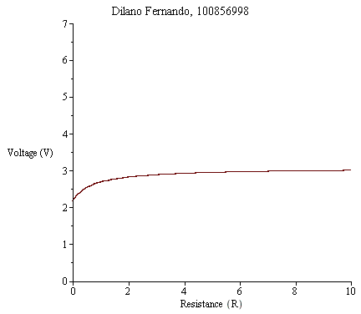

Part 2
The temperature of the robot arm is assigned as the following function

*There are two constants for the above function (A and k), the following are the steps perfomed to obtain these values into the complete function

*First of all, it is a given that room temperature of the room that houses the robot is 23.2 and that time (t) is considered 0 as I enter the room when the robot has a temperature of 27.5
Now that A is solved, it's time to declare that the temperature of the robot is 25.7 after 5 minutes of me being in the room so that the 'k' constant can be solved

*Now that all unknown constants are determined, the temperature at which the robot shuts down from overheating is substituted into the equation find the time at which this would happen

*The funtion is plotted

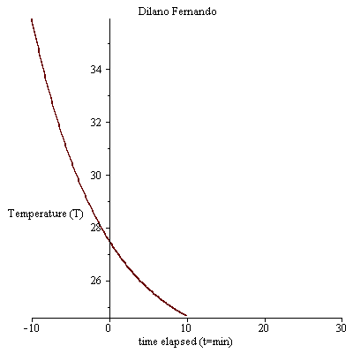

* The expression is used to solve for the limit as it approaaches infinity; by right clicking the function and setting the t = infinity

* The expression solves that temperature of the robot will eventually reach the 23.2 which is the room temperature as time is infinity (very long time)
Part 3
*Assgning the Volt function
* assigning given value for in Coulombs
* The following step defines the funtion for Current
* input of the given value for current at time in seconds at 0
* solve for the derivative of the function by right clicking on the function and selecting solve DE interactively from the drop down menu

3.2
* The Voltage function is assigned
* The plot of the assigned function
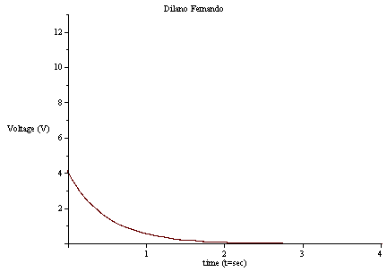
3.3
*The charge function is assigned

* The derivitive of the assigned function is formulate so that it can be plotted


