Research Methods in Psychology

Ch.1: Scientific Understanding of Behavior
* Prof’s hints

Scientific Research: a method of inquiry that follows a standardized approach to answering questions
- Not a “thing” but a way of thinking

Uses of Research Methods: Informed consumer information
- Read reports critically
- Evaluate the methods used
- Determine if conclusions are reasonable
- Make better decisions: personal & work
- Influences public policy and judicial decisions
- Evaluate the effectiveness of goal-oriented programs

Methods for Acquiring Knowledge:
Intuition: judgments based on our own ideas and biases; preconceived notions and historical backgrounds make our intuition biased
- Erroneous conclusions about the cause and effect: we draw incorrect conclusions
- Illusionary correlation: focus on two events that stand out and occur together
Authority: believing ideas to be true because they were presented by an authority figure
- News media
- Books
- Government officials
- Religious figures
- Political pundits
Scientific Approach: acknowledges that both intuition and authority are sources of ideas
Objective set of rules for gathering, evaluating, and reporting information
Open system that allows ideas to be supported or refuted
Acknowledges value of intuition and authority as a basis for generating research ideas
- BUT does not accept these ideas without question
- Ideas must be evaluated on the basis of careful logic and systematic observation
- Empiricism: knowledge based on structured, systematic observations
- Formulate Hypothesis Collect Data Analyze Results

Steps Scientific Approach
- Make systematic observations and report them accurately; allows for replication
- *Two Forms of Replication:
- Direct replication: exact same study, exact same method
- Conceptual replication: when you are going after the same idea, using different methods, different system, to extend or expand the existing study
- Engage in theory-building: involves the development, testing, and refining of theories
- Maintain an open system where falsifiable ideas are exchanged, debated and challenged… researchers are only interested in falsifiable ideas
- Submit findings for peer review – evaluation by a panel of experts

Scientific Skepticism: the ideas must be evaluated on the basis of careful logic and results from scientific investigations
What are the person’s credentials?
What is the person’s reputation?
Who is funding the research?
Beware of pseudoscience
- Hypotheses generated are not typically testable
- If scientific tests are reported, the methodology is not scientific and validity of data is questionable
- Supportive evidence is anecdotal and does not cite scientific references
- Claims ignore conflicting evidence
- Claims tend to be vague, and appeal to pre-conceived ideas
- Claims are never revised

Goals of Scientific Research
- Describe Behavior: careful observation and measurement
- Predict Behavior: based on the observation that events are systematically related to one another
- Determine the Causes of Behavior:
- Covariation (two things are occurring together) of cause and effect e.g. we need to know that children who watch violent TV behave aggressively and those who don’t, don’t
- Temporal Precedence: there is an order of events in which the cause precedes the effect e.g. viewing a particularly violent tv show occurred first and acts of aggression followed
- Elimination of alternative explanations, the cause is the ONLY reason for effect, e.g. child that watches violence is not left alone more than child that doesn’t adding to the aggression
- Explain Why Behavior Occurs: much experimentation is often necessary to shed light on possible explanations of why one event causes another

Basic and Applied Research
Basic Research: attempts to answer fundamental questions about the nature of behavior (theoretical) addresses cognition, emotion, motivation, learning, social behavior etc.
Applied Research: address practical issues and potential solutions, includes program evaluation (real world)
Neither is considered superior to the other
Applied research is often guided by theories and findings of basic research
Findings in applied settings often require modification of existing theories and spur more basic research
Program Evaluation: evaluates social reforms and innovations in gov, education, criminal justice system, industry, health care, and mental health institutions.

Ch.2 Where to Start

Hypothesis and Predictions
Hypothesis: a tentative question/statement waiting for evidence to support or refute it, important to be falsifiable, data can prove that hypothesis is false, if it is false
Prediction: a prediction (guess) about what will occur in a particular research investigation, evolution from a hypothesis more concrete
Evidence is supported not proven

How to Create Hyp and Pred: Sources of Ideas
- Common assumptions about the world around you
- Observations of the world around us (serendipity): notion that you will find something that you weren’t even looking for
- Practical Problems: problems that we encounter in our everyday lives
- Theories
- Past research

Theory: a system of logical ideas proposed to explain a particular phenomenon
- Organize and explain observations
- Generate new knowledge
- Can be modified by new research
- Parsimony: if multiple theories are equally successful, parsimony dictates that the least complex theory is most desirable because easiest to falsify
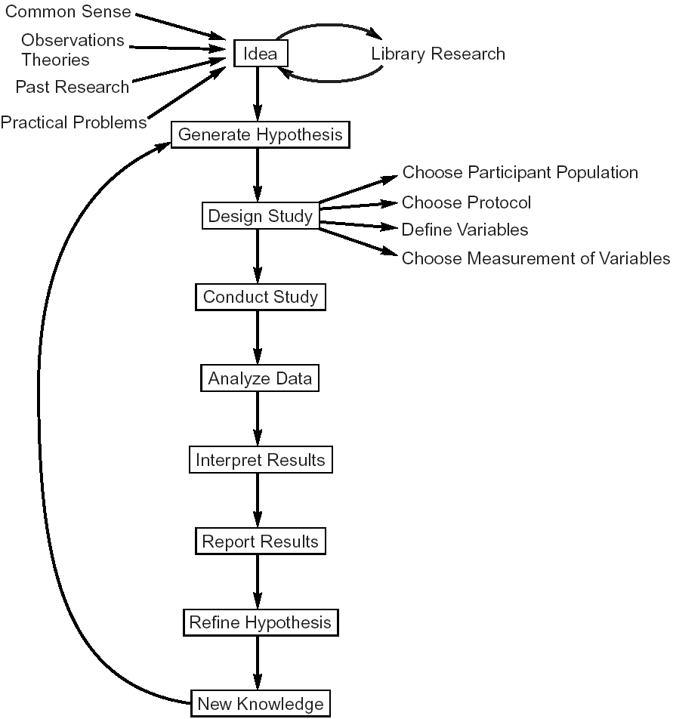

Anatomy of Research Article
Abstract:
- A summary of the research report
- 150-250 words
- Includes the hypothesis, procedure, and the broad pattern of results
- 1 sentence to represent big/main point of each section
Introduction:
- Outlines the problems investigated
- Past research and theories relevant to the problems described
- Formal hypothesis or specific expectations are introduced and connected to past research
Method:
- Made up subsections
- Overview of design
- Characteristics of participants: describe who participants are
- Procedure: details so that it could be easily repeated
- Equipment or testing materials
Results:
- Findings presented in three ways:
- Description in narrative form
- Description in statistical language
- Material in table or graphs
Discussion:
- Review research from various perspectives
- Present methodological weakness and/or strengths
- Explain how the results compare with past results
- Include suggestions for practical applications
- Include suggestions for future research on the topic

Finding Existing Research
PsycINFO: electronic index of all abstracts from 1800s to present
- Updated weekly
- Library home page subject guides (more) psych databases
Strategy 1: use fields such as TI and AU
- Requires that a name appear as author or that a term appear in title
- E.g., divorce in TI
Strategy 2: use AND to limit search
- Requires that both terms appear term appear in the search field
- E.g. divorce AND children
Strategy 3: use OR to expand search
- Requires that either of two terms appear in search field
- E.g. divorce AND (children OR youth)
Strategy 4: use NOT to exclude search terms
- Searches for first terms but excludes the combination of terms in search field
- E.g. (children AND divorce) NOT custody
Strategy 5: use the wildcard asterisk (*)
- Looks for any word that begins with the letters typed into the search field
- E.g. child* finds children, childless, childish ect.
Strategy 6” find “key” article and use the “cited by” feature
- You can see the research that has been done that referenced that key article
Web of Science & Review Articles

Ch.3 Ethical Research

Milgram’s Obedience Experiment: classic study in social psychology examining the phenomenon of obedience to authority
- Inspired by the events that took place during the Holocaust
- Results challenged beliefs about our ability to resist authority
- Studies have been heavily criticized for being unethical
- Led to development of many ethical principles guiding research today
- Confederate: accomplice of the experimenter, participants don’t know

Ethical Research in Canada:
Tri-council Policy Statement
- Canadian Institutes of Health Research (CIHR)
- Social Sciences and Humanities Research Council of Canada (SSHRC)
- Natural Sciences and Engineering Research Council of Canada (NSERC)
- Core Principals: respect for persons (enabling people to choose participation freely and without interference), concern for participants’ welfare (attempt to minimize risks while maximizing benefits), justice (treat participants fairly)
Nuremburg Code: code of ethics
World Medical Association Helsinki Declaration
Belmont Report: defined the principals and applications that have guided more detailed regulations
American Psychological Association

Ethical Research In Canada
- Canadian researchers must:
- Adhere to the TCPS guidelines
- Comply with the Canadian Charter of Rights and Freedoms, Canadian privacy information laws, and relevant provincial laws

Risks/Benefits Analysis
Potential Risks in Psych Research:
- Physical harm e.g. blood sample
- Psychological stress
- Loss of privacy and confidentiality
Confidentiality*: kept secret, researcher knows who you are and can take that data and link it back to you, but they’re not letting anybody see it
Anonymity*: no way to connect any person’s identity with the data, researcher has no way to figure out who did their survey

Potential Benefits:
- Educational benefits, learn new skill, access to treatment for psych or medical condition
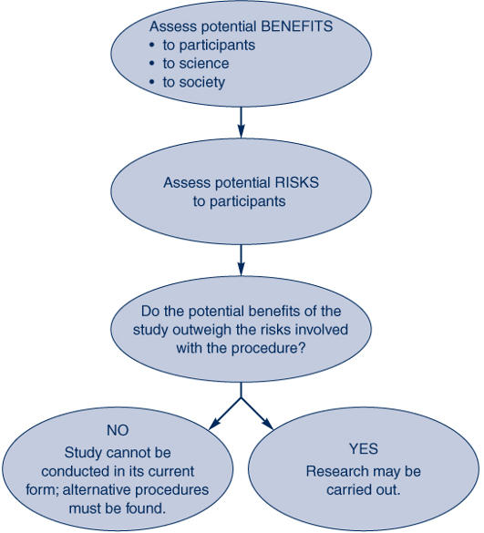
- Material benefits
- Personal satisfaction

Informed Consent:
- The purpose of the research
- Procedures that will be used, including time involved
- Risks and benefits to the participant and in general
- Any compensation
- How confidentiality will be protected
- Assurance of voluntary participation and permission to withdraw
- Contact info for questions about the research

Issues: Autonomy Issues: rational individual able to make informed decision
Possible Coercion: forcing another party to act involuntarily manner intimidation & threats
Withholding information and deception

Debriefing: full disclosure
- Occurs after completion of the study
- Addresses issues of withholding information, deception, and potential harmful effects of participation
- Explain why deception was necessary
- Provide additional resources if necessary
- Ensure participant leaves the experiment without feeling bad or having any ill feelings about the field
Deception: occurs when there is active misrepresentation of information, e.g. milgram experiment: deception about purpose of the study, participants didn’t know what they were getting themselves into
Alternatives to Deception:
- Role Playing: asks participants how they would respond to certain situation or to predict how others would respond. Not considered satisfactory alternative to deception
- Simulation Studies: variation on role-playing that involves simulation of real-world situation. Has a high degree of involvement from participants
- Honest Experiments: participants are made aware of the purpose of the research (e.g. speed dating studies)
- *Can you have an honest experiment, where you’ve manipulated something in the study: yes

Justice and Participant Selection: justice principle requires researchers to address issues or equity
- Any decisions to include or exclude certain people form a study must be justified on scientific grounds
- Tuskegee Syphilis Study: chose 30 African Americans with syphilis, didn’t treat them in order to find out long term effects of syphilis
- Benefits of research must also be equitably shared across groups
- Those studied should benefit from what is learned from research
- TCPS & research with Native population sin Canada

Researcher Commitments: Implied Contract with Participants
- Punctuality, summary of results, course credit
Research Ethics Board (REB)
- Each institution that receives federal funds must have an IRB
- Responsible for reviewing research at the institution
- REB approval must be obtained prior to starting research
Types of Research & REB:
- Exempt Research: no risk
- Employs publicly available information that is legal/accessible
- Involves observing people in public places without any interaction
- Uses already controlled data that are completely anonymous
- Minimal Risk Research: risk or harm is no greater than risk encountered in daily life or routine physical or psychological tests
- Questionnaires or interviews on non-sensitive topics
- Greater Than Minimal Risk: subjected to thorough review
- Additional safeguards beyond informed consent (nurse to do blood tests, having councilor on site)

The Research Ethics Board: Impact on Research
- Extended time for approval of study
- Submissions often need to be revised or clarified
- Very cautious about approval

Ethics and Animal Research: Reasons
- Full experimental control
- Used for research not possible or ethically acceptable with humans
- Procedures that are irreversible
Standards: proper handling & care of animals
- Minimize pain & avoid cruelty
Canadian Council on Animal Care: (3 R’s)
- Replacement: where possible avoid using an animal model
- Reduction: minimize the number of animals used
- Refinement: modifying process to minimize pain & distress

Professional Ethics:
- Research Fraud:
- Fabrication of data (making up data and passing it off as true)
- Results difficult to replicate (anomalies)
- Reporting by colleagues (using another persons data as own)
- Plagiarism: misrepresenting someone else’s work as your own
- Failure to cite resources
- Safeguard = peer review
- 4 consecutive words of an original article claiming they’re your own is plagiarism

Ch. 4 Studying Behavior
Define variables and describe the four categories of variables
Define operational definition of a variable
Compare and Contrast non-experimental and experimental research methods
Describe the different possible relationships between variables

Variables: anything that can generate more than one value
Four Categories
- Situational Variables: can take on a whole host of different characteristics e.g. how large is this classroom, how children like to play in a playground: situational variable could be is it sunny or rainy, were there toys or play structure
- Response Variables: behavioral, cognitive response to a stimulus, response to a drug (eye dilation), when given alcohol does the subject talk more etc.
- Participant or Subject Variables: classifying/characterizing the subjects that are of interest to the study: gender, age height, IQ, GPA, religion, race, in animal research the characteristics of your animals
- Mediating Variables: relationship between two variables, is explained because of another variable that influences both e.g. finance influencing happiness, because you’re going to more expensive parties, and health, because you can now afford a gym membership

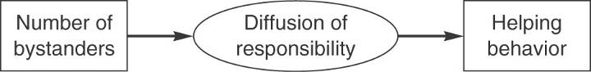 Situational Variable Mediating Variable Response Variable

Operational Definitions of Variables:
- Defines the operations or techniques the researcher will use to measure or manipulate a variable
- Necessary for empirical study
- Help communicate ideas to others
- Construct: an abstract concept that must be translated into concrete forms of observation or manipulation
- E.g. hunger, intelligence, aggression
- Many ways to operationalize the same construct

Non-Experimental vs. Experimental Methods:

Non-experimental: ONLY OBSERVING: no manipulation of variables, just description of behavior e.g. one cannot manipulate gender, age, IQ
- Correlational Method: measure variation between two variables
- No manipulation, just observation = no causation
- Can learn about direction and strength
- Positive Linear Relationship: increases in one variable relate to increases in another e.g. hotter weather = higher ice-cream sales
- Negative Linear Relationship: increases in one variable relate to decreases in another e.g. colder weather = lower ice-cream sales
- Curvilinear Relationship: increases in one variable relate to both increases and decreases in another: u-shape e.g. staff cheerfulness and customer satisfaction, the more cheerful staff the higher customer satisfaction, by only up to a certain point, when too cheerful might be fake or annoying, bringing down satisfaction
- No Relationship: change in one variable do not relate to change in another (flat line)
Non-experimental results cannot make causal statements, cannot establish temporal precedence, there is a 3rd variable problem

Experimental Method: direct manipulation of variable, explanation of behavior
- Cause and Effect relationships between independent (anything that you are manipulating) and dependent (what you’re interested in) variable
- Can make causal statements: you know that what you did happened before you took the other measurement
- Can establish temporal precedence
- Attempt to eliminate alternative hypotheses
- Experimental control & random assignment = eliminate confounds
Experimental Control: accompanied by treating participants in all groups in the experiment identically, only difference between groups is the independent variable
Random Assignment: ensures that the extraneous variable is just as likely to affect one experimental group as it is to affect the other group
Issues to Consider: artificiality of experiments (independent variable is manipulated within the carefully controlled confines of lab could cause artificial results)
- Ethical and practical considerations
- Participant variables (age, gender, ethnicity, birth order, personality) cannot be manipulated
- Causation or description or prediction

Causality & Validity:
- Internal Validity: the ability to determine causation, can draw accurate conclusions about casual relationships from our data… one variable caused changes in another = drinking caused the low scores on the exam for everybody
- Necessary & Sufficient conditions: the first variable has to be the cause of the second, rare in psychology, no third variable can have an effect

Ch 5: Measurement Concepts

Self-report measures
- Typically questionnaires or scales
- Answer on a continuum anchored by polar opposites (e.g., Likert scale)
- Strongly Disagree – Strongly Agree

Reliability of Measures
- Consistancey or stability of a measure (does it give you the same result over and over again)
- True score (person’s real score on the variable) + measurement error
Achieving Reliability: training observers
- Wording of questions: questions are clear
- Calibration & placement of equipment
- Multiple observations
Assessing Reliability: Pearson’s product moment correlation coefficient (r)
- Test-Retest Reliability: assessed by measuring the same individuals two points in time
- Vulnerable to artificiality
- Alternate forms of reliability
- Internal Consistency Reliability: assesses how well a certain set of items relate to eachother, they should yield similar or consistent results
- Split-half reliability: correlation between the two halves, split however you want it
- Cronbach’s alpha: indicator of internal consistency, and receive an alpha score
- Item-total correlations and number of items
- Interrater Reliability
- Correlation between observations of raters
- Cohen’s Kappa

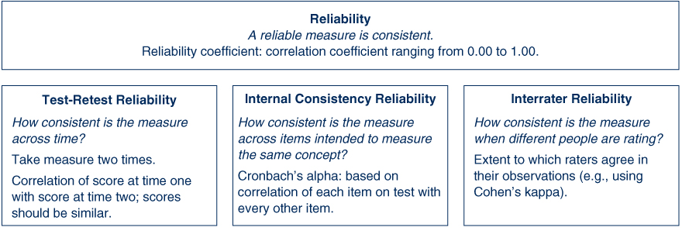

*A test can be highly reliable and not valid, but any test that is valid must be reliable
- Something can be reliable, but that doesn’t mean it’s accurate

Validity:
Construct Validity: the degree to which the operational definition of the measure reflects the construct
- Are you measuring what you say you’re measuring? Asking for someone’s shoe size 3 times and getting the same answer, and then trying to determine IQ
- Face Validity: the content of the measure appears to reflect the construct being measured
- Content Validity: theoretical definition of what you’re trying to measure. The content of the measure is linked to the universe of content that defines the construct
- Predictive Validity: scores on the measure predict behavior on a criterion measured at a time in the future
- Concurrent Validity: scores on the measure are related to a criterion measured at the same time (they should be highly correlated)
- Convergent Validity: scores on the measure are related to other measures of the same construct
- Discriminant Validity: scores on the measure are not related to other measures that are theoretically different
Evidence Construct Validity: the more methods used, the better
- Sometimes a measure is valid in one context but not another
- Must be tested and reassessed
Method: how you’re going to get the data
Measure: how you will assess the data

Reactivity of Measures:
- Measure is reactive if awareness of being measured changes an individual’s behavior: having a tape recorder in a room changes the entire conversation
- Measures of behavior vary in terms of their potential reactivity
- Can allow for familiarization & use unobtrusive measures

Variables and Measurement Scales: the scale you choose determines what statistics
- Nominal Scales: number that’s represented for a name
- Ex. makes/females; experimental condition/control condition
- Impossible to define any quantitative values or differences across categories
- Ordinal Scales: rank ordering with numeric values
- Ex. restraint ratings; birth order; Olympic medals
- Has magnitude; values are smaller or larger than the next
- Interval between items not known
- Interval Scales: has magnitude, values are smaller or larger than the next
- Interval between items is known as meaningful
- No true zero point
- Ex. Intelligence score, temperature
- Ratio Scales: has magnitude; values are smaller or larger than the next
- Interval between items is known and is meaningful
- Has true zero point
- Ex. reaction time, duration of response
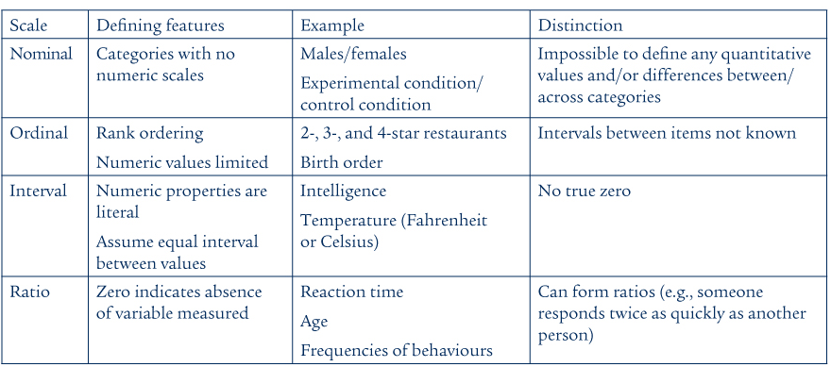

CH. 6: Observational Methods
Qualitative Approaches: test theories in a controlled setting
- Collect numerical data
- Uses large samples, analyze data via statistical methods
- In depth description of individuals in their natural setting
- Data=words rather than numbers
- Small number of participants
- Data are content analyzed for major themes

Naturalistic Observation: observations made in a natural setting over a period of time, using a variety of techniques
- Describe and understand how people live, work, and experience their particular setting
- Researchers become immersed in the situation
- Goal= accurate description and interpretation
- Strategies= observation, interviewing, and surveying documents
Naturalistic Observation: Issues
- Participation and loss of objectivity
- Concealment and ethical concerns
- Limiting the scope of the study
- Time-consuming
- Data interpretation is complex

Systematic Observation: careful observation of specific behaviors in a particular setting
- Less global than naturalistic observation
- Observations are quantifiable (did it happen, yes)
- Testing specific a priori hypothesis
- Ex. Trying to understand if there is a difference in graffiti between male and female bathrooms
- Developed a priori
- Should be simple and easy to apply
Issues:
- Reliability
- Reactivity
- Sampling

Case Studies: description of ONE individual or event
- Psychobiography- the use of psychological theory to explain the life of an individual
- Methods include library search, interviews, and sometimes direct observation
- Rich in information
- Valuable in informing us of conditions that are rare or unusual
- Can lead to the development of hypotheses to be tested
- Generalizability is limited: from that one case we don’t know how it would impact somebody else (guy with a road spike through brain)

Archival Research: involves using previously compiled information to answer research questions
- Data can be qualitative or quantitative
- Three major sources of data: statistical records, survey Archives, and written records
- Statistical Records: public and private organizations, public records, sports
- Survey Archives: world values survey, general social survey

Ch 7 Survey Research
Defining Research Objectives:
- Attitudes and Beliefs: focus on the ways that people evaluate and think about issues
- Facts and Demographics: factual questions ask people to indicate things they know about themselves and their situation.
- Behaviors: focus on past behaviors or intended future behaviors

Question Wording
- Unnecessary Complexity: questions asked should be relatively simple. People should be able to easily understand and respond. Avoid Jargon and technical terms
- Double-Barreled Questions: ask two things at once, if interested in both issues ask two different questions
- Loaded Questions: written to lead people to respond in one way, to elicit a response e.g. using words such as rape, waste, immoral or dangerous may influence the way people respond = biased conclusions
- Negative Wording: phrasing questions with negatives, “do you believe that they city should not approve the posed women’s shelter?” agreement means disagreement
- Yea-Saying, Nay-Saying: when asking several questions about a topic there is a possibility that a respondent will employ a response set to agree or disagree with all the questions.

Closed Ended Question: limited number of response alternatives are given
- More structured, easy to code, response alternatives same for everyone
- Use rating scales, fixed number of judgments on any number of dimensions
- Strongly Disagree, Strongly Agree
Open-Ended Questions: respondents are free to answer in a way they like
- Require time to code, more costly, sometimes cannot be categorized
Graphic Rating Scale: requires a mark along a continuous 100-millimeter line that is anchored with descriptions at each end
Semantic Differential Scale: a way to measure the meaning people ascribe to concepts, respondents rate any concept (people, objects, behaviors, ideas) on a series or bipolar adjectives using 7 point scale.
Non-Verbal Scale: researcher might want to offer images instead of words or numbers. E.g. young children may not understand the types of scales we’ve just described, but they are able to give ratings (choose which happy/sad face)

Administering Questionnaires: less costly than interviews, ensures anonymity, boredom and distraction
- IN person to groups or individuals: distribute questionnaires
- Mail surveys: mailed to individuals at home
- Internet surveys: online
- Other technologies (smartphones)

Interview Surveys
- Face-to-face interviews: interviewer and respondent meet to conduct interview
- Telephone interviews: less expensive, allow data to be collected relatively quickly
- Focus group interviews: an interview with a group of about 6-10 individuals brought together for a period of usually two or three hours. Virtually any topic can be explored
- Problem: Interviewer bias

Sampling From a Population
- Confidence Intervals: level of confidence that the true population value lays within an interval of the obtained sample. Sampling error or margin or error
- Sample Size: a larger sample size reduces the size or the confidence interval. Must consider the cost/benefit of increasing sample size

Sources of Bias: The sampling rate and response rate (number of people responded)

Sampling Techniques:
Probability Sampling
- Simple Random Sampling: Chosen at random, every member of the population has an equal probability of being selected (theoretically the best, almost never works)
- Stratified Random Sampling: population divided into subgroups (strata) and simple random samples taken from each strata so that every subgroup is sampled from
- Cluster Sampling: researcher identifies clusters of individuals and samples from the clusters, after they are chosen the individuals are sampled
Non-Probability Sampling
- Haphazard Sampling – Convenience Sampling: asking friends and family, someone conveniently beside you, people walking out of a certain building
- Snowballing *: falls under convenience sampling: start off by asking a group of people (friends and family), to fill out a questionnaire, and then get them to ask their friends and family, and that group’s friends and family etc.
- Purposive Sampling: sample meets predetermined criterion (key characteristics that you’re looking for) e.g. only sampling teenagers at a movie and excluding adults and children
- Quota Sampling: sample reflects the numerical composition of various subgroups in the population (looking for sample represented in all groups)

Convenience Samples Etc: Less expensive and less time consuming
- Suitable for measuring relationships between variables
- BUT findings may not be generalizable – further replication with different sample is required

AFTER MIDTERM
Ch. 7
Confounding Variable: another variable that occurs along with the independent variable
- An uncontrolled variable
- Cannot determine which variable is responsible for the effect
Internal Validity: ensure that only the independent variable can be cause of the results
- Try to make your experimental conditions the same every time
- Not so much yes/no, more of how much internal validity do you have

Basic Experiments: most simple experiment
- 2 Conditions: experimental group and control group
- 2 Measures
Planning: 3 Steps
- Choose participants and assign them to the levels of the independent variable
- Operationally define the independent variable to created at least two levels
- Operationally define the dependent variable to allow for comparisons
Assigning Participants
- Independent groups design: different participants are assigned to each level of the independent variable; assignment to conditions is random
- Pre/Post-Test design: a pretest is given to each group prior to introduction of the experimental manipulation; test to ensure that groups are equivalent at the beginning of the experiment (were there any differences)
  - Useful when sample size is small
  - When you need specific participants for the experiment
  - When the likelihood of mortality (dropout) is high
  - Disadvantages: can be time consuming, can reduce external validity
  - Solutions: use deception, embed the test with irrelevant measures, mass testing
  - Solomon Four-Group Design: four different categories, assess impact of the pretest
    - No Pretest (posttest only)
    - Pretest and Posttest
- Repeated Measures Design: fewer participants needed, extremely sensitive to statistical differences, error variance is reduced because people serve as their own control group

CH. 9: Complex Experimental Designs

Selecting Research Participants: draw samples from the population using probability or nonprobability sampling
- Determine sample size: larger samples provide more accurate estimates of population values
- 10 people per group (bare minimum): 4 groups, 40 people
- Large Affect: you can see a big difference between the two groups e.g. introvert and extrovert in class

Manipulating the Independent Variable
Setting the Stage: obtain informed consent
- Decide on straightforward or staged manipulation (staged: rigging something in a real world situation, to see effect on person)
- Decide on mundane versus experimental realism (most likely not going to happen in real world)
- Ensure manipulation is strong enough to detect differences
- Consider the cost of the manipulation

Measuring The Dependent Variable
Three Types:
- Self-Report measures: asking how happy the subject is
- Behavioral measures: observing behavior to determine how happy subject
- Psychological measures: watching facial twitches to determine how happy
  - Galvanic skin response (GSR)
  - Electromyogram (EMG)
  - Electroencephalogram (EEG)
  - Electrocardiogram (ECG)
  - Functional MRI (fMRI)
  - Hormonal
  - Blood pressure
- Issues: sensitivity of the dependent variable: ceiling (everybody got the same effect, everybody got it right) and floor effects (making question so incredibly difficult that nobody got it right)
  - Multiple dependent measures
  - Valuable but not always feasible
  - Cost consideration (time and money)

Additional Controls:
- Controlling for Participant Expectations
  - Demand characteristics: deception & using unrelated filler items on a questionnaire
  - Placebo effect: use a placebo group
  - Experimenter bias or expectancy effects
  - Treat participants differently or interpret behaviors differently
  - Solutions: automated procedures, used of double-blind experiments
- Pilot studies: a test run: if you’re not sure if it’s possible to make it happen or if you’re trying to manipulate something
- Manipulation Checks: need to check and prove that what you did worked
- Debriefing:

Chapter 10: Complex Experimental Design
Anova: analysis of variants: you have two conditions and want to add another variable that has two or more conditions
Increasing the Levels of the IV: provides more information about the relationship between the IV (independent variable) and the DV (dependent).
- Allows you to check for curvilinearity
- Allows you to compare the effects of more than two groups

Factorial Designs:
Interpretation of Factorial Designs
- Main effects of an independent variable
- Interaction between the independent variables
- Factorial designs with manipulated and non-manipulated variables
- IV x PV designs (independent vs. participant)
- Both interested in the IV and the PV: not one or the other, interaction between them
- Interactions are known as moderator variables
- A 2 x 2 factorial design can yield one of eight combinations of main effects and interactions
**if lines are parallel then you do not have an interaction
**if lines are not parallel then you do have an interaction
Assignment Procedures:
- Independent group design: all different people
- Repeated measures design: e.g. 10 people in each cell but repeated over and over again
- Mixed factorial design using combined assignment
Complex Factorial Designs
- Higher order factorials **more on slide

Ch. 11 Single case, Quasi-Experiment and Developmental Research

Single Case Experimental Designs
- Measured from baseline period to treatment
- Reversal (ABA) of withdrawal design: baseline treatment baseline
- E.g. detention, grounding… will they stop the bad behavior
- ABA designs can be improved by extending them to ABAB or ABABAB designs
- Benefits: Increased power + more ethical
Multiple Baseline Designs
- Multiple measures taken before and after the manipulation
- Treatment is effective if change in behavior occurs following manipulation, under multiple circumstances
- Can be measured across subjects, behaviors, and situations
Replications:
- Is it possible to replicate procedures
- Present individual rather than group data
- Cannot test hypothesis using statistical procedures, however.

Scales of Measurement in Review

Analyzing Research Results:
Three approaches
- Comparing group percentages
- Correlating individual scores: correlations and regressions
- Comparing group means

Frequency Distributions
4 types of graphs
- Pie charts
- Bar graphs: has nominal grouping on bottom
- Histograms: on bottom instead of grouping variable normally ordinal or interval or ration scale.
- Frequency polygons: two different info on top of each other: at what point in time does ___ change. Doesn’t HAVE to be with two sets of data

Useful for Several Reasons
- Visual display of responses
- Shape of distribution
- Identification of outliers: someone off to the side
- Group comparisons

Descriptive Statistics
Central Tendency:
- Mean: average
- Median: if you line everything up, the one in the very middle
- Mode: the number that occurs the most
Variability (spread): highest score minus the lowest score (range)
- Standard deviation: how far away (on average) the scores are away from the overall average
- Closer to the mean = less variation
- Range: spread of scores

Correlation Coefficients
Pearson r: Correlation Coefficient
- Strength of relationship
- Direction of relationship
- Values range from 0.00 to +- 1.00
  - If all in same line: perfect positive correlation upwards, perfect negative correlation downwards: -1.00

Ch 13: Understanding Research Results

Statistical Significance
Significant: mean differences due to true effect
Non-significant: mean differences due to chance
Significance level: chances of being wrong about your inference

Null Hypothesis: H_{o}: population means equal
Research Hypothesis: H_{t}: population means are not equal

Probability and Sampling Distributions
Probability: the likelihood of some event or outcome
Statistical Significance: decisions are based on sampling distributions
Sampling Distributions: reflect the probability that the null hypothesis is true

Statistical Testing: The t Test
- Used to assess differences in group means
- t value is a ratio of the difference between the group means and the variability within groups

- 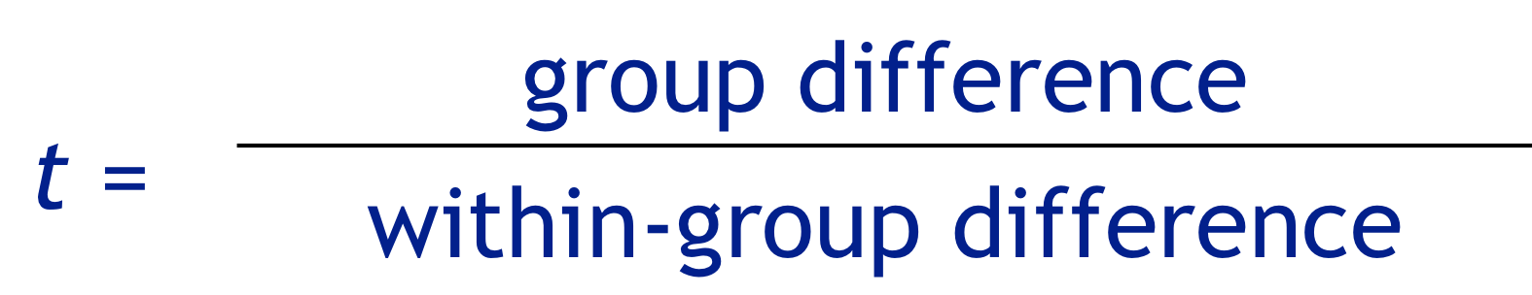

Critical t:
- Cut-off point for claiming statistical significance, obtained t must be equal to or greater than critical t
- Differs for one-tailed versus two-tailed tests
- Based on degrees of freedom (relative to sample size) and alpha level

The f Test:
- Extension of the t-test
- Used when there are more than two levels of the independent variable or more than two independent variables

- 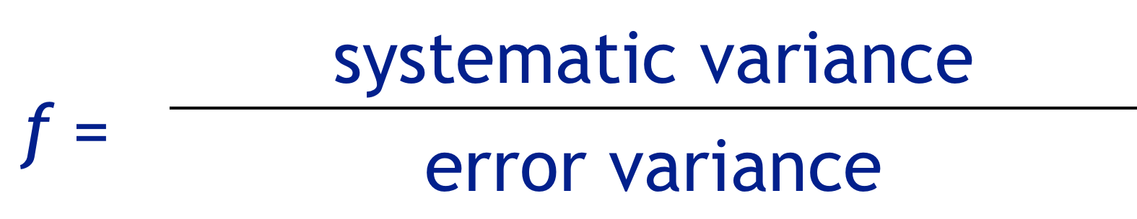

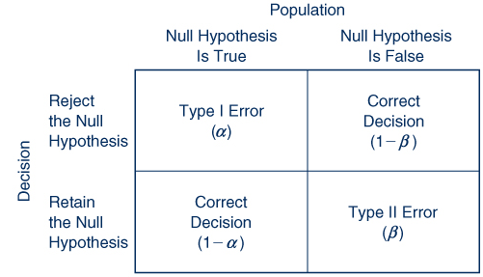
Decision Matrix:

Type 1 Error: Made when the null hypothesis is rejected but the null hypothesis is actually true
- You claim that population means are likely to be different when in fact, they are not
- Probability of Type 1 error is reflected in the alpha level (what you said)
- E.g. you say that drug is doing something, when it really isn’t

Type 2 Error: Made when the null hypothesis is accepted when it is in fact false
- You claim that population means are the same when in fact, they are different
- Factors related: alpha level, sample size, effect size, type of research design

Type 1&2 Errors in Everyday Life:

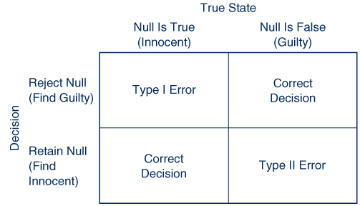

Interpreting Non-Significant Results: Accepting the null hypothesis versus failing to reject the null hypothesis
- Non-significant results can be attributed to a number of factors other than the true absence of an effect
Choosing a Sample Size: a method for determining the optimal sample size based on the probability of correctly rejecting the null hypothesis
- Power = 1 – p (Type II Error)
- 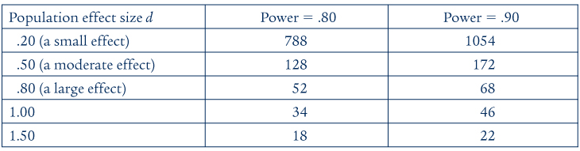

Computer Analysis of Data:
- Software Programs include: SPSS, SAS, R, and Microsoft Excel
- Steps in analysis: input data, conduct analysis, interpret output

Selecting the Approperiate Statistical Test:

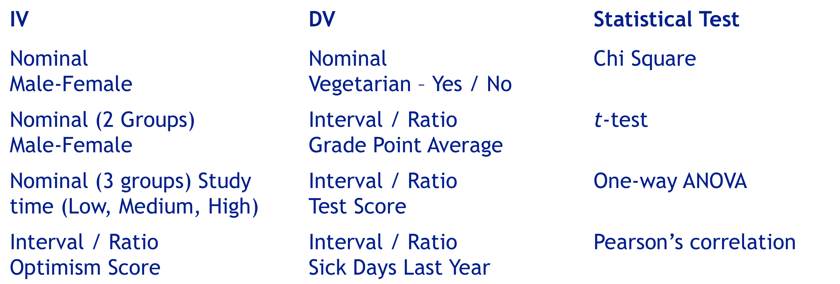

Considering More Than Null Hypothesis
- Hypothesis testing is pass or fail
- This leaves out interesting information about the data, such as effect sizes and confidence intervals

Importance of Replications:
- Scientists attach little importance to results of a single study
- Detailed understanding requires numerous studies examining same variables
- Researchers look at the results of studies that replicate previous investigations

Exam: Alumni Hall
- ROW: 20-28
10 true and false on scantron
4 short answers worth 3 marks each
53 multiple choice on scantron
1 bonus
- Chapter 8 to 13 (No 14)
- How info is applied versus memorization
- Some “define and compare/contrast
  - Don’t just define
  - Make a statement about how or what makes the two terms different
  - E.g. confidentiality & anonymity define… contrast: which is better for what

In testing the effect of noise on performance of a task, Ernie tests half of the participants in a cool, comfortable, quiet room, and the other half in a hot, noisy room. Ernie's failure to control for temperature of the room may result in a(n)
- Confound

When a confounding variable is present in an experiment, one cannot tell whether the results were due to the
- Independent variable or confound variable

Which of the following statements is least likely to be correct? A researcher might employ a pretest-posttest design when
- There is an extraneous variable

A researcher wants to know whether wearing sunglasses improves driving performance. In a counterbalanced repeated measures design, presence or absence of sunglasses would be varied by
- Everybody drives with and then without sunglasses and then visa versa

Ralph has a confederate cut in front of a person who is second or ninth in line at a grocery store checkout counter. He then records the number of verbal responses towards the confederate as a measure of aggression. Which manipulation?
- Staged

A researcher conducts his study with a small number of participants in order to reveal whether the instructions and procedures are clearly understood. This procedure is an example of a
- Pilot study

A researcher finds that for female applicants, the likelihood of being hired for a job increases as their work experience increases. However, for male applicants, the likelihood of being hired decreases as their work experience increases. This is
- An interaction between gender and work experience

Single-case experiments were developed from a need to
- Determine whether a manipulation had an affect on single research particpnt
A researcher has children watch 30 minutes of violent television and then measures their aggressiveness. The researcher concludes that television violence causes aggressiveness. A problem here is that
- There is no control group

You studied the same people when they were 7, 14, 21, and 30 years old. You have used the _________ method
- Longitudinal (over time)

You studied the same people when they were 7, 14, 21, and 30 years old. You have used the _________ method
- Cross-sectional (one time, different groups)

