THE BIOLOGICAL BASIS OF BEHAVIOR

COMMUNICATION IN THE NERVOUS SYSTEM:
- Structure of the neuron: the basic hardware of communication in the nervous system
- Action Potential: how nervous impulses work within the neuron
- Synapse: how one nerve communicates to another through the synapse
- Neurotransmitters: chemicals in the brain, roles with respect to behavior

THE NERVOUS SYSTEM’S HARDWARE:
- Neural Basis of Behavior:
  - The nervous system consists of neurons
  - They receive and conduct electrical impulses
- Communication in the nervous system:
  - Neurons: communication cells
    - Receive, integrate and send information
  - Glia: structural support, insulation and other communication functions

THE NEURAL IMPULSE: SENDING INFORMATION:
- Electrochemical Beginnings:
  - Hodgkin & Huxley – Giant Squid (1952)
    - Fluids inside and outside the neuron
    - Electrically charged particles (ions)
    - When the neuron is at rest, there is a negative charge on the inside compared to the outside
    - -70 millivolts – resting potential
      - Action potential
- The Action Potential:
  - Absolute refractory period
    - After an action potential, the neuron has some time
  - Relative refractory period
    - Gradual return to resting potential
    - More stimulation needed

THE SYNAPSE: WHERE THE NEURONS MEET:
- Between neurons, communication occurs through the transmission of neural information across a synapse by neurotransmitters
- Chemicals as Signal Couriers:
  - **Note: axon terminals (when sending neurons) almost completely cover the cell body of the receiving neuron
  - Synaptic cleft/gap
  - Presynaptic neuron
    - Synaptic vesicles
    - Neurotransmitters
  - Postsynaptic neuron
    - Receptor sites
- When a neurotransmitter binds: The Postsynaptic Potential:
  - Voltage changes at the receptor site – postsynaptic potential (PSP)
    - Not all-or-none
    - Changes the probability of the postsynaptic neuron firing
  - Positive voltage shift: excitatory PSP
  - Negative voltage shift: inhibitory PSP
- Signals from postsynaptic potentials to neural networks:
  - One neuron signals from thousands of other neurons
  - This requires integration of the signals
    - PSPs add up and balance out
  - Neural networks
    - Patterns of neural activity
    - Interconnected neurons that fire together or sequentially
- Synaptic Connections:
  - Elimination and creation
  - Synaptic Pruning
- Neurotransmitters:
  - Specific neurotransmitters work at specific synapses
    - Lock and Key mechanism
  - Agonist – mimics the neurotransmitter action
    - Ex: Chemicals acting like serotonin
  - Antagonist – opposes the action of a neurotransmitter
    - Ex: dopamine
  - 15-20 are known at present
  - Interactions between neurotransmitter circuits

Check & Review:
- Dendrites (receive information from neurons), Axons (carries the neurons message to other cell bodies)
- Communication within the neuron is Electrical (action potential), Communication between neurons is Neurotransmitters (Chemical)

THE ORGANIZATION OF THE NERVOUS SYSTEM:
- 2 basic systems:
  - Peripheral
  - Central

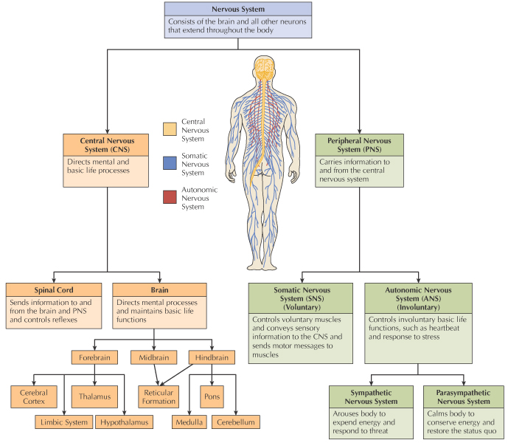

STUDYING THE BRAIN: RESEARCH METHODS:
- Electroencephalography (EEG)
  - Monitors the electrical activity of the brain
  - Mental State – Sleeping
- Damage studies/lesioning
  - Destroying a part of the brain to see the impact on behavior
  - Animal Research
- Electrical stimulation (ESB)
  - Sending a weak electric stimulus into the brain to see the impact on behavior
  - Mostly animal research
  - Humans during brain surgery
    - Wilder Penfield e.g. epilepsy
- Transcranial Magnetic Stimulation
- Brain Imaging
  - Computerized tomography (CAT)
  - Positron emission tomography (PET)
    - For locating neurotransmitter activity
  - Magnetic resonance imaging (MRI)
- What is this about?
  - Diagnosis
  - Treatment
  - Researching brain functions

A TOUR THROUGH THE BRAIN: HINDBRAIN:
- 3 key structures of the hindbrain:
  - Medulla: essential automatic bodily functions
  - Pons: breathing, movement, walking, sleeping and dreaming
  - Cerebellum: coordination of fine muscular movements, balance and some aspects of perception, cognition and language

A TOUR THROUGHT THE BRAIN: FOREBRAIN:
- Forebrain: the collection of upper-level brain structures including the thalamus, hypothalamus, limbic system and the cerebral cortex
  - Limbic System: Regulates fear and other emotions, memory and drive reduction
    - Amygdala
    - Hypothalamus
    - Hippocampus
  - Thalamus: Integrates input from the senses
  - Hypothalamus: Controls emotions and basic motivations such as hunger
  - Cerebral Cortex: Governs a higher mental process
- Lobes of the Cerebral Cortex:
  - Occipital Lobes: located at the back of the brain and is responsible for vision and visual perception
  - Parietal Lobes: located at the top of the brain directly behind the frontal lobes and is responsible for interpreting bodily sensations
  - Temporal Lobes: located on each side of the brain above the ears and are responsible for hearing, language, comprehension, memory and some emotional control
  - Frontal Lobes: located at the front of the brain – receives and coordinates messages from the other lobes and is responsible for motor control, speech production and higher functions such as thinking, personality, emotion and memory

Check & Review:
- The 3 key structures of the brain are: Pons, Medulla and Cerebellum
- The Forebrain includes the Thalamus, Hypothalamus, Limbic System and the Cerebral Cortex

PLASTICITY OF THE BRAIN:
- Neuroplasticity: the brain’s lifelong ability to reorganize and change its structure and function
- Neurogenesis: the division and differentiation of non-neuronal cells to produce neurons
- Stem Cells: Immature cells that gave birth to new specialized cells

CEREBRAL LATERARILITY:
- Left/Right brain
- Intact brain – hemispheric specialization
  - Right: spatial, nonverbal abilities (music, art, recognition of faces etc.), synthetic (figures thing out by combining to form wholes)
  - Left: language (speaking, reading, understanding etc.), analytical (step-by-step)

COMMUNICATION THROUGH THE ENDOCRINE SYSTEM:
- Endocrine system: a collection of glands that manufacture and secrete hormones into the bloodstream
- Hormones: chemical messengers in the bloodstream
  - Released by the endocrine glands
  - Negative feedback system
- Endocrine glands:
  - Pituitary: “master gland”, growth hormone
  - Thyroid: metabolic rate
  - Adrenal: salt and carb metabolism
  - Pancreas: sugar metabolism
  - Gonads: sex hormones
- Little research on behavior
- Testosterone:
  - Aggression
  - Cognitive functioning but biased

OUR GENETIC INHERITANCE:
- Behavioral Genetics: studies the relative effects of nature (genes, chromosomes and heredity) and nurture (environment) on the behavior and the mental processes

METHODS FOR INVESTIGATING HEREDITY:
- Gene-Environment Interaction:
  - The two factors influence many traits, for example; early malnourishment may affect height and cognitive abilities.
- Molecular Genetics: is the study of the biochemical bases of genetic inheritance
  - Genetic mapping: locating specific genes
  - The Human Genome Project
- Behavioral Genetics:
  - The interactionist model
  - “We inherit dispositions, not destinies.” – Richard Rose (1995)

EVOLUTION’S ROLE IN BEHAVIOR:
- Evolutionary Psychology: studies how natural selection and adaption help explain behavior and mental processes
- Based on Darwin’s ideas of natural selection:
  - Reproductive success key
- Adaptations – behavioral and physical
  - Fight-or-Flight response
  - Taste preferences
  - Parental investment and mating

