MIDTERM #1 NOTES

- 3 theories that explain behavior
  - Mentalism
    - Aristotle
    - All human behavior caused by the psyche
      - Psyche = responsible for life, when it leaves you die
  - Dualism
    - Descartes
    - Behavior is controlled by both the mind & body
    - Mind resides in the pineal gland
      - Fluid in gland moves and expands muscles
  - Materialism
    - Darwin
    - Rational behavior explained by the brain & nervous system
    - Theory of evolution
      - Traits passed down, natural selection
- Encephalization Quotient
  - The actual brain mass compared to what we think it should be defined by the size of the animal
- Why has the brain enlarged?
  - Life style
  - Changes in hominid physiology
  - Neoteny
    - the retention of juvenile features in the adult animal

- Anatomical Organization of the Nervous System
- 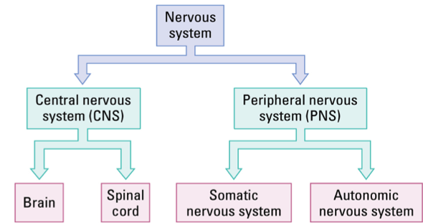

Functional Organization of the Nervous System

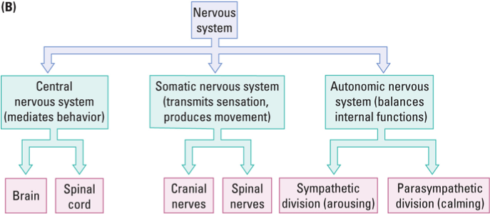

- Central Nervous System (CNS)
  - Core of the nervous system
  - Mediates behavior
- Somatic Nervous System (SNS)
  - Carries sensory information to the CNS from muscles, joints, skin, ect. and also transmits outgoing motor instructions to produce movement
- Autonomic Nervous System (ANS)
  - Balances internal organs from “rest & digest” (parasympathetic) to “fight or flight” (sympathetic)
- Cerebral Security
  - The meninges
    - Dura mater
      - Encloses brain & spinal cord
      - Hard & tough
    - Arachnoid layer
      - Thin sheet of delicate connective tissue
      - Follows brain’s contour
    - Pia mater
      - Moderately tough membrane of connective tissue
      - Clings to brain surface

- Nomenclature
  - Dorsal – up
  - Ventral – down
  - Anterior – front
  - Posterior – behind
  - Medial – in the middle
  - Lateral – to the side
- Cerebrum
  - Forebrain structure
  - 2 hemispheres
  - responsible for conscious behavior
- Cerebellum
  - Control/coordination of fine motor skills
- Brainstem
  - Responsible for unconscious behavior
- Gyri
  - Bumps on the brain
- Sulci
  - Cracks & fissures in the brain
- Grey Matter
  - Made of cell bodies and capillary blood vessels
  - Process information and support behavior
- White Matter
  - Nerve fibers w/ fatty covering
  - Connections between cells
- Ventricles
  - Cavities filled with spinal fluid
    - Cerebral spinal fluid (CSF)
      - NaCl (sodium chloride) & other salts
      - Cushions the brain
      - Cells that line the ventricles produce CSF
- Corpus Callosum
  - Millions of nerve fibers that connect the 2 hemispheres of the brain
  - Divides the brain into cortical & subcortical regions (aka. Above and below the corpus callosum)
- Cells & Fibers
  - Neurons
    - Responsible for all major functions of the brain
  - Glia Cells
    - Support the neurons (modulate behaviours, clean up, ect.)
  - Axons
    - White matter – connecting neurons
    - Axons running together form a nerve (outside of the CNS)
    - Axons running together for a tract (within the CNS)
- Spinal Cord
  - Controls most body movements
  - Can act independently of the brain
- Brainstem
  - Receives afferent nerves from senses
  - Sends efferent nerves to the spinal cord
  - 3 regions
    - hindbrain
    - midbrain
    - diencephalon
  - Hindbrain
    - Contains:
      - Cerebellum
        - Controls fine motor skills
      - Reticular Formation
        - Core of the brainstem
        - Netlike mixture of gray & white matter
      - Pons
        - Connects the cerebellum to the rest of the brain
      - Medulla
        - Controls breathing & cardiovascular system

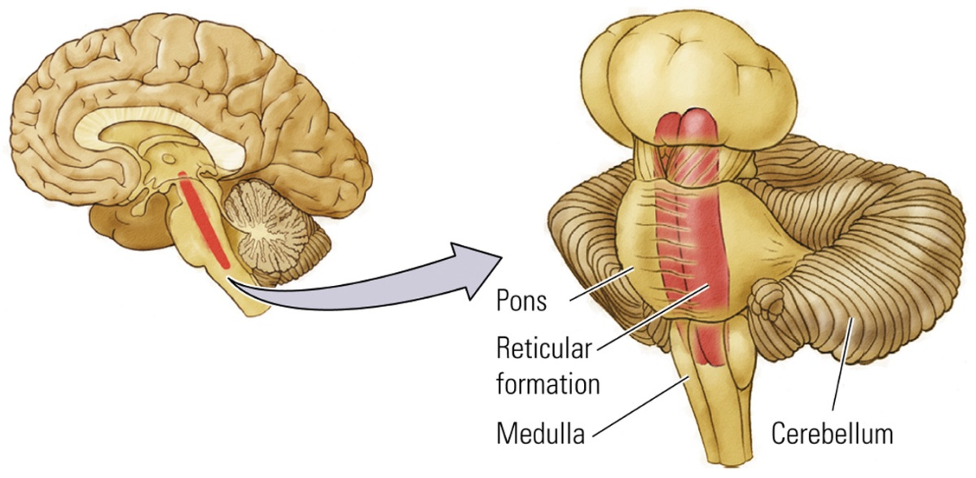
  - Midbrain
    - Contains:
      - Tectum (roof)
        - Receives sensory information from eyes & ears
        - Allows production of oriented movements
      - Tegmentum (floor)
        - Red nuclei – limbs
        - Substantia nigra – initiates movement
        - Periaqueductal gray matter – sexual behaviors
  - Diencephalon
    - Contains:
      - Hypothalamus
        - Controls hormone production
        - Influences feeding, sexual behavior, sleeping, ect.
      - Thalamus
        - Relay station for sensory information travelling to cortex
        - All sensory systems send inputs to the thalamus
- Forebrain
  - Largest region of the brain
  - 3 major sections
    - neocortex
    - basal ganglia
    - limbic system
  - Cortex
    - Contains:
      - Neocortex
        - 6 layers of gray matter
        - creates & responds to a perceptual world
      - Limbic Cortex
        - 3 – 4 layers of gray matter
        - controls motivational & emotional states
      - each layer has certain cell types that are characteristically found in that layer
      - density relates to function
      - cytoarchitectonic map
        - map of neocortex based on organization, structure & distribution of cells
      - Cortical lobes
        - Frontal
          - Executive function
          - Motor Control
        - Occipital
          - Vision
        - Parietal
          - Tactile Function
        - Temporal
          - Auditory
          - Visual, gustatory
  - Basal Ganglia
    - Controls some voluntary movement
    - Contains:
      - Caudate nucleus
      - Putamen
      - Globus Pallidus
  - Limbic System
    - Contains:
      - Hippocampus
        - Memory storage (spatial memory*)
      - Amygdala
        - Negative emotion
        - Fear acquisition
        - Fearful memories
      - Limbic Cortex
        - Aids certain aspects of memory
  - Olfactory System
    - Permits sense of smell
    - Sends sensory information directly to pyriform cortex (bypassing the thalamus)

- The Somatic Nervous System – Transmitting Information
  - Cranial Nerves
    - 12 pairs of nerves that control:
      - afferent functions (aka. Eyes, ears mouth & nose)
      - efferent functions (aka. Motor control over facial muscles, tongue & eyes)
      - or BOTH
      - Connects brain with internal organs (creates automatic responses)

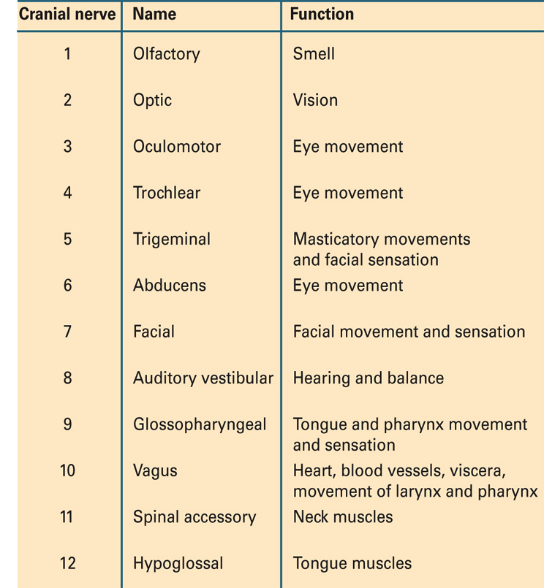
  - Vertebrae
    - Segments of the spinal cord
    - 5 regions
      - cervical
      - thoracic
      - lumbar
      - sacral
  - Dermatomes
    - Segments of the body
    - Each one contains a sensory nerve & a spinal nerve (aka. peripheral nerves)
  - Spinal-Nerve Connection
    - Dorsal fibers – afferent
    - Ventral fibers – efferent
  - Law of Bell & Magendie
    - Dorsal side of spinal cord is sensory and ventral side is motor

