ECOR 1010 – Introduction to Engineering

Laboratory #9
Maple

To:
TA Name: Mr. Romualdez
Email: jromuald@connect.carleton.ca
Lab Section: A5
Room: 2256ME – Carleton University

From:
Student name: Abdulrahman Almalki
Student number: 100 854 570
Email: aalmalki@connect.carleton.ca

Date: December 5, 2011
Introduction:
The purpose of this lab is to utilize the program Maple to solve and model engineering problems. It will explore different functions and codes involved with Maple.
Method:
For part 1, the circuit problem was transformed into two matrices. One matrix was for resistance values and another for the voltage. The third matrix (C) was the inverse of matrix A multiplied by matrix B to get the value of the unknown resistance. Then a plot was created for the first resistance and a value for the current was found at R = 7. Then Maple was used to solve the three currents using the unknown resistance equations. This can be found in the appendix (part 1). Part 2 then explored finding two unknown constants using information and equation provided. The TSD equation was then found and a plot was created. The limit for the equation represents the minimum as which the robot arm temperature can reach (limited to the equation). Maple solve function was used extensively and all work can be found in the appendix (part 2). For part 3, the second derivative of F (t) = Ate^{-2t} was taken. Using the equation:$L\frac{d^{2}i}{dT^{2}}+R\frac{di}{dt}+\frac{1}{C}i=F(t)$ the values given were substituted and expanded to prove that i(t)= Ate^{-2t} is actually true. Then t was set to 1 and the variable A was solved. The functions; F(t)= 4e^{-2t}, and i(t) = Ate^{-2t} were then plotted with range limited to 0<t<5. The maximum transient current was found by taking the first derivative of the current with respect to time functions (with the variable A that was found included). This involved taking the zeros of the derivative and subbing it back into the equation.
Discussion/Results:
For part 1, the value for I1was found to be 1.75 amps. The three currents in terms of the unknown resistance R were found to be -0.57, 0, and -6.7. For part 2, the A was found to be 4.2, K was found to be -0.11, and TSD was found to be 5.1 min. The limit of the equation as time goes to infinity was 23.2 degrees and thus it is the minimum temperature it can have using that equation. Conversely 23.2 degrees is the room temperature. For part 3, the transient current flows can be attributed to the equation i (t) = Ate^{-2t}. Constant A was found to be -2/3. The equations F (t) = 4e^{-2t} and i (t) = Ate^{-2t} were both plotted from 0<t<5 and graphs can be found in appendix (part 3). Then the maximum transient current was calculated to be -0.12 amps.

Conclusion:
- Being familiar with Maple’s different features will be efficient and can save time
- Maple different solve and plotting functions can be implemented easily to different situations

Appendix

PART 1:

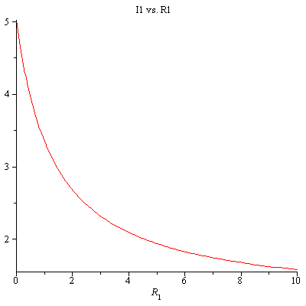

PART 2:

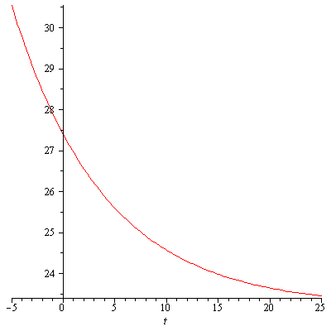

PART 3:



