ITM 301 Notes FARID SHIRAZI
Lecture 1 – A quick overview of all the chapters
Chapter 1
Client/Server Vs. Peer to Peer Model
- Peer to Peer
- Small network
- Supports up to 10 computers (node)
- There is no centralized server
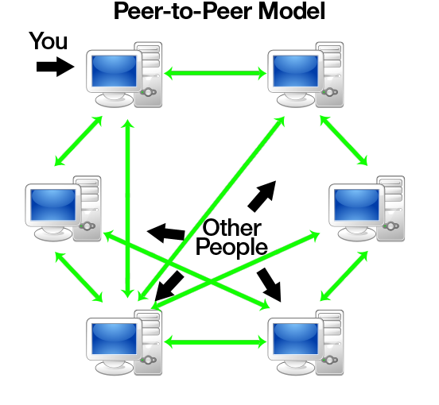
WS2 WS4 WS6 WS8 WS10

WS 1 WS3 WS5 WS7 WS9
WS = Workstation
- Each node is responsible for maintaining its resources
- Each node acts as a client(very active) and a server (very passive)

- Client/Server Model
- A dedicated server designed to manage and control network resources
- Supports unlimited number of clients
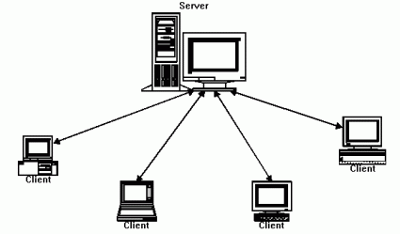
Note: P2P does not have a centralized
security feature while Client/Server does

Chapter 2: OSI/ISO Model OSI: Open Systems Interconnection, ISO: International Organization for Standardization
- A model for computer communication
- 7 Layers
Layer 7: Application: provides interface between software applications and a network for interpreting applications’ requests and requirements- use of interface browser
Layer 6: Presentation: Allows hosts and applications to use a common language: performs data formatting, encryption, and compression
Layer 5::.Session: handshaking, establishes, maintains, and terminates user connections
Layer 4:Transport: Data delivery TCP, ensures accurate delivery of data through flow control, segmentation, and reassembly, error correction, and acknowledgement
Layer 3: Network: Addressing IP, establishes networking connections; translates network addresses into their physical counterparts and determines routing
Layer 2: Data Link: Generates Bits (Two parts MAC,LLC) packages data in frames appropriate to network transmission methods
Layer 1: Physical: Manages signaling to and from physical network connections
Actual net connectivity (cables, signals,wireless)

Chapter 3: OSI Connectivity Devices

Layer 7: Application
Layer 6: Presentation
Layer 5: Session
Layer 4: Transport
Layer 3: Network
Layer 2: Data Link
Layer 1: Physical
Layer 4-7 are Gateway: a router that understands more than one device,

- Router, switch
- NIC: Network Interface Card, Bridge
- Cable, Hub, Repeater, Modem, Wireless Signal

Chapter 4: Introductions to TCP/IP Protocols
Definitions
- Protocol Communication Language: a set of standard settings and regulations
- Components of a communication system
- Sender
- Message
- Media
- Recievers
- Protocol
TCP/IP: Transmission Control Protocol
- Gurantees Message Delivery
IP= Addressing ex. 192.168.13
5 Classes
Class A, B and C are commercial
Class D: Multimedia
Class E
Private IPs
10 - x – x – x
192 – 16 – x – x
192 – 164 – x – x
APIPA 169 – 254 – x – x
AUTOMATED PRIVATE IP ADDRESS
Chapter 6: Security
- File security – encryption – symmetric vs asymmetric
- Channel Encryption VPN
- Malware – viruses, worms, Trojan horse
- Firewall – intruder detection system
- DMZ
Chapter 7: System Managemnet
- Backup
- Redundary: RAID
- Clustering : fall over, load balancing

Lesson 2: Network Standards, Chapter 2 +
There are 65000 TCP(Transmission Control Protocol) Parts available in your computer
There are 65000 UDP(User Datagram Protocol) parts available in your computer
- Both belong to the Transport layer of the OSI/ISO models. TCP is connect-oriented (makes sure it gets connection before sending data) UDP is connectionless and has no delivery gurantee
OSI/ISO
Layer | Description | Major Protocols/ Services/ Formats
Layer 7: Application | User interface to network  - Provides communication between client and the server | HTTP, HTTPS, FTP(FILE TRANSFER PROTOCOL), SMTP (Simple Mail Transfer Protocol), POP3 (Post Office Protocol Version 3), DNS (Domain Name System)
Layer 6: Presentation | Data format, encryption, compression, language support  - Common language for hosts and application | .doc, .docx, .jpg,,mov,,zip,  English (fonts, characters), DES: Data Encryption System, SSL: secure socket layer  *socket = IP + port
Layer 5:Session | Handshaking: establish or tear down connection | Simplex::  Half Duplex:  full duplex:
Layer 4: Transport | Responsible for data delivery :connection oriented or connection-less oriented | TCP: connection oriented, point to point, guarantees message delivery, error handling  UDP: User datagram protocol  - Connectionless  - Doesn’t gurantee mssg delivery
Layer 3: Network | Responsible for addressing | IP, ICMP(Internet Control Message Protocol) IGMP(Internet Group Message Protocol)-Skype  RTP: real time protocol
Layer 2: Datalink (MAC, LLC)  MAC: Physical Layer | Interface physical layer, responsible for CRC(cyclic redundancy checker)(error handling) & data flow | Ping, ipconfig,  ARP: address resolution protocol -> connects to MAP and makes a map of the MAC address to host IP  RARP: Reverse ARP
Layer 1: Physical | The actual physical connectivity occurs at this layer, signaling, topologies, standard | IEEE

*NOTE: FTP: File Transfer Protocol/ File Download/Upload
SMTP: simple mail transfer protocol
POP3: post office protocol version 3
DNS: Domain Name System: converts domain names into IP addresses and reverse

IEEE Standards : Institute of Electrical and Electronics Engineers
802.1 net to net bridging
- routing, bridging, and network to network communication
802.2 LLC: Logical Link Control
- error and flow control over data frames
802.3 Define Topologies (Such as Bus + Star Ethernet (CSMA/CD) carrier sends multiple access/ collision detection
- ethernet
802.5 Token Ring
- no collision
802,6 MAN: Metropolitan Area Network (HAN, PAN, LAN, MAN, WAN)
- Home* Public* *local * metropolitan * wide
FDDI/Lan: Fiber distributed data interface
802.11_{a,b,g,I,N}
B and G are like coffee networks, and N is the safest network
802.11_{b} is called wifi
802.15 is PAN
802.15.1 is bluetooth
802.15.3 -> WPAN (high speed)
802.16 -> broadband wireless (HiMax)
Note: 802.11 deploys an algorithm called CSMA/CA (Carrier Sense Multiple Access with Collision Avoidance)

OSI Layer | Data
Layer 7 – Application | Date File Created (UDP) Universal Data Protocol
Layer 6- Presentation | Date File Created (UDP)
Layer 5 –Session | Date File Created (UDP)
Layer 4 – Transport | Segmentation (sender), Reassembling (receiver), MTU (max. transmission unit)
Layer 3 – Network | Packets = a packet = segment + source for destination IP
Layer 2 – Data Links | Frames: blocks of bits and CRC (cyclic redundancy checker)
Layer 1 –Physical | If positive 1, negative charge 0 goes up and down in squares*

1 | 2 | 3 | 4 | 5 | 6 | 7 | 8
9 | .. | ..
one box of that is a segment, a segment is a unit of data that results from subdividing a larger protocol data unit
- The size of a segment is decided by the MTU (Maximum transmission unit) eg. 2K

Chapter 3+: The Physical Layer
- Analog Signal Vs. Digital Amplitude
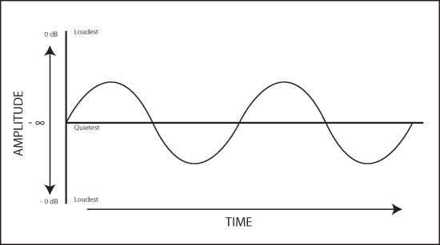
Hertz = a frequency/second
Ex. CPU= 2.5 Ghz
Analog Signals are used as carrier media to send/ receive data signals
Analog signals are used as carrier media to send / receive data signal
- Data Signals are digital Signals

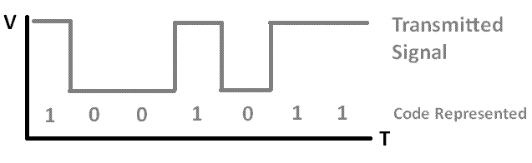
Digital Signals

Definitions:
Modulation: the process of embedding Data signals into a carrier signal
Demoulation: the process of separating data signals (receiver)
- A device that does modulation/ demodulation is a modem
Multiplexing: is a process of embedding multiple data signals (channels)
Demultiplexing: the process of separating channel signals from carrier medium
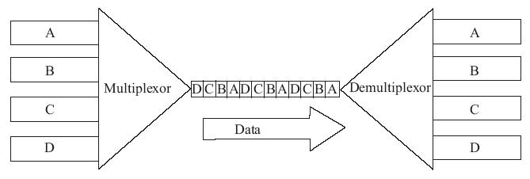

INPUT OUTPUT

Types of Muxes:
- Frequency Division Multiplexing (FDM)
Ex.

95.97.3
88 MHZ 108 MHZ

- Your radio set is acting as a FDM device that receives a multiplexed signal
- NOTE: the human ear can detect a frequency around 22 KHZ
- FDM is a type of multiplexing that assigns a unique frequency band to each communication subcahannal. Signals are modulated with different carrier frequencies then multiplexed to simultaneously travel over a single channel.
- Time Division Multiplexing (TDM): multiplexes time based signals into a carrier channel
- A special version of TDM is STDM
- Used CPU
- The CPU time is divided between multiple APPs
- CPU does one task at a time but because its so fast it seems as if its multitasking
- Funfact: CPU = fasted device, keyftcboard = slowest
STDM divides CPU time among multiple applications, each application requires its own time for sending or receiving data

- CPU allocates portion of its time to that application (resource sharing)
Fun Fact: Ch 0 -> Internet Signal
- Wavelength Division Multiplexing: multiplexes fiber optic signals into a carrier signal
Note: a fiber optic cable transmits data using light frequency (yellow, green, blue orange) (Light Wave Length)
- Using multiple different lights (colors) gives us the possibility to send data using color frequency

Note: Standard WDM can send upto 16 diff signals by using a fibre optic cable
DWDM: DENSE WDM expands WDM to send up to 126 different light signals with a fiber optic cable.

5. Baseband Vs. Broadband
- baseband sends/receives data using a single type of signal
-> coaxial cable (Networks)
Broadband uses many different signals to send and receive data

Baseband is faster than broadband

Transmission Speeds:
1 Bit
1 KB = 1000 bits
1 MB = 100 000 bits
1 GB = 1 000 000 000
Transmedia
Coaxial Cable  Problem: EMI:  Electro Magnetic Interference  10 MB/S  Baseband  Bus Topology  Thin Net | Twisted Pair  Problem:  Cross Talk: leak of data into wires  10 MB/S  Baseband  Star Topology  Connector: RJ45  STAR TOPOLOGY | Fiber Optic:  Autennuation: light signal loses strength  2 Types:  - Single Mode (Pure Fibre Glass)  - Multi Mode (brand band)  Speed: fastest*  FDDI SONET | Wireless  RFI: radio frequency interference  802.11a: 5.6 Hz  802.11b 2.5 mHz  802.11g 2.56 mHz  *max distance to access point 25 m

Chapter 4 +
- TCP/IP: is a suite of protocols with more than 120 protocols from HTTP to RDP & more
- Socket = a logical address assigned to a specific process running on a computer –
The IP ADDRESS plus the Port Number are equal to the the processes socket

Ports to Memorize!
Name | Port
FTP: File Transfer Protocol  - Used to send and receive files | 21
SMTP: Simple Mail Transfer Protocol | 25
HTTP: Hyper Text Tranfer Protocol | 80
TFTP: Trivial File Transfer Protocol  - Simpler version of FTP  - Connectionless method | 69
NNTP: Network News Transfer Protocol | 119
DNS: Domain Name system | 53
Telenet: used to log into remote hosts* | 23
POP3: Post Office Protocol | 110
IMAP4- Internet Mail Access Protocol | 143
HTTPS: Hyper Text Transfer Protocol Secure | 443
NTP: Network Time Protocol | 123
RDP: Remote Desktop Protocol 3389

- TCP: Transmission Control Protocol
- Connection oriented protocol
- Guarantees message delivery
- It does error checking
- It is slower than UDP
UDP: - connectionless oriented protocol
- It is a broadcast protocol
- Does not guarantee mass delivery
- Faster then TCP
- Ex. Junk mail DHCP
4 DHCP: Dynamic Host Config. Protocol
- Is a server that assigns IP addresses to client computers
- The IP Assignment is done in 4 steps called DORA
STEP 1 : DISCOVERY
STEP 2: OFFER
STEP 3: REQUEST
STEP 4: ACKNOWLEDGE
5 – Dynamic Updates (DDNS)
Updated DNS records for a host dynamically
Client: MAC, computer server received this IP
6- A DHCP server assigns an IP to a client for 8 days by default
- After 50% of lease time the client applies for IP renewel IPConfig/renew
- If the server is not available, it tries again after 8 days
- If the server is not available after 8 days
- The client assigns itself and APIPA address
- Which is an IP in the following range
169.254.x.x
Ex: 169.254.1.8

7. DNS: Domain Name System
- DNS resolves domain names into their IP Addresses
- DNS resolves also IP to Name
Ex. Nslookup – type = NS Ryerson.ca
- Who is Ryersons DNS Server
- an IP
- a DNS is a database of Network Resources
- DNS network resources can be queried by the above command (see lab 3)
DNS Registers the fallowing Resources in it database
A – hostname, ComputerName,
ex: PC1, 141.117.145.1
NS – name server (DNS ITSELF)
SRV- server
PTR – pointer for IP-to- Name
Ex. 141.117.145.1 PC1
CNAME Alias
CanonicalName Alias*
Ex seven1
8. DNS ROOT SERVERS
Top level domain names are assigned by ICANN, these names are globally unique
- Secondary domain names can be changed by the organization itself
- A query is sent to SOA which com, if com server can nt locate the URL we get an error called 404 error
# of computer CPUs Role
> 100 Super Computer
<= 64 Main Frame
<=32 Mid-level server
<=2 Workstation
- Laptop, PC,iPad,iPhone
- secondary domain names can be changed by the organization itself
- Service Oriented Architecure (SOA) of Microsoft.com is -.com
- DNS is looking for microsof domain if the above domain does not exist
- -> a query is sent to SOA, which is com, if com server can not connect the URL will get an error called 404 error

9. IP:
is responsible for Packet Generation
- A packet is defined as :
a combination of two parts datagram=655555 bytes and Source, Destination IPs and flags
- Is responsible for network addressing,
10. there are two types of IPs:UP
IPv4: 32 bit x.x.x.x octed 1-255
- IPv6: 128- bit (next gen IP)
11. The following classes of IPs exist
Class A – 1-126 ex. 18.182.5
# of IPs 16.7 mil
CLASS B- 128-191 65535 IP5
CLASS C- 192-223 254IP5
CLASS D 224-239 multimedia class
CLASS E: 240 – 255 experimental

12, A IP address contains two types of information
- Network address
- Host Address
To separate network address or host address from a given IP we need subnet mask
13. The following subnet masks are defined by default
Class A: 255.0.0.0
Class B: 255.255.0.0
Class C: 255.255.255.0
14.Network Vs. Host Address
Given the following IP Address: 192.168.1.28
Whats its network address?
Whats its host address?
192.168.1.28
255. 255. 255.0
*192 falls under class C which is defined by the subnet mask 255.255.255.0
All the parts which fall under the 255 sections are the network address and any that fall under the 0 sections are the host addresses
Therefore the network address is 192.168.1 while the host address is 28
Eg2 141.117.145.51
*falls under class B
So 255.255.0.0
Therefore the network address is 141.117 and host address 145.51

15. The following range of IPs can be used for LAN networking for free called Private IP
Class a 10.x.x.x
Class B: 172.16.x.x
Class C: 192.168.x.x
APIPA: 169.254.x.x.
-> the private IPs can not be used for accessing the internet
16. To access internet using private IPs we need a dedicated server called NAT- Net Address Translator
Notes
IMAP4: Internet Mail Access Protocol
HTTPS = HTTP + SSL (Secure Socket Layer)
TFTP = trivial FTP
NNTP = Network News Transfer Protocol
NTP: Network Time Protocol
RDP: remote desktop protocol
DISCOVERY: a client discovers an existing DHCP server: my IP address is : 0.0.0.0
Who is 255.255.255
Offer: a DHCP offers an IP from its Pool of IP Addresses
Request: the client must request the offered IP
ACK: DHCP acknowledges IP by updating DNS
APIPA: automatic private IP address

Chapter 5+ : Network Topologies
- Bus
WS2 WS4 WS6
! ! !
Terminator-->|------------------------------------------------------| Terminator
! ! ! !
WS1 WS3 WS5 WS7

- The cable must be closed using terminators
- CSMAICD: Carrier service multiple access/ collision detect
- There are data collisions in this topology
- If collision happens stop sending/receiving data
- Wait for green signal to resume sending CSMA/CD is handled by NIC cards in Layer 2 (LLC)
Disadvantages:
- Very slow (10 m/s)
- If the cable is broken the entire network shuts down
- If the terminators go missing the entire network shuts down
- Star

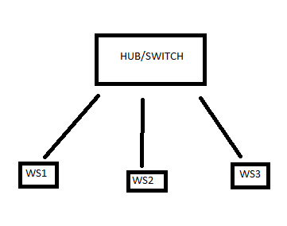
- At the heat of star topology there is a cable connector called: Hub
- Recentally the HUB has been replaced with a more advanced device called Switch
- Like bus topoplgy, the star topology is based on CSMA/CD
- Star topology IEEE 802.3 standard
Star + Bus = Ethernet 802.3
- Token Ring: IBM token ring
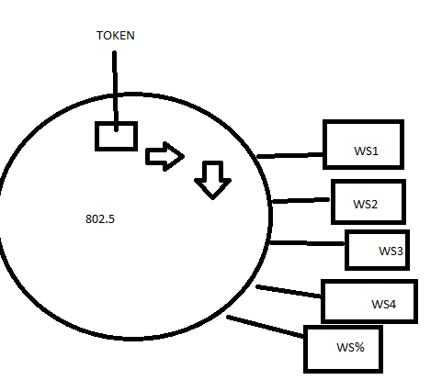
- at the heart of token ring there is a token circulating around the ring with the speed of 60,000 rounds per second
- Clockwise
- Collision free network
- To send data to a workstation must grab a token
- Only one token per network
- After sending data the work station releases token
- STP or UTSP
- Token Ring is physically star but logically ring
- The HUB is called MAU (Multiple Access Unit)
- Widely used for sensitive applications (bank, airport)
Disadvantages:
- Speed problem (100 m/s)
- Expensive
- Maxiumum cable lengths
- If ring breaks entire system shuts down
- FDDI : Fiber Distributed Data Interface
- Fault Tolerent System
- 802.8
- This a dual ring network
- By default data flows through the outer ring clockwise
- If the outer ring breaks info flows in the inner ring in the reverse direction
Each m.c. contains two parts for fiber optic cable
Advantages: supports up to 100 mi distance
Fault tolerant system
- Supports up 1 G/S Note: this speed is equal to high speed star using CAT 5E(1G/S)
- Wireless
Baseband: 802.11_{a, b g n}
Broadband: 802.16 WiMax
802.15.1-> Bluetooth and other info wireless

 | Frequency | Speed | Max Distance
802.11a | 5 Ghz | 54 mhz | 100 m
802.11b(wifi) | 24 ghz | 11 m/s | 20 m
802.11g | 2.4 ghz | 54 m/s | 100,
802.11n (High Secure Wifi) | 2.4 ghz | 54 m/s | 100m

Topologies: Bus, Star, Token, FDDI, Wireless 802.11 -> LAN TOPOLOGIES
Man Topology: Sonet
WAN Topology: Mesh, Web
- Mesh Topology is called a completely fault tolerant system
- All nodes are connected to each other
- Each node on internet Mesh represents a router
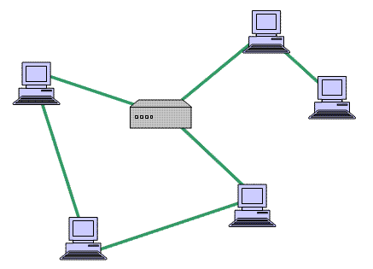
# of links = n(n-1)/2
Example: four nodes = 4(3)/2
12/2 =6 links

- Backbone Topologies:
a)Serial Backbone:
- backbone network which is essential to all other networks, because they are the main entries of organizations
DATA INPUT/OUTPUT
3 Versions of Serial Backbone
- Old IEEE 802.3 using thick coat (10 buses)
10 WS on 7th floor is bus 1
10 WS on 6th floor is bus 2
… goes on till 1st floor
- Fiber Optic of 5E, the wire connects down the floors
- Switch -> Switch-> Router-> Internet
Connects straight to Internet so no floor wires needed

b)Parallel( Fault Tolerant System)
Internet connected to router which is connected to parallel cables, which are connected to the router connected to switch (ws) and internet

- Collapsed Backbone: router connected two multiple switches and internet, switches connected to multiple WS
Switch Vs. Hub
- A hub is a layer 1 device it allocates net bandwidth equally among all stations
- Switch is a more advanced device
- It allocates net bandwidth among active stations only
*Distributive Backbone is an advanced version of serial backbone

Chapter 6
NIC: The main port for network connectivity -> has a physical address: MAC
- A mac addres contains 12 exact numbers OR 48 bits
- The first 6 are called manufacturers ID, the second half is called Device ID
Types of NIC – ISA 16 bit – oldest NIC
-PCI_{e}: Laptop Version (Cable)
3. Switch
a) Types of switching technology
1) Circuit Switching: technology used for voice transmission i.e. landline
-> switch is used to establish physical connectivity before two end users
-> switch is available during communications
2) Message Switching
-> is widely used with Data Transmission using dedicated digital lives
Note: message switch has a fixed path (not shared with others)
Note: Circuit Switch is also called office switch
3)Packet Switch: widely used with internet and network connectivity
-> data in form of text, picture voice is packed into TCP/IP packets for delivery
-> usually contain source and destination IP
4. Cell Switching:
-> a cell is a special type of packet
-> a cell is defined by a high speed topology called ATM
-> asynchronous transfer mode
-> ATM was originally designed for high quality image data exchange (hospitals)
-> ATM was the first topology to define Quality of Service *53 Byte frame – 5 bytes header, 48 bytes data
b) Switching Modes:
Packet Switching technology defines two modes
- Store & Forward
- Stores packet band checks for errors before forwarding to destination
- Pass Through
- Faster than store and forward
- Does not check for errors
c)VLAN (Virtual LAN)
-> switches can be used to manage VLANS
-> a vlan defines a broadcast domain as the connection of similar positions in different switches, i.e managers
4. A bridge connects two or more topologies togeather
-> bridge contains database of al MAC addresses
-> a bridge can be used to filter out unwanted MAC addresses
-> if a mac address is removed from bridge the computer holding that MAC address is disconnected from net
c) Spanning Tree Protocol of Spanning Tree Algorithom
(STP) (STA)
- STP/STA is the standard protocol (802.1p) that is used for the purpose of communication among bridges
- In a larger network i.e Ryerson network there is bridging & infrastrucre on place
- The bridge periodically checks on ts children
- Using STA/STP the root bridge checks the child bridge by sending a “hello packet” (by default every 180 seconds
- If the root bridge doesn’t receive ‘hello’ back from a child bridge it assumes the child is offline or dead. It triggers an alarm
- On the other hand if a child bridge doesn’t receive a hello packet it urgently requests a hello packet
- If it doesn’t receive a hello packet it broadcasts the root as dead
- The bridge with the lowest bridging ID takes the role of root bridge
- Router
- A device that connects two or more networks togeather
- A router is also used for filtering networking broadcasts
3 Types of Routers
- Distance Vector Router
- These routers communicate with neighbouring routers using ‘Hop’
- Ex. RIP (routing info protocol) - Contains a table of all connected routers
- RIP V2 more advanced than RIP v1 supports up to 15 bytes
- Another type of distance vector router is the BGP (Border Gateway Protocol2
- Link State Routers
- This type of router has a more advanced metrics than RIP or BGP
- They use a combination of the following metrics
- Link Speed
- Link Reliability
- MTU (Max Transmission Unity)
- Cost
- # of Hops
-Example: Open Shortest Path First (OPSF)
3. Hybrid: uses a mix of Distance Vector Router and Link State Routers
-> the best example would be Enhanced Interior Gateway Routing Protocol
EIGRP

