GMS 200
Final Exam Review
November 30, 2012
Lecture 6/Chapter 6 (Planning Processes and Techniques)
- What is planning?
Ans: Planning is the process if setting objectives and determining how to accomplish them. It involves deciding exactly what you want to accomplish and how to best go about it.

- In our evaluation of WalMart’s approach to planning, we noted that it primarily gain direction from two factors. What are they? (from lecture, beliefs and customer rules).
Ans: The two factors are beliefs and customer rules. Three basic beliefs are: 1. Respect for the individual. 2. Service to our customers. 3. Striving for excellence.
The guiding rules on customer service are: 1. Sundown rule-if a request comes in, it should be satisfied on that day. 2. Ten foot rule-if your within 10ft of a customers, you should approach the customer about needing help. 3. Everyday low price.

- What did we identify as the main responses of Loblaws to the entry of Walmart in the Canadian grocery industry?
Ans: Loblaw has spent $2.3 billion on technology over the last 5yrs which eliminates about 700 jobs (a cost of $60 million). Also Loblaw has directed more resources to its discount chains (ie. No Frills, Superstore), who account for 2/3 of it annual sales of approx. $31 billion.

- What is scenario planning? What are its benefits? (text, Benefits: focus, flexibility, action, coordination, control, make major adjustment strategies.)
ANS: Scenario planning-identifies alternative future scenarios and makes plans to deal with each.
Benefits: Improves Focus and Flexibility: both are important for performance success. An organization with focus knows what it does best, knows its customer needs and how to serve them well. An individual with focus knows what they want. An organization with flexibility is willing to change and adapt to shifting circumstances and operate towards the future. An individual with flexibility adjusts career plans to fit new and developing opportunities.
Improves Action Orientation: planning helps avoid the complacency trap which is simply being carried along by the flow of events. Planning helps the organization be more (1) results-orientated – creating performance-orientated sense of direction; (2) priority-orientated—making sure the most important things get first attention; (3) advantage-orientated—ensuring that all resources are used to best advantage; (4) change-orientated –anticipating problems and opportunities so they can be best dealt with.
Improves Coordination and Control: When plans are coordinated among people and subsystems, there is greater likelihood that their combined accomplishments will advance performance for the organization. When planning is done well, there is control. Planning and control work closely together in the management process. Without planning, control lacks objectives and standards. Without control, planning lack the follow-through needed to ensure that things work out as planned.
- What is contingency planning?
Ans: Contingency Planning: identifies alternative courses of action to take when things go wrong. Eg. Coca-Cola and Pepsi have contingency plans in place, in case there is a change in politics, changing in social trends or currency fluctuations.
- What are organizational procedures and policies? What is the main difference between them?
Ans: Policy: is a standing plan that communicates broad guidelines for decisions and action.
Procedures (rules): precisely describes actions that are to be taken in specific situations.
Lecture 7/ Chapter 7 (Strategy and Strategic Management)
- What is strategy? What is strategic management?
Ans: Strategy is a comprehensive plan guiding resource allocation to achieve long-term organization goals.
Strategy Management: is the process of formulating and implementing strategies. It has to have competitive advantage. Competitive advantage is the ability to do something so well that one outperforms competitors. Competitive advantage should include sources such as: cost and quality—where strategy drives an emphasis on operating efficiency and product or service quality; knowledge and speed—where strategy drives an emphasis on innovation and speed of delivery to market for new ideas; barriers to entry—where strategy drives an emphasis on creating a market stronghold that is protected from entry to others; financial resources—where strategy drives and emphasis on investments or loss absorption that competitors cant match.
- What are the two basic ways in which firms compete against their rivals?
Ans: Product-different strategy (Differentiation): a strategy that offers products that are different from the competition at above average prices.
Cost Leadership Strategy: is a strategy that seeks to operate with low cost so that products can be sold at low prices(offer same products at below-average prices)
- Review Porter’s five forces framework’ review its application to the Canadian auto industry-what factors are associated with greater competition, and hence, a lower average price? (IMPORTANT)
Ans: 1. Industry competition—is the intensity of rivalry among firms in the industry and the ways they behave competitively toward one another. (High fixed cost of production, there is intense competition for greater market share to ensure cost recovery at competitive prices.)
2. New entrants: is the threat of new competitors entering the market, based on the presence or absence of barriers to entry.
3. Substitute products or services—is the threat of substitute products or services, based on the ability of consumers to find what they want from other sellers. Eg. The relatively high reliance on power cars compared to taxis and bikes system suggests that the latter models of transport are weak
4. Bargaining power of suppliers—is the ability of resource suppliers to influence the price that one has to pay for their products or services. Eg. Auto parts suppliers are likely to have a low bargaining power relative to leading auto manufacturers.
5. Bargaining power of customers—is the ability of customers to influence the price that they will pay for the firm’s products or services. Eg. Buyers have low to high bargaining power relative to manufacturers/ dealers because of the variety in car models over arrange of prices
- Review Porter’s model of generic strategies (ie. Cost leadership strategy, focused low-cost strategy; differentiation strategy, focused differentiation strategy.) (IMPORTANT)
Ans: Product-different strategy (Differentiation): a strategy that offers products that is different from the competition at above average prices. Eg. Coke and Pepsi
Cost Leadership Strategy: is a strategy that seeks to operate with low cost so that products can be sold at low prices(offer same products at below-average prices). Eg. Sam Choice Cola and President Choice’s financial.
Focus Strategy: concentrates on serving a unique market segment better than anyone else.
Focused differentiation strategy—the strategy that offers a unique product to a special market segment.
Focused cost leadership—is the strategy seeks the lowest costs of operations within a special market segment.
- Review the various components of a SWOT analysis.
Ans: SWOT—Strengths, Weaknesses, Opportunities and Threats. Toyota SWOT analysis
- Strengths: good competitive strategy, pioneered just in time inventory, world’s largest automaker, largest market capitalization, solid brand image (durability, reliability, and flexibility), and effective quality control system.
- Weaknesses: out dared facilities, Inadequate R and D and Weak Management.
- Opportunities: early start in the production of hybrid cars, good position to meet the demands of an emerging younger target market, greater facilities relative to rivals (GM, Ford, and Chrysler) and therefore puts them in a good position to take advantage for growth.
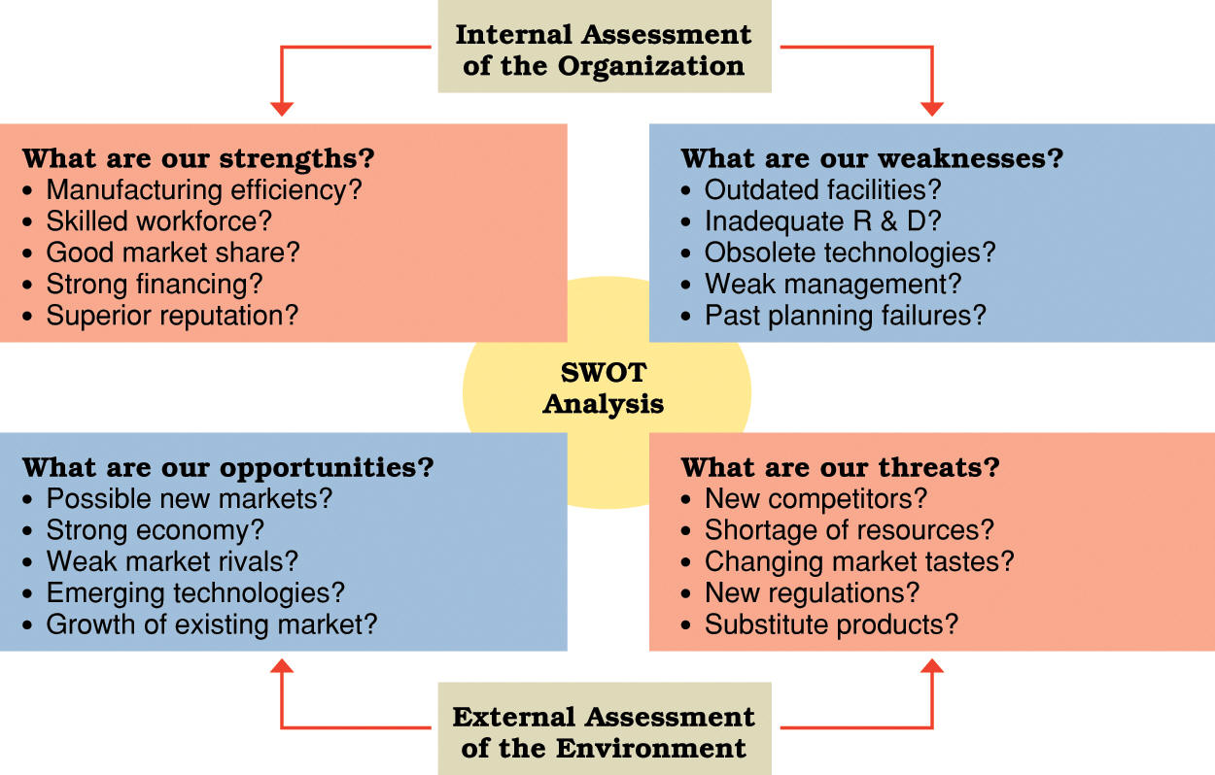
- Threats: Mature market with limited growth, Dominance of Big 3, Shifting consumer tastes and preferences, Rapid technological change in North America, Price of petrol and improvement of public transport.

- Concepts to review: customer relationship management, supply chain management, total quality management, organizational culture. (IMPORTANT)
Ans: Customer Relationship Management (CRM)—strategically tries to build lasting relationships with customers and to add value to customers
Supply chain Management—strategically links all operations dealing with resource supplies.
Total Quality Management—is managing with an organization-wide-commitment to continuous improvement, product quality, and customer needs.
Organizational Culture—is the system of shared beliefs and values that guides behaviour in organizations.
- Review the BCG Matrix approach.
Ans: BCG matrix analyzes business opportunities according to market growth rate and market share. There are 4 possible business conditions that is associated with a strategic implication:
- Stars—are high market share businesses in high growth market. They produce larger profit by expanding markets.
- Question marks—are low market share businesses in high growth markets. They do not produce much profit, but they compete in rapidly growing market.
- Cash cows—are high market share businesses in low growth markets. They produce large profit and a strong cash flow. Because the markets offer little growth opportunity
- Dogs—are low market share businesses in low growth markets. They do not produce much profit and they show little potential of future improvement.
- Concepts to review: strategic alliance, vertical integration, retrenchment strategy, restructuring, globalization strategy, multi-domestic strategic, transnational strategy.
Ans: Strategic Alliance—organizations join together in partnership to pursue an area of mutual interest. This can be done through outsourcing alliances—contracting to purchase important services from another organization.
Vertical integration—is growth by acquiring suppliers or distributors.
Restructuring- changes the mix or reduces the scale of operations.
Globalization Strategy—adopts standardized products and advertising for use worldwide.
Multi-domestic Strategic—customizes products and advertising to best fit local needs.
Transnational Strategy—seeks efficiencies of global operations with attention to local markets. It tries to balance the efficiencies of global operations and responsiveness of local market.

Lecture 8/ Chapter 11 (Leading and Leadership Development)
- What is leadership?
Ans: Leadership is the process of inspiring others to work hard to accomplish important tasks
- Review of concepts: emotional intelligence, transactional leadership, transformational leadership; visionary leader, charisma, symbolism, empowerment. (IMPORTANT)
Ans: Emotional Intelligence—is the ability to manage our emotions in social relationships.
Transactional leadership—uses tasks, rewards and structures to influence and direct the efforts of others.
Transformational leadership—is inspirational and arouses extraordinary efforts and performance.
Visionary leader- brings to the situation a clear sense of the future and an understanding of how to get there.
Charismatic leader—develops special leader-to-follower relationships and inspires followers in extraordinary ways.
Symbolic leader— uses symbols to establish and maintain a desired organizational culture.
Empowerment—enables others to gain and use decision-making power.
- Review the following theories/models of leadership (see text and lecture notes on McCain’s leadership at Maple Leaf):
- Hersey-Blanchard situational model
Ans: Has 4 leadership styles:
- Delegating—allowing the group to take responsibility for task decisions; a low-task, low-relationship style.
- Participating—emphasizing shared ideas and participative decisions on task directions; a low-task, high-relationship style
- Selling—explaining task directions in a supportive and persuasive way; a high-task, high- relationship style.
- Telling—giving specific task directions and closely supervising work; a high-task, low-relationship style.
- Fiedler’s contingency model
- Understanding leadership style—it is measured on the least-preferred co-worker scale. It is either you are a task-motivated leader or relationship-motivated leader.
- Understanding leadership situation—three contingency variables are used to control situations. 1. The quality of leader-member relations (good or poor)—measures the degree to which the group supports the leader. 2. Task structure (high or low)—measures the extent to which task goals, procedures and guidelines are clearly spelled out. 3. Amount of position power (strong or weak)—measures the degree to which the position gives the leader power to reward and punish.
- Matching leadership style and situation—each style seem to work best when used in the right situation.
- House’s path-goal leadership model
- The effective leader is one who clarifies paths by which followers can achieve both task-related and personal goals.
- Directive leadership—letting subordinates know what is expected; giving directions on what to do and how; scheduling work to be done; maintaining definite standards of performance; clarifying the leader’s role in the group.
- Supportive leadership—doing things to make work more pleasant; treating group members as equals; being friendly and approachable; showing concern for the well-being of subordinates.
- Achievement-orientated leadership—setting challenging goals; expecting the highest levels of performance; emphasizing continuous improvement in performance; displaying confidence in meeting high standards
- Participative leadership—involving subordinates in decision-making; consulting, asking for suggestions from subordinates and using these suggestion when making decisions.
- Path-goal contingencies
- Substitutes for Leadership—are factors in the work setting that direct work efforts without the involvement of a leader.
- Vroom-Jago leader-participation model
- Indicates that leadership success results when the decision-making methods are used by a leader that best fits the problem.
- These leader choices have categories such as: authority decision—is made by the leader and then communicated to the group. Works best when leaders personally have expertise to solve the problem
- A consultative decision—is made by a leader after receiving information, advice or opinions from group members. Works best when leader lacks sufficient expertise or the problem is unclear, acceptance of the decision and commitment by others are necessary for implementation or adequate time is available to allow for true participation.
- A group decision—is made by group members themselves. Works best as the same in consultative decision.
- Other: leadership styles (ie. Democratic, autocratic, etc.)
- Democratic – emphasize on both tasks and people.
- Autocratic—acts in a command –and-control fashion
- Human relations- emphasizes people over tasks
- Laissez-faire—displays a “do the best you can and don’t bother me attitude.
Lecture 9/Chapter 5 (“Entrepreneurship and Small Business Management)
- Who is an entrepreneur? What is entrepreneurship? (text)
Ans: Entrepreneur is willing to pursue opportunities in situations others view as problem or threats. Entrepreneurship is risk taking behaviour that results in new opportunities.
- What are the myths about entrepreneurs? (text) question-which statement is a myth?
Ans: - Entrepreneurs are born, not made (not true)
- Entrepreneurs are gamblers (not true, they are risk-takers, but risk are informed and calculated)
- Money is the key to entrepreneurial success (not true, money is no guarantee of success)
- You have to be young to be an entrepreneur (not true, age is no barrier, with age comes experience)
- You have to have a degree in business to be an entrepreneur. (not true, you may not need a degree at all, but it helps)
- Review the different forms of business ownership (sole proprietorship, partnership, corporation, limited Liability Corporation).
Ans: Sole Proprietorship—is a form of business where an individual pursues a profit. It is simple to start, run and terminate and it is the most common in small businesses in Canada.
- Partnership—is a form of business where two or more people agree to contribute resources to start and operate a business together. It is usually backed by a legal and written agreement. A general partnership is the simplest and most common, they also share management responsibility. A limited partnership consists of a general partner and one or more ``limited partner`` who do not participate in everyday business management. They share profits but losses depend on their initial investment in the business. A limited liability partnership limits the liability of one partner for the negligence of another.
- Corporation—is a legal entity that exists separately from its owners.
- Limited liability Corporation—is a hybrid business form combining advantages of the sole proprietorship, partnership, and corporation.
- Review the financing option available to new ventures (debts, equity, venture capitalists, initial public offering, and angel investor).
Ans: Debt Financing – involves borrowing money that must be repaid over time, with interest.
- Equity Financing – involves exchanging ownership shares for outside investment (outside cash investment)
- Venture Capitalists—make large investments in new ventures in return for an equity stake in the business.
- Initial public offering (IPO)—is an initial selling of shares of stock to the public at large.
- Angel investor—is a wealthy individual willing to invest in a new venture in return for equity in a new venture.
- Review the stages in the life cycle of an entrepreneurial firm (firm, breakthrough and maturity).
Ans: Birth stage—establishing the firm; getting customer and finding the money (fighting for existence)
- Breakthrough stage—working on finances; becoming profitable and growing (coping with growth and takeoff).
- Maturity stage—refining the strategy; continuing growth and managing success (investing wisely and staying flexible).

- Review the Cupcake case from lecture.
- Concepts to review: first –mover advantage, business plan, intra-preneurship.
Ans: First- mover advantage—comes from being first to exploit a niche or enter a market.
Business plan-- describes the direction for a new business and the financing needed to operate it.
Intra-preneurship- is the act of behaving like an entrepreneur, except within a larger organization

Lecture 10/ Chapter 8 (Organization Structure and Design)
- What information do you expect to obtain from an organization chart? (like hierarchy)
Ans: An organization chart describes the arrangement of work positions within an organization (hierarchy)
- What are informal and formal structures? And difference
Ans: Formal Structure—is the official structure of the organization. The basics of the structure include: Division of work – positions and titles; supervisory relationships—lines show who reports to whom; communication channels—lines show formal communication flow; major subunits—positions reporting to a common manager are shown; level of management—vertical layers of management are shown.
Informal Structure—is the set of unofficial relationships among an organization`s members.

- Organization structures to review: functional, divisional, matrix, network (i.e. Nike).`
Ans: Functional Structure—groups together people with similar skills who perform similar tasks. They share technical expertise, interests and responsibilities.
Advantages: task assignments consistent with expertise and training; high-quality technical problem solving; clear career paths within functions.
Disadvantages: difficulty in pin-pointing responsibilities, lack of communication (functional chimneys problem)
Divisional Structure—groups together people working on the same product, in the same area, with similar customers o on the same processes.
- Product structure—groups together people and jobs focused on a single product or service
- Geographical structure—groups together people and jobs performed in the same location
- Customer structure- groups together people and jobs that serve the same customers or clients
- Process structure—groups jobs and activities that are part of the same processes.
Advantages
- More flexibility in responding to environmental changes; improved coordination across functional departments; clear point of responsibility for product or service delivery;
Disadvantages
- They can reduce economic scale and increase cost through duplication of resources and efforts across divisions. Create unhealthy rivalries between divisions.

Matrix Structure—combines functional and divisional approaches to emphasize project or program teams.
Advantages- better cooperation across functions. It improves decision-making; problem solving takes place at a team level. It increases flexibility in adding, removing, changing operation to meet changing demands. Better customer service. Better performance accountability. It improves strategic management.
Disadvantages- power struggle with 2 boss system. 2 boss systems can create task confusion and conflicting work priorities. Team meetings takes up a lot of time and it can result in higher cost.
Network Structure—uses information technologies to link with networks of outside suppliers and service contractors.
Advantages—help organizations stay cost-competitive through reduced overhead and increased operating efficiency. It allows organizations to employ outsourcing strategies. Information technology makes it easier to manage.
Disadvantages—is the more complex the business is the more complicated it is to control and coordinate. If one part of the network breaks down the entire system suffers.
- Contemporary organizing trends. Horizontal, shorter change of command, wider stance of control, effective delegation and empowerment, decentralization(but still centralized control) and reduction in the size of staff
Ans: Fewer Levels of Management—a chart shows a chain of command—which links all persons with successively higher levels of authority. Span of control is the number of subordinates directly reporting to the manager. Flat structures have wider spans on control and fewer levels of management and this reduce overhead cost.
More Delegation and Enpowerment—Delegation is the process of distributing and entrusting work to other persons. Empowerment allows others to make decisions and exercise discretion in their work.
Decentralization with centralization—centralization is the concentration of authority for most decisions at the top level of an organization. Decentralization is the dispersion of authority to make decisions throughout all organization levels.
Reduce of staff—staff positions provide technical expertise for other parts of the organization. Only need one single person to maintain, coordinate and control over a variety of matters.
- Concepts to review: departmentalization, cross-functional team.
Ans: Departmentalization—is the process of grouping people and jobs into work units
Cross-functional team—brings together members from different functional departments.

Other /Miscellaneous
- Review the earlier review materials for the midterm exam:
- Henry Mintzberg identified a set of roles that managers perform- These roles are grouped the following three categories: Interpersonal, informational and decisional
- In individual and Group decision making: we want timely decision, quality decision and commitment.
- What are the characteristics of useful information?

