INTRODUCTION TO CRIMINOLOGY
Week 8: The Meaning of Crime: Social Structure Perspective
Overview
  - Premise of sociological theories
  - Origins: the Chicago School and social ecology
    - modern legacies
  - Further development: Anomie and Strain
  - Subcultures as a social product

- Sociological Theories & the chicago school
Crime is a result of an individual’s location within the structure of society
Crime is the ed product of various social processes, esp inappropriate socialization and social learning
- Sociology and criminology are highly interrelated.
- Many of the ideas in criminology came from the field of sociology.
- Until recently, criminology was a sub-discipline of sociology, and was usually subsumed under the sociology department
Ecological Theory
-the Chicago School of criminology
-park and burgess- concentric city zones
-society has a major influence on behaviour

THE CHICAGO SCHOOL
- Cities grew at rapid rate during later half of 1800s.
- 1790-1890: Urban population increased 139 times.
- Chicago: 4,100 residents in 1833; one million in 1890; two million in 1910.

- City grew through successive waves of immigrants.
- Also grew through displaced farm workers & Blacks moving from rural South.
- Laborers putting in 12 hour days, 6 days a week.
- Low wages, living in slums.
BURGESS’ CONCENTRIC ZONE THEORY

- Urban development is patterned socially.
- Stated that cities grow in concentric rings.
- Loop-central business district (close to transportation network).
- Residential zones on outskirts—away from crowding, noise, pollution.

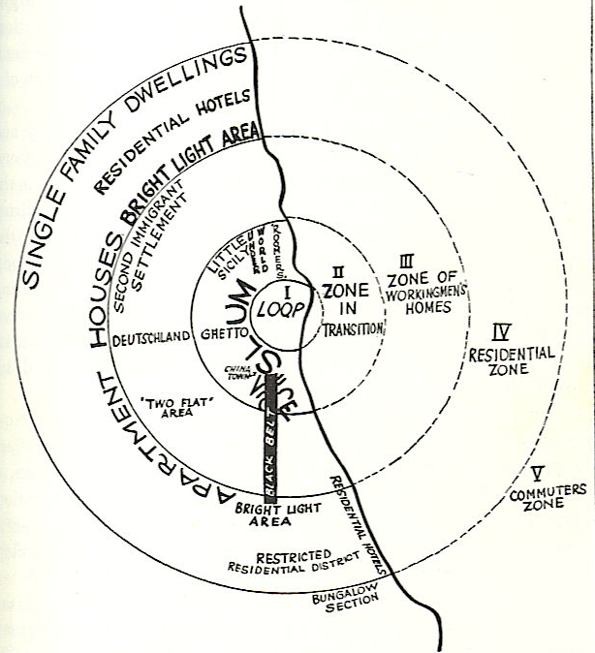

MODERN APPLICATIONS:

Environmental criminology
Brantingham and Brantingham:
Crime Pattern Theory
- Complexity of the criminal event
- Crime is not random
- Criminal opportunities are not random
- Offenders and victims are not pathological in their use of time and space

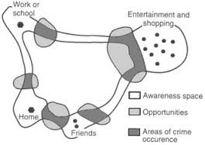

Routine Activities: The daily rhythm, Activity Space
Awareness space: Around Activity Space
Social Networks: Family, friends, repeat contacts
Urban Structure: Nodes, paths, edges

Geographic profiling:

“For any violent crime to occur there must have been an intersection in both time and place between the victim and offender” (Rossmo, 1996)
“The spatial relationship between the offender's home and his or her crimes is an underlying theme in much of this work. Is it possible to "invert" this research and use the locations of a series of crimes to suggest where an offender might reside?”
- Applied geographic profiling to police investigations

- "geographic profiling" technique designed to map unsolved crimes and highlight any pattern or criminal "signature" overlooked by detectives assigned to individual cases”
- May 1999 Rossmo reported an unusual concentration of disappearances in Downtown Eastside
  - Ignored and then punitively demoted
Inspector Gary Greer advised the press, "We’re in no way saying there is a serial murderer out there. We’re in no way saying that all these people missing are dead. We’re not saying any of that."

- Map boundaries delineating the offender's hunting area are first established using the locations of the crimes
- Manhattan distances from each point on the map to the crime location
- Distances are used as independent variable values in a formula where:
    - if the point lies outside the buffer zone, becomes smaller the longer the distance, following some form of distance-decay; or
    - if the point lies inside the buffer zone, becomes larger the longer the distance
- Numbers are multiplied together to produce a single score for each map point.
- three-dimensional surface, the "height" of which represents the relative probability that a given point is the residence or workplace of the offender

B. ANOMIE & STRAIN:
Durkheim:
-said that people would suicide due to the lack of engagement with society

Law and Moral order:

- Moral order more fundamental than economic order.
- Influence of Saint-Simon, who talked extensively about importance of moral order.
- For Durkheim, law was reflection of moral beliefs/sentiments.
- Moral order or moral consensus would create a unified social order.

Integration and Regulation
Integration:
-Social forces of attraction
-social bonds, collective beliefs
Regulation:
-social forces of restraint
-laws and social structure
A happy Balance
-society/social system strive for balance or stability, often referred to as equilibrium
-watch words are consensus and integration

Merton: The Skinny

Durkheim = absence of norms results in anomie
Merton = presence of norms results in strain if you can’t keep up
“Goals outweigh your legit means of getting them”
- 5 possible responses to strain:
- Conformity – legitimate ways to reach your goals
- Innovation – illegitimate, the ends justify the means
- Ritualism – shifts the goals
- Retreatism – abandon everything, don’t give a shit
- Rebellion - ex. terrorist

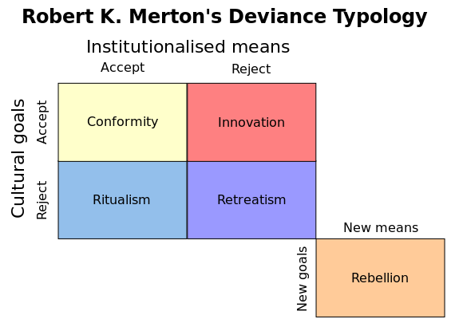

C. SUBCULTURE

- Emerged during the 1950s.
- Relative prosperity, compared to the Great Depression (the Dirty Thirties).
- Relative peace and prosperity, compared to World War II, which lasted from 1939 until 1945.

FIRST FOCUS ON YOUTH GANGS:

- Gang delinquency most prevalent amongst lower class males.
- Nonutilitarian, malicious and negativistic behaviour.
- Short term hedonism, often causing discomfort to others.

Status Frustration

- Members of lower class unable to achieve social status, because they lacked the means.
- Would come up against middle class standards at school, and find they couldn’t meet them.
Violent Subcultures:
Violence is a learned form of adaptation to certain problematic life circumstances
For participants in violent subcultures, violence can be a way of life
Two types of socially structured opportunities for success:
  - Legitimate opportunity structures
  - Illegitimate opportunity structures

Reaction Formation
The “middle-class measuring rod” -> Status-frustration -> Reaction formation -> Crime

Miller’s lower-class focal concerns:
- Trouble
- Toughness
- Smartness
- Excitement
- Fate
- Autonomy
Not the opposite of the American dream; entirely different because of context.

Wolfgang & Ferracuti:
- Members of a subculture hold different values but some are similar to mainstream
- Learned a willingness to resort to violence
- Favorable attitude toward violence
- Violent problem solving

GANGS TODAY
- Over 300 street gangs identified in Canada
  - Approximately 11,000 gang members
- More violent
- More involved with drugs
- Legacy of Anomie and strain
Key Points
-The Chicago school and social ecology
-modern legacies: ICURS, Profiling
-Anomie and Strain
-Subcultures as a social product:
-can be a response to strain but also a reflection of anomie
-Created within a social structure

