Mid Term Review Biology

Chapter 10 DNA Information Transfer
Chapter 11 DNA Replication
Chapter 12 Cell Cycle
Chapter 13 Gene Expression, Transcription

DNA Information Transfer (10)

- Prokaryotes
  - BINARY FUSSION
- Duplication of chromosome and separation of copies
- Elongation and cell movement
- Division of two identical daughter cells

- Eukaryotic Cells
  - Nucleus and DNA
  - Prokaryotic Cell
  - DNA, No Nucleus
  - Cell Cycle
- Common Traits of Cells
  - Somatic cells are genetically Identical
  - Same amount of DNA
  - Replication: mechanism to transfer DNA to daughter cells
- Cell Specialization
  - Control of gene expression
- Cell Division
  - Total DNA Replication
  - Mitosis, exact replication
- CELL CYCLE
  - InterPHASE
    - G₁ First Gap – Chill Cell
    - S Phase (DNA Synthesis)
      - DNA in all chromosomes has been replicated, two sister chromatids, attached by centromere.
    - G₂ Second Gap
  - MITOTIC PHASE
    - ProPHASE
      - Early spindle, Centrosome, Sister Chromatids, nuclear membrane dissolves, attachment of Kinetochores
    - MetaPHASE
      - Metaphase plate, Mitotic spindle
    - AnaPHASE
      - Daughter Chromosomes split
    - TeloPHASE and CytoKINESIS
      - Cleavage Furrow, nuclear envelope
- DNA Replication
  - Three parts, Covalent Bonds
    - BASE: Adenine, Thymine, Cytosine, Guanine
    - Purines Pyrimidine
    - Pentose Sugar
    - Phosphate Group
- Friedrich Mieshcher – 1871
  - Leukocytes, bandages
  - Nuclein
- Frederich Griffith - 1927
  - Protein was believed to be hereditary
  - Smooth/rough mouse death experiment
- Oswald Avery - 1944
  - Destroying just DNA resulted in only non harmful R strain
- Hershey and Chase -1952
  - Radioactive Tagged Protein vs. Rad DNA
- Chargaff’s Rules
  - AT and GC pairs
  - A= 30.9% and T=29.4%
  - G=19.9% and C = 19.8%
  - Composition of DNA varies
- Linus Pauling
  - Triple Helix Model, neutral phosphate groups
- Deoxyribose sugars are linked by phosphate groups to form sugar phosphate backbone
- Anti-Parallel Strands
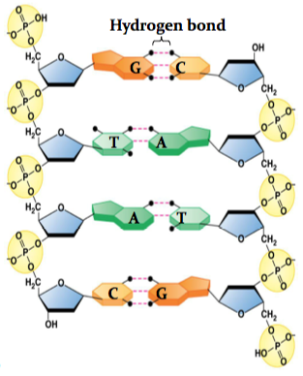
- Stored in compact form. Histones pack DNA at successive levels.
- CHROMATIN =DNA complexed with histone and non-histone Proteins
- DNA wraps around a Nucleosome, (balls wrapped around yarn) histones H2A, H2B, H3 and H4.
- Linker DNA connects adjacent nucleosomes
Size:
DNA Double Helix < Nucleosome < Solenoid < Tight helical fibre < Super Coil < Chromosome

- Plasmids in Bacteria replicate independently of the host chromosome.

DNA Replication (11)

- Semi Conservative Replication
  - Parent DNA molecule Splits
    - Complimentary Daughter DNA strands
- Complimentary Chains
  - DNA is produced by DNA Polymerase
  - Parent DNA is Template
  - DNA growth is 5’ to 3’, Polymerase attaches to 3’ end (OH bond)
  - Nucleoside Triphosphate bonds comp. pairs and releases pyrophosphate
- Replication of bidirectional
  - Begins at many sites, Replication forks

- Helicase untwists double helix
- SSBP covers split helix strands
- Topoisomerase corrects winding
- Primase adds RNA primer, 5’ to 3’, Attaching to 3’ ends.
Polymerase III builds DNA chain with sliding clamp at RNA primers

- Polymerase I removes RNA primer
DNA Ligase patches removed primer and links chains
- Lagging Strand:
  - The strand where which complimentary strands must be built in non- continuous OKASAKI fragments.
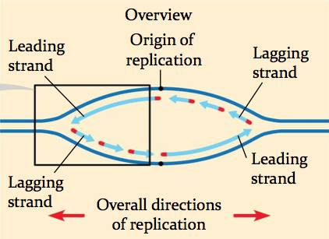
DRAW PICTURES HERE:

The Mitotic Cell Cycle (12)

- Interphase
  - Begins as daughter cell from previous division cycle
  - Chromosomes are doubled
  - Cell gets bigger
- PROPHASE
  - Chromosomes have condensed into threads, ie, sister chromatids
  - Centrosome has divided into two parts, ie. Spindle
  - Nucleus disappears
- PROMETAPHASE
  - Nuclear envelope fragments
  - Spindle fibres from centrosomes attach to kinetochores and centromere.
- METAPHASE
  - Chromosomes are pulled, and assemble on metaphase plate.
- ANAPHASE
  - Sister Chromatids are pulled apart
  - Nonkinetochores move against each other and begin to elongate cell.
- TELOPHASE
  - Elongation continues
  - Nucleolus reforms, and nuclear envelope
- Cytokinesis
  - Cleavage furrow splits cell membrane
  - Ring of microfilaments
- Plant Cell Cytokinesis
  - Cell plate forms, vesicles containing cell wall material form.
  - New cell wall and daughter cells.
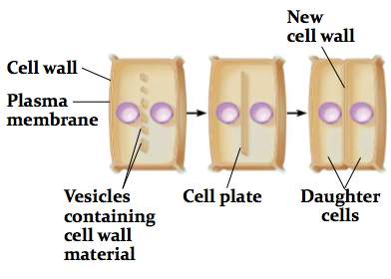
  - Cell Cycle Regulation
    - Cyclins and cyclin-dependent kinases regulate cell division
    - Internal CHECKPOINT at G1, G2, and M.
    - Coordinates mitotic cell cycle with overall activities of organism
  - Proper Cell Cycle Function
    - Growth
    - Replacement of damaged cells
    - Asexual reproduction
  - Cancer cells
    - Divide rapidly without regulation
    - Spread to other tissues
    - Grow without being inhibited by other cells.
Gene Expression and Transcription (13)

- Gene Expression Controls:
  - mRNA transcription
  - P-transcriptional, translational and post-translational
- TRANSCRIPTION
  - All within Nucleus!
  - RNA molecule are started from DNA double strands, similar to DNA replication
    - AUG U,
    - Transcription enzyme RNA Polymerase
    - Activated by AUG start Codon
    - DNA code is TAC
- TRANSCRIPTION PROCESS
  - mRNA is made in 5’ to 3’ direction, starting at 3’ end.
  - Produces mRNA with unique triplet code called codons.
- Genetic Code
  - 61 Codons correspond to amino acids
  - AUG for methionine and signals start of translation
  - Rules Codons
    - Redundant
    - Unambiguous
    - Universal
    - Without punctuation
  - STOP codons:
    - UAA, UAG, UGA
      - On the template DNA, can be read as ATC, etc.
- RNA is processed before leaving the nucleus as mRNA
  - RNA splicing removes introns and produces a continuous coding sequence
  - Guanine cap added and tail of nucleotides added to the ends of the RNA
- The Central Dogma
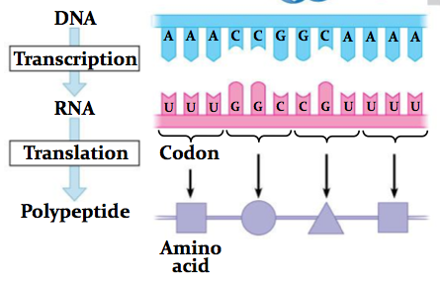
  - DNA makes RNA makes Protein, and that's how it works
- Discovery
  - Nirenberg and Leder (NIH 1964)
    - Short artificial mRNAs
    - Bound to a single tRNA + AA
  - Khorana (1966)
    - Long artificial mRNAs
    - In vitro Translated
    - Polypeptide sequence analyzed

GENE EXPRESSION- TRANSLATION (14)

- Occurs in Ribosomes
  - mRNA
  - tRNA
    - Converts genetic message of mRNA into protein code. Uses Anti-Codon.
    - Bonded to Specific AA
  - Large subunit
  - Small subunit
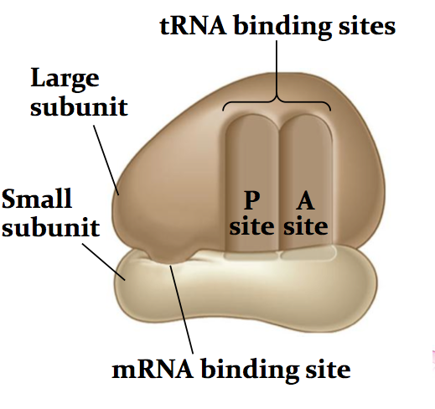
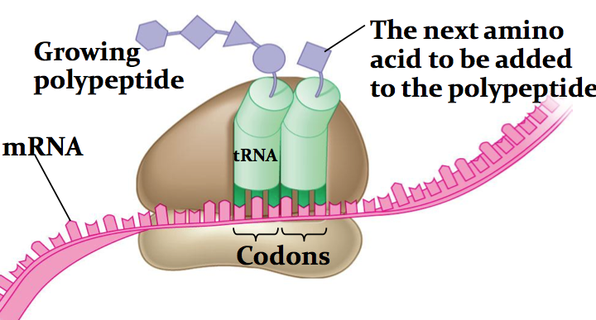

- Translation
- Initiation
- Brings together mRNA
- tRNA bearing the first amino acid
- Two subunits of ribosome
- Elongation
  - Codon recognition
    - The anticodon of an incoming tRNA molecule carrying its amino acid, pairs with mRNA codon in the A site of the ribosome
  - Peptide bond formation
    - The new amino acid is joined to the chain
  - Translocation
    - tRNA is released from the P site and the ribsome moves tRNA from the A site into the P site.
- Termination
  - Ribosome reaches a stop codon.
  - The completed polypeptide is freed from the last tRNA
  - The ribosome splits back into its separate subunits
- Mutations
  - Base substitutions
    - Silent mutation
    - Missense mutation
    - Create a stop codon, AKA nonsense mutation
  - Deletions or insertions
    - Alter the reading frame
- Mutagenesis
  - The production of mutations
    - Caused by errors in DNA replication, recombination or,
  - Mutagens
    - Include X-rays and UV light
    - Chemicals

