Chapter 7

Homonymy: the situation in which words with the same spelling and pronunciation have entirely distinct, historically unrelated meanings.
Examples: light “not heavy” “illumination”
Bank “a financial institution” “of a river”
Club “a social organization” “a blunt weapon”
Polysemy: the situation in which a word has two of more related meanings.
Examples: bright “shining” “intelligent”
To glare “to shine intensely” “to stare angrily”
A deposit “minerals in the earth” “money in the bank”
Homographs: bow /bow/ weapon for shooting arrows and bow /baw/ “to bend at the waist”
Homophones: write /rait/ and right /rait/

Semantics
Semantics: the study of linguistic meanings of morphemes, words, phrases, and sentences is called semantics.
Semantic relations
The Greek root cosm “universe” or “adorn”
Cosmos, microcosm
In ancient greek: cosmos= “order”

Reasons for semantic change
~Errors and misinterpretation
~Creative variation
~Abbreviation (ellipsis0
Examples: human communication is also oriented towards the best usage of the material
available. Tendency towards expressing ourselves quickly and efficiently.
Church from greek cyriacon doma “ord’s house”
Microwave from microwave oven
~Change in the thing named
~The most important single reason for multiplying the meanings of words is that we find the number of vocabulary items to be small in relation to the infinite variety of the things we have to say.
Examples: make new words
Use longer phrases
Extend the use of existing words

How do meanings develop?
Examples: horse
Equus caballus – four legged support – cavalry（骑兵）- the pulling power of one
Horse
Hyster
Originally known as uterine – psychiatric disorders- hysterical anger of laughter –
joke

Affixes and meaning
Prefixes and suffixes contribute meaning to the word
Suffix –oid not only changes the lexical category of the word into an adj or a noun, but also implies that the thing described by the word resemble the thing described by the root.
Examples: a spheroid resembles a sphere
A humanoid resembles a human

Polysemous suffixes
Meanings of the suffix -ous
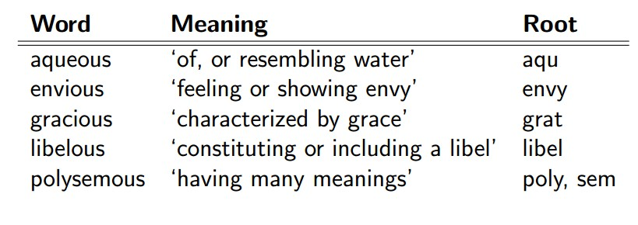
Meanings of the suffix –c
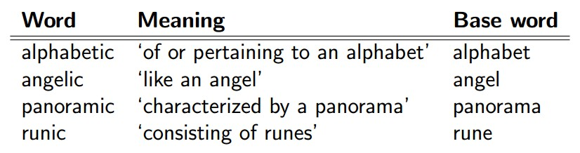

Types of semantic change

Metaphor: the range of entities a word refers to can be extended to include an additional set of entities that resemble, formally or functionally, the original set.
1, a change based on resemblance
Bright as synonym for intelligent
Leaf to refer to a page in a book
2, shift from concrete to abstract
Understand originally known as “stand below”
Figurative meaning: the image of holding up an idea
Spatial metaphor is a fundamental method in human language for developing new meanings.
Metaphoric extension of meaning of spatial prefixes (see textbook page 146)
Many prefixes analyzed in this course are spatial in their basic meanings, but can be metaphorically extended to express non-spatial meanings

Metonymy: the possibility of a connection in physical space, time or relationship of cause and effect. It is a shift in meaning from some object to something connected with it in some way other than resemblance.
Examples: Ottawa announced a new tax on homeowners.
The use of word pulp to refer to a variety of literature: pulp fiction
The connection involved in metonymic change can be of almost any kind

Metaphor and metonymy
Examples: compare how the same word functions when used as a metaphor and when used as a
metonym.

Outcomes or results of semantic shift
Narrowing
The restriction of the meaning of a word to a subset of what it originally denoted
Examples: Hound any dog a hunting breed
Meat any type of food flesh of an animal
Disease any unfavorable state an illness

Widening
Refers to the semantic process by which the meaning of a word extends to include cases that go beyond the original ones
Examples: bird small fowl any winged creature
Barn place to store barley farm building
Arrive come ashore reach any destination

Melioration
Shift from negative to positive

Pejoration
Opposite of melioration

Euphemism （委婉的说法）
The process of using a new word to refer to an item or concept that people hesitate to talk about.
When the euphemism is well accepted, the original term becomes less acceptable, undergoing pejoration.
Examples: cripple replace by handicapped person

