ACTIVITY BASED COSTING SYSTEMS

A cost accounting system
- collects and classifies costs and assigns them to cost objects
- goal – measure the cost of designing, developing, producing/purchasing, selling, distributing, and servicing particular products or services

Technique to determine cost:
- job costing
- activity based costing
- process costing

ACTIVITING BASED COSTING (ABC)
- Attention is directed on activities rather than products
- If many costs are caused by non-volume-based cost drivers, activity-based costing (ABC) should be considered
- Indirect Costs are allocated first to activities

GENERAL IDEA:
- accumulates overhead costs for each of the activities of an organization
- assigns the costs of activities to the products, services, or other cost objects that caused that activity
- Allocation of indirect costs to products/services is done in relation to the activities which caused them to be incurred
- For example, apply more "quality control" costs to those products which require more quality control testing

Cause-effect relationship between an activity and a cost object is established by identifying the cost drivers for each activity

EXAMPLE ACTIVITY COST DRIVER
Cost-driver activity Production Set-up #of production runs
Is measured by the Production Control #of production process changes
#tranx involved in Engineering #of engineering change orders
Activity. Maintenance #of machine hours
Power #of kilowatts

TRADITIONAL COST SYSTEM

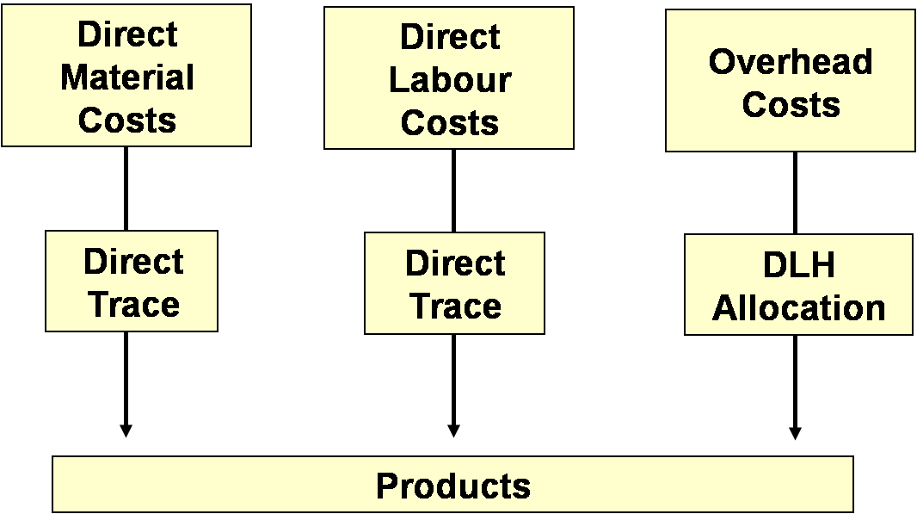
The portion of total overhead allocated to a product depends on the proportion of total direct labour hours consumed in making the product

ABC COST SYSTEM

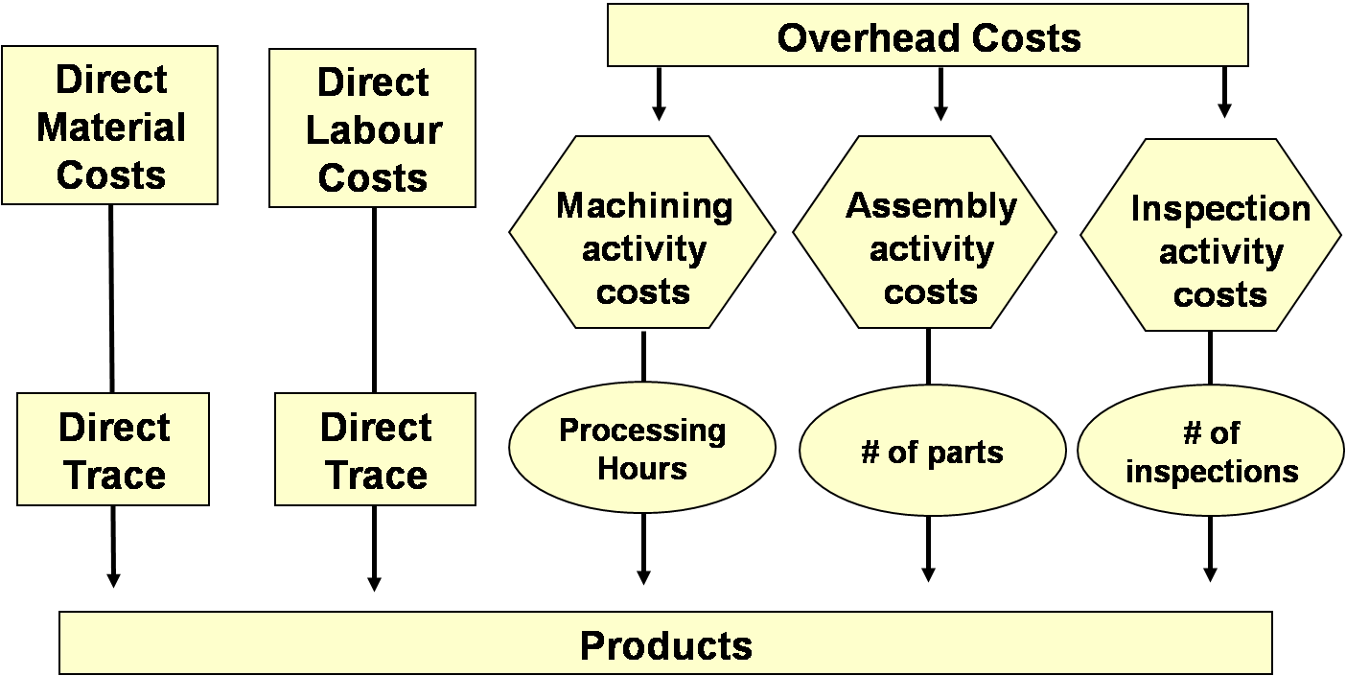
- Significant overhead activities and related resources are separately identified and traced to products using cost drivers
Overhead activities:
machining, assembly, quality inspection
Cost drivers:
machine hrs, #of parts, #of inspections

- Amount of overhead cost allocated to a product depends on say, total machine hrs, parts, and inspections, consumed in making the product

- A pool of overhead cost is broken into several pools, each associated with a key activity

ILLUSTRATION OF ACTIVITY-BASED COSTING

Consider: Billing department (BD) at PPC, an electronic utility, that provides:
- Accounting inquiry services
- Bill printing services
Services are provided to classes of customers – residential and commercial

2 factors influence PPC’s profitability:
- Deregulation of the power industry has led to increased competition and lower rates, so PPC must find ways of reducing its operating cost
- Demand for power in PPC’s area will increase due to the addition of a large housing development and a shopping centre. This signifies an increase in residential and commercial customers. PPC’s BD department needs to find ways to create capacity to service the expected increase in demand
Cost Objects and the Resources used to support the BD:

- Telecommunications $58,520
- Computer $178,000
- Paper $7,320
- Occupancy $47,000
- Supervisors $33,600
- Account Inquiry labour $118,400
- Printing Machines $55,000
- Billing Labour $67,500

All cost are indirect and amounts total = $565,340
(Because they cannot be identified specifically & exclusively w/ either customer class in an economically feasible way)

THE BD USED A TRADITIONAL COSTING SYSTEM THAT ALLOCATED ALL SUPPORT COSTS BASED ON THE NUMBER OF ACCOUNT INQUIRIES OF THE TWO CUSTOMER CLASSES
- Total Account Inquiries = 23,000
- So, indirect cost per inquiry = 565,340 ÷ 23,000 = $24.58

Total Account Inquiries for
- Residential = 18000 = 78% of 23000
- Commercial = 5000 = 22% of 23000

Cost/Inquiry #of Inquiries #of Accounts Cost/Account
$565,340/23000
₁ ₂ ₃ ₁ × ₂ ÷ ₃

Residential $24.58 18,000 120,000 $3.69
Commercial $24.58 5,000 20,000 $6.15

A local service bureau has offered to take over the BD functions at an attractive lower cost (compared to the current cost). The service bureau’s proposal is to provide all the functions of the BD at $3.50 per residential account and $8.50 per commercial account

Based on the costs provided by the traditional system, the BD management would
- Be motivated to accept the service bureau’s proposal to service all residential accounts because of the apparent savings of ($3.69 – $3.50 = $0.19)
- Continue to service its commercial accounts because its costs are ($8.50 – $6.16 = 2.35) less than the service bureau’s bid

HOWEVER, MANAGMENT BELIEVED THAT THE ACTUAL CONSUMPTION OF SUPPORT RESOURCES WAS MUCH GREATER THAN 22% FOR COMMERCIAL ACCOUNTS BECAUSE OF THEIR COMPLEXITY.
For example – commercial accounts average 50 lines per bill compared with only 12 for residential accounts

THEREFORE – COMPANY DECIDED TO STUDY THE BD USING ACTIVITY-BASED COSTING INSTEAD

THERE ARE 4 STEPS INVOLVED IN ACTIVITY-BASED COSTING

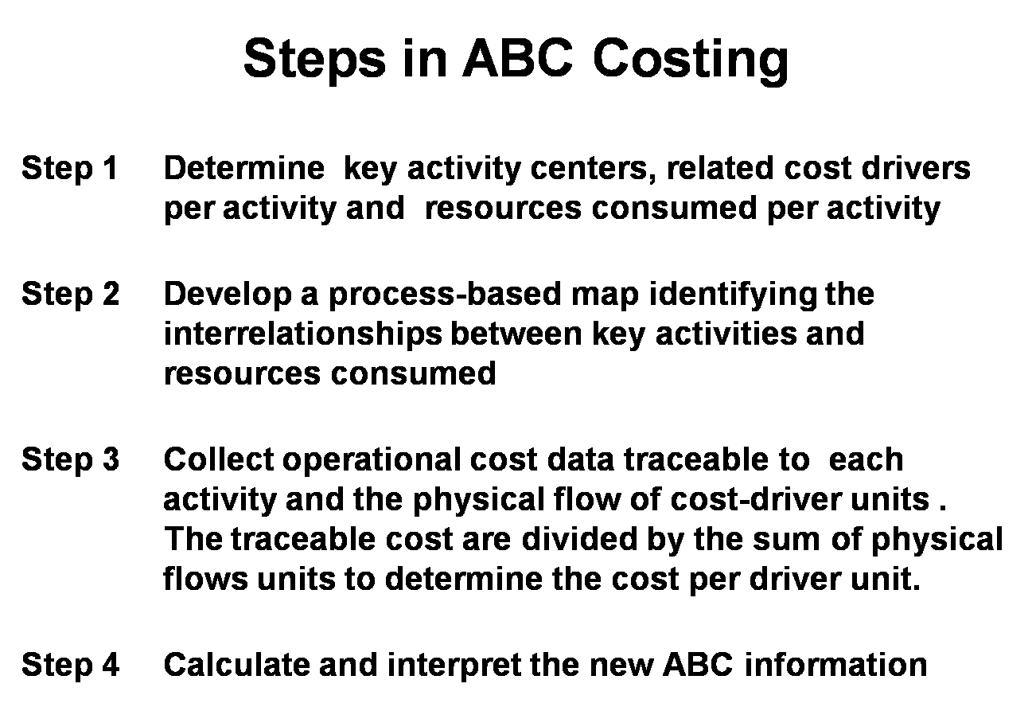

USING THE 4 STEPS – APPLY IT TO THE BD – SEE PAGE 212 – 215

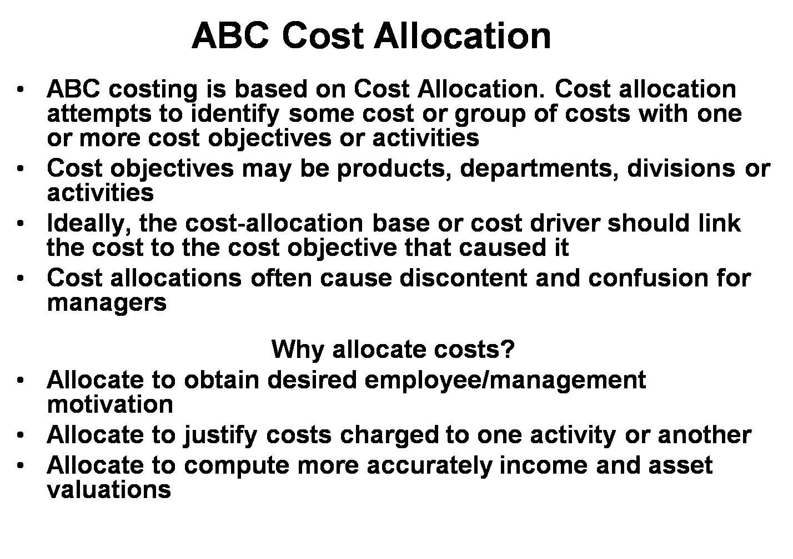
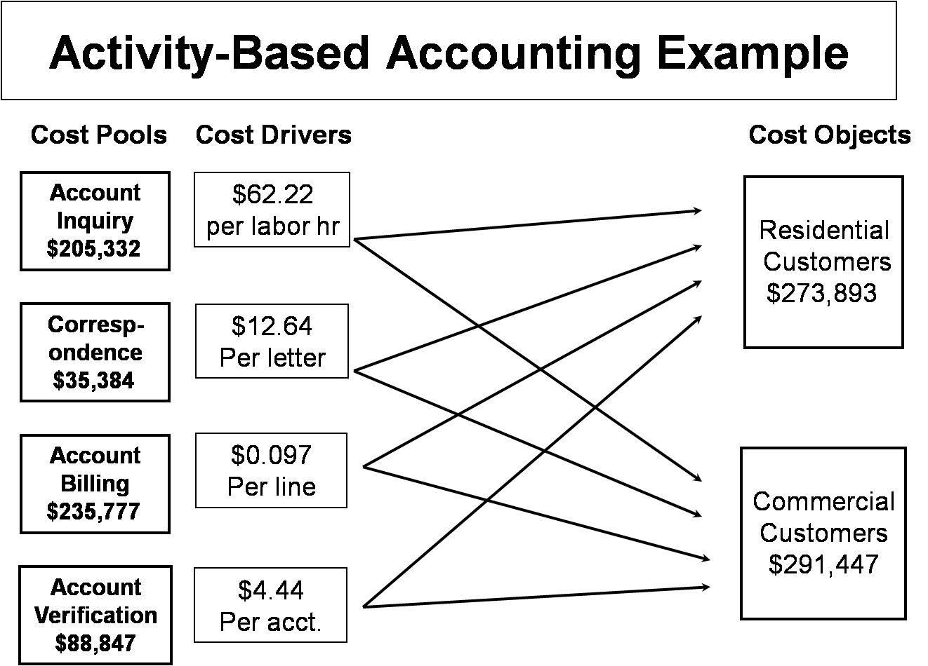

ACTIVITY-BASED MANAGEMENT

Activity-based Management (ABM)
- is the use of activity-based costing system to improve the operations of an organization
- aims to improve the value received by customers and to improve profits by providing this value

- distinguishes between value-added costs and non-value added costs

  - value-added costs are the necessary costs of an activity that cannot be eliminated without affecting a product’s value to the customer

  - non-value-added costs are costs that can be eliminated without affecting a product’s value to the customer

To better support manager’s decisions, a cost management system is developed to indentify how management’s decisions affect costs by:
- measuring the resources used in performing the organization’s activities
- assesses the effects on costs of changes in those activities

SUMMARY OF ACTIVITY-BASED COSTING

- can turn many indirect overhead costs into direct cost by identifying each overhead cost/activity separately and using different cost drivers to trace certain costs directly to each activity – costs identified specifically with given cost objects

- more complex and costly than traditional system

JUST-IN-TIM (JIT) SYSTEM
- focus on eliminating waste and improving quality
- purchase material and produce products when needed in the production process

- Factors that are crucial to the success of JIT systems:
  - focus on timely delivery-quality
  - shorter production cycle times
  - smooth the flow of production no bottle necks
  - Flexible production operation
– adopt more flexibility with facilities (variety of components) and employees (variety of tasks)

- Goal – zero or near zero inventory, because holding inventory is a non-value added activity

