University of Toronto – Scarborough Instructor: Prof. Carl Mitchell
“Introduction to Environmental Science” (EESA01 L01 and L60)
Mid-Term Examination: Saturday, October 24, 2009, 5-7 pm.
Time Allotted: 2 hours.
This mid-term examination has 70 questions and is worth 25% of your final grade.
INSTRUCTIONS: Answer ALL questions on the SCANTRON sheet provided. Choose the answer which is most correct. Make only one mark per answer. Use either pencil (preferred) or black ball-point pen. Do not use felt-tipped pens or anything that writes in red. If you make a mistake, call over an invigilator; do not attempt to make corrections on the Scantron sheet.
ANSWER ALL THE FOLLOWING QUESTIONS:
1. The scientific process and knowledge are based on:
- observation
- testing hypotheses that are built on observations
- the fact that hypotheses can be proven
- quantitative data only
- educated guesses

2. An experiment:
- is an activity designed to test the validity of a hypothesis
- should involve manipulating as many variables as possible
- does not need to be repeated
- is designed to prove a scientific hypothesis
- all the above except (c)

3. Ruben has a new puppy and wants to feed it the best possible food. He decides on an experiment where he will feed it the very best canned food plus a dietary supplement of vitamins recommended by a veterinarian. Which of the following best describes Ruben’s project?
- This is an example of an excellent, controlled experiment as it is written.
- Ruben needs to take careful measurements of the puppy’s weight and height at least once a week for it to be a good experiment.
- Ruben needs to control for the amount of exercise, sunshine, water, and care that the puppy gets each week, so that they are equal from week to week.
- Both (b) and (c) above.
- None of these options would make this a proper experiment.

4. Nearly 50% of the land on Earth is currently used for agriculture. If everyone on the planet had an ecological footprint the size of the average citizen of Canada, then:
- we would have 50% more food to go around
- we would be able to provide for everyone without much difficulty, using the other 50% of the land currently not being used
- we would need at least two more planet Earths to feed and support everyone
- we could support 50% more people on Earth
- about 50% of people on Earth would starve

5. Sustainable development:
- ensures an economy that will decline over time
- means consuming resources without compromising future availability
- is impossible to accomplish
- is beyond our current technology and attitudes
- is possible given our increased use of fertilizers and technology for agriculture

6. In a controlled experiment, _______:
- the researcher has several hypotheses, one of which will be proven correct
- the researcher knows the outcome before she or he begins
- the experimental organisms have all been used before and given good results
- the research controls for the effects of all variables except one
- you need only a single experimental organism; replicates are not needed

7. The theory explaining that unregulated exploitation of resources leads to resource depletion has been coined:
- Tragedy of the Community
- Tragedy of the Common
- Tragedy of the Commons
- Common Environmental Tragedy
- Communal Tragedy

8. Which of the following would be the strongest experimental design?
- Repeated correlative study with good control
- Controlled correlative study
- Controlled manipulative study
- Repeated manipulative study with good control
- Repeated cross-hatch study with good control

9. The Cornucopian viewpoint suggests that resource depletion due to greater number of people _____________.
- is not a problem if new resources can be found to replace the depleted ones
- is not a problem because disease will limit population size
- is not a problem because we will be able to import new matter into Earth’s closed system
- none of the above
- all of the above

Figure 1:

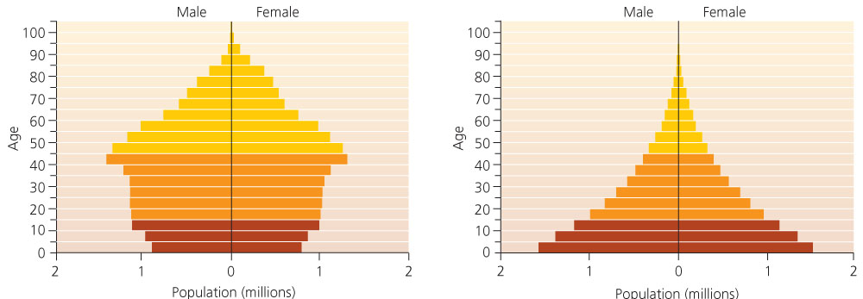

10. Refer to figure 1 above. Looking at the figure, you are able to determine:
- that the population in part (a) is growing rapidly
- that the population in part (b) is growing rapidly
- that the population in part (b) has many more males than females
- that the population in part (b) is aging rapidly
- that there was a “baby boom” in the population on the right about 30 years ago

11. Refer to figure 1 above. What is the population in part (b) likely to experience soon?
- more single males
- more households
- lack of economic growth
- more senior citizens
- resource depletion and decreased quality of life

12. Refer to figure 1 above. What is the population in part (a) likely to experience soon?
- more single males
- exponential population growth
- government institution of a population control policy
- more senior citizens
- resource depletion and decreased quality of life

13. During which of the following time periods did the world’s population more than double?
- 1800-1850
- 1850-1900
- 1900-1950
- 1950-2000
- both (c) and (d)

14. Why was human population growth originally considered a good thing?
- greater pool of workers and helpers
- larger armies for conquering new lands
- fewer children to support folks in old age
- to spread religion around the world
- none of the above

15. If a population roughly doubles in the course of 50 years, its annual growth rate would be close to:
- 5%
- 1.5%
- 10%
- 0.7%
- 25%

16. Replacement fertility _______:
- restores population size after a catastrophic event
- is a contraceptive technique
- is below 2 in Latin America and the Caribbean
- is below 2 in Africa
- is equal to 2.1 in stable populations

17. Declining death rates due to increased food production and improved medical care while birth rates remain high is characteristic of the ___________ stage.
- pre-industrial
- stabilization
- post-industrial
- transitional
- revolutionary

18. The annual global growth rate of the human population peaked in the _________ and has been declining ever since.
- early 1900’s
- 1950’s
- 1960’s
- 1990’s
- the year 2000

19. A country with ____________ is not expected to grow quickly in the near future.
- a pyramid-shaped age-structure diagram
- high female literacy
- a female to male ratio of 1.2 to 1
- growing industrialization
- many developing regions

20. According to the IPAT model, technology that enhances our acquisition of minerals, fossil fuels, timber, and ocean fish ______________.
- increases environmental impact
- decreases environmental impact
- increases population
- increases sensitivity
- decreases sensitivity

21. Because of the success of China’s population control programs, ___________.
- environmental problems in China have been virtually eliminated
- African nations have instituted similar programs
- there is a younger population in China today
- China’s population growth rate is much lower than it was in the 1970’s
- both (c) and (d)

22. Which of the following is not a common limiting factor to carrying capacity?
- genetics
- space
- water
- food
- disease

23. We moved to an omnivorous diet and began to make tools during the:
- cultural revolution
- industrial revolution
- green revolution
- neandrethal transition
- none of the above

24. A key result in agricultural lands subject to long-term irrigation is:
- infinite high crop yields
- salinization
- reduced runoff
- decreased soil compaction
- oligotrophication

25. According to the IPAT(S) model, if technology were to lessen the impact due to increases in population and affluence, T would likely be:
- highly positive
- highly negative
- zero
- less than one
- greater than one

26. Demographic fatigue is:
- the inability to conduct demographic studies
- not a coined term
- occurs when demographers cannot deal with challenges related to environmental degradation
- occurs when nations cannot deal with challenges related to population growth
- was a term coined by Malthus

27. Which of the following is not a main focus of study by demographers:
- population growth
- environmental degradation
- population density
- death rates in relation to HIV/AIDS
- immigration

28. A bias towards males in sex ratios may be the result of:
- putting female babies up for adoption
- infanticide
- targeted abortion
- all the above
- parts (b) and (c) only

29. All countries are subject to the Demographic Transition:
- true
- false

30. ____________ is NOT a strong control on birth rates:
- all the below
- poverty
- access to contraception
- female education
- literacy

31. Which of the following are associated with negative feedbacks?
- outputs that cause the system to move in an opposite direction
- dire environmental consequences
- outputs that cause the system to continue to move in the same direction
- inputs that cause the system to shut down
- the evaporation of water

32. Which of the following are associated with positive feedbacks?
- outputs that cause the system to move in an opposite direction
- outputs that cause the system to continue to move in the same direction
- inputs that cause the system to shut down
- the evaporation of water
- melting of metals in a smelting operation

33. Which of the following is an Earth system most associated with frozen water?
- hydrosphere
- lithosphere
- cryosphere
- anthrosphere
- atmosphere

34. Which of the following is true?
- igneous rocks can become metamorphic rocks, but never sedimentary rocks
- igneous rocks can become sedimentary rocks, but never metamorphic rocks
- igneous rocks can become either sedimentary or metamorphic rocks
- igneous rocks can become neither sedimentary or metamorphic rocks

35. The main process driving the movement of tectonic plates is:
- divergence
- convergence
- convection
- submergence
- subduction

36. Cattle on an open range are compacting fragile soils while grazing. This is damaging plant roots, leading to fewer, smaller plants, which may in turn cause cattle to graze more and work harder to obtain food. This is an example of a ____________.
- positive feedback loop
- negative feedback loop
- homeostatic system
- dynamic equilibrium
- food web

37. Rock that has undergone heat or pressure that causes it to change form is called _________.
- conglomerate
- igneous
- sedimentary
- deformative
- metamorphic

38. A small section of prairie grasses, over a year, produces enough biomass to feed insects, mice, rabbits, birds, deer, antelope, and a host of decomposers. The amount of food potentially available to the herbivores is the ___________.
- net primary production
- gross primary production
- secondary production
- productivity
- food chain

39. The origin of all phosphorus in biological tissues is ___________.
- volcanic activities
- atmospheric phosphorus gas
- phosphorus in animal bones
- phosphorus dissolved in the ocean and taken up by shellfish
- phosphorus weathered from rock

40. The origin of all nitrogen in biological tissues is _____________.
- earthquake activities
- atmospheric N₂ gas
- lightning
- nitrogen weathered from rock
- volcanoes

41. Nitrogen fixation is a process that makes nitrogen available to plants by __________.
- photosynthesis
- volcanic eruptions
- dissolving in freshwater and in the ocean
- bacteria
- all of the above

42. Human beings have dramatically altered the flux rate of nitrogen from __________.
- the atmosphere to various pools on earth’s surface
- from soils to the atmosphere
- proteins to inorganic ions in soils
- oceans to soils
- producers to consumers through increased wildfires

Figure 2:
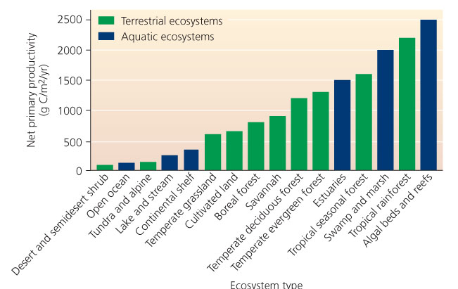

43. Refer to Figure 2 above. This graph helps explain ____________.
- why the open ocean is so productive
- why cultivated lands are a logical choice to replace rainforests
- why we need to be concerned with damage to rainforests and coral reefs
- why tundra has such high net primary productivity of biomass
- the importance of deserts

44. Refer to Figure 2 above. Overall, it appears that biomes with more available freshwater __________.
- tend to have less productivity than those without much freshwater
- tend to have about the same productivity as those without much freshwater
- tend to have more productivity than those without much freshwater
- don’t differentiate between freshwater as rainfall and freshwater as ice in glaciers
- no real conclusions can be drawn

45. Which of the following ecosystem structures are not possible:
- producer detritus producer detritus
- producer primary consumer secondary consumer
- primary consumer secondary consumer tertiary consumer
- producer primary consumer detritus producer
- none of the above are possible

46. The principal difference between GPP and NPP is:
- biomass production
- herbivory
- soil accumulation
- respiration
- oxidation

47. If less nitrogen is exported from a lake than is imported to a lake, the lake is a ___________ for nitrogen:
- flux source
- reservoir
- sink
- eutrophy
- pool

48. A bucket of water contains 69 litres of water. Water is added to the bucket at the same rate as it leaves the buck, which is 1.6 litres every 4 hours. What is the approximate residence time of water in the bucket?
- 4 hours
- 43 hours
- 43 days
- 7 days
- zero units

49. Farmers tend to rotate crops between corn, wheat, and soybeans because:
- specialized bacteria in corn roots provide needed phosphorus to the soil
- legumes harbour nitrogen-fixing bacteria
- corn is easier to grown than wheat
- soybeans are good at increasing phosphorus levels in soil water
- soybeans are 10X better at conserving water for photosynthesis

50. The key issue with the global mercury cycle is that:
- fluxes from the hydrosphere to the deep ocean have been significantly enhanced
- fluxes from the atmosphere to the lithosphere have been significantly enhanced
- fluxes from the lithosphere to the atmosphere have been significantly enhanced
- fluxes from the lithosphere to the anthrosphere have been significantly reduced
- fluxes from the hydrosphere to the anthrosphere have been significantly reduced

Table 1:

Temp | Incoming  Shortwave  Radiation | Stefan-  Boltzmann  Constant | Emissivity | Outgoing Shortwave Radiation
29°C | 98 Wm⁻² | 5.67x10⁻⁸ Wm⁻²K⁻⁴ | 0.42 | 91 Wm⁻²

51. Refer to Table 1 above. Given this data, albedo is:
- 1.077
- 1
- 0.39
- 0.93
- cannot be calculated because net longwave radiation cannot be determined

52. Refer to Table 1 above. Given this data, the maximum wavelength at which radiation can be emitted is:
- 100 μm
- 9.593 μm
- 9.6 μm
- 0.0096 μm
- cannot be determined given the information in Table 1

53. Refer to Table 1 above. Given this data, the flux of energy from this surface would be equal to:
- 0.017 W m⁻²
- 200 W m⁻²
- 4.7 x 10² W m⁻²
- 140 W m⁻²
- 20 W m⁻²

54. Refer to Table 1 above. Given this data and also that incoming longwave radiation is equal to 47 W m⁻², the net balance of radiation at this surface at this time is equal to:
- outgoing longwave radiation is needed and cannot be calculated here
- 7 W m⁻²
- -40 W m⁻²
- -146 W m⁻²
- 54 W m⁻²

55. An area at 68°N would receive less insolation than an area at the equator during April because:
- Earth is tilted away from the sun
- there is more atmosphere for insolation to pass through at 68°N
- there is a more direct angle of incoming radiation at the equator
- all of the above
- none of the above

56. Which takes more energy?
- raising the temperature of a glass of water by 1°C
- raising the temperature of a glass of water by 50°C
- changing ice at 0°C into water at 0°C
- changing water at 100°C into water vapour at 100°C
- changing ice at 0°C into ice at -180°C

57. The difference between a cold front and a warm front is that:
- cold fronts have less dense air masses
- cold fronts produce more violent rain storms
- cold fronts produced more areally extensive rainfall
- cold fronts are the largest cause of hurricanes
- cold fronts tend to negatively affect water balances

58. Which of the following is not a requirement for precipitation to form and fall to Earth?
- dew point must be reached
- condensation must occur
- considerable water must be imported into the air mass
- rain drops must grow to a considerable size
- vapour pressure must be greater than the vapour pressure at which water vapour is saturated in an air mass

59. A watershed of 5.7 square kilometers receives 9 trillion cubic centimeters of rainfall. What is the depth of rainfall?
- 157 mm
- 633 cm
- 633 mm
- 0.002 cm
- 1.6 mm

60. The loss of wetlands in Canada has been mainly due to:
- urbanization
- waterfowl damage
- precipitation exceeding evapotranspiration
- agriculture
- climate change

61. The hypolimnion denotes:
- the transition between salty and fresh water
- the transition between cold and warm water in a lake or pond
- the shallower warm area of a lake or pond
- the deeper, salty area of a lake or pond
- the deeper, colder area of a lake or pond

62. In the following diagram, the arrow denotes:

- stream order
- drainage divide
- a tributary
- the watershed
- runoff

Figure 3:
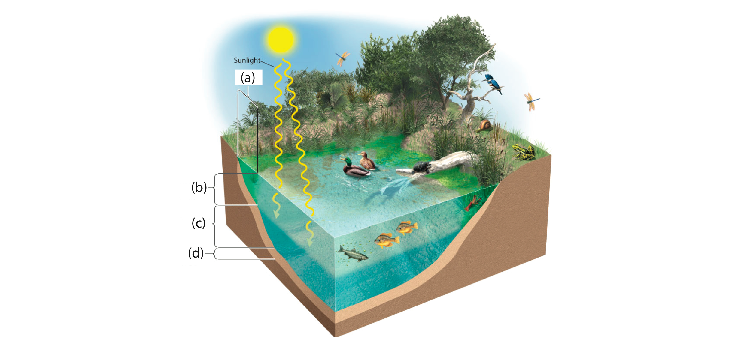

63. Refer to figure 3 above. The portion labeled (a) is the:
- profundal zone
- limnetic zone
- littoral zone
- benthic zone
- riparian zone

64. Refer to figure 3 above. The portion labeled (b) is the:
- profundal zone
- limnetic zone
- littoral zone
- benthic zone
- riparian zone

65. Refer to figure 3 above. The portion labeled (c) is the:
- profundal zone
- limnetic zone
- littoral zone
- benthic zone
- riparian zone

66. Frogs eggs are usually attached to vegetation or rocks near the surface of a pond. Tadpoles can use essentially all areas of a shallow pond, or the top meter or so of a deeper lake or pond. Adult frogs can live on land or in the water. A frog’s life would thus be least likely to be disrupted by a change in the _____________.
- profundal zone
- limnetic zone
- littoral zone
- benthic zone
- riparian zone

67. A rainshadow is a dry area on the __________ of a mountain.
- leeward side
- windward side
- crest
- summit
- footslope

68. About one-fifth of Earth’s total supply of freshwater is in _______.
- lakes and rivers
- the ocean
- groundwater
- estuaries
- wetlands

69. Water may reach a river via:
- the atmosphere
- the lithosphere
- running across soil in sheets
- all of the above
- only (a) and (b)

70. Which of the following is a common air mass uplift mechanism?
- torographic lifting
- confectionary lifting
- oporophic lifting
- topoliftage
- orographic lifting
END OF EXAM

