Lecture 1: Representation of Knowledge and Mental Imagery
Important Page #’s: ***STILL NEED TO FILL IN***
Representation of Knowledge
Types of Knowledge
- Procedural
  - How you do something, acquired through practice, hard to extinguish; there are implications for emergencies
  - Ex. How do you play an instrument?
- Declarative
  - Facts, events, acquired with organization, easily forgotten.
    - Episodic: autobiographical, personal, uses temporal tags (time tags)
    - Semantic: factual, words, concepts, does not have to be from actual experience – to acquire this you do not have to experience it.
Episodic vs. Procedural
COHEN & CORKIN (1982)
- Normal People vs. Amnesiacs
- Task: Learn a puzzle (Tower of Hanoi) which requires applying a set of procedures
- Results:
  - Normal People; learn the procedures indicting a transfer and had episodic memory of performing the task
  - Amnesiacs; learned the procedures indicting a transfer but have no episodic memory of doing the task.
- Suggests:
  - There is dissociation (separate and discreet) between episodic and procedural memory.
Semantic Memory ~ Organization
- Semantic knowledge is highly organized and relied on a lot.
- Ex. Psychoanalysis; relies on semantic memory in free recall.
- We wish to examine and formalize this organization!
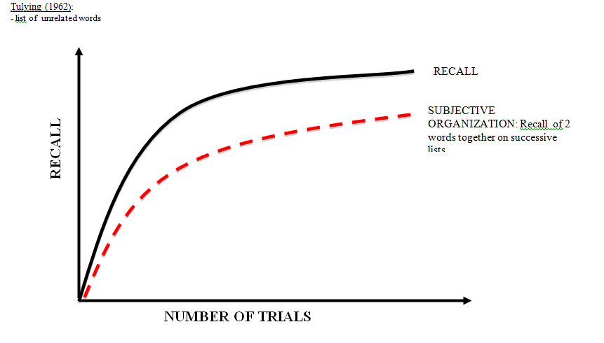
Organization of Semantic Memory
- The list was of unrelated words (not semantically connected)
- Participants performed better after more and more trials
- People imposed subjective organization to improve recall, by recalling them in order repeatedly.
Models of Semantic Memory
- Feature Model: Semantic Feature-Comparison Model
- Network Models: (1) Hierarchical Network Model (2) Spreading Activation Level
Semantic Feature-Comparison Model
RIPS, SHOBEN & SMITH (1973)
- Structure
- Knowledge consists of sets of features, features are weighted on a dimensions of categories
- Example: Small --------------------------------------- Large
- Types of Features;
  - Defining: which are important or critical to organization .
  - Characteristic: which are less important, more descriptive.
- Example: Bird… has wings = defining…. can fly = characteristic

- Process and Decision pg 261
The overlap between helicopter and bird does not reach the threshold and so we can say no.
Is a robin a bird? Is a helicopter a bird?
The overlap between robin and bird reaches the threshold, and so we are able to say yes.
Encoding
features retrieved

x < C_{lower} Stage 1 x > C_{upper}
global compare ALL features

C_{L} < x < C_{U}

Stage 2
compare defining features

FALSE TRUE

- Stage 1: decision is made based on comparison of all features (either exceeding a lower/higher threshold)
- Stage 2: decision is based on defining features (those critical for the category)
- This is a self terminating process, if we only use step 1, we are fast to respond.
Evidence
Bird | Rating
Robin | 3.0
Sparrow | 3.0
Pigeon | 2.8
Hawk | 2.6
Chicken | 2.0
Typicality Ratings ~ RIPS ET AL. (1973)
Based on semantic organization, things are generally ordered the way you think they are. All birds have most defining features so it is assumed that typicality reflects characteristic features.
Typical Item; lots of overlap = fast RT
Atypical Item; not a lot of overlap = slow RT (needs stage 2)

Sentence Verification ~ ROSCH (1973)
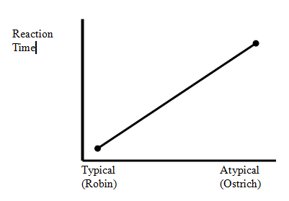
- Typical Task: Is a _______ a bird?
- The semantic feature-comparison model predicts:
  - Typical items have defining and many characteristic features
    - FAST RT based on stage 1 only
  - Less typical items have fewer characteristic features, which are not enough so we go to defining ones
    - SLOW RT based on stage 1 + stage 2
- Simple model with simple decisions, the idea is that we have features stored and we can compare them.
Problems with Semantic Feature-Comparison Model
- Disconfirming Sentences!
  - RT should be faster to “Collies are birds” because there is little overlap = S1
  - RT should be slower to “Collies are poodles” because there are hard to distinguish= S1+S2
    - Results are opposite! This violates the model…
Hierarchical Network Model
COLLINS & QUILLIAN (1969-1973) *pg 261
- RT for “robin is a bird” is less than RT for “robin is an animal”

- faster to tell us Robin-Bird than to tell us
Animal Robin-Animal (length of arrow)
“is a”
Bird ”has” feathers
Robin “has” red breast
- Structure
- Semantic memory is a vast collection of associated nodes (concepts)
- Links consists of;
  - “is a” – denotes subsets and hierarchy
  - “has” “can” – attributes relations, related attributes
- Hierarchy;
  - The higher the node, the more inclusive it is – it includes all that below it
- Cognitive economy;
  - Common information is stored at only one level; it is uneconomical to attach “feathers” to every “bird”, so instead it is stored at a more inclusive level for faster access.
- Processing
- Information retrieval is done as a search of pathways
  - “A canary can sing” – find canary, retrieve properties
    - Should be faster… because info is stored on same level.
  - “A bird can breathe” – bird node, need to move up a level
    - Activate a node then connection fans up along pathways
Heirarchical Network Model
- Assumes:
  - A set amount of time to move across levels
  - Fanning is paraelle
  - Self-terminating search
- Decisions:
  - “yes” if retrival is successful
  - “no” if not
- Evidence (pg 264)
  - RT canary-canary < RT canary-bird < RT canary-animal
    - Zero Level One Level Two Levels

Problems with Hierarchy Network Model
- Typicality effects!
  - Why is robin rated more typical than chicken?
  - Why are we faster to respond to typical than atypical?
  - Hierarchy Network model can’t explain typicality rates are varying because all birds are only one level away from bird…

Reaction Time

Typical Atypical
(Robin-Bird) (chicken-bird)
Spreading Activation Model
COLLINS & LOFTUS (1975)
- Structure
- Not hierarchical but related nodes are still connected
- The length of the line communicates degree of relatedness
- There are links…. “is a” and “is not a” that are bi-directional
- This ones all about RELATEDNESS!
Robin
Chicken
Feet
Fly
Bird
Animal
*Ebbinghaus: learning through associations which vary in degree of relatedness strength

- Process
- Activate one node and there is a spread of activation to related nodes
- The amount of spread depends on the strength of the activation and the semantic distance (degree of relatedness)
- Decision
- We evaluate evidence at the intersections between nodes
  - “is a” and “ is not a” gives super ordinate
  - Strength of activation at intersections
Evidence
- Verification of RT
  - Robin is a bird < robin is an animal
  - Robin is a bird < chicken is a bird
    - Robin-bird is more strongly related and is associated more often with bird than chicken is.
- Semantic Priming
  - MEYER & SCHVANEVELDT (1973)
    - Using a lexical decision task; is house a word? Is houde a word? (word/nonword)
    - Results:

RT RT 940ms
904ms 900 ms
850ms 850ms

Related unrelated closely distantly unrelated
- For both words (word and non word); when semantically related people respond more quickly
- These reflect the structure and process in semantic memory, reaction time is ordered according to degree of relation and associations
- *these are believed to provide insight into how semantic networks are organized*
Summary – Semantic Organization
- There are different types of representations in long term store:
  - procedural, declarative (episodic/semantic)
- Long term store is highly organized
- There are several approached to modeling semantic memory:
  - Feature lists, hierarchical network, spreading activation
Mental Imagery
Picture Memory
SHEPPARD (1967)
- Recognition memory for up to 200 pictures was found to be 98% correct!
  - Note: not a recall test, and would be impossible with words
NICKERSON (1965)
- Used 600 pictures; after one day, 92%; one year later, 63%
We have excellent recognition for images…
LEEHEY pg 61
- Information is processed differently due to hemispheric specialization
- Either pictures or words were presented to one’s left-visual field (LVF) and right hemisphere (RH) or right-visual field (RVF) and left hemisphere (LH)
- Results:
  - Words: RVF (LH) > LVF (RH)
  - Pictures: LVF (RH) > RVF (LH)
- Suggests….
  - Verbal and non-verbal stimuli are processed using different codes and different structures
  - There is something special about non-verbal information!
  - LH = verbal RH= non-verbal
  - Information from one eye goes to both hemispheres depending on visual field


*Verbal* LVF RVF *Non-Verbal*

LH RH

Dual-Coding Theory
PAIVIO (1974)
- Says there are two ways to represent (code) information:
  - Verbal
  - Visual
- Type of code used depends on:
  - Nature of information
  - Task
  - Individual differences
- Study used concrete vs. abstract words
  - Step 1: rated the images imagbility (ex. house ……………. Justice)
  - Step 2: words are matched on meaningfulness and frequency ( to control confounds!)
  - Task! A paired associate task for recall later!
    - On imagability:
      - HIGH-HIGH car-house
      - HIGH-LOW car-justice
      - LOW-HIGH justice-car
      - LOW-LOW justice-dignity
  - If only verbal coding was used imageibility wouldn’t have an impact but it does!

Recall

H-H H-L L-H L-L
- Suggests:
  - We used compound images to improve recall
  - When we compare H-L > L-H
    - The first item provides cue(s) to reinstate compound image
    - The highly imageable item gains access to lower image item
    - The low imageable items decreases our access to even highly imageable items
  - Imagery plays a role! And imageability is a CODE and a CUE for retrieval.

Dual-coding and Individual Differences
- Individual differences in imagery are accessed with various rating scales…
  - VVIQ (Marks)
  - QMI (Betts)
  - TVIC (Gordon), a test for visual imagery control: close your eyes, image a Volkswagen beetle moving, changing location and speed….
Evidence: Memory
- MORRIS & GALE (1974)

Concrete
Abstract
Memory
Performance

High Imagers Low Imagers
    - HI: Concrete > Abstract
    - LI: Concrete = Abstract
    - HI abstract = LI abstract
    - Used: VVIQ/QMI
    - THEREFORE: some people are better imagers than others! Individual Difference!
Evidence: Mental Practice
- RICHARDSON & START (1963)
Sports and Mental Practice
High imager
Low imager

Bounce a Ball and catch it (performance)

p+m p m no-prac. *Control*
  - Suggests:
    - When people imagine themselves doing a task it increases performance
    - p+m: better performance than just physical practice…
    - m: did better than no practice-control group, especially high imagers

Evidence: Mental Practice
- HERMAN & ERNEST *honors thesis*

Simple Task Complex Task
High imagers
Low imagers
Performance Performance

P M control P M control
- Simple task: keep a wand on a rotating disc
  - Mental imaging benefitted relative to control group, especially high imagers
- Complex task: mirror image of own hand and draw a star
  - Mental imaging doesn’t help because imagining the task is very hard….
Functional Equivalence
- Images are abstract-analog representations of objects
  - Abstract; isn’t one to one representations, and are not tied to visual imput
  - Analog; can simulate continuous change, rotation
Second-Order Isomorphism
- “relations between objects in cognitive system is the same as the relation in physical world”
- Mental representations are = physical representations
Not First-Order
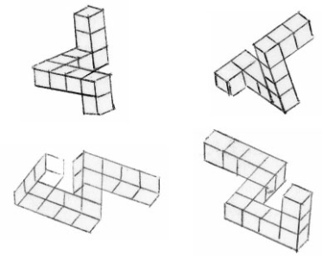
- “objects are not directly or structurally represented in the brain”
Evidence for functional equivalence: Mental Rotation
SHEPARD & METZLER (1971)
- Participants were timed on how long it took them to decide whether an object was the same or different
- IV: degree of rotation varied.
- Analog nature of mental images…
- The more people had to rotate, the longer they took.

More Evidence for functional equivalence: Size of Mental Objects
- Perceptual acuity varies with the size of objects in one’s visual field = things look clearer when they are larger, and less clear when they are small.
  - Is this true of mental images?
KOSSLYN (1975)
- Experiment 1: image a rabbit (small) and an elephant (large) together; ask participant for details (ear?) ~ equal knowledge but different sizes.
  - Results… RT rabbit details is longer than RT for elephant details
- Experiment 2: controlled the size of objects by having participants placing the objects into a mental square box
  - “shows that internal visual images are analogous to perception of visual objects”
- Mental imagery ~ visual field = same are real world….
Even more evidence for functional equivalence: Mental Scanning
KOSSLYN (1978)
- Trained participants to image a map of an island and asked them to focus on one object, say in the top right corner.
- Then asked them to scan to a 2nd object and tell when they arrived.
  - Results… scanning time varied with mental distance!
    - Suggests: mental images have spatial properties similar to those in the physical visual world.
    - “images have spatial properties which can be mentally scanned, similar to visual perceptions”

Summary
- Our picture memory is very good.
- Dual-coding
- Dual-coding and individual differences
- Functional equivalence of mental images and physical visual perceptions.
Implications
- Learning/refining motor skills, example, in sports
- Education: there is more than one way to learn, and there are individual differences in the types of ways to learn !

Lecture 2: Comprehension in Written Language
Important Page #’s: ***STILL NEED TO FILL IN***
Basic Processes in Reading
Visual Processing
- Getting words into the system involves translation of written symbols into meaning… and the goal of reading is to understand or to C O M P R E N D.
  - Involves Eye Movements
    - Reading is a series of pauses, called fixations, and jumps, called saccades.
      - Fixation ~ 250ms (80% of content words)
      - Saccades ~ 10-20ms
  - Why do we have this series of fixations and saccades?
    - For the best resolution, because visual acuity is at its best at the foveated area! We need this to see details, like letters, clearly.
    - Fixate on a letter string; make a saccade, then fixate on the next, and so on. This ends up feeling like a smooth continuous process but its not – we know this from eye tracking studies.
- Evidence 1: Gaze-Contingent Paradigm
RAYNER
  - If we cover (or mask out) the foveated letters such that only the parafoveal (equivalent to the peripherals) can be seen what happens?
    - Reading rate drops from 300-50 words per minute… slow + inaccurate!
  - Concludes… that foveating words is critical to comprehension!
    - Special fast eye trackers set up to blank out an area being foveated on, as their eyes move, new areas would be blanked out!
- Evidence 2: Skipping Words
CARPENTER & JUST (1983)
  - When we skip a word, it is usually a function word then / and / but / or / a
  - Readers also tend to skip more often with easy text
    - People do not foveaete on every word, they skip connecting function words
    - When material is easy it allows the reader to skip more words and “read faster”
- Evidence 3: During Normal Reading
  - What happens if we change the next word during a saccade?
    - People do not notice the change!
  - Concludes… that very little of the next word is pre-processed
  - We do however, preprocess low level information like size (this is what enables us to skip small function words).
    - This is known from eye tracker studies…

- Evidence 4: Fixations and Reading Skill
  - When you compare fixation patterns of high skill vs. low skill readers, they differ!
- There are different patterns of reading depending on skill
    - LOW skill patterns show more fixations, backtracking and longer fixations per word. basically a less systematic pattern
    - HIGH skill patterns show shorter fixations
good at word processing
- Word processing is more efficient for a high skill reader than low.
Visual Word Recognition
- Definition: “Encoding of words (letter strings) and activation of their corresponding orthographic, phonologic, and semantic representation”
  - Typical Tasks aka. PROBES TO PROCESS
    - Eye tracking – data as dependent measure
    - Lexical decision – making a judgement about the “lexicality” of a letter string (Is ____ a word? RT or Accuracy as measures.
    - Naming – present a letter string and name it; RT as measure.
- How to model word recognition?
  - Center the model around robust “marker” effects” and then build around these effects
    - Where do you start? The one independent variable that gives you BIG impact.
    - Marker Effect:
      - Word frequency; common vs. less common words… this affects…
- Fixation time spend less time on common words, they are encoded and recognized quicker.
- Lexical decision tasks easier if words are common
- Naming time faster to name more common words
  - 1967: book of norms for frequency of words, the / a / and = extremely common, stupendous = rare!
Uncommon “serendipity,” harder to activate.
Common “house,” more easily activated.
- MORTON’S (1969) LOGOGEN MODEL
-fixate, words come in
Encoding
Resting level
-task response
-word origin sys.
Output
Logogen System

- More from MORTON’S LOGOGEN MODEL
  - Logogen;
    - 1 per known word, orthographic and phonological attributes of each word, a representation of a word.
    - Have different resting activation levels… but this is NOT why common words are recognized in this model.
    - “information accumulator”
    - Threshold – energy has to exceed this to activate… so uncommon words take more activation and longer, to exceed threshold.
  - Frequency Effect ?
    - Threshold is lower for common words…
  - Context (Priming) Effects
    - Doctor-nurse vs. tree-nurse
                - Spread of activation to related words from Logogen system to context system
Context System
Logogen System
Encoding
Output
                - This feedback raises the resting activation level NOT the threshold***
              - We need to account for priming effects; recognition is faster if the word preceeding it is semantically related, SO one system is affected by meaning!
1st time
              - Semantic information affects this!
  - Repetition Effects
    - Visual/visual presentation
      - House-house
      - Recognition is faster the 2nd time… this is because the resting activation level is taking time to return back to baseline
2nd time
    - Auditory/visual presentation
      - /house/ and house
      - No repetition effect!... but according to the MORTON model; visual/phonological representation of words are in their logogens together – this model needs to be expanded.
- Expanded MORTON model
- There is no backward feedback into opposite lexicon within the logogen system.
Context System
Logogen System
Phonological Lexicon
Orthographic Lexicon
Output
Encoding

- A role for phonological (speech) coding during reading
- EDFELT (1960)
        - EMG (electromyography) during “silent” reading
          - *movement in the throat*
          - Used more when text is difficult
        - EMG (easy text) < EMG (hard text)
- MEYER, SCHVANEVELDT & RUDDY (1974)
        - Sound priming occurs, example: bribe/tribe
        - Visual priming DOES NOT occur, example: couch/touch
- RUBENSTEIN, LEWIS & RUBENSTEIN (1971)
        - Ran a study that used pseudo homophones and non-words
          - Pseudo homophones: non-words that sounds like another word
            - Brane --- “brain”
            - Froot --- “fruit”
            - Phocks --- “fox”
          - Non-words: can be sounded out
            - Brone
            - Freet
            - Snocks
        - Naming Task: RT (brane) < RT (brate) … Sound benefits performance; name time is faster for non-words that sound like real words.
        - Lexical Decision Task: RT (brane) < RT (brate)… Sound interferes performance; time to decide a pseudo homophones are longer!
        - CONCLUDED: phonology is being accessed automatically.

Why are speech codes available during reading?
- To keep information active in working memory to facilitate understanding.
- To derive meaning of individual words (ambiguity)
- To pull meaning out of sentences
- **phonological loop uses acoustic verbal linguistic code in short term memory**
      - Letter strings need context to understanding meaning

  - How do we name non-words?

DUAL ROUTE MODEL!
LEXICAL ROUTE
NON LEXICAL ROUTE
Phonological Lexicon
Orthographic Lexicon
Context System
Output
Encoding
Grapheme to Phoneme
Logogen System

Grapheme to phoneme conversion route dissects graphemes 1st.

- Grapheme: combinations of letters
- Phoneme: letter sounds

  - Other factors affecting word recognition
    - Recall: using additive factors logic, Sternburg… set size and degraded stimulus.
      - Stimulus Quality (SQ) – if degraded, longer RT’s result in Lexical Decision Time and Naming Tasks.
      - SQ and Frequency (F) – use additive factors logic to determine center of stimulus quality effects.
clear
degraded
LF
HF
RT
            - Therefore; separate stages are involved!
            - SQ if additive with F then they are in separate stages.
            - Therefore; same stages!
            - SQ if interacting with F then they are in the same stage
clear
degraded
LF
HF
RT

\\\
- According to dual route, Horse Race Model.
  - High frequency word goes through lexical route so quickly it doesn’t make it through the non-lexical in time to influence output
  - Low frequency; if regular, both routes will give you same answer; if irregular, both routes give different answers.
  - FAST HORSE
  - SLOW HORSE
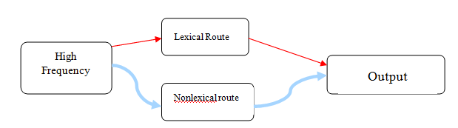
      - Regularity and Frequency – when spellings map onto the same sounds words are regular, when they do not, they are irregular.
        - Examples: Regular (mint, hint, tint) Irregular (pint)
Naming time
HF LF
Reg
Irr
                - Regularity interacts with frequency, and
therefore must occur in the same stage!

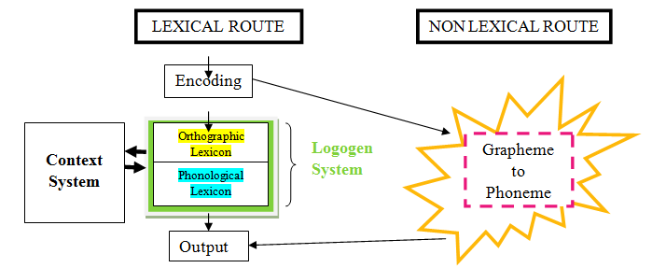
DUAL ROUTE EXPLANATION OF REGULARITY INTERACTION

Lexical Route | Non Lexical Route
Sensitive to frequency | Not sensitive to frequency
Not sensitive to regularity – stores regular and irregular words the same way | Sensitive to regularity – uses phoneme rules and takes irregular words and makes them regular
- Correct phonological code for regular and irregular words | - Correct code for regular words, and incorrect code for irregular words.

Learning to read: the whole-word vs. phonics debate!
MCCANDLISS & SCHNEIDER (1997)
- Trained people on a novel script with a made up language
  - Set of “logographic-looking words” containing a hidden alphabetic system
- In 2 separate groups, trained to read aloud – whole word or phonics
- Debate: how to teach children how to learn words
(1) phonics: “ca” “a” “t” –
(2) whole word “cat” –argued for because English is irregular, and higher skilled readers process at a higher whole-word level.
- Results:
  - Initial Trials… whole word group performed better than the phonics group
  - Later Trials… whole word group performance decreased –they were not able to learn new world because they couldn’t decipher, phonics group performance increased.

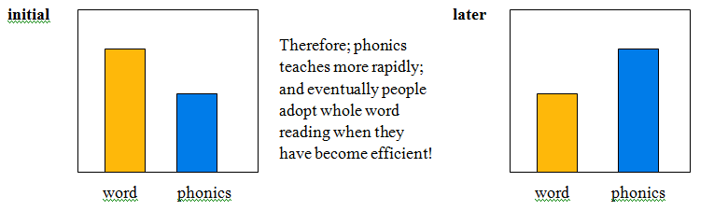
Summary
- Reading involves sophisticated visual processing
- Learning and access of word representations (orthographic, phonological, and semantic)
- Learning of complex rules (GPC)
- Are many sources of individual differences in reading skill, but word recognition ability is requisite to reading. This is the primary source of difference, hard to become a good reader if your recognition system doesn’t work properly.
- Low phonological awareness benefit from whole word program.
☺Good Luck☺

