Abstract

The objective of this experiment was to identify two types of materials by x-ray diffraction. X-Ray powder diffraction analysis is a powerful method by which X-Rays of a known wavelength are passed through a sample to be identified in order to identify the crystal structure. In this experiment the film strips were already premade so it was just the analysis that was done during the lab. For the first film strip it was discovered that it was element was copper and for the second film strip it was potassium chloride. This lab had lots of possible sources of error but it was taken into account when the readings were done because when choosing the possible elements a ±0.05$\dot{A}$ was used. The final results showed that x-ray diffraction process is a very useful tool when an element is unknown and it is trying to be identified.

Introduction

Metals and alloys are usually simple geometric configurations. The three most common unit cell structures are the body centred cubic with atoms at every corner and one in the middle, the face centred cubic with an atom at every corner as well as every face centre, and the close pack hexagonal[1].
Since atoms can’t be seen with powerful microscopes the way to determine the substance and its structure is with X-ray diffraction. Then the X-rays are diffracted through a crystal, which is made up of many particles.
X-ray diffraction can be also described by Bragg’s Law
nλ = 2dsinθ [2]
Where θ is the angle at which diffraction occurs, d is the distance between successive planes of atoms, λ is the wavelength of X-rays, and n is the diffraction order.
The value of d can be found by the Debye-Scherrer powder method. The sample is finely grounded and rotated while the X-ray beam is directed at it. The result of this method is multiple arcs drawn on a photographic film. The number of arcs and the distance between them is a characteristic of the material. Knowing the distance between the diffraction lines we can use Bragg’s Law to find the angle.
S=2θ for direct reflection and S=180-2θ for back reflection. Then once the angle is found Bragg’s Law can be applied to find the distance between successive planes.

The material is identified from the reference index. Find the d closest to the measured d and narrow it down to those that are within 0.05A of the measured d. From there the second d and third until it’s narrowed down to one d. Once there’s only one d the material can be identified.

Apparatus/ Experimental Procedure

The samples of thin films used for the experiment had already been set up by the instructor previously as in figure 1.
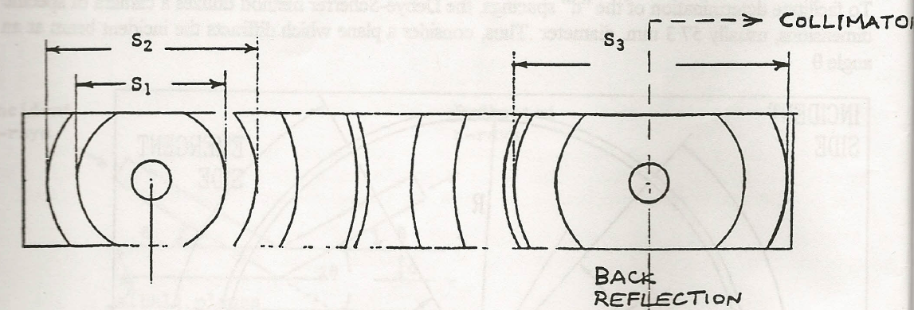
Figure 1

Light was directly displayed through the back collimator slot to identify the first material. The front collimator slit was observed using the camera centering device, with some adjusting of the lenses such that was visible through the front slit, the data of the “d” spacing was recorded as it was observed. Following this procedure, the first piece of thin film was identified. The second piece of unknown thin film material was also identified using this method. The materials used for this experiment were a collimator machine, a meter stick and two pieces of unknown thin film materials.

Results and Discussion

Using the equation: S = $2θ$
(Table 1 data collected from First film)
Intensity level of line | Distance from the center  d  mm | Angle of reflected ray  $$θ$$  $$°$$
Strongest intensity | 44.0 | 22.0°
Middle | 51.0 | 25.5°
Weakest intensity | 74.0 | 37.0°

Using the equation: nλ = 2dsinθ
(Table 2 summary of calculations results for first film)
Arc Number | Distance between planes  D  A° | Range the plane distance could be found between  D  A° | Arc intensity value  %
1 | 2.06 | 2.16-1.96 | 100
2 | 1.79 | 1.89-1.69 | 70.0
3 | 1.28 | 1.18-1.38 | 50.0

Second film
Using the equation: S = $2θ$
(Table 3 data collected from second film)
Intensity level of line | Distance from the center  d  mm | Angle of reflected ray  $$θ$$  $$°$$
Strongest intensity | 29.0 | 14.5°
Middle | 41.0 | 20.5°
Weakest intensity | 67.0 | 33.5°

Using the equation: nλ = 2dsinθ
(Table 4 summary of calculations results for second film)

Arc Number | Distance between planes  D  A° | Range the plane distance could be found between  D  A° | Arc intensity value  %
1 | 3.10 | 3.0-3.2 | 100
2 | 2.20 | 2.1-2.3 | 50.0
3 | 1.79 | 1.89– 1.69 | 20.0

By using the distance between plane and comparing with arc number, a range the for the plane distance and be given. If all plane distance match with a range, then a substance can be identified. For the three films mentioned above, here are the follow identified substances:
Film 1: Copper
Film 2: Potassium Chloride

Questions

5)In order to find angle of diffraction for the set planes by x-rays with given wavelength 0.711 A° and an inter-planar spacing of 1.82 A°, and using first order of diffraction:

nλ = 2dsinθ
sin θ = nλ/2d
θ = sin⁻¹(nλ/2d)
θ = sin⁻¹ [(1*0.711)/(2* 1.82)]
θ = 11.264 °

6) In order to find closet distance between centers of adjacent of sodium in a BC arranged unit cell with edge length of 4.24 A° is as follow: and given distance 2R:

A= 4R*(3)^{-0.5}
4.24= 4R*(3)^{-0.5}
R= 1.83 A°
There distance is twice radius: 3.67 A°

7) In order for a crime investigator in a forensic science laboratory to identify makeup of some material evidence. The investigator also suspects the material to be a mixture of two substances.

i) The first step would be to photograph the material used into photographic film in a dark room.

ii) Place the film on a light source to identify the arcs.

s6 s4 s2 s1 s3 s4 Figure 1

With the film six different arcs are displayed and using the formula shown on the appendix, the unidentified substance can be identified.

Conclusion
The objective of this lab was to study film strips and identify the element or compound that was represented by each film based on its strips “d” spacing’s. Through the usage of x-ray diffraction, with the implementation of the Debye-Scherrer method and Bragg’s law one is able to identify corresponding materials precisely. Although this process isn’t without its complexities, due to some materials having very similar “d” spaces, the relative intensities of the arcs on the strip, help to distinguish each material more clearly.
The results obtained from lab show that the material observed on the first film strip was copper. This element had “d” spacing’s of 2.06, 1.79, and 1.28 angstrom units on its first, second and third arcs.
Results obtained from the second film strip show that the material being represented on the strip was potassium chloride. This compound had “d” spacing’s of 3.1, 2.2, and 1.79 angstrom units on its first, second and third arcs. The identification of potassium chloride was rather difficult because its angstrom units for “d” spacing’s were so close to other materials’ spacing’s. In certain cases such as potassium chloride, it is very significant to consider the relative intensities of each arc, as they can be the determining factor in identifying the correct material.
A materials specific characteristics such as the distance between planes of atoms (the “d” values) provides an important fundamental concept in understanding materials. These natural observances allows for the identification of substances which has helped developed usage and manipulation of materials for beneficial factors. The use of x-ray diffraction to recognize materials is a powerful procedure, which extend beyond this lab into many applicable real life situations. One career example would be a crime investigator who could use this method to determine the type of substance used in crime, eventually helping to solve the case.
The intensities of the fringe line were qualitative values and this created a large source of error. They qualitative values of intensity made it very difficult to compare to the calculated values. The film strips which had smudges and faded lines were not in good condition which contributed to the source of error. Another error possibility was in measurement because during this process the film strips were not perfectly straight and aligned with the measuring apparatus. An error may also have occurred during the x-ray diffraction process, such as light exposure. To reduce these errors in future new samples should be taken and the film sample should be properly aligned during measurement. Overall the lab was a success in trying to identify elements using x-ray diffraction.

References

[1] MTL200 Lab Manual
[2] MTL200 Lab Manual

MTL200 Lab Report No. 3

Identification of Materials by X-ray Diffraction

Program: Civil Engineering
Lab Group 4.1
Lab Date: February 9, 2010
Due Date: March 2, 2010
Prepared for: Dr. H. Boughaeraer

Names | Student ID | Signature
Darren Bynoe | 282467
Lauren Dawe | 328103
Justin Fiorini | 329138
Jason Hanna | 331462
Usama Hussein | 352540
Karim Meleka | 321178

