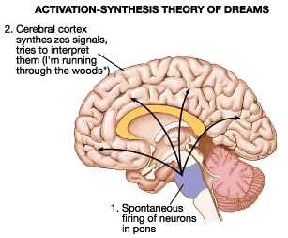
What We Dream About?

J. Allan Hobson: Activation-Synthesis Theory
- The cortex is bombarded with signals from the brainstem, producing the pattern of waking EEG
- In response, the cortex generates images, actions and emotions from personal memory stores
- Dreams are personal, but they have no meaning

Dreams as Meaningless Brain Activity (Activation-Synthesis theory)
p.463
Activation-Synthesis Theory - J. Allan Hobson
The theory suggests that, during a dream:
- The cortex is bombarded by signals from the brain stem these signals produce the pattern of waking (or activated) EEP.
- In response to the excitation the cortex generates images, actions and emotions from personal memory stores.
- In absence of external verification:
  - these dream vents are fragmented and bizarre
  - and reveal nothing more than that the cortex has been activated.

Hobson also proposed that:
- On the basis of PET-imaging results, That part of the frontal cortex is less active in dreaming than in waking on the basis of PET-imagine results.
- Dreams are personal (in that memories and experiences are activated), but they have no meaning.
- The dreamer may attempt to create a story line (a meaning) for the fragmented, meaningless dreams after the fact.

The frontal cortex controls:
- working memory
- memory for events that have just happened, and
- attention

What We Dream About?
Annttio Revonsuo: Evolutionary Hypothesis
  - Dreams are highly organized and biased toward threatening images
  - Dreams are biologically important because they lead to enhanced performance in dealing with threatening life events (adaptive function)
  - Dreams are a coping strategy

Dreams as a coping strategy (Evolutionary Hypothesis)

p.463
Evolutionary Hypothesis: Annttio Revonsuo:
Revonsuo agrees with Hobson about the content of the dreams, however, he uses content analysis to argue that dreams are biologically adaptive (they lead to enhanced coping strategies in dealing with threatening life events).

The evolutionary aspect of the (coping hypothesis) is:
- Enhanced performance is especially important for people whose environment typically includes dangerous events that constitute extreme threats to reproductive success.
- Dreams are highly organized and are significantly biased toward threatening images. (people seldom dream about reading, writing and calculating even though they may occupy much of our day).
- Dream threats are the same events that are threatening in waking life:
  - E.g. animals and strange men that are considered as “enemies”
  - Dream content incorporates the current emotional problems of the dreamer and leads to improvements in and adjustments to life problems.
- Recurrent dreams and nightmares:
  - generally begins in childhood, when a person is most vulnerable.
  - Are associated with: anxiety, threats and pursuit
  - Dreamer usually watching, hiding or running away
  - The experience of dealing with threats in dreams is adaptive, because it can be applied to dealing with real-life threats.

Review:
Activation Synthesis Hypothesis: suggests that dreams are simply a by-product of the brain’s activity, and so have no meaning
while, the Coping Hypothesis suggests that: dreams help people to work out solutions to threatening problems and events

What does sleep accomplish?

What does sleep accomplish?
Early explanation: sleep is a passive process that takes place as a result of a decrease in sensory stimulation
- Does not account for the complexity of sleep
- No direct evidence
  - Sensory deprivation research has shown that people actually sleep less, not more, when placed in isolated environments (contrary to what one would expect)

- What does Sleep Accomplish? Sleep as a Passive Process

Early explanation: sleep is a passive process that takes place as a result of decrease in sensory stimulation.
  - as evening approaches, there are fewer stimuli to maintain alertness, so sleep sets in.
- This theory (sleep as a passive process) does not account for the complexity of sleep:

The theory hypothesis that “when participants are deprived of all stimulation, they will go to sleep”. However, there is no direct experimental evidence that proves this hypothesis is true.
  - Sensory deprivation research has shown that people actually sleep less, not more, when placed in isolated environments (contrary to what one would expect).
- The passive-process theory of sleep originally did not consider biological rhythms as a contributing factor.
  - The activities in which we engage before we sleep and after we wake up can become Zeitgebers by being associated with light-dart changes
    - Therefore, exposure to darkness and quiet in the evening and to light and other kids of stimulation in the morning is one way to synchronizing biological rhythms.

- What does Sleep Accomplish? Sleep as a Biological Adaptation

- Sleep is a biologically adaptive behaviour
  - it is influenced by the many ways in which a species adapts to its environment.
- Sleep is an energy-conserving strategy to cope with times when food is scares
  - Animal species gather food at optimal times, and conserve energy the rest of the time.
  - If the nutrient value of the food that a species eats is high, the species can spend less time foraging and more time sleeping.
- An animal's behavior is influenced by whether the species is predator or prey.
  - The predator can sleep at its ease;
  - the prey's sleep time is reduced because it must remain alert and ready to fight or flee at unpredictable times
- An animal that is strictly nocturnal or diurnal is likely to sleep when it cannot travel easily. (example: humans can’t see well at night).

Sleep patterns of most animal species are consistent with the adaptive explanation.
- Herbivores (Donkeys, horses, and cows)
- spend a long time collecting enough food to sustain themselves, which reduces their sleep time.
- Because they are also prey, their sleep time is further reduced as they watch for predators.
- Carnivores: ( Including domestic cats and dogs)
- eat nutrient-rich foods and usually consume most of a day's or even a week's food at a single meal.
- Because they do not need to eat constantly and because by resting they can conserve energy, carnivores spend a great deal of time each day sleeping.
- Opossums, which spend much of their time asleep, may have specialized in energy conservation as a survival strategy.
- Humans
- Are average among species in our sleep time,
- which is presumably indicative of an evolutionary pattern in which food gathering was not an overwhelming preoccupation and predation was not a major concern.

Sleep can contribute to energy conservation in a number of ways:
- During sleep: energy is not being expended in moving the body or supporting posture.
- The brain: conserving energy during sleep and especially NREM sleep:
- through switching off the brain during sleep (the brain being a major energy user),
- The drop in body temperature that typically accompanies sleep slows metabolic activity, so it too contributes to energy conservation.

A good explanation of sleep must explain not only sleep but also NREM and REM
sleep.

BRAG: Basic Rest-Activity Cycle

Before the discovery of REM sleep, Kleitman suggested that animals have a basic rest-activity cycle (BRAG) that, for humans, has a period of about 90 minutes

He based his hypothesis on the observation that human infants have frequent feeding periods between which they sleep.
Example: The behavior of adult humans also suggests that activity and rest are organized into temporal packets. School classes, work periods, meal times, coffee breaks, and snack times appear to be divided into intervals of 90 minutes or so.

The later discovery that REM sleep occurs at intervals of about 90 minutes added support to Kleitman's hypothesis, because the REM periods could be considered a continuation into sleep of the 90-minute BRAG cycle. The hypothesis now assumes that periods of eating are periods of high brain activity, just as are periods of REM.

-Kleitman proposed that the BRAG rhythm is so fundamental that it cannot be turned off.
Accordingly in order for a night's sleep to be uninterrupted by periodic waking (and perhaps snacking), the body is paralyzed and only the brain is active.

- What does Sleep Accomplish? Sleep As a Restorative Process

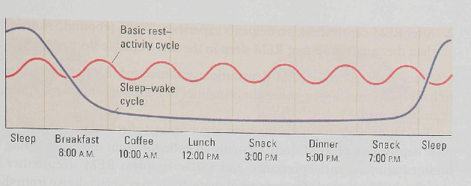
(behavioural rhythms: our behaviour is dominated by basic rest-activity cycle (red), through which our activity levels change in the course of the day and by an nrem-rem sleep cycle (purple) during the night.

Sleep, as a restorative can be understood from a personal perspective: (tired towards end of the day, refreshed when awaken from sleep, and become irritable if we do not get enough sleep)

One hypothesis presumes that chemical events that provide energy to cells are reduced during waking and are replenished during sleep. Nevertheless, fatigue and alertness may simply be aspects of the circadian rhythm and have nothing at all to do with wear and tear on the body or depletion of essential bodily resources.

Sleep-deprivation studies: to evaluate whether sleep is essential for one or another bodily process.
These studies have not clearly identified any function for which sleep is essential.

The case of Randy Gardner: Science project, Dement, 1965
- Dement participated as an observer
- Gardner planned stayed awake for 260 hours (almost 11 days)
- After breaking the record, the student then slept for 14 hours and reported no ill effects. However, one of the observers reported that Gardner had experienced hallucinations and cognitive and memory lapses during deprivation, but these negative effects were not lasting.

A number of sleep-deprivation research reviews are consistent in concluding that:
- Long periods of sleep deprivation do not seem to have adverse physiological consequences, however, it is associated with
  - poor cognitive performance.
  - Decreased performance contributes to accidents at work and on the road.
  - The sleep-deprivation deficit does not manifest itself in an inability to do a task, because sleep-deprived participants can perform even very complex tasks.
  - Rather, the deficit is revealed when sustained attention is required and when a task is repetitive or boring.
- Short periods of sleep deprivation (amounting to the loss of a few hours of sleep), can increase errors on tasks requiring sustained attention.

- Microsleeps: A confounding factor in cognitive performance is that sleep-deprived participants will take microsleeps, brief sleeps lasting a few seconds.
  - During microsleep, participants may remain sitting or standing, but their eyelids droop briefly and they become less responsive to external stimuli.

REM sleep deprivation:

- little effect on daytime functioning.
- To deprive a participant of REM sleep, researchers allow participants to sleep but awaken them as they start to go into REM sleep. REM-sleep deprivation has two effects:
- Participants show an increased tendency to go into REM sleep in subsequent sleep sessions, so awakenings must become more and more frequent.
- After REM deprivation, participants experience "REM rebound," showing more than the usual amount of REM sleep in the first available sleep session.

- Some early reports of REM-deprivation studies stated that participants could begin to hallucinate and display other abnormalities in behavior, but these reports have not been confirmed.
- Two kinds of observations, however, argue against effects of prolonged or even complete deprivation of REM sleep.

Virtually all antidepressant drugs, including MAO inhibitors, tricycHc antidepressants, and SSRIs, suppress REM sleep either partly or completely. The clinical effectiveness of these drugs may in fact derive from their REM suppressant effects.
There are no reports of adverse consequences from prolonged REM deprivation as a consequence of treatment with antidepressants.

Lower brainstem damage:
- In a number of reported cases, lower-brainstem damage resulted in a complete loss of REM sleep.
- Some of these people suffered from locked-in syndrome:
  - they were fully conscious, alert, and responsive but quadriplegic and mute.
  - Five of seven patients with locked-in syndrome were reported to have no REM sleep, without apparent ill effects
- Patients with more selective brainstem lesions reportedly remained ambulatory and verbally communicative, but their REM was abolished.
  - They were reported to live quite satisfactorily without REM sleep

- What does Sleep Accomplish? Sleep and Memory Storage.

- sleep plays a role in solidifying and organizing events in memory.

One group of experimenters proposes that events are stored in permanent memory in NREM sleep, whereas another group proposes that REM sleep fulfills this function.

Place cell:
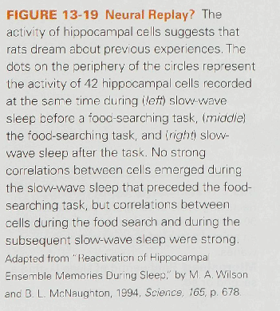
- Gerrard et al. (2008) made use of the finding that many hippocampal cells fire when a rat is in a certain location in an environment.
  - place cells are relatively inactive until the rat passes through a particular place in its environment
    - then they display a high rate of discharge.

- Recordings made from as many as 100 cells at the same time in three conditions, suggest that cell activity is correlated in waking and NREM sleep. The three conditions are:
- during NREM sleep,
- during a food-search task,
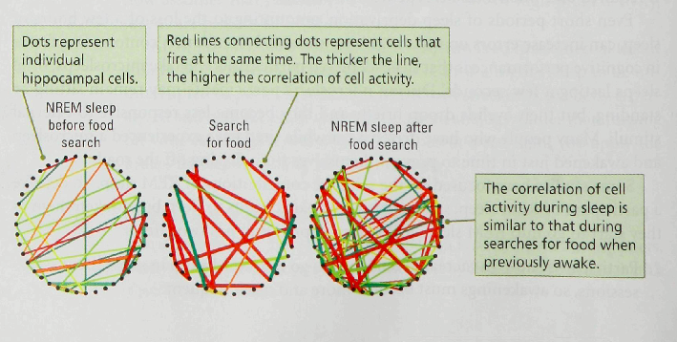
- and during NREM sleep after a food-search session

Result: The result suggests that the memory of the previous food searching experience is stored during NREM sleep.

Sleep and Memory Storage:
Are humans' dreams are related to memory?

Pierre Maquet & workers, (2000)
- his coworkers in Belgium trained participants on a serial reaction task and observed regional blood flow in the brain with PET scans during training and during REM sleep on the subsequent night
- The participants faced a computer screen displaying six positional markers.
- They were to push one of six keys when a corresponding positional marker was illustrated
- They did not know that the sequence in which the positional markers were illuminated was predetermined.
- Consequently, as training progressed, participants indicated that they were learning (because their reaction time improved on trials on which one positional marker was correlated with a preceding marker).

- On the PET-scan measures of brain activation, a similar pattern of neocortical activation was found during task acquisition and during REM sleep (Figure below).
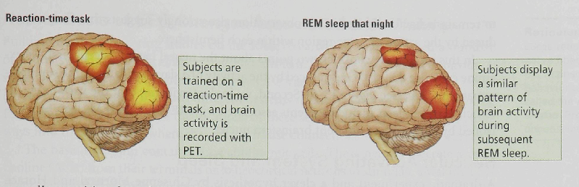
- On the basis of this result, Maquet and coworkers suggest:
first, that the participants were dreaming about their learning experience,
second, that the replay during REM strengthened the memory of the task.

Other findings:
1. Among more interesting speculations is a proposal that elaborate memories are formed during sleep and then pruned to more useful dimensions during waking.
2. Another suggestion is that only certain events are likely to be consolidated during sleep and that these may become associated with unrelated events, thus risking creating a false or distorted memory of an event.

REVIEW: What Does Sleep Accomplish?
• Among the explanations put forward for why we sleep, the biological explanation—that sleep is an adaptive strategy for conserving energy during times when food resources are hard to obtain—has replaced the passive explanation— that sleep results from lack of sensory stimulation.
• Sleep may also be a restorative process and may have a role in storing and sorting memory.

Neural Bases of Sleep

- A popular idea about sleep:
  - The idea that the brain contains a sleep-inducing substance has long been popular
  - This idea is reinforced by knowledge that a variety of chemical agents induce sleep.
    - Such as sedative hypnotics and morphine.
- A twist on this idea held that:
  - The body secretes a chemical that induces sleep and that can be removed only by sleeping.
  - The hormone melatonin, (secreted from the pineal gland during the dark phase of the light-dark cycle, causes sleepiness, and is taken as an aid for sleep, so it might be thought to be the sleep-producing substance.

Sleep, however, survives the removal of the pineal gland. Thus, melatonin and many other chemical substances may only contribute to sleep, not cause it.

In fact, experimenters have obtained evidence that sleep is not produced by a compound circulating in the bloodstream.
- When dolphins and birds sleep, only one brain hemisphere sleeps at a time.
  - This ability presumably allows an animal's other hemisphere to remain behaviorally alert.
This observation also strongly suggests that sleep is produced by the action of some region within each hemisphere.

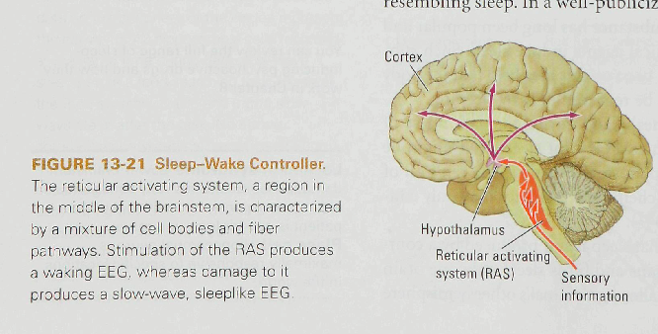
Two points about the neural basis of sleep:
First: examine the evidence that sleep is produced by the activity of a slave oscillator of the suprachiasmatic nucleus (see Figure on the right).

Second: various events associated with sleep, including events associated with REM and NREM sleep, are controlled by a number of different brainstem nuclei.

Reticular Activating System and Sleep (RAS)
RAS is a large reticulum (mixture of cell nuclei and nerve fivers) that runs through the center of the brainstem. Group of deep brain neucli.

Associated with sleep wake behavior and behavioral arousal

Stimulation of the RAS produces a waking EEG,
Damaging to it produces slow-wave EEG
We conclude that - normal RAS leads to desynchronized EEG

Moruzzi and Magoun hypothesis: Which areas of the brain regulate sleep?

They were recording cortical EEG from anesthetized cats while electrically stimulating the cats' brainstems.
Brainstem: an area that is composed of a mixture of cell nuclei and nerve fibers that form a reticulum.

They discovered that, in response to the electrical stimulation:

- The large, slow cortical EEG typically produced by anesthesia was dramatically replaced by the low-voltage, fast-wave EEG typical of waking.’

- The waking pattern of EEG activity outlasted the period of stimulation, demonstrating that the pattern was produced by the activity of neurons in the region of the stimulating electrode.

- During the "waking period," the cat did not become behaviorally aroused, because it was anesthetized, but its cortical EEG appeared to indicate that it was awake.

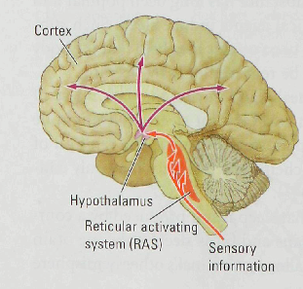
- Findings from subsequent experiments by Moruzzi and Magoun and by others show that: a waking EEG can be induced from a large area running through the center of the brainstem.

- They named this brainstem area the reticular activating system (RAS) and proposed that it is responsible for sleep-waking behavior.

To explain why do people wake up if someone disturbs them when they are asleep. Moruzzi and Magoun proposed that:
- Sensory pathways entering the brainstem have collateral axons that synapse with neurons in the RAS.
- Sensory stimulation is conveyed to RAS neurons by these collaterals,
- and then RAS neurons produce the desynchronized EEG via axons that project to the cortex.

* Neurons, NOT sensory-pathway stimulation produced the waking EEG.

- When experimenters cut the brainstem just behind the RAS, thereby severing incoming sensory pathways, RAS stimulation still produced a desynchronized EEG.

- The brainstem damage can result in coma, because it plays a role in waking behavior (a coma is a prolonged state of deep unconsciousness resembling sleep).

Neural Basis of EEG Changes Associated with Waking

- Two brainstem systems influence waking:
Basal Forebrain, and
Median Raphe Nucleus (Midbrain).
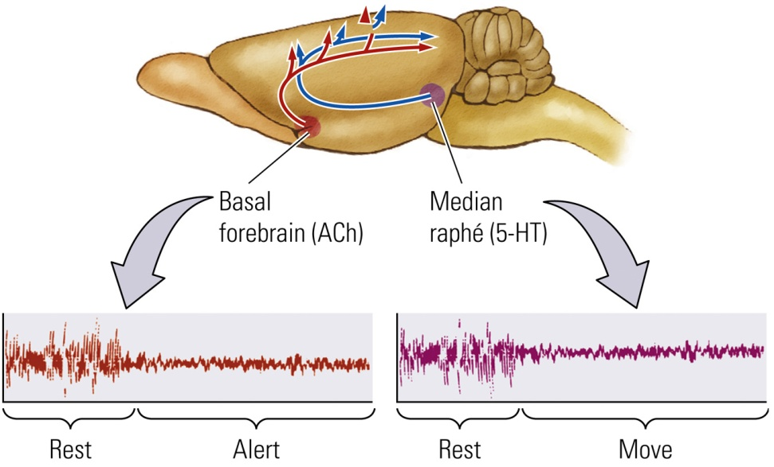

Basal Forebrain
    - Contains large cholinergic cells that secrete acetylcholine (ACh) from their terminals onto neocortical neurons that stimulate a waking EEG (beta) rhythm.
    - Animal is `still, but alert`

Median Raphe Nucleus (midbrain structure)
    - Contains serotonin (5-HT) neurons that project diffusely to the neocortex; also stimulate beta rhythms (recorded as waking EEG)
    - Animal is alert and moving

- Both (Basal forebrain and midbrain) send neural pathways into the neocortex, where they make diffuse connections with cortical neurons.

- Although both pathways produce a very similar pattern of waking EEG activity, the relations of the two types of waking EEG to behavior are different.

- If the activity of the cholinergic projection is blocked by drugs or by lesions to the cells of the basal forebrain, the waking EEG normally recorded from an immobile rat is replaced by EEG activity resembling that of NREM sleep.

- If the rat walks or is otherwise active, a waking EEG is obtained from the neocortex.

- If both structures are pharmacologically or surgically destroyed, a rat can still stand and walk around. Its neocortical EEG, however, resembles that of a sleeping animal.
These findings suggest that the cholinergic EEG is responsible for the waking associated with being still yet alert, whereas the serotonergic activation is additionally responsible for the waking EEG when the animal moves.

  - Neither the basal forebrain system nor the median raphe system is responsible for behavior.
The cortex is like a house in which the lights are powered by two separate power sources:
both must fail for the house to be left in darkness, but, if at least one source is operating,
the lights can be on

  - As long as one of the activating systems is producing a waking EEG, rats can learn simple tasks.

  - If both systems are destroyed, however, an animal, although still able to walk around, is no longer able to learn or display intelligent behavior.

when we are alert, the cholinergic neurons are likely to be active, and when we move, the serotonin neurons are likely to be additionally active.

Further explanation (example):
- If you feels sleepy in a class or behind the wheel, you can to wake yourself up by moving—shaking your head or stretching.
  - Presumably your arousal level decreased as your cholinergic neurons became inactive.
  - When you moved, your serotonergic neurons became active and restored your level of arousal.
  - When we enter sleep, both cholinergic and serotonergic neurons become less active, allowing slow waves to emanate in the cortex.

Neural Basis of REM Sleep
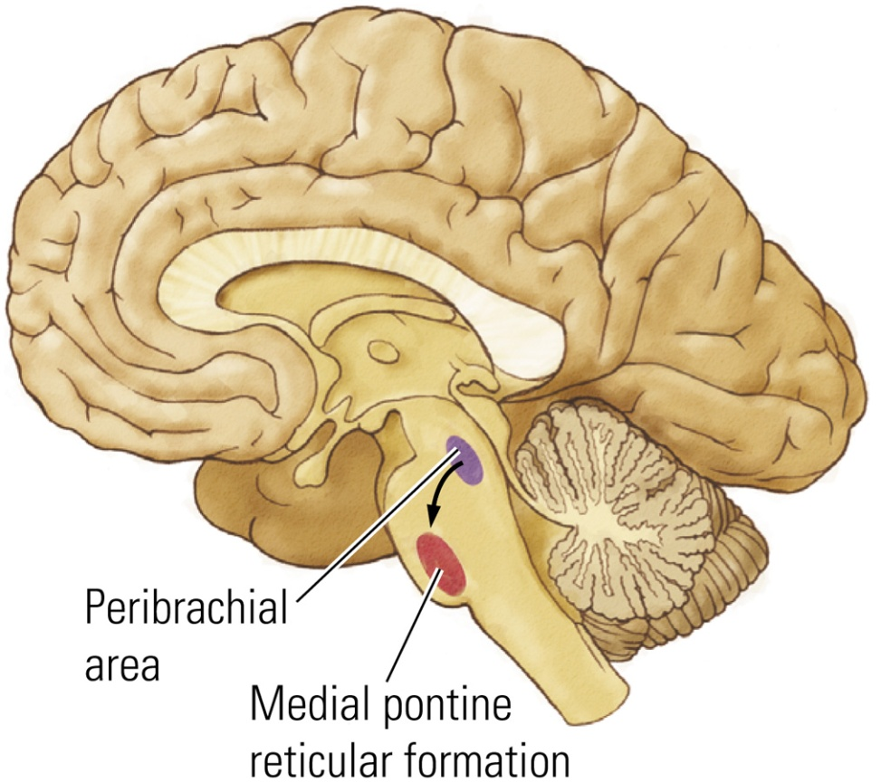
- Peribrachial Area: Cholinergic nucleus in the dorsal brainstem (anterior to the cerebellum) have a role in REM sleep behaviors; projects to the medial pontine reticulum
  - Initiates REM sleep and REM-related behaviors.

- Medial Pontine Reticular Formation (MPRF)
  - Nucleus in the pons participating in REM sleep
  - Projects to several other brain areas that produce REM-related behaviors
    - Example: Produces the atonia of REM sleep
  - Lesions of the MPRF also abolish REM sleep, and injections of cholinergic agonists (drugs that act like ACh) into the MPRF induce REM sleep.

Thus, both the peribrachial area and the MPRF, illustrated take part in producing REM sleep.

How do the below events related to REM sleep take place?
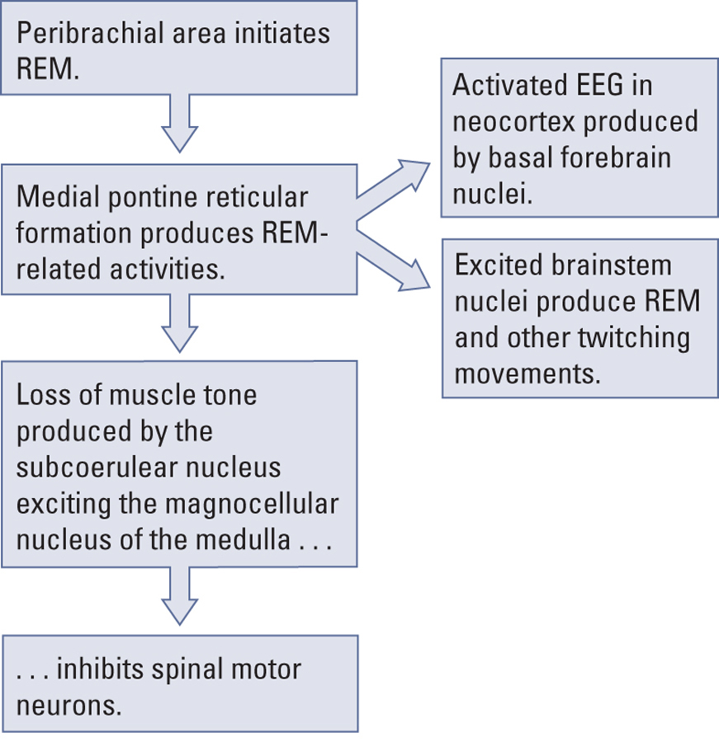
1. EEG pattern similar to waking EEG
2. Rapid eye movements, or REM
3. Atonia, the absence of muscle tone

- The peribrachial area initiates REM sleep and activates the medial pontine reticular fromation.

- The MPRF then sends projections to activate basal forebrain cholinergic neurons, resulting in the activated EEG recorded from the cortex,
- also excites brainstem motor nuclei to produce rapid eye movements and other twitches.

- The atonia of REM sleep is produced by the MPRF through a pathway that sends input to the subcoerulear nucleus, located just behind it.

- Finally, the subcoerulear nucleus excites the magnocellular nucleus of the medulla, which sends projections to the spinal motor neurons to inhibit them so that paralysis is achieved during the REM-sleep period.

Sleep Disorders

(very rare) A genetic condition, fatal famial insomnia causes individuals to stop sleeping altogether, this might contribute to death after a number of months of not sleeping.

Sleep disorders may occur during NREM and REM sleep:

A. Disorders of Non-REM Sleep

- Insomnia (most common)
- Disorder of slow-wave sleep resulting in prolonged inability to sleep
- Multiple causes:
  - 35% of cases are associated with depression and anxiety.
  - Staying up late may set a person’s circadian rhythm forward, encouraging a cascade of late sleep followed by still later staying up.
  - Indoors and outdoors, light pollution disturbs circadian rhythms as well.
  - Shift work, or jet lag, stress, long hours of work, irregular life style, and worrying about Insomnia is a cause as well.

- Drug-Dependency Insomnia
  - Condition resulting from continuous use of “sleeping pills”; drug tolerance also results in deprivation of either REM or NREM sleep, leading the user to increase the drug dosage and become dependent on them, and display rebound insomnia when stop taking them.

- Narcolepsy
Affects 1% of the population and is distinguished from abnormal tiredness by its frequency and tendency to disrupt normal daily activates. One cause of narcolepsy is sleep apnea.
  - Slow-wave sleep disorder in which a person uncontrollably falls asleep at inappropriate times
  - May be due to mutations in the gene that produces hypocretin/orexin peptides

Sleep Apnea: Inability to breathe during sleep; person has to wake up to breathe.

B. Disorders of Non-REM Sleep

- Sleep Paralysis
  - Inability to move during deep sleep owing to the brain’s inhibition of motor neurons
- Cataplexy
  - A rare form of narcolepsy linked to strong emotional stimulation in which an animal loses all muscle activity or tone, as if in REM sleep, while awake often during times of high emotional arousal.
  - During a Cataplexy episode, an individual might experience hypnogogic hallucinations that are thought to result from stimulation of brain mechanisms normally activated during dreams.

Hypnogogic Hallucination
  - Dreamlike event at the beginning of sleep or while a person is in a state of cataplexy
In contrast to sleep paralysis, REM without atonia, is a condition in which individuals do not undergo paralysis during REM sleep, and can result in complex movements, often resulting in the person acting out the dream.

Both Cataplexy and narcolepsy can be treated with amphetamines, where REAM without atonia is treated with benzodiazepines that block REM sleep.

What Does Sleep Tell Us about Consciousness?

- Consciousness is not a unitary condition, but rather, there are “states of consciousness”
- Studying sleep may also help us to understand some psychiatric and drug-induced conditions
  - Example: Are hallucinations related to dream events that occur during REM sleep?

