Introductory Lecture. What in the World is Going on with the World? Introducing the Course
GEOG 2200, Global Connections, Fall Semester 2012
John Milton, Instructor

How are we connected?
- In what ways are we connected?
- How are these connections made possible?

This course is about making connections:
- between different aspects of human activities us next door to us and on the ‘other’ side of the world;
- between the changes and challenges being felt at different places defined at different geographic scales; and
- between conditions in the past, the present and the future.

Introducing the Course

Deliverables for this course include:
- A series of weekly on-line quizzes based upon the lectures and assigned readings for that week;
- Two assignments; and
- A Final Examination.

What is the most important issue today in your opinion?
Jobs -- Energy -- Financial crisis -- Terrorism/security -- Climate change -- Health care: The list goes on and on.

We live in a world of increasing interdependence in which the economic and social well-being of countries, regions and cities everywhere depend on increasingly complex interactions framed at the global scale.
- How might we understand both the general economic forces and socioeconomic relationships that connect specific places, or the local, and its unique features?

Oil as an Example
Let’s take energy and more specifically oil, as an example here. What impacts on the price of oil and, as an extension of this, gas?
- Hurricanes in the Gulf. Terrorism in the Middle East and its impact on the security of supply from that crucial region. A strike at a refinery in the US. The promise of the oil sands in Alberta. Higher demand in China and India. Issues associated with energy, and oil, impacts upon us in many ways. As events unfold it is becoming increasingly clear how fragile our society is, based upon oil.
- To make a more general observation: behind every commodity, good or service, is a complex geography that links different people and places together.

Looking for the Hidden Story

Ultimately, this is the purpose of this course. I want you:
- to think critically about the dynamics and sets of relations behind the things that we buy or consume in some other way;
- to think critically about the complex histories that connect the present both to the past and the future;
- to think critically about the idea of global connections from the perspective of your field of study, your discipline; and
- when I say critically, I mean to question and challenge what you have been told is the status quo, or the way things are.

Approaching Questions of global Connection – Research and Thought
Geographers introduce three spatial concepts to the study of any question:
- Space
- Place
- Scale

In much of the research and thought of economic and development geographers focuses on three key forces:
- Globalization;
- Uneven development; and
- The role of place.

Theme 1: Globalization and connections across space
What do we mean by globalization? [p.315*]
- Globalization refers to “the growing connections and linkages between people and firms located in different places, manifested in increased flows of goods, services, money, information and people across national and continental borders” (MacKinnon and Cumbers 2007:2).
- This has been facilitated by advances in information/communications technology and advances in transportation.
- Some have argued that globalization is bringing about ‘the end of geography.’ Thomas Friedmann in 2005 argued that new technologies are creating an undifferentiated, or flat, world.

Geographers beg to differ with Friedmann.
- De Blij, as you will read for next week, rejects this idea.
- Globalization is creating the opposite effect, resulting in different outcomes in different places. Today’s world is characterized by huge inequalities in wealth and other social and cultural variables that go into our ‘quality of life.’
- Processes of globalization have also triggered a counter-force of sorts, termed ‘glocalisation’ or the re-emergence of localities and their identities.
- These processes operate not only politically but economically too, creating unique regions.

The advances in ICT and transportation technologies have described as ‘space-shrinking’ technologies resulting in what David Harvey in 1989 described as a ‘time-space compression’ as it becomes easier and cheaper to move money and information across space. [p.833]
- This is not an entirely novel process: “a previous ‘round of time-space compression occurred towards the end of the nineteenth-century through interventions such as the railways, steamships, the telegraph and the telephone which allowed goods, information and money to be moved far more rapidly than ever before” (MacKinnon and Cumbers 2007:5).

There has also emerged ever more complex commodity chains that link together the production and supply of raw materials, the processing of these materials, the processing of components, the assembly of finished products, and the distribution, sales and consumption of these products.
- These commodity chains involve a range of different organizations and actors including, as examples, farmers, miners, mining and plantation companies, component suppliers, manufacturers, sub-contractors, transport operators, distributors, retailers, consumers.

Theme 2: Uneven development
Uneven development is an inherent feature of capitalism. [p.867]
- Growth and investment tend to become concentrated in particular locations. This might be due to its geographical position, resource base, the availability of capital, and the skills and capabilities of the local workforce and/or social traits such as security.
- As such a location begins to grow, it tends to such in further capital, labour and resources from surrounding regions.

The processes of uneven development occur at different geographical scales:
- At the global level, there is a marked divergence between the ‘core’ of North America, Western Europe, Japan and the ‘periphery’ of the ‘global South’ of Asia, Latin America and Africa.
- Within individual countries between regions.
- Divides even exist at the local level, within cities (and between cities and the surrounding rural).

Economic development is highly dynamic.
- Circumstances and relationships are constantly shifting due to new technologies and new forms of consumer demands. (Consider, for example, the emergence and then re-defining of industrial districts.)
- Patterns of uneven development periodically restructure as capital moves from one location to another.
- As a result, new growth regions emerge while others stagnate and decline. And again this happens at all three scales.

Theme 3: The importance of place
Yet, while we might operate across space, we exist in place. We act in specific places. The philosopher, Edward Casey, wrote that we are ‘placelings.’ [pp.582-584]
- Uneven development creates an uneven geography.
- Similarly, we associate different regions with different resources.
- While the manufacturing regions might have weakened, new regions have emerged reflecting new economies and industries.
- As the world has increasingly become driven by the “Knowledge Society,” the world has also become increasingly characterized by regions of innovation.

But it would be wrong to see places as homogeneous or clearly bounded areas.
- This was the principle critique of the regional geography of pre-World War II that attempted to organize the world into unique, discrete regions.
- To Doreen Massey, places should be seen as a meeting place, a point where wider social relations and connections come together.
- She argues that it is the suite of social networks and relations that define a place as much as the spatiality of the place. Place can be seen as a process rather than as some static and unchanging essence. AND that place is defined both from within and from without.

Two Theoretical Frameworks
In looking at the nature and dynamics of global connections, I want you to draw upon two theoretical frameworks in this course:
- Political economy; and.
- Actor Network Theory (ANT).

The Framing of Global Connections through Political Economy
Political economy acknowledges that economic activity cannot be separated from political, social and cultural dimensions of a society.
- These are all bound together in a Gregorian Knot.
- Inspired by the cultural turn of postmodernism, some geographers have sought to adapt their interests, methods and approaches to include notions of difference, identity and language.
- They have focused on links between economy and culture arguing that the economy has increasingly become cultural. At the same time, culture has become increasingly economic – viewed as a set of commodities that can be bought and sold in the market.
- Economic action is always embedded (grounded) in social relations.

Untangling Global Connections through Actor Network Theory
Actor Network Theory provides us with a different way of understanding the world.
- Nigel Thrift writes that ANT studies ‘heterogeneous engineering’: “heterogeneous because it is concerned with a vision of the world as a multiplicity of different connections; and engineering because it sees these connections as fabricated out of a diverse range of materials.”
- Actor networks include not only people as actors but technologies and non-humans as well. How does technology change the way you do things?
- ANT argues that institutions in a society emerge out of these networks.

An example of ANT: The Emergence of Portugal as a Dominant Maritime Power in the early 16th Century
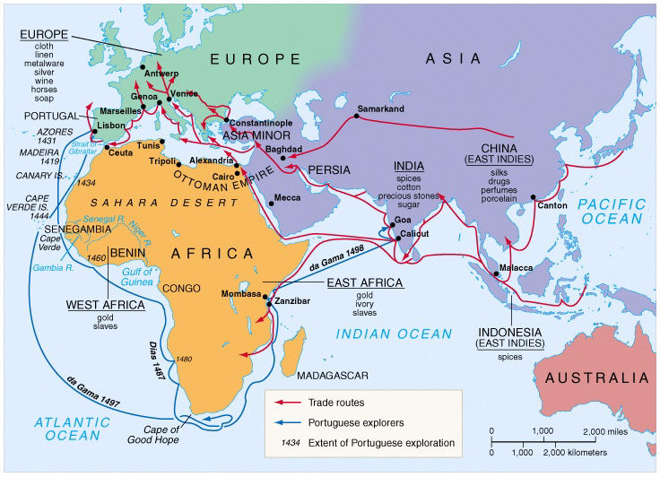
Figure 1. Spice Trade Routes and the Portuguese Solution to the Monopoly of Arab Traders

In 1492, Columbus (re)-discovered the Americas. In 1498, da Gama round the Cape of Good Hope and entered the Indian Ocean. And, in 1509 Viceroy Francisco de Almeida defeated the combined fleets of the Gujarati and Egyptians at Dui, the Gujarati coastal city on the Indian Ocean, seizing control of the spice trade for Portugal from the Arab traders.
- To John Law, the explanation of this success was in the creation of a new set of human skills, knowledge and technologies that enabled the Portuguese to exert long-distance control of the spice trade.
- See: Law, J. 1986. On the Methods of Long Distance Control: Vessels, Navigation, and the Portuguese Route to India. In: John Law (ed), Power, Action and Belief: A New Sociology of Knowledge? Sociological Review Monograph 32, Routledge, Henley, 1986, pages 234-263.

Law argued that three classes of actors, together and separately, made it possible for the Portuguese to seize from the Arab traders the spice trade with India and to retain control over it. These classes of actors were:
- Knowledge (documents);
- Devices; and
- People.

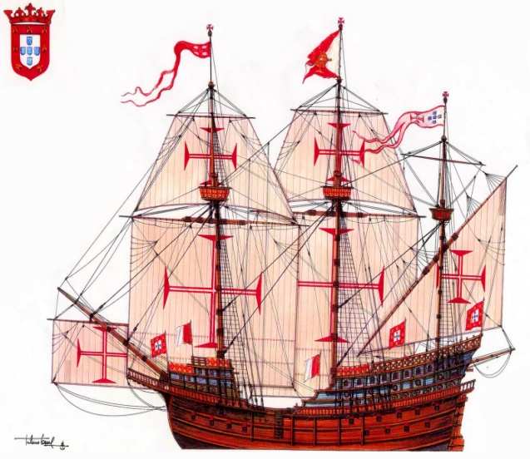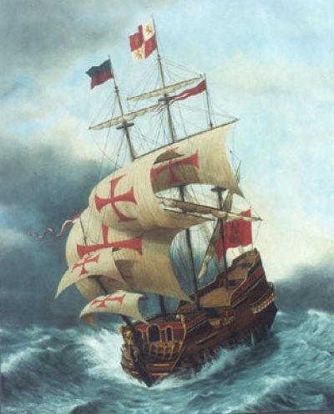
Figure 2: The Carrack.

First, there were the advances in ship building that extended their range (or envelope) beyond the coastal regions of Europe and the Mediterranean Sea.
- In their explorations the Portuguese used a range of vessels, but the most important of these was the Carreira, the carrack. Chaunu (1979:242) described the carrack as the 'perfected transport ship' (Chaunu, 1979:242).
- The hull was broad, heavily built and powerful, made in the carvel manner with large castles, both fore and aft, which formed an integral part of the structure of the hull. The forecastle was topped off by a large pointed platform which projected forward of the bows and was used for raising and lowering anchors. These castles, were used for defence and cabin accommodation.

Along with the advances in ship building was the re-design of its sails.
- Most depictions of these craft show thefts as stepping three or sometimes four masts - a small foremast, often with a square sail, a main mast with a large square sail, sometimes topped by a top mast with a further small square sail, and a mizzen mast usually with the traditional lateen sail.
- If there was a fourth mast this would be a bonaventure mizzen. Sometimes vessels also carried a small spritsail beneath the bow.
- This resulted in a vessel that had both speed and maneuverability under a wide range of conditions.

The features of these vessels that, when taken in context with other aspects of the Portuguese system, generated an envelope of mobility and durability appropriate to the Eastern trade:
  - First, they were virtually impregnable to attack by boarding from small craft – the principal hazard of the Eastern trade.
  - By the standards of the age the carracks carried a great deal of cargo. This not only meant that profitable trade was possible, although this is true. It also meant that they did not have to make frequent stops en route and could steer the most efficient course, one which routinely took them thousands of miles from land. Because of this, they were relatively independent of their surroundings.
  - The combination of square and (triangular) lateen sails characteristic of the carrack and other contemporary vessels marks a successful attempt to obtain versatility in the face of a range of different wind conditions.
  - Since the lateen sails of the carrack were relatively small the size of the crew was correspondingly reduced. This increased the envelope of mobility and durability of the vessels in a variety of ways. They could be sailed with relatively small crews, something that was particularly important given the high degree of mortality on the long voyages of the Carreira da India (Rego 1964:45).

Complimenting the advances in ship design were advances in weaponry, and specifically cannon. The carrack was well armed.

The second set of components in this new complex consisted of nautical knowledge and the tools for easily determining latitude.
- In the fifteenth century their explorations were beginning to take them beyond the charts and rutters of their time. Compass courses and dead reckoning were useful allies in the Mediterranean where it was impossible to get very far from shore and they might be checked against written descriptions of important landmarks en route.
- So they turned their sights to the stars.

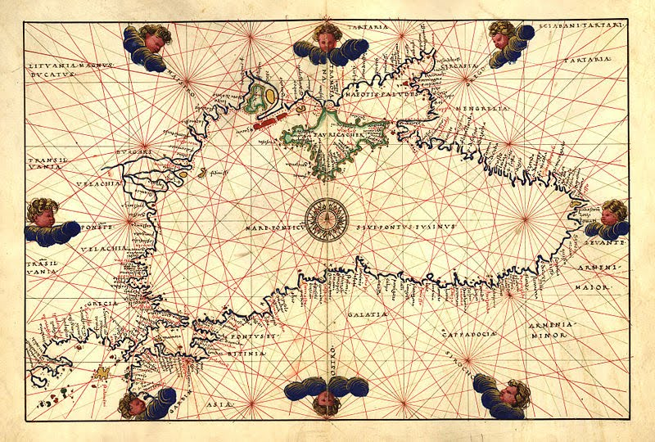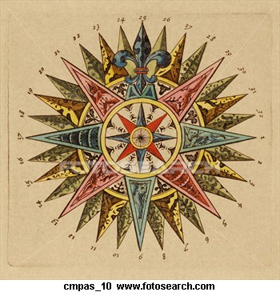
Figure 3. an Example of a Portolan Chart and Rose.

Perhaps as early as the 1460s they started to make systematic observations of the angular altitude of the Pole Star, Stella Maris, above the northern horizon. By the later 1480s their mariners were using not only the Pole Star (which could be used only in the northern hemisphere) but also measuring the Alturas of the Sun and the Southern Cross as an aid to navigation.
- These methods, and the instruments and tables of data used in their practice, though not novel in scientific terms, nevertheless mark a major breakthrough in methods of navigation and the construction of a system within which global mobility and communication might be ensured.
- In 1484 King John II convened a small commission and charged it with the task of finding a method for navigating outside European waters. This became the Regimento do Astrolabio et do Quadrante.

The final collection of actors in this new network were the people themselves, and the navigators specifically.
- A printed copy of the Regimento, dated 1509, exists and it has been suggested that there was an earlier 1495 printed edition, and that handwritten copies would have been prepared in the 1480s for selected pilots.
- Combined with the Regimento were three sets of rules telling the mariner how he should use the instruments and data provided to determine the latitude. The commission came up with simplified rules for navigators to follow. These rules were written on the reasonable assumption that most navigators had little grasp of the principles of astronomy. They were, accordingly, rather literal in nature.
- The simple rules, the simple data and the simple instruments were further supplemented by systematic training, at least from the turn of the sixteenth century.
- The Portuguese set up the Casa de Guinea e India at Lisbon, an office where navigational knowledge was constantly updated and expanded and where pilots were trained.

Together, the advances in ship building and sail configuration, the accumulation and organization of nautical knowledge along with the simplification of the tools used to navigate, and finally, the training of people combined to propel first Portugal and eventually Europe (ultimately France and England) in general into global dominance.

Note: You will come across page citations from time to time in my text. These are page references for topics covered in the Dictionary of Human Geography. I encourage you to read these brief explanations. The page references might differ in the various editions of the Dictionary. Copies of in the library on the second floor (in the Reference Section).

