Week 7 Lecture 2. The Future of Cities: Is there anywhere left to go but up?
GEOG 2200 Fall 2012

Visioning the city of the future
How do we see the city of the future? Movies generally see tomorrow’s city as dark environments with towering high rise structures and vehicles that fly or a self-driven (as frightening thought is that self-parking cars already exist and several companies are testing self-driving vehicles). (See Cities in Science Fiction Films , http://www.youtube.com/watch?v=VG2IGawB9lQ ). Science fiction provides us with a wider spectrum of future cities ranging, also from dystopian visions to utopian ones.

Is the Compact City the City of the Future?
The challenge is to envision new form of architect design and urban planning to response the problems of limited territorial space, super-population, and the horizontal growth of the cities which has too many problems of economic, environment and political sustainability. But it also includes how we understand the nature of our homes, our offices, our urban areas. Where does the ‘private’ space end and the ‘public’ space begin in architectural design and urban planning? Where does ‘human’ space end and ‘nature’s’ space begin (with the risk of perpetuating the human-nature dichotomy)? Architecture and urban planning –ideally – exist at the intersection of the real and the imaginative. Urban planning involves very real technical issues, associated with infrastructure, but it also must consider the social, the living space in which we, people, inhabit.

Urban Design Traditions: Foundations or Distractions?
Let’s take a step back first, before looking at the future. While human settlements throughout history are varied and complex, all have some mix of public space and private space. Public spaces have existed since humans have begun creating settlements, some 10,000 years ago. Public spaces include streets, sidewalks, parks, plazas, squares and public buildings. They are where people gather and interact. This is where the social occurs. These spaces support activities that take place in the civic realm – markets, exchange, defense, pageantry, sports, and for leisure. Public spaces connect people with each other and with activities across the urban landscape. Publicly shared parts of cities and towns connect the private realms and activities that occur in the home with activities that occur outside the home. We move through public spaces to and from private spaces.

The Organic Tradition
Termed as naturalistic, vernacular, indigenous, incremental, romantic, picturesque, the Organic Tradition reflects emerging settlements reflecting their activities and their connections largely according to natural systems (water systems, land contours, arable lands, orientation, climate) without any formal oversight or minimal restrictions. Ancient towns on all continents followed this tradition. Examples globally and in history – Medieval towns; Indian towns (e.g., old town of Mumbai – go to Google Earth; or Old Delhi versus New Delhi), But also first towns of European settlement (Old Boston; Old New York; Old Quebec), frontier towns of western United States; and pueblos all reflect the Organic Tradition. Cities like Boston, New York, Montreal and Quebec – and so many others – found their beginnings in the organic tradition; generally defined by access (in these cases, river highways, ports).

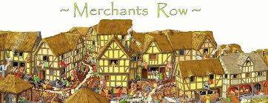Figure 1. The Medieval Town
Figure 2. The Medieval Town of Brugge. 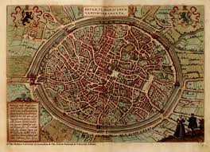

Such urban spaces evolved. There was no real planning. People were effectively left to build their own environment; buildings and their activities shaped the streets and the urban area in general more than the other way around. Houses and shops of various shapes and sizes, using readily available materials, often attached to one another defined the streets and public spaces that connected them, their workplaces and shared civic spaces; as long as access was provided linking private places to the public network there was no particular concern for straightness or standard widths and lengths of street blocks.

Even as the formalist tradition, with its grid of standardized blocks and straight streets took hold of urban design, the organic tradition remained. The emerging cities of industry, became sumps of air and pollution and the quality of urban life deteriorated through the nineteenth century and into the twentieth century. People who could afford too, moved out of the city into the surrounding countryside. While this was once the privilege of the rich, the emerging middle class could now do so. This process was also driven by advances in transportation technology – first rail systems and later the car. In his process, the Organic Tradition found its way from city centres to suburban. One of the earliest examples of this was Olmstead and Vaux’s 1857 Riverside Plan of Chicago; a vision known as “landscape urbanism.” The Riverside Plan created a neighbourhood of tree-lined winding streets and an undulating topography out of a treeless plain. This was to become the model of later sub-urbanization even to this day.
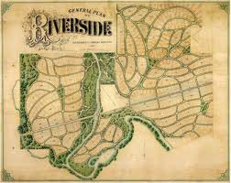Figure 3. Olmstead and Vaux’s 1857 Riverside Plan of Chicago.

The Formal Tradition
The Formal Tradition consists of a collection of planning forms including planned, classical or classicist, grid, monumental, beaux arts, and the City Beautiful Movement but its antecedents can be traced back to ancient Egypt, Greece and Rome, and China. It flowered during the Renaissance and Baroque periods, inspiring the creation of grand spaces and geometric spatial organization. Examples of formalism in the United States include: James Oglethorpe’s Savannah, Georgia; William Penn’s Philadelphia; Pierre L’Enfant’s Washington, DC. It was the form adopted by Boston for Back Bay; and New York City for Manhattan above 14th street [and beyond].
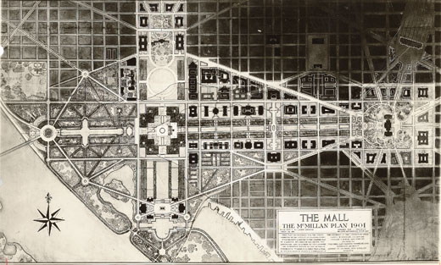
Figure 4. The Mall – A Detail of Pierre L’Enfant’s plan for Washington, DC.
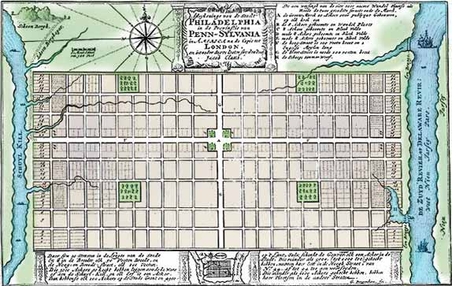Figure 5. William Penn’s Philadelphia.

The Formal Tradition involved the creation of grand spaces and geometric spatial organization. Tradition has a purposeful geometry to it – often an orthogonal/Cartesian grid of hierarchically street systems complimented by sweeping diagonals across existing patterns of land use, as well as the creation of formal parks, squares and plazas. Buildings or monuments deemed of significance or importance to the powers of the specific time often punctuate or terminate the vistas of major, often ceremonial, boulevards – such as churches, triumphal arches, obelisks, parks, courthouses, palaces, capitols or corporate headquarters. It had political overtones to it.

The City Beautiful Movement
The City Beautiful Movement embraced the formal vision. It transformed many city centres both in Europe and North America – Baron Haussmann’s Paris (for Napoleon III); Daniel Burnham and Edward Bennett’s Chicago Plan of 1909. The City Beautiful Movement also sought to incorporate a new technology – the car – into urban design with grand boulevards for cars and pedestrians without overwhelming the rest of the urban structure; in their grandest boulevards, they framed streets with building fronts and created a streetscape of trees, lights, benches and wide enough sidewalks to create balance [Champ d’Elysee].

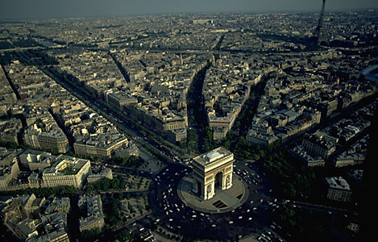Figure 6. Baron Haussmann’s Paris.
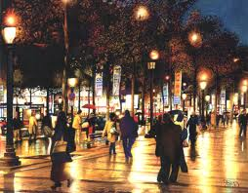Figure 7. Champ d’Elysee.

As this was going on on the larger scale, Clarence Perry was applying the principles of the City Beautiful at the scale of the neighbourhood in the 1920s; drawing upon the rationale designs of Ebenezer Howard’s Garden City, to create the ‘neighbourhood unit” that contained mixed housing types, retail and work places, civic buildings and parks. This was to be the inspiration for the current ideas of new urbanism and smart growth.

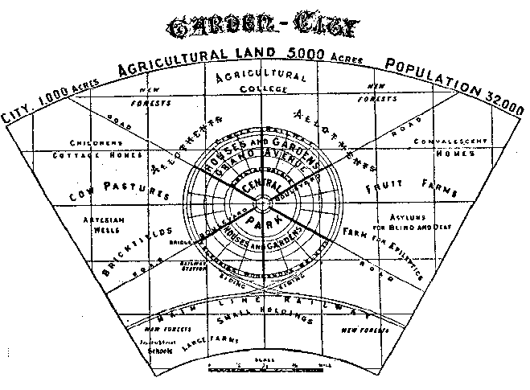Figure 8. The Garden City.
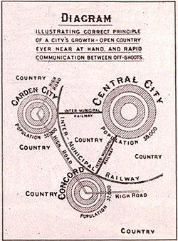Figure 9. The hierarchy of the Garden City.
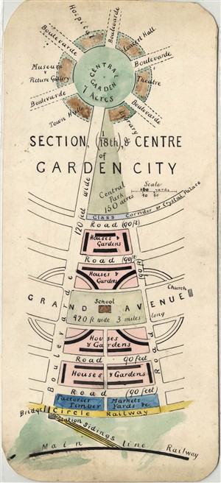Figure 10. Section of the Garden City.

To the Garden Suburb
Howard’s design was first adapted by Raymond Unwin and Barry Parker in Letchworth, England, beginning in 1904 and subsequent New Town projects. The Garden City ideal was subsequently translated into the Garden Suburb, the first expression of this being Clarence Stein and Henry Wright’s Radburn, NJ Plan (1929). The Radburn Plan was to be seen as a model village for the diasporas of suburban development; incorporated, like the Garden City, a blending of mixed housing, workplaces, stores/shops, schools; warped the basic grid design around natural features and interrupt cross-street continuity to create a picturesque, naturalistic setting .

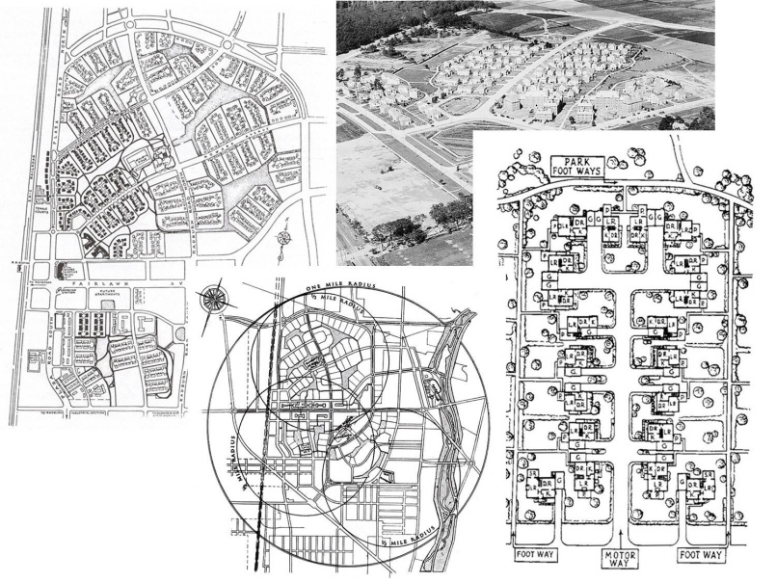Figure 11. Clarence Stein and Henry Wright’s Radburn, NJ Plan
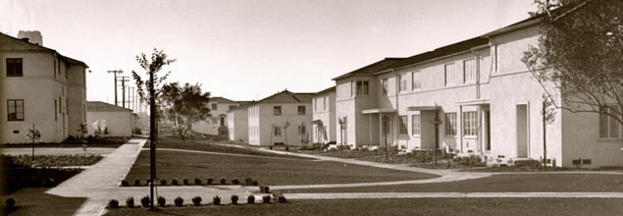
Figure 12. Wynernood – inspired by Radburn.

And to the Garden Neighbourhood
Perry saw the neighbourhood unit as fitting into the larger urban grid and provided for integration of needs and activities necessary to provide a cohesive and definable neighbourhood . While similar to Radburn, the neighbourhood unit was more systematic, almost formulaic – defined the unit by size (about 160 acres or half a square mile), walking distance (about a quarter of a mile), connectivity (using a hierarchy of streets that discourages cut-through traffic) and appropriate levels and locations of shops, schools, park spots and other community facilities. He described how bounding streets should engage the neighbourhood unit and how blocks, streets and sidewalks should be laid out to internally how to accommodate the full range of anticipated neighbourhood activities. He did not disassociate pedestrians from auto travel ways, as was proposed in Radburn Plan, nor did he propose the superblock concept, evident by both Radburn and modernist practice.

And finally to New Urbanism
BUT there has re-emerged under New Urbanism a return to Old Urbanism. Traditional neighbourhood and New Urbanist models proclaim a return to diversity in neighbourhood through the re-discovery of the lost features of Perry’s model. This movement tapped into a desire to live in an environment that allows for diversity, community, civic values, walkability, multi-use and mixed-density patterns that include homes, shops, workplaces. Part of the stimulus for this shift has been the environmental movement and activism of the 1960s inspiring architects and lanners to seek a better balanced way of accommodating a growing population with environmental sustainability.

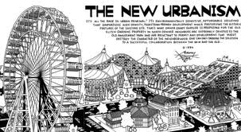Figure 13. New Urbanism

The 10 principles of New Urbanism, as presented in their website (www.newurbanism.com) are:
- Walkability -- Most things within a 10-minute walk of home and work; Pedestrian friendly street design (buildings close to street; porches, windows & doors; tree-lined streets; on street parking; hidden parking lots; garages in rear lane; narrow, slow speed streets); Pedestrian streets free of cars in special cases.

- Connectivity -- Interconnected street grid network disperses traffic & eases walking; A hierarchy of narrow streets, boulevards, and alleys; High quality pedestrian network and public realm makes walking pleasurable.

- Mixed-Use & Diversity -- A mix of shops, offices, apartments, and homes on site. Mixed-use within neighborhoods, within blocks, and within buildings; Diversity of people - of ages, income levels, cultures, and races.

- Mixed Housing -- A range of types, sizes and prices in closer proximity

- Quality Architecture & Urban Design -- Emphasis on beauty, aesthetics, human comfort, and creating a sense of place; Special placement of civic uses and sites within community; Human scale architecture & beautiful surroundings nourish the human spirit.

- Traditional Neighborhood Structure -- Discernable center and edge; Public space at center; Importance of quality public realm; public open space designed as civic art; Contains a range of uses and densities within 10-minute walk; Transect planning: Highest densities at town center; progressively less dense towards the edge. The transect is an analytical system that conceptualizes mutually reinforcing elements, creating a series of specific natural habitats and/or urban lifestyle settings. The Transect integrates environmental methodology for habitat assessment with zoning methodology for community design. The professional boundary between the natural and man-made disappears, enabling environmentalists to assess the design of the human habitat and the urbanists to support the viability of nature. This urban-to-rural transect hierarchy has appropriate building and street types for each area along the continuum.

- Increased Density -- More buildings, residences, shops, and services closer together for ease of walking, to enable a more efficient use of services and resources, and to create a more convenient, enjoyable place to live; New Urbanism design principles are applied at the full range of densities from small towns, to large cities.

- Green Transportation -- A network of high-quality trains connecting cities, towns, and neighborhoods together; Pedestrian-friendly design that encourages a greater use of bicycles, rollerblades, scooters, and walking as daily transportation.

- Sustainability -- Minimal environmental impact of development and its operations; Eco-friendly technologies, respect for ecology and value of natural systems; Energy efficiency; Less use of finite fuels; More local production; More walking, less driving.

- Quality of Life -- Taken together these add up to a high quality of life well worth living, and create places that enrich, uplift, and inspire the human spirit.

The benefits of New Urbanism, also outlined on their website are:
BENEFITS TO RESIDENTS – Higher quality of life; Better places to live, work, & play; Higher, more stable property values; Less traffic congestion & less driving; Healthier lifestyle with more walking, and less stress; Close proximity to main street retail & services; Close proximity to bike trails, parks, and nature; Pedestrian friendly communities offer more opportunities to get to know others in the neighborhood and town, resulting in meaningful relationships with more people, and a friendlier town; More freedom and independence to children, elderly, and the poor in being able to get to jobs, recreation, and services without the need for a car or someone to drive them; Great savings to residents and school boards in reduced busing costs from children being able to walk or bicycle to neighborhood schools; More diversity and smaller, unique shops and services with local owners who are involved in community; Big savings by driving less, and owning less cars; Less ugly, congested sprawl to deal with daily; Better sense of place and community identity with more unique architecture; More open space to enjoy that will remain open space; More efficient use of tax money with less spent on spread out utilities and roads.
BENEFITS TO BUSINESSES – Increased sales due to more foot traffic & people spending less on cars and gas; More profits due to spending less on advertising and large signs; Better lifestyle by living above shop in live-work units - saves the stressful & costly commute; Economies of scale in marketing due to close proximity and cooperation with other local businesses; Smaller spaces promote small local business incubation; Lower rents due to smaller spaces & smaller parking lots; Healthier lifestyle due to more walking and being near healthier restaurants; More community involvement from being part of community and knowing residents.
BENEFITS TO DEVELOPERS – More income potential from higher density mixed-use projects due to more leasable square footage, more sales per square foot, and higher property values and selling prices; Faster approvals in communities that have adopted smart growth principles resulting in cost / time savings; Cost savings in parking facilities in mixed-use properties due to sharing of spaces throughout the day and night, resulting in less duplication in providing parking; Less need for parking facilities due to mix of residences and commercial uses within walking distance of each other; Less impact on roads / traffic, which can result in lower impact fees; Lower cost of utilities due to compact nature of New Urbanist design; Greater acceptance by the public and less resistance from NIMBYS; Faster sell out due to greater acceptance by consumers from a wider product range resulting in wider market share.
BENEFITS TO MUNICIPALITIES – Stable, appreciating tax base; Less spent per capita on infrastructure and utilities than typical suburban development due to compact, high-density nature of projects; Increased tax base due to more buildings packed into a tighter area; Less traffic congestion due to walkability of design; Less crime and less spent on policing due to the presence of more people day and night; Less resistance from community; Better overall community image and sense of place; Less incentive to sprawl when urban core area is desirable; Easy to install transit where it's not, and improve it where it is; Greater civic involvement of population leads to better governance.
In its current iteration, it is known as “Smart Growth” – visions a compact form, walkable, transit-able and environmentally sustainable use of the land and water, along with broader emerging issues of climate change and energy conservation. Formalist implications of smart growth is [as was the case at the turn of the last century and the City Beautiful Movement] emphasized the repopulation of older, more compact towns and cities, many of whose city cores have eroded in the wake of suburbanization. Further reinforcing the advent of smart growth are demographic shifts in which seniors and empty-nesters are increasingly finding their traditional suburban environment isolated, hard to maintain, and with growing travel times that make meeting their needs increasingly difficult. The formalist tradition continues to be championed and has become a dominant form of infilling under new urbanism – Glenwood Park in Atlanta won the US Congress of New Urbanism’s to award in 2004.

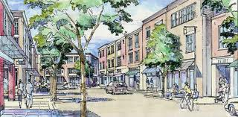Figure 14. New Urbanism.

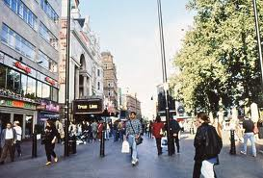Figure 15. New Urbanism.

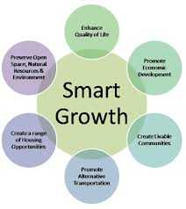Figure 16. Smart Growth principles.

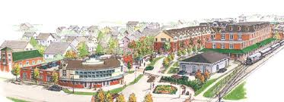
Figure 17. Another variation of New Urbanism: Transport-Oriented Development.

The Modernist Tradition
A third tradition, the Modernist Tradition (or modernism), covers such descriptions as functionalist, utilitarian, systematic, rationalist, technological and efficient. It was sent as a bold effort to use technology and notions of an egalitarian populace to recast how people should live and work that include a distinct separation of these spaces. It saw earlier forms of urban design as incapable of achieving the goals set out in the conditions of urban places at the time of the last century, a time that also saw planners like Howard and Olmsted finding answers to similar questions in the form of the Garden City and City Beautiful.

The first expressions of the Modernist Tradition can be traced to the post-WW-I period in the Beaux arts movement. Planners, notably Le Corbusier and Ludwig Miles van der Rohe, saw technology as the best way of reducing the costs of decent habitation and for improving the conditions (sanitary and health) of the city as it was at that time. They saw it as a way to improve health, to improve light and air into homes and workplaces, and to bring parks and cultural institutions more affordably to the ordinary citizens. For example, Le Corbusier described the home as “a machine for living in.” They also recognized, unlike Howard, the potential of the car and as part of the ordinary man movement, these designers emphasized “machine aesthetics.”

The Compact City: Where do we go today?

“Scale has always been an important issue in architecture. The most common approaches on scale in architecture were normative indicating norms like “human scale” or “in context” as appropriate, or talking about “in or out of scale”, “harmonious scale” or “order”. Another use of scale focused on the semantic/symbolic aspect when it was used to impress or to impose in authoritarian or monumental architecture. There is not extended literature on architectural scale in architecture or in cognitive studies and studies of perception.

“Usually there is literature on perception of size, perception of distance, and perception of form but not of scale. In architectural studies usually it is referred to as architectural or urban scale but there is no actual word explaining the more complex relation of what a human mind perceives when walking down a street which is a combination of architectural forms juxtaposed in a specific formal configuration which creates the urban form. In a way, the wrong assumption is that the sum of the parts (architectural forms) is equal to the whole when what actually happens is that the whole (urban form) is much more than the sum of the parts, as in gestalt theory.” - Magda Mavridou (2009)

How are differences in scale of an urban built environment perceived by people moving in it? “A clear distinction should be made here between the term “scale” as this appears in the Geography literature and the “scale” this paper is dealing with. Scale in traditional geographical studies is an abstract notion referring to the extent, either spatial or temporal, to which a phenomenon, physical or not, applies. In the geography studies there is no reference to architectural and urban scale as this is defined in this paper, as the scale of the forms in relation to space. This is a more concrete sense of scale dealing with the relation of form to space which is apprehended through movement.” Magda Mavridou (2009)

This, by the way, is not true. We call this “contextuality.”

BUT is “up” a realistic direction? A compact design is characterized by the importance of the vertical spatial and space, combining less land area too many activities (multi-zoning) and creating different levels connected by a path of vertical circulation. Are these new visions to be restricted to fiction OR will we see such urban complexes rising up? From flights of fancy, such as the Mushroom City to the Vertical Garden City (the Mori Building) proposed for Tokyo, Japan.

In describing their Vertical City, the architects wrote
“By assembling land that has been subdivided into small parcels into a large block and then consolidating building needs in high-rise structures while exploiting man-made foundations and underground space, this approach can free a vast amount of open space at the ground level. … Through “vertical” land development that makes intelligent use of ultrahigh-rise structures as well as underground space, we can create a “compact city” that enhances the efficiency of urban infrastructure, such as rail transportation and road systems, while systematically integrating diverse urban functions, including work, residence/living, entertainment, education, and commercial/retail. … Intelligent and efficient land utilization creates not only an “eco-friendly city” with a pleasurable environment that contributes to reduced CO₂ emissions and other benefits, but also a comfortable, safe and secure “sustainable city” that is resistant to earthquakes and enduring.”

The Issue of Social Sustainability and the City
“The cities of the twenty-first century must place the citizen at the centre of public policy, reinvent the concept of the city, and realize the many ways of sharing in urban life.”
Ali Kazancigil, Executive secretary, UNESCO

How do we define ‘Social Sustainability’?
The ultimate challenge is addressing environmental and other constraints in urban design with that of fostering a positive social environment. Although the term ‘sustainability’ is, itself, a highly contentious term, there is some agreement concerning its normative understanding/vision. There is general agreement it links current consumption with the anticipated needs of future generations. There is also general agreement that sustainability links economics, social activities (primarily of the ‘Developed’ nations) and environmental change. And, as such, it seeks to provide a more holistic ethos to sustainability. But what about social sustainability? What do we mean by it?

Actual attempts to define social sustainability go back to the 1990s. Yiftachel and Hedgcock (1993:140) defined it as “the continuing ability of a city to function as a long-term viable setting for human interaction, communication and cultural development.” Stren and Polses (2000:16-17) defined it as “development (and/or growth) that is compatible with the harmonious evolution of civil society, fostering an environment conducive to the compatible cohabitation of culturally and socially diverse groups while at the same time encouraging social integration, with improvements in the quality of life for all segments of the population.” An issue that Davidson (2010) raises is that social sustainability, as thus defined, does not possess normative judgements – either explicitly or implicitly – that sustainable development does.

The absence of this normative context has lead some to attempt to incorporate it. McKenzie (2004:12) defined it as “a life-enhancing condition within communities and a process within communities that can achieve that condition” but McKenzie does not provide guidance about what constitutes a “life-enhancing condition.” Maloutas (2003:168) argues that, in light of the absence of normative context, social sustainability has been informed by environmental thinking. He argues that social sustainability has been usurped by environmental sustainability and that this has “re-socialized” sustainability where “social objectives are reintroduced, but as subordinate to the primary goal” of environmental sustainability. However this environmental framing of the social has contributed to “the general withdrawal from radical objectives of social equality and justice in favour of less ambitious objectives of social cohesion, solidarity and inclusion.”

To Yiftachel and Hedgcock (1993), this influence of environmental sustainability thought is clearly seen. They wrote, “the concept of urban social sustainability conceives the city as a backdrop for lasting and meaningful social relations that meet the social needs of present and future generations” (1993:140). They continue, the “socially sustainable city is marked by vitality, solidarity and a common sense of place among its residents. Such a city is also characterized by a lack of overt or violent inter-group conflict, conspicuous spatial segregation, or chronic political instability” (1993:140).

More recently, Bramley and Power (2009) adopt a two-fold definition:
- Social equality issues – addressing such issues as access to services, facilities and opportunities; and
- Issues to do with sustainability of community itself – a nebulous term focussing on issues of social equity, capital and social cohesion.

Others have rejected this movement – or watering-down – of the idea, and has urged a return to a more political utility. Baehler (2007:27) argues that social sustainability is – and should – remain focused on the more fundamental tensions of democracy: “we might venture to define social and political (or “nationhood”) sustainability as the ability of a society to resist internal forces of decay while also maintaining and reproducing the background social, cultural and institutional conditions necessary for healthy democratic social relations to flourish.” This would, once again, reinsert radical concerns and help recast issues such as equity, consensus and security as social sustainability.

Translating social sustainability to actionable ideas
How, then, might we operationalize the idea (– even if we do not have a truly clear idea of its meaning)? Remaining at the scale of the city/region, those cities that have attempted to adopt social sustainability, have adopted different working definitions and foci. These have included:
- Social mix (Vancouver);
- Liveability (Boulder, CO);
- Affordable housing (Ottawa);
- Community services (adelaide, AU); and
- Street life (Dubai, UAE).
The variety in interpretations reinforces the reality that social sustainability, as a working concept, has not coalesced around a single set of ideas and actions.

In Vancouver, they have set out three major components:
- The provision of basic needs such as housing and with this, recognition that sufficient income that must be met before capacity can develop;
- Individual or human capacity or opportunity for learning and self-development; and
- Social or community capacity for the development of community organizations, networks that foster interaction.
This equals:
- The economic requirements;
- Capability building of individuals; and
- Institutional/social structures supportive of the individual.
And Vancouver has adopted four guiding principles: (1) equity; (2) social inclusion and interaction; (3) security; and (4) adaptability.

Other cities have been less ambitious with definitions either vague or non-existent. San Gabriel, CA uses the slogan: “Invest in neighborhood conservation and community-building.” Adelaide, AU states: “Socially sustainable cities are equitable, diverse, connected and democratic, and provide a good quality of life.” Also, different cities see the application of social sustainability differently. Aalborg, Denmark focuses on the homeless and severely disadvantaged while Boulder, CO, focuses on the ‘under-served’ – youth, seniors, and children. Still others are more inclusive. Bloomington, MN argue: “Social sustainability is about meeting the needs of everyone in our community, regardless of their socio-economic status.”

Neighbourhood density and social sustainability
How does one go about assessing a “good quality of life”? Seema Dave (2009), of the ISD at Oxford examined the social aspects of sustainability in relation to urban densities and form (of cities of the developing world). He used Mumbai, India as his case study interviewing more than 200 households in 11 districts. His work challenges the idea that a high density compact form of development is necessarily a better form of urban design that a lower-density vision. While certain benefits can be derived from high density design – such as walkability, for example, it also is correlated with smaller dwelling sizes, less gardens and open spaces. It can have adverse impacts on the quality of life and equity, on health, social relationships, privacy and services such as education. Urban design can also affect social interaction and community spirit, expressed as social capital and social cohesion too.

He identified six aspects of social sustainability:
- Access to facilities and amenities;
- Amount of living space;
- Health of the inhabitants;
- Community spirit and social interaction;
- Sense of safety; and
- Neighbourhood as a place to live in.

He then developed indicators for each of these. For example, he used five indicators to measure a neighbourhood’s sense of safety:
- Perceived friendliness of the neighbourhood;
- Perceived safety within the neighbourhood during daytime;
- Perceived safety within the neighbourhood after dusk;
- Perceived vandalism in the neighbourhood; and
- Perceived reputation of the neighbourhood.
- Neighbourhood density and social sustainability
He further developed measures of physical and perceived density.

For physical density he used two indicators:
- Measuring capacity and usage – net residential density; net residential population density; average number of households per block; and floor area per person; and
- Measuring physical form – coverage; and average number of floors per block.
For perceived density, he used two indicators:
- Measuring external crowding – resident’s perception of their neighbourhood in terms of space between buildings (measuring the crowding of buildings); and resident’s perception of their neighbourhood in terms of number of people (measuring crowding of people); and
- Measuring internal crowding – resident’s perception of their size of home (measuring crowding within dwelling).
- Neighbourhood density and social sustainability
Finally, he further developed four intervening variables:
- Mix of use – percentage of residential land use;
- Building form – type of building form (chawl, row houses/tenements; flats fewer than 5 stories; flats 5 to 7 storey; and high rises more than 7 storey high;
- Design and lay-out – closeness; betweeness; straightness; cost-network; effiiciency-network;
- Socio-demographic variables – location of the neighbourhood within the city; type of ownership; years of residency in the neighbourhood; family income; level of education; age of the neighbourhood.
- All of these were seen as influencing a participant’s perception of his/her neighbourhood.
- Neighbourhood density and social sustainability

Dave posed three basic questions:
- Does density have any impact on the social sustainability of neighbourhoods in Mumbai?
- If it does, what impact is density likely to have on selected aspects of social sustainability?
- What aspects of density have the most positive impacts on social sustainability?
- This last research question was added since it was important for policy implications to find out which aspects of density were likely to have significant impacts on society.
- Neighbourhood density and social sustainability
He found that density is significantly related to each aspect of sustainability, even when controlling for the intervening variables.

There were, however, differences in which density was significant for what factor:
- Aspects of social sustainability affected by physical density were: access to facilities and amenities AND health of the inhabitants;
- Aspects of social sustainability affected by perceived density were: community spirit and social interaction AND sense of safety; and
- Aspects of social sustainability affected by both physical and perceived density were: amount of living space AND satisfaction with the neighbourhood.
- Neighbourhood density and social sustainability

As a general conclusion, Dave writes: “Overall, the findings of the research suggest that, for social aspects of sustainability, higher household density and population density have no negative impacts. Importantly, most of the negative associations of density were related to the perceptions of density, and therefore the built form, layout, design and amount of mix of uses of a neighbourhood, as well as socio-demographic variables such as family income and location, were found to have an important role in achieving social sustainability.”

Social sustainability and urban form: lessons from Britain
But what about Euro-American attitudes? Bramley et al (2009) examined the relationship between social sustainability of neighbourhoods and urban form, drawing upon 15 neighbourhoods in five British mid-size cities. They (2009:2125) argued that “urban forms cannot be considered sustainable if they are not acceptable to people as places in which to live, work and interact, or if their communities are unstable or dysfunctional.” They examined the impact of differing urban neighbourhood forms on social sustainability. Three neighbourhoods were selected from five mid-size British cities: an inner city neighbourhood, a ‘suburban’ neighbourhood and one somewhere in between. All five cities were considered compact with the average distance to the city centre being less than seven kilometres even from the ‘outer’ areas. A total of 4,381 households responded to a mailed questionnaire.

Bramley et al, see social sustainability as having two dimensions. One is social equity – specifically addressing access to services and opportunities (such as essential local services such as shops, schools, health centres; recreational opportunities and open space; public transport; job opportunities; and affordable housing). The second is sustainability of community – considering various sub-dimensions (including pride in and attachment to neighbourhood; social interaction within the neighbourhood; safety/security [vrs risk of crime, antisocial behaviour]; perceived quality of the local environment; satisfaction with the home; stability [vrs residential turnover]; and participation in collective group/civic activities).

Their results seem to continue to echo our tendencies for space. There was a general draw towards neighbourhoods with lower home densities and the existence of gardens. The indicators included ‘neighbourhood pride and attachment,’ ‘social interaction,’ ‘safety,’ ‘satisfaction with the home,’ and ‘neighbourhood environmental quality’ all correlated to this desire for more space and gardens. The variable ‘residential stability’ correlated to lifestyle demographics – age, family status, family size – and tenure – private renting. ‘Participation in groups’ and ‘use of neighbourhood facilities’ had weak correlations.

They concluded that: “The measurement of density itself is not simple, and our findings suggest the need to take into account housing-type mix, the role of gardens and greenspace, land-use mix, and network-connectivity characteristics.” In their analysis, they further concluded that: “Broadly, social outcomes relating to attachment, satisfaction, safety and the environment are more positive at lower densities and in less central locations, while outcomes relating to use of local services display the opposite tendency.” (Why do you think this is so?)

In addition, they cite three relationships of note:
- “Firstly, outcomes relating to neighbourhood pride and attachment, stability, safety, environmental quality, and home satisfaction all display negative, nonlinear relationship with density.”
- “Secondly, outcomes relating to social interaction and group participation tend to improve as density rises up to a medium level, and then falls off at higher levels.”
- “Thirdly, outcomes relating to the use of local services are broadly positive related to density.”
They determined that the idea density level was 100 to 140 DPH (density per hectare). In conclusion, they write that: “An exclusive emphasis on high density, particularly if this takes the form of apartment accommodation with little provision of gardens, is unlikely to produce happy, well-functioning communities. Compromise between the arguments (particularly from the sustainable transport perspective) for high density and the social and quality of life considerations will be needed.”

What is the future of the City?

Is the Future City Utopian?
The designs presented in the powerpoint, point to a utopian vision of tomorrow’s cities – which stands in interesting contrast to the continual presentation of the dark and dangerous future city in movies. How might we achieve this ‘better tomorrow’? Consider:
- The Future City (Christopher Barnatt, Associate Professor of Computing & Future Studies in Nottingham University Business School) http://www.youtube.com/watch?v=NmRoc7_jVdo [5.18]
- The Sharable Future of Cities (Alex Steffen) http://www.youtube.com/watch?v=mjDjbJJlqZ0 [10.13]
- Masdar – The World’s First Eco-city http://www.youtube.com/watch?v=AyD4k8Du83I [5.47]
- Peter Katz on Smart Growth http://www.youtube.com/watch?v=Kczh2bU_nQo [14.15]
- The Smart City (Richard Florida) http://www.youtube.com/watch?v=94iy1xm69xw [24.47]
- Arcosanti - http://www.youtube.com/watch?v=qBGDXxvn1k4 [12.39]

Is the Future City Dystopian?
There are others who see the future cities as something quite different, pointing the slums as the reality of tomorrow’s city. Consider:
- The Shadow Cities of the future (Robert Neuwirth)
http://www.youtube.com/watch?v=_2Js_g7M60M [10.13]
- Future of Urbanism (Mabel wilson) http://www.youtube.com/watch?v=pezDmYIYdKU [13.45]
- Dharavi http://www.youtube.com/watch?v=EUMMq7B_DDs [7.33]

Designing the Future
How do we re-conceive urban space? Is this simply a design issue? Can architecture solve “the problem”? Can urban design solve “the problem”? Is there a ‘techno-solution’ to “the problem”?

OR is it more than that? [Really it involves more than technical questions] Do we need to look beyond the technical and into the social, the cultural, and the historic? Is there an economic component to “the solution”? Can we make people futurists and visionaries?

