Chapter 1

Premise: In an argument, a statement, or reason, given in support of the conclusion

Conclusion: In an argument, the statement that the premises are intended to support

Inference: The process of reasoning from a premise or premises to a conclusion based on those premises

Chapter 2

Fallacy: bad argument form or bad argument pattern

Fallacy of appeal to popularity: Some claim or statement is true merely because it’s popular
Ex. Racist belief

Fallacy of appeal to common practice: This is the way we do things therefore this is the best way to do things (the present)

Fallacy of appeal to tradition: We have always done things this or that way so then we ought to do it this way (the past)

Genetic fallacy: “Genesis” meaning origin, some position is correct or incorrect based solely on where it came from

Different uses of “knowledge”:
- Knowledge by acquaintance
- Knowledge-how
- Propositional knowledge (knowledge-that)

Three key ingredients in propositional knowledge:
- Belief: If you know something then you must believe it
- Truth: some of our beliefs are true while some of our beliefs are false. If you really know something is the case, it must be true.
- Justification: Your belief must have reason

Realism: there are objective truths in that subject area and what these truths are does not depend upon anyone’s beliefs about them.

Nihilism: there just are no truths whatsoever in that subject area

e.g.: Moral nihilism: the view that moral assertions have no truth-value (are neither true nor false)
Relativism: there are truths in that subject area but what the truths are depends upon what we believe them to be.

Subjective Relativism: The idea that truth depends on what someone believes

Social Relativism: The view that truth is relative to societies

Philosophical Skepticism: The view that we know much less than we think we do or that we know nothing at all

Why Hold This View:
(a) Dream Hypothesis
(b) Evil Genius Hypothesis
e.g. Machine hypothesis

Objections:
- Requiring absolute certainty for a belief to count as knowledge seems to be asking too much
- Skepticism about everything is self-defeating

Philosophical Skeptics: Those who embrace philosophical skepticism

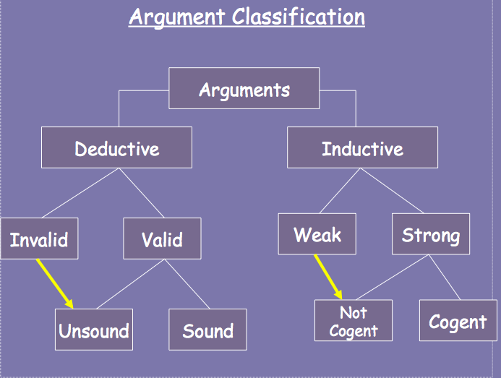

Chapter 3

Conditional Statements
A conditional statement is a statement of the form
If p, then q.
Examples:
- If it rains, then the picnic will be cancelled.
- If Jones didn’t commit the murder, the butler did.

Conditionals are compound statements composed of two parts:
The antecedent – what follows the word “if”
The consequent – what follows the word “then”

Disjunctive Statements
A disjunctive statement is a statement of the form
Either p or q.
Examples:
- Either the picnic was cancelled or it rained.
- Either Jones committed the murder or the butler did.
Disjunctions are compound statements composed of two parts called the disjuncts

Some valid conditional argument patterns:
- Affirming the antecedent (Modus Ponens):
If p, then q.
p.
Therefore, q.
Example:
(1) If Ryerson is a great university, then many students apply there.
(2) Ryerson is a great university.
______________________________________________
Therefore,
- Many students apply there.
(From premise (1) and premise (2) by Modus Ponens)

- Denying the consequent (Modus Tollens)
If p, then q.
Not q.
Therefore, not p.
Example:
(1) If Jim committed the murder, he used his gun on Tuesday.
(2) Jim did not use his gun on Tuesday.
________________________________________________
Therefore,
(3) Jim did not commit the murder.
(From premise (1) and premise (2) by Modus Tollens)

- Hypothetical Syllogism
If p, then q.
If q, then r.
Therefore, if p, then r.
Example:
- If Mitt Romney loses the election, Barack Obama wins.
- If Barack Obama wins, Michelle Obama will be happy.
______________________________________________
Therefore,
- If Mitt Romney loses the election, Michelle Obama will be happy.
(From premise (1) and premise (2) by Hypothetical Syllogism)

Some invalid conditional argument patterns:
- Denying the Antecedent
If p, then q.
Not p.
Therefore, not q.
Example:
(1) If Einstein invented the computer, then he’s a genius.
(2) Einstein did not invent the computer.
_____________________________________
Therefore,
(3) He’s not a genius.

- Affirming the Consequent
If p, then q.
q.
Therefore, p.
Example:
(1) If Einstein invented the computer, then he’s a genius.
(2) Einstein is a genius.
_____________________________________
Therefore,
(3) He invented the computer.

A valid disjunctive argument pattern:
Disjunctive Syllogism
(i) Either p or q.
Not p.
Therefore, q.
(ii) Either p or q.
Not q.
Therefore, p.
Example:
(1) Either the Liberals won the election or the Conservatives did.
(2) The Liberals did not win the election.
_______________________________________
Therefore,
(3) The Conservatives won. (From premise (1) and premise (2) by Disjunctive Syllogism)

Diagramming Arguments
Step 1: Mark all the indicator words
Step 2: Number all the assertions in the argument in order of appearance
Step 3: Identify the main conclusion of the argument
Step 4: Identify the premises that directly support the conclusion
Step 5: Decide whether these are dependent or independent premises

Dependent Premises: depend on each other to provide support for the conclusion. A dependent premise, by itself, does not support the conclusion

Independent Premises: these offer support for the conclusion without the help of any other premises.

Step 6: Draw a diagram for these premises and the main conclusion

Two Ways to figure out of premises are dependent:
- The Words Test: if some important words/ideas in the conclusion only occur in one premise and other important words/ideas from the conclusion only occur in the other premise, then the premises are probably dependent.

Aristotle is a man, and all men are mortal, so Aristotle is mortal.

- The False/Absent Premise Test: if a premise would provide some reason to accept the conclusion even if the other premise(s) were false (or not present), then the premises are probably independent.

Bill robbed the bank and shot the guard. Bill is obviously a criminal.

Chapter 4

Justification
- Some Ways our Claims Can be Justified And/or Acceptable:
- It is true by definition
- It is an item of background information
- It is supported by personal experience- includes beliefs based on our senses, our memory and our intellect
A form of testimony, which can justify beliefs, statements and premises.
- It is supported by testimony: such as (1) experts
(2) the news
(3) advertising

Appeal to authority- the fallacy of relying on the opinion of someone deemed to be an expert who in fact is not an expert

Gambler’s Fallacy- the error of thinking that previous events can affect the probabilities in the random event at hand

Fooling Ourselves
- Under-value contrary evidence
- Over-value confirming evidence
- Over-value “psychological available” evidence

Reasons to doubt personal experience
- Innumeracy: means, ‘roughly’, being really bad with numbers
- Expectation: we often perceive exactly what we expect, regardless of whether there’s really anything there to detect. Ex. Pareidolia
- Impairment: if our perceptual powers are somehow impaired, we have reason to doubt them

Chapter 6

Symbol | Meaning | Example
&  (ampersand) | Conjunction  (and) | p & q  “John had cake and Jill had pie.”  False if and only if one or both of the conjuncts is false.
V  (wedge) | Disjunction  (or) | p v q  “Either John had cake or Jill had pie.”  False if and only if both of the disjuncts are false. (Inclusive vs. Exclusive “OR”)
~  (tilde) | Negation  (not) | ~p  “John did not have cake.”  False if and only if p is true.
(arrow) | Conditional  (if-then) | p q  “If John had cake, then Jill had pie.”  False if and only if the antecedent is true AND the consequent is false.

A truth-table sets out all possible truth-value assignments for a given complex statement, and its component simple statements.

Truth-Table for Conjunction

Alice rode her bike | John walked | Alice rode her bike and John walked
A | J | A & J
T | T | T
T | F | F
F | T | F
F | F | F

* If one sentence is false the whole argument is false*

Truth-Table for Disjunction

Always remember that in logic, we treat “or” in the inclusive sense: “A or B” means “Either A or B or both ”

Alice rode her bike | John walked | Alice rode her bike or John walked
A | J | A v J
T | T | T
T | F | T
F | T | T
F | F | F

* A disjunction is true when either sentence is true*

Truth-Table for Negation

John walked | It’s not true that John walked
J | ~ J
T | F
F | T

* You flip the truth-value of the sentence*

Truth-Table for Conditionals

* Remember to convert conditionals to our regular form: P Q.

You pass SSH105 | I will buy you a donut | If you pass SSH105,  then I will buy you a donut
P | D | P D
T | T | T
T | F | F
F | T | T
F | F | T

* The only conditional when it is false is when the antecedent is true and the consequent is false*

