DATE
CHAPTER 5: MEASURING NATIONAL INCOME

Main Questions
- What is Gross Domestic Product (GDP)?
- How is GDP related to a nation’s total income and spending?
- What are the components of GDP?
- How is GDP corrected for inflation?
- Does GDP measure society’s well-being?

Income and Expenditure
- Gross Domestic Product (GDP) measures two things at once:
  - Total income of everyone in the economy.
  - Total expenditure on the economy’s output of goods & services.
- For the economy as a whole income = expenditure

The Circular-Flow Diagram
- Is a simple depiction of the macro economy
- Illustrates GDP as spending, revenue, factor payments, and income.
- Factors of production are inputs like labour, land, capital, and natural resources.
- Factor payments are payments to the factors of production. (e.g., wages, rent)

The Circular-Flow Diagram
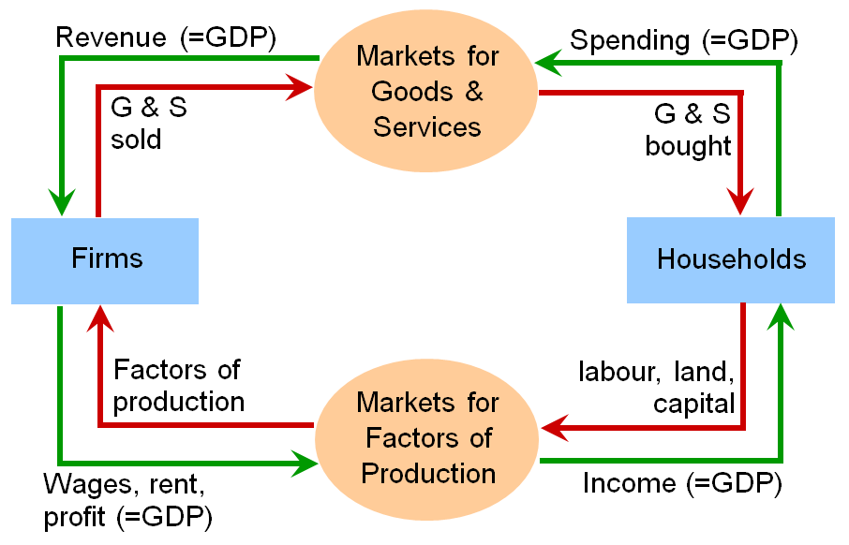
- Circular flow diagram omits:
- The government- collects taxes, purchases g&s
- The financial system - matches savers’ supply of funds with borrowers’ demand for loans
- The foreign sector - trades g&s, financial assets, and currencies with the country’s residents

Gross Domestic Product (GDP)
- The market value of all final goods & services produced within a country in a given period of time.
- Goods are valued at their market prices.
- GDP measures all goods using the same units; things that don’t have market value are excluded.

Main points:
- Market value
- Final goods
- Currently produced goods and services
- Within a country
- In a given period of time

Components of GDP
- GDP is total spending. Its four components are:
  - Consumption (C)
  - Investment (I)
  - Government Purchases (G)
  - Net Exports (NX)
- These components add up to GDP (denoted Y):
Y = C + I + G + NX

Consumption (C)
- Is total spending by households on goods & services.
- Housing costs:
  - For renters, consumption includes rent payments.
  - For homeowners, consumption includes the imputed rental value of the house, but not the purchase price or mortgage payments.

Investment (I)
- Total spending on goods that will be used in the future to produce more goods.
- Includes spending on
  - capital equipment (e.g., machines, tools)
  - structures (factories, office buildings, houses)
  - inventories (goods produced but not yet sold)
- Note: investment does not mean the purchase of financial assets like stocks and bonds

Government Purchases (G)
- All spending on the goods and services purchased by local, provincial, and federal governments.
- G excludes transfer payments, such as Canada pension plan benefits or employment insurance benefits.
- These payments represent transfers of income, not purchases of goods and services and do not represent production.

Net Exports (NX)
- NX = exports – imports
- Exports represent foreign spending on domestically produced goods.
- Imports are the portions of C, I, and G that are spent on g&s produced abroad.

Canadian GDP and Its Components, 2008
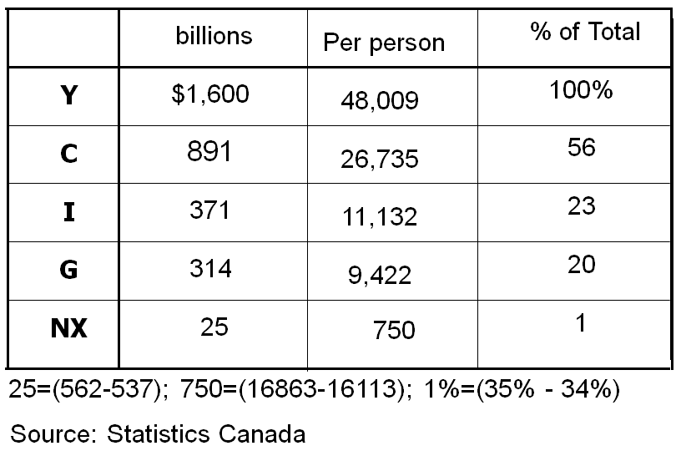

GDP: Total Income and Its Components
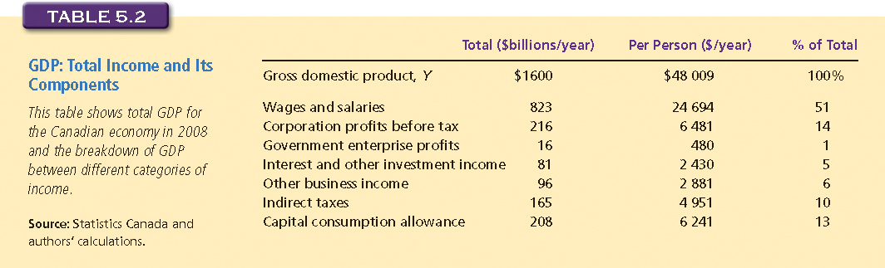

Exercise 1: GDP and Its Components
- In each of the following cases, determine how much GDP and each of its components is affected (if at all).
  - Debbie spends $200 to buy her husband dinner at the finest restaurant in Vancouver.
  - Sarah spends $1800 on a new laptop to use in her publishing business. The laptop was built in China.
  - Jane spends $1200 on a computer to use in her editing business. She got last year’s model on sale for a great price from a local manufacturer.
  - General Motors builds $500 million worth of cars, but consumers only buy $470 million worth of them.

Real versus Nominal GDP
- Inflation can distort economic variables like GDP, so we have two versions of GDP: One is corrected for inflation, the other is not.
- Nominal GDP: output valued at current prices. It is not corrected for inflation.
- Real GDP: output valued at constant prices of a base year. Real GDP is corrected for inflation.

Example:
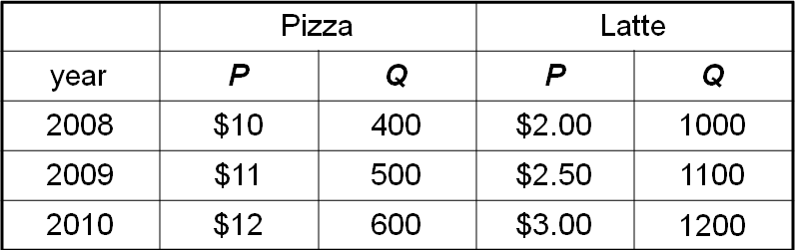
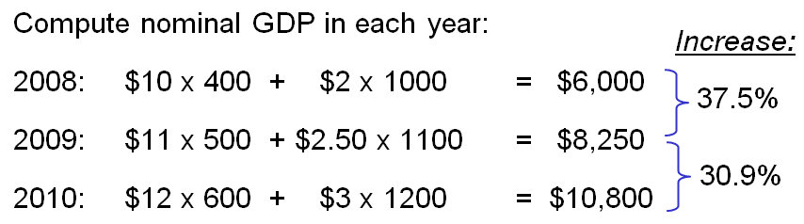

Example:
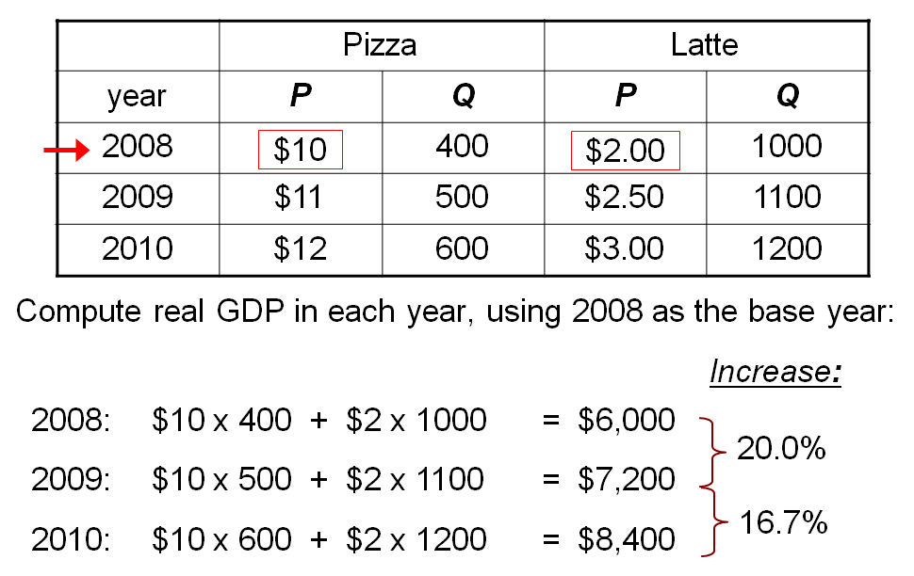

Example:
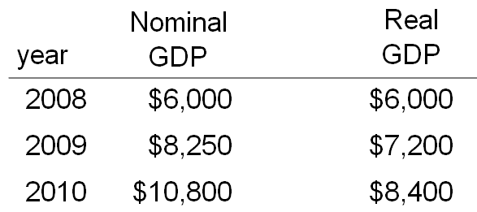
- In each year,
- Nominal GDP is measured using the (then) current prices.
- Real GDP is measured using constant prices from the base year (2008 in this example).

Example:
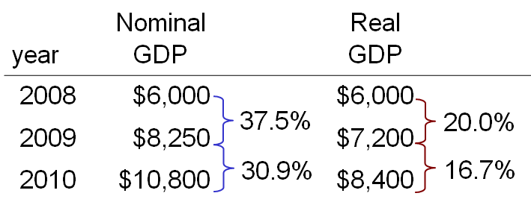
- The change in nominal GDP reflects both prices and quantities.
- The change in real GDP is the amount that GDP would change if prices were constant (i.e., if zero inflation).
- Hence, real GDP is corrected for inflation.

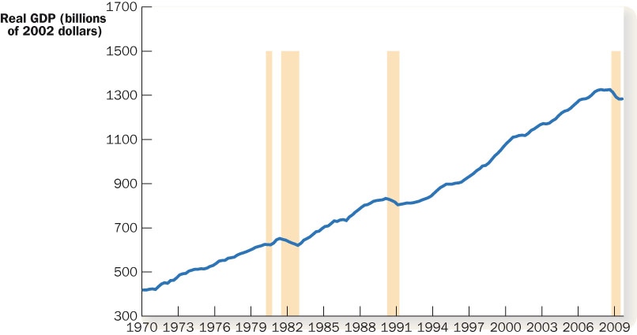

The GDP Deflator
- The GDP deflator is a measure of the overall level of prices.

- One way to measure the economy’s inflation rate is to compute the percentage increase in the GDP deflator from one year to the next.

Example:
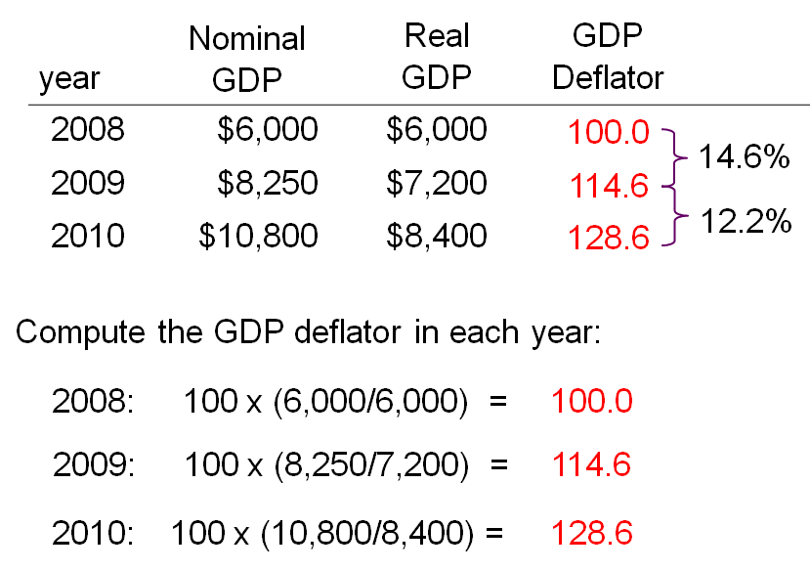

Exercise 2: Computing GDP
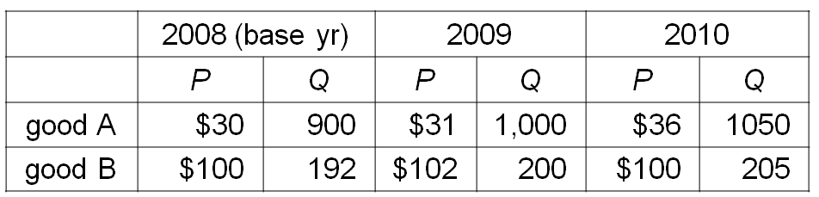
- Use the above data to solve these problems:
  - Compute nominal GDP in 2008.
  - Compute real GDP in 2009.
  - Compute the GDP deflator in 2010.

GDP and Economic Well-Being
- Real GDP per capita is the main indicator of the average person’s standard of living.
- But GDP is not a perfect measure of well-being.
- Robert Kennedy’s criticism of GDP

Gross Domestic Product…
“… does not allow for the health of our children, the quality of their education, or the joy of their play. It does not include the beauty of our poetry or the strength of our marriages, the intelligence of our public debate or the integrity of our public officials. It measures neither our courage, nor our wisdom, nor our devotion to our country. It measures everything, in short, except that which makes life worthwhile, and it can tell us everything about America except why we are proud that we are Americans.” - Senator Robert Kennedy, 1968

GDP Does Not Value:
- The quality of the environment
- Leisure time
- Non-market activity, such as the child care a parent provides to his or her child at home
- An equitable distribution of income

Why We Care About GDP
- Having a large GDP enables a country to afford better schools, a cleaner environment, health care, etc.
- Many indicators of the quality of life are positively correlated with GDP e.g. life expectancy, literacy

GDP, Life Expectancy and Literacy
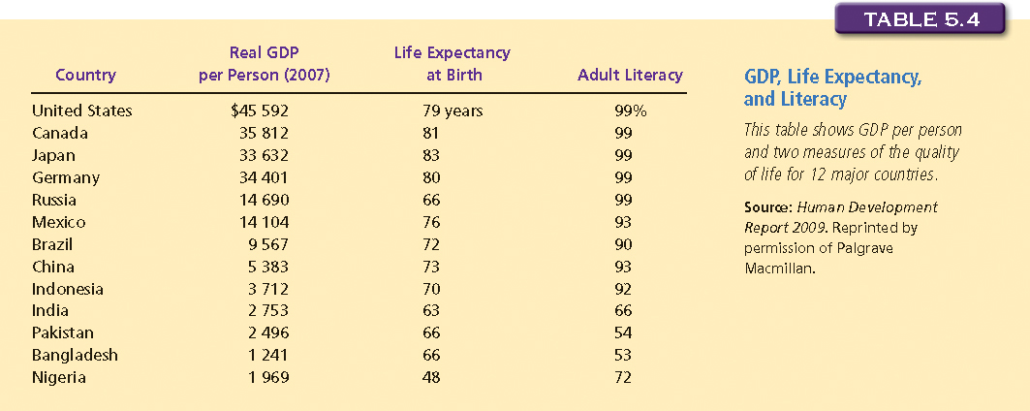

GDP and Life Expectancy in 13 Countries
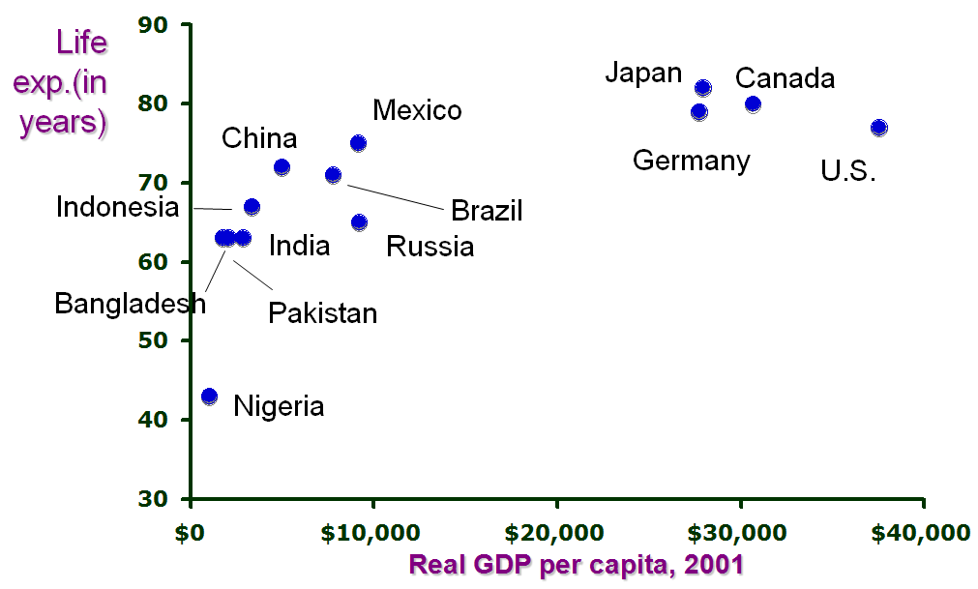

GDP and Literacy in 13 Countries


