ECOR 1010 – Introduction to Engineering

Jaspreet Sanghra
Assignment #7
Matrix Operations With MATLAB
TO Marking TA:
Name: Pablo Molina Cabrera
Email: PabloMolinaCabrera@cmail.carleton.ca

Lab Section: A6
Room: ME2256 – Carleton University

FROM:
Email: jaspreetsanghra@cmail.carleton.ca
Student Number: 100893501

Number of Figures and Tables (Including handwritten ones): 12
Last Date and Time of Revision: 20 November 2012 @ 5:40 PM

Introduction
Over the course of an engineer’s career, they are required to solve many complicated problems that can be considered tedious to solve by hand. In this situation and others, an engineer seeks the aid of MATLAB in order to make life easier and get the job done quicker. This lab walks through the process of using MATLAB for solving various problems with the use of the variety of functions MATLAB is able to perform. The lab was done to gain a general understanding of the operations of MATLAB. By doing this, engineer students are able to gain a appreciation for such a handy tool as some problems no longer have to solved by hand (by the use of pen and paper).

Materials and Methods
This lab was primarily done with the use of MATLAB and partly by IntelliCAD. IntelliCAD was used to provide a visual reference for Part 2 Question 5 (P2Q2 in appendices). The use of IntelliCAD allows the reader of the lab to have a visual representation of the solution. MATLAB was used throughout the lab as the goal was to learn of its basic functions. In MATLAB, many questions were solved using codes specified for use in MATLAB. After completing the work on MATLAB, the script was copied and pasted on to the lab report in columns in order to save paper while still having content that is readable and understandable.

Results
For P1Q1, the answers were obtained for all but the last operation as seen in the appendix. P1Q2 involves testing of a navigational system. The system causes the boat to travel a total distance of 69.0887 km and the boat did not return to the origin. P1Q3 resulted in the plotting of a graph that looks very much like an “M” as seen in Graph 2. P2Q1 was solved with MATLAB and all matrixes were obtained and W was plotted in part c. P2Q2 was solved similarly to how it would be solved by hand, but in MATLAB. P2Q3 encountered a problem and the pinv() function (pseudoinverse) was used to obtain an answer. P2Q4 gives a scalar value. P2Q5 shows a circuit and through MATLAB is it found that I1=2.4468A, I2=2.6604A, and I3=1.1457A. P2Q6 shows that the value of E is 142.92.

Discussion
This lab introduces MATLAB to the student body. This allows the students to become somewhat familiar with the program and gain some experience in using it. The ability of MATLAB to solve matrixes and vectors is very helpful in solving complex problems with a large number of equations and a large number or variables. MATLAB allowed the ship crew to calculate whether or not the navigation system was directing them correctly. This is very important as the problem was detected before setting sail instead of in the middle of the sea where the crew could face many problems and obstacles. MATLAB can solve complex problems and this saves the time of engineers. In addition there is less possibility of error when solving a matrix on MATLAB. The disadvantages of MATLAB is that all variables have to be defined before hand, so that the system recognizes them, this can sometimes take a while. In addition, MATLAB takes a while to get use to and the master.

Conclusions
In conclusion, MATLAB’s pros highly outweigh its cons as any engineers would be thankful to have MATLAB at their disposal.

APPENDIces- Figures and Tables

Part 1
P1Q1) H= [8;3;-6]
H =
8
3
-6
>> I =[0;1;-3]
I =
0
1
-3
>> J= [9,4,-7]
J =
9 4 -7
>> K= [6;4;0;1]
K =
6
4
0
1
>> L= [10;9]
L =
10
9
>> p=0.32
p =
0.3200

>> q=2.25
q =
2.2500
>> r=-0.4
r =
-0.4000
a) >> dot_product_of_x_and_y=dot(H,I)
dot_product_of_x_and_y =
21
b) >> p*K
ans =
1.9200
1.2800
0
0.3200
c) >> dot_product_of_x_and_y=dot(L,K)
??? Error using ==> dot at 30
A and B must be same size.
d) J'-K
??? Error using ==> minus
Matrix dimensions must agree.

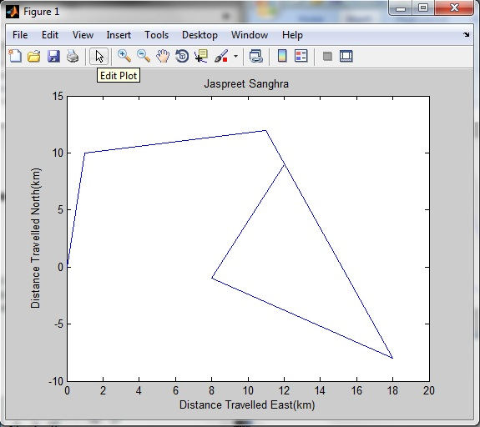
P1Q2) >> x=[0;1;11;18;8;12]
x =
0
1
11
18
8
12
>> y=[0;10;12;-8;-1;9]
y =
0
10
12
-8
-1
9
>> plot(x,y)
>> xlabel('Distance Travelled East(km)')
>> ylabel('Distance Travelled North(km)')
>> title('Jaspreet Sanghra')
>> xlim([0 20])
>> ylim([-10 15])
a=[0,0]
>> b=[1,10]
>> c=[11,12]
>> d=[18,-8]
>> e=[8,-1]
>> f=[12,9]
>> norm(a)
ans =
0
>> norm(b)
ans =
10.0499
>> norm(c)
ans =
16.2788
>> norm(d)
ans =
19.6977
>> norm(e)
ans =
8.0623
>> norm(f)
ans =
15
Total Distance Travelled = 69.0887
This is the addition of all norms.

P1Q3) >> x=[-2:0.1:2]
x =
Columns 1 through 5
-2.0000 -1.9000 -1.8000 -1.7000 -1.6000
Columns 6 through 10
-1.5000 -1.4000 -1.3000 -1.2000 -1.1000
Columns 11 through 15
-1.0000 -0.9000 -0.8000 -0.7000 -0.6000
Columns 16 through 20
-0.5000 -0.4000 -0.3000 -0.2000 -0.1000
Columns 21 through 25
0 0.1000 0.2000 0.3000 0.4000
Columns 26 through 30
0.5000 0.6000 0.7000 0.8000 0.9000
Columns 31 through 35
1.0000 1.1000 1.2000 1.3000 1.4000
Columns 36 through 40
1.5000 1.6000 1.7000 1.8000 1.9000
Column 41
2.0000
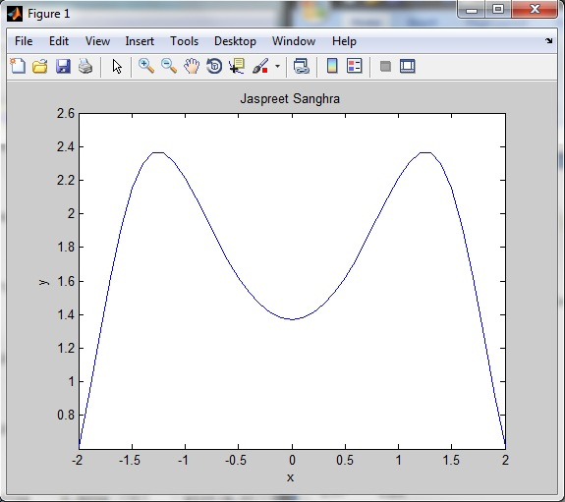
>> y=(sin(x.^2))+((10+(2*x)+(x.^2))/(5+(2*x.^2)))
y =
Columns 1 through 4
0.6150 0.9204 1.2736 1.6208
Columns 5 through 8
1.9212 2.1499 2.2970 2.3647
Columns 9 through 12
2.3633 2.3074 2.2133 2.0961
Columns 13 through 16
1.9690 1.8424 1.7241 1.6192
Columns 17 through 20
1.5311 1.4617 1.4118 1.3818
Columns 21 through 24
1.3718 1.3818 1.4118 1.4617
Columns 25 through 28
1.5311 1.6192 1.7241 1.8424
Columns 29 through 32
1.9690 2.0961 2.2133 2.3074
Columns 33 through 36
2.3633 2.3647 2.2970 2.1499
Columns 37 through 40
1.9212 1.6208 1.2736 0.9204
Column 41
0.6150
>> plot(x,y)
>> title('Jaspreet Sanghra')
>> xlabel('x')
>> ylabel('y')
P2Q1) >> F=[3,9;7,-2;5,0;6,8;9,4;5,2]
F =
3 9
7 -2
5 0
6 8
9 4
5 2
>> G=[-9,2,8,5,-1,2;7,-1,-2,9,3,8]
G =
-9 2 8 5 -1 2
7 -1 -2 9 3 8
>> Q=[4,-7,2;1,0,8;-5,3,5]
Q =
4 -7 2
1 0 8
-5 3 5
>> U=[1,0;0,1]
U =
1 0
- 1

a) >> F*G
ans =
36 -3 6 96 24 78
-77 16 60 17 -13 -2
-45 10 40 25 -5 10
2 4 32 102 18 76
-53 14 64 81 3 50
-31 8 36 43 1 26
>> r*ans
ans =
-14.4000 1.2000 -2.4000 -38.4000 -9.6000 -31.2000
30.8000 -6.4000 -24.0000 -6.8000 5.2000 0.8000
18.0000 -4.0000 -16.0000 -10.0000 2.0000 -4.0000
-0.8000 -1.6000 -12.8000 -40.8000 -7.2000 -30.4000
21.2000 -5.6000 -25.6000 -32.4000 -1.2000 -20.0000
12.4000 -3.2000 -14.4000 -17.2000 -0.4000 -10.4000
b) W= F-G'
W =
12 2
5 -1
-3 2
1 -1
10 1
3 -6

c) >> A=[1,2,3,4,5,6]'
A =
1
2
3
4
5
6
>> plot(A,sort(W))
>> plot(A, sort(W))
>> xlabel('indices')
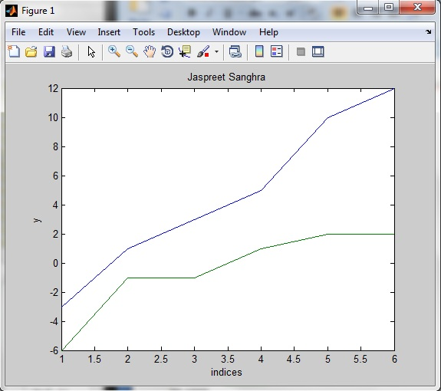
>> ylabel('y')
>> title('Jaspreet Sanghra')
d) >> U*G
ans =
-9 2 8 5 -1 2
7 -1 -2 9 3 8

e) >> F*U
ans =
3 9
7 -2
5 0
6 8
9 4
5 2
f) >> Q*H
ans =
-1
-40
-61
g) >> (q*G)+ (p*F')
ans =
-19.2900 6.7400 19.6000 13.1700 0.6300 6.1000
18.6300 -2.8900 -4.5000 22.8100 8.0300 18.6400
P2Q2) >> A= [9,2,5;1,4,6;2,3,1]
A =
9 2 5
1 4 6
2 3 1
>> inv(A)
ans =
0.1085 -0.1008 0.0620
-0.0853 0.0078 0.3798
0.0388 0.1783 -0.2636

>> b= [5;1;3]
b =
5
1
3
>> inv(A)*b
ans =
0.6279
0.7209
-0.4186
P2Q3) >>B= [1,-1,0,0,0,0;0,1,-1,0,0,0;0,0,1,-1,0,0;0,0,0,1,-1,0;0,0,0,0,1,-1;-1,0,0,0,0,1]
B =
1 -1 0 0 0 0
0 1 -1 0 0 0
0 0 1 -1 0 0
0 0 0 1 -1 0
0 0 0 0 1 -1
-1 0 0 0 0 1
>> c= [75;-60;115;-120;55;-65]
c =
75
-60
115
-120
55
-65

>> inv(B)*c
Warning: Matrix is singular to working precision.
ans =
NaN
NaN
NaN
NaN
NaN
NaN
x= pinv(B)*c
x =
49.1667
-25.8333
34.1667
-80.8333
39.1667
-15.8333
B*x-c
ans =
1.0e-012 *
-0.0142
-0.0284
0.1137
-0.0853
0.0426
-0.0142
The answer should be 0, and this indicates that since it is a VERY small number, we consider it to equal 0.

P2Q4)
>> A=[27600000,30200000;3100,6400;240,350]
A =
27600000 30200000
3100 6400
240 350
>> B=[162000000;23611;1566]
B =
162000000
23611
1566
>> X=A\B
X =
3.8996
1.8003
P2Q5) >> A=[12,-7,-5;-7,8,-1;-5,-1,13]
A =
12 -7 -5
-7 8 -1
-5 -1 13
>> B=[-5.01;-3.01;0]
B =
-5.0100
-3.0100
0
>> inv(A)
ans =
0.3131 0.2918 0.1429
0.2918 0.3982 0.1429
0.1429 0.1429 0.1429
>> ans*B
ans =
-2.4468
-2.6604
-1.1457
P2Q6) >> A=[1,0,0;8,9,3;5,0,1]
A =
1 0 0
8 9 3
5 0 1
>> b=[5,4,3]
b =
5 4 3
>> c=b*A*b'
c =
449
>> E=c/3.141592654
E =
142.92

