Answers for

ECON 1000 C

2012 April
(Winter)
Macro Final – ANS

George Kowalski

Macro Final April 2012
PART A. MULTIPLE CHOICE ANSWER SHEET

NAME___________________________________________________________
[SURNAME, GIVEN NAME]

STUDENT NUMBER_______________________________________________

USE UPPER CASE LETTERS TO ANSWER.

- __________C
- __________D
- __________D
- __________D
- __________A
- __________D
- __________B
- __________C
- __________C
- __________B
- __________A
- __________D
- __________C
- __________D
- __________B
- __________B
- __________D
- __________D
- __________B
20.__________A

Part B Short Answer.
Answer ANY 5 of the following questions. 8 marks each.
1. a. How does the Consumer Price Index differ from the GDP deflator?
b. Explain what is meant by the “substitution bias” in the CPI.
c. If food prices increased by 10%, and movie ticket prices decreased by 10%, and all other prices stayed the same, would the CPI increase or decrease? Explain.

Answer:

a. The GDP deflator and the CPI differ in two important ways.

First: what goods and services are included.

GDP deflator reflects:
Prices of all final goods and services produced domestically
Many not bought by consumers (e.g., plant machinery)

CPI reflects:
Prices of all goods and services bought by consumers
Includes prices of imported goods (e.g., Italian shoes)

Second: the difference, how prices are weighted.

The GDP deflator compares:
The price of currently produced goods and services

The CPI compares:
The price of a fixed basket of goods

b. Substitution bias: the CPI ignores the fact that consumers substitute toward goods that have become relatively less expensive.

c. The 10% increase in food prices will increase the CPI by more than the 10% decrease in movie ticket prices because the portion of the market basket that is for food is much larger than the portion for movie tickets.

2. a. What are the long run benefits of increased saving and investment?
b. What are the opportunity costs of increased saving and investment?
c. How will increased saving and investment affect consumption, in the short run, and in the long run?

Answer

a. The long run benefit of increased saving and investment is a higher standard of living in the future. Increased saving and investment raises productivity. Productivity is the quantity of goods and services that a worker can produce from each hour of work (output per labour hour of work). Productivity can be enhanced by increasing the level of technology available to the economy, as well as the physical capital and human capital available per worker.

Hence, the more an economy saves, the more it can invest in physical capital, human capital and technology. This increases productivity (output per worker) which, in turn, raises output and living standards (i.e., real GDP per capita).

b. If resources are used to invest in physical capital, human capital and technology (i.e., to produce capital goods), fewer goods and services can be produced for current consumption. One has to consume less now (i.e., give up current consumption) so that one can consume more in the future. Therefore, the opportunity cost of increased saving and investment is forgone current consumption.

c. In the short run, consumption will fall but in the long run consumption will be higher than what it would have been without the increased saving and investment. There is a tradeoff between current consumption and future consumption.

3. Explain the difference between these two theories of unemployment: Search Theory; Efficiency Wage Theory.

Answer

Search Theory

According to search theory, there is always a certain amount of frictional unemployment, which arises as people and employers take time to search for the best match. Job search is the process by which workers try to find the most appropriate jobs given their tastes and skills. It takes time for qualified individuals to be matched with appropriate jobs. Search unemployment is unavoidable because the economy is always changing. Some firms are laying off, others hiring. Some industries are contracting, others expanding. Some regions are stagnating, others are booming.

Theory of Efficiency Wages

The theory of efficiency wages states that firms operate more efficiently if wages are above the equilibrium level. Therefore, it may be profitable for firms to willingly keep wages high (above equilibrium level) in order to increase worker productivity even in the presence of an excess supply of labour. If so, firms will keep wages above the equilibrium level, creating unemployment. A firm may prefer to pay higher than equilibrium wages for the following reasons:
  - Worker Health: Better paid workers eat a better diet and thus are more productive (more relevant for developing countries).
  - Worker Turnover: A higher paid worker is less likely to look for another job.
  - Worker Effort: Higher wages motivate workers to put forward their best effort.
  - Worker Quality: Higher wages attract a better pool of workers to apply for jobs.

Major difference:

Search unemployment results from the time it takes for workers to be matched with a job. There are sufficient jobs available for everyone willing to work.

Unemployment resulting from the theory of efficiency wages is structural in nature. It arises because there are insufficient jobs available for everyone willing to work due to employers paying wages above the equilibrium wage level.

4. a. Write down an equation to describe the relation between the money supply M, the velocity of circulation V, the price level P, and real income Y.
b. If real GDP is growing at 3% per year, and velocity of circulation is constant, and the Bank of Canada wants 2% annual inflation, what must the Bank of Canada do with the money supply?
c. If inflation increased to 100% per year, what would probably happen to velocity? Explain.

Answer

a. M x V = P x Y

M is the quantity of money, V is the velocity of money, P is the price level, and Y is the quantity of output (real GDP). P x Y is nominal spending (i.e., nominal GDP). The amount people spend should equal the amount of money in the economy times the average number of times each unit of currency is spent.

b. If V is constant and Y is growing at 3%, then M, the money supply, would have to grow by 3% for P to remain constant. In order for P to rise at a rate of 2% per annum, M would have to rise at a rate of 5% per annum.
. If M x V is rising at 5%
then P x Y is rising at 5%
since Y is rising at 3%
then P is rising at 2%

c. According to the classical theory of inflation, monetary developments affect only nominal variables and not real variables. In the long run, prices rise (causing inflation) when the money supply rises. V is the rate at which money changes hands or the number of transactions in which the average dollar is used. It tends to be stable or constant. Y (a real variable) is a function of the quantity of factor inputs, technology and the rate of saving.

Hence, if prices are rising at a rate of 100% per year, the cause must be excessive growth of the money supply. An inflation rate of 100% would imply an expansion of the money supply of 100%, assuming that Y (real GDP) is unchanged.

Alternatively, if the money supply did not rise by 100% then the velocity of circulation would have to rise accordingly since

V x M = P x Y

If (P x Y) increases at a rate of 100% per year so must (V x M). But it is difficult to envisage V rising year-after-year after-year. Even if the velocity of circulation of money rose initially, it certainly would not continue to rise year- after - year for any length of time. In fact, empirical evidence confirms that the circulation of money is constant or relatively stable.

5. According to Purchasing Power Parity (PPP):
a. If a dozen eggs cost $2.50 in Canada, and 10 shillings in Kenya, what would be the exchange rate between the Kenyan shilling and the Canadian dollar (how many Kenyan shillings would you get for one Canadian dollar?)
b. What is the mechanism that would tend to make PPP approximately true for some goods?
c. What could prevent PPP being exactly true for some other goods?

Answer

a. If purchasing-power parity (PPP) holds, the real exchange rate would be equal to one.

Therefore, real exchange rate = (e x P) / P* = 1

Or e = P* / P

e = 10 shillings / $2.50 = 4 shillings per CDN dollar

(or 0.25 CDN dollars per Kenyan shilling)

b. The logic behind purchasing-power parity is the law of one price, which asserts that a good must sell for the same price in all locations. If the price for a good is higher in one market than in another, someone can make a profit by purchasing the good where it is relatively cheap, and selling the good where it is relatively expensive. This process of arbitrage leads to an equalization of prices for the good in all locations. The nominal exchange rate (e) adjusts so the price in one country is equal to the price of the same good in another country.

c. Two reasons why exchange rates do not always adjust to equalize prices across countries:
(1) Many goods cannot easily be traded
      - Examples: haircuts, going to the movies
      - Price differences on such goods cannot be arbitraged away

(2) Foreign and domestic goods not perfect substitutes
      - E.g., some Canadian consumers prefer Toyotas (Japanese) over Chevys (Canadian), or vice versa
      - Price differences reflect taste differences

6. Suppose that Canadians decide to save a bigger proportion of their incomes. If Canada is a small open economy, use two diagrams to show how this will affect: Canadian investment; Net capital Outflow; the real exchange rate; and net exports.
Answer
If Canadians decide to save a bigger proportion of their incomes, national saving would rise and the supply of loanable funds in the Market for Loanable Funds would shift to the right (see diagram below).

Net capital outflow (NCO) would rise, domestic investment would remain the same. The interest rate would remain at the world level.

The increase in NCO would increase the supply of Canadian dollars in the foreign-currency exchange market. The supply of dollars curve would shift to the right (see diagram below). The real dollar exchange rate would depreciate. The lower dollar would make Canadian goods more competitive resulting in higher net exports.

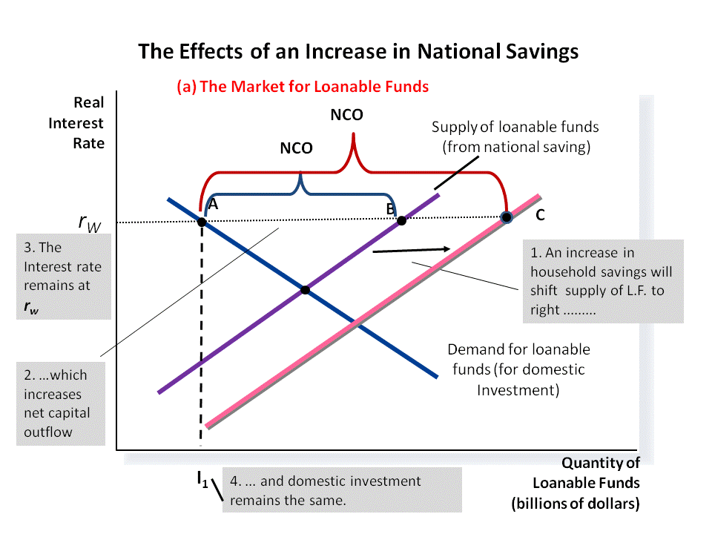

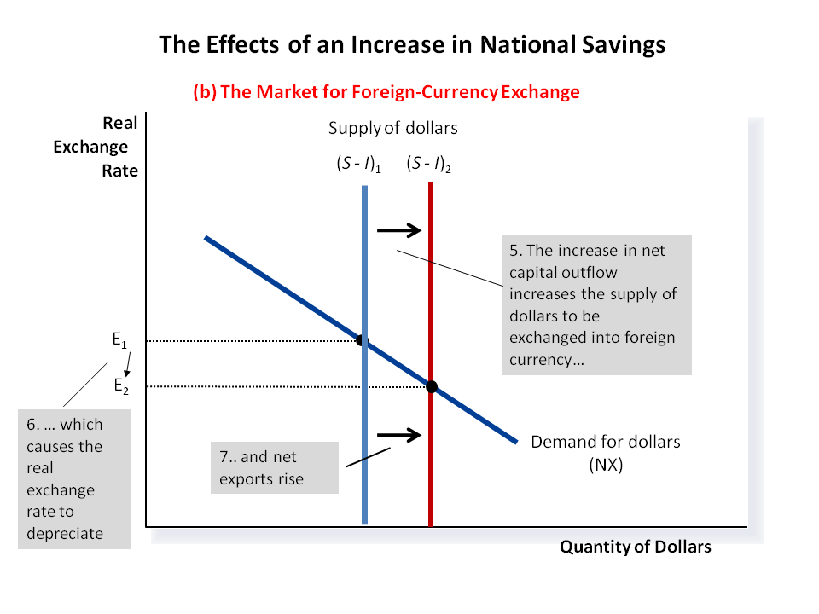
7. a. Draw a diagram showing the Long Run Phillips Curve and Short Run Phillips Curve.
b. What happens on your diagram if the actual inflation rate increases to 10% but the expected inflation rate stays at 2%?
c. What happens on your diagram if the expected rate of inflation then increases to 10% too?
d. What happens on your diagram if the natural rate of unemployment increases?

Answer
a. The LRPC is vertical at the natural u-rate. The SRPC is downward sloping, PC₁ in diagram below.

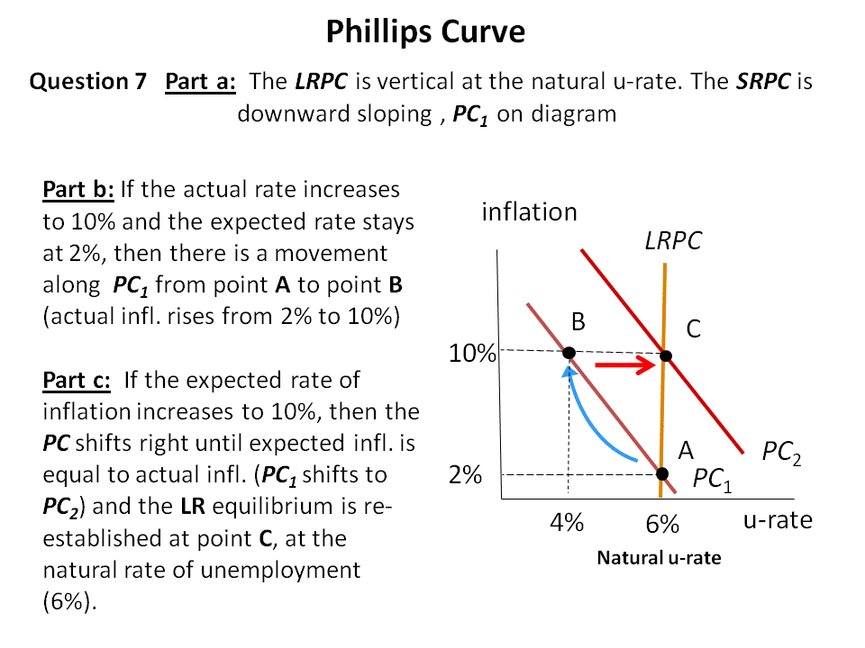

b. If the actual inflation rate increases to 10% and the expected rate stays at 2%, then there is a movement along the PC₁ from point A to point B in diagram above. Actual inflation rises from 2% to 10% but expected inflation is still 2%.

c. If the expected rate of inflation increases to 10%, then the PC shifts right until expected inflation is equal to actual inflation (PC₁ shifts to PC₂) and the LR equilibrium is re-established at point C, at the natural rate of unemployment of 6%.

d. A rise in the natural rate of unemployment shifts the long-run Phillips curve (LRPC₁) to the right, as shown in the diagram below. The economy is initially on LRPC₁ and SRPC₂ at an inflation rate of 10%, which is also the expected rate of inflation (at point C).
The increase in the natural rate of unemployment shifts the long-run Phillips curve to LRPC₂ (e.g., 8% unemployment). The short-run Phillips curve shifts from SRPC₂ to SRPC₃, with the expected rate of inflation remaining equal to 10%. The new LR equilibrium is at point D.
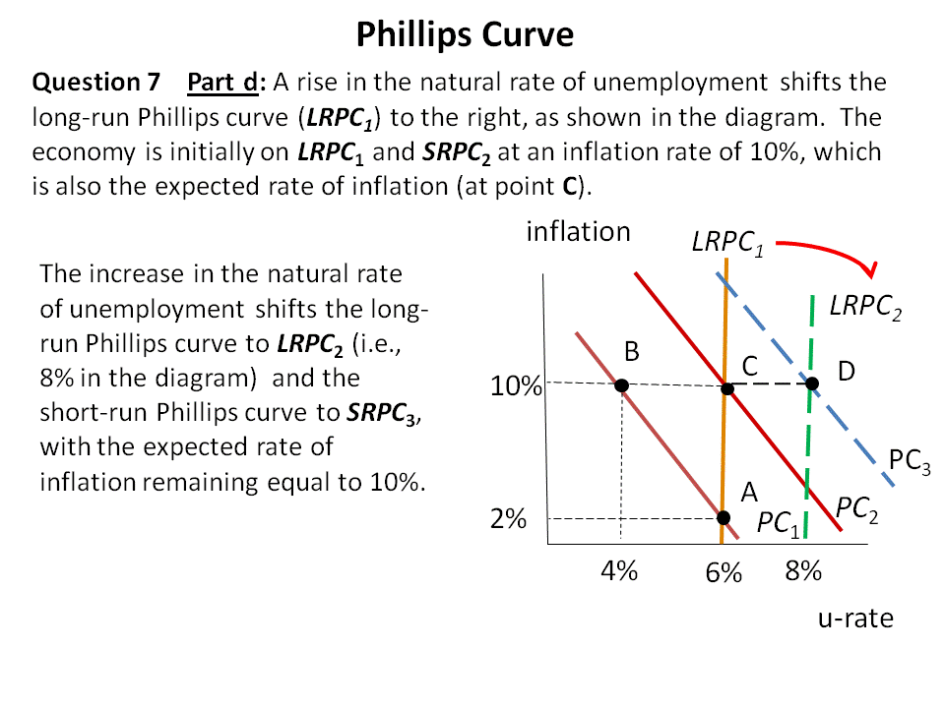
8. a. Explain the relation between the Multiplier Effect and the effect of an increase in government spending on the Aggregate Demand curve.
b. Explain the relation between the Multiplier Effect and the Marginal Propensity to Consume.

Answer

a. When the government increases the level of its purchases, it influences aggregate demand directly. An increase in government purchases shifts the aggregate-demand curve to the right.

Aggregate demand shifts further to the right (increases) because of the multiplier effect. When the government buys a product from a company, the immediate impact of the purchase is to raise profits and employment at that firm. As a result, owners and workers at this firm will see an increase in income, and will therefore likely increase their own consumption. Thus, total spending rises by more than the increase in government expenditures.

The multiplier effect is the additional shift in aggregate demand that results when expansionary fiscal policy increases income and thereby increases consumer spending.

b. The size of the multiplier effect depends on the marginal propensity to consume (MPC); the fraction of extra income that a household consumes rather than saves.

The total increase in aggregate demand (direct plus multiplier effect) resulting from an increase in government expenditures is equal to the multiplier times the increase in government expenditures.

The multiplier is as follows:

where MPC denoting the marginal propensity to consume (the fraction of extra income that is consumed rathe than saved).

The higher is the MPC, the larger the multiplier, and therefore the larger the increase in AD resulting from an increase in government expenditures. In other words, the more people spend of their extra income (and the less they save), the larger is the impact on aggregate demand.

PART C Long Answer.
Answer ANY ONE question. 20 marks
1. Canada is a small open economy. Explain, with the aid of diagrams, the effects of an increase in government spending on Aggregate Demand, real income, the rate of interest, the exchange rate, and net exports.
a. First, assuming flexible exchange rates.
b. Second, assuming fixed exchange rates.

Answer

a. Flexible Exchange Rates

To achieve short-run macroeconomic goals, governments can use fiscal policy to shift the AD curve by changing government expenditures (G). In addition to the direct effect, fiscal policy has three (additional) effects on AD:
1. Multiplier effect
2. Crowding-out effect on investment
3. Crowding-out effect due to lower net exports

For steps 1 to 4 see 1st diagram below and for steps 5 to 10 the 2nd diagram.

1. Increase in government spending causes aggregate demand to shift right – direct effect (AD₁ shifts to AD₂ ).

2. Aggregate demand shifts further to right through multiplier effect (AD₂ shifts to AD₃ ).

3. But higher AD₃ and Y₃ results in a rise in the demand for money (from MD₁ to MD₂).

4. The increase in money demand raises the interest rate above world level (r₁ > r_{W}).

5. The higher interest rate causes investment (I) to fall shifting AD₃ to AD₄ , resulting in the crowding out effect due to investment .

6. If the exchange rate is flexible (i.e., free to adjust to market conditions) then .......

7. Since r₁ > r_{W} , net capital outflow (NCO) declines (because Canadians and foreigners prefer to invest more of their funds in financial instruments in Canada due to the higher Canadian interest rate). With the fall in the supply of Canadian dollars on the foreign exchange market (NCO), the Canadian dollar appreciates, Canadian goods become more expensive, and net exports (NX) fall.

8. The fall in net exports shifts AD₄ back to AD₁ – crowding out effect due to net exports.

9. The lower aggregate demand causes the money demand, MD₂ to shift back to MD₁ and the interest rate to fall back to r_{W .}

10. Hence, without accommodating Bank of Canada monetary policy (i.e., with a flexible exchange rate) the two crowding-out effects due to:
    - lower investment
    - lower net exports
fully offset the initial increase in aggregate demand, income and output.

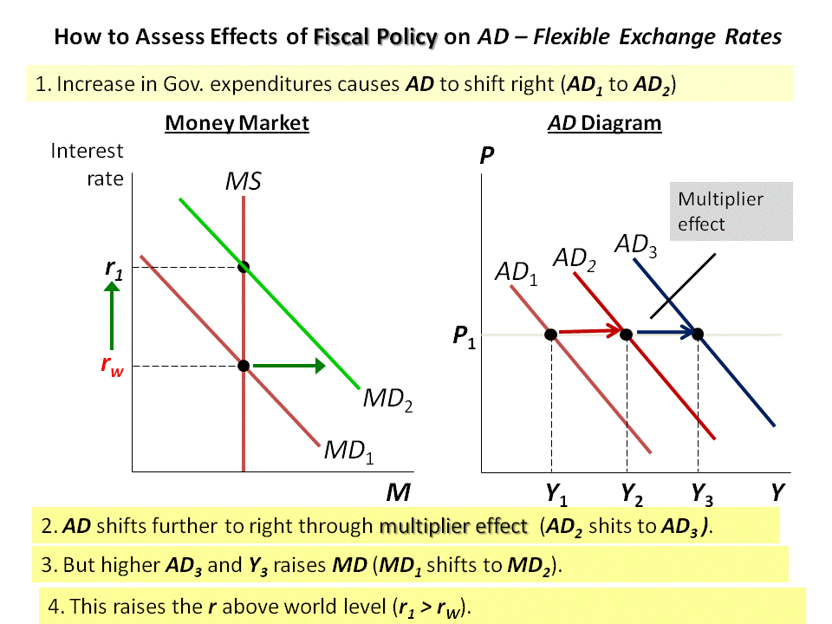

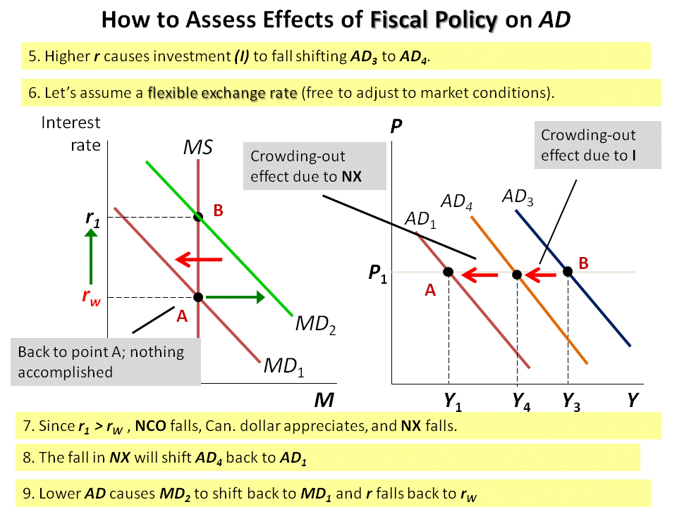

b. Fixed Exchange Rates

For steps 1 to 8 see the diagrams below.

1. How can the Bank of Canada prevent the two crowding-out effects)?

2. By injecting Canadian dollars in the foreign exchange market to prevent the appreciation of the Canadian dollar.

3. This also has the effect of increasing the money supply preventing the interest rate from rising above the world level (MS shifts right as the BOC increases money supply).

4. By raising the money supply to MS₂, the BOC can stop the Canadian interest rate from rising above the world level.

5. The injection of Canadian dollars by the BOC on the foreign exchange market eliminates the crowding out effect due to net exports.

6. The increase in money supply preventing the interest rate from rising eliminates the crowding out effect due to investment.

7. Therefore, with accommodating BOC monetary policy (i.e., an injection of Canadian dollars on the foreign exchange market to fix the exchange rate at its current level), the two crowding out effects are fully offset by monetary policy.

8. Without the two crowding out effects, aggregate demand rises from AD₁ to AD₃ – see last diagram.

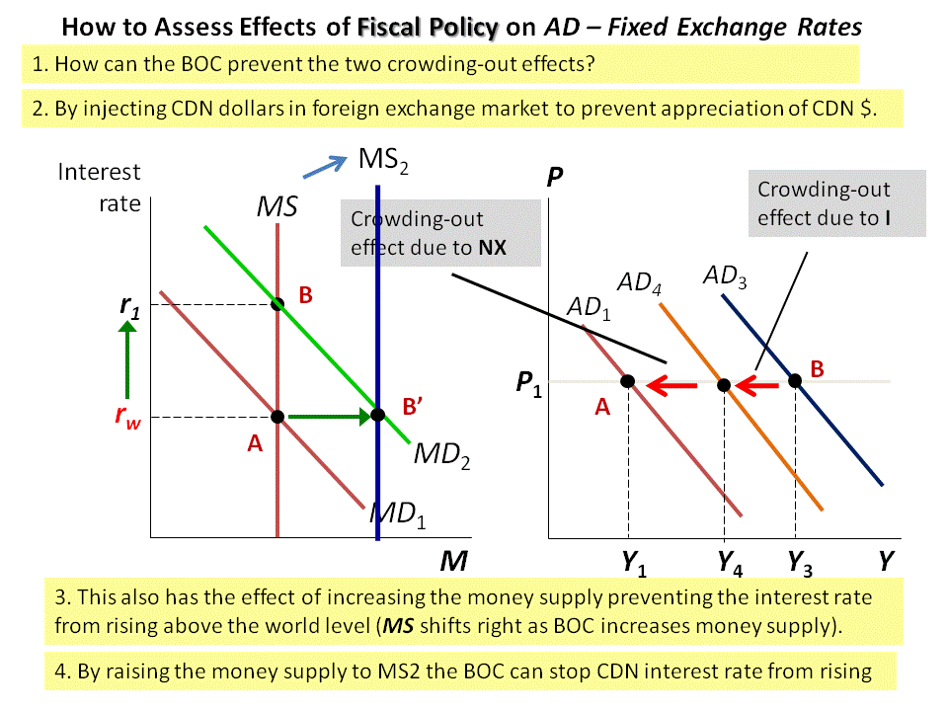

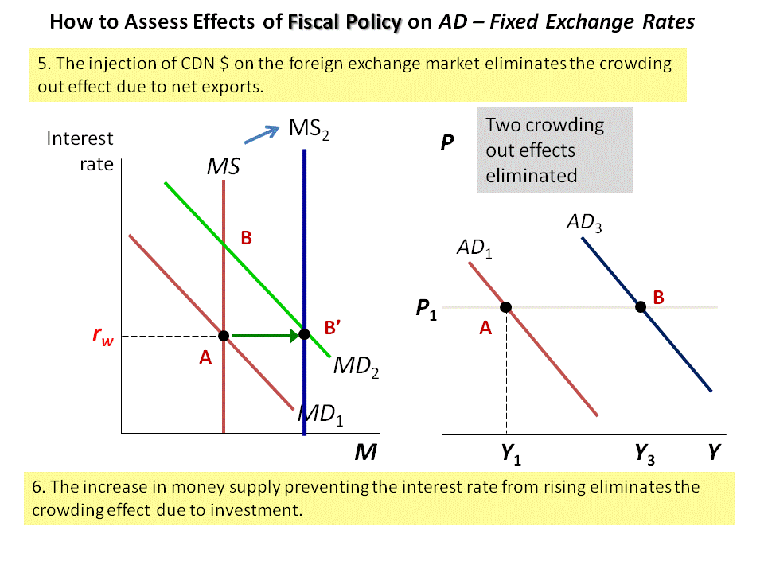

2. The Bank of Canada currently targets 2% inflation. Would it be a good idea or a bad idea for the Bank of Canada to target 10% inflation instead?
a. Explain the effects of this change on: the growth rate of the money supply; nominal and real interest rates; nominal and real income.
b. Explain the effects on creditors and debtors.
c. Explain the costs and/or benefits of this increase in the inflation rate.

Answer

Preamble (the following has to be mentioned in a preamble or alternatively has to be mentioned when responding to items a, b and c): Most economists believe that the classical dichotomy and neutrality of money describe the economy in the long run. The classical dichotomy states that there is a theoretical separation between nominal and real variables. And, monetary neutrality is the proposition that changes in the money supply affect only nominal variables but not real variables.

Therefore, inflation is the product of monetary developments. Real variables are largely independent of the monetary system and are determined by productivity and real changes in the factor and loanable funds markets.

In essence, the growth in output, real income and a nation’s standard of living (i.e., growth in real GDP per capita) is independent of monetary policy and the rate of inflation. In other words, whether the Bank of Canada targets a rate of inflation of 2% or 10%, this will not affect the economy’s long run output and income.

In the short run, however, monetary policy can affect real variables. An expansionary monetary policy, implied by the BOC’s increased target rate of inflation, would temporally increase output and decrease unemployment. With time, output and the unemployment rate would fall back to their natural long- run levels, determined essentially by productivity, the loanable funds market, the factor market and the labour market.

This can best be illustrated by the following Phillips Curve Diagram.

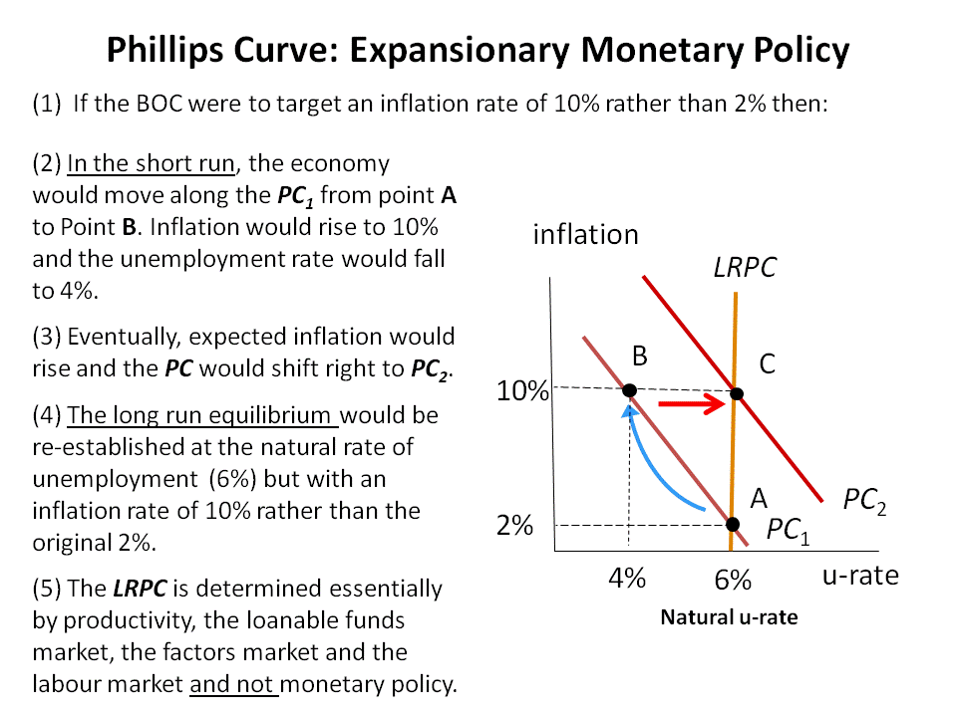

a. Growth rate of the money supply: According to the classical theory of inflation, increases in money supply create inflation. Monetary developments do not affect real variables in the long run. Hence, an increase in inflation from 2% to 10% would involve an increase in the growth of the money supply.

Nominal and real interest rates: According to Fisher, nominal interest rates are determined as follows:

Nominal interest rate = real interest rate + rate of inflation.

There is a one-for-one adjustment of the nominal interest rate to the rate of inflation. The real interest rate is a function of national saving and investment. Hence, an increase in inflation from 2% to 10% would raise the nominal interest rate by 8 percentage points and leave the real interest rate unchanged.

Nominal and real income: Most people think that inflation erodes real income (the inflation fallacy). This is not usually the case. Inflation is a general increase in prices of the things people buy and the things they sell (e.g. their labour). As long as nominal wages rise along with inflation – which tends to be the case – real incomes will be unaffected. Hence, an increase in inflation from 2% to 10% would raise the rate of growth of nominal income from 2% to 10% (an increase of 8 percentage points. Real incomes will be unaffected.

b. Arbitrary redistributions of wealth: Higher-than-expected inflation transfers purchasing power from creditors to debtors. It rewards debtors and is detrimental to lenders. Debtors get to repay their debt with dollars that aren’t worth as much. This redistribution occurs because loans are specified in terms of the unit of account (money) -- not indexed to inflation. Hence, an increase in the target rate of inflation from 2% to 10% would benefit debtors (the borrowers) and be detrimental to creditors (the lenders).

c. Economists who favour a low inflation rate target of about 2% would argue as follows.

(1) Inflation confers no benefits on society, but it poses real costs. The costs of inflation are permanent. These include the following range of costs:

(2) Shoeleather costs: the resources wasted when inflation encourages people to reduce their money holdings which include the time and transactions costs of more frequent bank withdrawals.
(3) Menu costs: the costs of constantly changing prices requiring the printing of new menus, mailing new catalogs, etc.
(4) Misallocation of resources due to relative-price variability: Firms don’t all raise prices at the same time, so relative prices can vary, which distorts the allocation of resources.

(5) Distortions in the tax code: Inflation makes nominal income grow faster than real income. Taxes are based on nominal income, and some are not adjusted for inflation. So, inflation causes people to pay more taxes even when their real incomes don’t change (if not adjusted for inflation).

(6) Arbitrary redistribution of wealth from unexpected inflation: Unexpected inflation redistributes wealth among the population in a way that has nothing to do with either merit or need. Inflation rewards debtors and is detrimental to lenders. (Deflation rewards lenders and is detrimental to debtors.)

(7) Confusion & inconvenience: Inflation changes the yardstick one uses to measure transactions. It complicates long-range planning and the comparison of dollar amounts over time. It is more difficult to compare real revenues, costs, and profits over time.
Economists who would not be overly concerned with an inflation rate target of 10% would argue as follows.

(1) The benefits of low inflation are small relative to the costs of maintaining inflation low. The costs of reducing inflation involve high social costs in terms of output and high unemployment (Phillips Curve tradeoff).

(2) The costs of maintaining low inflation are borne by the workers with the lowest level of skills and experience who lose their jobs when central banks adopt deflationary policies. Moreover, when workers become unemployed, they lose valuable job skills.

(3) Deflationary policies leave permanent effects. Investment falls, lowering the future capital stock.

(4) Policymakers may be able to lower the costs of inflation (by indexation, for example).
(5) In the long run, real incomes are determined by real variables, not the inflation rate.
(6) The costs of inflation are quite high for economies experiencing hyperinflation. But for economies with low inflation (equal or less than 10% per year), these costs are small.

3. Draw a diagram showing the Aggregate Demand curve, Long Run Aggregate Supply curve, and Short Run Aggregate Supply curve.
a. Explain one theory why the SRAS curve has a different slope to the LRAS curve.
b. Use this diagram to explain why governments might wish to use monetary and/or fiscal policy for macroeconomic stabilization.
c. Explain some of the difficulties of using monetary and/or fiscal policy for macroeconomic stabilization.

Answer

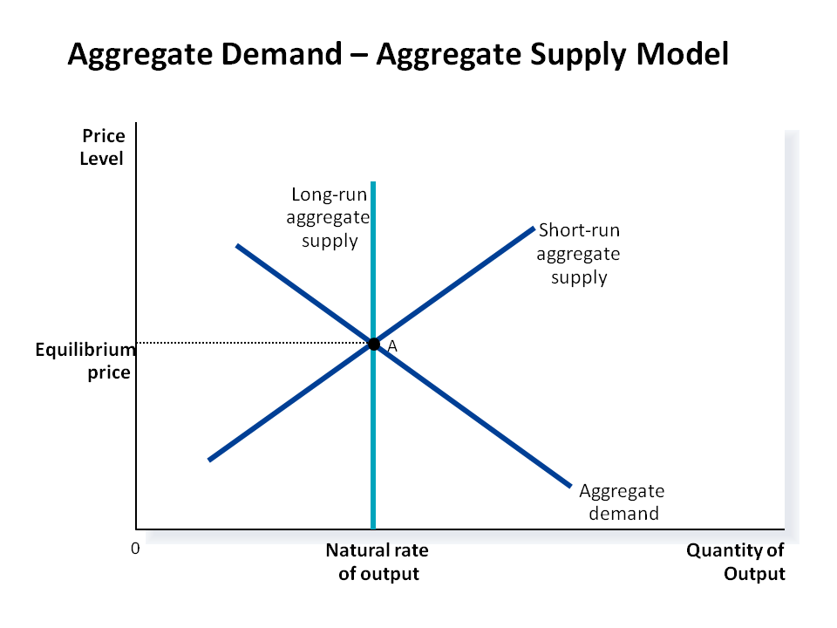

a. Three economic theories have been put forward to explain the slope of the SRAS which is upward sloping compared to the LRAS curve which is vertical at the natural rate of output. In addition, there is a fourth theory based on “price expectations” , which combines elements of the first three theories.

Answer requires an explanation of one of the four theories described below

The Sticky-Wage Theory

Premise: Nominal wages are slow to adjust, or are “sticky” in the short run
Example: Let say that nominal wages are set for 3 years based on price
expectations
Assume: There is an unanticipated fall in prices
        - Since real wages = W/P
        - If actual prices fall, then real wages will rise
Result: If nominal wages are sticky (don’t change)
This makes employment/ production less profitable (real wages are higher)
        - Firms respond by hiring less labour
        - And reduce output supplied

The Sticky-Price Theory

Premise: Nominal prices are slow to adjust, or are “sticky” in the short run
Example: Let say that prices are set in advance
Assume: There is an unanticipated fall in prices
Result: If nominal prices are sticky
Some firms lag in adjusting their prices downward
Their sales decline
Makes employment/ production less profitable
        - Firms respond by hiring less labour
        - And reduce output supplied

Misperceptions Theory

Premise: changes in overall price level temporarily mislead suppliers about
what is happening in their individual markets
Example: Let’s say that the overall price level falls
And producers see their individual prices fall
Assume: Producers believe their relative prices have fallen (i.e., they believe their prices have fallen but that the general price level has not)
Result: From this, they infer that profits will decline
Will make employment/ production less profitable
- Firms respond by hiring less labour
- And reduce output supplied

“Price Expectations” ; What the 3 Theories Have in Common

Economists introduced the notion of “expected prices” to develop a mathematical formulation of the SRAS. Each of the 3 theories above implies that the quantity supplied deviates from the natural rate of output when actual prices deviate from expected prices as follows:
Quantity of output supplied | = | Natural rate of output | + | a (Actual price level – Expected price level)
Or Y = Y_{N} + a (P – P_{E})

The above equation defines an upward sloping supply curve.

If P > P_{E} , then a (P – P_{E}) is positive. Therefore, Y > Y_{N} .

If P < P_{E} , then a (P – P_{E}) is negative and Y < Y_{N} .

If P = P_{E} then a (P – P_{E}) is 0 and Y = Y_{N} . In other words, the SRAS curve intersects the LRAS where actual prices are equal to expected prices. For each expected price level, there is a separate SRAS curve, with expected prices equal to actual prices at the point of intersection with the LRAS.

The imperfections in these theories are temporary. Over time, sticky wages and sticky prices become flexible and misperceptions are corrected. In the long run, P = P_{E} and the AS curve is vertical at the natural rate of output.

b. (i) Adverse Shift in Aggregate Demand
The diagram below illustrates the short-run effects of a recession due to a fall in aggregate demand. The economy starts at point A on the aggregate-demand curve AD₁ and the short-run aggregate-supply curve SRAS₁. The decline in aggregate demand shifts the aggregate-demand curve from AD₁ to AD₂ and the economy moves to point B. Total output falls from Y₁ to Y₂, and so does income and employment fall as well.

With no policy changes, the economy will restore itself gradually over time. The recession will induce declines in wages, so the cost of production will decline. In turn, this will feed into price expectations which will also decline, thereby shifting the short-run aggregate-supply curve to the right to SRAS₂. The economy will end up at point C, with a lower price level, but with output back at Y₁. However, this process could take time and take even years to complete. If policymakers are passive, the economy will eventually restore itself, but could do so very slowly.

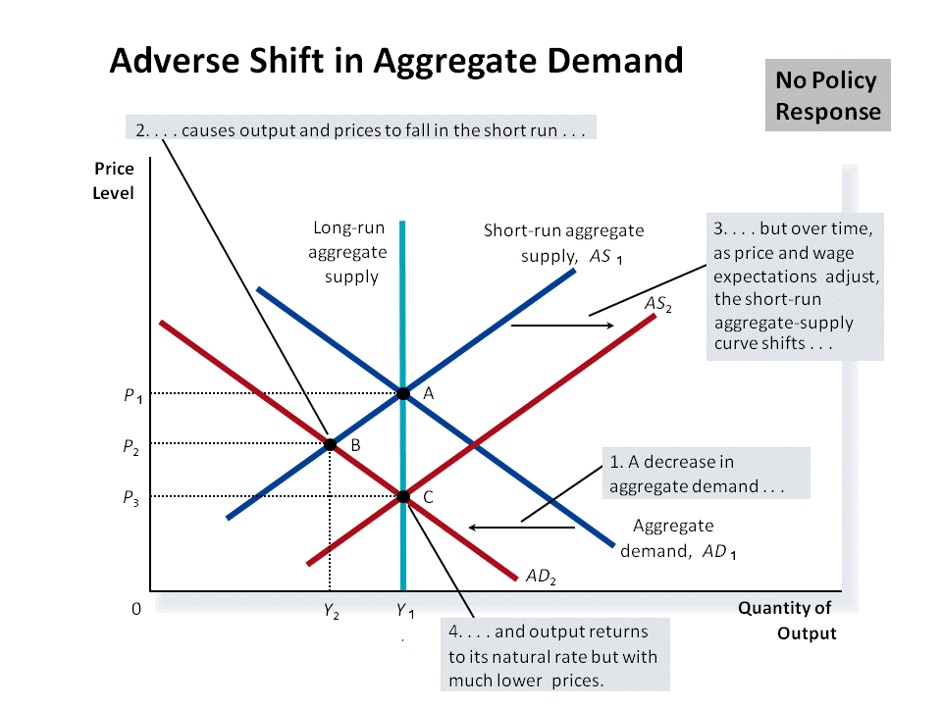

By using expansionary monetary and/or fiscal policy, policymakers can shift the aggregate demand curve to the right. In so doing, they can get the economy back to the long-run equilibrium much more quickly. With reference to the diagram below, it would mean shifting the aggregate demand curve from AD₂ back to AD₁ (and moving from point B back to point A).

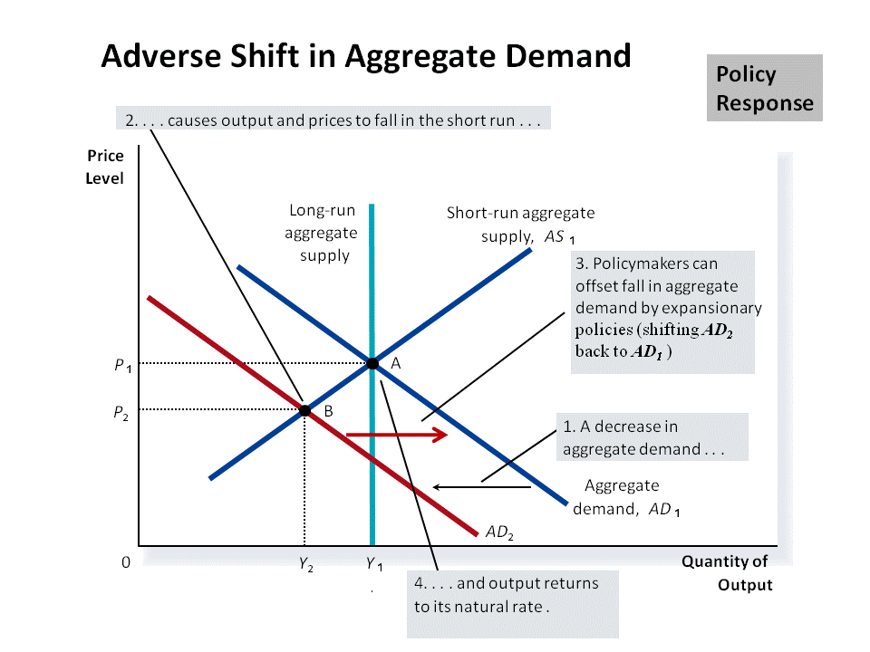

(ii) Adverse Shift in Aggregate Supply
The diagram below illustrates the short-run effect of a recession due to a fall in aggregate supply. The economy starts at point A on the aggregate-demand curve AD₁ and the short-run aggregate-supply curve SRAS₁. The decline in aggregate supply shifts the aggregate-supply curve from AS₁ to AS₂ and the economy moves to point B. The result is stagflation: output falls from Y₁ to Y₂, and the price level rises from P₁ to P₂.

The government could wait for the economy to adjust itself. The low level of output and employment would eventually put downward pressure on workers’ wages. Price and wage expectations would adjust and the SRAS₂ would gradually shift to the left. As it shifts back toward SRAS₁, the price level falls, and the quantity of output approaches its natural rate. In the long run, the economy returns to point A.

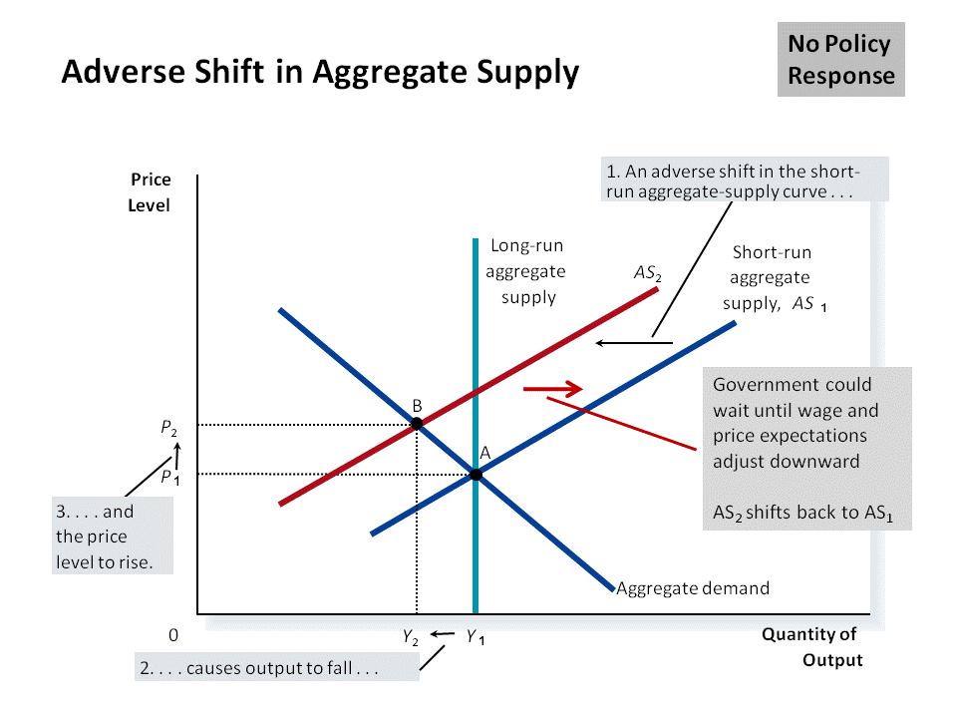

However, this process could take considerable amount of time. Therefore, policymakers could attempt to offset some of the effects of the shift in the short-run aggregate- supply curve by shifting the aggregate-demand curve to the right by using expansionary monetary and fiscal policy. In sum, policymakers could shift the aggregate-demand curve from AD₁ to AD₂ as shown in the diagram below.

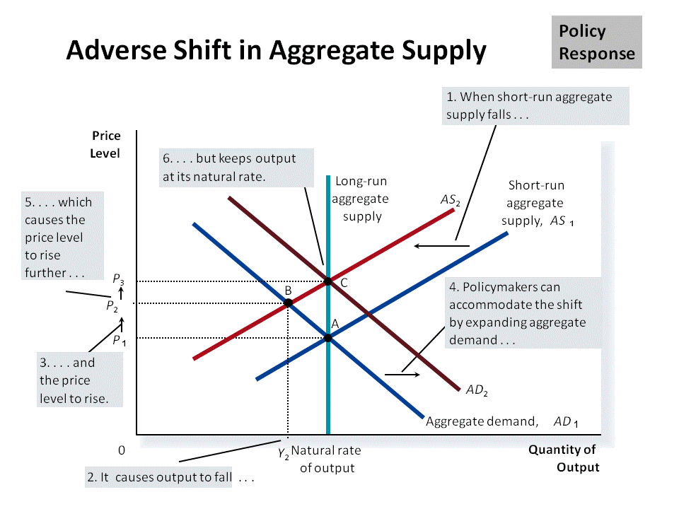

With expansionary policies, the economy would move from point B to point C. Output would return to its natural rate of output but the expansionary policy would increase prices further from P₂ to P₃. In sum, policymakers would have to accept a permanently higher level of prices.

To recap, adverse shifts in aggregate supply cause stagflation and policymakers can potentially mitigate the adverse impact on output, but only at the cost of exacerbating the problem of inflation.

c. (1) There is a debate among economists whether the government and the Bank of Canada should let markets and the economy adjust by themselves, or should the government and the BOC intervene with monetary and fiscal policy to reduce or eliminate economic fluctuations. The debate centers on the effectiveness of monetary and fiscal policies.

(2) Monetary policy affects the economy with lags. Studies tend to indicate that it takes six months for monetary policy to have an effect on aggregate demand.

(3) Fiscal policy works with lags because of the political process that governs changes in spending and taxes. It takes time for Parliament to propose, pass and implement major changes in fiscal policy.

(4) Both monetary and fiscal policies are prone to lags, but the lags are different for the two types of policy. Monetary policy can be enacted quickly, but since it works through changes in interest rates and investment, it may take months to have an impact. Fiscal policy has an immediate impact, but takes a long time to enact.

(5) The use of monetary and fiscal policy may act to destabilize the economy. The ability to forecast future economic conditions and take appropriate action well ahead is difficult. The economy might have already recovered by the time the fiscal and monetary measures take effect. Even worse they could destabilize the economy (i.e., could lead to inflationary spirals).

(6) While there are lags associated with monetary and fiscal policy, there are also lags associated with how quickly an economy can adjust itself without accommodating monetary and fiscal policy.

(7) If expectations adjust slowly, it will take longer for an economy to return to its natural rates of output and employment. In that case, there is a better chance that expansionary policy will act in time to alleviate a recession, rather than push the economy into an inflationary boom.

(8)If expectations adjust quickly, it is better to leave the economy to adjust by itself. By the time expansionary policy is implemented, the economy would have already recovered by itself and the expansionary policy would simply destabilize the economy.

