Marketing Final Review
Chapter 5
Marketing Information: is fresh and deep insights into customers needs and wants. Its difficult to obtain, not obvious and even customers are unsure of why they behave the way they do. Better information not more is more effective use of existing information.
Marketing Information system
Consists of people and procedures for
- assessing information needs
- developing the needed information
- helping decision makers to use the information to generate and validate actionable customer and market insights
MIS provides information to the marketing managers as well as helps third parties (suppliers, retailers, partners)

A good MIS balances the information users would like to have against what they really need and what is feasible to offer.

Marketers obtain information from
- Internal Data
Internal databases are electronic collections of consumer and market information obtained from data sources within the company network. (Accounting, Sales reporting system, Operations/production)
- Marketing Intelligence
Marketing intelligence is the systematic collection and analysis of publicly available information about consumers, competitors and developments in the marketplace
- Marketing Research
Marketing research is the systematic design, collection, analysis, and reporting of data relevant to a specific marketing situation facing an organization.

- Observational research involves gathering primary data by observing relevant people, actions, and situations

- Ethnographic research involves sending trained observers to watch and interact with consumers in their natural environment

Research process
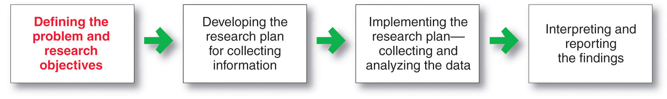

Types of Research objectives
Exploratory research: Marketing research gathers preliminary information that will help define problems and suggest hypotheses.
Descriptive research: Marketing research to better describe marketing problems, situations, or markets, such as the market potential for a product or the demographics and attitudes of consumers.
Survey research is the most widely used method and is best for descriptive information, knowledge, attitudes, preferences, and buying behaviour
Causal research: Marketing research to test hypotheses about cause and effect relationships.
Experimental research is best for gathering causal information—cause-and-effect relationships
Marketing research strengths
 | Mail | Telephone | Personal | Online
Flexibility | Poor | Good | Excellent | Good
Quantity of data collected | Good | Fair | Excellent | Good
Control of interviewer effects | Excellent | Fair | Poor | Fair
Control of sample | Fair | Excellent | Good | Excellent
Speed of data collection | Poor | Excellent | Good | Excellent
Response rate | Poor | Poor | Good | Good
Cost | Good | Fair | Poor | Excellent

Online Research

Types of samples
Probability Sample
Simple random sample | Every member of the population has a known and equal chance of selection
Stratified random sample | The population is divided into mutually exclusive groups and random samples are drawn from each group
Cluster (area) sample | The population is divided into mutually exclusive groups and the researcher draws a sample
Nonprobability Sample
Convenience sample | The research selects the easiest population members
Judgment sample | The researcher uses their judgment to select population members
Quota sample | The researcher finds and interviews a prescribed number of people in each of several categories

Questionnaires
- Most common
- Administered in person, by phone, or online
- Flexible
- Research must be careful with wording and ordering of questions

- CRM consists of sophisticated software and analytical tools that integrate customer information from all sources, analyze it in depth, and apply the results to build stronger customer relationships

Chapter 10

There are two ways to obtain new products
- Acquisition refers to the buying of a whole company, a patent, or a license to produce someone else’s product
- New product development refers to original products, product improvements, product modifications, and new brands developed from the firm’s own research and development

Why do so many new products fail?

*Stages to New product development*

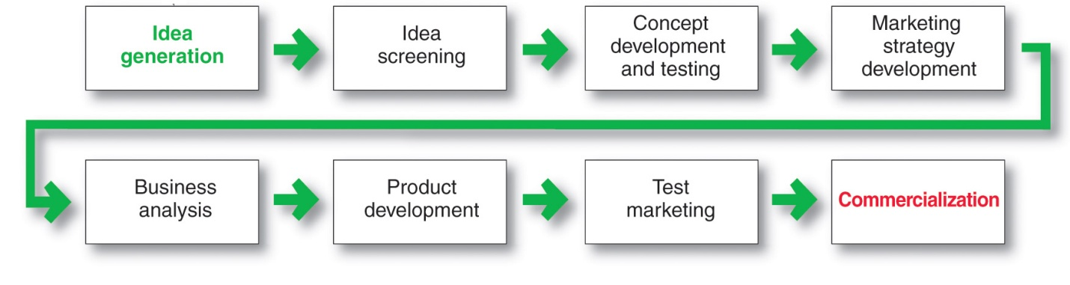

Idea Generation
- Internal sources refer to the company’s own formal research and development, management and staff, and entrepreneurial programs
- External sources refer to sources outside the company such as customers, competitors, distributors, suppliers, and outside design firms

Concept development and testing
Product idea is an idea for a possible product that the company can see itself offering to the market
Product concept is a detailed version of the idea stated in meaningful consumer terms
Product image is the way consumers perceive an actual or potential product

Marketing strategy development refers to the initial marketing strategy for introducing the product to the market

Marketing strategy statement includes:
- Description of the target market
- Value proposition
- Sales and profit goals

Business analysis
A review of the sales, costs and profit projections for a new product to find out whether these factors satisfy the company’s objectives.

Product development
Developing the product concept into a physical product to ensure that the product idea can be turned into a workable market offering.

Test Marketing
The stage of new-product development in which the product and marketing program are tested in realistic market settings.

Types of test markets
- Standard test markets
-Companies find small number of representative test cities, conduct full marketing campaigns, use store audits, consumer surveys and other measures to gauge product performance. Most used method today, however they are shifting to quicker cheaper alternatives.
-Disadvantages of this method are
    - Costly
    - Long time
    - Competitors can monitor results as well as skew them with dropping their prices.
    - Gives competitors a chance to view product and even create their own version or defensive strategy to compete with it.
- Controlled test markets
-A specifically chosen group of shoppers are chosen and are given cards to present at the checkout line of stores they frequent. These cards keep track of the consumer’s purchases in stores where the new product is being sold.

-This method is cheaper and faster to gain results than the standard test but still has the set back that competitors can view their new product and replicate it. As well firms have to adjust data to project market trends in larger markets to make up for any potential bias the smaller controlled test would present.

- Simulated test markets
  - Advantages of simulated test markets
    - Less expensive than other test methods
    - Faster
    - Restricts access by competitors
- Disadvantages
    - Not considered as reliable and accurate due to the controlled setting

Successful new product development should be
- Customer centered
- Team centered
- Systematic

Four types of new product development
- Customer-centered new product development focuses on finding new ways to solve customer problems and create more customer satisfying experiences. Begins and ends with solving customer problems
- Sequential new-product development is a development approach where company departments work closely together individually to complete each stage of the process before passing it along to the next department or stage. Increased control in risky or complex projects. Can be dangerously slow
- Team-based new-product development is a development approach where company departments work closely together in cross-functional teams, overlapping in the product-development process to save time and increase effectiveness.
- Systematic new-product development is an innovative development approach that collects, reviews, evaluates, and manages new-product ideas. Creates an innovation-oriented culture. Yields a large number of new-product ideas.

Stages of product life cycle
- Product development
  - Sales are zero and investment costs mount
- Introduction
  - Slow sales growth and profits are nonexistent
Objective is to create product awareness and trial
  - Offer a basic product
  - Use cost-plus pricing
  - Build selective distribution
  - Build product awareness among early adopters and dealers
  - Use heavy sales promotions to entice trial.
- Growth
  - Rapid market acceptance and increasing profits.
Objective is to maximize market share
  - Offer product extensions, service, warranty
  - Price to penetrate market
  - Build intensive distribution
  - Build awareness and interest in the mass market
  - Reduce sales promotion to take advantage of heavy consumer damage.
- Maturity
  - Slowdown in sales growth and profits level off or decline
Objective is to maximize profit while defending market share
  - Diversify product brand and models
  - Price to match or beat competitors
  - Build more intensive distribution
  - Stress brand differences and benefits
  - Increase sales promotion to encourage brand switching
Market modifying tries to increase consumption of the current product – looking for new users and market segments or inventing new uses for existing products
Product modifying changes characteristics of products such as quality, features, style, or packaging to attract new users and to inspire more usage.
Modifying the Marketing Mix involves improving sales by changing one or more of the marketing mix elements
- Offer new or improved services to buyers
- Cut prices to attract new users and competitor’s customers
- Launch a better advertising campaign or aggressive sales promotion
- Move into new marketing channels

- Decline
  - Sales fall off and profits drop
Objective is to reduce expenditure and milk the brand
  - Phase out weak items
  - Cut prices
  - Selective distribution – phase out unprofitable outlets
  - Reduce advertising to level needed to retain hardcore loyalists
  - Reduce sales promotion to minimal level.
Carrying a weak product can be costly to a firm. Companies must decide what to do with declining products.
- Maintain the brand without change in the hope that competitors will leave the industry
- Harvest the product by reducing various costs and hoping that sales hold up
- Drop the product from the line

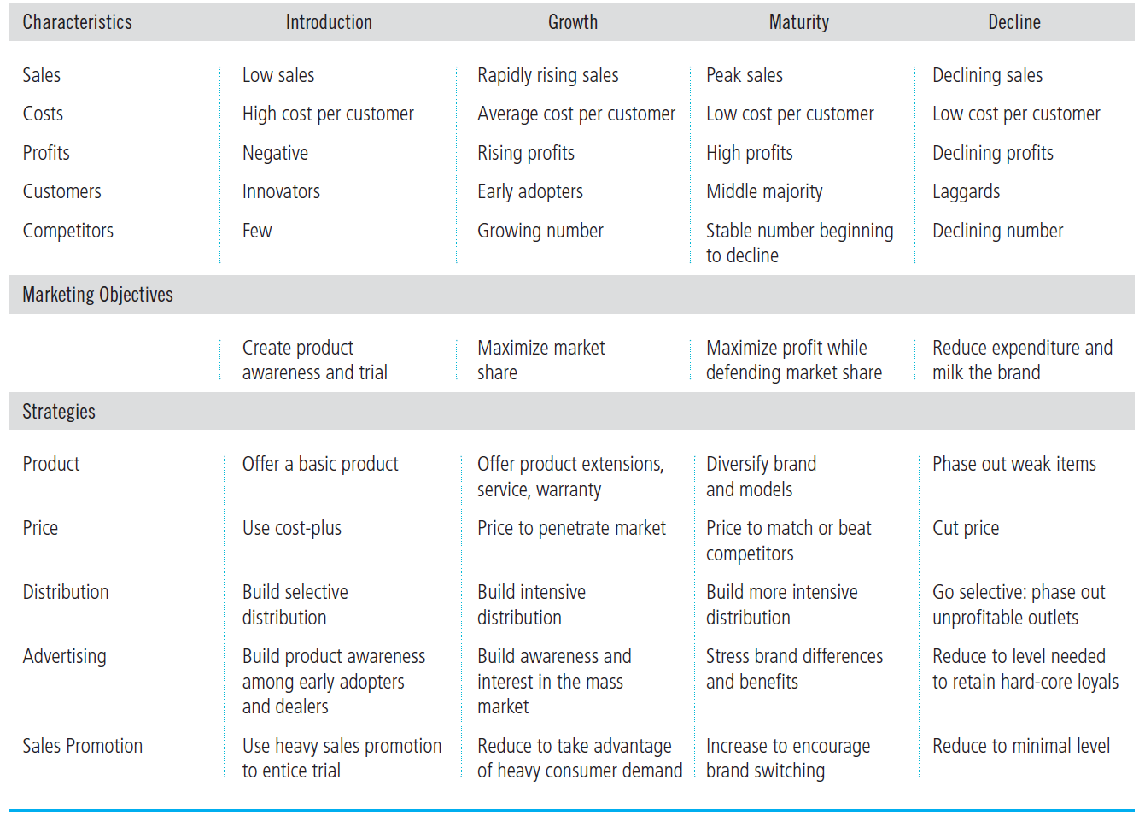

International product and services marketing
- Standardization helps a company develop a consistent worldwide image. It also lowers the product design, manufacturing, and marketing costs of offering a large variety of products. However markets and consumers around the world differ widely. Companies must usually respond to these differences by adapting their product offerings.

Chapter 11

Customers perception of value
Value-based pricing uses the buyers’ perceptions of value, not the sellers’ cost, as the key to pricing. Price is considered before the marketing program is set.
- Value-based pricing is customer driven
- Cost-based pricing is product driven

Cost-based pricing involves setting prices based on the costs for producing, distributing, and selling the product plus a fair rate of return for its effort and risk

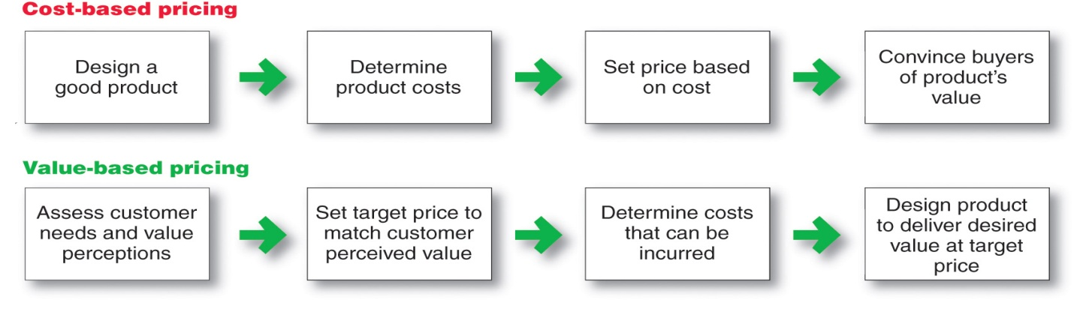
Good-value pricing offers the right combination of quality and good service to fair price
Existing brands are being redesigned to offer more quality for a given price or the same quality for less price

Value-added pricing attaches value-added features and services to differentiate offers, support higher prices, and build pricing power. Pricing power is the ability to escape price competition and to justify higher prices and margins without losing market share.

Cost-plus pricing adds a standard markup to the cost of the product. It’s the simplest pricing method.
Benefits
- Sellers are certain about costs
- Prices are similar in industry and price competition is minimized
- Consumer’s feel it is fair
Disadvantages
- Ignores demand and competitor prices
Break-even pricing or target profit pricing prices products at the point that they will break even or make their targeted profits. GM and utility companies use this method.

Break even volume = $\frac{Fixed costs}{Price-Variable costs}$

Things to consider when setting price
- Customer perceptions of value set the upper limit for prices, and costs set the lower limit
- Companies must consider internal and external factors when setting prices
- Comparison of offering in terms of customer value
- Strength of competitors
- Competition pricing strategies
- Customer price sensitivity
- Economic conditions
- Reseller’s response to price
- Government
- Social concerns

Organizational considerations include:
- Who should set the price
- Who can influence the prices

Under pure competition, the market consists of many buyers and sellers trading in a uniform commodity
Under monopolistic competition, the market consists of many buyers and sellers who trade over a range of prices
Under oligopolistic competition, the market consists of a few sellers who are highly sensitive to each other’s pricing and marketing strategies
Under pure monopoly, the market consists of one seller

Price elasticity of demand illustrates the response of demand to a change in price
Inelastic demand occurs when demand hardly changes when there is a small change in price
Elastic demand occurs when demand changes greatly for a small change in price
Price elasticity of demand = % change in quantity demand
% change in price
Pricing strategies
Market Skimming pricing: Setting high price for a new product to skim maximum revenues. Company makes fewer but more profitable sales. Competitors should not be able to enter market easily.

Market penetration pricing: setting low price for a new product to attract a lot of buyers and large market share.

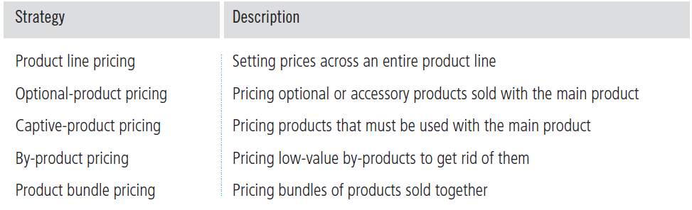

Two-part pricing: Is the same pricing strategy as captive product pricing but its for services. Involves breaking the price into fixed fee, Variable usage fee (for services such as movie theatre admission plus user fee of buying food. Cell phone plan plus user fee of extra minutes)

Segmenting pricing strategies
The types of segmented pricing are:
- Customer segment pricing is when different customers pay different prices for the same product or service.
- Product-form segment pricing is when different versions of the product are priced differently but not according to differences in cost.
- Location pricing is when the product sold in different geographic areas is priced differently even though the cost is the same.
- Time pricing varies by the season, the month, the day, and even the hour.

To be effective:
- Market must be segmentable
- Segments must show different degrees of demand
- Watching the market cannot exceed the extra revenue obtained from the price difference
- Must be legal

Promotional pricing strategies
- Loss leaders are products sold below cost to attract customers in the hope they will buy other items at normal markups.
- Special event pricing is used to attract customers during certain seasons or periods.
- Cash rebates are given to consumers who buy products within a specified time.
- Low-interest financing, longer warrantees, and free maintenance lower the consumer’s “total price.”

Geographical pricing
- FOB-origin (free on board) pricing means that the goods are delivered to the carrier and the title and responsibility passes to the customer
- Uniformed-delivered pricing means the company charges the same price plus freight to all customers, regardless of location
- Zone pricing means that the company sets up two or more zones where customers within a given zone pay a single total price
- Basing-point pricing means that a seller selects a given city as a “basing point” and charges all customers the freight cost associated from that city to the customer location, regardless of the city from which the goods are actually shipped
- Freight-absorption pricing means the seller absorbs all or part of the actual freight charge as an incentive to attract business in competitive markets.

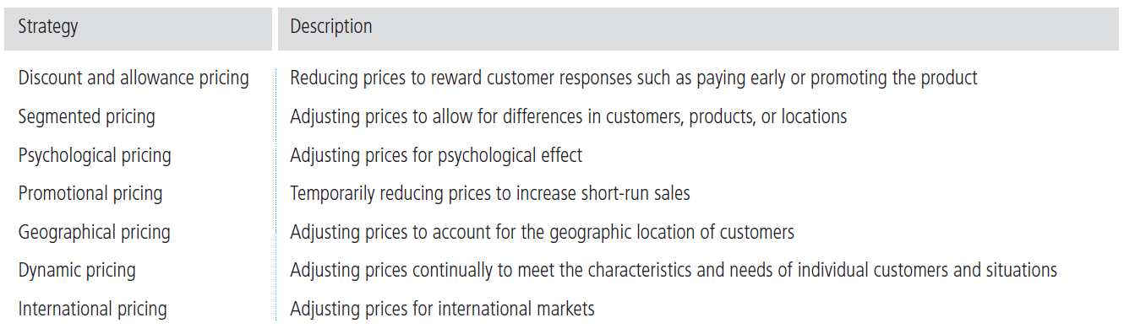

Price changes
Firm’s perspective

Techniques to avoid customer issues regarding price increases
- Maintain fairness when increasing price. Communicate to customers the reasons why.
- Reducing discounts, increasing minimum order sizes, dropping production on low margin products.

Customer perspective

Competitor’s perspective
Competitors are more likely to react when the number of firms involved is small, when the product is uniform, and when the buyers are well informed about products and prices. Firms could react by changing their own prices up or down.

Laws regarding pricing
Price fixing: Sellers must set prices without talking to competitors
Predatory pricing: Selling below cost with the intention of punishing a competitor or gaining higher long-term profits by putting competitors out of business

Retail (or resale) price maintenance: is when a manufacturer requires a dealer to charge a specific retail price for its products. (Like apple and its retailers)

