SOCI 2001 - CHAPTER ONE: GENERAL RESEARCH ORIENTATIONS

Theory is an explanation of observed regularities or patterns. For example, the finding that schizophrenia is more common in the working class then in the middle class, or that more men than women are alcoholics. Theories are composed of interrelated and verifiable statements or propositions.

Purpose of theory:
- To assess the adequacy of a particular social theory
- To gather information to create social theory
- To understand pressing social problems
- To explore personal experience
Three components of a theory:
- Definitions specify what the key terms in the theory mean; for example, “crime is any violation of the Canadian Criminal Code and includes arson, embezzling, etc.”
- Descriptions outlines the characteristics of the phenomena of interest; for example, 'Arson involves the illegal setting of fires and is often done at night, either to abandoned buildings or houses when no one is home. There are 438 cases of arson last year, with estimated damage over $2 billion.'
- Relation statements connect two or more variables, so that knowing the value of one variable conveys information about the other; for example, 'As the economy experiences a downturn, the arson rates increases'. Rational forms could be either deterministic or probabilistic.
Types of theories
Theories of middle range
- Theories that represent attempts to understand and explain a limited aspect of social life. Example of this would be Durkheim's theory of suicide, which maintains that suicide is the function of the level of social integration. Another example is Mertons anomie theory, which suggests that crime is more common when a society instils a desire for wealth in everyone but provides insufficient means for all to achieve it. It is limited in scope and could be tested directly.
Grand theories
- Theories that are general and abstract, cannot be tested directly. Includes theories such as structural functionalism, symbolic interactionism, critical theory, post-structuralism, feminism, and so on. They often collect few direct indications of how to collect evidence to test them, but they provide ways of looking at the world that can be inspiration for a wide variety of research programs. For example standpoint theory by Dorothy Smith, maintained that the way we the view the world and make our way in it is largely determined by our placement in various hierarchies of status and power.

Relationship between theory and research
Deductive theory
- One way to conduct social scientific inquiry is through deduction.
- Using deduction, one begins with a theory or explanation for something, then goes into the world and tests it.
- Represents most common type of theory in social research
- The researcher deduces a hypothesis that must then be subjected to empirical scrutiny.
- Embedded within the hypothesis are concepts that need to be translated into researchable entities, to specify how empirical data can be collected in relation to the concept that make it the hypothesis.
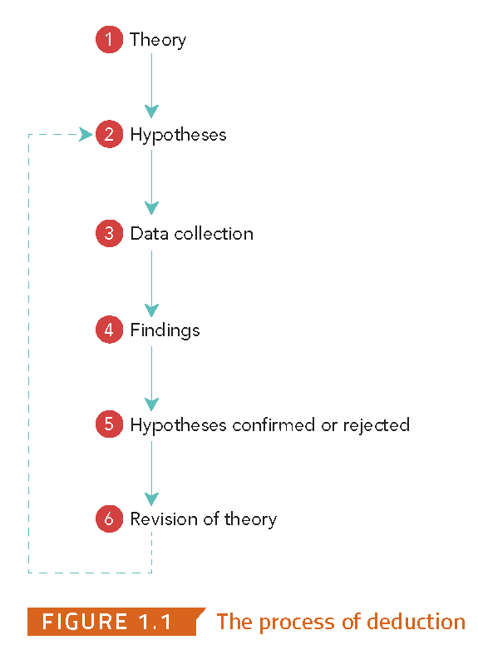

Inductive theory
- involves researchers examining their data and evaluating the implications of their findings for the theory that first promoted the whole exercise.
- Gathering data and tries to derive a theory or explanations from the data. Gathering a data comes first to construct a theory.
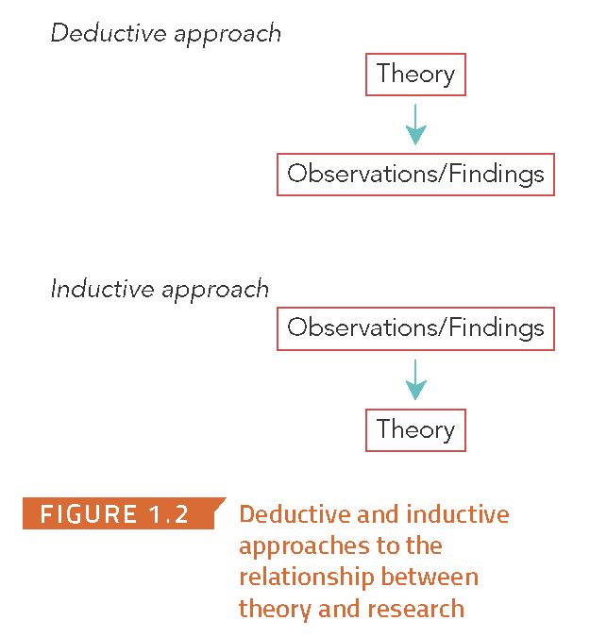

- Sometimes inductive research is iterative: the researcher goes back and forth from the data to the theory or explanation which can sometimes leads only to empirical generalization (generalizing a research finding is to apply it to people or groups who were not in the study = problem)
- grounded theory: Deriving theories or explanations from qualitative. It is grounded because the data has primacy over theory because the theme emerges from looking at the data after it has been collected. It asks 'how does this social space work?'
Epistemological positions: positivism
- notions of what can be known and how knowledge can be acquired.
- Knowledge must be based on information gathered through the senses (hearing, sight etc)
- A deductive approach (hypothesis testing) can be used to acquire knowlwdge.
- A key purpose of theory is to generate hypothesis that can be tested and theory and thereby allow explanations of observed laws and principles to be assessed (deduction).
- Science must be 'value free'- conducted in a way that different researchers given the same data will always reach the same conclusions aka intersubjectivity.
- In some instances induction may provide knowledge or generalization or laws.
- Relies on scientific statements not normative statements. No judgement attached, therefore intersubjectivity (objectivity) should be possible.
Epistemological positions: Interpretivism
- This natural observation approach is very limited in its ability to produce social knowledge.
- Researchers should use inductive methods to try to grasp the subjective meanings of people's actions.
- Actions should be viewed from the point of view of the social actors, i.e., the people studied.
- Researchers should develop an empathetic understanding of the people studied, sometimes referred to as verstehen (Weber).
- Interpret peoples actions and their social world from the point of view of actors.
- Social interactionism is an example of a sociological perspective that falls under the heading in interpretivism.
Epistemological positions: Ontological
- based on two debates:
- The first one asks, Do social phenomena have an objective reality, independent of our perceptions? Or is what passes for reality merely a set of mental constructions? If you answer 'yes' then you are an objectivist. These people maintain that there is such thing as social reality, and that it is the job of social scientists to discover what that reality is and therefore social reality is fixed; we have little or no control over it. If you disagree, you are a constructionist, such people maintain that there is no objective social reality against which our conceptions and views of the world may be tested (hard). Constructionist (soft), is where there is an objective social reality. However many of the ideas and perceptions are false because they have been constructed to justify some form of domination rather than the objective social reality. Therefore constructionist believe that they create their social worlds through our actions, in particular through negotiation.
Orientations: Qualitative and Quantitative research
Quantitative
- Uses numbers and statistics in the collection and analysis of data.
Qualitative
- Uses mainly words and other non-numeric symbols in the collection and analysis of data.

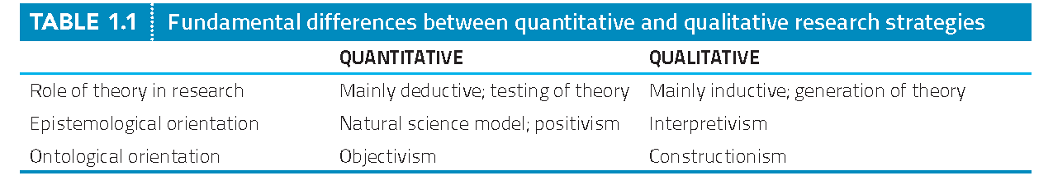

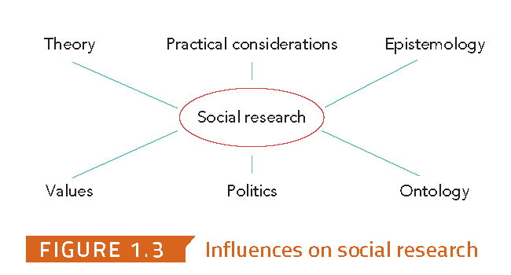

***CHECK SLIDES

