Chapter 11: Managing People for Service Advantage
11.1 Service Employees Are Extremely Important
Importance of Service Personnel
- Help maintain firm’s positioning. They are:
      - A core part of the product
      - The service firm
      - The brand
      - Affects sales
      - Determine productivity
- Frontline is an important driver of customer loyalty
      - Anticipate customer needs
      - Customize service delivery
      - Build personalized relationships

Front Line in Low-Contact Services
- Many routine transactions are now conducted without involving front-line staff, e.g.,
      - ATMs (Automated Teller Machines)
      - IVR (Interactive Voice Response) systems
      - Websites for reservations/ordering, payment etc.
- Though technology and self-service interface is becoming a key engine for service delivery, front-line employees remain crucially important
- “Moments of truth” affect customer’s views of the service firm

11.2 Frontline Work Is Difficult and Stressful
Boundary Spanning and Role Stress
- Boundary spanners link inside of organization to outside world and often experience role stress from multiple roles they have to perform
- 3 main causes of role stress:
      - Organization vs. Client: Dilemma whether to follow company rules or to satisfy customer demands
        - This conflict is especially acute in organizations that are not customer oriented
      - Person vs. Role: Conflicts between what jobs require and employee’s own personality and beliefs
      - Client vs. Client: Conflicts between customers that demand service staff intervention

Emotional Labor
- “The act of expressing socially desired emotions during service transactions” (Hochschild, The Managed Heart)
- Occurs when there is gap between what employees feel inside, and emotions that management requires them to display to customers
- Performing emotional labor in response to society’s or management’s display rules can be stressful
- Good HR practice emphasizes selective recruitment, training, counseling, strategies to alleviate stress
- “The act of expressing socially desired emotions during service transactions” (Hochschild, The Managed Heart)
- Occurs when there is gap between what employees feel inside, and emotions that management requires them to display to customers
- Performing emotional labor in response to society’s or management’s display rules can be stressful
- Good HR practice emphasizes selective recruitment, training, counseling, strategies to alleviate stress

11.3 Dimensions of the Service Environment
Cycles of Failure, Mediocrity, and Success
Cycle of Failure (Fig 11.6)
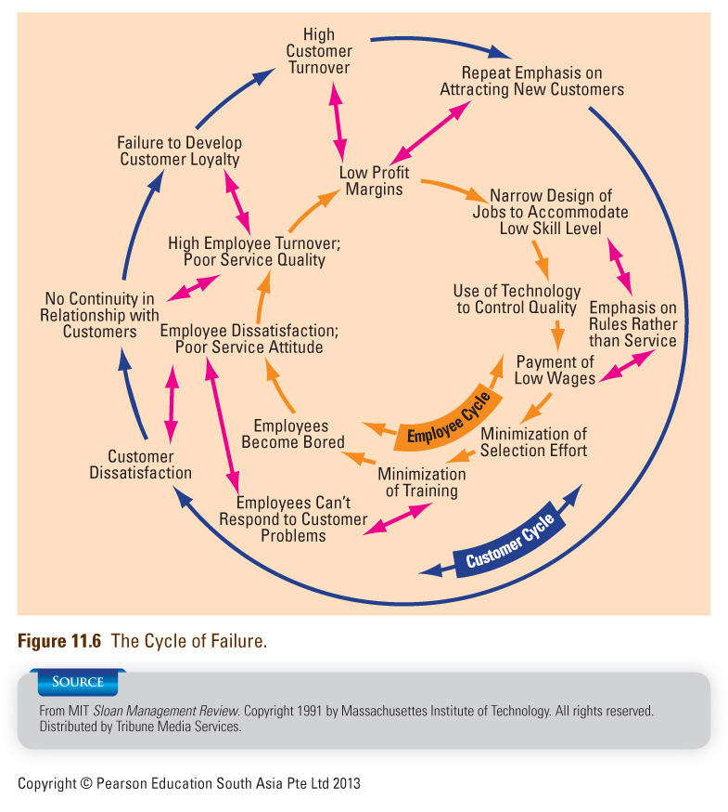
- The employee cycle of failure
      - Narrow job design for low skill levels
      - Emphasis on rules rather than service
      - Use of technology to control quality
      - Bored employees who lack ability to respond to customer problems
      - Dissatisfied with poor service attitude
      - Low service quality
      - High employee turnover
      - Repeated emphasis on attracting new customers
      - Customers dissatisfied with employee performance
      - Customers always served by new faces
      - Fast customer turnover
      - Ongoing search for new customers to maintain sales volume
      - Repeated emphasis on attracting new customers
      - Customers dissatisfied with employee performance
      - Customers always served by new faces
      - Fast customer turnover
      - Ongoing search for new customers to maintain sales volume
- Costs of short-sighted policies are ignored
      - Constant expense of recruiting, hiring, training
      - Lower productivity of inexperienced new workers
      - Higher costs of winning new customers to replace those lost—more need for advertising and promotional discounts
      - Loss of revenue stream from dissatisfied customers who go elsewhere
      - Loss of potential customers who are turned off by negative word-of-mouth

Cycle of Mediocrity (Fig 11.9)
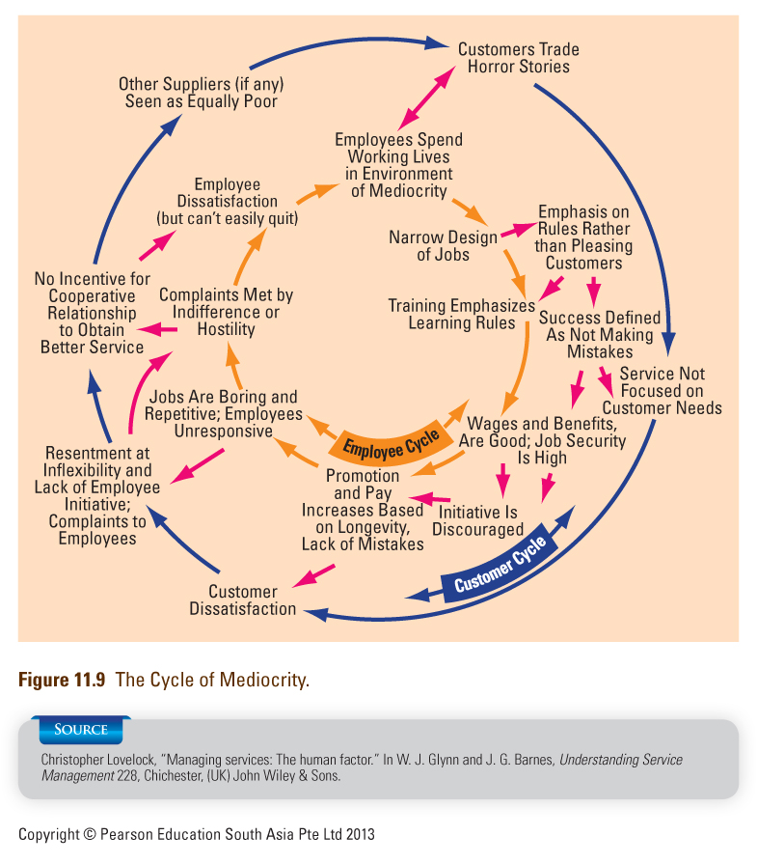
- Most commonly found in large, bureaucratic organizations
- Service delivery is oriented towards
      - Standardized service
      - Operational efficiencies
      - Promotions based on long service
      - Successful performance measured by
absence of mistakes
      - Rule-based training
      - Little freedom in narrow and repetitive jobs
- Customers find organizations frustrating to deal with
- Little incentive for customers to cooperate with organizations to achieve better service
- Complaints are often made to already unhappy employees
- Customers often stay because of lack of choice

Cycle of Success (Fig 11.11)
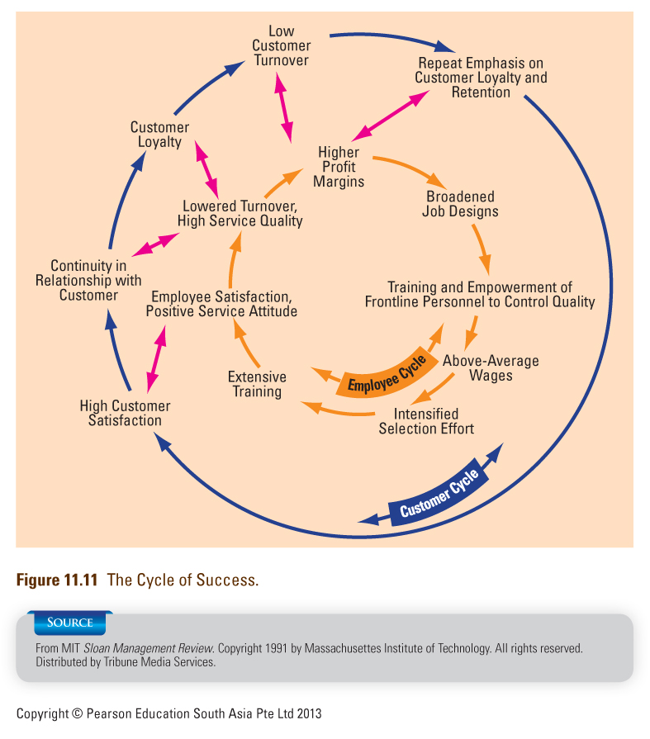
- Longer-term view of financial performance; firm seeks to prosper by investing in people
- Attractive pay and benefits attract better job applicants
- More focused recruitment, intensive training, and higher wages make it more likely that employees are:
      - Happier in their work
      - Provide higher quality, customer-pleasing service
- Broadened job descriptions with empowerment practices enable front-line staff to control quality, facilitate service recovery
- Regular customers more likely to remain loyal because:
      - Appreciate continuity in service relationships
      - Have higher satisfaction due to higher quality

11.4Human Resources Management ― How to Get It Right?
The Service Talent Cycle for Service Firms (Fig. 11.12)
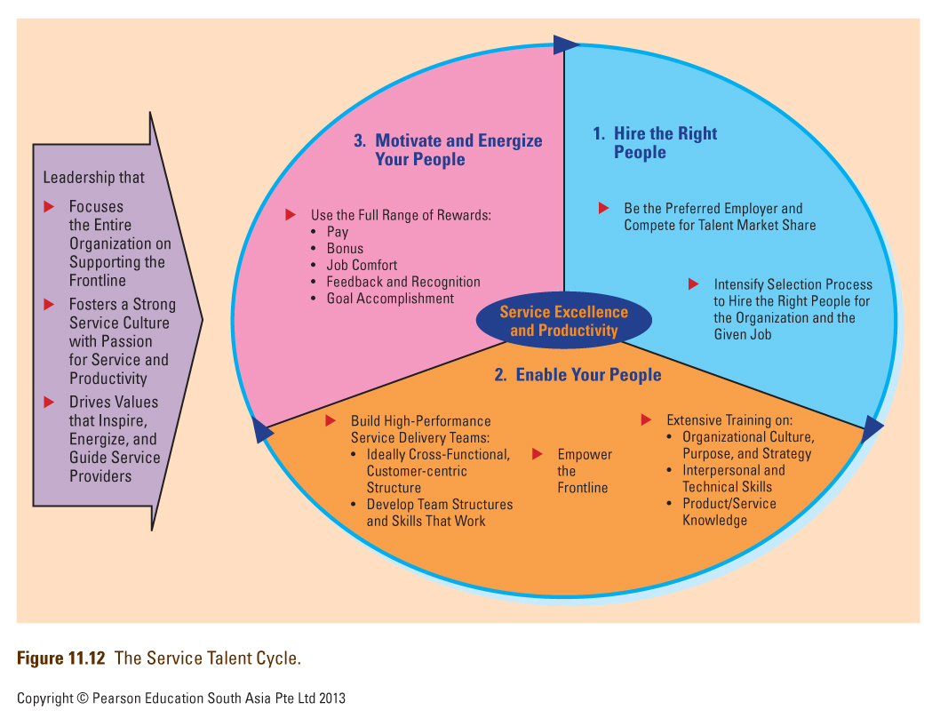

Hiring the Right People
- Be the Preferred Employer
      - Create a large pool: “Compete for Talent Market Share”
      - What determines a firm’s applicant pool?
        - Positive image in the community as place to work
        - Quality of its services
        - The firm’s perceived status
- Select the right people
      - There is no perfect employee
        - Different jobs are best filled by people with different skills, styles or personalities
        - Hire candidates that fit firm’s core values and culture
        - Focus on recruiting naturally warm personalities for customer-contact job
Tools to Identify the Best Candidates
- Employ multiple, structured interviews
      - Use structured interviews built around job requirements
      - Use more than one interviewer to reduce “similar to me” biases
- Observe candidate behavior
      - Hire based on observed behavior, not words you
hear
      - Best predictor of future behavior is past behavior
      - Hire those with service excellence awards and
complimentary letters
- Conduct personality tests
      - Willingness to treat co-workers and customers with courtesy, consideration and tact
      - Perceptiveness regarding customer needs
      - Ability to communicate accurately and pleasantly
- Give applicants a realistic preview of the job
      - Chance for candidates to “try on the job”
      - Assess how candidates respond to job realities
      - Allow candidates to self select themselves out of the job

Train Service Employees Actively
- Service employees need to learn:
- Organizational culture, purpose and strategy
      - Get emotional commitment to core strategy and core values
      - Get managers to teach “why”, “what” and “how” of job
- Interpersonal and technical skills
      - Both are necessary but neither alone is enough for performing a job well
- Product/service knowledge
      - Staff’s product knowledge is a key aspect of service quality
      - Staff must explain product features and help consumers make the right choice

Is Empowerment Always Appropriate?
- Empowerment is most appropriate when:
      - Firm’s business strategy is based on personalized, customized service and competitive differentiation
      - Emphasis on extended relationships rather than short-term transactions
      - Use of complex and non-routine technologies
      - Service failures are non-routine and cannot be designed out of the system
      - Business environment is unpredictable, consisting of surprises
      - Managers are comfortable letting employees work independently for benefit of firm and customers

Levels of Employee Involvement
- Suggestion involvement
      - Employee make recommendation through formalized programs
- Job involvement
      - Jobs redesigned
      - Employees retrained, supervisors
reoriented to facilitate performance
- High involvement
      - Information is shared
      - Employees skilled in teamwork,
problem solving etc.
      - Participate in management decisions
      - Profit sharing and stock ownership

Build High-Performance Service Delivery Teams
- Many service require cross-functional coordination for excellent service delivery
- Teams, training and empowerment go hand-in-hand
- Creating Successful Service Delivery Teams
      - Emphasis on cooperation, listening, coaching and encouraging one another
      - Understand how to air differences, tell hard truths, ask tough questions
      - Management needs to set up a structure to steer teams towards success

Motivate And Energize The Frontline
- Use full range of available rewards effectively, including:
  - Job content
      - People are motivated and satisfied knowing they are doing a good job
  - Feedback and recognition
      - People derive a sense of identity and belonging to an organization from feedback and recognition
  - Goal achievement
      - Specific, difficult but attainable and accepted goals are strong motivators

11.5 Service Leadership and Culture
Service Leadership and Culture
- Charismatic/transformational leadership:
      - Change front line’s values, goals to be consistent with firm
      - Motivate staff to perform their best
- Service culture can be defined as:
      - Shared perceptions of what is important
      - Shared values and beliefs of why they are important
- A strong service culture focuses the entire organization on the frontline and top management is informed and actively involved

The Inverted Organizational Pyramid (Fig. 11.25)
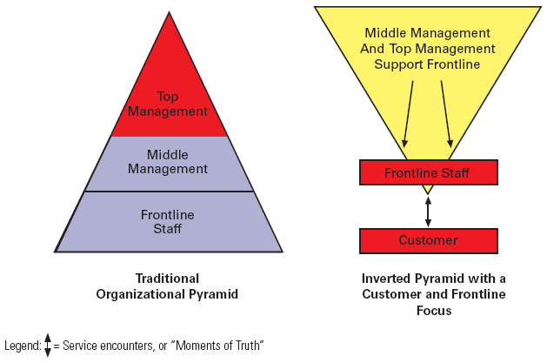
Summary of Chapter 11 ―Managing People for Service Advantage
- Service employees are extremely important to firm’s success
      - Help maintain firm’s positioning
      - Source of customer loyalty
      - Generate sales
      - Drive productivity of frontline operation
      - Low-contact situations are the “moments of truth” in the occasional encounter
- Front-line work is difficult and stressful; employees are boundary spanners, undergo emotional labor, face a variety of conflicts
      - Person/role conflict
      - Organization/client conflict
      - Interclient conflict
- Understand cycles of failure, mediocrity, and success
- Know how to get HRM aspect right
      - Hire the right people
      - Identify the best candidate
      - Train service employees actively
      - Empower the front-line
      - Build high-performance service delivery teams
      - Motivate and energize people
- Understand role of service culture and service leadership in sustaining service excellence

12.1 The Search for Customer Loyalty
How Much Profit a Customer Generates Over Time (Fig 12.3)
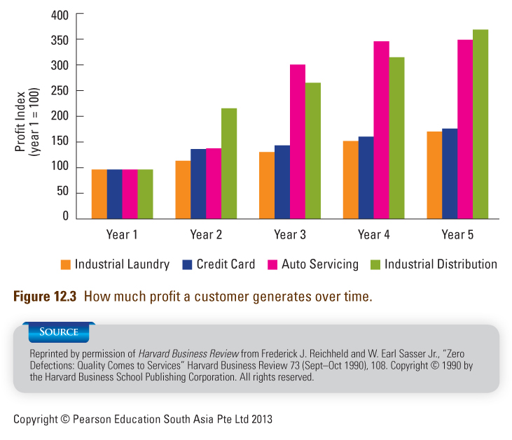

Why Is Customer Loyalty Important to A Firm’s Profitability?
- Customers become more profitable the longer they remain with a firm:
      - Increase purchases and/or account balances
        - Customers / families purchase in greater quantities as they grow
      - Reduced operating costs
        - Fewer demands from suppliers and operating mistakes as customer becomes experienced
      - Referrals to other customers
        - Positive word-of-mouth saves firm from investing money in sales and advertising
      - Price premiums
        - Long-term customers willing to pay regular price
        - Willing to pay higher price during peak periods

Why Customers Are More Profitable Over Time (Fig. 12.4)
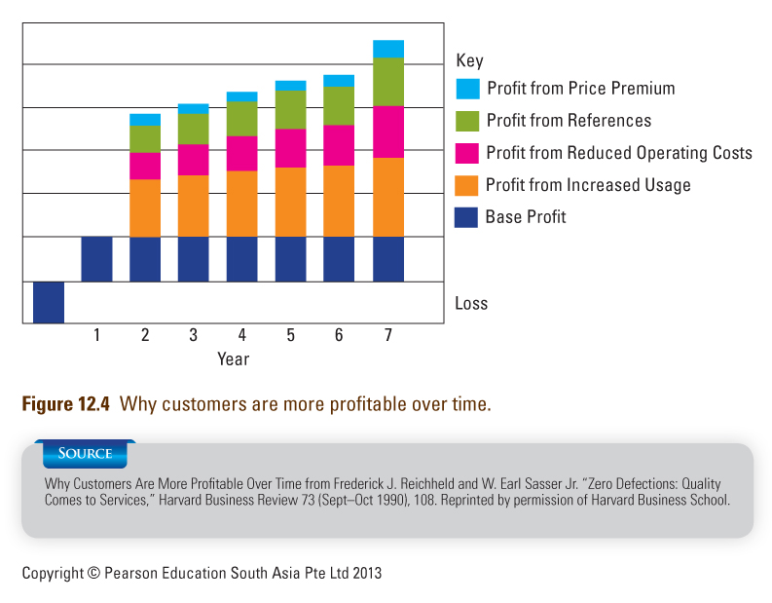

Assessing the Value of a Loyal Customer
- Must not assume that loyal customers are always more profitable than those making one-time transactions
      - Large customers may expect price discounts in return for loyalty
      - Revenues don’t necessarily increase with time for all types of customers
- Tasks:
      - Determine costs and revenues for customers from different market segments at different points in their customer lifecycles
      - Predict future profitability

Measuring Customer Equity: Lifetime Value of Each Customer
- Acquisition revenues less costs
      - Revenues (application fee + initial purchase)
      - Costs (marketing +credit check + account set up)
- Projected annual revenues and costs
      - Revenues (annual fee + sales + service fees + value of referrals)
      - Costs (account management + cost of sales + write-offs)
- Value of referrals
      - Percentage of customers influenced by other customers
      - Other marketing activities that drew the firm to an individual’s attention
- Net Present Value
      - Sum anticipated annual values (future profits)
      - Suitably discounted each year into the future

Why are Customers Loyal?
- Customers stay loyal when we create value for them
- Value can be created for customers through
      - Confidence benefits
      - Confidence in correct performance
      - Ability to trust the provider
      - Lower anxiety when purchasing
      - Knowing what to expect and receive
  - Social benefits
      - Mutual recognition and friendship between service provider and customer
  - Special treatment
      - Better price
      - Discounts not available to most customer
      - Extra services
      - Higher priority when there is a wait

12.2 The Wheel of Loyalty
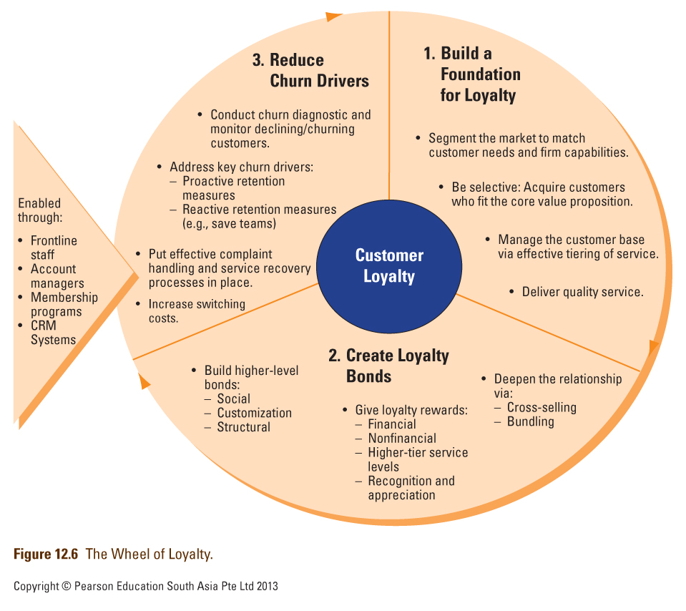

12.3 Building a Foundation for Loyalty
Targeting the Right Customers and Searching for Value, Not Volume
- Target the right customer and match them to what firm can deliver
      - How do customer needs relate to operations elements?
      - How well can service personnel meet expectations of different types of customers?
      - Can company match or exceed competing services that are directed at same types of customers?
- Focus on number of customers served as well as value of each customer
      - Some customers more profitable than others in the short term
      - Others may have room for long-term growth
- “Right customers” are not always high spenders
      - Can come from a large group of people that no other supplier is serving well

Effective Tiering of Service
The Customer Pyramid (Fig 12.8)
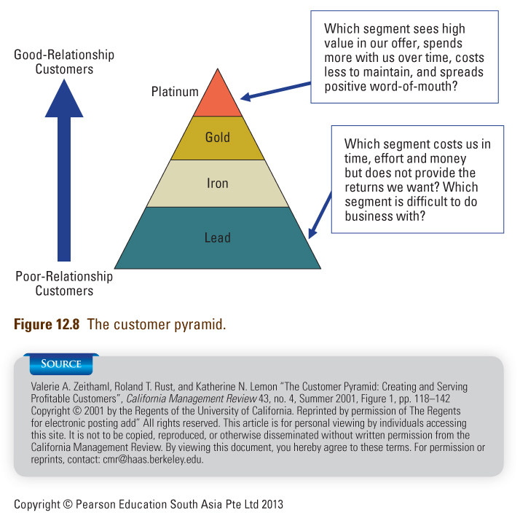

The Customer Satisfaction Loyalty Relationship (Fig. 12.10)
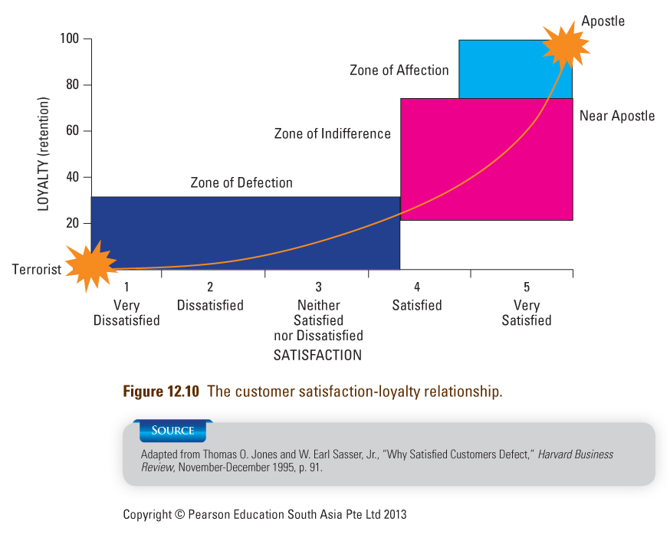

12.4 Strategies for Developing Loyalty Bonds with Customers
- Deepening the relationship
      - Bundling/Cross-selling services makes switching a major effort that customer is unwilling to go through unless extremely dissatisfied with service provider
      - Customers benefit from buying all their various services from the same provider
        - One-stop-shopping, potentially higher service levels, higher service tiers etc
- Reward Based Bonds
      - Can be financial or non-financial bonds or a combination of both
        - Financial bonds
          - Discounts on purchases, loyalty program rewards (e.g. frequent flier miles), cash-back programs
        - Non-financial rewards
          - Priority to loyalty program members for waitlists and queues in call centers; higher baggage allowances, priority upgrading, access to airport lounges for frequent flyers
      - Intangible rewards
        - Special recognition and appreciation
      - Reward-based loyalty programs are relatively easy to copy and rarely provide a sustained competitive advantage
- Social Bonds
      - Based on personal relationships between providers and customers
      - Harder to and takes a longer time to build, but also harder to imitate and thus, better chance of retention in the long term
- Customization Bonds
      - Customized service for loyal customers
        - e.g. Starbucks
      - Customers may find it hard to adjust to another service provider who cannot
customize service
- Structural Bonds
      - Mostly seen in B2B settings
      - Align customers way of doing things with supplier’s own processes
        - Joint investments in projects and sharing of information, processes and equipment.
      - Can be seen in B2C environment too
        - Airlines - SMS check-in, SMS email alerts for flight arrival and departure times
      - Difficult for competition to draw customers away when they have integrated their way of doing things with existing supplier

12.5 Strategies for Reducing Customers Defections
What Drives Customers to Switch? (Fig 12.14)
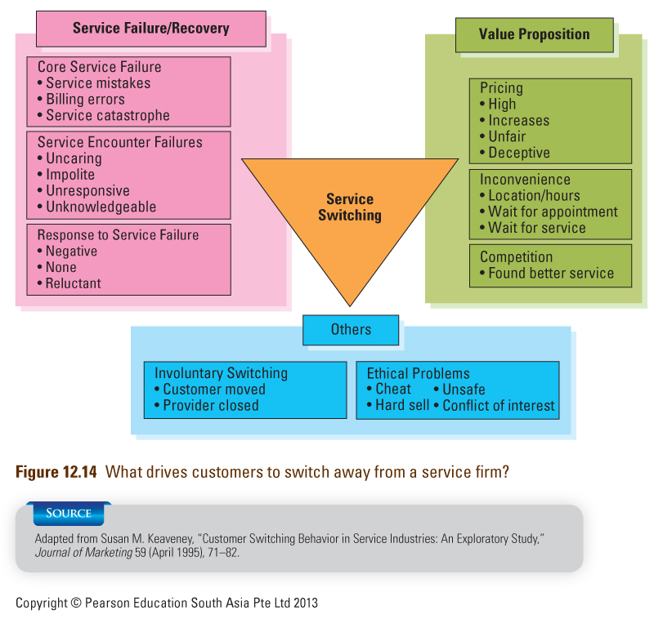

Address Key Churn Drivers
- Deliver quality service
- Reduce inconvenience and non-monetary costs
- Have fair and transparent pricing
- Industry specific drivers
      - Cellular phone industry: handset replacement a common reason for subscribers discontinuing services – offer handset replacement programs
- Take active steps to retain customers
      - Save teams: specially trained call center staff to deal with customers who want to cancel their accounts
      - Be careful about how save teams are rewarded (see Service Insights 12.5)

Other Ways to Reduce Churn
- Implement Effective Complaint Handling and Service Recovery Procedures
- Increase Switching Costs
      - Natural switching costs
        - e.g. Changing primary bank account – many related services tied to account
      - Can be created by instituting contractual penalties for switching
        - Must be careful not to be perceived as holding customers hostage
        - High switching barriers and poor service quality likely to generate negative attitudes and bad word of mouth

12.6 CRM: Customer Relationship Management Systems
Common Objectives Of CRM Systems
- Customer perspective
      - Unified customer interface that delivers customization and personalization
      - Vast service improvement and increase customer value
- Company perspective
      - Better segment, tier customer base and target promotion
      - Implement churn alert systems if customers are in danger of defecting
- Data collection
      - Customer data such as contact details, demographics, purchasing history, service preferences, and the like
- Data analysis
      - Data captured is analyzed and categorized
      - Used to tier customer base and tailor service delivery accordingly
- Sales force automation
      - Sales leads, cross-sell and up-sell opportunities can be effectively identified and processed
      - Entire sales cycle from lead generation to close of sales and after- sales service can be tracked and facilitated through CRM system
- Marketing automation
      - Mining of customer data enables the firm to target its market
      - Goal to achieve one-to-one marketing and cost savings, often in the context of loyalty and retention programs
      - Results in increasing the ROI on its marketing expenditure
      - CRM systems also allows firms to judge effectiveness of marketing campaigns through the analysis of responses
- Call center automation
      - Call center staff have customer information at their finger tips and can improve their service levels to all customers
      - Caller ID and account numbers allow call centers to identify the customer tier the caller belongs to, and to tailor the service accordingly
        - For example, platinum callers get priority in waiting loops.

12.7 What a Comprehensive CRM Strategy Includes
Comprehensive CRM Strategy (Fig 12.14)
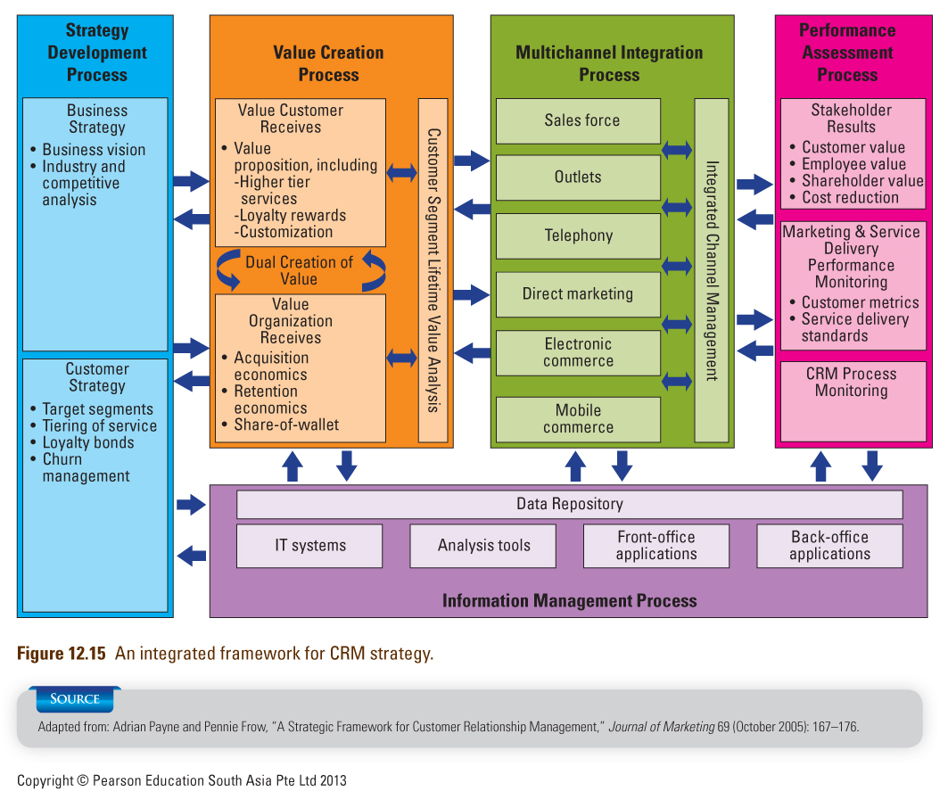

Integrated Framework for CRM Strategy
- Development
- Assessment of business strategy
- Business strategy guides development of customer strategy
- Value Creation
- Translates business and customer strategies into specific value propositions for both customers and firm
  - Customer benefit from priority, tiered services, loyalty rewards and customization
  - Company benefits from reduced customer acquisition retention costs, and increased share-of-wallet
- Dual creation of value: customers need to participate in CRM to reap value from firm’s CRM initiatives
- Multi-Channel Integration
- Serve customers well across many potential interfaces
- Offer a unified interface that delivers customization and personalization
- Performance Assessment
- Is CRM system creating value for key stakeholders?
- Are marketing and service standard objectives being achieved?
- Is CRM system meeting performance standards?
- Information Management
- Collect customer information from all channels
- Integrate it with other relevant information
- Make useful information available to the frontline
- Create and manage data repository, IT systems, analytical tools, specific application packages

Common Failures in CRM Implementation
- Unfortunately, there is a high failure rate for CRM implementations
- Common reasons for failures
      - Viewing CRM as a technology Initiative
      - Lack of customer focus
      - Not enough understanding of customer lifetime value (CLV)
      - Inadequate support from top management
      - Failure to reengineer business processes
      - Underestimating the challenges in data integration

How to Get CRM Implementation Right?
- How should our value proposition change to increase customer loyalty?
- How much customization or one-to-one marketing and service delivery is appropriate and profitable?
- What is the increase in profit from increasing share-of-wallet with current customers? How much does this vary by customer tier and/or segment?
- How much time and resources can we provide to CRM right now?
- If we believe in customer relationship management, why haven’t we taken more steps in that direction in past?
- What can we do today to develop customer relationships without spending on technology?

Summary of Chapter 12: Managing Relationships and Building Loyalty
- Customer loyalty as an important driver of profitability for service firms so firms need to
      - Assess value of loyal customer
      - Narrow gap between actual and potential customer value
  - Wheel of Loyalty shows how firms can:
      - Build a foundation of loyalty
      - Create loyalty bonds
      - Reduce churn drivers
- Building a foundation of loyalty involves
      - Good fit between customer needs and capabilities
      - Searching for value, not just volume
      - Tiering services effectively
      - Obtaining customer satisfaction through service quality
- Customer loyalty bonds include
      - Reward-based bonds
      - Social bonds
      - Customization bonds
      - Structural bonds
- Strategies for reducing customer defections include
      - Analyzing customer defections and monitoring declining accounts
      - Addressing key churn drivers
      - Implementing effective complaint-handling and service recovery procedures
      - Increasing switching costs
- Customer relationship management (CRM) is a whole process by which relations with customers are built and maintained
- An integrated CRM system includes
      - Strategy development process
      - Value creation process
      - Multichannel integration process
      - Performance assessment process
- Cresting a successful CRM program requires understanding common failures in CRM implementation and knowing how to get it right

Chapter 13: Complaint Handling and Service Recovery
13.1 Customer Complaining Behavior
Customer Response Categories to Service Failures (Fig. 13.3)
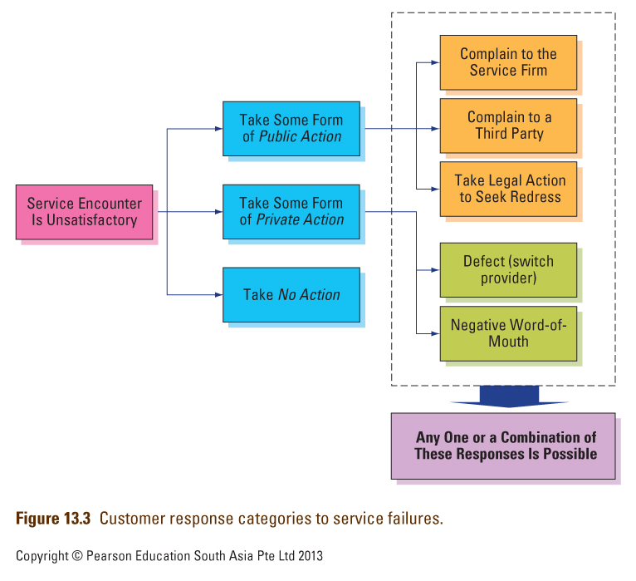

Understanding Customer Complaining Behavior
- Why do customers complain?
      - Obtain compensation
      - Release their anger
      - Help to improve the service
      - Out of concern for others
- What proportion of unhappy customers complain?
- Why don’t unhappy customers complain?
- Who is most likely to complain?
- Where do customers complain?
- What do customers expect once they have made a complaint?
      - Procedural, interactional and outcome justice

3 Dimensions of Perceived Fairness in Service Recovery Process (Fig. 13.6)
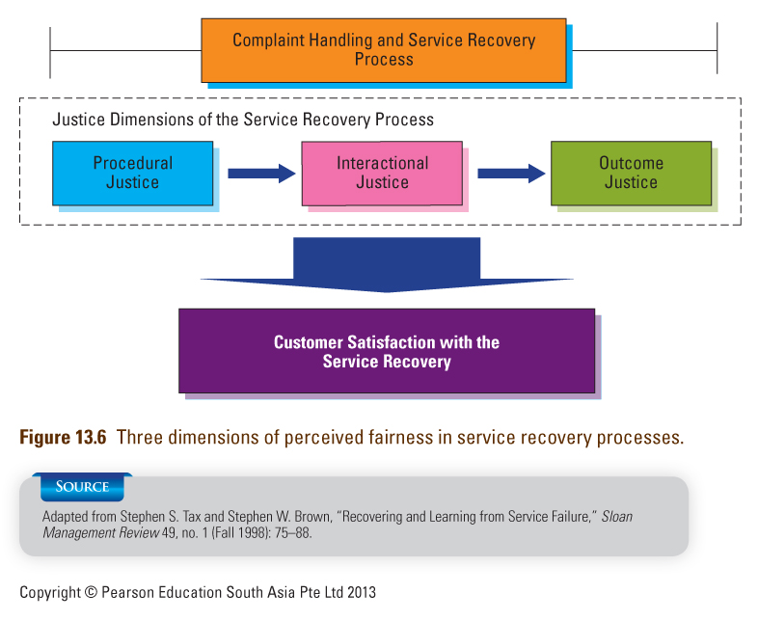

13.2 Customer Responses to Effective Service Recovery
Importance of Service Recovery
- Plays a crucial role in achieving customer satisfaction
- Tests a firm’s commitment to satisfaction and service quality
      - Employee training and motivation is highly important
- Impacts customer loyalty and future profitability
      - Complaint handling should be seen as a profit center, not a cost center

The Service Recovery Paradox
- Customers who experience a service failure that is satisfactorily resolved may be more likely to make future purchases than customers without problems (Note: not all research supports this paradox)
- If second service failure occurs, the paradox disappears—customers’ expectations have been raised and they become disillusioned
- Severity and “recoverability” of failure (e.g., spoiled wedding photos) may limit firm’s ability to delight customer with recovery efforts
- Best strategy: Do it right the first time

13.3 Principles of Effective Service Recovery Systems
Components of Effective Service Recovery System (Fig. 13.7)
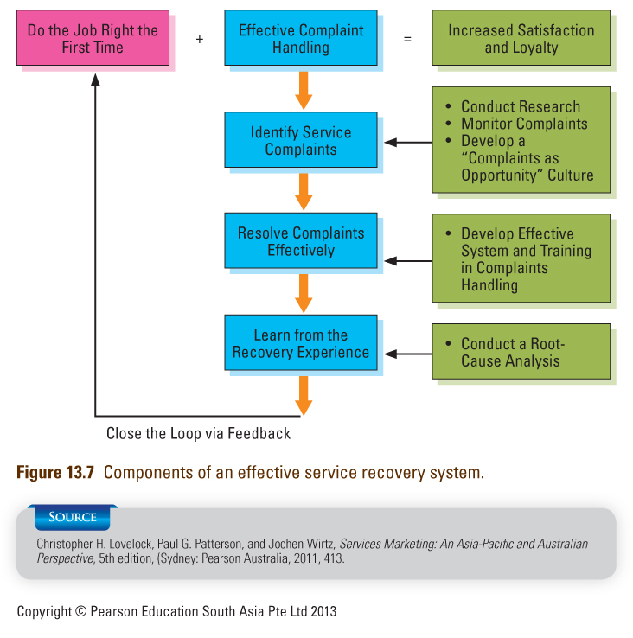

Strategies to Reduce Customer Complaint Barriers (Table 13.1)
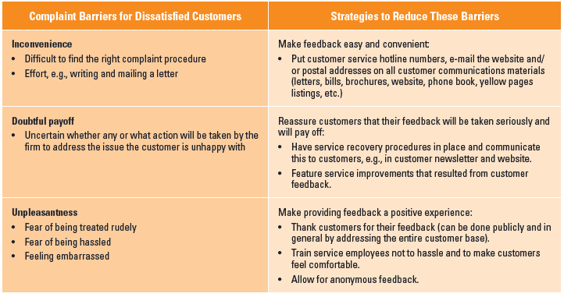

How to Enable Effective Service Recovery
- Be proactive
      - On the spot, before customers complain
- Plan recovery procedures
      - Identify most common service problems and have prepared scripts to guide employees in service recovery
- Teach recovery skills to relevant personnel
- Empower personnel to use judgment and skills to develop recovery solutions

How Generous Should Compensation Be?
- Rules of thumb for managers to consider:
      - What is positioning of our firm?
      - How severe was the service failure?
      - Who is the affected customer?

13.4 Service Guarantees
The Power of Service Guarantees
- Force firms to focus on what customers want
- Set clear standards
- Require systems to get & act on customer feedback
- Force organizations to understand why they fail and to overcome potential fail points
- Reduce risks of purchase and build loyalty

How to Design Service Guarantees
- Unconditional
- Easy to understand and communicate
- Meaningful to the customer
- Easy to invoke
- Easy to collect
- Credible

Types of Service Guarantees (Table 13.2)
- Single attribute-specific guarantee
      - One key service attribute is covered
- Multiattribute-specific guarantee
      - A few important service attributes are covered
- Full-satisfaction guarantee
      - All service aspects covered with no exceptions
- Combined guarantee
      - All service aspects are covered
      - Explicit minimum performance standards on important attributes

Is it Always Suitable to Introduce a Guarantee?
It is not appropriate to introduce guarantees when:
      - Companies have a strong reputation for service excellence
      - Company does not have good quality level
      - Quality cannot be controlled because of external forces
      - Consumers see little financial, personal or physiological risk associated with the purchase
13.5 Discouraging Abuse and Opportunistic Customer Behavior
Addressing the Challenge of Jaycustomers
- Jaycustomer: A customer who behaves in a thoughtless or abusive fashion, causing problems for the firm, its employees, and other customers
- More potential for mischief in service businesses, especially when many customers are present
- No organization wants an ongoing relationship with an abusive customer

Seven Types of Jaycustomers:
The Cheat and Thief
- The Cheat: thinks of various way to cheat the firm
- The Thief: No intention of paying―sets out to steal or pay less
      - Services lend themselves to clever schemes to avoid payment
        - e.g., bypassing electricity meters, circumventing TV cables, riding free on public transportation
      - Firms must take preventive actions against thieves, but make allowances
for honest but absent-minded customers

The Rulebreaker
- Many services need to establish rules to guide customers safely through the service encounter
- Government agencies may impose rules for health and safety reasons
- Some rules protect other customers from dangerous behavior
      - e.g. ski patrollers issue warnings to reckless skiers by attaching orange stickers on their lift tickets
- Ensure company rules are necessary, not should not be too much or inflexible

The Belligerent
- Shouts loudly, maybe mouthing insults, threats and curses
- Service personnel are often abused even when they are not to be blamed
- Confrontations between customers and service employees can easily escalate
- Firms should ensure employees have skills to deal with difficult situations
      - In a public environment, priority is to remove person from other customers
      - May be better to support employee’s actions and get security or the police if necessary if an employee has been physically attacked

Family Feuders And Vandals
- Family Feuders: People who get into arguments with other customers ― often members of their own family
- The Vandal:
      - Service vandalism includes pouring soft drinks into bank cash machines; slashing bus seats, breaking hotel furniture
      - Bored and drunk young people are a common source of vandalism
      - Unhappy customers who feel mistreated by service providers take revenge
      - Prevention is the best cure

The Deadbeat
- Customers who fail to pay (as distinct from “thieves” who never intended to pay in the first place)
      - Preventive action is better than cure--e.g., insisting on prepayment; asking for credit card number when order is taken
      - Customers may have good reasons for not paying
        - If the client's problems are only temporary ones, consider long-term value of maintaining the relationship

Dealing with Customer Fraud
- If in doubt, believe the customer
- Keep a database of how often customers invoke service guarantees or of payments made for service failure
- Insights from research on guarantee cheating:
      - Amount of a guarantee payout had no effect on customer cheating
      - Repeat-purchase intention reduced cheating intent
      - Customers are reluctant to cheat if service quality is high (rather than just satisfactory)
- Managerial implications:
      - Firms can benefit from offering 100 percent money-back guarantees
      - Guarantees should be offered to regular customers as part of membership program since regular customers are unlikely to cheat
      - Excellent service firms have less to worry about than average providers

Summary of Chapter 13 ― Service Recovery and Customer Feedback
- When customers are dissatisfied, they can
      - Take some form of public action
      - Take some form of private action
      - Take no action
- To understand customer responses to service failures, some questions to ask are
      - Why do customers complain?
      - What proportion of unhappy customers complain?
      - Why don’t unhappy customer complain?
      - Who is most likely to complain?
      - Where do customers complain?
      - What do customers expect once they have made a complaint?
- Effective service recovery can lead to customer loyalty
- The service recovery paradox does not always hold true—better to get it right the first time
- Guiding principles for effective service recovery include
      - Make it easy for customers to give feedback
      - Enable effective service recovery
      - Focusing on how generous compensation should be
- Issues to consider in having services guarantees are
      - Power of service guarantees
      - How to design service guarantees
      - Is full satisfaction the best a firm can guarantee?
      - Is it always appropriate to introduce a service guarantee?
- There are seven types of jaycustomers
      - The Cheat
      - The Thief
      - The Rule Breaker
      - The Belligerent
      - The Family Feuders
      - The Vandal
      - The Deadbeat
- To discourage abuse and opportunistic behavior, we need to deal with customer fraud

Chapter 14: Improving Service Quality and Productivity
14.1 Integrating Service Quality and Productivity Strategies
- Quality and productivity are twin paths to creating value for both customers and companies
- Quality focuses on the benefits created for customers; productivity addresses financial costs incurred by firm
      - If service processes are more efficient and increase productivity, this may not result in better quality experience for customers
      - Getting service employees to work faster to increase productivity may sometimes be welcomed by customers, but at other times feel rushed and unwanted
- Marketing, operations and human resource managers need to work together for quality and productivity improvement

14.2 What is Service Quality?
Dimensions of Service Quality
- Tangibles: Appearance of physical elements
- Reliability: Dependable and accurate performance
- Responsiveness: Promptness; helpfulness
- Assurance: Competence, courtesy, credibility, security
- Empathy: Easy access, good communication, understanding of customer

14.3 The GAP Model ― A Conceptual Tool to Identify and Correct Service Quality Problems
Six Service Quality Gaps (Fig. 14.3)
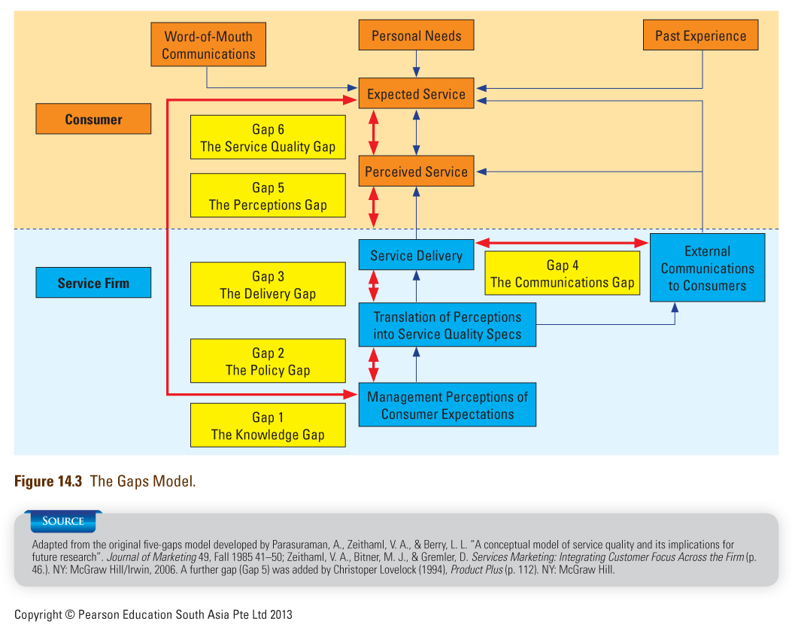

Suggestions for Closing the 6 Service Quality Gaps
Types of Quality Gap | Proposed Solution
Gap 1: The Knowledge Gap | Suggestion: Educate management about what customers expect  - Increase interactions between customers and management  - Facilitate and encourage communication between frontline employees and management  - Implement an effective customer feedback system that includes satisfaction research, complaint content analysis and customer panels  - Sharpen market research procedures, including questionnaire and interview design, sampling, and field implementation, and repeat research studies once in a while
Gap 2: The Policy Gap | Suggestion: Establish the right service processes and specify standards  - Get the customer service processes right:  - Use a rigorous, systematic, and customer-centric process for designing and redesigning customer service process  - Standardize repetitive work tasks to ensure consistency and reliability by substituting hard technology for human contact and improving work methods (soft technology)  - Develop tired service products that meet customer expectations:  - Consider premium, standard, and economy-level products to allow customers to self-segment according to their needs, or  - Offer customers different levels of service at different prices  - Set, communicate, and reinforce measurable customer-oriented service standards for all work units:  - Establish for each step in service delivery a set of clear service quality goals that are challenging, realistic, and explicitly designed to meet customer expectations
Gap 3: The Delivery Gap | Suggestion: Ensure that performance meets standards that are based on customer needs and expectations  - Ensure that customer service teams are motivated and able to meet service standards:  - Improve recruitment with a focus on employee – job fit; select employees for that abilities and skill needed to perform their job well  - Train employees on the technical and soft skills needed to perform their assigned tasks effectively, including interpersonal skills, especially for dealing with customers under stressful conditions  - Clarify employee roles and ensure that employees understand how their jobs contribute to customer satisfaction; teach them about customer expectations, perceptions and problems  - Build cross-functional service teams that can offer customer-centric service delivery and problem resolution  - Empower managers and employees in the field by pushing decision-making power down the organization  - Measure performance, provide regular feedback and reward customer service team performance as well as individual employees and managers or attaining quality goals  - Install the right technology, equipment, support processes and capacity:  - Select the most appropriate technologies and equipment for enhanced performance  - Ensure that employees working on internal support jobs provide good service to their own internal customer, the frontline personnel  - Balance demand against productive capacity  - Manage customers for service quality:  - Educate customers so that they can perform their roles and responsibilities in service delivery effectively
Gap 4: The Communications Gap | Suggestion: Close the internal and external communications gaps by ensuring that communications promises are realistic and correctly understood by customers  - Educate managers responsible for sales and marketing communications about operational capabilities:  - Seek inputs from frontline employees and operations personnel when new communications programs are being developed  - Let service providers preview advertisements and other communications before customers are exposed to them  - Get sales staff to involve operations staff in face-to-face meetings with customers  - Develop internal educational and motivational advertising campaigns to strengthen understanding and integration among the marketing, operations, and human resource functions, and to standardize service delivery across different locations  - Align incentives for sales teams with those of service delivery teams. This will avoid the problem where the sale teams focus exclusively on generating sales (e.g., through overpromising) and neglect customer satisfaction (e.g., through disappointed expectations)  - Ensure the communications content sets realistic customer expectations  - Be specific with promises and mange customers’ understanding of communication content:  - Pre-test all advertising, brochures, telephone scripts, and website content prior to external release to see if target audience interprets them as the firms intends (if not, revise and retest). Make sure that the advertising content reflects those service characteristics that are most important to customers. Let them know what is and is not possible, and why.  - Identify and explain, in real time, the reasons for shortcomings in service performance, highlighting those that cannot be controlled by the firm.  - Document beforehand what tasks and performance guarantees are included in an agreement or contract. After the completion of the work, explain what work was performed in relation to a specific bulling statement.
Gap 5: The Perception Gap | Suggestion: Tangibilize and communicate the service quality delivered  - Make service quality tangible and communicate the service quality delivered:  - Develop service environments and physical evidence cues that are consistent with the level of service provided.  - For complex and credence services, keep customers informed during service delivery on what is being done, and give debriefings after the delivery so that customers can appreciate the quality of service they received  - Provide physical evidence (e.g., for repairs, show customers the damaged components that were removed
Gap 6: The Service Gap | Suggestion: Close gaps 1 to 5 to consistently meet customer expectations  - Gap 6 is the accumulated outcome of all the preceding gaps. It will be closed when Gaps 1 to 5 have been addressed.

14.4 Measuring and Improving Service Quality
Soft and Hard Measures of Service Quality
- Soft measures—not easily observed, must be collected by talking to customers, employees or others
      - Provide direction, guidance and feedback to employees on ways to achieve customer satisfaction
      - Can be quantified by measuring customer perceptions and beliefs
        - e.g. SERVQUAL, surveys, and customer advisory panels
- Hard measures—can be counted, timed or measured through audits
      - Typically operational processes or outcomes
      - Standards often set with reference to percentage of occasions on which a particular measure is achieved

14.5 Learning from Customer Feedback
Key Objectives of Effective Customer Feedback Systems
- Assessment and benchmarking of service quality and performance
- Customer-driven learning and improvements
- Creating a customer-oriented service culture

Customer Feedback Collection Tools
- Total market surveys
- Annual surveys
- Transactional surveys
- Service feedback cards
- Mystery shopping
- Unsolicited customer feedback
- Focus group discussions
- Service reviews

Key Customer Feedback Collection Tools: Strengths and Weakness (Table 14.3)
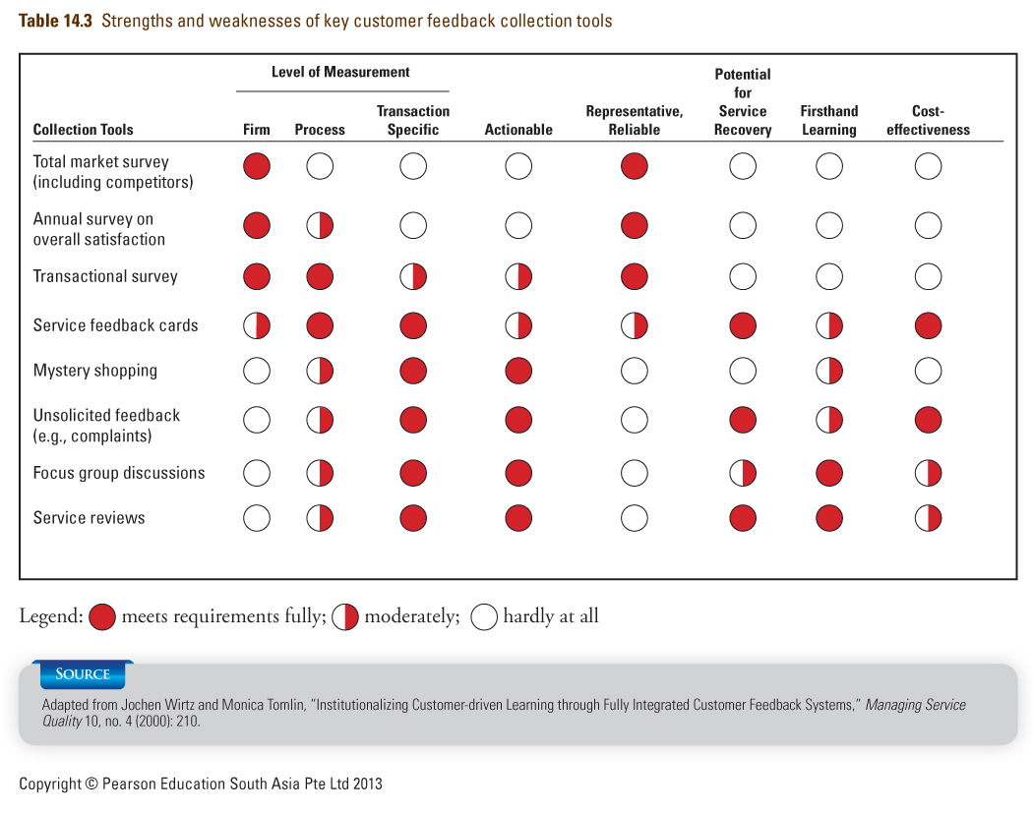

Analysis, Reporting and Dissemination of Customer Feedback
- Choosing the relevant feedback tools and collecting customer feedback is meaningless if the information is not passed back to the relevant parties to take action
- Reporting system needs to deliver feedback to frontline staff, process owners, branch/department managers and top management
- Three types of performance reports:
      - Monthly Service Performance Update
      - Quarterly Service Performance Review
      - Annual Service Performance Report
14.6 Hard Measures of Service Quality
- Service quality indexes
      - Embrace key activities that have an impact on customers
- Control charts to monitor a single variable
      - Offer a simple method of displaying performance over time against specific quality standards
      - Enable easy identification of trends
      - Are only good if data on which based
are accurate

Control Chart for Departure Delays (Fig. 14.8)
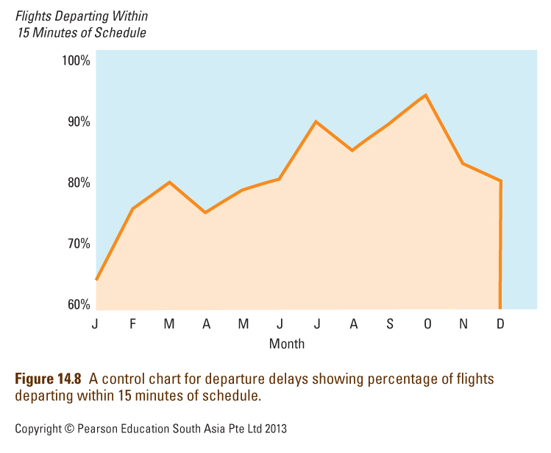

14.7 Tools to Analyze and Address Service Quality Problems
- Fishbone diagram
      - Cause-and-effect diagram to identify potential causes of problems
- Pareto Chart
      - Separating the trivial from the important. Often, a majority of problems is caused by a minority of causes (i.e. the 80/20 rule)
- Blueprinting
      - Visualization of service delivery, identifying points where failures are most likely to occur

Cause-and-Effect Chart for Flight Departure Delays (Fig. 14.9)
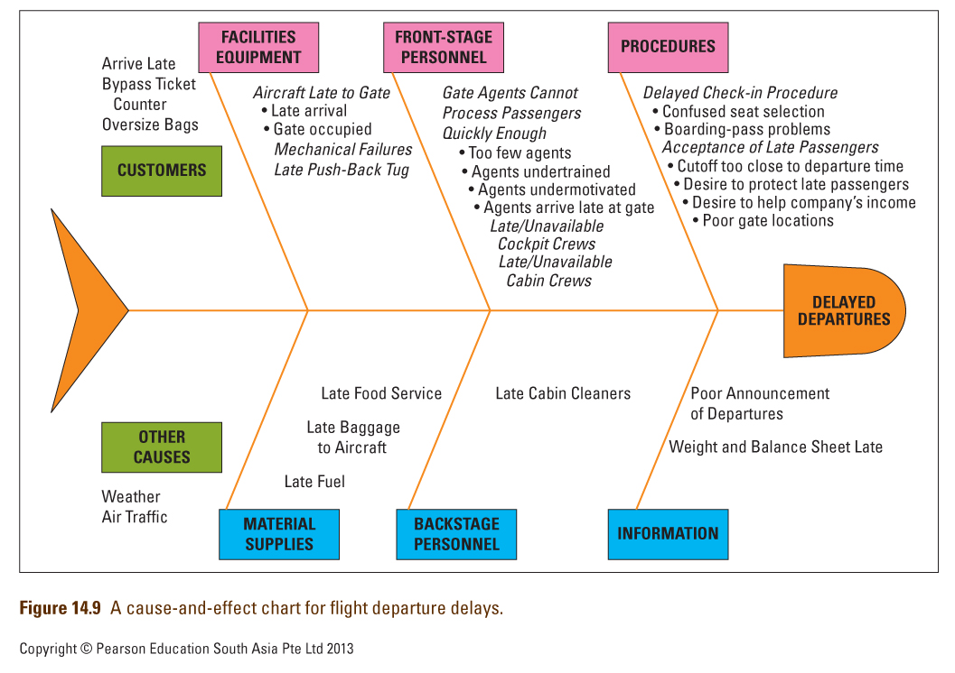

Analysis of Causes of Flight Departure Delays (Fig. 14.10)
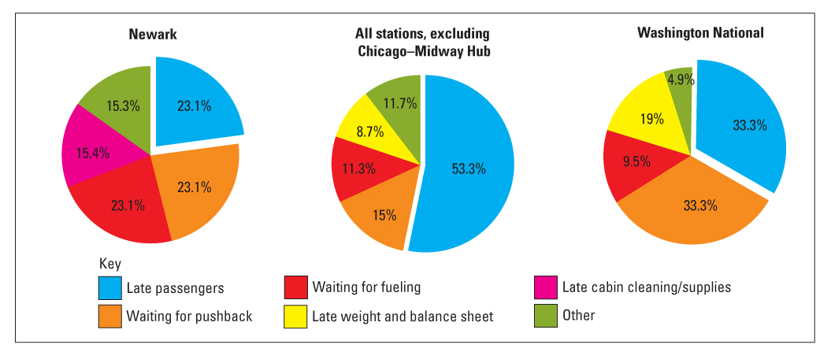

14.8 Return on Quality
- Assess costs and benefits of quality initiatives
      - ROQ approach is based on four assumptions:
        - Quality is an investment
        - Quality efforts must be financially accountable
        - It’s possible to spend too much on quality
        - Not all quality expenditures are equally valid
      - Implication: Quality improvement efforts may benefit from being related to productivity improvement programs
      - To see if new quality improvement efforts make sense, determine costs and then relate to anticipated customer response
- Determine optimal level of reliability
      - Diminishing returns set in as improvements require higher investments
      - Know when improving service reliability becomes uneconomical

When Does Improving Service Reliability Become Uneconomical? (Fig. 14.11)
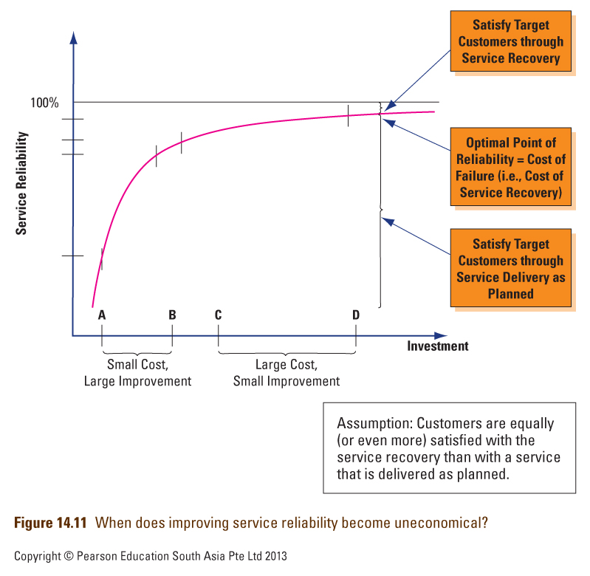

14.9 Defining and Measuring Productivity
Productivity in a Service Context
- Productivity measures amount of output produced relative to the amount of inputs.
- Improvement in productivity means an improvement in the ratio of outputs to inputs.
- Intangible nature of many service elements makes it hard to measure productivity of service firms, especially for information- based services
      - Difficult in most services because both input and output are hard to define
      - Relatively simpler in possession-processing services, as compared to information- and people-processing services

Service Efficiency, Productivity and Effectiveness
- Efficiency: involves comparison to a standard, usually time-based (e.g., how long employee takes to perform specific task)
      - Problem: focus on inputs rather than outcomes
      - May ignore variations in service quality/value
- Productivity: involves financial value of outputs to inputs
      - Consistent delivery of outcomes desired by
customers should command higher prices
- Effectiveness: degree to which firm meets goals
      - Cannot divorce productivity from quality and customer satisfaction
14.10 Improving Service Productivity
Generic Productivity Improvement Strategies
- Typical strategies to improve service productivity:
      - Careful control of costs at every step in process
      - Reduction of wasteful use of materials or labor
      - Teaching employees how to work more productively
      - Providing employees with equipment and databases to work faster and to a higher quality
      - Broadening variety of tasks that service worker can perform
      - Installing expert systems that allow paraprofessionals to take on work previously performed by professionals who earn higher salaries
- Although improving productivity can be approached incrementally, major gains often require redesigning entire processes

Customer-driven Ways to Improve Productivity
- Change timing of customer demand
      - By shifting demand away from peaks, managers can make better use of firm’s productive assets and provide better service
- Encourage use of lower cost channels
      - Get customers to self-serve
      - Encourage customers to obtain information and buy from firm’s corporate Websites
- Ask customers to use third parties
      - Delegate delivery of supplementary service elements to intermediary organizations

How Productivity Improvements Impact Quality
- Front-stage productivity enhancements are especially visible in high contact services
      - Some improvements only require passive acceptance, while others require customers to change behavior
      - Must consider impacts on customers and address customer resistance to changes
- Backstage changes may impact customers
      - Keep track of proposed backstage changes, and prepare customers for them
        - e.g., new printing peripherals may affect appearance of bank statements
- See Service Insights 14.3 : Managing Customers’ Reluctance to Change

A Caution on Cost Reduction Strategies
- Most attempts to improve service productivity seek to eliminate waste and reduce labor costs and does not involve new technology
- Reducing staff means workers try to do several things at once and may perform each task poorly
- Better to search for service process redesign opportunities that lead to:
      - Improvements in productivity
      - Simultaneous improvement in service quality
      - See Service Insights 14.4: Biometrics

Summary of Chapter 14: Improving Service Quality and Productivity
- Quality and productivity need to be considered jointly in marketing services
- Research consolidated service quality dimensions into five
      - Tangibles
      - Reliability
      - Responsiveness
      - Competence
      - Courtesy
- GAP model is a tool to diagnose problems in service design and delivery. Service gap is the most critical and can only be closed if the other six gaps are closed
- Both soft and hard measures used to measure service quality
- We can learn from customer feedback--key objectives:
      - Assessment and benchmarking of service quality and performance
      - Customer-driven learning and improvements
      - Creating a customer-oriented service culture
- A mix of customer feedback collection tools can help to deliver needed information to firms
      - Total market surveys, annual survey, and transactional surveys
      - Service feedback cards
      - Mystery shopping
      - Unsolicited customer feedback
      - Focus group discussions and service reviews
      - Capture unsolicited feedback
- Feedback must be analyzed, reported, disseminated and used
- Hard measure of service quality include service index and control charts
- Tools used to analyze and address service quality problems
      - Fishbone diagram
      - Pareto chart
      - Blueprinting
- Measuring productivity in services is difficult and there is a need to determine when service reliability becomes uneconomical
- Efficiency, productivity and effectiveness need to be distinguished when measuring service quality
- To improve service productivity, there are generic improvement strategies and customer-driven approaches
- Customer-driven approaches to improving productivity include
      - Changing timing of customer demand
      - Involving customers more in production
      - Asking customers to use third parties
- Backstage and frontstage productivity changes both affect customers
- Cost-reduction strategies should be used with caution as this may impact service quality negatively. A better way may be to look for service process redesign opportunities

Approaches to Productivity and Quality Improvement and Standardization (Appendix 14.3)
- Total Quality Management (TQM)
- ISO 9000
      - Comprises requirements, definitions, guidelines, and related standards to provide an independent assessment and certification of a firm’s quality management system
- Malcolm Baldrige Model Applied to Services
      - To promote best practices in quality management, and recognizing, and publicizing quality achievements among U.S. firms
- Six Sigma
      - Statistically, only 3.4 defects per million opportunities (1/294,000)
      - Has evolved from defect-reduction approach to an overall business-improvement approach

Chapter 15: Organizing for Service Leadership
15.1 The Service Profit Chain (Fig. 15.2)
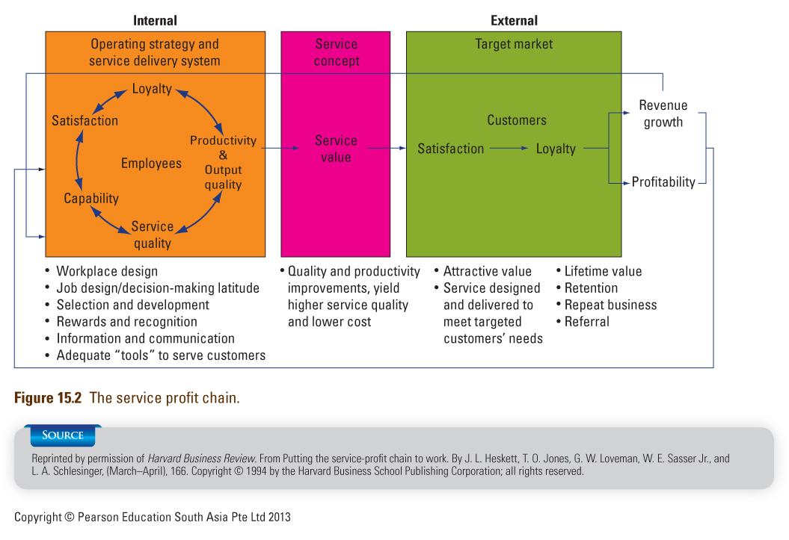

Links in the Service Profit Chain
- Customer loyalty drives profitability and growth.
- Customer satisfaction drives customer loyalty.
- Value drives customer satisfaction.
- Quality and productivity drive value.
- Employee loyalty drives service quality and productivity.
- Employee satisfaction drives employee loyalty.
- Internal quality drives employee satisfaction.
- Top management leadership underlies the chain’s success.

15.2 Integrating Marketing, Operations and Human Resources
Interdependence between Functions (Fig. 15.3)
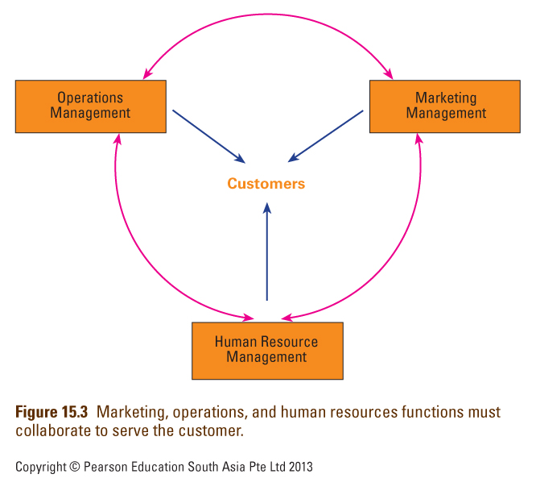

Defining the Three Functions
- Marketing Function
      - Target “right” customers and build relationships
      - Offer solutions that meet their needs
      - Define quality package with competitive advantage
- Operations Function
      - Create, deliver specified service to target customers
      - Adhere to consistent quality standards
      - Achieve high productivity to ensure acceptable costs
- Human Resource Function
      - Recruit and retain the best employees for each job
      - Train and motivate them to work well together
      - Achieve both productivity & customer satisfaction

Facilitating Cooperation
- Transfer individuals to other functions and allow development of holistic perspective
- Establish cross-functional project teams
- Have cross-functional service delivery teams
- Appointing individuals to integrate specific objectives, activities and processes between departments
- Carry out internal marketing and training
- Have top management commitment to ensure overarching objectives of all departments are integrated

15.3 Creating a Leading Service Organization
From Losers to Leaders: Four Levels of Service Performance
- Service Losers
      - Bottom of the barrel from both customer and managerial perspectives
      - Customers patronize them because there is no viable alternative
      - New technology introduced only under duress; uncaring workforce
- Service Nonentities
      - Dominated by a traditional operations mindset
      - Unsophisticated marketing strategies
      - Consumers neither seek out nor avoid them
- Service Professionals
      - Clear market positioning strategy
      - Customers within target segment(s) seek them out
      - Research used to measure customer satisfaction
      - Operations and marketing work together
      - Proactive, investment-oriented approach to HRM
- Service Leaders
      - The crème da la crème of their respective industries
      - Names synonymous with outstanding service, customer delight
      - Service delivery is seamless process organized around customers
      - Employees empowered and committed to firm’s values and goals

Moving to a Higher Level of Performance
- Firms can move either up or down the performance ladder
- Organizations that are devoted to satisfying their current customers may miss important shifts
in the marketplace
      - As a result, they may face difficulties attracting demanding new consumers with different expectations
- Companies defending their control of their competitive edge may have encouraged competitors to find higher-performing alternatives
- Organizations with a service-oriented culture may turn otherwise as a result of a merger or acquisition that brings in new leaders who emphasize short-term profits

Leading Change toward a Higher Performance Level
- Create urgency to develop the incentive to change
- Put together a strong team to direct the process
- Create appropriate vision of where the organization needs to go
- Communicate new vision broadly
- Empower employees to act on that vision
- Produce sufficient short-term results to create credibility
- Build momentum to tackle tougher change problems
- Anchor new behaviors in organizational culture

15.4 Leadership, Organizational Culture, and Climate
Leadership, Culture and Climate
- Organizational culture:
      - Shared understanding regarding what is important in the organization
      - Shared values about what is right or wrong
      - Shared understanding about what works and what doesn’t work
      - Shared beliefs, and assumptions about why things are important
      - Shared styles of working and relating to others
- Organizational climate
      - The tangible surface layer on top of the organization’s underlying culture
      - Factors of influence:
        - Flexibility, Responsibility, Standards that people set, Perceived aptness of rewards, Clarity people have about mission and values, Level of commitment to a common purpose
- Creating a new climate for service, based on understanding of what is needed for market success, may require
      - radical rethinking of HRM activities, operational procedures, and the firm’s reward and recognition policies

15.5 Leadership in the Future
- Leadership is more collaborative, using team approach with process of collective genius
- Leadership is from behind, by a leader not afraid of sharing power with others
- Innovation will remain key for organizations to succeed
- Collective efforts will yield results far superior to individual efforts

Summary of Chapter 15: Change Management and Service Leadership
- Service profit chain provides useful summary of behaviors required of service leaders to manage effectively
- Marketing, operations, and human resource management functions need to be closely coordinated and integrated in service businesses
- Four levels of service performance
      - Service losers
      - Service nonentitites
      - Service professionals
      - Service leaders
- Service leadership is not based on outstanding performance within a single dimension, but must cut across marketing, operations and human resources
- Leaders play a big part in nurturing an effective organizational culture that transforms an organization into a successful one
- Leadership in the future does not just lie in one person. It relies on collective genius. Leaders of the future are not afraid of sharing power with others
- Innovation will remain key for organizations to succeed

