PSCI 2601 – Tuesday, January 29th 2013
- Realism is seen as pessimistic – fair to believe that we’re never going to be done with violence. The best way to maintain order is the mitigation of violence through the balance of powers.
- This week, we’re turning to one of the classic theories used in IR, developed by an economist. We’ll see how Marxism speaks to issues of order and conflict.

Marxism

Caveats about Marxism
- Often discredited, but a driver behind social programs
  - While some of this discredit is true, there are some aspects that are seen in our world from which these things sprout from
  - Ex. Tommy Douglas, socialism and healthcare
- Seems to be having a revival for two reasons:
  - The end of the Cold War and the break-up of the Soviet Union
    - The Soviet Union as an embarrassment for Marxists – it was an authoritarian regime that took the blanket of Marxism to pursue dictatorial systems
  - Seems to explain many of the global challenges we face today
    - 2008 recession
    - IMF policies, development, etc.
    - Marxist analysis helps to understand why capitalism has pursued these paradoxes that we face today
- Seems to have a lot of popularity in academic institutions.

Marxism: History
- Father of Marxism: Karl Marx
- Born to a wealthy middle-class family
- An economist by training
- Studied at the University of Bonn and University of Berlin
- Became a writer for a number of radical newspapers
- Why would he go from having such a nice life towards a radical root?
  - Industrial revolution:
  - Stage 1: 1780-1840
    - Characterized by per-capita economic growth and the onset of the capitalist system
  - Stage 2: 1840-1870
    - Characterized by economic progress, backed by new technologies (steam-power, railways, etc.)
- The industrial revolution is not just about economics – it’s also about people, politics and power. This can be understood in terms of competing perspectives about the benefits of the industrial revolution:
  - Nicholas Crafts – economic historian – argues that British income per person rose from:
    - $400 in 1760 to $430 in 1800
    - $430 in 1800 to $500 in 1830
    - $500 in 1830 to $800 in 1860 (calculated in 1970 US dollars).
  - This suggests that the welfare of the average worker increased as a consequence of the industrial revolution
  - But much of the income generated by the industrial revolution is concentrated in the hands of the upper class, and a growing middle class. Thus, while incomes were increasing, ameliorating conditions for most people – so too were discrepancies in class
    - Ex. Relative gains
- The Industrial Revolution is thus characterized by divisions in class, accompanied by a relationship of exploitation between the proletariat and the bourgeoisie
  - It is also important to consider the limited protections and poor working conditions faced by the proletariat. Again, this is not just about economic, but also people, power and politics.
- Whereas many IR theories originate with a specific inter-state conflict, Marxism begins with class conflict

Marxism: Philosophical Background
- Though an economic analysis of the industrial revolution, Marx develops a key argument that now informs that Marxian literature: antagonisms exist in the class structure of capitalism
- This is observable in at least for ways:
- Division of society into classes
  - Proletariat, Middle Class, Bourgeoisie
- Pre-eminence of class
- Class is the defining feature of one’s status in the state
- Inequality of class
- Division of classes bespeaks inequalities
- Bias of the state
- The state is bias in favour of Bourgeoisie, who contribute to its economic wellbeing
- Although Marx focussed on the domestic level, his analysis has important implications for IR. According to Marx:
- Class conflict in a domestic society will inevitably lead to revolution
    - The Proletarian Revolution
- For Marx, this is however only possible in advanced capitalist societies. For instance:
    - Establish a middle class that is educated and cognizant of problems
    - Welfare programs that cannot satisfy unrest, and mobilize support
    - Exacerbation of class tensions
- In Marx’s view, revolution could then spread outwardly/internationally, brining about global change – a single revolution would not be sufficient
- A number of criticism have been made against Marx:
  - Do people really identify with their class in Western-style democracies?
    - Marxists acknowledge that in many capitalist societies, a sense of belonging to class is weak, but that doesn’t mean the structure of the system doesn’t perpetuate cleavages
- But then, how does Marxism explain the resilience of capitalism in spite of these cleavages?
- A: False consciousness: low- and middle-classes develop a belief that their best interests are tied with capitalism (ex. Upward mobility and the American Dream)
- A: Business confidence: ensures the pre-eminence of capitalism by punishing those that strive against capitalist interests (ex. 2008)

Marxism: What is it?
- Marxian theories have four continuities:
- The view that the social world needs to be analyzed in its totality
- Academic divisions are arbitrary and unhelpful, the social world must be understood as a whole – the medieval system of disciplinary divisions inhibits understanding
- Ex. While Marx performed an economic analysis of the industrial revolution, it is also a social/political analysis
- The materialist conception of history – historical materialism
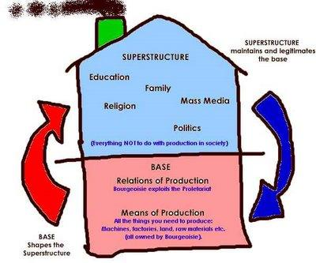
- The main idea is that: processes of historical change are a reflection of economic development.
- ‘Economic development is the motor of history’
- The main dynamic is between the means of production (see p 569) and relations of production (see p. 573)
- As the means of production develop, so to must the relations of production, leading to social change.
- This also speaks to the base-superstructure relationship
- Class plays a key role in Marxian analyses
- Whereas liberals perceive a harmony of interest between different classes – ex. Absolute gains and free trade – Marxists perceive conflict
- According to Marx and Engels in the Communist Manifesto, “the history of all hitherto existing societies is the history of class struggle”
- The researcher/analyst should remain an impartial/detached observer of the conflict between capital and labour, but rather to engage in it, with a view towards emancipation
- Remember idealism and the critique of Carr?
- This also runs contrary to next week and the epistemology of positivism

Marxism: World Systems Theory
- Early Marxists tended to focus on the domestic level as a means of understanding class conflict
  - Ex. Marx was not an international relations theorist
  - Marx’s analysis was principally of British capitalism
- Later Marxists began focussing more of the international level as a means of understanding capitalism
  - Ex. Lenin’s Imperialism, the highest stage of capitalism, argued that the world economy was characterized by a dominant core and a less economically developed periphery
  - As to the core exploited the periphery, it continuously sought to expand in accordance with the dictates of capitalism, leading to imperial activities. Over time, this expansion led to inevitable conflict as expanding capitalist empires began competing for the same resources
- World Systems Theory builds on the core-periphery relationship
  - Immanuel Wallerstein argues that history is characterized by world systems
  - The contemporary world system begain in Europe during the 16th century, and expanded outward. This system is defined by capitalism
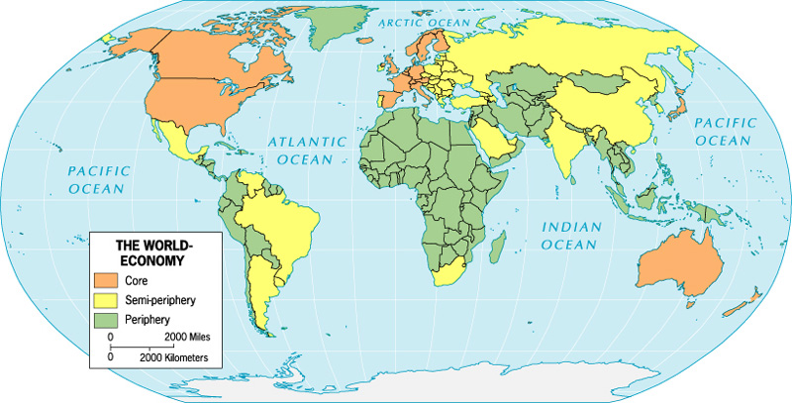
- Wallerstein argues that the contemporary world system is defined by three geographic regions: the core, periphery and semi-periphery that are locked into a system of exploitation

- According to Wallerstein, all systems have a beginning, a middle and an end. According to him, the contemporary world system is coming to an end – this was marked by the end of the Cold War and what was in his opinion the onset of a moment of crisis.
- This crisis is also a moment of opportunity for the establishment of a more equitable system, because actors have more agency

Marxism: Gramscianism
- Antonio Gramsci – an Italian Marxist and founding member of the Italian communist party, imprisoned prior to WWII was primarily concerned with why revolution had proven difficult in Western Europe
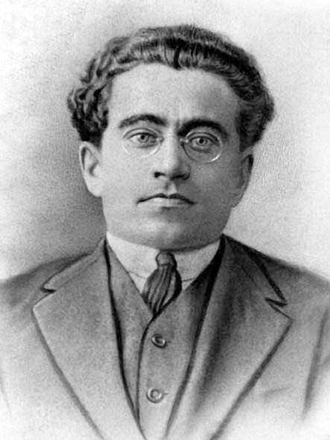
  - Gramsci reminds us that Marx argued that revolution would begin in advanced capitalist societies, not Tsarist Russia
- According to Gramsci, Marx – along with most other Marxists – failed to predict this because of a strict focus on coercive power
- Instead, Gramsci borrows from Machiavelli and argues that power is more like a centaur, a mix of coercion and consent
  - If you can get people to buy into the system, that’s power
- In Gramsci’s view, coercion may be a key feature in less-developed states, but advanced capitalist states maintain power through a hegemony of consent, built into civil society:
  - Civil society refers to the network of institutions and practices that enjoy some autonomy from the state, and through which groups and individuals organize, represent, and express themselves to each other and to the state
- Gramsci’s analysis has two key implications:
  - Marxism needs to take the superstructure seriously: it may be true that the engine of history is the economic base, but values, beliefs and norms in the superstructure condition the vulnerability of a society to change
  - If hegemony is located in the ruling class, it can only be challenged if that ruling class is successfully challenge

Marxism: Critical Theory
- Begins with the Frankfurt school, a group primarily composed left-leaning Jewish scholars that were exiled by Nazi Germany.
- Three key feature of critical theory:
  - This ‘school’ has focussed on questions relating to culture, bureaucracy and social basis and nature of authoritarianism. In addition, they have launched epistemological critiques about theories of knowledge
  - Highly dubious of the emancipatory potential of the proletariat; they believe the proletariat have been absorbed into the system through the commodification of consumer life (ex. hip hop culture?)
  - Very influential in work on the meaning of emancipation. Most Marxists equate this with some form of economic emancipation from capitalist society, the mastery of new technology by humanity and the benefits of this being shared by all.
- Critical thinkers like Jurgen Habermas argue that emancipation is more closely connected with communication and not the ‘natural world.’ For Habermas, emancipation is to be achieved through radical democracy and the removal of barriers to meaningful participation in society.
- Andrew Linklater argues that what needs to happen at the international level is to move away from rights and obligations to the state, and towards a system that does not delineate rights and obligations between citizens and non-citizens. In this respect, he points to the EU as an important step forward

Discussion Group
- The unit of analysis of Marxism is classes, the unit of analysis of realism is states
- Distribution of power – In your opinion, what is the distribution of power in the current world system?
  - Unipolar, bi-polar or multipolar?
  - State
  - Non-state
  - Soft-power
    - Ideas, changing people’s perceptions (I.e. media, propaganda, movies, etc.)
    - Consent of the population
    - Changing the mind through culture – it’s more about the means rather than the ends
  - Power
    - Military
    - Economic

