PSCI 2601 – Tuesday, January 15th 2012

Take-Out
- The expansion of international society
  - Traditional Account
  - Critical Account
- Liberalism
  - History
  - Philosophy
  - Future
- Proposal/Annotated Bibliography

How do you create order in an anarchic system composed of self-interested actors?
- To begin, two historical perspectives on this concerned with the expansion of international society: 1) the traditional perspective; and 2) the critical perspective

The expansion of international society: The Traditional Account
- The international system was not always structured around states. The political structure of Europe in the Middle Ages, is best described as overlapping layers of religious and secular authority
  - Ex. The pope was more or less influential everywhere, there were kings influential in other parts, nobles, etc.
- This meant that political society was not strictly associated with territory, but rather to overlapping layers of authority shifting allegiances
  - Ex. The Tudors
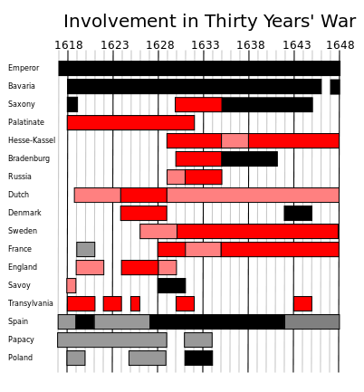
- Because of competing interests and shifting alliances, the medieval system was both quite fluid and relatively unstable
- This was made obvious by the Thirty Years War (1618-48)
  - Conventionally, the Thirty Years War is usually thought to be a religious war between Protestant and Catholic forces, but it was also about settling the question of political authority in Europe
  - Between people with different political claims
- Key players in the Thirty Years War were:
  - Protestant (revisionist powers)
    - Swedish Empire
    - France
    - United Provinces
    - Denmark-Norway (1625-29)
    - England (1625-30)
    - German states (under control of the Habsburg Empire)
  - Catholic (status quo powers)
    - Holy Roman Empire (ie. The Habsburg Empire)
    - Spain
    - Denmark-Norway (1643-45)
- The primary status quo power, the Holy Roman Emperor (Habsburg Empire), entered the war with the aim of retaining secular authority over the German states in its control, and gained support from the Papacy by virtue of being Catholic
- The revisionist powers entered the war with the aim of securing their own political power, and fought on the purported basis that Christian peoples had a right to worship in the Protestant way
- The war is thus a blend of secular and religious interest
- In terms of outcomes, the war is costly in both resources and lives.
  - Estimated population in the German states over the course of the war was between 25%-40%
  - Swedish army alone is estimated to have destroyed: 2000 castles, 18000 villages and 1500 town in the German states (1/3 of all towns)
  - Major disease outbreaks are caused by troop movements and shifting battle locations
  - Massive refugee populations result from the chaos
- The war is an absolute disaster for both sides, but the Revisionist forces (protestants) come out as the victors and sign two agreements with the status quo powers (Catholic): The Treaty of Osnabruck and the Treaty of Munster
- Together, these treaties form the Peace of Westphalia (1648)

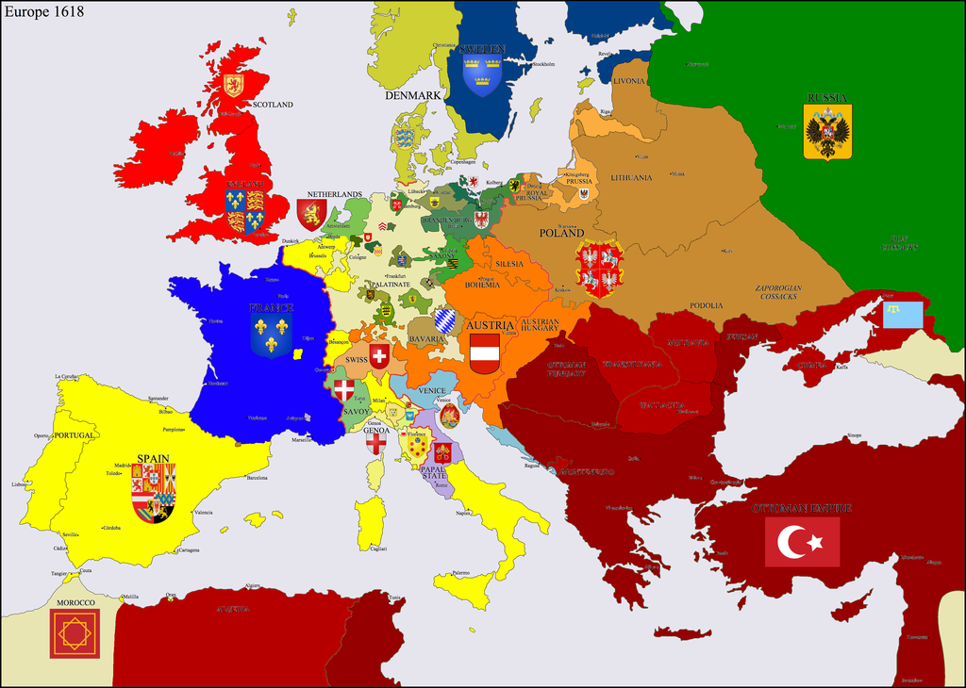

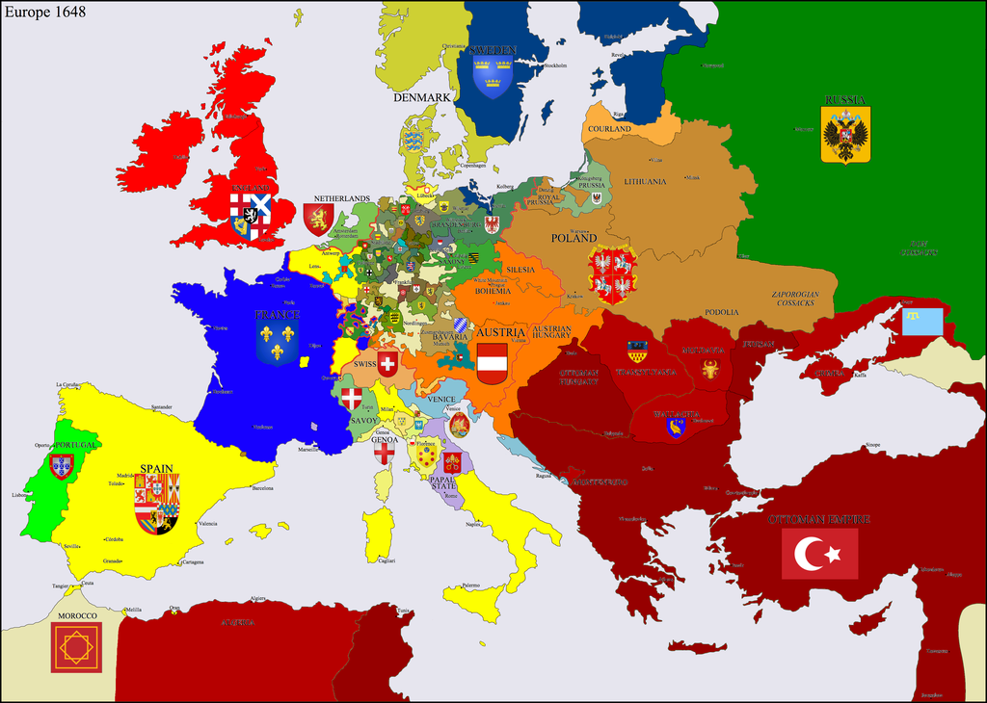

- What does the Peace of Westphalia do?
  - Establishes the right of German states to conduct their own diplomatic relations (external)
  - German states are formally granted an exact and reciprocal right to equality with other states
  - By being granted this ‘equality,’ the German states are granted control over their internal and external affairs
    - Moreover, the idea of internal/external control ushers in an important principle of international relations, sovereignty. Specifically, sovereignty is the principle that within its territorial boundaries the state is the supreme political authority, and that outside those boundaries the state recognizes no higher political authority.
- Implications of sovereignty and the Peace of Westphalia:
  - Intra-European order is generated through a territorial solution to anarchy.
  - This does not mean that anarchy disappears, but that it lays the foundation for important norms and values that limit its destructive potential
    - States must respect the territorial integrity of other states, to retain legitimacy in the nascent international society: The concept used to describe a group of sovereign states that recognize, maintain, and develop common norms, rules, and practices the enable them to coexist and cooperate.
    - The Peace of Westphalia is thus a territorial solution to the problem of anarchy

The Expansion of International Society: the Critical Account
- Edward Keene, Beyond the Anarchical Society (2002)
  - According to Keene, the traditional account of international society is misleading. Societies can live in anarchy based on common values
    - Yes, Europeans do establish a Westphalian system, which helps establish order between the great powers.
    - But, this system also generates order in Europe, and actually facilitates disorder in most other parts of the world until the mid-20th century. In fact, it actually created a lot of disorder outside of Europe because it allowed other countries to do whatever they wanted outside of Europe
- To understand this argument we need to return to 1492, when Columbus sailed the ocean blue … and happened upon the island of Hispaniola (today the Dominican Republic and Haiti) (last week)
- In addition to what was discussed last class, the discovery of the Americas set off a wave of tension in Europe, especially between the Spanish and Portuguese
  - From the perspective of Portugal, the Spanish discovery poses a threat. With the discovery, Spain might secure a new trade route to Asia and/or claim new resources; meaning an increase in Spain’s commercial and military power (economic/military benefits). This would threaten the Iberian Peninsula
  - People feared that Spain would become a hegemon, threatening the entire Iberia. Hegemony: one great power over a given region
- Portugal turns to its ally, the Papacy
  - Portugal had previously been granted control of some territory by the Papacy (remember that the European system was based on overlapping layers of authority and allegiance)
  - The Papacy replies by issuing the Treaty of Tordesillas (1494)
    - Two years after Columbus
- In a nutshell, the Treaty of Tordesillas resolves Portugal and Spain’s dispute by dividing newly discovered lands between Portugal and Spain along a meridian 370 leagues west of the Cape Verde Islands (owned by Portugal) and the islands discovered by Columbus (owned by Spain)
- Fun fact: Ever wonder why Brazil speaks Portuguese, and the rest (almost) of South America speaks Spanish?
- In effect, the Treaty of Tordesillas establishes a territorial arrangement that:
  - Enables intra-European order (like Westphalia) by settling the dispute between Spain and Portugal through a territorial solution
  - Enables European expansion into the ‘new’ world, by easing tensions and resolving competing claims. This expansion of course would be marked colonialism and other forms of violence.
    - Countries didn’t have to argue over territory
  - In other words ... the Treaty of Tordesillas reflects the argument advanced by Keene
- Is the Treaty of Tordesillas an anomaly?
  - The Doctrine of Discovery: A ten point legal framework that emerges over time to define the terms of European expansion and claims to land in the new world. The purpose of which is to promote European colonial activities by easing intra-European tensions over land claims
  - The Berlin Conference (1884/85): A conference established by Europe’s great powers to enable the orderly partition of Africa - European negotiators meet to negotiate land claims/property rights.
- But, a question remains unresolved: How could the European powers justify their colonial activities?
- In short, by forming an international society, Europeans establish rules and norms that help justify expansion. At the centre of these norms/values is the concept of civilization.
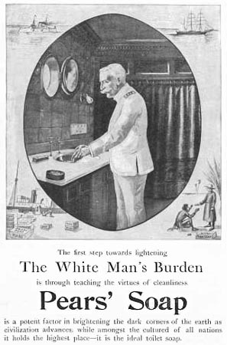
- As some scholars point out, the international society that formed in Europe premised their norms and values on the idea that they were civilized and others were not (Self/other dichotomy: civilized self and uncivilized other)
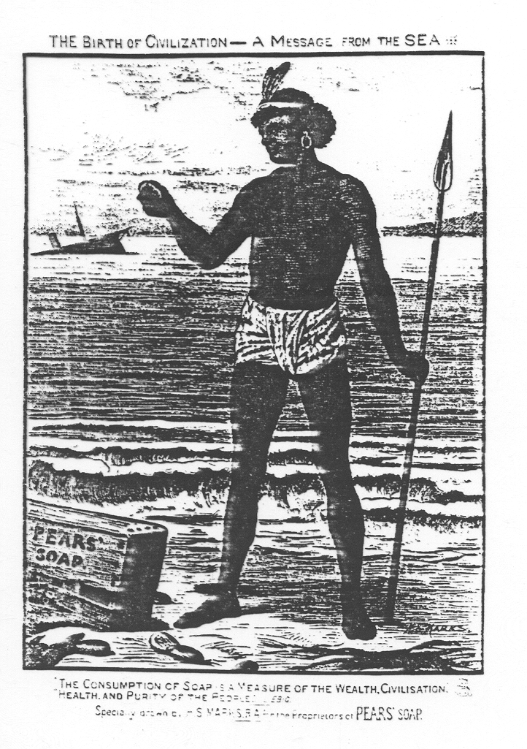
- In this way, they distinguished themselves from others and could justify expansion on the basis that they were spreading civilization to the uncivilized world – this meant expanding their colonial empires
- “White Man’s Burden” – Europeans had the obligation to go and civilize the rest of the world
- Traditional Account focuses primarily on Europe and is more state-centric (places emphasis on the role of the state in creating order). The Critical Account argues that there’s more than just Europe. Intra-European order may have been established, but it fostered a lot of disorder in the rest of the world, particularly in the Americas, Africa and Asia. It looks at other political structures, thus more than just states.

Liberalism
- First, make distinction between theory and practice, liberalism is not the Liberal Party

History – World War I
- By the late-19th century, much of the world had been carved up into European empires, with little room for further expansion
- According to Vladimir Lenin, the inability of these primarily capitalist empires to expand resulted in important tensions
- With no where else to expand, the only place to look was toward other European colonies
- In addition to these ‘imperial tensions,’ new mentalities about warfare were becoming more influential, like the Cult of the Offensive.
- With tensions boiling over, and ‘experts’ believing in the capacities of new technology, First World War erupted in 1914
- Some liberals blame the autocratic regime that in power in Germany, others complex alliances; regardless, the end result is total warfare
  - WWI was both total – in its global scope and in the terms of both sides (only total surrender would be accepted)
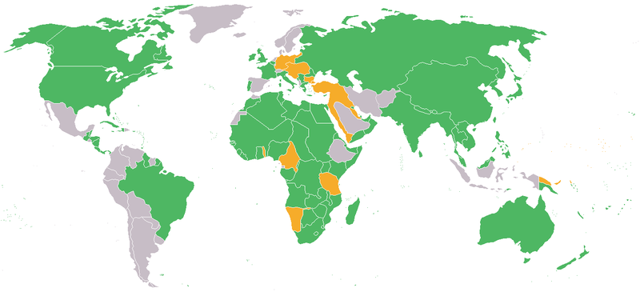
- Allied Powers
  - France
  - British Empire
  - Russia
  - USA (1917-18)
- Central Powers
  - Germany
  - Austria Hungary
  - Ottoman Empire
- A sense of the devastation (like Westphalia) is highlighted by these figures:
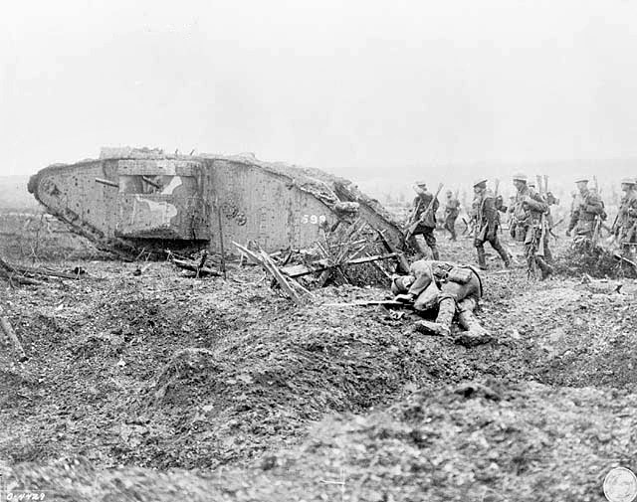
- Allied Powers:
  - 5,525,000 military dead
  - 12, 831, 500 military wounded
  - 4, 121, 000 military missing
- Central Powers:
  - 4, 386, 000 military dead
  - 8, 388, 000 military wounded
  - 3, 629,000 military wounded

History – Treaty of Versailles
- Also like the Thirty Years War, WWI ends with a politically significant peace treaty, the Treaty of Versailles, which leads to the establishment of the League of Nations – the predecessor of the United Nations. And, it is through the League of Nations that we observe one of the first ‘modern,’ liberal manifestos: Woodrow Wilson’s Fourteen Points
- Wilson’s Fourteen Points was designed to guide the peace process at Versailles. Significantly, it articulates ‘principles’ that are clearly indebted to the work of classical liberal philosophers, like Immanuel Kant and Richard Cobden.
  - Fun Fact: The end of WWI also results in the establishment of the Woodrow Wilson Chair of International Politics at the University College, Wales, Aberystwyth. This chair marked the creation of the first ever department of international politics, ushering in the discipline of international relations (thus end of WWI sparked this discipline).
  - Fun fact: Despite advocating for the creation of the League of Nations on behalf of the USA, the USA never joined the League of Nations

Philosophical Background
- Amongst those to influence the views of Wilson was the classical liberal philosopher is Immanuel Kant (1724-1804)
  - Kant began his work out of a reaction to the barbarity of international relations, or what Kant referred to as ‘the lawless state of savagery’
  - In this sense, neither Kant nor other liberals were idealistic about human nature – as they would later be depicted – but were rather concerned with creating a political agenda to overcome the problem of anarchy. This goes against the common criticisms of liberals, such as they are too utopian and non-realistic.
- Fun Fact: Despite writing on international politics, Kant never left his hometown in Konigsberg, Prussia (now located in Russia).
- Kant’s political agenda: Perpetual Peace
  - Kant develops a plan for perpetual peace on the basis of three articles
    - The civil constitution of every state shall be republican (i.e. democratic)
    - The right of nations shall be based on a federation of free states (complete sovereignty, external and internal)
    - Cosmopolitan right shall be limited to conditions of universal hospitality (do to others what you want them to do)
- Richard Cobden’s political agenda: Free Trade
  - Cobden argued that free trade would create a more peaceful world order, by offering mutual benefits to all participants
  - From the standpoint of Cobden, actors were interested in absolute gains
- It doesn’t matter if the other person gained more, because you both gained
- Relative gain: take into consideration the difference between the gains achieved from trade

Modern Implications
- To return to Wilson’s Fourteen Points, you can see the influences of these views under points: 1, 2, 3, 14.
  - Point 1: Open covenants of peace, openly arrived at, after which there shall be no private international understandings of any kind but diplomacy shall proceed always frankly and in the public view.
  - Point 2: Absolute freedom of navigation upon the seas, outside territorial waters, alike in peace and in war, except as the seas may be closed in whole or in part by international action for the enforcement of international covenants.
  - Point 3: The removal, so far as possible, of all economic barriers and the establishment of equality of trade conditions among all the nations consenting to the peace and associating themselves for its maintenance (Cobden)
  - Point 14: A general association of nations must be formed under specific covenants for the purpose of affording mutual guarantees of political independence and territorial integrity to great and small states alike. (Kant)
- Liberal antecedents do not only appear in the work of Wilson though, they have also been very influential the contemporary theory and practice of international relations:
  - Influence of Kant in theory: Democratic Peace Theory (DPT)
    - DPT points out that, generally speaking, democratic countries do not go to war with one another
    - Golden Arches theory has been used to critique DPT – point out that virtually no two countries that have a McDonalds have ever gone to war together. DPT theorists would argue that it is because McDonalds are associated to the democratic states that they originate from and the associated free trade
  - Influence of Cobden in practice: Look at the global economy
    - Pretty much any free trade agreement you can think of (ex. North American Free Trade Agreement)

In light of this background, what is contemporary liberalism?
- Philosophically, liberalism fundamentally believes in the possibility of progress (this speaks to the fact that despite liberal philosophers respond to the problems of anarchy with political programs).
- But, liberalism also relies on a set of four key assumptions that we see in much of the modern world:
  - Citizens are equal before the law and possess basic rights
    - Ex. Liberalism is at the heart of the human rights regime, both internationally and domestically
  - The legislative assembly of a state possesses only the authority invested in it by its people/population (ex.)
    - Democratic states are founded on this very basis
  - A key right of the individual is to own property for productive forces
    - The ability to be use land for productive purposes founded much of the liberal philosophy that supported English colonialism, and also the basic assumption of capitalism (ex. To maximize profit out of available resources)
  - The most effective economic system is one driven by the free market, and not one that is heavily regulated
    - Think the global economy, especially pre-2008
    - Most states, even China, buy into the idea of market capitalism
    - Fun fact: These criteria have led to the perception of liberalism as an inside-out theory of international politics; specifically, because order at the international level is generated by these domestic features (rights, democracy, etc.)
      - Ex. Kant – we need republic states for international system, which are built domestically

Proposal/Annotated Bibliography
- The proposal is very broad
- Meet two requirements: interested in it and must be relevant to the course
  - Must touch on a topic (empirical issue) that the course speaks to – trade, warfare, rights, etc.
  - Must speak to one of the theories – liberalism, Marxism, etc.
- 12 point TNR or 11 point Calibri work
- Bibliography:
  - 5 academic sources
  - 2-3 sentences that explain the article and how it applies
- Current topics: (ex. Arab Spring) there may be a lot of news coverage, but not academic sources
- Try to use contemporary sources
  - Empirical information (ex. Trade agreements, war) – use recent info
  - Theoretical information – more or less timeless, thus you can go back further

Discussion Group
- TA: Babita Bhatt
- E-mail: babitabhatt@cmail or bbhatt2@gmail.com
- Office Hours: Mondays, DT 2101 15:00-16:00

History of International Relations
- Assumption of international relations: peace is possible, all parties benefit
- States are no longer the only actors
- Main events affecting IR:
  - After WWII: end of Euro centralization, emergence of international institutions
  - Fall of Berlin Wall
  - Washington Consensus
  - 9/11

