PSCI 2601 – Tuesday, January 8th 2013

Introduction

Globalization Defined
- Globalization: is “the process of increasing interconnectedness between societies such that events in one part of the world increasingly have effects on peoples and societies far away”
- Globalization is categorized into three types; though these categories bleed into each other:
  - Social/Cultural (ex. Gangnam Style)
  - Economic (ex. International financial institutions)
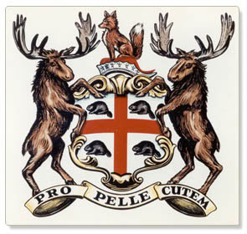
  - Political (ex. Rise of non-state actors)

Is Globalization Something New?
- On the one hand, some scholars suggest that yes, it is:
  - New non-state actors are emerging
  - Time and space is rapidly shrinking
  - An emerging global polity is forming
- On the other hand, some scholars counter that no, it is not:
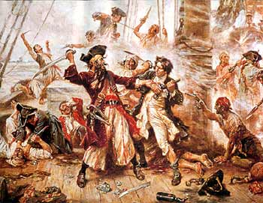
  - Pirates, mercenaries and more
  - An acceleration of old processes/forces
  - A new form of imperialism

Why these Competing Perspectives?
- Explained through a story:
  - In 1942, Columbus sailed the ocean blue… and happened upon the island of Hispaniola (today the Dominican Republic and Haiti)
  - In addition to marking “first contact” between ‘old’ and ‘new’ world, Columbus’ discovery would set off European colonialism in the centuries to come
- European empires quickly recognized the potential value of the ‘new world’, setting off competing claims to land and provoking intra-European tensions.
- From an International Relations (IR) perspective, the onset of colonialism is important for a number of reasons, but especially for highlighting the fundamental problem of international anarchy (Ex. The absence of government)
  - How can order be established in an otherwise anarchical system composed of self-interested actors?
- From a practical perspective, the onset of colonialism also meant a rejuvenation of interest in cartography – a critical tool in the colonial project.
- Amongst the most important of these maps, was the Mercator projection, presented in 1569 by Flemish cartographer Gerardus Mercator.
- During the 1970s – a period marked by decolonization and a change in the international political climate – scholars, statesmen and UN agencies point out that the Mercator projection skews the world because of its focus on Europe
- Consider this: Greenland is represented as three times the size of Australia, when in fact, Australia is three times the size of Greenland
- The map was used during the Cold War to reinforce perceptions of the Soviet “treat”
- Gall-Peters Projection: contours of landmasses are distorted in favour of equal-area cylindrical size

Moral of the story:
- All maps give you a specific perspective of the world, and this perspective is often conditioned by politics
  - The Mercator projection skews the world by placing Europe at its centre
  - The Gall-Peters projection was a politically motivate map used to conquest colonial renderings of the world
  - I.e. Product of power politics
- World maps are also a lot like theory:
  - They give basic contours with which to understand the world, but do not give you specific like a road map
  - All these theories are perspectives, that are conditioned by political representation
    - Ex. Thing of wearing different coloured glasses
    - The first great debate in IR, between Idealism and Realism pivoted around this very issue
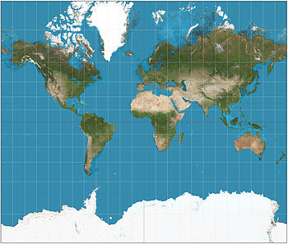
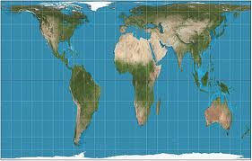

- Post-colonialism, Orientalism, Imperialism and Edward Said
  - Book written 20 years before 9/11
  - Power and knowledge are intimately connected, and every theory is a form of power – simplifying device of how we see the world. Theory can thus be very powerful, and in turn dangerous

