Neurobehavioural Disorders
Causes of Abnormal Behaviour
- Evidence for brain abnormalities in organic-neurobiological disorders is straightforward, and the causes are generally
- Genetic Error (Ex. Huntington’s Disease)
- Progressive Cell Death (Ex. Alzheimer’s Disease)
- Rapid Cell Death (Ex. Stroke)
- Loss of Neural Connections (Ex. Multiple Sclerosis)
- We don’t know what causes a person to be more susceptible than another to these diseases.
- Far less is known about the causes of Behavioural-Psychiatric Disorders, but there must be some abnormality in the brain structure or activity.
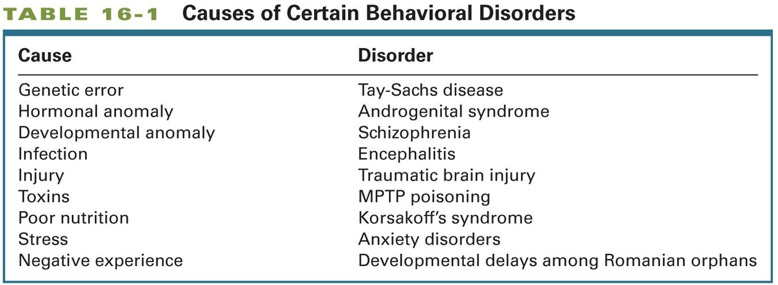
Micro

Macro
Identifying and Classifying Mental Disorders
- Epidemiology
- The study of the distribution and causes of diseases in human populations
- DSM
- The Diagnostic and Statistical Manual of Mental Disorders, the American Psychiatric Association’s classification system for psychiatric disorders
- Current edition is DSM-IV-TR, DSM-V slated for May 2013
- Psychiatric Disorders are to some extent arbitrary and depend on prevailing cultural views
Challenges in Diagnosis
- It is difficult to diagnose behavioural disorders
- People are seldom objective observers of their own behaviour or that of a loved one
- The patient and their loved ones may be selective in what they notice
- People are seldom specific in identifying symptoms
- Many disorders can result in Memory Deficits
- With memory being effected remembering symptoms can be difficult
- Evaluations have their own conceptual biases, which may influence the questions that they ask and the information that they gather
- General Practioner, Social Workers, Neurologist, etc.
Treatments for Disorders
- The long-term prospects for curing organic or behavioural disorders on the Macro Level depends upon the ability to treat structural and biochemical abnormalities at the Micro Level
- Ultimate Clinical Problem:
- Apply the knowledge of behavioural neuroscience to general treatments that can restore a disordered brain (and mind) to the range of normalcy
- Nosology proceeds Etiology: This means that we name disorders before we know what causes them. How do we treat a disorder when we don’t know what causes it?
Traumatic Brain Injury
- Head injuries are the most common form of brain damage in people younger than 40.
- There are two important factors:
- Age
- Children and older adults are more likely to suffer from head injuries due to falls
- Sex
- Males between 15 and 30 are more likely to suffer from head injuries especially from automobiles and motorcycle accidents
Traumatic Brain Injury: Effects
- Trauma can disrupt the brain’s blood supply, induce bleeding (hematoma), causes swelling (edema), expose the brain to infection, and scar brain tissue
- Unconsciousness: Brief or Prolonged (Coma)
- Two Behavioural Effects:
- Specific Impairments may be the result of the coup (site of impact) and the countercoup (the opposite side of the site of impact) lesion
- More Generalized impairments may be due to widespread damage through-out the brain
Traumatic Brain Injury
- Often misdiagnosed when there is no abnormal MRI or CT scans
- There can be small areas of damage that are undetectable on MRI or CT Scans
- Most cognitive recovery occurs within the first 6 to 9 months
- Cognitive abilities tend to make a good recovery, but social skills and normal personality typically do not show significant change
Stroke
- Stroke
- An interruption of blood flow either from the blockage of a blood vessel or from bleeding of a vessel
- Ischemia
- Lack of blood to the brain as a result of stroke
- This sets off a cascade of cellular events that cause the real damage to the intial site and surrounding areas
- Diaschisis
- Neural shock that follows brain damage in which areas connected to the site of damage show temporary arrest of function
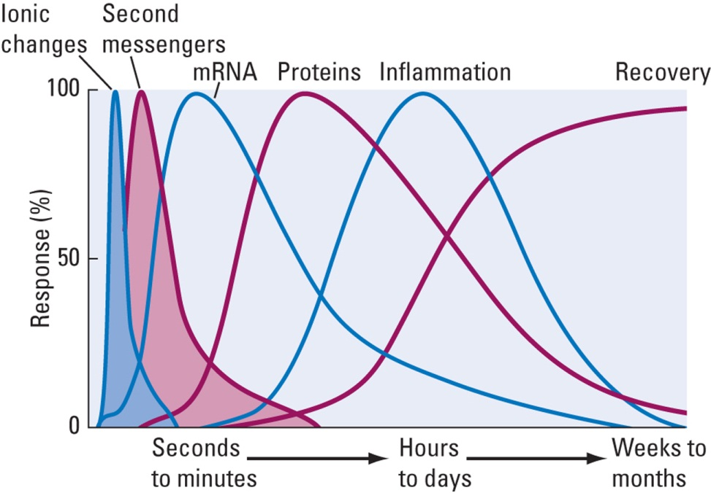
- Apoptosis: Cell death
- The cascade of events the follow a stroke are represented on the left.

Stroke: Treatment
- Administer Anti-Clot Drugs
- Ex. t-PA (Tissue Plasminogen Activator)
- This must be administered within 3 hours of the stroke
- Neuroprotectant
- These are drugs that are used to try to block the cascade of post-stroke neural cascade events
- There are no good neuroprotectants available as of yet
- Therapies (Ex. Speech Therapies or Physical Therapies) are often used to facilitate plastic changes in the brain following a stroke.
Epilepsy
- Recurrent seizures accompanied by loss of consciousness
- Symptomatic Seizures
- Identified with a specific cause, such as infection, trauma, tumor, vascular formation, toxic chemicals, very high fever, or other neurological disorders.
- Idiopathic Seizures
- Appears spontaneously and in the absence of other diseases of the Central Nervous System
- A variety of factors may precipitate a seizure
- Three Common Symptoms of Seizures
- An Aura, or warning of impending seizures – a sensation (odor or noise) or a “feeling”
- Loss of consciousness often followed by a period of amnesia that can include the seizure itself
- A motor component that can vary from shaking to automatic movements such as hand-rubbing or chewing
Two Types of Epileptic Seizures
- Focal Seizure
- A category of seizure that begins locally (at a focus) and then spreads out to adjacent areas
- “Jacksonian March” as the seizure progresses the movements become like a march
- Complex Partial Seizure
- This is a type of focal seizures
- Originate mostly in the Temporal Lobe
- Characterized by:
- Subjective experiences that presage the attack (ex. hallucinations)
- Automatisms or repetitive stereotyped movements (ex. lip smacking)
- Postural Changes (ex. catatonic or frozen posture)

Two Types of Epileptic Seizures
- Generalized
- There is a lack of focal onset and they occur on both sides of the body
- Grand Mal Seizure
- Characterized by loss of consciousness and stereotyped motor activity that take place in 3 stages
- Tonic Stage: Body stiffens and breathing stops
- Clonic Stage: Rhythmic Shaking
- Postictal Depression: Postseizure state of confusion
- Petit Mal Seizures
- Of brief duration, characterized by loss of awareness with no motor activity expect for blinking, turning the head, or rolling of the eyes.
- Ictal Stage: When the seizure is taking place
Epilepsy: Treatment
- Anticonvulsant Medications
- Ex. Dihenylhydantion or Phenobarbital
- Work by stabilizing the neuronal membrane, especially inhibitory neurons (ones that actively inhibit activities through-out time)
- Surgical removal of the abnormal tissue that is the focus of the seizure is sometimes performed in severe cases (focal seizures)
Multiple Sclerosis
- Diease characterized by a loss of myelin, largely in the motor tracts but also in sensory nerves
- Relapses and remissions are common
- Brain imaging reveals discrete lesions
- The cause is unknown, but proposed causes include: bacterial infection, a virus, environmental factors (ex. pesticides), and an immune response of the Central Nervous System
- Autoimmune Disorder: The Myelin Sheath is seen as a threat so the Autoimmune System begins to attack the Sheath.
Dementia
- Acquired and persistent syndrome of intellectual impairment
- Diagnostic Features (DSM):
- Memory and other cognitive deficits
- Impairment in social and occupational functioning.
- Two Broad Categories:
- Nondegenerative Dementias are a heterogeneous group of disorders with diverse etiologies
- Ex. Vascular Dementia; Karsokoff’s
- Degenerative Dementias are presumed to have a degree of genetic transmission
- Ex. Alzheimer’s; Huntington’s; Parkinson’s
Parkinson’s Disease
- Related to the degeneration of the Substantia Nigra and to the loss of the neurotransmitter Dopamine
- Despite a common site of damage, symptoms vary enormously among people
- Many symptoms resemble the changes in motor activity that take place as normal consequences of aging
- Positive Symptoms
- Tremor at rest
- Muscular Rigidity (increased muscle tone)
- Involuntarily Movements
- Akathesia: Small. Involuntary movements, or changes in posture and motor restlessness
- Occulogyric Crisis: Involuntary turns of the head and eyes to one side
- Negative Symptoms
- Disorders of posture (fixation and equilibrium)
- Disorders of righting (ex. standing up)
- Disorders of Locomotion
- Festination: The tendency to engage in behaviour, such as walking at a faster and faster speed
- Speech Disturbances (ex. loss of prosody)
- Akinesia (poverty or slowness of movement)
- Also: Cognitive Sympotoms impoverishment of feeling, libido, motive, and attention; cognitive slowing
Parkinson’s Disease: Causes
- Loss of cells in the Substantia Nigra, which may be causes by diseases such as encephalitis, syphilis, drugs (ex. MPTP), or unknown causes
- Environmental Pollutants? Insecticides?
- Increasing incidence among individuals <40. This suggests environmental toxins
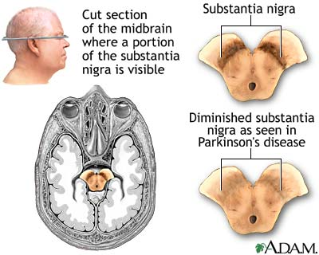
Parkinson’s Disease: Treatment
- Behavioural
- Ex. Physical Therapy is often helpful
- Pharmacological
- Increase levels of Dopamine (ex. Dopamine agonists such as L-Dope which is a precursor of Dopamine which will later produce Norepinephrine)
- Suppress the activity of structures that show heightened activity in the absence of adequate Dopamine action (ex. Anticholinergic Drugs)
- Surgical
- Electrical stimulation or lesioning of the internal Global Pallidus which reduces rigidity and tremor
- Deep Brain Stimulation (DBS)
- Neurosurgery in which an electrode is implanted in the brain stimulating a targeted area with low-voltage electrical current to facilitate behaviour
- This is used to treat Parkinson’s and depression
- Transplantation
- Transplant embryonic Dopamine-Producing cells or multi-potential stem cells into the Basal Ganglia. They will become the cell population that is lost
- Highly experimental
Alzheimer’s Disease
- Approximately 65% of dementia cases
- Cause is unknown, but proposed causes include:
- Genetic Predisposition
- Environmental Toxins (Aluminum)
- Autoimmune Reponses (Recognizes something as a threat and tries to fight it)
- A slow-acting virus
- Cardiovascular Functioning: Reduced blood flow to the hemispheres
Alzheimer’s Disease: Anatomical Correlates
- Neuritic (amyloid) Plaques
- Located mostly in the Cerebral Cortex
- It can interfere with Normal cellular functioning
- Also found in non-Alzheimer dementia patients
- Neurofibrillary Tangles
- Paired helical filaments found in the Cerebral Cortex and Hippocampus
- Also found in Patients with Down Syndrome, Parkinson’s Disease and other types of Dementia.
- Cortical Degeneration
- Most affected areas are in the Limbic Cortex, Inferior Temporal Cortex, and Posterior Parietal Cortex
- The Entorhinal Cortex (link between Neocortex and Hippocampus) shows clearest evidence for cell loss, which may explain why memory problems occur early in the disease.
- The primary sensory and motor area spared
- Patients do not die from Alzheimer’s, but die from associated problems.
- Cerebral atrophy may be due in large to the loss of Dendritic Arborization, which is associated with the number of connections.
- Loss of specific neurotransmitter population
- Acetylcholine
- Noradrenaline
- Dopamine
- Serotonin
- NMDA and AMPA Glutamate Receptors
- Depression is caused because of the loss of the neurotransmitters
Understanding and Treating Psychiatric Disorders
- A wide range of psychiatric disorder are listed in the DSM
- There are three general categories
- Psychotic Disorders
- Mood Disorders
- Anxiety Disorders

Schizophrenia
- Six Diagnostic Symptoms
- Delusions (Persecution or Grandeur)
- Hallucinations (Auditory or Visual rarely)
- Disorganized Speed
- Disorganized Behaviour
- Catatonic Behaviour
- Negative Symptoms (ex. Blunted Emotions)
Two Types of Schizophrenia?
- Type I
- Positive Symptoms
- Delusions
- Hallucinations
- Agitated Movements
- Likely due to a Dopaminergic Dysfunction
- Associated with acute onset (sudden), good prognosis, and a favorable response to Neuroleptics (main category of drugs used to treat Schizophrena)
- Type II
- Negative Symptoms
- Catatonia
- Negative Affects
- Cell Lose: Enlarged Ventricles and Cortical Atrophy, particularly in the Frontal Cortex
- Associated with Chronic affliction (long prodormal period), poor prognosis, poor response to Neuroleptics, cognitive impairments
- 20 – 30% of patients show “mixed” symptoms
- Prodormal Period: The time between when the odd behaviours begin to when the actual diagnosis of the disorder
Schizophrenia: Neuroanatomical Correlates
- Memory Deficits: Large ventricles and thinner Cortex in the Medial Temporal Regions (learning and memory: Hippocampus and Amygdala) and abnormal Dendritic Fields in the Dorsal Prefrontal Area, Hippocampus, and Entorhinal Cortex.
- Deficits in Executive Functioning: Abnormal blood flow in the Dorsolateral Prefrontal Cortex
- Auditory Hallucinations: Abnormalities in the Auditory Regions of the Temporal Lobes (Patients show activation in these regions in a PET scan even though there is no external stimuli)
- Thought Disorders: Abnormalities in Wernicke’s area (language comprehension)
- There is no brain region associated with Schizophrenia, but instead numerous brain regions
- The process of cell growth is possibly affected
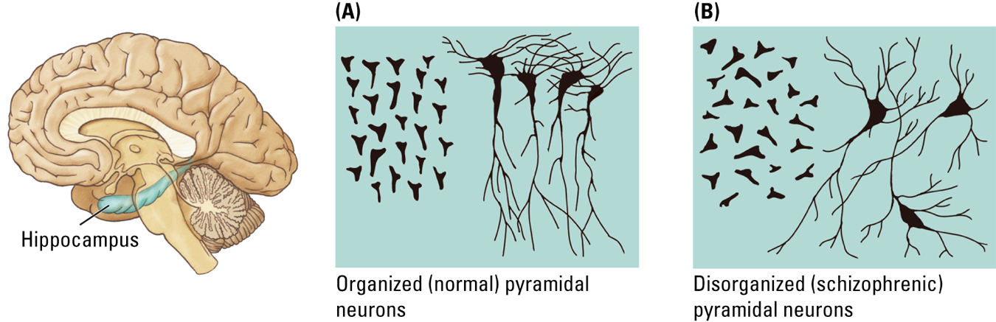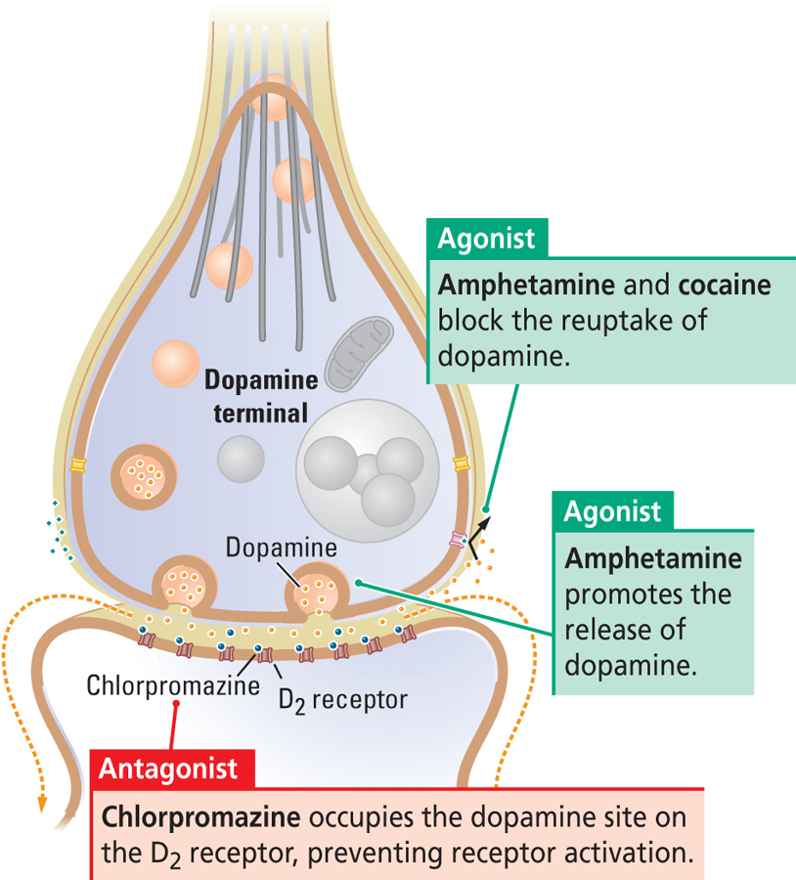
Dopamine Hypothesis of Schizophrenia
- Proposal that Schizophrenia Symptoms are due to excess activity of the Neurotransmitter Dopamine
- Evidence
- Antipsychotic drugs block D2 receptors (Dopamine Antagonist)
- Amphetamine promotes release of Dopamine and can also produce symptoms similar to Schizophrenia
- But there is still no conclusive evidence of Dopamine –Related difference in the brains of Schizophrenia Patients
- It is not true that they have excess Dopamine levels and they do not have excess D2 Receptors
Schizophrenia: Neurochemical Correlates
- Dopamine
- One of the first Neurotransmitters to be implicated in Schizophrenia
- Neuroleptics are Dopamine Antagonists
- Dopamine Agonist can produce Psychotic Symptoms
- The Dopamine Theory appears too simple
- Many other Neurochemical abnormalities are associated with Schizophrenia
- Glutamate and GABA regulate Dopamine which are becoming critical in the development Schizophrenia
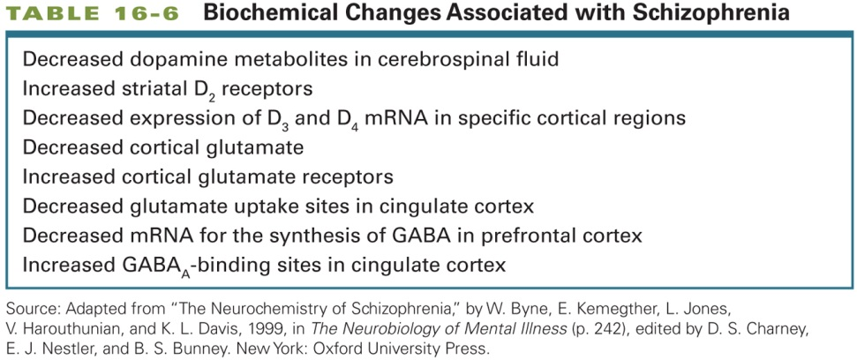
Schizophrenia: Treatment
- Typically, antipsychotics (Narcoleptics)
- Some drugs have negative side effects (target all Dopamine systems)
- Tardive Dyskinesia
- Inability to stop the tongue from moving
- Motor side effect of Neuroleptic drugs
- The side effects can last long after the person stops taking the drug
- The second generation of Antipsychotics (A-Typical) do not necessarily target the primary Dopamine Systems (GABA and GLUTAMATE) and they reduce the presence of these side-effects
Mood Disorders
- Depression
- Prolonged feelings or worthlessness and guilt, disruption of normal eating habits, sleep disturbance (circadian rhythm disturbances), a general slowing of behaviour, and frequent thoughts of suicide
- Mania
- Disordered mental states characterized by excessive Euphoria
- Very happy, may experience delusions, excessive goal directed behaviour, risky behaviour.
- Bipolar Disorder
- Mood disorder characterized by alternating periods of depression and mania
Depression: Neurobiology
- Thought to be due to low levels of Serotonin and Norepinephrine
- Antidepressant drugs act to increase levels of Norepinephrine and Serotonin
- There is little evidence, however, that low levels of these Neurotransmiters cause depression
- Lowering levels of these Neurotransmitters in normal people does not produce depression (ex. Tritaphan Milkshake)
- Antidepressant medications alter the levels of these Neurotransmitters within days, but it takes weeks for the drugs to start relieving depression despite of the fact that they immediately start effecting the neurotransmitter system
- Duman (2004) Neurotrophic Theory
- This Theory suggested that depression may involve low levels of Neurotrophic Factors and Neurogenesis
- Brain-Derived Neurotrophic Factor (BDNF) is down – regulated by stress and up-regulated by anti-depressant medication.
- Antidepressant medication may increase levels of BDNF via altering Intracellular signalling.
- Is there a relationship between mood and reactivity to stress?
- HPA Axis
- Hypothalamic-Pituitary- Adrenal Circuit (slow pathway) that controls the production and release of hormones related to stress
- It also regulates Serotonin release downstream
- This system can be unregulated. Regularly we have a peak and a tough.
- Chronic stress can lead to over-secretion of Cortisol, which is associated with depression in adulthood.
- It begins to kill off cells in the Hippocampus, making it harder for the system to shut down this secretion
- 45% of adults with depression lasting more than 2 years experienced abuse, neglect, or parental loss as a child.
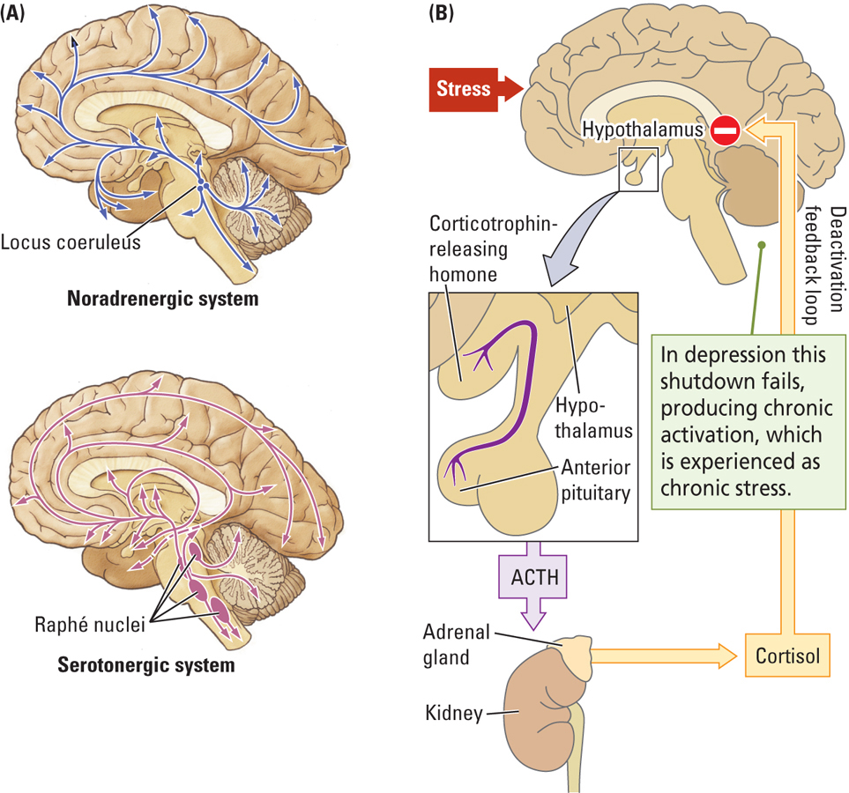

Depression: Treatment
- Pharmacotherapy:
- SSRIs (Selective Serotonin Reuptake Inhibitors)
- Tricyclics
- MAO-Is (There inhibit Monoamine Oxidase)
- The best treatment do not need to be directed at biological intervention
- Cognitive Behavioural Therapy (CBT)
- Problem-focused, action-oriented, structured treatment for eliminating dysfunctional thoughts and maladaptive behaviors
- At least as effective as medication as a treatment for depression
- This treatment is better for mild to moderate depression
Electroconvulsive Therapy (ECT)
- Using electrical current to produce seizures as a treatment for severe depression
- Restarts all the Neurotransmitter systems, but if there is an underlying problem the break down will reoccur
- Stimulates the production of Neurotrophic Factor
- Problems:
- The person must be medicated in order to avoid muscular stress that is cause by the electrical stimulation
- ECT leads to memory loss, which can show a cumulative effect with repeated ECT treatments
Transcranial Megnetic Stimulation (TMS)
- An alternative to ECT for treating depression
- TMS is far less drastic than ECT
- It targets the brain region that you would specifically like to restart
- There are fewer side effects with TMS than with ECT because the magnetic stimulation can be applied narrowly, to a focal area, rather than diffusely, as in ECT
- There are no memory problems or seizures.
Anxiety Disorders
- Six Different Types
- Generalized Anxiety Disorder (worry about what is going to happen)
- Panic Disorder (Abnormal fear response to something that isn’t there)
- Post-Traumatic Stress Disorder (Adnormal fear response to a specific event)
- Social Phobia (ex. Agoraphobia)
- Specific Phobias
- Obsessive-Compulsive Disorder (Marked by obsessions and compulsions)
Anxiety Disorders: Neural Correlates
- Brain Imaging Studies
- Increased activation in the Cingulate Cortex and Parahippocampal Gyrus (involved in Emotional Processing)
- Enhanced response to Anxiety-Provoking stimuli in the Amygdala and Prefrontal Cortex
- Excessive excitatory Neurotransmission may enhance anxiety
- GABAergic Drugs are effective at reducing anxiety (high GABA calms the Nervous System)
- Anxiety disorders may be caused by stressful experiences that occur early in life (Ex. Grooming Rat Mothers)
Gene and Environment Interaction
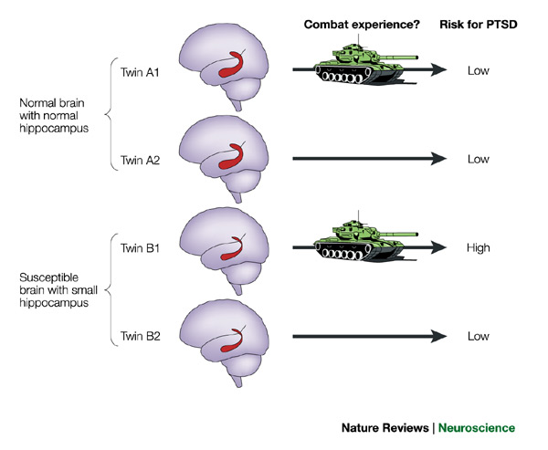
Anxiety Disorders: Treatment
- Pharmacological
- Benzodiazepines were once the primar treatment for Anxiety Disorders, but SSRIs (antidepressants) are now commonly used treatments for anxiety
- Cognitive-Behaviour Therapy
- Focuses on challenging the reality of patient’ obsessions and the behavioural necessity for their compulsions
- As effective as medications in treating chronic anxiety disorders.
Is Misbehaviour Always Bad?
- Miller and Colleagues (2000)
- Loss of function in one brain areas (ex. Frontal or Temporal Regions) sometimes can release new functions elsewhere
- Ex. The case of Tommy McHugh, a drug addict, who had a stroke and completely changed his personality
- Neurocognitive Enhancement
- Brain-function enhancement by pharmacological, physiological, or surgical manipulation
- Raises a number of moral and ethical concerns

