How Do We Learn and Remember?
Connecting Learning and Memory
- Learning
- A change in an organism’s behaviour as a result of experience
- Can be measured the same way in humans and animals
- Memory
- The ability to recall or recognize previous experience
- It is the persistence of learning in animals
- Memory Trace
- A mental representation of a previous experience
- Presumed to correspond to some physical change in the brain
Pavlovian Conditioning
- Classical Conditioning
- Learning procedure whereby a neutral stimulus (such as a tone) comes to elicit a response because of its repeated pairing with some event (such as the delivery of food); also called respondent conditioning or Pavlovian Conditioning
- Unconditioned Stimulus (UCS):
- Stimulus that evokes an unconditioned response withing previous conditioning
- Ex. Meat Powder
- Unconditioned Response (UCR):
- Unlearned reaction to an unconditioned stimulus that occurs without previous conditioning
- Ex. Salivation
- Conditioned Stimulus (CS):
- Previously neutral stimulus that has, through conditioning, acquired the capacity to evoke a conditioned response
- Ex. Tone or Visual Image
- Conditioned Response (CR):
- Learned reaction to a conditioned stimulus that occurs because of previous conditioning.
- Ex. Salivation, craving for coffee, tummy rumbling.
UCS (Food) UCR (Salivate) CS (Tone) + UCS (Food) UCR (Salivate) CS (Tone) CR (Salivate)

Eye Blink Conditioning
- Commonly used experimental technique in which subjects learn to pair a formely neutral stimulus o a defensive eye-blinking response
- Puff of air is paired with an Audio Tone.
- The Trigeminal Nucleus and the Cranial Motor Nuclei are part of the brainstem and are linked to the cerebellum.
- If you repeated to pair the two neural pathways with the eye blink the Synapse T becomes stronger
- Once it is strongly paired the tone will elicits an eye blink.
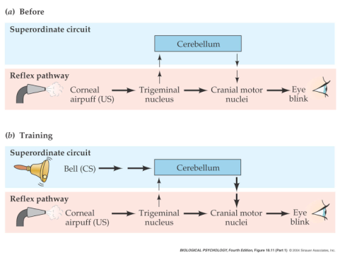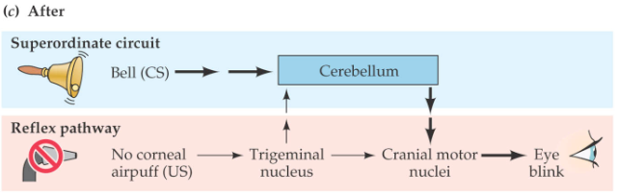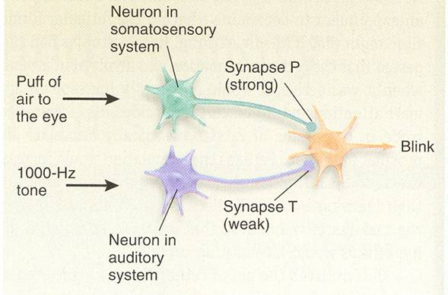
Fear Conditioning
- A learned association, a conditioned emotional response, between a neutral stimulus and a noxious event such as shock, fear, etc.
- Thought to involve the Amygdala, which is important in processing arousal information.
- It produces an emotional response.
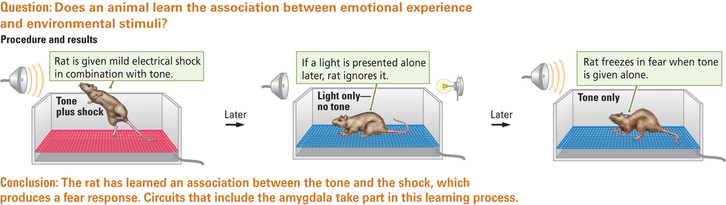

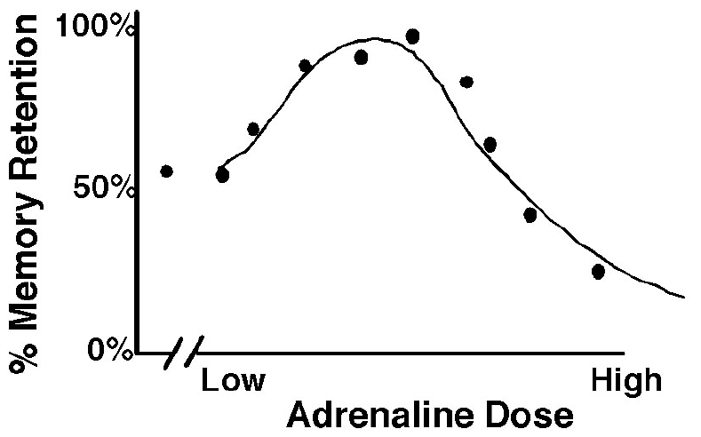
Emotion and Memory
- Memory is best when there is a medium dose of Adrenaline involved
- In low doses you are not able to remember as much, which is also found in high dose Adrenaline.

Instrumental Condition (Operant Conditioning)
- The learning procedure in which the consequences (such as obtaining a reward) of a particular behaviour (such as pressing a bar) increase or decrease the probanbility of the behaviour occurring again.
- This procedure includes reinforcers
- Thorndike’s Puzzle Box
- A hungry cat will eventually learn that pressing a lever will open the door so that it can reach some food.
- Positive Reinforcement: The Behaviour is reinforced, so it increases the chance of the behaviour.
Principles of Reinforcement
- Fundamental Principle:
- Organisms tend to repeat responses that are followed by favourable consequences.
- These behaviours are reinforced:
- When an event following a response increases an organism’s tendency to make that response.
Two Types of Reinforcement
- Positive Reinforcement:
- Increases the Likelihood of the behaviour
- Response is followed by a rewarding stimulus
- Ex. Tasty Meal, Pay Cheque, or Good Grades.
- Negative Reinforcements:
- Increases the likelihood of a behaviour
- The response is followed by the removal of an aversive stimulus
- Ex. Press on a lever to remove shock, taking pain medications to relieve a headache, etc.
- Possible explanation for drug addiction (self-medicating?)
- The two types of Reinforcers can co-occur
Reinforcement vs. Punishment
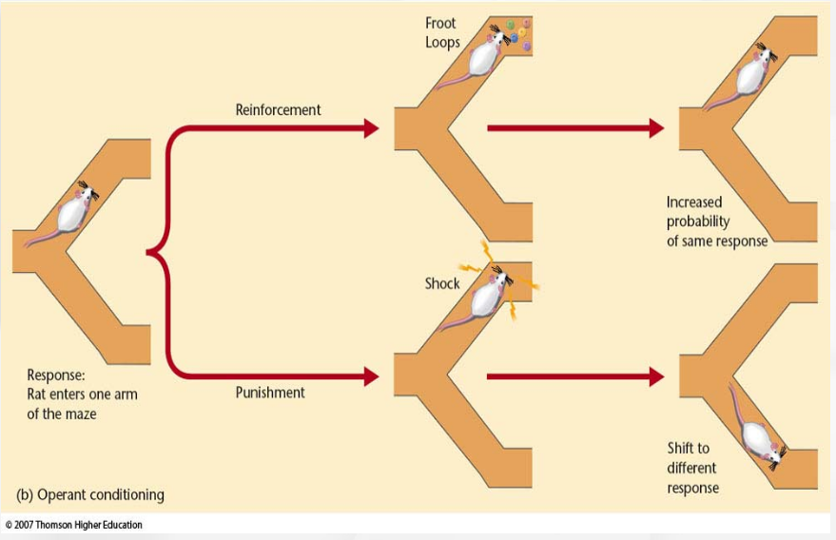
- Both forms of Punishment decrease the likelihood that the behaviour will occur again
- Positive Punishment: Shock
- Negative Punishment: Taking something away that someone wants.
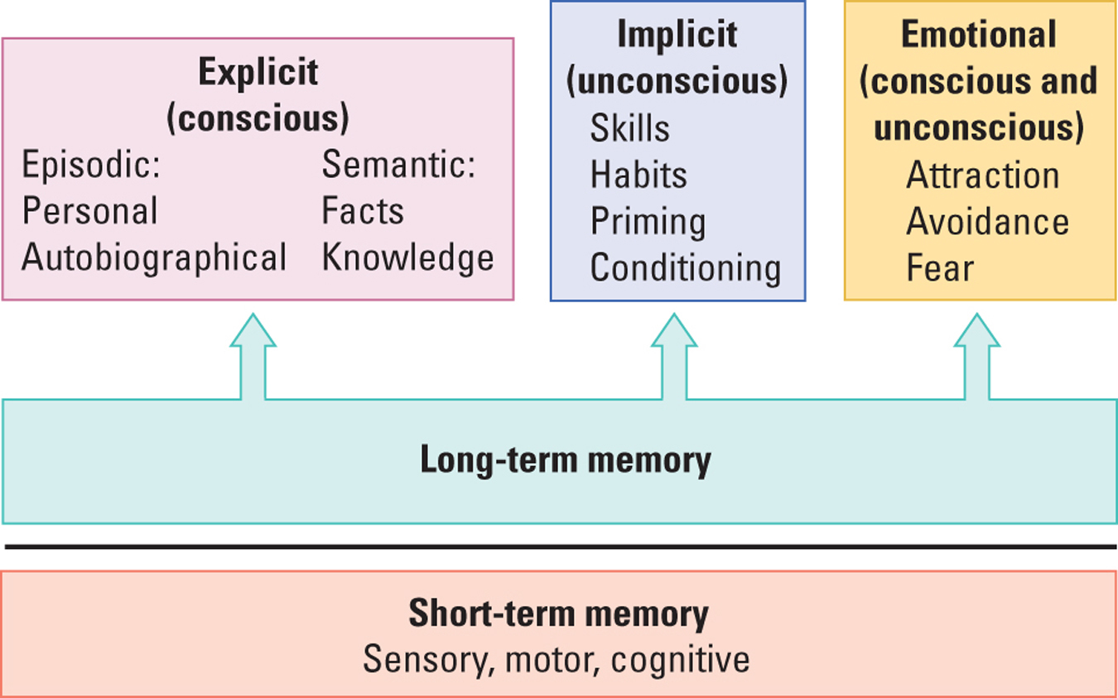
Independent Memory Systems
- Explicit (Declarative) Memory
- Conscious Memory: Subjects can retrieve an item and indicate that they know that the retrieved item is the correct item
- Implicit = Procedural Memory
- Unconscious Memory: Subjects can demonstrate knowledge, such as a skill, conditioned response, or recalling events on promoting, but cannot explicitly retrieve the information.
- Ex. Riding a Bike (Passive Learning)
What Makes Explicit and Implicit Memory Different?
- Encoding Memories
- Implicit information is processed in a “bottom-up” or data-driven manner as little bits of information are put together to develop a skill or habit
- The information in encoded in the same way it was perceived
- It is sent from the Sensory Systems to the Cortex
- Uni-Directional: It is not sent back to the Frontal Lobes so this is all done unconsciously.
- Explicit information is processed in a “top-down” or conceptually-driven manner
- The subject reorganizes the information before it is encoded (recognizes it as a whole before it is broken down into its parts)
- In Implicit tasks, the person has a passive role; whereas in explicit tasks, the person has an active role.
- Priming:
- Using a stimulus to sensitize the nervous system to a later presentation of the same of similar stimulus; often used to measure implicit memory
- Ex. Gollin Figure Test.
Neurobiology of Memory
- Karl Lashley
- There is no single place in the nervous system that can be identified as the location of memory or learning
- The Cortex works as a whole to process the pieces of information
- It does not depend on the connections across the Cortex
- He cut many different regions of the brain.
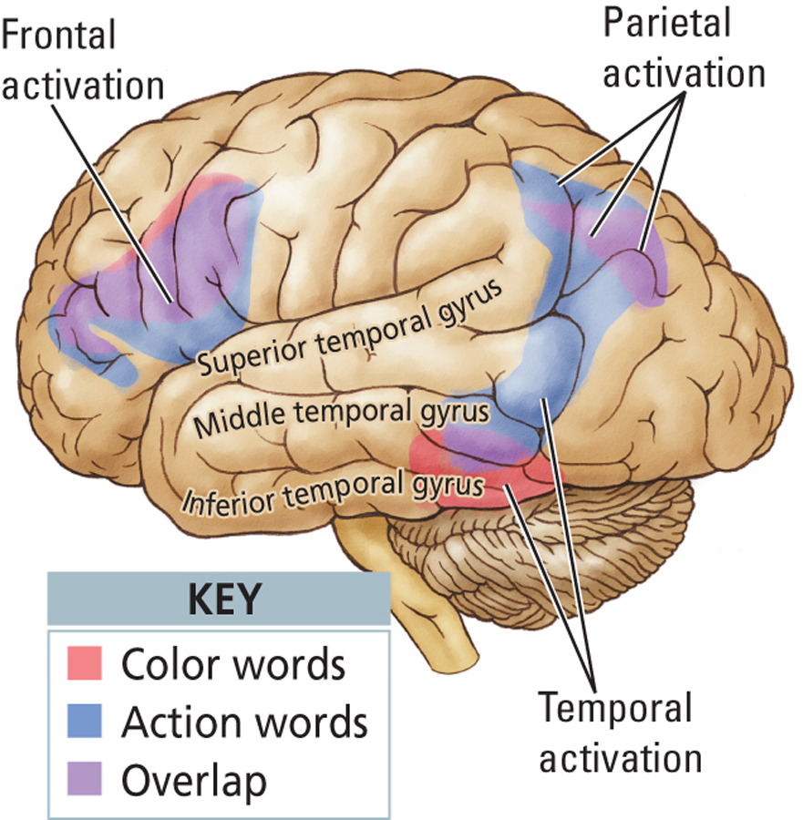
- Information from each sensory modality (ex. Visual audition) is processed and stored in different neural areas.
- Martin and Colleagues (1995)
- Participants shown black and white line drawings of objects and were asked to generate words denoting either colours or actions of objects.
- Recall of colours activated regions in the Ventral Temporal Lobe
- Recall of action words activated a region in the Middle Temporal Gyrus.

Personal Memory
- Episodic Memory
- Autobiographical memory for events pegged to specific place and time contexts.
- Episodic Amnesia (ex. Patient K.C.)
- Inability to recall any personally experienced events
- Associated with Frontal Lobe injuries or reduced blood flow to the Frontal Lobes
- Unable to recall any personal information that occurred before the accident, or form new personal information.
- Frontal Lobes may allow us to mentally travel through our past
Dissociating Memory Circuits: Disconnecting Explicit Memory
- Patient H.M.
- In 1953, William Scoville performed a Bilateral Medial – Temporal Lobe resection on patient H.M. for relief of severe epilepsy. These structures were removed:
- Hippocampal Formation
- Amygdala
- Adjacent Cortices in the Medial Temporal Lobe
- Following the surgery, H.M. suffered from a severe amnesia
- He could not recall anything that had happened after the surgery (no explicit memory)
- Implicit memories were intact
- Despite this deficit, H.M. had an above average IQ, he performed will on perceptual tests, and he could still recall events from his childhood
- H.M.’s performance on implicit memory tests was left intact
Amnesia
- Partial or Total Loss of Memory
- Retrograde Amnesia: Inability to remember events that occurred before
- Anterograde Amnesia: Inability to form new memories after the event
- Implicit Memory Task
- People with amnesia can perform normally on tests of implicit memory but not explicit memory
- H.M. had impaired explicit memory with an intact implicit memory
- He was not able to recall that he had done the task before (ex. Mirror Tracing Task – He got better at the tasks even though he had never remembered doing it before)
- This is possibly because of the loss of the Hippocampus
Dissociating Memory Circuits: Disconnecting Explicit Memory
- Patient J.K.
- Impaired implicit memory with intact explicit memory
- Developed Parkinson’s disease in his mid 70’s and started to have memory problems at 78.
- Damage to Basal Ganglia, and pathways to the Basal Ganglia
- The Basal Ganglia is important to implicit memory
- Impaired ability to perform tasks that he had done all of his life
- Ex. Turning off the Radio
- He was still able to recall explicit events.
Different Types of Memory Involve Distinct Brain Regions
- Short-Term Memory
- A few minutes in duration
- Involves the prefrontal Cortex, and Sensory Association Areas
- Superficial processing
- Long-Term Memory
- Indefinite duration
- Declarative (Explicit) Memory
- Involves the Medial Temporal and Frontal Lobes (Episodic Memory)
- Procedural Memory
- Involves the Basal Ganglia, Motor Association Areas, and the Cerebellum
- Episodic Memory
- Involves the Frontal Lobe
- Emotional Memory
- Involves the Amygdala
Neural Circuit for Explicit Memories
- Prime structures for Explicit Memory
- Medial Temporal Region
- Hippocampus: Spatial Learning
- Amygdala: Emotional Memories
- Entorhinal Cortex: Integrating information in the Environment
- Parahippocampal Cortex: Visual Spatial Information
- Perirhinal Cortex: Visual Object Recognition.
- Frontal Cortex: Making all the information consciously processed
- Parahippocampal Cortex:
- Cortex located along the Dorsal Medial Surface of the Temporal Lobe
- Receives connections from Parietal Cortex; believed to be involved in Visuospatial Processing
- Perirhinal Cortex
- Cortex lying next to the Rhinal Fissure on the base of the brain
- Receives connections from the Visual Regions of the Ventral Stream; believed to be involved in Visual Object Memory

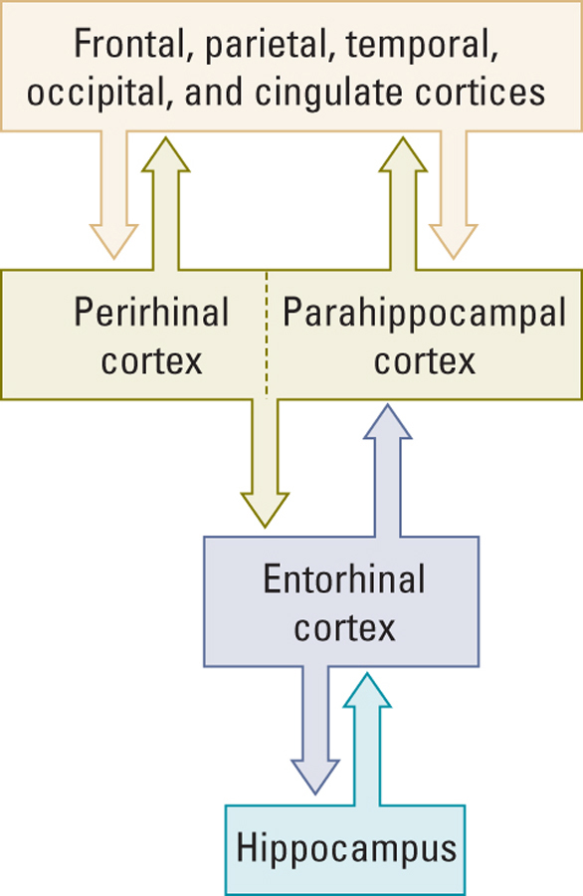
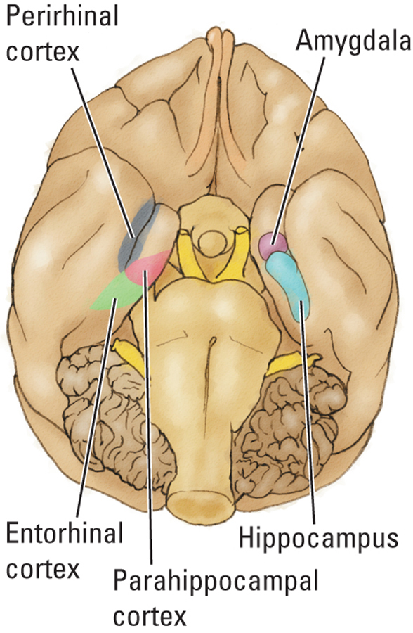

The Hippocampus and Spatial Memory
- Visuospatial Memory
- Using visual information to identify an object’s location in space
- Monkey’s with Hippocampal lesions have difficulties with Visuospatial learning
- Monkeys with Perirheral lesions were impaired in task B)
- Monkey’s with Hippocampal lesions were impaired in task C)
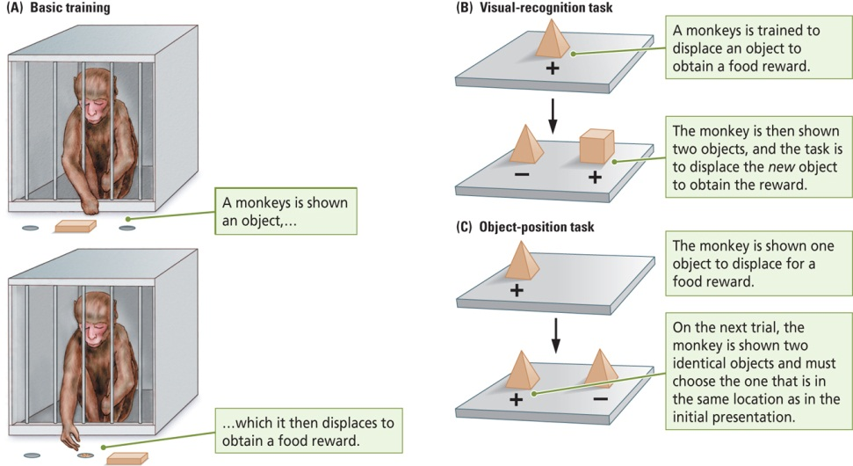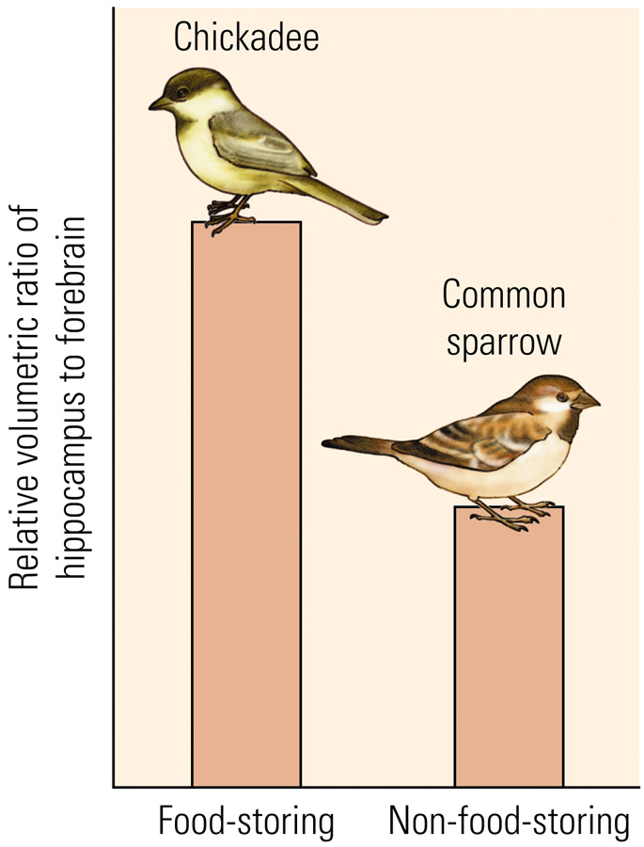
- The Hippocampal formation in food-storing birds and rodents is larger than the Hippocampal formation in birds and rodents that do not store food
- Food Storing birds have larger Hippocampuses
- Hippocampal Place Cells and Grid Cells:
- Hippocampal Place Cells are activated in specific areas
- Grid Cells are activated in different areas of the environment and form a grid
- Together they help us in realizing where we are in space.

The Frontal Lobe and Short-Term Memory
- All sensory systems project to the Frontal Lobes
- During tasks in which Monkey’s must keep information in the short-term memory over a delay, certain cells in the Frontal Cortex will fire through-out the delay
- Animals that have not learned the task show no such cell activity
Reciprocal Connections for Explicit Memory
- The Neocortex projects to the Entorhinal Cortex, which projects back to the Neocortex.
Benefits:
- Signals from the Medial Temporal Regions are sent back to the Cortical Sensory Regions which keep the sensory experience alive in the brain. The neural record outlasts the actual experience.
- The pathway back to the Neocortex keeps it appraised of the information being processed in the Medial Temporal Regions.
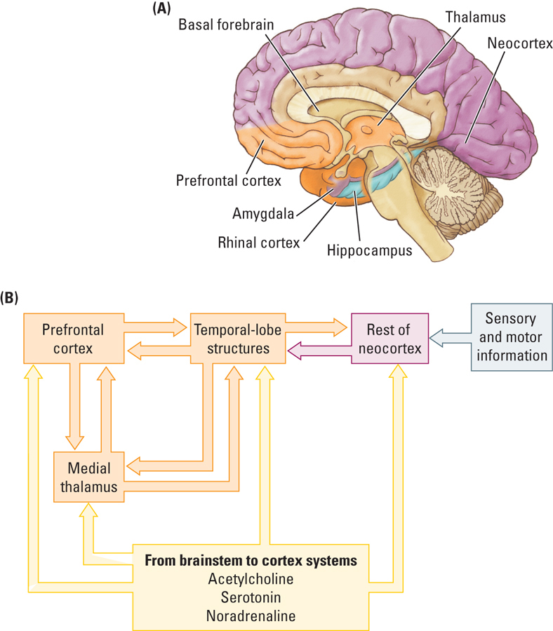
Proposed Neural Circuit for Explicit Memory
- Mishkin and Colleagues
- Temporal Lobe Structures
- Frontal Lobe Structures
- Medial Thalamus
- Basal Forebrain – Activating System

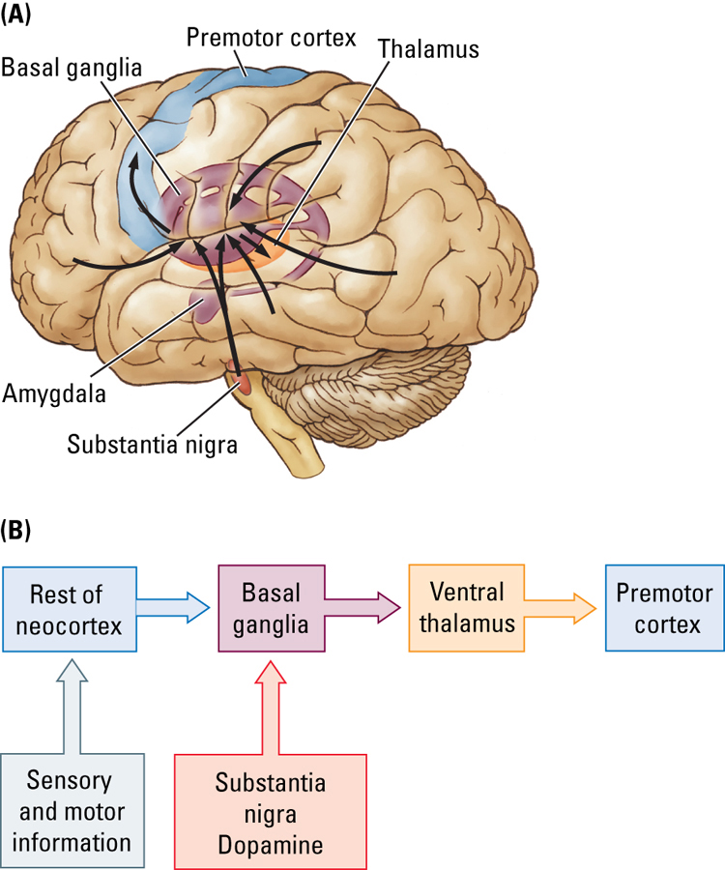
Proposed Circuits for Implicit Memory
- Mishkin and Colleagues
- Basal Ganglia
- Ventral Thalamus
- Substantia Nigra
- Premotor Cortex

Neural Circuits for Implicit Memories
- Unconscious nature of implicit memory
- Mishkin believes that implicit memories are unconscious because the connections between the Basal Ganglia and the Cortex are Uni-Directional
- The Basal Ganglia receives information from the Cortex, but does not project back to the Cortex
- For memories to be conscious there must be feedback to the Cortex
- The Medial Temporal Lobe projects back to the Cortex, so explicit memories are conscious.
Neural Circuit for Emotional Memories
- Emotional Memory
- Memory for the affective properties of stimuli or events
- They could be implicit or explicit
- The Amygdala is the critical structure for emotional memory
- Damage to the Amygdala abolishes emotional memory but has little effect on implicit or explicit memory
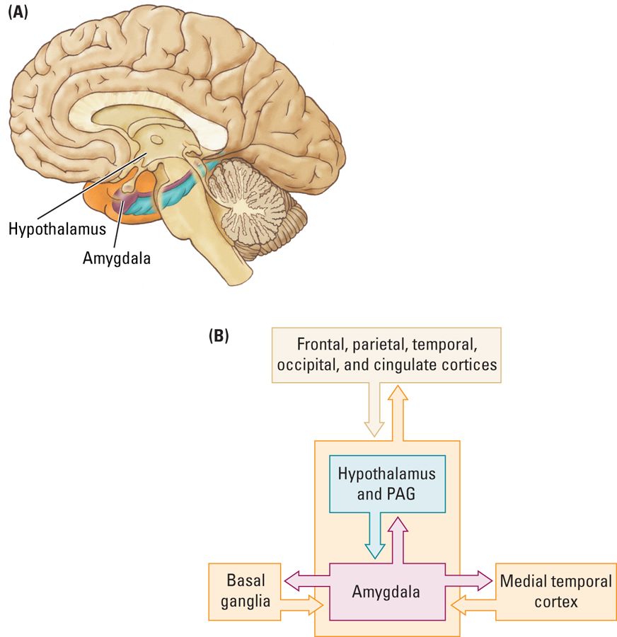
- Circuitry
- Amygdala
- Medial Temporal Cortex (Explicit Memory)
- Brainstem (Autonomic Arousal)
- Hypothalamus (Hormones)
- Periaquaductal Gray Metter (PAG – Pain)
- Basal Ganglia (Implicit Memory)
Korsakoff’s Syndrome
- Indirect cause of chronic alcohol consumption as a direct cause of malnutrition.
- Poor Diet: Lack of Vitamin B1 (Thiamine)
- Chronic alcoholism compromises Thiamine absorption from GI tract, which impairs Thiamine storage
- This may also result from dietary deficiencies such as prolonged vomiting, or eating disorders
- The result id permanent loss of the ability to learn new information (Anterograde Amnesia) and Retrieve old information (Retrograde Amnesia)
- Explicit Memory disturbances (some implicit)
- Confabulation: The subject does not see that they have a memory issue. They just add in the details that they do not recall.
- There is also damage to the Medial Thalamus and the Frontal Lobes
Structural Basis of Brain Plasticity
- All brain regions can be modified by experience
- They can become more or less complex
- At the neural level, memory is associated with changes that take place at the synapse
- The synapse is where one neuron influences another neuron
- There are two research approaches
- The synaptic changes in the nervous system of “simple” organisms
- Ex. Aplysia (Seaslug)
- The Synaptic changes in the mammalian brain
Structural Basis of Brain Plasticity: Measuring Synaptic Changes
- Modifying existing circuits
- Neurons change their structure in response to their changing experiences
- Changes in the number of Dendrites can be used to infer synaptic changes
- More Dendrites = more connections = changes in the synaptic organization
- Dendritic spines also can change based on experience.
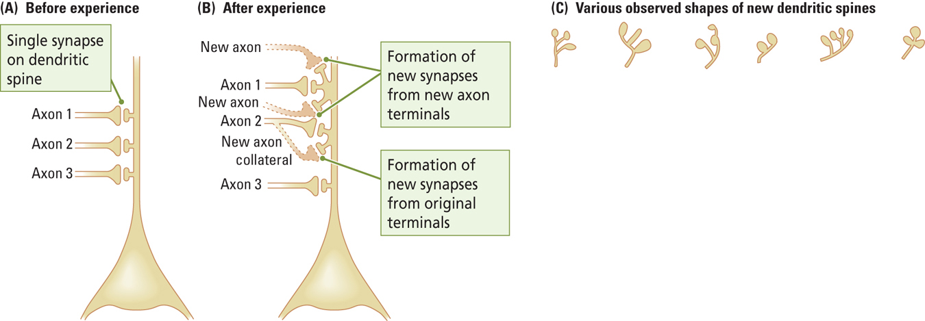
- New synapses can form between neurons that are already connected or between neurons that were no previously connected
Structural Basis of Brain Plasticity: Measuring Synaptic Change
- Creating Novel Circuits
- Predominant view prior to the mid-1990’s
- The mammalian brain does not make new neurons in adulthood (The neurons that we are born with are the only neurons that we will ever have)
- There is now no evidence that Neurogenesus (the generation of new neurons that occurs in adulthood in specific areas) does not occur in the mammalian brain
- The Olfactory Bulb, the Hippocampal Formation, and possibly the Neocortex
- The reasons for Neurogenesis are unclear.
Enriched Experience and Plasticity
- Raising rats in enriched enclosures is associated with an increase of complexity:
- Increased brain weight
- More Dendrites
- More Astrocytes
- More Blood Capillaries
- More Synapses per Neuron
- Increased Mitochondrail volume
- Marker of greater Metabolic Activity
Sensory or Motor Training and Plasticity
- Chang and Greenough (1982)
- Placed patches over one eye of each rat so that the Contralateral Hemisphere was deprived of Visual Input
- They found that the side of the brain associated with the covered eye was much less complex.
- They trained rats on a maze
- The Visual Cortex of the “trained hemisphere” (that received input from the eye without the patch) had more extensive Dendrites
- Nudo and Colleagues (1997)
- They had monkey’s retrieve food from small or large food wells
- Small wells required dexterous movements of one or two fingers, whereas the monkeys could put their entire hand in the large wells
- The digit representation on the Motor Cortex was larger for animals that had to retrieve food from the smaller wells.
- Ramachandran (1993)
- Certain areas in the motor cortex are dedicated to certain movements/limbs. So when a limb is no longer there the area that was dedicted to this limb is taken over, but not completely.
- He indirectly measured the Cortical maps in individuals with limb amputations
- When the face was stroked softly with a cotton swab, amputees reported sensation of being touched in the amputated hand
- This may explain “phantom limb” pain.
Experience – Dependant Changes in the Brain
- Is there a relationship between neuronal structures and education?
- Wernicke’s Area has more dendritic branching with more education
- Speech and Language Comprehension
- Scheibel and Colleagues
- The relationship between the complexity of the Dendritic branching and the nature of the computational task performed by the brain area.
- Ex. Neurons receiving input from fingers vs. the chest wall
- Life experience alters the dendritic morphology
- Ex. Career word processors have greater differences between finger and trunk neurons than salespeople.
Molecular Basis of Memory
- The Repeated and Persistent stimulation of the postsynaptic neuron by the presynaptic neuron leads to an increase in synaptic efficacy
- Ex. Increase the strength of the Post Synaptic Potential
- More receptors, stronger EPSP’s and IPSP’s, the neurotransmitters stay in the cell longer etc.
- The disuse of a synaptic pathway leads to a decrease in synaptic efficacy.
- Ex. Decrease in the strength of the Post Synaptic Potential.
- “Use it or you lose it”

Hebbian Learning
- Concept of Reverberating Circuits
- Interneurons could be used to feed excitation back into a given neural circuit, keeping that circuit active long after the original source of excitation had been removed.
- There is always a circuit of neurons that are communicating.
- Cell Assembly
- Interlinking neurons capable of acting as a closed system
- “Cells that fire together wire together”
Long – Term Potentiation
- Increase in the synaptic strength following high frequency stimulation of a neural pathway that remains even after the stimulus has been removed
- Ex. Long – Term increase in the magnitude of EPSP’s in the postsynaptic neuron
- This can remain for minutes, hours or even days after the one high frequency stimulation
- A rapid rate of stimulation is required.
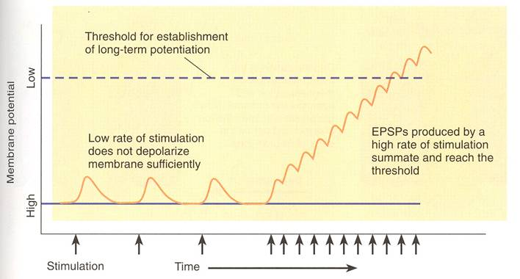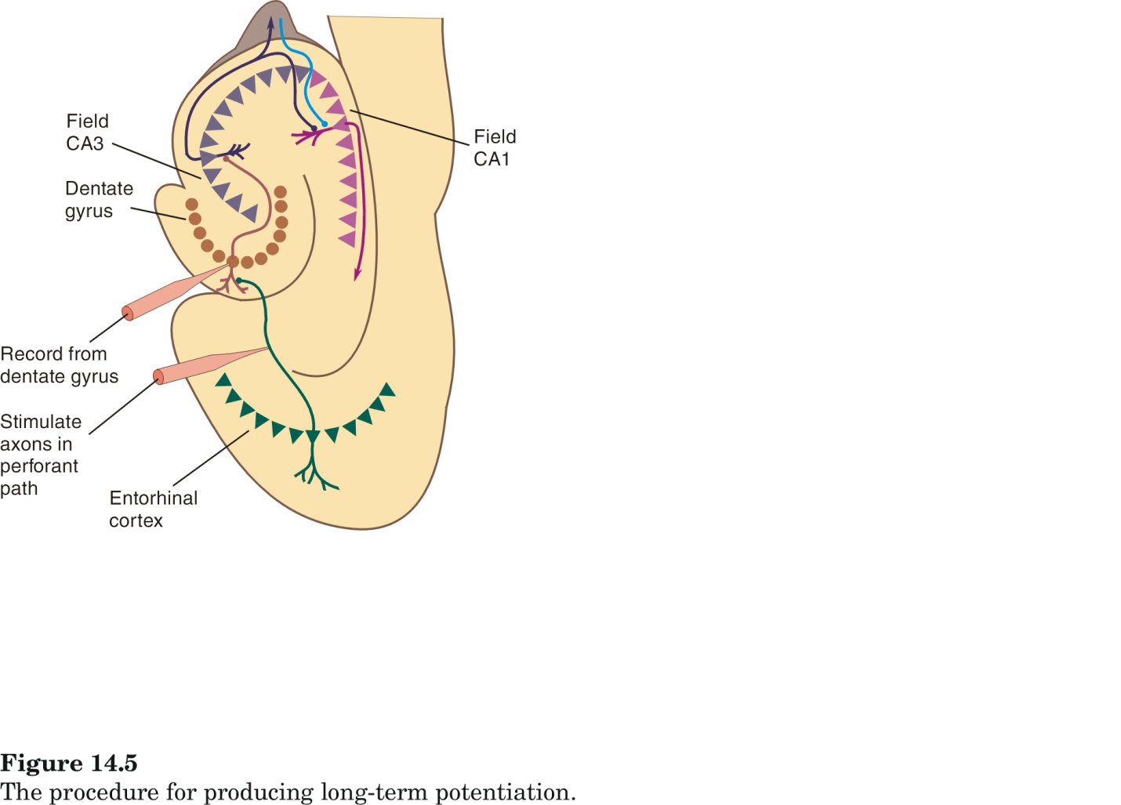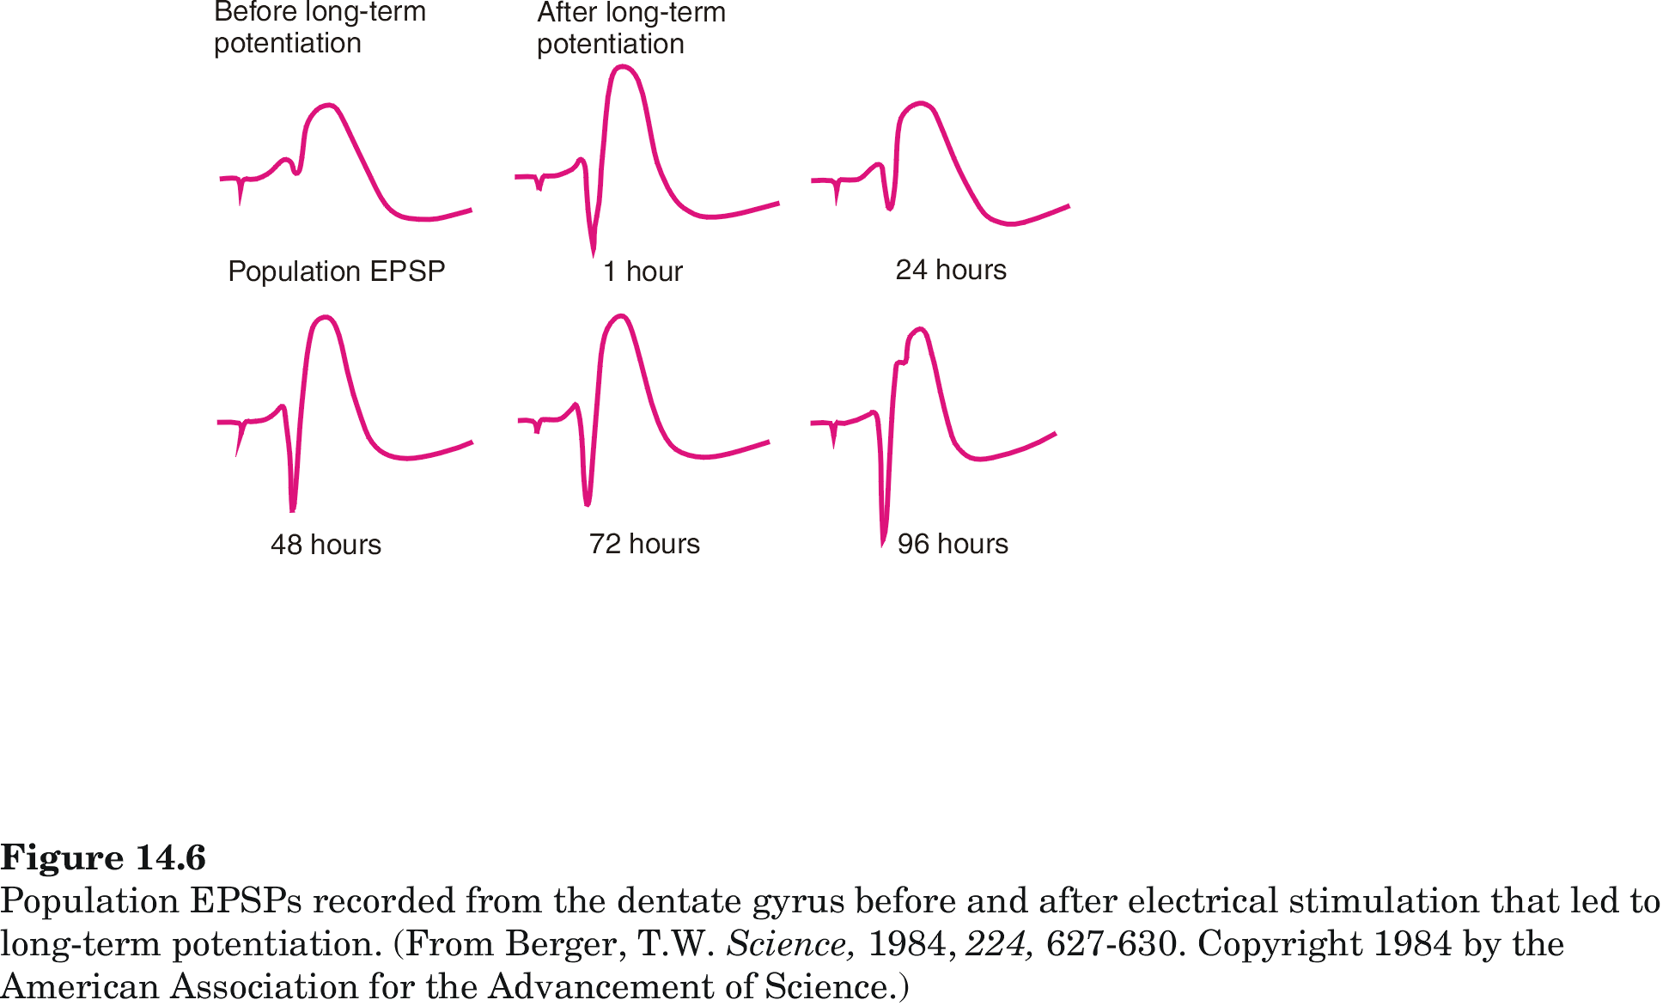
- Procedure: High frequency electrical stimulation of the Prefrontal pathway
- Observe: Then observe population postsynaptic potential induced by a single pulse given repeatedly over days
- Record: Cells within the Dentate Gyrus
- Results: The gradual increase in EPSP size over days.
- Long – Term Potentiation involves activation of synapses AND depolarization of the postsynaptic membrane
- Long – Term Poteniation involves activation of NMDA and non – NMDA (AMPA and Kainate) receptors
- Glutamate
- NMDA critical for Long – Term Potentiation
- The NMDA receptors controls a calcium channel which is blocked by Mg2+ ions
- Mg2+ ions are ejected from the calcium channel when the membrane is depolarized through the activation of AMPA receptors
- On a cell there are both NMDA and AMPA receptors that glutamate can bind to.
- Opening the Calcium Chanel requires activation of the NMDA receptors which requires the presence of glutamate and a depolarized membrane (binding Glutamate to the AMPA receptors changes the voltage in the Post-Synaptic Neuron which kicks out the Mg2+)
- Drugs that block the NMDA receptors (ex. AP5) block the formation of LTP
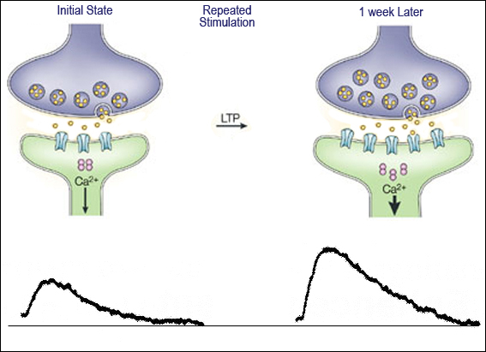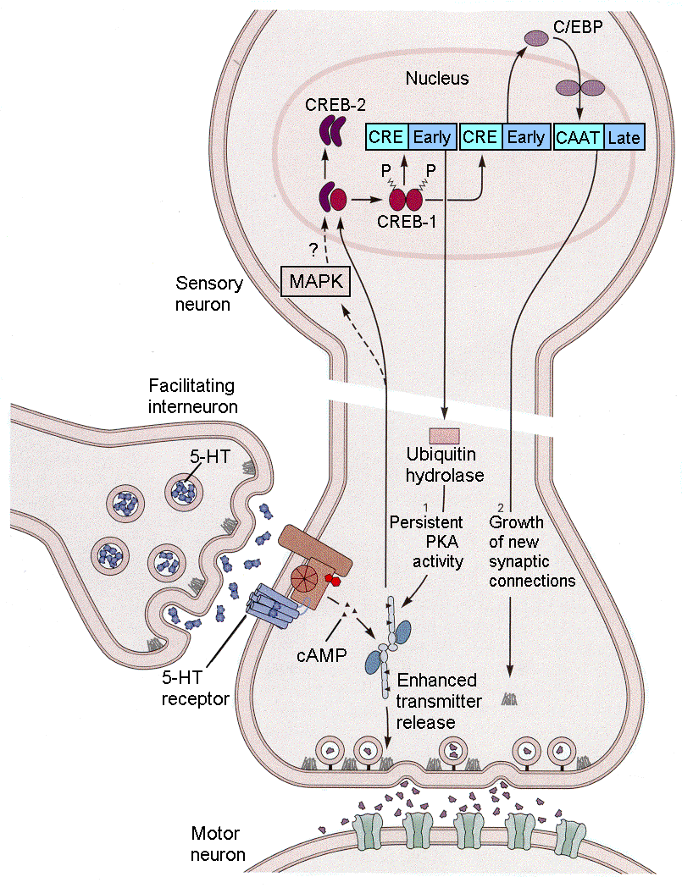
- Protein synthesis that occurs because of Long – Term Potentiation and when we block that there is an:
- Inhibition Effects Learning
Long – Term Depression
- This is the opposite of Long – Term Potentiation
- A Long-Term decrease in the excitability of a neuron to a particular synaptic input caused by stimulation of the terminal button while the postsynaptic membrane is hyperpolarized
- Low frequency stimulation decreasing the strength of synaptic connections (>10Hz)
- This may allow for the reversal of learned patterns in response to changes in the environment
- This is not negative. It slows for Plasticity based on the environment.
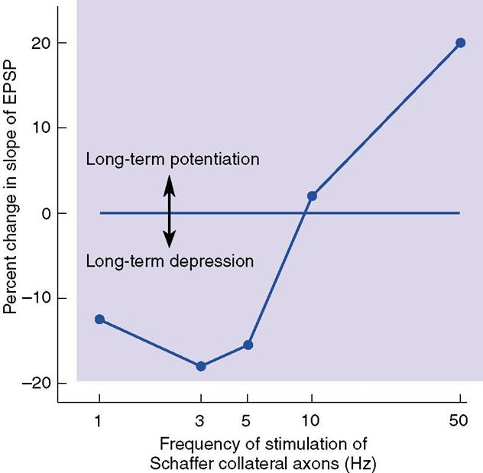
Hormones and Plasticity
- High levels of Estrogen
- More Dendritic spines in the Hippocampus
- Low Levels of Estrogen
- More Dendritic spines in Neocortex but fewer Dendritic spines in the Hippocampus.
- Related to memory decline in middle-aged females?
- Low Levels of Testostrone
- More Dendritic spines in Neocortex
- Related to decrease in Spatial ability?
- Glucocorticoids
- Released from the Adrenal Cortex in times of stress (The Slow Pathway)
- Assists in the metabolism of Proteins and Carbohydrates and the control of sugar levels in the blood and cells
- Steady levels of Glucocorticoids that are soon with prolonged stress may be neruotoxic
- Stress can kill the Hippocampal cells.
Neurotrophic Factors and Plasticity
- Nerve Growth Factor
- Neurotrophic factor that stimulate neurons to grow dendrites and synapses and, in some cases, promotes the survival of neurons
- Brain – Derived Neurotrophic Factor (BDNF)
- Implicated in depression and stress (lower levels)
- May enhance plastic changes, such as the growth of dendrites and synapses.
- Increased levels when animals learn to solve problems
Psychoactive Drugs and Plasticity
- Drug – Induced Behavioural Sensitization
- Escalating behavioural response to the repeated administration of a psychomotor stimulant. Such as Amphetamine, Cocaine, or Nicotine; also called behavioral sensitization.
- Sensitization is associated with an increased number of receptors, synapses, and dendrites
- These changes were localized to regions (ex. Prefrontal Cortex, Nucleus Accumbens) that receive a large Dopamine projection.
Some Guiding Principles of Brain Plasticity
- Behavioural changes reflects change in the brain
- All Nervous Systems are plastic in the same general way (from C. Elegans to Humans)
- Plastic changes are age specific (more malleable when you are younger than older)
- Prenatal events can influence brain plasticity throughout life
- Plastic changes are brain-region dependent
- Experience – dependent changes interact
- Giving drugs prior to rat condos for example
- Plastic events are not always a good thing
Recovery from Brain Injury
- Three possible ways to recover from brain injury
- Learn new ways to solve problems
- Reorganize the brain to do more with less
- Generate new neurons to produce new circuits.
Three-Legged Cat Solution
- When a cat loses a leg, it usually is able to compensate, not by growing a new leg. But rather, by learning how to walk with only three legs
- The same ability to compensate is also present in humans
- If someone loses a certain ability, such as being able to write with their right hand, they may be able to compensate by learning how to write with their left hand
New – Circuit Solution
- In response to injury, the brain can form new connections and “do more with less”
- The amount of recovery is increased significantly of the person also engages form of intervention.
- Behavioural Therapy: Speech or Physiotherapy
- Pharmacological Therapy: Nerve Growth Factor, Amphetamine
Long – Neuron – Replacement Solution
- Fetal Tissue Implantation
- Limited success to date; more suited for situations where only a small number of cells are needed.
- Dopamine – Producing cells in the Substantia Nigra for Parkinson’s Disease patients
- These added cells eventually die out as well. The reason why the first cells died is still there causing the second cells to die.
- Replace Lost Cells
- Epidermal Growth Factor
- Neurotrophic factor that stimulates the Subventricular zone to generate cells that migrate into the Striatum and eventually differentiate into Neurons and Glia.
- It is possible that, in the future, Trophic Factors may be useful in the treatment of brain injury.

