Why Do We Sleep and Dream?
Origins of Biological Rhythms
- Biorhythm: Inherent timing mechanism that controls or initiates various biological processes
- Inside of us there are neurons that keep track of how time is going
- This is linked to the cycle of days and seasons produced by the Earth’s rotation around the sun
- Animals living near the poles of the Earth are more affected by seasonal than animals living in equatorial regions
- Human behaviour is governed more by daily cycles than by seasonal cycles (animals)
Biological Clock
- Behaviour is not simply driven by external cues from the environment
- Rhythms are endogenous (control comes from within)
- Biological Clock (Endogenous Clock)
- Neural system that times behaviour
- Allows animals to anticipate events before they happen
- Example: Birds migrate before it gets cold
Biological Rhythms
- Period
- Time required to complete a cycle of activity
- Circannual Rhythm
- Yearly (e.g. migratory cycles of birds)
- “Around a Year”
- Infradian Rhythm
- Less than a year (e.g. human menstruation cycle)
- Circadian Rhythm
- Daily (e.g. human sleep cycle)
- “Around a Day”
- Ultradian Rhythm
- Less than a day (e.g. eating cycle)
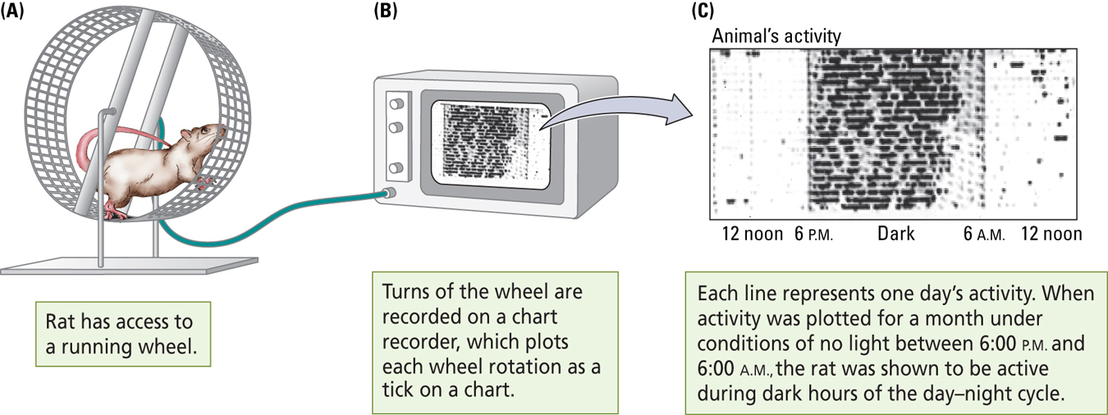
We measure this by measuring activity level when they are awake (nocturnal), measure the activity of rat on the running wheel.
Free-Running Rhythms
- Rhythm of the body’s own devising in the absence of all external cues.
- If a human is removed from the external cue we still show a rhythm
- Without input from external cues, our bodies have their own rhythms with periods of 25 to 27 hours
- Sleep-Wake cycle shifts an hour or so everyday
- This is important and is adaptive
- Animals expand and contract their sleep periods as the sleep-related lighting period expands or contracts.
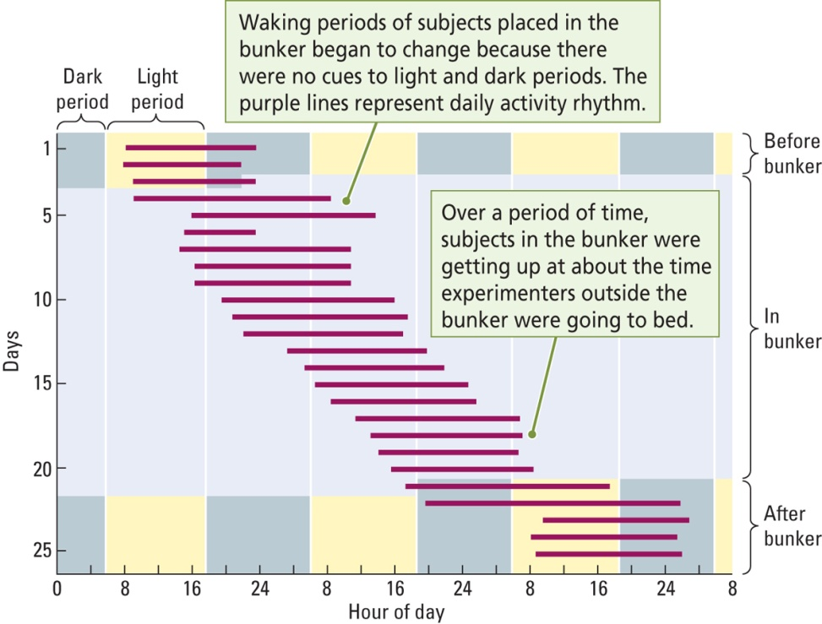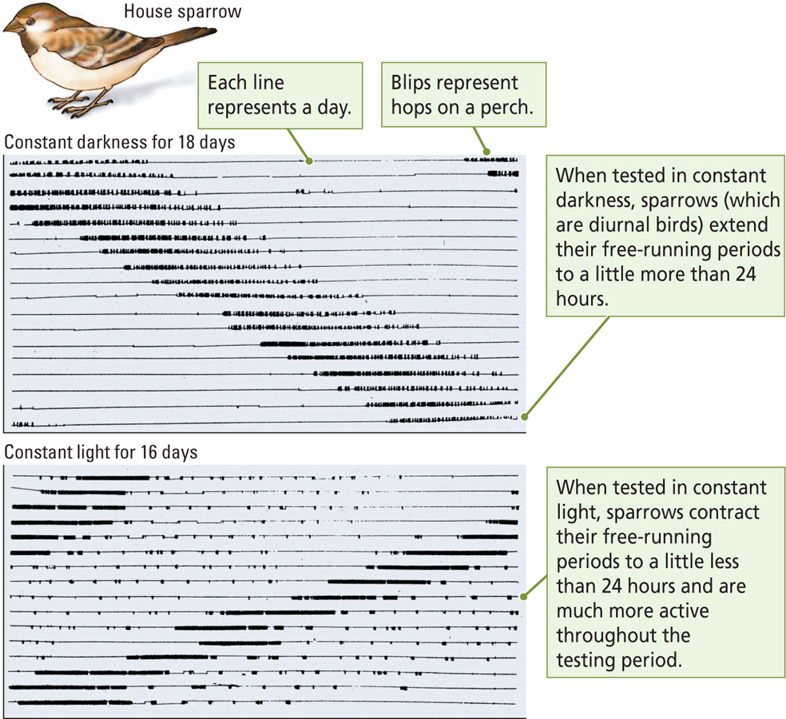
Zeitgebers
- Environmental event that entrains biological rhythms; a “time giver”
- Example: Light resets the biological clock
- Example: Food tells our body what time of day it is
- Entrainment
- Determination or modification of the period of a biorhythm
- Jet Lag
- Fatigue and disorientation from rapid travel through time zones an exposure to a changed light-dark cycle
- Eating and exercise can retrain your biological clock.
Neural Basis of the Biological Clock
- There are cells in the back of our eyes that are sensitive to light.
- Suprachiasmatic Nucleus (SCN)
- Main pacemaker of circadian rhythms located just above the optic chiasm (cross between the optic nerves)
- Found in the Hypothalamus
- Retinohypothalamic Pathway
- Extends from the retina to the Hypothalamus
- Neural route from a subset of cone receptors in the retina to the Suprachiasmatic Nucleus of the hypothalamus which allows light to entrain the rhythmic activity of the Suprachiasmatic Nucleus
- Other pacemakers (cells that are responsive to time and lights illumination) exist in the retina and pineal gland, but the Suprachiasmatic Nucleus is the main one.
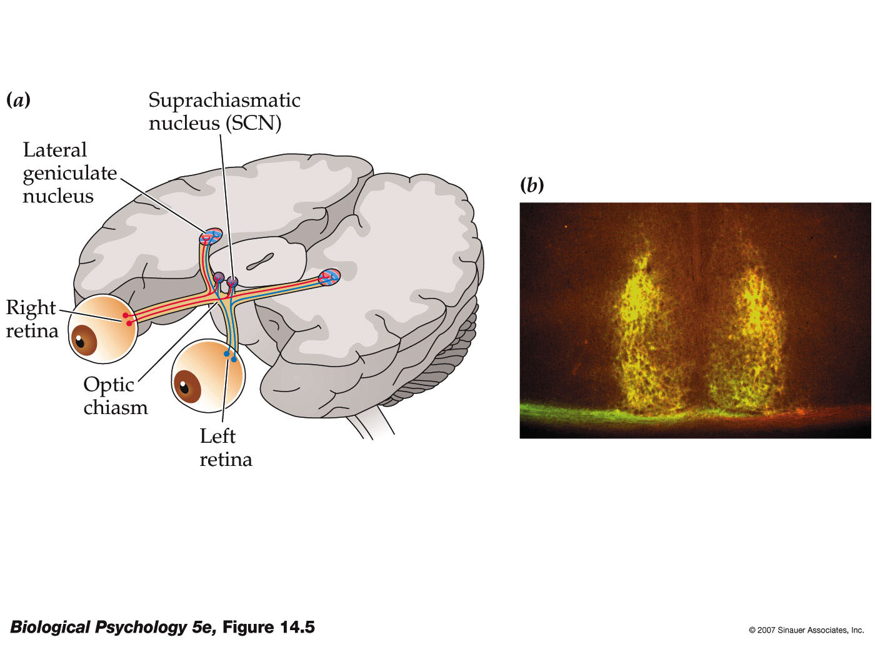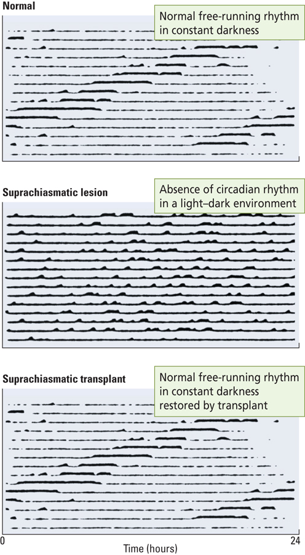
Immortal Time
- Endogenous rhythm is not learned
- Martin and Colleagues: transplantation studies in hamsters
- After lesions to the Suprachiasmatic Nucleus eat and sleep a normal amount, but the rhythmic nature of these behaviours disappear.
- If the Suprachiasmatic Nucleus cells from embryos are transplanted into the lesioned animals, they will re-establish circadian rhythms

Neural Basis of the Biological Clock What Ticks?
- At least half a dozen genes and the proteins they make seem to produce the circadian rhythm of the Suprachiasmatic Nucleus cells in mammals
- Mechanism is not fully understood.
Pacemaking Circadian Rhythms
- Model for Circadian Timing System
- Light entrains the Suprachiasmatic Nucleus pacemaker
- The Suprachiasmatic Nucleus pacemaker drives a number of “slave oscillators”, each of which controls the rhythmic occurrence of one behaviour (e.g. body temperature)
- Suprachiasmatic Nucleus pacemaker may drive the slave oscillators via hormones, proteins, or neurotransmitters.
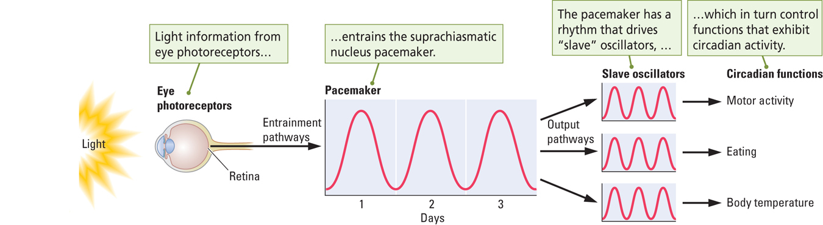
Pacemaking Circannual Rhythms
- Melatonin:
- Hormone secreted by the pineal gland during the dark phase of the day-night cycle in humans; influences daily and seasonal biorhythms in other species.
- Example: Hamsters
- In Winter: Melatonin levels increase, gonads shrink, testosterone levels decrease and sexual behaviour decreases
- In Summer: Melatonin levels decrease, gonads grow, testosterone levels increase, and sexual behaviour increases.
Sleep Stages and Dreaming Measuring How Long we Sleep
- There is considerable variation in people’s sleep-waking behaviour
- There are developmental changes in sleep cycles
- People sleep more when they are younger
- Most people sleep 7-8 hours per night
- Cognitive alertness effects the brain more and gets the brain more tired than physical activity
- Some sleep much more or less
- As little as 1 hour per day!
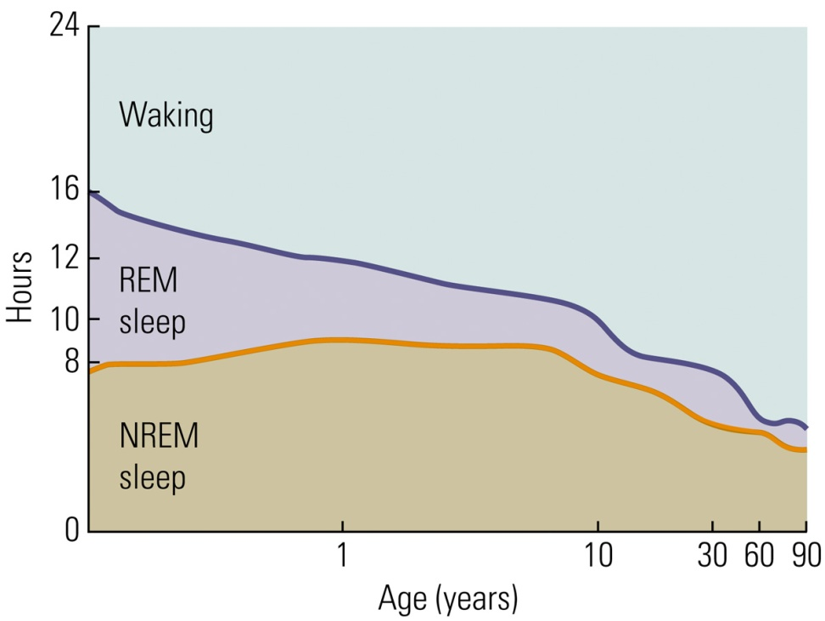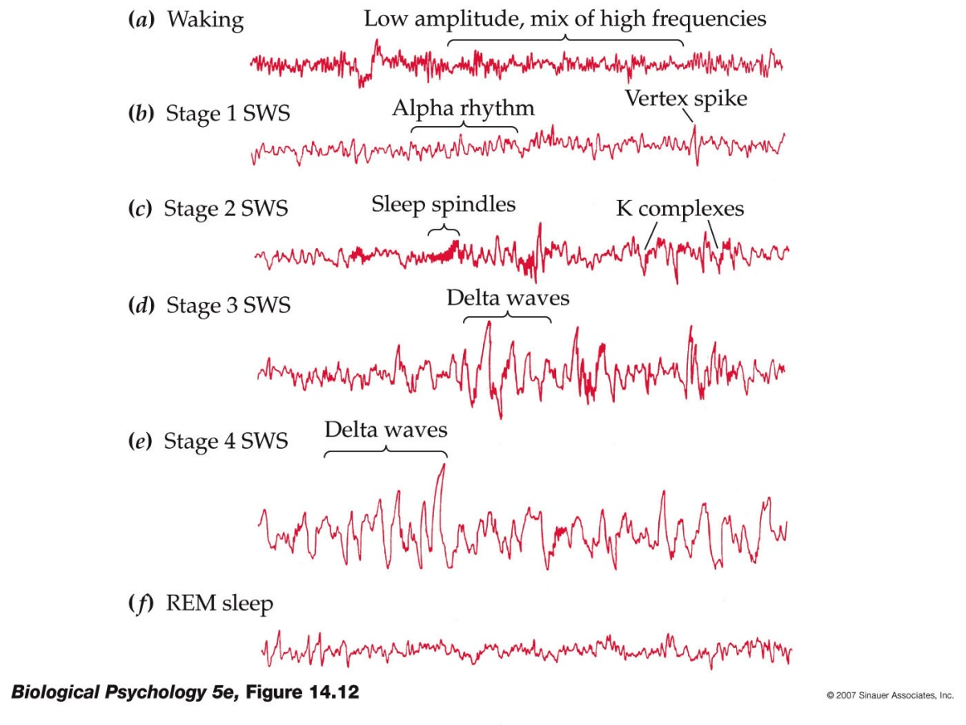
Measuring Sleep in the Laboratory
- A Polygraph is used to measure the electrical activity of the brain and body. All of these are Polygraphs:
- Electroencephalogram (EEG)
- Record of brain-wave activity
- Electrodes all over the scalp that measure graded potentials
- Electromyogram (EMG)
- Record Muscle acitivity
- Electrodes all over the scalp that measure graded potentials.
- Electrooculogram (EOG)
- Record of eye movements.
Stages of Waking and Sleeping
- Beta Rhythms (Waking State)
- Fast brain-wave activity (15 to 30 Hz) pattern associated with a waking EEG
- Low amplitude, and mix of high frequencies
- Alpha Rhythms (Drowsy State)
- Large, extremely regular brain waves (7 to 11 Hz) associated with drowsiness
- Delta Rhythm (Sleeping State)
- Slow brain-wave activity (1 to 3 Hz) pattern associated with deep sleep (NREM sleep)
- Larger amplitude waveforms
- Frequency slowing down
- REM Sleep (Dreaming State)
- Fast brain-wave pattern displayed by the neocortical EEG record during sleep
- Looks very similar to the Waking State
- Rapid Eye Movements
Sleep Stages and Dreaming: A Typical Night’s Sleep
- Four stages of Non-REM (NREM; Slow Wave) Sleep
- Stage 1 (Most Shallow)
- Stage 2
- Stage 3
- Stage 4 (Most Deep)
- Stages go from: Stage 1 Stage 2 Stage 3 Stage 4 Stage 3 Stage 2 REM Stage 2 Stage 3 Stage 4 Stage 3 Stage 2 REM
- As the Night progresses we have more and more REM sleep
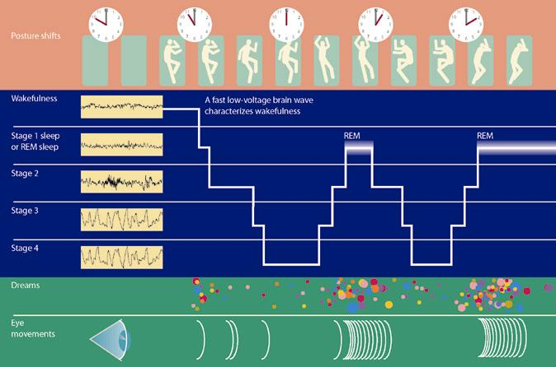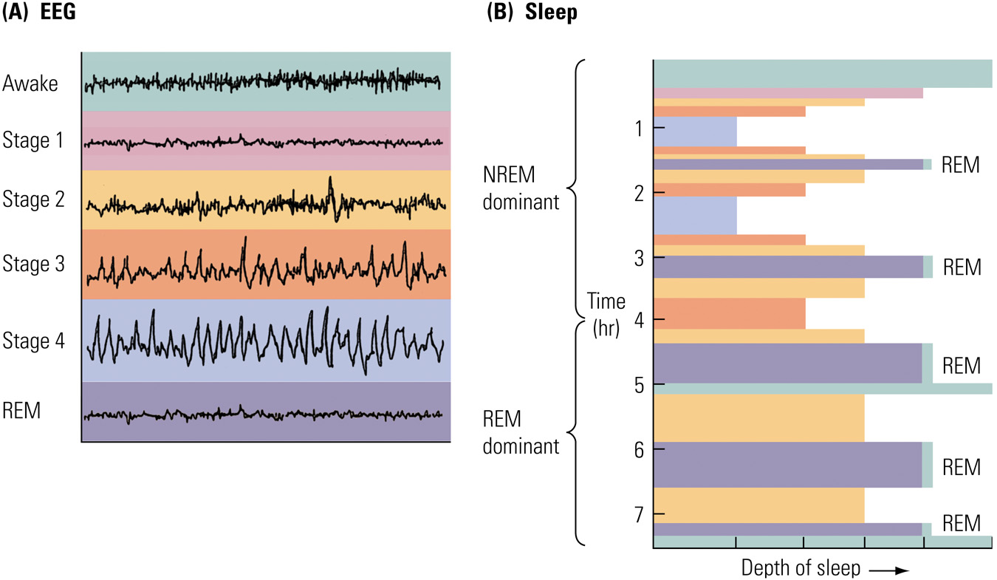
NREM Sleep
- Large range of activities take place
- Examples: Decrease in body temperature, and increase in growth hormone release
- Dreaming does occur in NREM sleep, but dreams are not as vivid as in REM sleep
- Sleep talking
- Sleep Walking
- Night Terrors
- Brief, very frightening dreams (have a much more realistic components)
- May be experienced by children
- Inconsistent with NREM sleep being a quiet, inactive period!
REM Sleep
- Atonia:
- No tone (in muscles); condition of complete muscle inactivity produced by the inhibition of motor neurons.
- Some can lack this Atonia or have a lack of muscle inhibition
- Mechanisms that regulate body temperature stop working (body temperature gets quite low)
- Vivid dreams occurs during REM sleep
- Everyone dreams a number of times each night
- Dreams appear to take place in real time, dream sessions get longer through-out a sleep session (no beginning or end)
What We Dream About
- Psychoanalytic Theory
- Sigmund Freud
- Dreams are the symbolic fulfillment of unconscious wishes
- Unconscious desires are suppressed during the day, then come to fulfillment during sleep.
- Manifest Content: Loosely connected series of bizarre images and actions
- Latent Content: True meaning of the dream
- Carl Jung
- Dreams are expressions of our “collective unconscious” (history of the entire human race)
- All of us are having similar dreams as part of our collective unconscious.
- J. Allan Hobson
- Activation Synthesis Theory
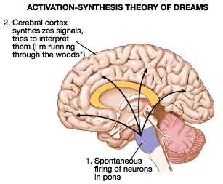
- The cortex is bombarded with signals from the brainstem, producing the patterns of waking EEG
- In response, the cortex generates images, actions, and emotions from personal memory store
- An attempt to interpret these signals from the brainstem
- Dreams are personal, but they have no meaning.

- Annttio Revonsuo
- Dreams are highly organized and biased toward threatening images
- Dreams are biologically important because they lead to enhanced performance in dealing with threatening life events (adaptive function)
- Dreams are a coping strategy
What Does Sleep Accomplish?
- Early Explanation: Sleep is a passive process that takes place as a result of a decrease in sensory stimulation (the brain is shutting down)
- This explanation does not account for the complexity of sleep
- There is no direct evidence that sleep deprivation causes sleep
- Sensory deprivation research has shown that people actually sleep less, not more, when placed in isolated environments (contrary to what one would expect)
What Does Sleep Accomplish?: Sleep as a Biological Adaptation
- Sleep is an energy-conserving strategy
- Gather food at optimal times (expend energy) and sleep to conserve energy that rest of the time
- Nocturnal or diurnal animals will sleep during those times in which they cannot travel easily
- Ex. Humans cannot see well at night
- Animals with nutrient-rich diets spend less time foraging for food and more time sleeping
- Animals that are predators sleep more than animals of prey.
- Basic Rest – Activity Cycle (BRAC)
- Reoccurring cycle of temporal packets, about 90 minute periods in humans, during which an animal’s level of arousal waxes and wanes
- Occur through-out the day and night
- Examples:
- School classes, work periods, meal times, coffee or snack breaks, and NREM – REM cycles are all 90 minutes approximately
- So it is fundamental as that it cannot be turned off even at night, so the body is paralyzed during REM sleep to prevent interruptions through-out sleep
Sleep as a Restorative Process
- Possible Hypothesis
- Chemical events that provide energy to cells may be reduced during waking and are replenished during sleep
- Fatigue and alertness may simply be aspects of the circadian rhythms and have nothing to do with wear and tear on the body.
Sleep Deprivation
- Recuperative theories make specific predictions about sleep deprivation:
- Long periods of wakefulness will produce physiological and behavioural disturbances
- Disturbances will grow steadily worse as deprivation continues
- After a period of deprivation has ended, much of the missed sleep will be regained.
- Case of Randy Gardner
- He stayed awake for 264 hours (about 11 days) for a Science Fair Project in 1965
- Long periods of wakefulness will produce physiological and behavioural disturbances
- YES
- Disturbances will grow steadily worse as deprivation continues
- YES
- After a period of deprivation has ended, much of the missed sleep will be regained.
- NO
What are Your Experiences?
- Most people who sleep irregularly or little, do so because they are under stress
- Ex. Shift Workers/Jet Lag Forced to do so; Circadian rhythm alterations (normal rhythmic processes are altered)
- We also either under or over estimate the effects of sleep deprivation in ourselves.
Sleep Deprivation Studies
- Measures: Sleepiness, Mood, Cognition, Motor Performance Physiological Function
- These studies can be done with complete or partial deprivation
- Complete Deprivation:
- 3 or 4 days max
- Negative effects on mood, cognition, and perceptual-motor tasks
- Microsleeps: 2 – 3 seconds; eyelids droop, and they become less responsive to external stimuli.
- Partial Deprivation or Sleep Restrictions
- Ex, 3 – 4 hours a night, or wake during REM or NREM cycles
- There are three consistent effects:
- Increased Sleepiness
- Disturbances in Mood
- Perform poorly on tests of vigilance/impaired attention, reaction time, coordination, and decision making.
- This become worse f the subjects performing long-lasting, difficult, monotonous taks; < 5 hours per night.
- Accidnets: Three Mile Island, Chernobyl, Exxon Valdez.
REM – Sleep Deprivation
- This has little effect on daytime functioning
- Two consistent effects:
- With each successive night of deprivation, there is a greater tendency to initiate REM sequences; 17 vs. 67 times in one night!
- Rebound Effect: Following REM deprivation, you have more than usual amount of REM for 2 – 3 nights
- Since our brain is always trying to go into REM it must be necessary
- There are similar side effects with Slow Wave Sleep deprived
- There will be more SWS cycles if we are SWS deprived
- Suggests amount of REM regulated separately from Slow Wave Sleep (different functions between the two cycles).
REM – Sleep Deprivation Studies
- Appear to be no adverse effects of REM sleep deprivation, according to the textbook.
- Their reasoning is that Antidepressants reduce the amount if REM sleep with no evidence of adverse comsequences
- However, a recent paper suggests that REM sleep suppression following antidepressant administration impairs hippocampus- dependant learning (Watts et al., 2012)
Sleep and Memory Storage
- Sleep plays a role in solidifying and organizing events in memory
- Place Cells:
- Hippocampal neurons that fire when a rat is in certain locations in an environment.
- These cells are the way of telling where you are in space
- Wilson and McNaughton (1994)
- Groups of place cells that fired during a food searching task also fired during the subsequent sleep period.
- The importance of NREM sleep for memory storage.
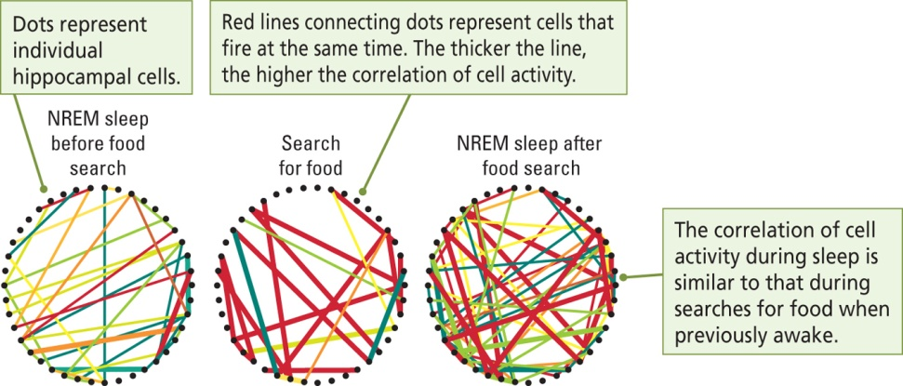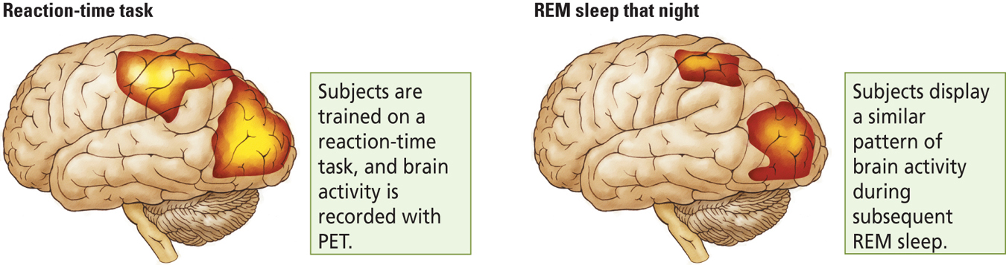

- Maquet and Collegues (2000)
- They used PET imaging to record brain activity while human subjects performed a serial reaction time task.
- The PET imaging during the subsequent sleep revealed that the same brain regions that were active during the task were also active during REM sleep
- Subjects were dreaming about their learning experience
- REM sleep strengthens the memory of the task
- This occurs more with repetitive cognitive tasks
Reticular Activation System and Sleep
- Reticular Activation System (RAS)
- Large reticulum (mixture of cell nuclei and nerve fibers) that runs through the center of the Brainstem
- Receives inputs from a lot of sensory systems (senses that sensory information is lessening at night)
- This sends information to the Hypothalamus that sends many hormones and neurotransmitters into the blood stream and cortex.
- Associated with sleep – wake behaviour and behavioural arousal
- Stimulation of the Reticular Activation System produces a waking EEG; damage to it produces a Slow – Wave EEG
- Normally the Reticular Activation System leads to desynchronized EEG

Neural basis of EEG Changes Associated with Waking
- Two Brainstem systems influence waking
- Basal Formation
- Contains cholinergic cells that secrete Acetylcholine onto Neocortical Neurons that stimulate a waking EEG (beta) rhythm
- Project into the cortex and part of the Hippocampus
- Animal is “still, but alert”
- Median Raphe Nucleus (midbrain)
- Contains Serotonin Neurons (secrete serotonin) that projects diffusely to the Neocortex; also stimulates Beta rhythms.
- Animal is alert and moving
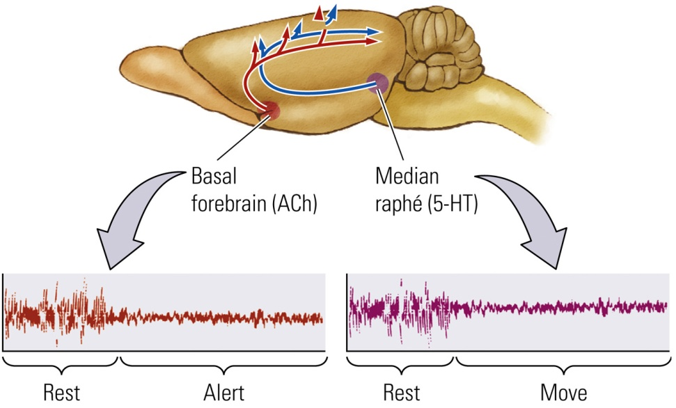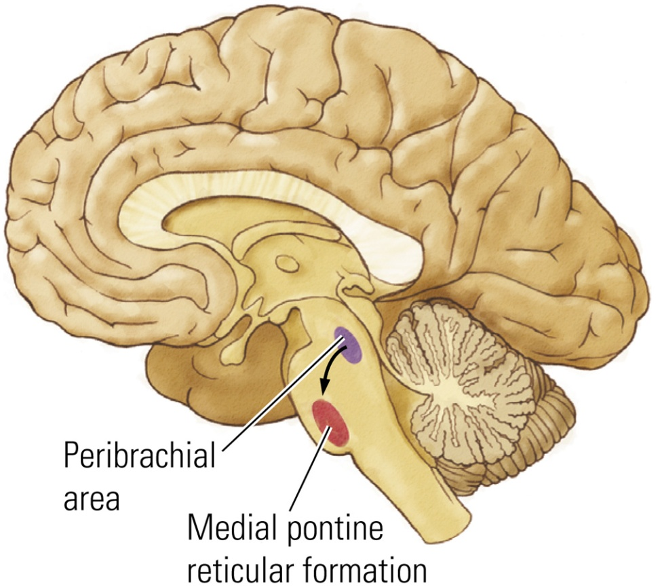

Neural Basis of REM Sleep
- A circuit in the brain initiates REM sleep
- Peribrachial Area
- Cholinergic nucleus in the dorsal brainstem has a role in REM sleep behaviours; projects to the Medial Pontine Reticulum
- Initiates REM sleep
- Medial Pontine Reticular Formation (MPRF)
- Nucleus in the pons participating in REM sleep
- Projects to several other brain areas that produce REM-related behaviours
- Ex. Produces the Atonia of REM sleep
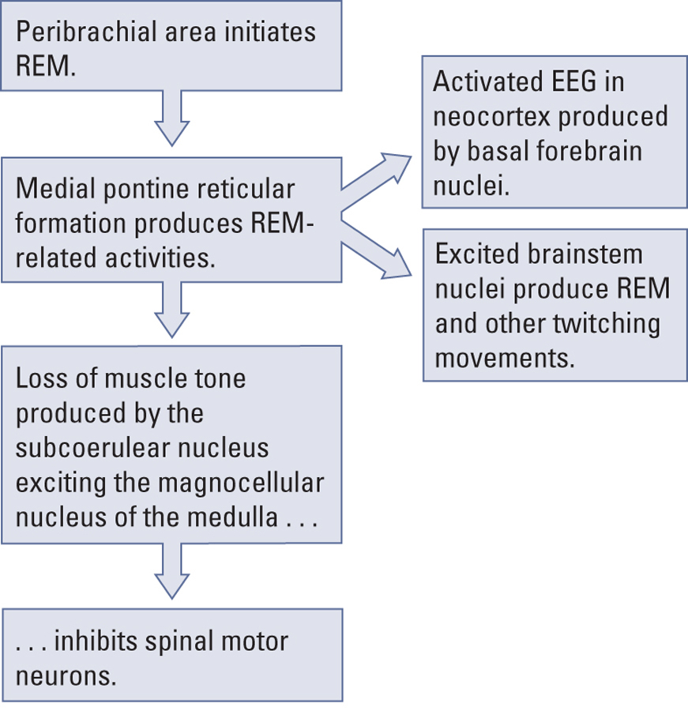
Disorders of Non-REM Sleep
- Insomnia
- Disorder of Slow – Wave Sleep resulting in prolonged inability to sleep (either falling asleep, or waking in the night and not beinf able to fall back asleep)
- There are multiple causes some of which are neural, but most are psychological
- Drug – Dependency Insomnia
- Condition resulting from continuous use of “sleeping pills”; drug tolerance also results in deprivation of either REM or NREM sleep, leading the user to increase the drug dosage.
- Narcolepsy
- Slow – Wave sleep disorder in which a person uncontrollably falls asleep at inappropriate times
- This may be due to mutations in the gene that produces Hypocretin/Orexin Peptides
- Sleep Apnea
- Inability to breathe during sleep, this means that the person to wake up to breathe.
Disorders of REM Sleep
- Sleep Paralysis
- Inabilty to move during deep sleep owing to the brain’s inhibition of motor neurons
- Cataplexy
- Form of Narcolepsy linked to strong emotional stimulation in which an animal loses all muscle activity or tones, as if in REM sleep, while awake.
- Hypnogogic Hallucination
- Dreamlike events at the beginning of sleep or while a person is in a state of Cataplexy
What Does Sleep Tell us About Consciousness?
- Consciousness is not a unitary condition, but rather, there are “states of consciousness”
- Studying sleep may also help us in understanding some psychiatric and drug-induced conditions
- Ex. Are hallucinations related to dream events that occur during REM sleep?

