How Does the Brain Think?
The Nature of Thought
- Thinking is an activity of complex neural circuits, not some region of the brain
- Cell Assembly
- Hypothetical group of neurons that become functionally connected because they receive the same sensory inputs
- Hebb proposed that cell assemblies were the basis of perception, memory, and thought.
- Thinking is due to activity of many different systems which, in the mammalian brain, are located in the Cortex
- It is difficult to study thought, language, memory, etc. As these are not observable.
- They are “Psychological Constructs”
- They are names without understanding of what they are
- The idea, resulting from a set of impressions, that some mental ability exists as an entity; examples include memory, language, and emotion.
- Difficult to localize constructs in the brain
- Cognition
- Act or process of knowing or coming to know
- In psychology, used to refer to the processes of thought
- Language, Memory, etc.
Characteristics of Human Thought
- Human thought is verbal (we think in language) while in other animals thinking is none verbal.
- Language gives humans an edge in thinking:
- Language makes our thought much more complex
- Language provide the brain with a ways to categorize information
- Language provides a means of organizing time (ex. Monday at 3:00pm)
- Language has syntax
- Ways in which words are put together to form phrases, clauses, or sentences; it is proposed to be a unique characteristic of human language
- It allows humans to have a language that moves beyond the concrete world of the “here and now”
- Ex. The boy who learned language late.

The Neural Unit of Thought
- Each neuron is capable of understanding and thinking
- Newsome and Colleagues (1995)
- Neurons in area V5 that are activated by movement
- Trained monkey’s on an apparent motion paradigm and performed single-cell recordings
- They found that the perception of apparent motion was influenced by individual neurons, not by the summed activity of many neurons.
- These individual neurons can communicate to the cortex
- Neurons are the foundation of thought and cognitive processes
- Multiple neurons converge to form cell assemblies to represent complex thought.
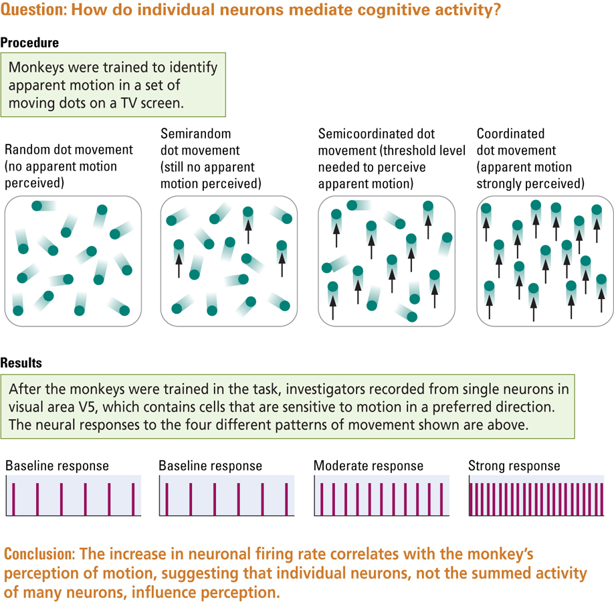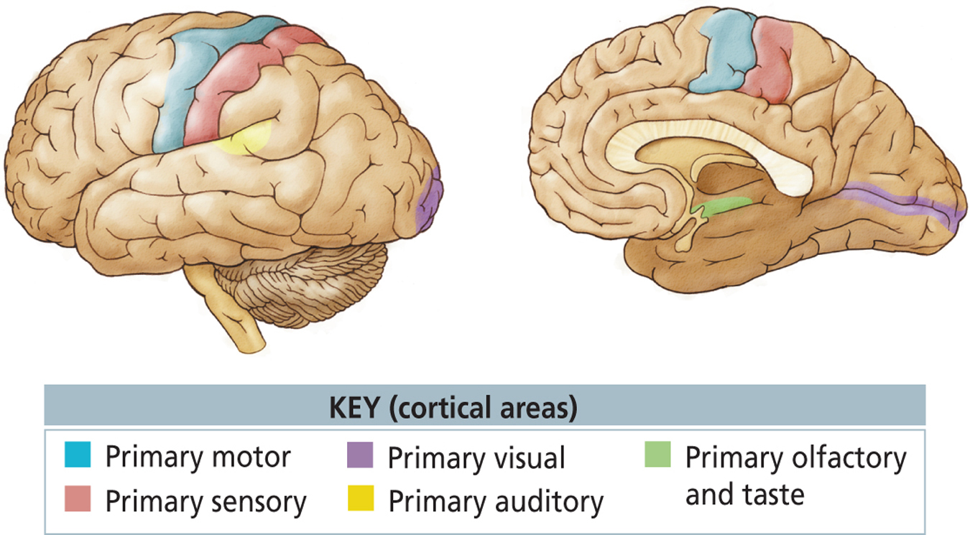

- All cortices that are not primary cortices are Association Cortices
- Every sense you have in the body all come into the Thalamus and then they travel to the appropriate Cortical Region.
Cognition and the Association Cortex
- Association Cortex
- Neocortex outside of the Primary Sensory and Motor Cortices that function to produce cognition.
- One of the key difference between Association Cortex and the Primary Sensory and Motor Cortices is the Pattern of Connections
- The Association Cortex receives information that is more highly processed than information received by the Primary Cortices
- Multi-Modal Regions (ex. They can connect auditory and visual information)
- Detailed knowledge about the external world and the internal world.
- Look at the different forms of Cognitive Behaviour Trace to parts of association cortex.
1. Knowledge about Objects
- Knowledge about what objects are represented in the Temporal Association Cortex, part of the Ventral Visual Stream
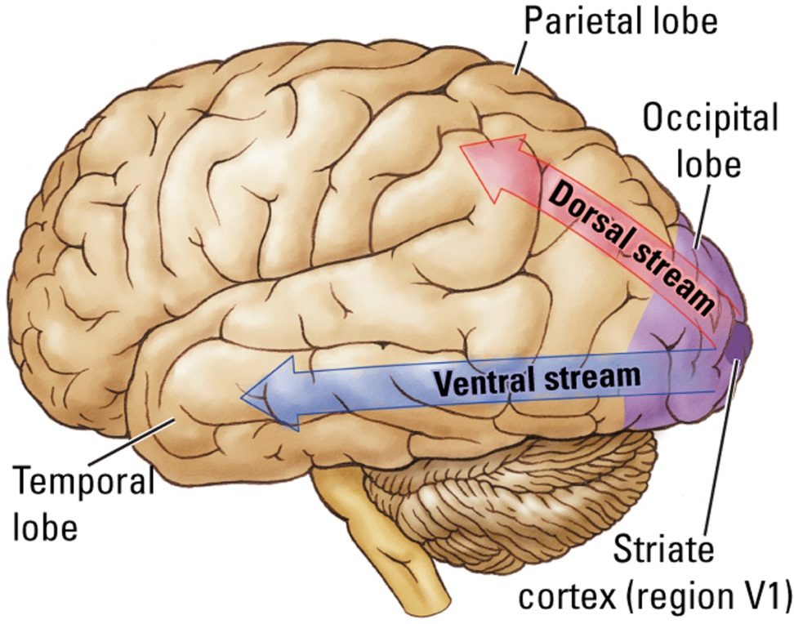
- If the Temporal Association Cortex is destroyed, the person will develop Visual Agnosia
- He or she will lose all visual knowledge about objects therefore unable to distinguish between them (ex. what they are and what they are used for)
- Prosopagnosia = Unable to recognize faces
- Dorsal = Where Pathway
- Ventral = What Pathway
Apperceptive Visual Agnosia
- Failure to perceive objects, even though visual acuity is normal
- You can still recognize objects by touch (different pathway in the brain)
- They cannot draw objects or copy other people’s drawings
- Deficit in perception.
2. Multisensory Integration
- Binding Problem
- Where in the brain do we bind all the sensory information?
- Philosophical question focused on how the brain ties single and varied Sensory and Motor events into a unified perception or behaviour
- One solution: Regions of the Association Cortex are Multimodal brain regions.
- These neurons respond to information from more than one sensory modality.
- No region that responds to all information
3. Spatial Cognition
- Refers to a range of mental functions ranging from the ability to navigate from point A to point B to the representation of complex visual arrays
- Imagine navigating in an unfamiliar location...then not sure how to get back to your hotel. How do you do it?
- Men are generally better at this ability than females
- The ability to mentally manipulate things likely evolved in parallel with our ability to navigate in space
- Ex. Study with kids as they age they use different tactics with age
- The Dorsal Visual Stream in the Parietal Lobes is important in Spatial Cognition.
- The right hemisphere of our brains.
4. Attention
- Selective narrowing or focusing of awareness to part of the sensory environment or to a class of stimuli
- It can be directed inward and outward
- Moran and Desimone (1985)
- Neurons in areas V4 could be trained to respond selectively to information in their receptive field
- Respond to stimuli in one location but not other locations.
Deficits of Attention
- Frontal Association Cortex
- Damage can lead to focusing excessively on external stimuli and difficulty shifting attention.
- Parietal Association Cortex
- Lose of attention to one side
- Damage can produce Contralateral Neglect
- Ignoring a part of the body or world on the side opposite (Contralteral) that of the brain injury
- Neglect is particularly severe in right hemisphere damage
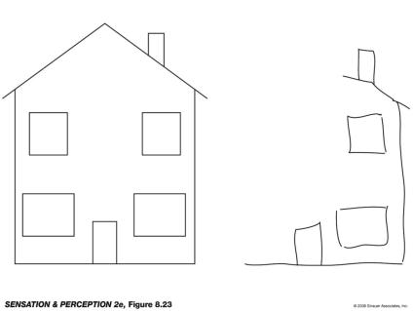
Neglect
- This is what can happen when a neglect patient tries to copya drawing

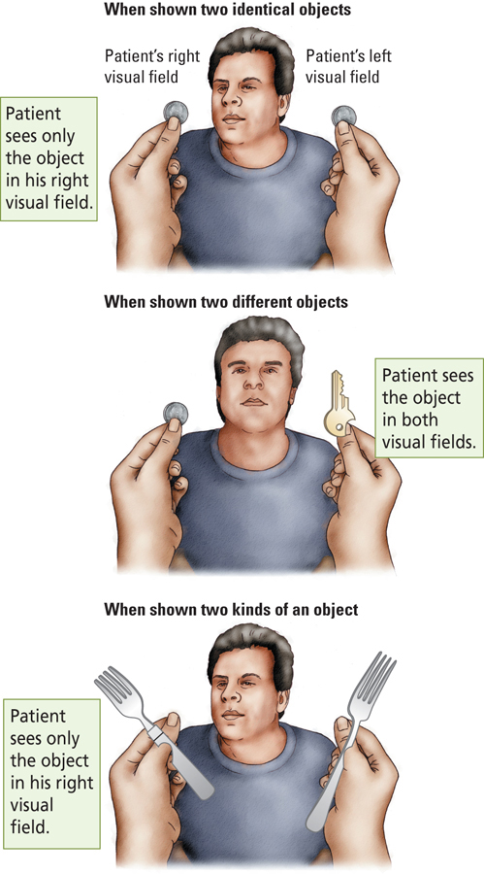
Attention
- Extinction
- Improvement from Parietal Association Cortex
- In Neurology, neglect of information on one side of the body is when it is presented simultaneously with similar information on the other side of the body
- Patients with contralateral neglect exhibit this symptom as they begin to recover.

5. Planning
- Act like an orchestra conductor
- Ex. Planning for a short weekend away on short notice. You must: select a course, ignore irrelevant stimuli, and remember what you have already done.
- People with Frontal Lobe injuries are unable to organize their behaviour
- Wisconsin Card Sorting Test
- Neuropsychological measure of planning and abstract reasoning.
- Sensitive to Frontal Lobe Damage
6. Imitation and Understanding
- For successful communication, sender and receiver must have common understanding of what counts
- Verbal and Nonverbal Information
- Smile, raised hand etc.
- Mirror Neurons
- Cells in the primate premotor cortex that fire when an individual observes a specific action taken by another individual.
- Rizzolatti: The human capacity to communicate with words may have resulted from the progressive evolution of mirror-neuron system
- Deficits in Autism Minds?

Cerebral Asymmetry in Thinking: Anatomical Asymmetry
- Gross anatomical differences between hemispheres:
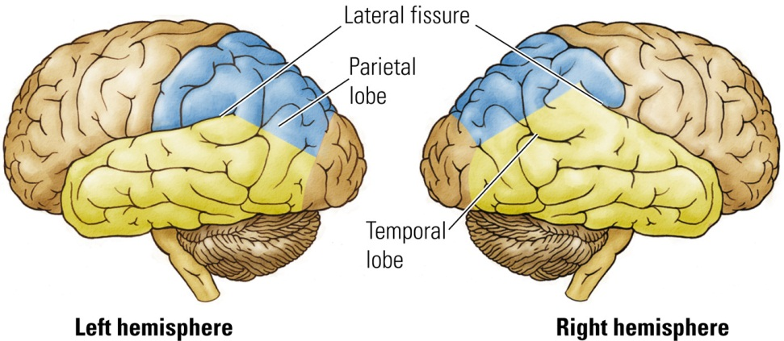
- Left Hemisphere
- Specialized role in Language
- Primary Auditory Cortex
- Larger on the right than on the left
- Secondary Auditory Cortex
- Larger on the left than on the right
- Sensory Motor Cortex representing the face
- Larger on the left than on the right
Functional Asymmetry in Neurological Patients
- Two cases of Brain Damaged Individuals
- Case of G.H.
- Damage to Right Parital Lobe
- Spatial Cognition
- Difficulties copying drawings, assembling puzzles, and navigating around familiar places.
- Case of M.M.
- Damage to the Left Parietal Lobe
- Difficulties with language, copying movements, reading, arthematic, and generating names of objects or animals.
- Conclusion: The right hemisphere is important in spatial skills while the left hemisphere in language, reading, writing, and math.
Functional Asymmetry in the Normal Brain
- Dichotic Listening
- Experimental procedure for simultaneously presenting a different auditory input to each ear through stereophonic earphones
- Right-Ear advantage for verbal information
- Left-Ear advantage for musical information
- Visual System
- Right – Visual Field (Left Hemisphere)has an advantage for language related information
- Left – Visual Field (Right Hemisphere) has an advantage for nonverbal spatial information
The Split Brain
- Surgical disconnection of the two hemispheres in which the Corpus Callosum is cut
- The axons that connect the left and right hemisphere are no longer functioning
- No cross-over of information.
- Language Abilities
- When objects are presented in the right visual field (information goes to left hemisphere), split – brain patients can easily name them
- When objects are presented in the left visual field (information goes to the right hemisphere), split-brain patients cannot name them
- Although split-brain individuals cannot name objects that are presented to their right hemisphere via the left visual field, they can make correct nonverbal responses
- Using their left hand, these individuals will correctly select the object that matches the one that was presented in the left visual field to their right hemisphere.
- The two hemispheres can act independently
- When each hemisphere is shown a different object, the two hands will each select different objects as being correct (choose specifically what that hemisphere saw)
- In addition to supporting the role of the left hemisphere in language, research with split-brain individuals also confirms the role of the right hemisphere in spatial tasks
- When asked to perform a Visuoconstruction task, split-brain individuals perform better with their left hand than with their right hand.
- The left hand superiority increases as the Visuoconstruction task becomes more difficult.
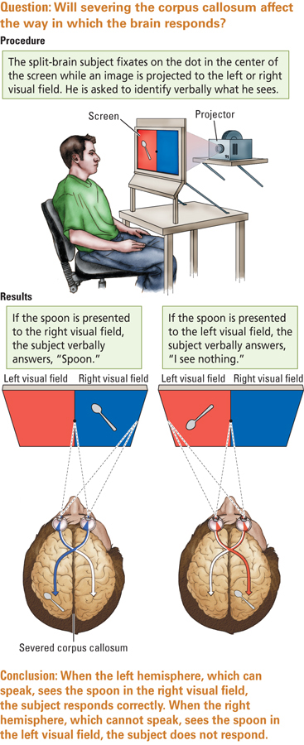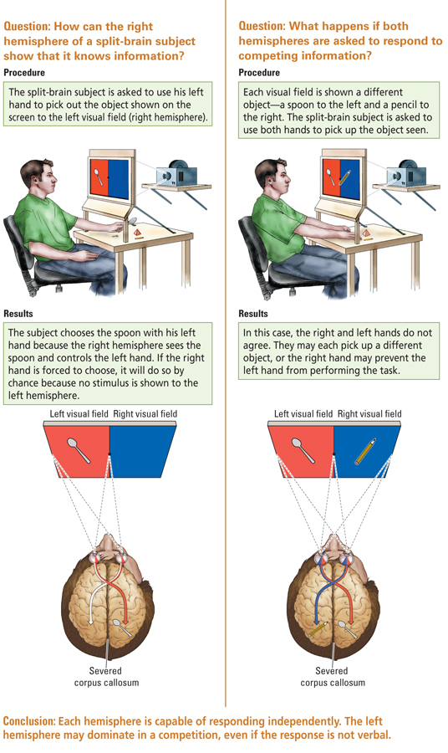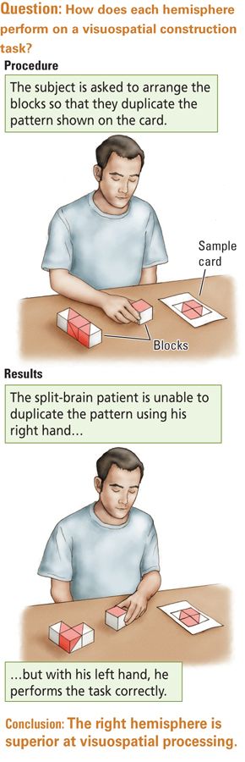

Explaining Cerebral Asymmetry
- Why is the Left hemisphere specialized for Language?
- Left hemisphere plays a role in the controls of fine movements and fine movements are necessary for the production of language
- Why is the right hemisphere specialized for spatial abilities?
- Right Hemisphere plays a role in the control of actual movements in space and in mental imagery of such movements (elaboration of the functions of the dorsal stream – where pathway)
The Left Hemisphere, Language, and Thought
- Gazzaniga (1992)
- Unlike other animals, the speaking left hemisphere in humans acts as an “interpreter”: It is able to inter relationships among stimuli.
- Ex. Present images to both hemispheres (match and a log) then another image that completes the sequence (bonfire) must be selected
- The right hemisphere is incapable of doing this task (it is unable to match the images)
Sex Differences in Cognitive Organization
- On average, females are better than males on short-term memory type tasks and verbal fluency type tasks
- On average, males are better than females on spatial relation type tasks and mental rotation type tasks.
Neural Basis of Sex Differences
- Gonadal Hormones
- Hormones effect the structure of the brain
- Influences the structures of neurons on the rat prefrontal cortex
- Medial Frontal Cortex
- Neurons in male rats have larger dendritic fields
- Orbitofrontal Cortex
- Neurons in female rats have larger dendritic fields
- These differences are not seen when the rats have their gonads or ovaries removed.
- Rowntree (2009)
- Tested girls at age 16 and found that:
- Girls who began menstruating early (age 12 or younger) were better on tests of verbal fluency than girls who began menstruating later
- Girls who began menstruating later were better at test of spatial ability than girls who began menstruating earlier.
- The age at which gonadal hormones affect the brain may be an important factor for cognitive development.
- Kimura (1999)
- Does brain damage affect females and males differently?
- Females were more likely to be aphasic (lose of language) and apraxic (motor difficulties) after lesions to the Left Frontal Cortex (Broca’s Area)
- Males were more likely to be aphasic and apraxic after lesions to the Left Posterior Cortex (Wernicke’s Area)
- These results suggest a sex difference in Intrahemispheric organization
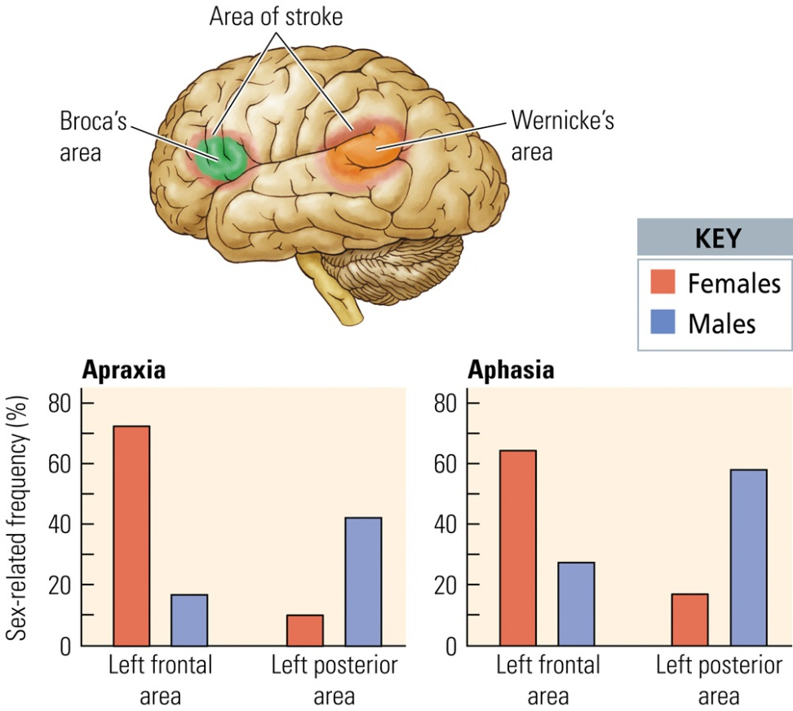

Evolution of Sex-Related Cognitive Differences
- Why do males have better Spatial Skills?
- Perhaps during evolution males had to tend over larger territories than females, thus good spatial skills would have been favored in males
- Men ,most likely, who did not have this capability would have died off
- Why do females have better language skills?
- Perhaps during evolution, females developed good language skills to engage in social interaction
- Also, females may have been selected for fine motor skills (ex. Making clothes), which are related to language
Handedness and Cognitive Organization
- Most right-handed people have language localized in their left hemisphere
- However, the opposite is not true of Left-Handed people
- Assessed using Sodium Amobarbital Test (a way to isolate one hemisphere from the other. They inject Sodium Ambarbital into the left or right carotid artery wich freezes that hemisphere of the brain)
- About 70% also have language localized in their left hemisphere
- About 15% have language localized in their right hemisphere
- About 15% have bilateral representation of language
- 15% and 15% are known as Anomalous Speech Representation
- Witelson and Goldsmith (1991)
- Found that the cross-sectional area of the Corpus Callosum was 11% greater in left-handed or ambidextrous individuals (no hand preference)
- More connections between the two hemispheres
- This could be due to a greater number of fibers, thicker fibers, or more myelin
- These individuals are less likely to develop dementia later on in life.
Synesthesia
- Ability to perceive a stimulus of one sense as the sensation of a different sense, such as when sound produces the sensation of odour.
- Estimated to occur in 1 out of 23 people
- It tends to run in families
- Its most common form is coloured hearing (words with colours)
- Most pairing are in one direction only
- Ex. In coloured hearing, seeing a colour does not elicit the sound
Variations in Cognitive Synesthesia
- Hypothesis regarding the neural basis of Synesthesia
- Extraordinary neural connections between different sensory regions (we are born with Synesthesia and usually the neurons that made these connections are pruned away, some individuals do not experience this pruning)
- Increased activity in multimodal areas of the frontal lobe that receives input from more than one sensory area.
- Unusual patterns of cerebral activation in response to particular sensory inputs
Intelligence: The Concept of general Intelligence
- Spearman (1920’s)
- General intelligence: “g” factor
- It is hard to localize general intelligence in the brain
- It is not related to any one brain region
- Einstein’s Brain
- It was of average size and weight
- Investigations imply that cerebral connectivity and high Glia-to-Neuron ratio may play important roles in intelligence.
- Ex. Greater Glia-to-Neuron ratio in the inferior Parietal Cortex, involved in mathematical reasoning.
Multiple Intelligences
- Gardner (1983)
- Neuropsychologists that examined the effects of brain injury on behavior
- Proposed seven distinct types of intelligence
- Linguistic
- Musical
- Logical-Mathematical
- Spatial
- Bodily-Kinethetics
- Intrapersonal (being aware of yourself)
- Interpersonal (being aware of others)
- Perhaps there are specific brain regions that are functionally more important for the different kinds of intelligence.
Divergent and Convergent Intelligence
- Convergent Thinking
- Form of thinking that searches for a single answer to a question, such as 2 + 2 = 4)
- This is measured in traditional intelligence tests
- People with Temporal and Parietal Lobe lesions perform poorly on these types of tests
- Divergent Thinking
- This form of thinking searches for multiple solutions to a problem, such as how many different ways can a pen be used?
- This can be referred to as thinking outside of the box
- People with Frontal Lobe lesions perform poorly on these tests.

Intelligence, Heredity, Environment, and the Synapse
- Intelligence A
- Hebb’s term for innate intellectual potential, which is highly heritable and cannot be measured directly
- 70% - 80% of our intelligence is due to the genes
- Intelligence B
- Hebb’s term for observed intelligence, which is influenced by experience as well as other factors in the course of development and is measured by intelligence tests
- Convergent Thinking
- Experience may influence intelligence by increasing the number of synapses and the number of glial cells
Consciousness: Why are we Conscious?
- Consciousness
- Level of responsiveness of the mind to impressions made by the senses
- One reason why we are conscious may be because it provides an adaptive advantage
- It can be altered: sleep, coma, anesthesia
- Jeannerod and Colleagues (1991)
- Can people alter their movements without conscious awareness?
- Unconscious minds that processes information very rapid (most likely Subcortical that has not yet gotten to our Cortex)
- Disassociation between Motor Behavior and conscious awareness
- Subjects made movements before they were actually aware of them.
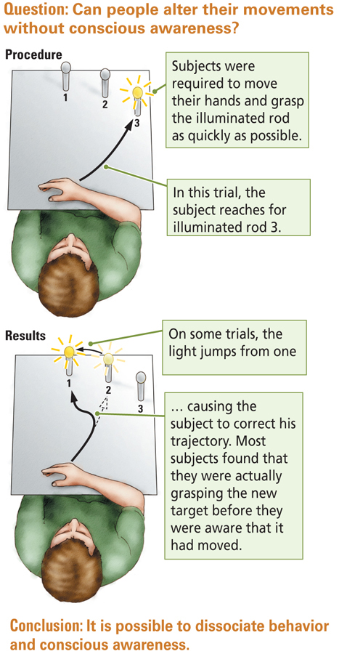

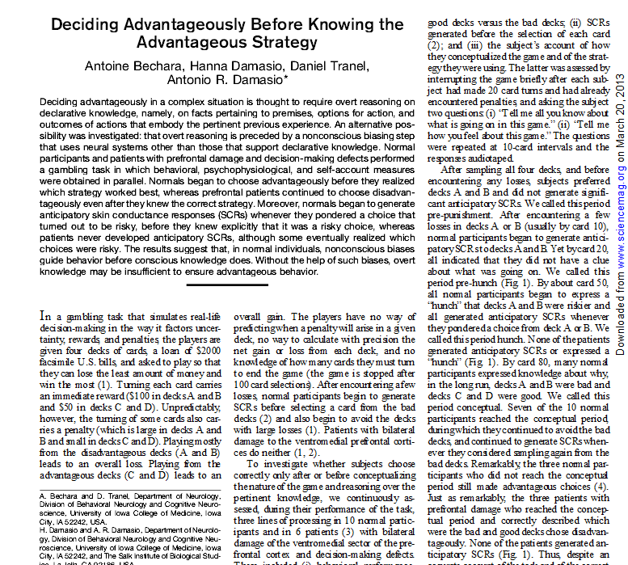
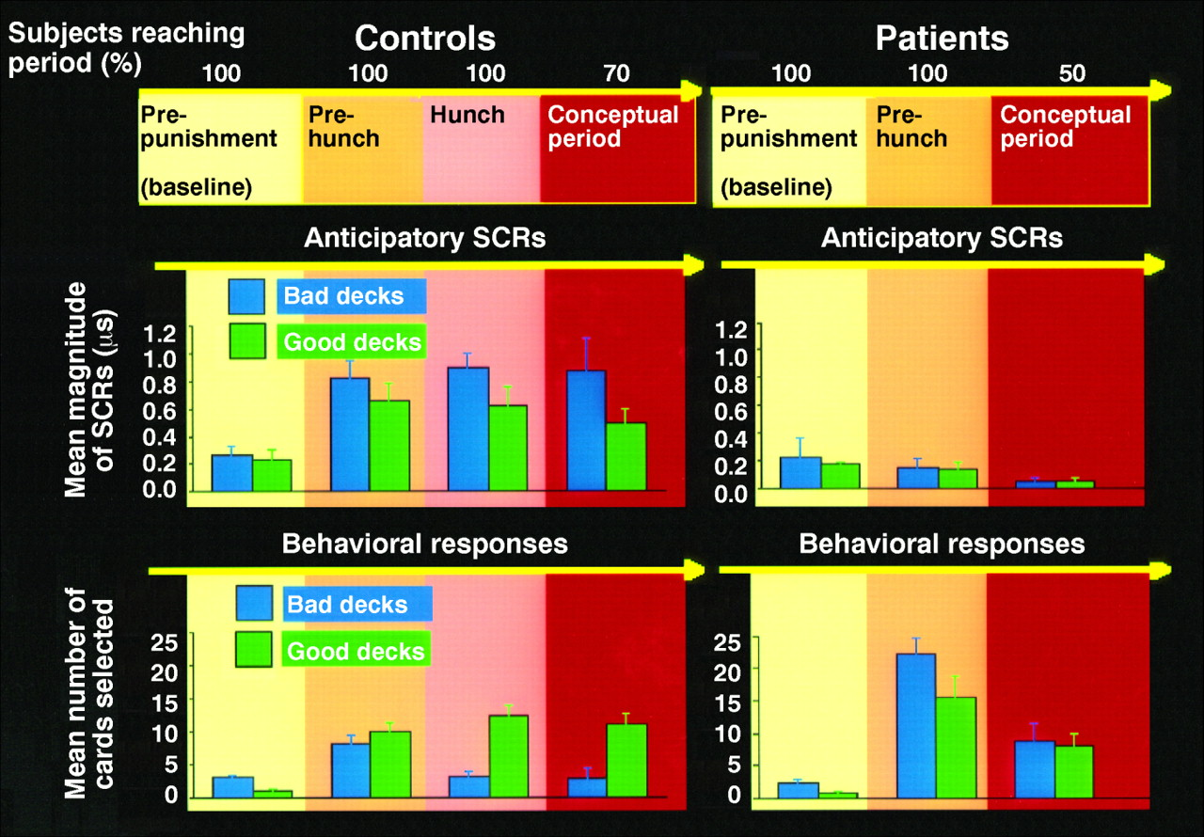
- Skin Conductance Response
- Unconscious mind is producing a skin response before the individual is even conscious of the “good” and “bad” decks

What is the Neural Basis of Consciousness?
- There are conditions in which people can process information without being aware of that information
- Blindsight (there is damage to the visual cortex but if you throw a ball they are still able to catch it) is a form on agnosia, visual neglect and amnesia.
- OCD Keep checking even though you have already checked it
- There are conditions in which people have conscious awareness of events that are not actually present
- Phantom Limbs, Hallucinations in Schizophrenia
- The representation of a visual object is likely distributed over many parts of the brain and part of this neural circuit must produce awareness.
- Consciousness is presumably a process that emerges from neural circuits rather than from individual neurons.
- The greater the degree of complexity in neural circuitry, the greater the degree of consciousness.
- This is why we can get so many complex disorders
- Consciousness is likely a product of all Cortical Areas, their connections, and their cognitive operations.

