- 13.1
  - Darwin
  - Evolution
    - Idea that species and all living things we see today are descendants of ancestral species
  - Different Views on Evolution
    - Aristotle
      - Species as perfect and permanent
    - Judeo-Christian
      - Species were individually designs by divine creator
  - Fossils
    - Imprints past organisms
      - Illustrate that species no longer seen today were once on this earth
  - Lamarck (looked at ‘how’ things evolved)
    - Body parts that are not used, traits will be changed and then passed off to its offspring
  - Adaptation
    - “descent with modification”
    - as species move into various environments, they acquire and collect a variety of modifications
    - end goal is to fit into the environment
- 13.2 & 13.3
  - Artificial Selection
    - Picking and breeding with desired trait over many generation
      - Ex. Dog breeding
  - Natural Selection
    - Genotypic characteristics that are better suited to an environment is more likely survive and reproduce, thus increasing the traits frequency and increasing the species chance for survival
      - Prevent population from “overproducing”
        - Natural Disaster, Increase in Predators Population, Decrease in food levels
        - Traits that can better tolerate harsher conditions have a higher percentage of passing on the trait
        - Natural selection will pick the best traits needed to meet the demands of the new environment
    - 3 key points of Natural Selection
      - individuals do not evolve, but the population
        - interaction between an individual and its environment, leads to natural selection
      - traits can only be amplified or diminishes
      - not goal driven
        - perfect organisms are not obtained
        - result of environmental factors that change from place to place
        - adaption is a compromise, as one trait is enhanced another is weakened
    - an editing process
      - ex. Presents of the pesticide leads to natural selection
    - heavily dependent on time and place
- 13.4
  - Fossils
    - Document past and present species
    - Fact that many species have become extinct
    - Many are replicas
      - Dead organism is left in sediment decay and mould is left, and filled with water and minerals
    - Trace Fossils
      - Remains of organism’s behaviour
        - Footprints, burrows
  - Palaeontologist
    - Study fossils
  - Fossil Records
    - pattern in which fossils appear in sedimentary layers
  - Strata/Layers
    - Result of sedimentation and variation in particle types that settle over time
  - Fossils
    - Show organism evolution sequence
  - Radiometric Dating
    - Determines rock’s age
- 13.5 Evidence Supporting Evolution
  - Biogeography
    - Distribution of species
      - Caused by migration
      - Isolation vs. Open
  - Comparative Anatomy
    - Homology
      - Characteristically similarities between species caused by common ancestry
    - Homologous Structures
      - Structures that are similar because of common ancestry but have different functions
    - “Descent With Modification”
      - structure is modified to take on another function
    - Vestigial Structures
      - Structures that have no function in the present organism
  - Molecular Biology
    - Looks at evolution of DNA sequences
- 13.6
  - Evolutionary Tree
    - Representation of descendants
      - Genetic Code
        - Are shared by all species because of how deep the ancestral is
        - New evolutions are seen within a smaller group
- 13.7
  - Evolution is seen within a population over time
  - Population
    - group of individuals that are the same species and live in the same area plus interbreed
  - Gene Pool
    - Collection of gene in population at one time
      - Includes all alleles in all individuals in the population
  - Microevolution
    - Change in relative allele frequencies change over time in a small scale
- 13.8 Causes of Microevolution
  - Genetic Variation
    - Phenotype is a result of genotype combination
  - Mutation
    - Changes in nucleotide sequence of DNA
      - ONLY mutations in gametes are passed on
    - Changing many loci at once can led to damage
    - Genetic variation is a result of minor errors in meiosis
    - Happens faster in prokaryotes
  - Sexual Reproduction
    - Genetic variation
      - Unique combination of alleles leads to an even greater variation
    - 3 random components
      - crossing over
      - independent orientation of homologous chromosomes
      - random fertilization
- 13.9
  - Hardy-Weinberg Principle
    - shuffling of alleles in sexual reproduction does not alter genetic makeup of population
    - frequency will remain the same unless other factors are introduced
  - Genotype Frequency Math
    - p and q allele frequency , p + q =1
Phenotype | No webbing | No webbing | Webbing
Genotype | WW | Ww | ww
# of animals (T=500) | 320 | 160 | 20
Genotype Frequencies | 320/500 = 0.64 | 160/500 = 0.32 | 20/500 = 0.04
# of alleles (T=1000) | 640 W | 160W + 160w | 40w
Allele Frequencies | 640+ 160= 800  800/1000 = 0.8 W |  | 160+40 = 200  200/1000 = 0.2  w
    - Gene pool of original population

    - P² +2pq + q² = 1
  - Only applies to closed population (where only birth and death is factors)
  - Hardy- Weinberg, main condition
    - Very large population
      - Less fluctuation of alleles frequency
    - No gene flow between population
      - Migration leads to removal and introduction to alleles
    - No mutation
      - Leads to modifications to gene pool
    - Random mating
      - Leads to missing to change in genotype frequency
    - No natural selection
      - Unequal survival and reproduction can alter allele frequencies
  - Realistically 5 conditions are not met and genotype do change
- 13.11
  - non-random mating affects the frequency of homozygous and heterozygous genotypes, not allele frequencies
  - 3 main causes of Evolutionary Change
    - Natural Selection
    - Genetic Drift
    - Gene Flow
  - Natural Selection
    - Variations in animals/ organism ability to reproduce
      - Ex. Some produce more
  - Genetic Drift
    - Chance events that causes a change in allele frequencies to increase and decrease unpredictably form one generation to the next
    - Smaller populations feel the effects greater in comparison to a smaller one
      - Bottleneck Effect
        - Drastic reduction in population size
          - Ex. Fires, floods
        - End result is the change in allele frequency or the removal of allele
      - Founder Effect
        - Few individuals move to another island or new habitat
  - Gene Flow
    - When alleles are added or removed due to migration of individuals
- 13.12
  - Relative Fitness
    - the contribution one makes to the gene pool in comparison to what others have contributed
- 13.13 Affects of natural selection on population
  - Stabilizing Selection
    - Extremes are eliminated and middle is favoured
    - Variation is reduced and one characteristic becomes the statues quo
  - Directional Selection
    - Make up of population is moved to one end of the phenotype extremes
  - Disruptive Selection
    - Both extreme phenotype make up the population
    - Two or more phenotypes are kept constant
- 13.14
  - Sexual Selection
    - Individuals with traits that increase the likelihood of them obtaining a mate
      - Males tend to be more showier
    - Intrasexual Selection
      - When males compete with each other for a mate
    - Intersexual Selection
      - Female (usually) are picky when it comes to selecting a mate
    - Both increase the chance of reproduction
    - It is said (not yet proven) that the showier males tend to have better genes
- 13.16 Preserving Genetic Variation
  - genetic variation is taken away from a population by natural selection, there are mechanisms that maintain the variation
    - Balance selection
      - When two more phenotypes are maintained in a population due to natural selection
        - Heterozygote Advantage
          - Heterozygotes individuals have a greater reproduction success rate in comparison to homozygote
        - Frequency-dependent selection
          - Two different phenotypic forms in a population are maintained
- 13.17 Rules of Natural Selection
  - Selection can act only on existing variation
    - Only phenotypes from the fittest variants are used
    - Alleles do not appear on demand
  - Evolution is limited by historical constraints
    - Is a building process, builds on what is already there
  - Adaptation are often compromises
    - While one trait is strengthen other is weakened
  - Chance, natural selection, and environment interact
    - All three play a huge role in evolution

- Lecture 1 Jan 9, 2013
  - Genetic Drift
    - Change in the gene pool of a population due to chance
  - Conceptual Graph
    - Look at trends
    - Expected results
  - Data Graph
    - Show experiments results
    - Real data
  - Big changes at the species level are the accumulation of smaller changes at population level
  - DNA unifies us but also differentiates each other
  - We all have the same genetic code, AGCT
    - Variations in this code leds to variation in the population
  - DNA changes is a result of
    - Genetic recombination
    - Mutation (biggest contribution)
  - Evolution
    - consists of the changes in the heritable traits of population of organism as successive generation replace one another
  - Evolutionary Biology
    - Study of evolution
    - Microevolution (main focus)
      - Look at traits inherited among population generations
    - Macroevolution
      - Looks at the big picture, diversity
  - Two answers to why?
    - Proximate (physiological, neurological)
    - Ultimate (evolutionary)
  - Scientific theory must have:
    - Explain past and present
    - Predict future
    - Better explain observation thn alternative theories
  - Fitness
    - how much an individual genes are used to contribute to future generation
  - Adaptation
    - …

- Jan 11, 2013
- Lecture 2
  - Darwin
    - Other people knew before him
    - he explained it better and he was able to explain the “how”
    - Prediction and theory are tested
  - Early Ideas
    - Georges
      - Realized that earth is older the Bile
      - Species change over time
    - George
      - Father to palaeontology
      - Did not accept evidence of evolution

    - Jean
      - Simple organisms can evolve into more complex organism

    - Natural Theory
      - Study of nature and understanding work of God
        - Heavily related/referred to God

- Jan 13, 2013
- Lecture 3- Variation & Selection
  - Variation is morphology, physiology and behaviour, some are more visible thn other
    - Use to environment
    - Genetic difference, only one that plays a role in evolution
    - Genotype
      - Genetic make up
    - Phenotype
      - Expressed trait
    - Phenotypic plasticity
      - The enviro effects how genotype is expressed
    - Variation
      - Can be continuous trait ex. Height
      - Discrete trait/polymorphism ex. Colour change
      - Illustrated using histogram
      - Amount of Variation is the spread on the y-axis
    - Genetic Variation comes from
      - Mutation
        - Most hat cause changes are harmful but some are beneficial
        - Leads to creation of new allele and thus cause evolution
        - Somatic mutation do not effect reproduction and are therefore not passed off
    - Natural selection acts on indiv within generation
    - Evolution happens between generations in population
    - Fitness is not about being the best but being able to live within the environment
- Agents of Microevolution

- Non Random Breeding
  - Inbread Coefficient (f)
    - Ranges from 0 (outbreds) to 1.0 (fully inbred)
    - Consequences

- Mutation
  - Heritable changes in DNA

- Genetic Drift
  - Small population random selection leads to genetic drift -> Loss of genetic diversity & fixation of alleles
- Lecture 5 Jan 21, 2013

- Observed genotype frequency -> 1. Calculate from genotype freq -> observe allele frequency ->2 calculate from HW equation -> Predicted genotype frequency <- compare ->

- To get Genotype frequency
- Met/Met
  - 31/140 = 0.22
- Met/Val
  - 72/140 =0.5

Val/Val
  - 37/140 =0.27
- Allel Freq.
  - Met = p
    - (2*31+72)/280 <- double 140
      - =0.48
  - Val= q
    - (2*32+72)/280
      - = 0.52

Predicted Geno Type
  - p^2= 0.48*0.48
    - =0.23
  - 2pq= 0.48*0.52*2
    - 0.50
  - q^2 = 0.52*0.52
    - = 0.27

Genotype Freq
  - M/M
    - = 4/30
    - =0.13
  - M/V
    - 23/30
    - = 0.77
  - V/V
    - 3/30
    - 0.1
- Allel Freq
  - P= (2*4+23)/60
    - 0.8
  - q= (2*3+23)/60
    - 0.2

- Lecture 6 Jan 23/2013

  - Sexual Dimorphism
    - Sexual characteristics that are different between female and male
  - Males tend to fight with each other and thus are bigger
  - Where males don’t fight females tend to be larger
  - In most females are lager
    - Why females are bigger?
      - Parental care (some cases)
      - Defensive reasons
      - Larger the female, the bigger and more eggs produced (Fertility selection)
  - Mate Selection and immunity
  - Bateman's principle which states that the sex which invests the most in producing offspring becomes a limiting resource over which the other sex will compete. This can be most easily illustrated by the contrast in nutritional investment into a zygote between egg and sperm, and the limited reproductive capacity of females compared to males. Thus, 'sexual selection' typically refers to the process of choice (the limiting factor, which is typically females) over members of the opposite sex (the non-limited factor, typically males).
    - Immunity – how well they can fight off illness
      - MHC the bigger the better chance of fighting off illness
        - Body odours
          - Woman like dissimilar one
            - Results were flipped when contraceptive, if are pregnant they try to find ppl/males that are like them

- Lecture 7 Jan 25, 2013
  - Biological species
    - two groups cannot reproduce
      - Basied against bacteria and other that do not “sexually”
      - Fossils is only way we can get info on past species
  - Morphological
    - Physical differences
      - Biased: if they look extremely different thn they should be evolutionary independent
      - How much differences do u need to make them different? What traits do you use?
    - Most commonly used
  - Phylogenetic
    - Groups species based/sharing on common ancestors
  - Reproduction isolation
    - Barriers need to be present to prevent the members of two species to reproduce and to block gene flow
      - Ex.
      - Geographic Barriers
        - Allopatric speciation
          - Creation of new species in population that are isolated from each other geographically
      - Prezygotic Barriers
        - Prevent mating or fertilization between species
          - Morphological
          - Habitat
          - Temporal
          - Behavioural
          - Gametic
      - Postzygotic Barriers
        - Operate after the zygote is formed
          - Reduce hybrid fertility
          - Hybrid breakdown
  - Speciation without geographical barriers
    - Sympatric Speciation
      - Without physical barriers isolation population
    - Polyploidy
      - Organism has more than two sets of chromosomes as a result of an error in chromosome duplication
        - Comes from producing asexually and hybrids
      - Common in plants because they do cell fertilization
    - Tetraploid cell (4n)
  - Secondary Contact
    - When two species come back a hybrid zone is created
      - Region which member of different species meet and mate producing hybrid
        - Stability
        - Reinforcement
          - Hybrids are less fit then the parent specie, selection will act against traits
        - Fusion
          - Hybrids are more fit than either parent and over time the gene will become favoured and become one population again

- Jan 28/2013

  - Adaptive radiation
    - Period of rapid evolutionary changes in which a small group of organisms form many new species
    - Happens when new environment is available or after mass extinctions
      - Happening on Hawaiian Island
        - Heavily seen in birds
          - Hawaiian Honey Creepers
            - 56 species (18 extinct)
- 14.1
  - Darwin’s works heavily focused on the role of evolution, more importantly on natural selection and its slow effects on the adaptation of the population to it’s environment
  - Speciation
    - When one species divide/split into two separate species
- Q: microevolution vs. speciation
  - Microevolution is changes within a population
  - Speciation is then change of one species so that it becomes its own species
- 14.2 Defining Species
  - Latin for “kind” or “appearance”
  - humans belong to the same species, Homo sapiens even though we have different appearances

  - Biological Species Concept
    - Species is defined as
      - Population group whom members are able to interbred in nature and produce fertile offspring
    - Reproductive isolation
      - Prevent gene flow and the gap between species are left open
    - Hybrids
      - Offspring created as a result of distinct species mating
  - Morphological species concept (controversial)
    - Traits such as shape, size, and other features of form (morphology) is used to classify most organisms
  - Ecological Species concept
    - Species are classified based on their ecological niches, and adaptation to certain roles in a biological community
  - Phylogenetic species concept
    - Species of a smaller group of individual that share a common ancestor and together form a branch on the tree of life
- 14.3 Reproduction barriers
  - reproduction barriers can be classified/categorized as prezygotic or postzygotic, depends if they go into effect before or after zygotes

Habitat Isolation
Behavioral Isolation
Mechanical Isolation
Gametic Isolation
Temporal Isolation
Fertilization (Zygote Form)
Viable, fertile offspring

Prezygotic Barriers
Reduce hybrid viability
Reduce hybrid fertility
Hybrid breakdown
Postzygotic Barriers

  - Prezygotic Barriers
    - Prevent mating or fertilization between species
      - Five types
        - Habitat isolation
          - Those that live in the same area but not the same habitat, rarely encounter each other
        - Temporal Isolation
          - Different breeding times
        - Behavioural Isolation
          - Species (male and female) do not recognize mating calls
        - Mechanical isolation
          - Female and male sex organs do not work together
        - Gametic Isolation
          - Sperm of one species cannot fertilize the egg of another species
  - Postzygotic barriers
    - Take into effect after hybrid zygote is formed
      - Reduced hybrid viability
        - Hybrids develop and become sterile
      - Reduced hybrid fertility
        - Hybrids cannot produce functional gametes
      - Hybrid breakdown
        - Frist generation is viable and fertile, but second generation is feeble and sterile
- 14.4
  - Gene flow will not be diluted by changes in allele frequency caused by natural selection, genetic drift and mutation
  - Allopatric speciation
    - Gene flow block caused by geographic barrier
    - Individuals colonize a remote area and become separated from parent population

14.5
  - Causes of barriers
    - Isolation may result in different food sources, predators, pollinations
- 14.6
  - Sympatric Speciation
    - new species appears within the same geographic area as parent population
    - sexual selection, habitat differentiation, and polyploidy are factors that effect gene flow between populations during mating
  - Polyploidy
    - New species has cells that have more than two complete sets of chromosomes
      - How tetraploid plant are formed from parent species?
        - Double the cell’s chromosomes can be caused due to chromosome duplication that did not go right
        - A diploid gamete is formed when a 4n cell reaches to tetraploid branch
        - Self fertilization is common in plants and when it happens a tetrapliod zygote is produced and the offspring can self fertilize and mate with others
    - Tetrploid cannot produce mate with a parent plant
      - Diploid (2n) from tetraploid + haploid (n) from diploid parent = triploid (3n) offspring
      - Tetraploid (4n) is a result of rapid speciation: a new species will reproductively isolate from parents species and one generation is produce
    - Polyploidy is a result of a hybridization of two different species
      - Hybrid is often sterile because its chromosome cannot pair up in meiosis
      - Hybrid might produce asexually
      - Errors in cell division may result in diploid set of (2n= 10)
        - Chromosomes can now pair up in meiosis and haploid can be produced, resulting in a fertile polyploidy species being formed
    - Most common in plants but has been know to have happen in animals
- 14.8
  - most diverse life-forms on Earth originated by allopatric speciation
    - evidence is seen on islands, they are far enough to allow population to evolve in isolation but close enough to allow dispersion
  - Adaptive Radiation
    - Diversity of species evolving from one common ancestor
- 14.10
  - Hybrid Zone
    - Regions in which different species can meet and mate to produce some hybrid offspring
      - The formation of hybrid zone
        - 3 populations are connected by gene flow
        - one population is separated by barrier and diverges from other two
        - Gene flow is re-established in the hybrid zone
    - Reinforcement
      - if hybrid offspring are less fit than both parents, natural selection will strengthen or reinforce reproduction barriers thus decreasing the formation of unfit hybrids
    - Fusion
      - If barrier is weak, gene flow will occur thus reversing speciation and the two species will fuse to become one
    - Stability
      - If hybrid zone is stable, hybrids are continuously produced, gene flow is present but the two parent populations remain separate

14.11
  - Punctuated equilibria
    - Describes the long periods of time at which little changes or when there is an abrupt episode of speciation (Punctuated pattern)
    - New species tend to gradually evolve from ancestral population (Gradual pattern)
- Midterm Info
  - 30 multiple choice
  - Lectures 1-9
  - Info from lectures and textbook
  - Do quiz on WebCT
  - Questions will be on comprehension and interpretation
    - Ex. Graphs
    - Bring calculator!

Scientific Writing Tips
  - Primary literature needs to be used
  - Lecture/lecture_7a_writing.pdf
- 15.1 – 15.3
- all life arise from pre-existing life through the process of reproduction

- it is has been hypothesize that the creation of earth can be summarized into 4 steps
  - nonliving/abiotic small organic molecules were created
    - e.g. Amino acid and nitrogenous bases
  - polymers were created by the joining of small molecules
    - e.g. proteins, nucleic acids
      - MAYBE waves (containing monomers) were splashed on the lava/hot rocks rising polymers and proteins into the ocean
  - “protocells” are the packed molecules, they are membrane enclosed droplets that maintain chemistry inside separate from the outside
    - MAYBE have been able to reproduce and create two a barrier that separate the inside and outside environment
  - self replicating molecules make inheritance possible
    - short RNA molecules can be made into nucleotide monomers
    - ribozymes are cable or carry out enzymes like activity
    - DNA is a result of a mutation, and because it was more stable it replaced RNA
- 15.4
  - macroevolution is the changes of/the Earth
  - History can be divided into three sections
    - Archaena
    - Proterzoic
    - Phanerozoic
  - Prokaryotes
    - Transformed the biosphere, they created oxygen and performed photosynthesis in the ocean causing saturation which then started to show up in the air
    - O₂ started to produce quickly leading to an oxygen revolution
      - Species that were aerobic became extinct, most of them only a few were able to
  - Origin of Single-Celled Eukaryotes
    - Small prokaryotes whom can perform aerobic respiration and photosynthesis live inside of other larger cells
  - Origin of Multicellular Eukaryotes
    - Great increase in animal diversity forms occurred in the Cambrain Period
    - Most widespread and diversity land animals
      - Arthropods (insects and spiders)
      - Tetrapod (anything with four legs, ex. Humans (we came later))
  - Geologic Record, was created based on rocks and fossils
  - History can be divided into three sections
    - Acrhaean
    - Proterozoic
    - Phanerozoic
      - Paleozoic
        - Aquatic life
      - Mesozoic
        - High reptile population
        - First Mammal and flower plant appeared towards the end
      - Cenozic
    - Period are marked by mass extinction
  - Plate tectonics move at a slow rate and is the cause for continental drift
  - Pangaea means all land
- 15.9
  - Species Extinct is caused by
    - Habitat destruction due to
      - Climate change
      - Changes in biological community
        - Evolution if new predator or competitors
    - Permain Extinction
      - 96% of marine animals became extinct
      - caused by massive volcano eruption
        - lead to massive amounts of CO2 being released and lead to globe warming, O2 levels dropped killing many marine live and land animals
        - many anaerobic bacteria produced poisonous
    - Cretceous
      - Asteroid
        - Clouds of vapour and debris killed everything in N.A
  - Consequences of Mass Extinctions
    - Large number of species are removed, as well as the diversity is removed
- Fungi
  - More like animals
  - Have common protein
  - Capable of breaking down cellulose, most abundant source of Carbon
  - Made of chitin
  - Makes it available for plants and everyone else
  - Many cause diseases to humans and or our resources
  - Many form mutualistic relationship with plants and animals
  - Used for food production (bread) and medical properties (antibiotic)
  - Heterotrophic
    - Obtain Carbon by breaking stuff down
  - Absorptive nutrition
    - Saprotrophic obtain Carbon from the dead
  - Egotism
    - Caused by a fungi infecting grains
    - Produces a toxin caused hallucination, nervous spasms, insanity, burning sensations
    - Believed to be the cause witch hunts
  - Dutch Elm Disease
    - Fungi spread by a bark beetle
    - Destroyed 70% of elm in eastern N.A
  - White Nose Syndrome (just showed up)
    - Caused by the fungus, dwells on rock, most active in caves in the winter
    - Present in bats
      - Wakes up and energy is used they died from starvation
    - Colonies have been wiped out
    - Appeared to be introduced rom Europe
  - Parasitic Fungi
    - Cordyceps
      - Fungi’s that eats bugs
  - Saprotropic Fungi
    - Decomposers
    - Makes nutrients of dead organism available to living organisms
    - Returns carbon to atmosphere through respiration
    - Cause damage to buildings
  - Mutualistic Fungi
    - Symbiosis
      - Physical close association between organisms of two or more species
    - Mutualism
      - An interspecific symbiosis between fungi and plant root
    - Mycorrhizae
      - Mutualistic symbiosis between fungi and plant root
    - Fungus uptake nutrients and minerals for the plant and provide defenses against…

Prokaryotes
  - Lack membrane enclosed nucleus and organelles
- 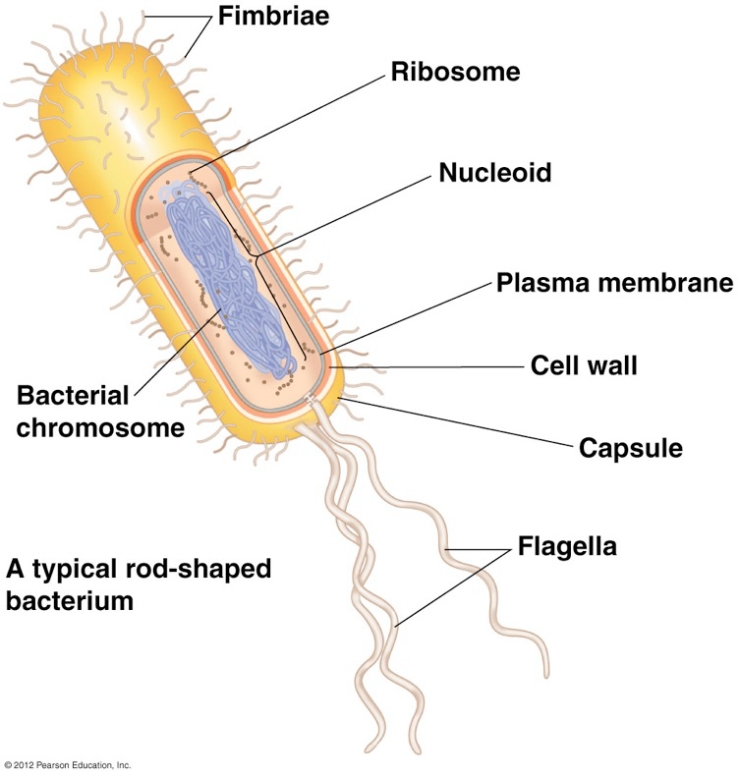

  - 3 domains
    - Achaea
    - Bacteria
    - Eukarkya
  - Common cell shape of prokaryotic cell
    - Cocci, singular is coccus
      - Spherical
      - Sometimes in chains or cluster
    - Bacilli
      - Rod shape
      - Often in single
      - Sometimes threadlike or filamentous
    - Spirilla
      - Spiral
      - Short and rigid
  - Near all of them have a cell wall
    - Provides physical protection
    - Prevents the cell from bursting in hypotonic environment
    - Divided into to groups, can be identified by Gram stain
      - Gram positive bacteria have
        - simpler wall with a thick layer of peptidoglycan
          - Polymer of sugars cross linked by short polypeptides
          - Stain purple
      - Gram negative bacteria have
        - less peptidoglycan
        - more complex
        - outer membrane contains lipids bonded to carbohydrates
        - stain pink
    - gram negative are more threating than gram positive
      - gram negative have
        - lipid molecules
        - outer membrane are
          - toxic
          - protect against body defence, making antibiotic entry harder
          - have LPS lipopolysaccharides
            - triggers immune system and induce fever
    - Capsule
      - Sticky layer of polysaccharide or protein
      - Enables cell to stick together to form colonies
      - Protects against attacks from host’s immune system
  - Projection
    - Flagella
      - Enables movement based on response to chemical or physical signals in environment
        - Also known as taxis
      - Can be all over body or at both/either ends of the cell
        - Prokaryotic flagellum is naked protein that lack microtubules
      - Fimbriae
        - Enables some to stick to surfaces or to each other
- A microscope would show the difference between a cooci that causes “straph” from “strep” by:
  - “straph” would be seen as a cluster
  - “strep” would be seen as a chain

  - High success is caused due to how fast they can reproduce in a favourable environment
  - Reproduce by binary fission
    - Spontaneous mutation happens every time the DNA is replicated right before binary fission
      - Leads to great genetic variation
    - DNA is usually a long, circular chromosomes
    - Plasmids
      - replicate separately
      - can/may carry genes important for survival and antibiotic resistance
    - Endospore
      - Thick protective coat that becomes dominate
      - Enables bacteria to survive in harsh conditions
      - When environment becomes stable again, water is absorbed and resumes growth
  - Nutrition
    - Phototrophs
      - Capture energy from sunlight
        - Some have thylakoid membranes where photosynthesis takes place
    - Chemotrophs
      - Harness energy found in chemicals either organic or inorganic
    - Autotrophic
      - Make own organic compound from inorganic sources
      - Autotrophs
        - Obtain carbon from CO₂
      - Heterotrophs
        - Get carbon from organic compounds of other organisms
  - Mode of nutrition
    - Describes how organism obtains energy and carbon
      - Photoautotrophs
        - Harness sunlight for energy and use CO₂
      - Photoheterotrophs
        - Obtain energy form the sun, but get carbon form other organisms
        - Found in aquatic sediment
      - Chemoautotrophs
        - Energy is from inorganic chemicals and get carbon from CO₂
        - found in place where conditions are extreme
      - Chemoheterotroph
        - Energy is form inorganic chemicals and carbon is form other organisms
        - Largest and diverse group
Nutritional Mode | Energy Source | Carbon Source
Photoautotrophs | Sunlight | CO₂
Chemoautotrophs | Inorganic Chemical | CO₂
Photoheterotrophs | Sunlight | Organic Compound
Chemoheterotroph | Organic Chemical | Organic Compound

  - Biofilms
    - Colony of specific bacteria
    - Can form on almost all surfaces
    - Gooey coating glues the bacteria, they glue to the surface and each other
    - Hard to take off because
      - Outer layer of cell prevent antimicrobial substance from getting into the centre
    - Used to clean contaminates in environment
    - Bioremediation
      - Uses organisms to remove pollutants from air, soil, or water
  - Prokaryotes are broken into two domains
    - Archeae
    - Bacteria
  - Some differences between the three domains are
    - Ribosomal RNA sequence
    - Cellular machinery for gene expression

Characteristic | Bacteria | Archea | Eukarya
rRNA sequence | Some unique to bacteria | Some unique to Archea, some match eukaryotic sequence | Some unique to Arche, some match Archea
RNA polymerase | One kind: relatively small and simple | Several kind; complex | Several kind; complex
Introns | Rare | In some | Present
Pedtidoglycan in cell wall | Present | None | None
Histones associated with DNA | None | In some | Present
- Archaea
  - Live in extreme environments
  - Have unusually proteins and other molecule adaptations that enable them to reproduce and metabolize effectively
  - Gropus
    - Extreme halophiles
      - Live in extremely salty places
    - Extreme thermophile
      - Live in very hot waters or acidic environments
      - Energy is obtained thru sulfolobus
        - Oxidizing sulphur
    - Methanogens
      - live in areas with little oxygen
      - release methane as waste
- Bacteria
  - Divide into five groups
    - Protepbacteria
      - Gram negative
      - Share a certain rRNA sequence
      - Includes
        - Bacteria that attack others
        - Symbiosis
          - Living within another
    - Gram Positive Bacteria
    - Cyanobacteria
      - Plantlike, oxygen generating photosynthesis
      - Makes large amounts of food for freshwater and marine ecosystem
    - Chlamydias
      - Live inside eukaryotic host cells
    - Spirochetes
      - Helical bacteria
      - Spiral through their environment
  - Pathogenic Bacteria
    - Cause illness by production of endotoxins and exotoxins
      - Exotoxins
        - Proteins secreted into the environment by bacteria
      - Endotoxins
        - Lipid components of the outer membrane of G-bacteria
  - Antibiotics
    - Organic molecules that inhibit or kills microbes by specific interaction with target
    - Most are produced by fungi and yeast
    - Bacteria are starting to become resistant to antibiotic
- 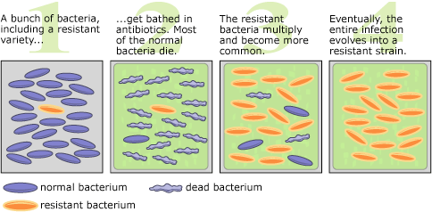

  - Superbugs
    - bacterial pathogens that are resistant to multiple drugs
- Protists
  - Mostly unicellular eukaryotes
  - Algae
    - are autotrophs
    - produce food by photosynthesises
    - many are multicellular
  - protozoans
    - heterotrophs
    - eat protists and bacteria
    - some absorb organic molecules
  - Parasites
    - Nutrition is obtained from living host
  - Mixotrophs
    - Capable of both photosynthesis and heterotrophy depending on amount of light and nutrients available
- 5 monophyletic “super groups”
  - Chromalveolata
    - Includes autotrophic, heterotrophic and mycotrophic both multicellular and unicellular
      - Diatoms
        - Unicellular alga
          - Unique glassy cell wall that has silica
        - Autotrophs
        - Primary producer in aquatic
        - Lipids are good source of energy for themselves, also used for buoyancy
        - Massive accumulation results in diatomaceous earth, used as grinding and polishing agent
      - Water mold (Oomycota)
        - Heterotrophic/parasitic
        - Typically decomposer of dead animals and plants in aquatics environments
    - Brown Algea aka Giant Kelp
      - Autotrophic
      - Largest and most complex protest
    - Dinoflagellates
      - Unicellular
      - Common component of marine and freshwater plankton
      - some causes “red tide”
        - toxins kill fish
      - some produces bioluminescence, supports marine environment ex. Coral reef
  - Beaver Feaver (Giardia)
    - Diplomands
    - Unicellular
    - Has flagellates
    - Parasitic
    - Lack mitochondria
  - Eulenozoans
    - Primary produces in freshwater ecosystem
    - Both autotroph and heterotroph
    - Movement by flagella
  - Amoebas
    - Single cell
    - Heterotroph
    - Some are parasitic
  - Rhizaria
    - Amoeba move and feed by pseudopodia
      - Temporary extension of cell
    - Foraminiferans
      - Found in both freshwater and ocean
      - Composed of organic material and harden by calcium carbonate
    - Radiolarians
      - Makes a mineralized support structure
- -Mineral compose forams test and radiolarian skeletons are
  - Forams
  - Calcium carbonate
  - Radiolarians
  - silica
    - Excavata
      - Mitochondria lack functional electron transport chains and use anaerobis pathways
    - Unikonta
      - Combines amoebozoaans, protest and animal and fungi
      - Plasmodial slime mold, common protists found where there is moisture, decaying material and are colourful
    - Archaeplatida
      - Autotrophic
      - Red Algae
        - Multicellular
      - Green Algae
        - Same photosynthic pigments as land plants
        - Fresh water environment
- Endosymbiosis
  - Chloroplast and mitochondria evolved from mall prokaryotic cell and were eaten by larger cell
  - Secondary endosymbiosis
    - Process in which autotrophic eukaryotic protest becomes endosymbiotic in heterotrophic eukaryotic protest
    - Key to protest diversity
  - Difference between secondary and primary endosymbiosis
    - Primary
      - Endosymbiont is prokaryote
    - Secondary
      - Endosymbiont is a eukaryote
- Multicellularity
  - Evolved independently three times
    - Chromalveolates (brown algea)
    - Unikonts (fungi and animals)
    - Archaeplastids (red and green algae)
- 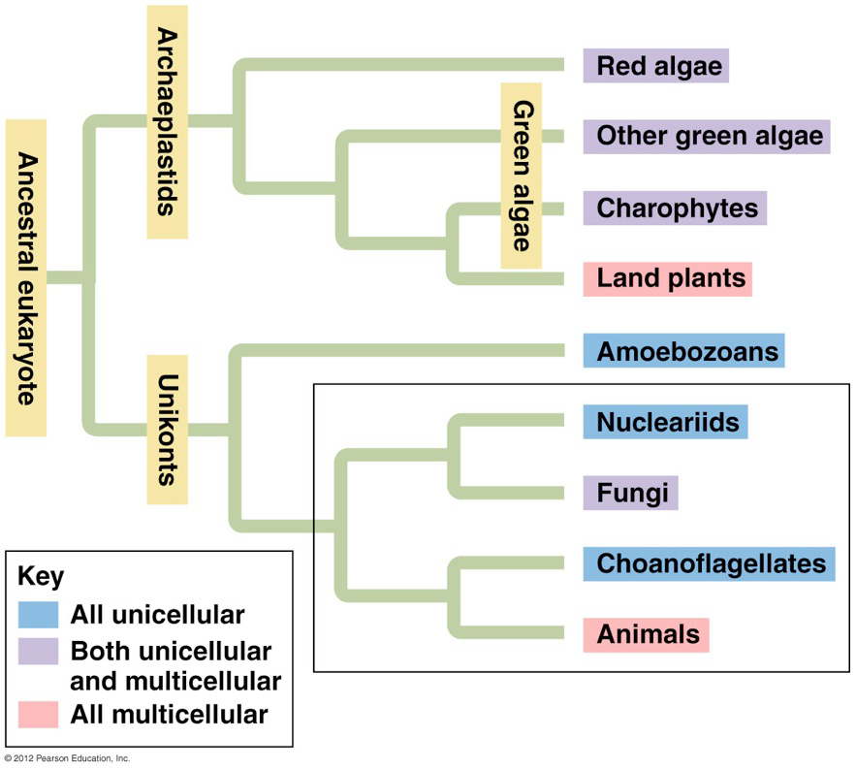

  - many of the adaptations the adaptions diverged from algae
    - the goal was for the features to survive and reproduce on dry land
  - Maintaining Moisture
    - covered with a waxy cuticle that prevents water loss
    - gas exchange takes place in the plant’s leaves thru stomata
      - usually open during the day/sunlight periods and closed at other times prevent water loss
  - Obtaining recourses from two places
    - Chemicals are obtained from both air and soil
    - Water and minerals are often found in soil
      - Apical meristems
        - Located at the tip of steam and roots
        - Grow longer max. exposure to resources in the air and soil
      - Vascular Tissue
        - Network of thick walled cell joined to a narrow tube, found all over the plant body
        - Two types
          - Xylem
            - Made up of dead cells that combine to form pipes
            - Convey water and minerals up from the roots
          - Phloem
            - Make up of living cells
            - Distributes sugars thru plant
        - Lignin
          - Chemical used to thicken and reinforce cell wall
          - Supports the plant body
        - Gametangia
          - Protective coat of cells surrounding gamete producing cell
            - Egg stays there and plants ex ferns have their sperm swim thru water
        - Pollen grain
          - Used/produced by pines and flowering pants
- Progress of terrestrial adaptation
  - Alga
    - Surrounded and supported by water
    - Whole thing performs photosynthesis
    - Absorbs water, CO2 and minerals form water
  - Moss
    - Stomata only on sporophytes
    - Primitive roots are anchored to planet
    - No lignin
    - No vascular tissue
    - Moisture is need for fertilization
  - Fern
    - Stomata
    - Roots anchor plants
    - Water absorption takes place
    - Lignified cell walls
    - Vascular tissue
    - Moisture is need for fertilization
  - Pine trees
    - Stomata
    - Plants are anchored by roots
    - Absorbs water
    - Lignified cell walls
    - Vascular tissue
    - Fertilization does not need water
- Adaptation that enables plant to grow tall
  - Vascular tissue transport material from the ground to higher parts and waste going from the top to the bottom, cell wall also provides structural support
- Major events in plant kingdom
  - Diversity of seedless, nonvascular plants called bryophytes
    - Lack true roots, lignified cell wall and leaves but have apical meristems and embryos that stay on parent plant
      - Ex. Moss, Liverwort, Hornwort
  - Vascular plant
    - had harden lignified vascular tissue = strong support
    - known as seedless vascular plants
      - offspring are disputed by spores
      - ex.
        - Ferns, club moss
  - Vascular Plants with seeds
    - Seed consist of embryo package with food and protection
    - This adaptation improved ability of plants to diversify
    - Gymnosperm
      - Were seen as naked seeds because they were not make in specialized chambers
    - Flowering plants called angiosperm is the most recent addition
    - Four adaptations for life on land
      - Dependent embryo is present in all plants
      - Lignified vascular tissue
      - Seeds
      - Flowering plants

An embryo retained on parent plant is common in all plants

Plant Life Cycle
  - Plants have alternation of generation
    - Diploid and haploid stages are distinct
    - Haploid generation produces gametophyte, plant gametes
    - Diploid generation produces sporophyte => spore
    - Both generation are alternated in production
    - Sperm and egg is produced by mitosis
    - Spores are produced by meiosis
- Gamete production in plants vs animals
  - Animal gamete is produced by meiosis
  - Plant gamete is produced by mitosis
- Moss Life cycle
  - Dominated by gametophyte
    - Gametes develop in male and female gametangia
      - Sperm is released and often swim to egg in female
    - Zygote remains in the gametangium
    - Divides by mitosis and develops to sporophyte embryo then matures
    - Meiosis takes place, haploid spore is released dome sporangium
    - Spores undergo mitosis and develop into gametophyte plant
- Fern Life Cycle
  - Dominated by sporophyte
    - Sperm is required to reach egg, various mechanism take place to encourage cross fertilization
    - Zygote develops into sporophyte
    - Gametophyte dies and sporophyte becomes it’s own plant
    - Black dots are cluster of sporangia which undergo meiosis and produce haploid spores, which are released and develop into gametophytes by mitosis

  - gymnosperms in pines are called pines
  - ovulate cone is larger than pollen cone, pair of ovules contain sporangium
  - pollution happens when pollen lands on ovulate scale and enters ovule
  - one surviving haploid develops into female gametophyte, makes eggs
  - sperm is released
  - all eggs are fertilized but only one zygote develops into sporophyte embryo
  - ovule matures into a seed, that feeds embryo and has a tough seed coat
  - wind carries and separate the seed which wait until conditions are favourable to grow
- Flowering plant
  - Female parts are carpel and ovule, used to make and house eggs
  - Male parts are stamen, catches sperm

- Fungi
  - Heterotrophs, obtains food by absorption
  - Most are decomposers/heterotrophic
    - Powerful enzymes digest macromolecules into monomers which are absorbed into their cells
  - Saprothroph
    - Get C form not living material
  - Symbionts, obtain C form living tissue
    - Some are parasites
    - Others work along side plants roots this is called mycorrhiza
  - Feeding structure is a network of thread like filaments called hyphae
    - Hyphae grow to create mass know as mycelium “umbrella”
  - Most cells walls are made of chitin
  - Mycelium compensate for the lack of movement
    - Hyphae extends into new territories
      - Grows longer without growing thicker

- 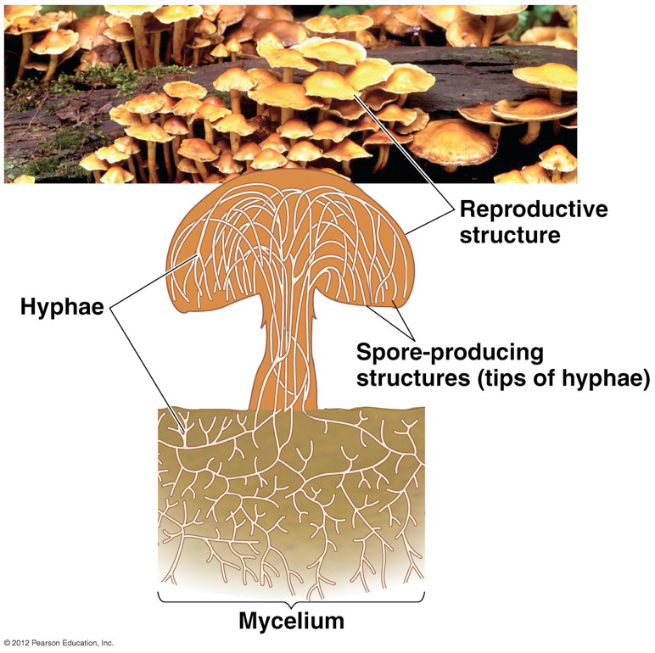

  - Five Groups of Fungi
    - Chytrids
      - Flagellated spores
      - Some are decomposers others are parasitize
    - Zygomycetes
      - Zygote fungi
      - Has protective zygosporangium
        - Ex. Molds that rot produce
    - Glomeomycetes
      - Found in plant roots
      - Symbiotic partnership between fungi and plant is common
    - Ascomycetes
      - Sac fungi
    - Basidiomycetes
      - Club fungi
      - Mainly decomposers

- Animals
  - Multicellular
  - Heterotrophic eukaryotes
  - Obtain nutrition by ingestion (few exception)
    - Ingestion means eating food
  - Food is digested within the body
    - Dead or alive
    - Part by part or whole
  - Cells with distinctive structure and specialization
  - Lack cell wall but has extracellular structure of protein
  - Collagen, type of intercellular junction
  - Transformation of zygote into adult is controlled by cluster of homeotic genes
- List distinguishing characteristics of animals
  - Body composed if multiple eukaryotic cells
  - Ingestion of food
  - No cell wall
  - Unique cell junction
  - Nerve and embryonic stages
  - Unique developmental genes
  - Gametes alone represent the haploid stages of life cycle

  - Invertebrates lack a vertebral column
  - Diversity of animals is described by using “body plan”
    - Radial symmetry
      - A top and bottom
      - Typically sedentary of passive drifting
      - Meets environment equally on all sides

- 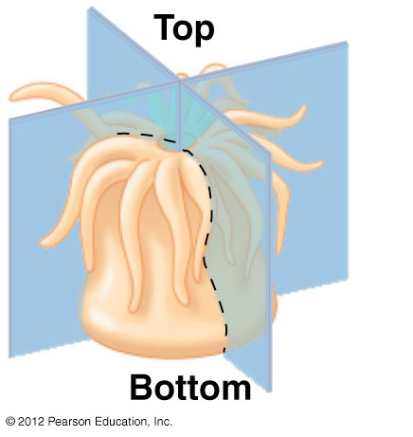
  - central axis divides animal into mirror image
    - Bilateral Symmetry
      - Mirror image right and left sides
      - Distinct head or anterior, end or tail or posterior, back or dorsal ,surface and a bottom or ventral surface
      - Mouth, brain, sensory organ are located in the head
      - Allows movement based on arrangement
      - Travels head first through environment
      - Eyes and other sensory organs contact environment first
- 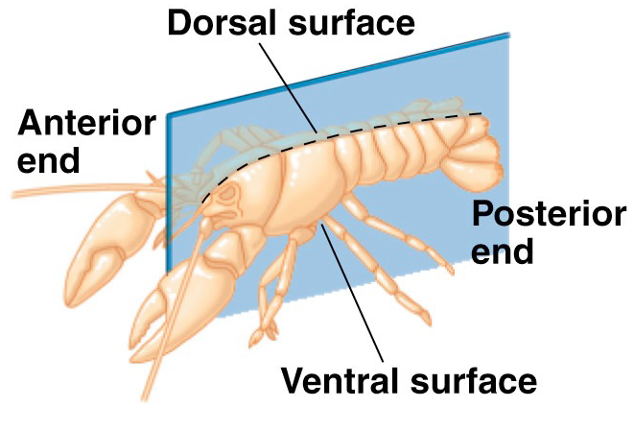

  - tissue is made up of specialized cell and are isolated from others by membrane layers that perform specific functions
  - some have embryo’s only have ectoderm and endoderm
    - most had mesoderm, resulting with three tissue layers

presence of body cavity, is also used to classify organisms
  - space is filled with a fluid that acts as a cushion and enables growth and independent movement of body wall
    - ectoderm (blue)
    - mesoderm (red)
    - endoderm (yellow)

  - True Coelom (Segmented worm)
    - lined by tissue derived from mesoderm
- 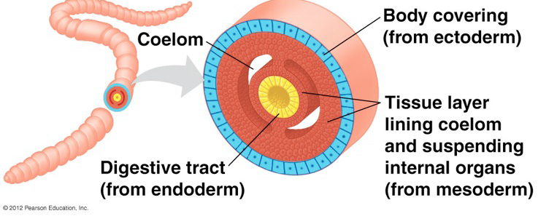

  - Pseudocoelom (Round worm)
    - not completely lined with tissue derived form mesoderm
- 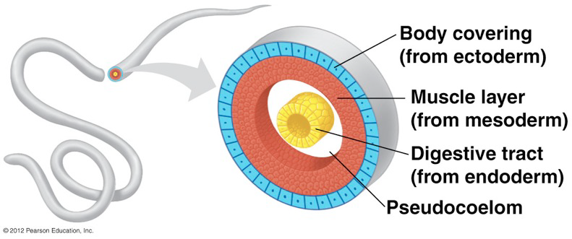

  - Pseudocoelom (Flat worm)
    - No body cavity
    - Lacks coelom

- 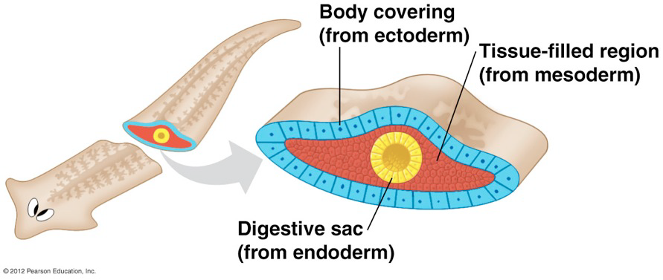

  - protostomes
    - opening that becomes the mouth is developed first s
  - deuterostomes
    - opening that becomes the anus is developed before the mouth

Four features used to describe animals body plan
  - symmetry
  - number of embryonic tissue layers
  - body cavity type
  - pattern of embryonic development

- 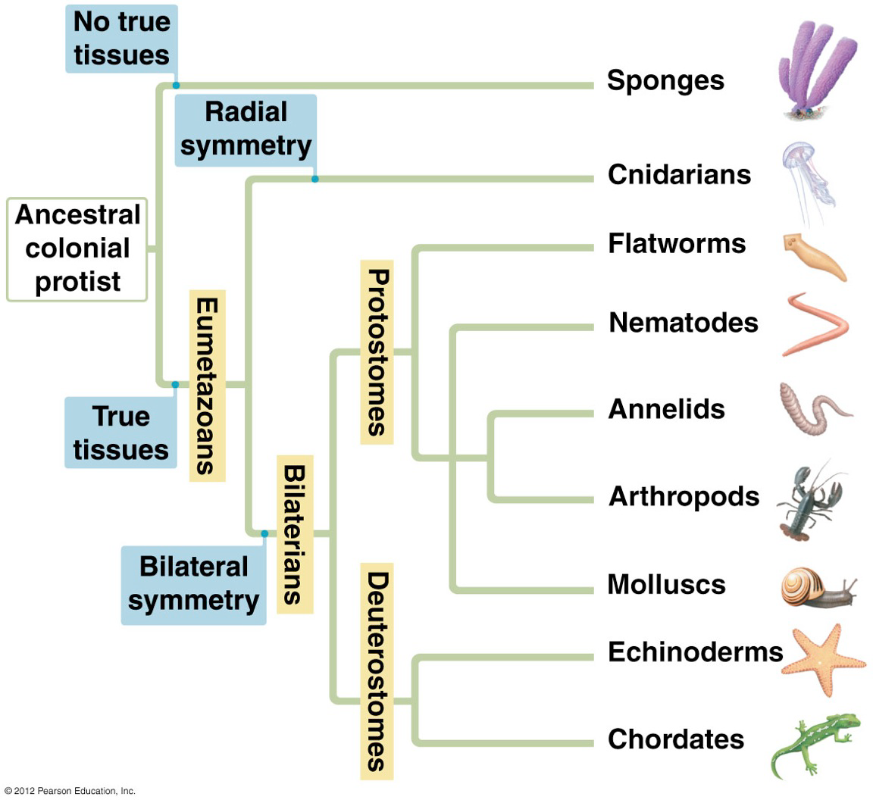
  - first clade of true animals, called eumtazoans
    - have true tissues
  - Second clade of animal symmetry, called bilaterians
    - bilateral vs. radial
  - Second clade is based on embryology
    - Deuterostomes vs. protostomes
- Sponges
  - Simplest animals
  - No nerves or muscles
  - Individual cells can sense and react to environmental changes
  - Lack body symmetry
  - Water enters through pores into one central cavity then flows out of larger opening
  - Inner cell layer consist of “collar” cells called choanocytes
  - Suspension feeders
  - Adult sponges are sessile
    - Anchored to a spot and cannot escape predators
    - Produces toxins to protect itself
- Sponges represent the earliest branch of the animal kingdom because…
  - They lack true tissue
  - Resemble flagellated protisit

- Cnidarians
  - Jellyfish, hydras, anemones, coral (predators)
  - Radical symmetry
  - Two layers of tissue
    - Outer epidermis and inner cell layer that lines digestive
  - Polyps are stationary
    - Cylindrical body with tentacle projection from other end
    - Example; hydras
  - Medusa are free moving
    - Have tentacles
    - Umbrella shaped
  - Gastrovascular Cavity
    - Multifunctional compartmental
      - Mouth is the only opening
      - 3 main functions
        - circulation
          - transport of
            - oxygen
            - nutrition
            - waste
        - digestion
        - structure support and shape
  - Cnidocyts
    - Are specialized stinging cells
      - Functions
        - Defense
        - Capturing prey
- Flatworm
  - Protostomes
  - Bilateral symmetry
  - Three embryonic tissue layer
  - Simplest if bilaterians
  - Three major groups
    - Planarians
      - Free living flatworm
        - Light sensitive eyecups and flaps to detect chemical changes
        - Mouth is located mid ventricle
        - Use cilia to move/crawl
        - Able to twist and turn
    - Flukes
      - Live parasites in living animals
      - Life cycle is mostly in a living host
    - Tapeworm
      - Live in animal digestive tracts
      - Very long, ribbonlike body
      - No mouth
      - Absorb nutrition across body surface
      - No digestive tract
  - Many are parasitic
  - Live in marine, freshwater and
- Flatworm and cnidarians differ in symmetry with flatworms being bilateral and cnidarians being radial but both have a gastrovascular cavity

- Nematodes
  - Roundworms
  - Fluid filled cavity
  - Digestive tract with two openings
  - Not segmented
  - Cuticle
    - All over body
    - Prevents the body from drying up
  - Has complete digestive system
    - Tube extends from mouth to anus
    - Food travels one way
- Molluscs
  - Soft body protected by hard shell
  - Three main parts
    - Foot
      - For locomotion
    - Visceral mass
      - Most of internal organs
    - Mantel
      - Secretes shell
  - Has circulatory system
    - Pumps blood and distributes nutrients and oxygen through the body
  - Three groups
    - Gastropods
      - Snails
      - Slugs
    - Bivalves
      - Clams
      - Scallops
      - Oysters
    - Cephalopods
      - Squids
      - octopuses
  - Gastropods
    - Protected by shell
    - Eyes located at the tip of tentacle
    - Land snails lack guilds but instead have mantel cavity for gas exchange
    - Slugs lack shell and mantle
  - Bivalves
    - Shell that are divided into two halves, hanged together
    - Most are suspended feeders
    - Mantel cavity is sued for feeding and gas exchange
    - Mucus coated gills trap food, cilia swipe particles into mouth
    - Scallop have eyes
  - Cephalopods
    - Fast agile predator
    - Smartest, big brain and complex sensory system
- Annelids
  - Segmented worms
    - Earthworms, leeches, tube dwelling worms
  - Segmentation
    - Allows greater flexibility and mobility
  - Earthworm
    - Close circulatory system with haemoglobin
    - Well developed nervous system
    - Hermaphrodite
  - Polychates
    - Live in tubes and extend feathery appendages coated mucus

that traps suspended food particles
  - Leeches
    - Blood sucking habits
- Arthropods
  - Hard exoskeleton
    - Made of chitin
    - External skeleton protects animal and provides points of attachment
  - Joined appendages
  - Molting
    - Process at which old shell is shaded off and replaced by another
  - Open circulatory system
- Chelicerates
  - Spiders
  - Scorpions
  - Chelicerate
    - Fanglike structure used to bite prey
  - Body segmented in two
    - Cephalothorax
    - Abdomen
    - Four pairs of walking legs
    - Modified legs
      - Pedipalps or claws
    - Feeds on liquid
    - Spiders and scorpions are predators
- Millipedes & Centipedes
  - Segmented body
    - Each with one or two pairs of legs
  - Millipedes
    - Herbivores or scavengers
  - Centipedes
    - Pair of poisonous claws used to paralyze prey
- Insects
  - Only flying invertebrates
  - Body segments
    - Head
    - Throax
    - Abdomen
  - 3 pairs of legs
  - Tracheal system used for gas exchange
- List characteristics that arthropods have in common
  - Segmentation
  - Exoskeleton
  - Specialized joint appendages
- Echinoderm
  - Sea stars, sea urchins, sea cucumbers
  - Larva are bilateral
  - Radial system is present in later development
  - Tube feet function in locomotion, feeding and gas exchange
- Chordates
  - Evolved from invertebrate
  - shares features with members of Chordata
    - dorsal hallow nerve chord
    - notochord
    - pharyngeal slits
    - post anal tail
- 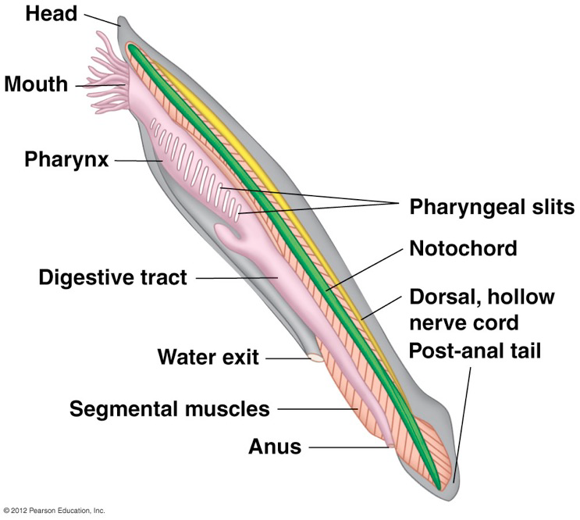

  - all chordates with a head is called crainates
  - vertebrate
    - more extensive skull and backbone or vertebral column
    - composed of a series of bones called vertebrate
    - encloses main part of nervous system

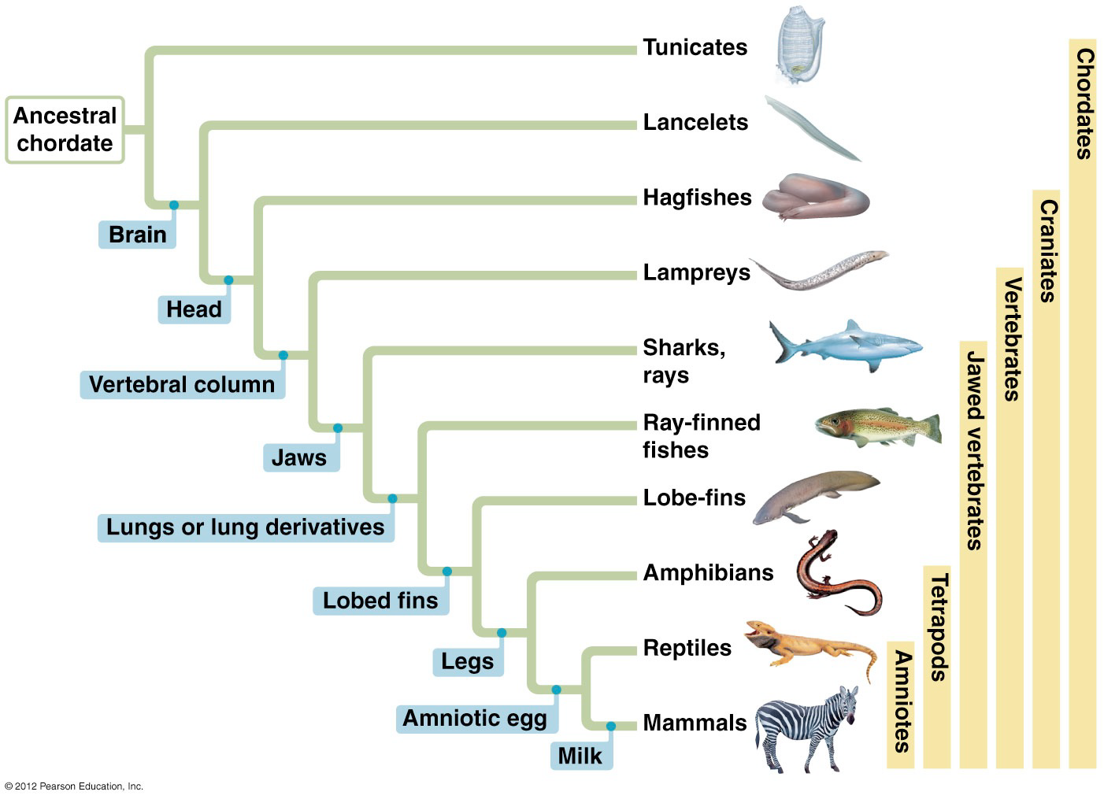
  - list hierarchy of clades to which mammals belong to
    - chordates
    - craniates
    - vertebrates
    - jawed vertebrate
    - tetrapod
    - amniotes
- Hagfishes and Lampreys
  - Lampreys are vertebrates, hagfishes are not
    - Cartilaginous skeleton
    - Scalesless skin
    - Slime is used as defesene
  - Neither have a jaw
  - Lamperys are oldest living lineage of vertebrate
    - Most are parasites
    - Oral disk
    - Cartilaginous skeleton
    - Scalesless skin

Jawed vertebrate
- 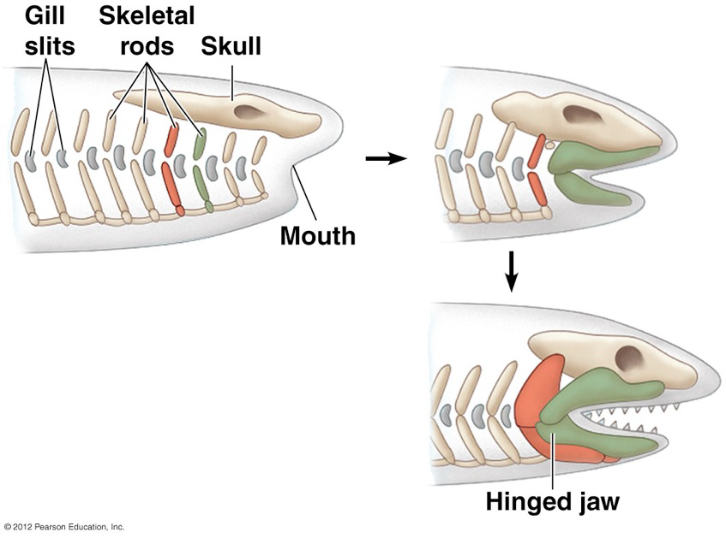
  - jaws evolved from paired gill, which main function was to trap suspended food particles
- Chondrichthyans
  - Sharks and rays
    - Flexible skeleton made of cartilage
  - Shark
    - largest suspended feeders, some are predators
    - sharp vision
    - keen sense of smell
    - has electrosensors that pick muscle contractions
    - lateral line sensory
      - found along each side and sensitive to changes in water pressure and vibrations caused by fish swimming by
    - has to keep swimming or will die, no air
  - Ray
    - Live on ocean floor
- Ray Finned Fish
  - Tuna, trout, goldfish
    - Bone cartilage reinforced with calcium phosphate
    - Operculum
      - Protective flap that houses gills
      - Enables fish to breath without moving
    - Swim bladder
      - Gas filled sac that keeps them buoyant
- Lobe finned Fish
  - Relatives to tetrapod
  - Coelacanth & lungfish

- Form fin to feet
- 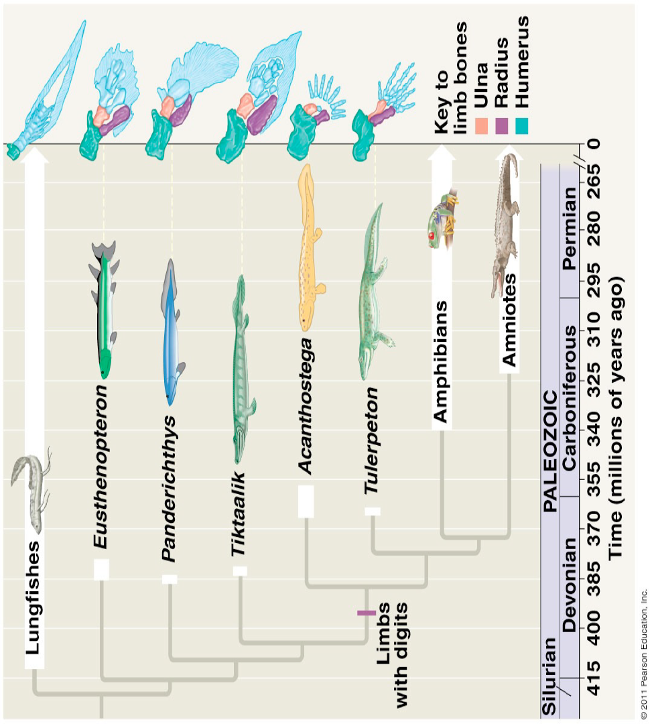
- Amphibians
  - Live on both land and water
  - Frogs, salamanders, caecilians
  - Scaleless skin
  - Moist skin used for gas exchange
  - Poison glands used for defense
  - Eggs are surrounded by jelly like material
  - Larval stages tend to be spent in water
  - Fist vertebrate to colonize on land
- Amniotes
  - Separated amphibians from reptile, and mammals
  - Amniotic eggs
    - Fluid filled sac surrounding embryo
- 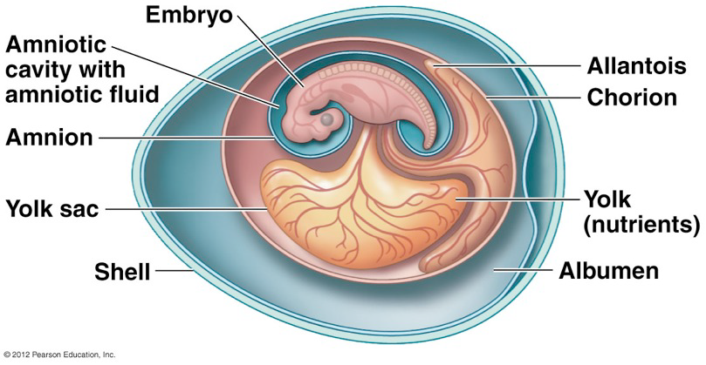
  - allantois
    - waste disposal
    - respiration
  - Amnio
    - Protection against shocks
  - Chorion
    - Respiration
  - Yolk
    - Sac nutrition
- Reptile
  - Snake, birds, turtles, crocodiles
  - Snakes
    - limbless
    - adaption for the borrowing life
    - reptilian skin
    - waterproof scales, with protein keratin
      - prevents body from drying out
    - cold blooded
      - metabolism cannot be used to produce body heat
    - ectothermic
      - absorb external heat rather than generate it
- Birds
  - Many features reduce weight for flight
    - Lack teeth
    - Feathers are made of hallow shafts
    - Bones are honeycombed structure
      - Strong but light
    - No urinary bladder
    - One ovary
    - Four chambred heart
    - High rate of metabolism
    - Lack teeth
    - Complex social behaviour
    - Endothermic
      - Heat is generated by metabolism to maintain body temp
    - Feathers
      - Acts as insulator
    - Lungs
      - Effective in extracting oxygen from air
    - Excellent eye sight
  - Feathers evolved before flight
    - Primarily for heat
- Mammals
  - Hair
    - Provides insulation to maintain body heat
  - Milk gland aka mammary glands
  - Endothermic
  - Living bearing
    - Placenta
      - Nutrients transfer between baby and mother
      - Nutrients from blood diffuse out of mothers blood into embryo
  - Monotrems
    - Egg laying mammals
  - Marsupials
    - Pouch mammals
  - Eutherians
    - Placental mammals
- Primates
  - Grasping hands
  - Binocular vision
  - Lineages leading to humans and chimps

Anthropoids
  - Greek anthropos = man and eidos = form
    - Includes monkey and aps
  - Diverged from other primates 50 million years ago
  - Have fully opposable thumbs
    - Can touch all 4 fingers with thumb
- New World Monkey
  - Found in Central and South America
  - Nostrils are wide open and far apart
- Old World Monkey
  - Lack prehensile tail
  - Nostrils open downwards
- Apes
  - Lack a tail
  - Long legs, short arms
  - High degree of social organization
- Chimpanzees
  - Resemble human behaviour
  - Human and chimpanzees genomes are 99% identical
  - Last common ancestor was between 5-7 million years ago
- Five groups of apes within anthropoid category
  - Gibbons
  - Orangutans
  - Gorillas
  - Chimps
  - Humans

- Hominins
  - Primates that relate more to humans than to chimps
- Paleanthropology
  - Study of human origins and evolution
- Oldest hominin discovered is Sahelanthrpus tchadensis about 7-6 million years ago

- Difference between humans and chimpanzees
  - Humans are
    - bipedal (walk upright)
    - larger rain
    - other adaptations come later because hominin intelligence
- Bipedalism
  - Is identified by location of opening in skull base, place where spinal chord exits
  - Chimpanzees
    - Primarily quadrupeds
      - Spinal chord exits thru back of skull, allows eyes to face forward
  - Human
    - Bipeds
    - Spinal chord comes from floor of braincase
    - Head is held directly over the body
- A.aferensis
  - have both ape and human characteristics
  - have small brain, walk on two legs
  - more like apes than humans
  - proportions are the opposite to humans
- Ecology
  - Study of interaction if organism with the environment
  - Describe the distribution and abundance of organism

Variables are grouped into two types
  - Biotic Factors
    - All organisms in the area
    - Living components of environment
  - Abiotic Factor
    - Nonliving components
    - Physical and chemical and chemical factors
      - Ex. Temptature
      - Forms of energy
      - Water
      - Nutrients
  - Habitat
    - Specific environment lived in
    - Made up of abiotic and biotic factors in surrounding
- Several Levels
  - Organism
    - Interaction between one organisms and opportunities and challenges faced in its environment
  - Population
    - Group of same species living in a geographic area
  - Community
    - A collection of population living close together for interaction
    - Main focus is interspecies interactions
  - Ecosystem
    - Both abiotic and biotic components of environment
    - Looks at chemical cycle and how energy flows between organisms and surroundings
  - Landscapes
    - Looks at array of ecosystem
- Energy Sources
  - Everything requires a source of energy
  - Solar energy is captured during process of photosynthesis
  - Underwater organisms obtain

