Total marks = 63

Q.1 (2*4 marks=8 marks)

Q.2 (5*4marks=20 marks)

Ans.
- Oil supply disruption from the Middle East decreases the supply of raw materials, which increases the world relative supply. The world relative supply curve shifts out, decreasing the world relative price of manufactured goods and deteriorating Japan’s terms of trade.

- Korea’s increased automobile production increases the supply of manufactures, which increases the world RS. The world relative supply curve shifts out, decreasing the world relative price of manufactured goods and deteriorating Japan’s terms of trade.

- U.S. development of a substitute for fossil fuel decreases the demand for raw
materials. This increases world RD, and the world relative demand curve shifts out, increasing the world relative price of manufactured goods and improving Japan’s terms of trade. This occurs even if no fusion reactors are installed in Japan since world demand for raw materials falls.

- A harvest failure in Russia decreases the supply of raw materials, which increases the world RS. The world relative supply curve shifts out. Also, Russia’s demand for manufactures decreases, which reduces world demand so that the world relative demand curve shifts in. These forces decrease the world relative price of manufactured goods and deteriorate Japan’s terms of trade.

- A reduction in Japan’s tariff on raw materials will raise its internal relative price of manufactures. This price change will increase Japan’s RS and decrease Japan’s RD, which increases the world RS and decreases the world RD (i.e., world RS shifts out and world RD shifts in). The world relative price of manufactures declines and Japan’s terms of trade deteriorate.

Q.3 (2 marks) Why are factor prices so similar in the U.S. and Canada?
- Factor prices in the U.S. and Canada are similar because U.S. and Canadian factor endowments are very similar.

Q.4 (4 marks)

- As trade opens up between countries, the price paid to the abundant factor of production rises, and the price paid to the scarce factor of production falls. If we assume that labor and capital remain fully employed both before and after trade, the real income of labor and capital moves in the same direction as factor prices.

- International trade has discernible effects on the distribution of income. This effect is known as the Stolper-Samuelson theorem, and states that the abundant factor tends to receive a larger share of national income and the scarce factor tends to receive a smaller share of national income.

Q.5: (6 marks)
Ans.
For example, assume that one U.S. worker can produce either 5 machines or 15 yards of cloth per day, and one Indian worker can produce 1 machine or 5 yards of cloth per day. Comparing the two countries, the U.S. has an absolute advantage in the production of both machines and cloth, and India as an absolute disadvantage in the production of machines and cloth. That is, U.S. workers can produce more machines and more yards of cloth than workers in India. In this example, India’s absolute disadvantage is smaller in producing cloth than in producing machines. Using Ricardo’s logic, when compared to the U.S., India has a comparative advantage in cloth because its degree of absolute disadvantage is lower, and a comparative disadvantage in machines because its degree of absolute disadvantage is higher.

Q.6:
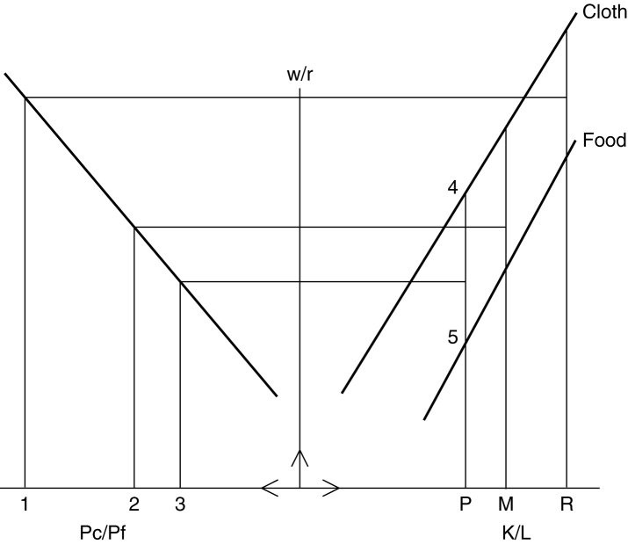

(4*1.5 marks=6 marks
Ans.
- You will find Sri-Lanka to the left of Australia on the K/L axis.
- Australia has a higher relative wage.
- Cloth is labor intensive and Food is the capital intensive product.
- The relative price PC/PF is found between the two price before trade opens (i.e. between points 2 & 3).
Q. 7: (4*1.5 marks=6 marks)
Answer:
- The proportion of food to cloth will increase in the production of Australia.
- Sri Lanka will export cloth.
- The relative (and real) incomes of workers will fall in Australia as a result of trade (Note: this explanation is not required: more production of food, which is capital intensive. Less production of cloth, which is labour intensive, resulting in unemployment of labour).
- Capital Owners in Australia should lobby in favor of trade, because they would export more food. (Note: this explanation is not required: More import of cloth would make cloth cheaper while international demand for food will raise their export price.)

Q.8: (6 marks) Use the information in the table below to answer the following questions.

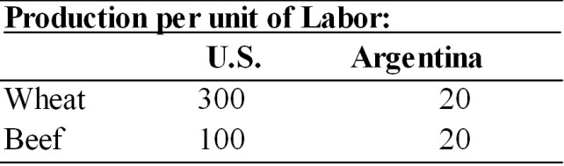

Answer:
- The U.S. has an absolute advantage in the production of both wheat and beef because labor productivity in the U.S. exceeds labor productivity in Argentina for both products.
- In the U.S., the opportunity cost of wheat is 100/300 or 0.33 units of beef. In Argentina, the opportunity cost of wheat is 20/20 or 1.0 unit of beef.
- The U.S. has a comparative advantage in wheat production and Argentina has a comparative advantage in beef production. If the U.S. can trade wheat to Argentina at a rate of more than 0.33 units of beef per unit of wheat, then the U.S. will benefit. If Argentina can trade beef to the U.S. at a rate of more than one unit of wheat per unit of beef, then Argentina will benefit.

Q. 9: (5 marks)
Answer:
In the two-good-two-country version of the Ricardian model, comparative advantage is totally determined by physical productivity ratios. Changes in wage rates in either country do not change physically determined comparative advantages, and therefore cannot affect which product will be exported by which country.

However, when there are more than two goods in the two-country model, changes in wage rates in one or the other country can in fact determine which good or goods each of the countries will export. The physical productivity definition of comparative advantage employed in the two-good model becomes ambiguous. Instead, changes in relative wage rates will alter international competitiveness along the "chain of comparative advantage."

