Sociology 1001C Mid-term Review

Outline:
- Students will have a selection of essay questions in which they are to write 2 essays. The breakdown is as follows:
- 17.5 marks per question, for a total of 35 marks.
- Introduction 3.5 marks
- Body of evidence 10.5 marks
- Conclusion 3.5 mark

Chapter 1 BRYM, LIE & RYTINA

Theories and theorist
Emile Durkheim (1858-1917)
- Functionalism( macro)
  - Human behavior is governed by stable social structures. Underlines how social structures maintain or undermines social solidarity, emphasizes that social structures are based mainly on shared values or preferences.
  - Leads to a meritocracy based on ability
  - Inequality is inevitable and desirable
    - Dysfunctional consequences: effects of social structures that creates social instability.
    - Manifest functions: visible& intended effects of social structures
    - Latent functions: invisible & unintended effects of social structures
  - Functionalism: How is social order supported by macrostructures?

- Social solidarity
  - Defined as (1) the degree to which group members share beliefs & values and (2) the intensity & frequency of their interaction
  - Society is held together by mechanical solidarity (social/ moral consensus) and organic solidarity (dependency of roles among people)
  - Durkheim expected high solidarity groups to have lower suicide rates than low solidarity groups did : married (low), unmarried (high), reason why because marriage creates social ties, women(low), men (high), because women are more involved in the inmate social relations of family life
  - Suicide varies with the degree of interaction of the social groups of which form an individual
  - Social structures: the relatively stable patterns of social relations
Karl Marx (1811-1883)

- Conflict theory(macro)
  - Focuses on large macro level structures & shows how major patterns of inequality in society produce social stability in some circumstance and social change in others
  - Inequality results from power groups dominating other groups
  - Those in power repress powerless to maintain the status quo
  - The means of production/economic sectors is most important in society
    - Class conflict: the struggle between classes to resist & overcome the opposition of other classes
    - Workers would become aware of belonging to the same exploited class
    - C. Wright Mils- “ the power of Elite”, he argued that power is highly concentrated in American society which is therefore less of a democracy than we are often led to believe
Max Weber, George Herbert Mead, Erving Goffman
- Symbolic Interactionism
  - Focuses on interaction in micro level social settings & emphasizes that an adequate explanation of social behavior requires understanding the subjective meanings people attach to their social circumstances
  - MEAD: University of Chicago, gave birth to symbolic interactionism in America
  - GOFFMAN: Compared social interaction to a carefully staged play, a person age, gender, race & other characteristics may help shape his/her actions. Symbolic interactionists validate popular & unofficial view points. This increases our understanding & tolerance of people who may be different from us
  - WEBER: created the “protestant ethic” which he believed that religious doubts can be reduced, and a state of grace ensured, if people work diligently& live ascetically. Had an unintended effect of increasing savings and investment and thus stimulating capitalist growth
    - Occupational groups stabilized society because they enjoy higher status and income than do manual workers
- Feminist Theory
  - Claims that patriarchy is at least as important as class inequality in determining a person opportunities in life. It holds that male domination & female subordination are determined not by biological necessity but by structures of power & social convention. Examines the operation of patriarchy in both micro & macro settings, it contends that existing patterns of gender inequality can & should be changed for the benefit of society
  - HARRIET MARTINEAU:
    - 1st female sociologist, 1st feminist
  - JANE ADAMS
    - Co-founder of hull house, was denied to become professor of sociology

Lecture 2- Social Institutions

What holds society together?
- Societies develop stable and reasonable consistent cultural and structural configurations to resolve recurrent problems
  - Social Cohesion--the degree to which members of a society feel united by shared values and other social bonds
    - Durkheim
  - Mechanical Solidarity
    - Performing similar tasks develops a shared consciousness
  - Organic Solidarity
    - Shared consciousness as a result of the division of labor
  - Groups: Primary, Secondary, in/out groups
    - Primary group- a small social group whose members share personal and enduring relationships.
      - Function
      - Socializing agent to acquire beliefs and attitudes.
      - Personal satisfaction or sense of well-being.
    - Instrument of social control.
    - Secondary group- A large and impersonal social group whose members pursue specific interests or activities.
      - Weak emotional ties, formal impersonal group, developed in work place
      - People make use of 2nd groups to carve out a niche in the larger social world
  - The family is a social institution that unites individuals into cooperative groups that oversee the bearing and raising of children.
  - Norms, values, statuses, and roles develop around a basic social goal- socialization and reproduction.
  - Family groups are composed of people who interact with each other in terms of their ascribed and achieved statuses
  - Leadership
    - Instrumental leadership- a group leadership that emphasizes the completion of tasks.
    - Expressive leadership- focuses on collective well-being.
  - In-group- refers to any group or category to which people feel they belong.
  - Out-group- refers to a group or category to which people feel they do not belong.
  - Roles- behaviour expected of someone who holds a particular status.
  - Role set- a number of roles attached to a single status.
  - Role conflict- an incompatibility among roles corresponding to two or more statuses.
  - Role strain- incompatibility among roles corresponding to a single status.
  - 4 Elements of Kingship
    - Property holding & inheritance (bilateral)
    - Housing & Residential proximity (neolocal)
    - Obligation to help
    - Affection

Lecture 3- Sociology applied levels of analyses

- 3 major research designs
  - Surveys- (qualitative) interview or questionnaire that provide info concerning how people think & act. Attitudes, opinions, reports of behaviour.
  - Qualitative interviews- ‘Structured conversation’
  - Interview schedule
  - Feminist perspectives
  - Highly descriptive analysis, but not always viewed as objective by more conventional researchers
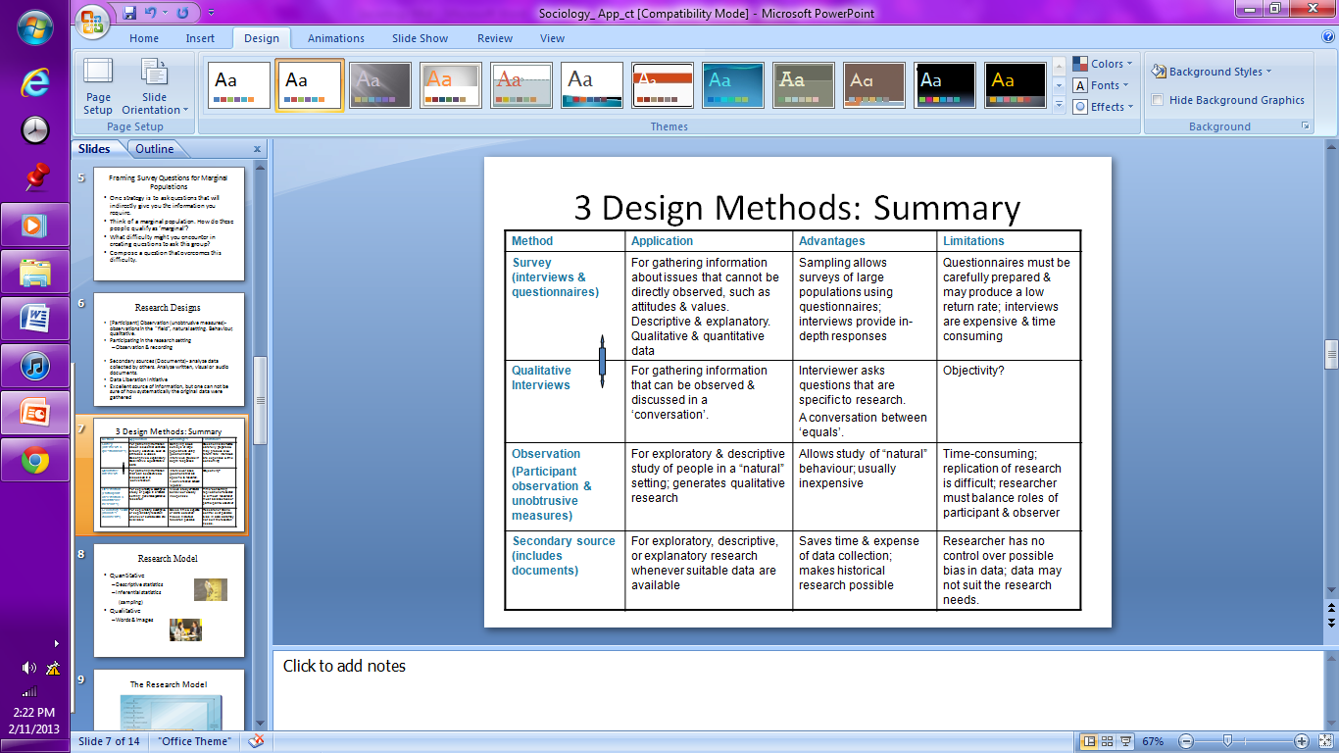
The Hawthorne Effect

Example: The Humphreys Research (1970, 1971, 1975) -Tearoom Trade & sociological snooping

