Chapter 12:

Freud’s
    - Sex and Aggression, Anxiety, Defense Mechanisms
- Reaction formation- a person preforming in the exact opposite way or display the exact opposite emotion or thoughts to someone. Example: You are very attracted to someone but instead of showing your emotion, you ignore them
- Rationalize: Why you would or would not skip class

- Sexual = physical pleasure
  - Five stages of personality development
  - Each associated with an erogenous zone
  - Getting stuck in one stage: Very bad
Freud’s Psychosexual stages
- Oral- Ages 0-1. Mouth (sucking and bighting) – Wearing from breast or bottle
- Anal- 2-3. Anus (expelling or retaining feces)- toilet training
- Phallic- Genitals (masturbating)- Identifying with adult or role models, coping with Oedipal crisis
- Latency- None (Sexually repressed). Expanding social contracts
- Genital- Genitals (being sexually intimate) Establishing intimate relationships, contributing to society through working

- Reaction formation- a person preforming in the exact opposite way or display the exact opposite emotion or thoughts to someone. Example: You are very attracted to someone but instead of showing your emotion, you ignore them
- Rationalize: Why you would or would not skip class
- Identification- people form real or imaginary bonds with people or groups of people, recognize they don’t really have an identify and see appealing traits of people in a group and join it
- Sublimation: Channeling, rerouting, socially unacceptable, actual, artistic unacceptable behaviors into more acceptable ones. Example: Someone who is aggressive goes into teaching marshal arts’ channeling that non-socially expectable behavior into acceptable ones

Freud’s Psychodynamic approach:
1. Unconscious forces can influence behavior
2. Internal conflict often plays a key role in generating psychological distress
3. Early childhood experiences can have powerful influences on adult personality
4. People do use defense mechanisms to reduce their experience of unpleasant emotions
If something is not observable, they do not exist

Carl Jung
  - Analytical Psychology
    - Personal and collective unconscious
    - Archetypes
    - Introversion/Extroversion
- Alfred Adler
  - Individual Psychology
    - Striving for superiority
    - Compensation
    - Inferiority complex/overcompensation
    - Birth order

- Respected Frued. Frued helped Carl Jung.
- According to Jung, people have a subconscious world, and dived it to personal and collective unconscious
- Personal: Thoughts, emotions that not everyone shares
- Collective: Emotion everyone shares, shared by everyone (idea of death, circle of life, rebirth) common to everyone
- Also talked about the division of introversion and Extroversion
- Being preoccupied with oneself, or preoccupied with the world.
- Introversion-preoccupied with oneself
- Extroversion- Preoccupation with what goes on OUTSIDE the person

Defense Mechanisms study in Book page 554

Humanistic Perspectives
- Abraham Maslow
  - Self-actualization theory
  - Hierarchy of needs
    - The healthy personality

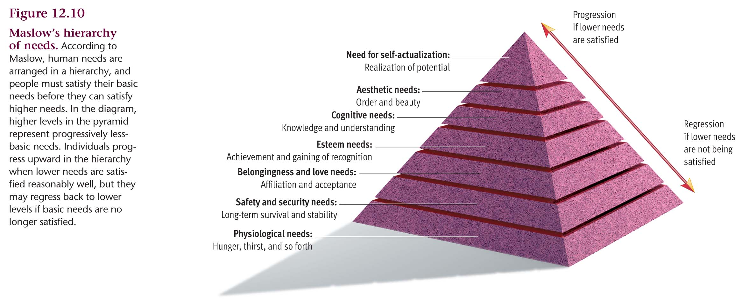

- Humanistic theories
  - Importance of a person’s subjective view of reality
  - Issue of what constitutes a healthy personality
- But
  - No strong research base
  - Poor testability
  - Overly optimistic view of human nature
    - Maslow had a hard time finding live people who had self-actualized

Bandura’s Social Cognitive Theory
- Helped reshaped the theoretical landscape of behaviorism
- people are self organizing, proactive and self regulating
- People routinely try to influence their lives and their outcomes
- People set goals for themselves
- People shape their own environments

*** Reciprocal determinism is the idea that internal mental events, external environment events and overt behavior all influence one another

View that behavior is governed by the environment and that freedom is an illusion. Bandura argues that internal mental events, external environmental contingencies and overt behavior all influence one another.

Self- Efficiency refers to ones belief about ones ability to perform behaviors that should lead to expected outcomes.

How do the humanists consider human nature?

Read pages 570-575

