aCHAPTER 1 – Marketing: Creating and Capturing Customer Value

Marketing – Process of building profitable customer relationships by creating value for customers and capturing value in return
- The activity, set of institutions, and processes for creating, communicating, delivering, and exchanging offerings that have value for customers, clients, partners and society at large (i.e. stakeholders)
- goal: attract new customers by promising superior value + keep and grow current customers by delivering satisfaction; satisfying customer needs in a socially responsible and ethnical manner

The Marketing Process:
- Understand Marketplace and Customer Needs
- Design customer-driven marketing strategy
- Construct a marketing program that delivers superior value
- Build profitable relationships and create customer delight
- Capture value from customers to create profits and customer equity

1. Understand Marketplace and Customer Needs – understand marketplace that they operate; needs&wants
5 core customer and marketplace concepts:
- Needs – states of felt deprivation (when person feels physiologically deprived of basic necessities)
e.g. physical: food, clothing, shelter. Social: belonging and affection. Individual: knowledge etc.
Wants – a felt need that is shaped by person’s knowledge, culture and personality (e.g. need for food, want hamburger) objects that will satisfy needs
- Marketers’ job = inform consumers how products can satisfy their needs and wants
  - Doesn’t create need, but shape person’s wants
Demands – wants that are back by buying power (given wants and resources, ppl demand products w/ benefits that add up to the most value and satisfaction)
- Market offerings– some combo of products, services, info or experiences offered to a market to satisfy need or want
Marketing myopia – mistake of paying more attention to specific products company offers than to the benefits and experiences produced by these products
- Value and satisfaction – key building blocks for developing& managing customer relationships
- Exchanges – act of obtaining a desired object from someone by offering something in return
- marketing occurs when ppl decide to satisfy needs&wants through exchange relationships
- Markets – the set of actual and potential buyers of a product/service (these buyers share a particular need/want that can be satisfied through exchange relationships)

2. Design a Customer-Driven Marketing Strategy
Marketing management – art and science of choosing target markets and building profitable relationships with them; design a customer-driven marketing strategy once consumers and marketplace is understood
- Must answer 2 questions: what’s our target market? What’s our value proposition?
Market segmentation – dividing the markets into segments of customers
Target Market – which segments to go after (decide who to serve by market segmentation; select target market)
Demarketing – marketing to reduce demand temporarily/permanently (not2 destroy demand but reduce/shift it)
Value proposition – how it’ll differentiate and position itself in marketplace; set of benefits/values it promises to deliver to consumers to satisfy their needs

Marketing Management Orientations: 5 concepts to designing Marketing Strategies:
- Production concept – idea that consumers will favour products that are available& highly affordable. Therefore, org should focus on improving production and distribution efficiency (e.g. low labour cost, high production efficiency, mass distribution etc.)
- Product Concept – idea that consumers will favour products that offer the most quality, performance and innovative features. Therefore, org should focus on making continuous product improvements
- Selling Concept – idea that consumers won’t buy enough of firm’s products unless it undertakes large-scale selling and promotion efforts (goods that buyers don’t normally think of buying, e.g. insurance)
- Aim: sell what company makes rather than making what market wants (inside-out focus)
- Marketing Concept – achieving org goals depends on knowing the needs and wants of target markets and delivering desired satisfactions better than competitors do. Focus on customer value (outside-in)
- Societal Marketing Concept –org’s marketing decisions must consider consumers’ wants, company’s requirements, consumers’ long-run interests, and society’s long-run interest [considers: society (human welfare), consumer (want satisfaction), company (profit)]

3. Construct a marketing program that delivers intended value to target customers
- Must blend all marketing mix (4Ps) into integrated marketing program that communicates and delivers the intended value to chosen customers
4. Build Customer Relationships
Customer Relationship Management – overall process of building and maintaining profitable customer relationships by delivering superior customer value and satisfaction (acquiring, keeping and growing customers)
- Key to lasting customer relationships is create superior customer value& satisfaction
Customer-perceived value – customer’s evaluation of difference between all benefits and all costs of a market offering relative to those of competing offers (CPV = total customer value – total customer cost)
Customer satisfaction – the extent of how well product’s perceived performance matches buyer’s expectations

Changing Nature of Customer Relationships
- Relating with more carefully selected customers (selective relationships management to target fewer, more profitable customers)
- Relating more deeply and interactively by incorporating more interactive 2way relationships (i.e. blogs, websites, online communities and social networks)
Consumer-generated marketing – marketing messages, ads and other brand exchanges created by consumers themselves (through blogs, websites etc.)
Partner relationship management – working closely w/ partners in other company departments& outside org to jointly bring greater value to customers

5. Capturing Value from Customers gains sales, market share& profit: outcome of creating customer value:
- Creates customer loyalty, delight and retention captures Customer lifetime value – value of entire stream of purchases that customer would make over a lifetime of patronage
- Grows Share of Customer – portion of customer’s purchasing that a company gets in its product categories
- Builds Customer Equity – total combined customer lifetime values of all of the company’s current and potential customers (the more loyal the firm’s profitable customers, the higher firm’s customer equity) (a good measure of firm’s performance)
Which customer should company acquire and retain? – classify customers according to potential profitability& manage its relationship w/ them accordingly

Marketing Process
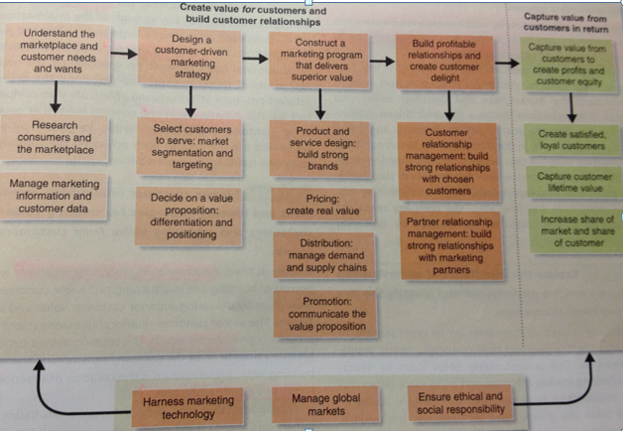
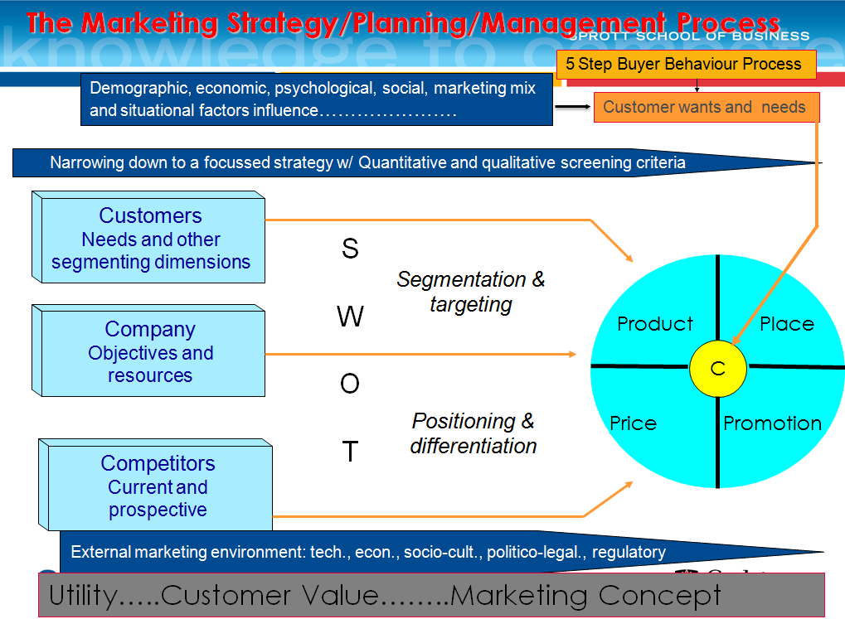

CHP 2 – Company and Marketing Strategy: Partnering to Build Customer Relationships to understand marketing role, must first know org’s overall strategic planning process

Strategic planning – process of developing& maintaining a strategic fit between org’s goals and capabilities and its changing marketing opportunities (sets the stage for the rest of the planning in the firm); 4 steps:
- Define company mission – statement of org’s purpose: what it wants to accomplish in the larger env (should be market oriented, defined in terms of satisfying basic customer needs)
- Set company objectives and goals – detailed supporting objectives for each level of management
- Design Business Portfolio – collection of businesses& products that make up the company
- Best portfolio= best fits org’s strengths and weaknesses w/ opportunities in the env
- 2 steps:
- Org must analyze current business portfolio& decide which businesses should receive more, less or no investment
Portfolio analysis – process where management evaluates products and businesses that make up org
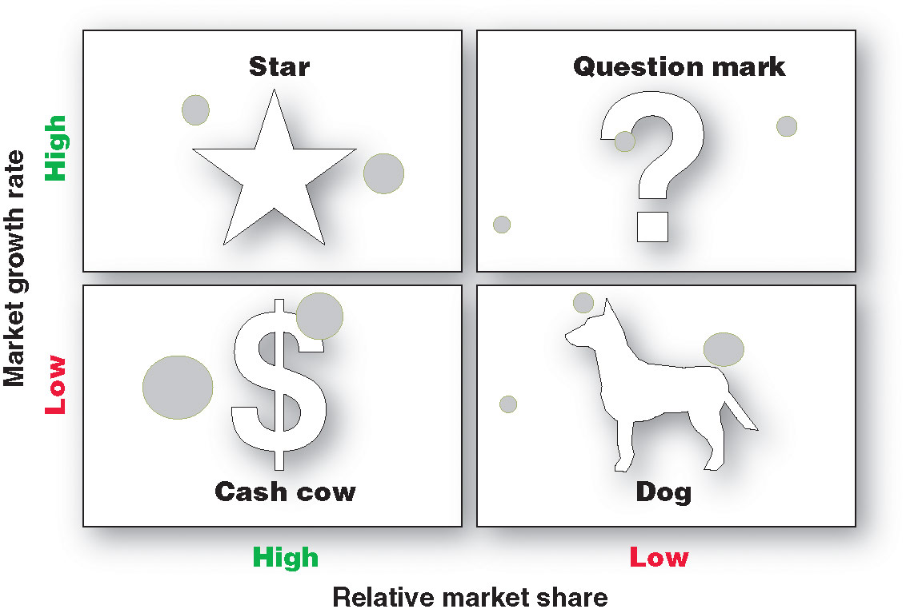
Growth-share matrix – a portfolio-planning method that evaluates org’s strategic business units in terms of its market growth rate and relative market share; classified as: Stars, Cash cows, Question marks, Dogs
- Disadv: difficult to define& measure SBUs, time consuming, costly to implement, focus on current and no advice for future
- Develop strategies for growth and downsizing to shape future portfolio
Product/market expansion grid – portfolio-planning tool for identifying org growth opportunities through market penetration, market development, product development or diversification
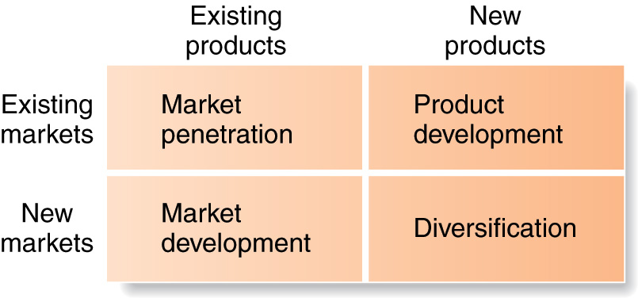
Market Penetration – strategy for org growth by increasing sales of current products to current market segments w/out changing product
Market development – strategy for org growth by identifying& developing new market segments for current org products (e.g. new demographic markets or new geographic location)
Product development – strategy for org growth by offering modified/new products to current market segments
Diversification – strategy for org growth through starting up/acquiring businesses outside org’s current products and market
Downsizing – reduce business portfolio by eliminate product/business units that arn’t profitable/that no longer fit org’s overall strategy

- Planning marketing – Partnering w/ other departments& others in marketing system to Build Customer Relationships (once corporate mission, obj, goal& business portfolio’s created, focus on business unit lvl)
- Internal: Value chain – series of departments that carry out value-creating activities to design, product, market, deliver, and support firm’s products
- External: Value delivery network – network made up of org, suppliers, distributors& customers who “partner” w/ each other to improve performance of entire system
- Planning marketing – Marketing Strategy and Marketing Mix
Marketing Strategy – marketing logic by which business unit hopes to create customer value& achieve profitable customer relationships (market segmentation, targeting, differentiation and positioning)
- Segmentation – dividing market into distinct groups of buyers who’ve dif needs, characteristics/ behaviours and who might require separate products or marketing programs
Market segment – group of consumers who responded in similar way to given set of marketing efforts
- Targeting – process to evaluate each market segment’s attractiveness& select 1/more segments to enter
- Positioning – arrange a product to occupy clear, distinctive& desirable place relative to competing products in the minds of target consumers
- Differentiation – provide unique market offering to create superior customer value
Marketing mix – a set of marketing tools that firm blends to satisfy customer needs and build lasting customer relationships (4Ps = Product, Price, Place, Promotion)
- Products – goods-and-services combination org offers to target market (Customer solution)
- Price – amount of money customer must pay to obtain product (Customer cost)
- Place – org activities that make product available to target consumers (Convenience)
- Promotion – activities to communicate merits of p; persuade target consumer to buy (Communication)

Managing Marketing Effort – 4 marketing management functions:
- SWOT Analysis – overall evaluation of org’s strengths, weaknesses, opportunities and threats
- Planning – decide marketing strategies (what each business unit’ll do) that’ll help org achieve its strategic obj (develop strategic plan, develop marketing plan) (e.g. executive summary, budget, analysis of current situation, targets and positioning, marketing mix etc.)
- Implementation – process that turns marketing strategies&plans into marketing actions to achieve obj (carry out plan)
- Control – process to measure, evaluate results of marketing strategies& plans; taking corrective action to ensure that objectives are achieved (measure results evaluate results take corrective action)
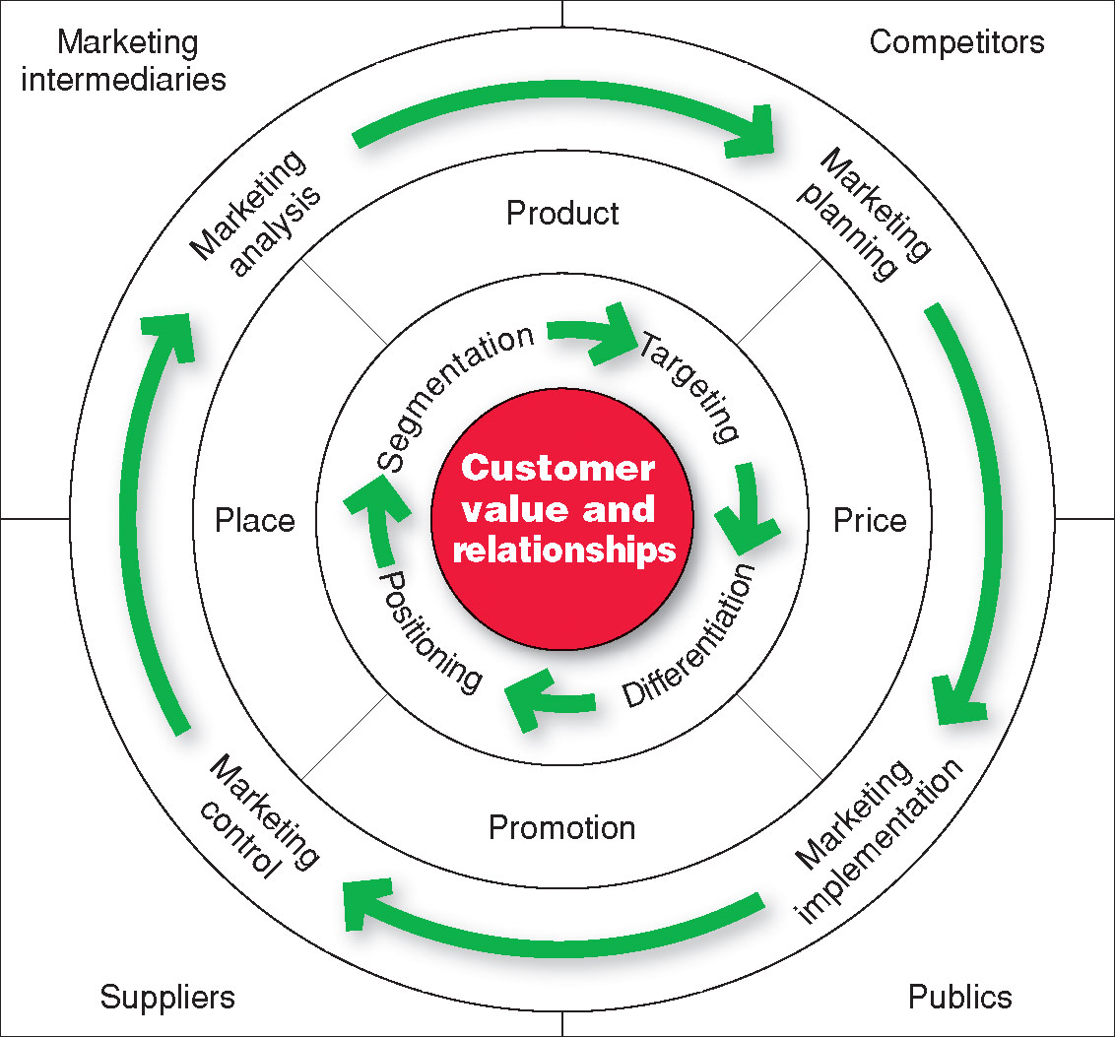

Measuring and Managing Return on Marketing Investment
Return on marketing investment (marketing ROI) – net return from marketing investment divided by cost of marketing investment

CHAPTER 3 – Analyzing the Marketing Environment
Marketing environment – actors and forces outside marketing that affect marketing management’s ability to build and maintain successful relationships w/ target customers. 2 Types:
1. Microenvironment – actors close to company that affect its ability to serve its customers:
- Company – top management, finance, R&D, operation, accounting etc. (collaboration between depr)
- Suppliers – provide resources to product g&s; they’re org partners to provide customer value
- Marketing intermediaries – firms that help org promote, sell& distribute its goods to final buyers
e.g. marketing service agencies, physical distribution firm, resllers etc.
- Customer –entire value delivery system aims to serve target customers& create strong relations w/ them
- 5 types:
  - consumer market – ind& households that buy g&s for personal consumption
  - business market – buy g&s for further processing/use in their production process
  - reseller market – buy g&s to resell at a profit
  - gov market – gov agencies that buy g&s to produce public services
  - international market – buyers in other countries (consumers, producers, sellers& gov)
- Competitors – gain strategic adv by positioning their offering against competitors’ offerings
  - Pure competition – similar products and customers view these products as close substitutes
  - Oligopoly – few org control majority of industry sales& price competition’s not desirable
  - Monopoly – 1 firm completely controls broad product market
  - Monopolistic competition – each attempts2 obtain control in its own target market (differentiate similar products); many dif firms offer mktg mixes that some customers view as different
Competitor Analysis (P5F) – organized approach2 evaluate S&W of current/potential competitors mktg strategies (new entrants, suppliers, buyers, substitutes, rivalries)
- Publics – any group that has an actual/potential interest in/impact on org’s ability to achieve its obj

2. Macroenvironment – larger societal forces that affect microenvironment:
- Demographic – study of human population i.e. size, density, location, age, gender, race, occupation etc.
- Trend: increase diversity (market’s become more diverse, international). Age Structure 3 groups:
- Baby boomers – ppl born between 1946-1964 (following WWII-mid 1960s)
- Generation X – born between 1967-1976; trends: high parental divorce rates, cautious economic outlook, less materialistic, family comes first, lag behind on retirement savings
- Millennials (Gen Y) – ppl borm between 1977-2000; trend: comfort w/ tech
- Generational Marketing is important in segmenting ppl by lifestyle/life state instead of age
- Economic – factors that affect consumer buying power and spending patterns
- Industrial economies – constitute rich markets for many dif kinds of goods
- Subsistence econ – consume most of own agricultural& industrial output; few market opportunities
- Developing economies – offer outstanding marketing opportunities for the right kind of products
Trends: Changes in income
- Value marketing – ways to offer financially cautious buyers greater value – the right combo of quality& services at a fair price
- Disposable income – how much money’s left to spend after taxes
- Discretionary income – money that remains after paying for taxes and necessities
Trends: Changes in Consumer Spending Patterns
- Engel’s laws – differences noted over a century ago in how ppl shift their spending across food, housing, transport, health care, and other g&s categories as family income rises
  - As family income rise, % spent on food ↓, housing remains, other categories+saving↑
- Natural – natural resources that’s needed as inputs by marketers/that’s affected by marketing activities
- Trends: shortage of raw material, ↑pollution, ↑gov intervention, env sustainable strategies
- Environmental sustainability – develop strategies& practices that create a world economy that the planet can support indefinitely
- Technological – forces that create new tech, creating new products and market opportunities
- Tech’s impact on marketers: electronic commerce, intranet, extranet, e-busi, e-marketing etc.
- Political – laws, gov agencies& pressure groups that influence& limit various org, ind in a given society
- Trends: ↑legislation, changing gov agency enforcement, ↑emphasis on ethics, socially responsible behaviour, cause-related marketing (org linking themselves to worthwhile causes e.g. charity)
- Cultural – institutions& other forces that affect society’s basic values, perception, preference; behaviors (ppl grow up in particular society that shapes their basic beliefs& values); Trends affect mktg decisions:
Persistence of cultural values – high degree of persistence that shape more specific attitudes& behaviours found in everyday life
- Core beliefs& values – passed on from parents to children, reinforce by school, gov, busi etc.
- Secondary beliefs& values – more open to change; include ppl’s views of themselves, others, org, society, nature, universe (e.g. belief in marriage= core; belief in marriage EARLY= second)
Shifts in Secondary Cultural Values – view of self: use products, brands, services as a means of self-expression
- Hiving/Cocooning – market trend where ppl socialize by spending more time in the home (e.g. home theatre system instead of local cinema ∴ widescreen TVs, computer games)
Views on Responding to Marketing Environment
Uncontrollable – react and adapt to forces in env
Proactive – aggressive actions to affect forces in the env
Reactive – watching and reacting to forces in the env
CHAPTER 6 – Consumer Markets and Consumer Buyer Behaviour
Consumer buyer behaviour – buying behaviour of final consumers – ind& households that buy goods& services for personal consumption
Consumer market – all inds& households who buy/acquire goods and services for personal consumption

4 Factors Affecting Consumer Behaviour:
- Cultural Factors
Culture – set of basic values, perceptions, wants& behaviours learned by a member of society from family and other important institution
Subculture – group of ppl w/ shared value systems based on common life experiences and situations
e.g. regional subcultures, founding nations (Aboriginal, Eng, Fren), ethnic consumers (minority)
Social class – relatively permanent and ordered divisions in a society whose members share similar values, interests& behaviours

- Social Factors – such as consumer’s small groups, family, and social roles and status
Group – 2 or more ppl who interact to accomplish ind or mutual goals (marketers try to identify reference groups of target market): membership group, aspirational groups (ind wish2 belong2), reference groups
Opinion leader – person w/in reference group who, due to special skills, knowledge, personality/other characteristics, exerts social influence on others (word-of-Mouth Influence& Buzz marketing)
Online Social networks – online social communities (blog, social network) where ppl socialize/exchange info& opinions
Role and Status – evry1 belongs to many groups. Role consists of activities ppl/re expected2 perform according to those around them. Each role carries a status reflecting the general esteem given to it by society

- Personal Factors – include: economic situation, occupation, age and life-cycle stage, self-concepts,
Lifestyle – person’s pattern of living as expressed in his/her activities, interests and opinions
Personality – unique psychological characteristics that lead to relatively consistent& lasting responses to one’s own env; described in terms of traits: self-confidence, sociability, defensiveness, adaptability etc.
Brand Personality – specific mix of human traits that may be attributed to particular brand (match brand personality w/ consumer personality)

- Psychological Factors – (VALS) 4 types:
- Motive (drive) – need that’s sufficiently pressing to direct person to seek satisfaction of the need
- Perception – process where ppl select, organize& interpret info to form meaningful picture of the world
- Ppl form dif perceptions of same stimulus due to 3 perceptual processes:
- Selective attention – tendency for ppl to screen out most of info that they’re exposed
- Selective distortion – tendency of ppl interpret info in way that’ll support what they already believe
- Selective retention – retain info that supports their attitudes and belief (remember good points bout brand they favour and forget good points made bout competing brands)
- Learning – changes in ind’s behaviour arising from experience (occur through drives – strong internal stimulus that calls for action; stimuli; cues – minor stimuli that determine when, where, how ppl respond; responses, reinforcement)
- Beliefs and Attitudes – Belief – descriptive thought that a person holds about something
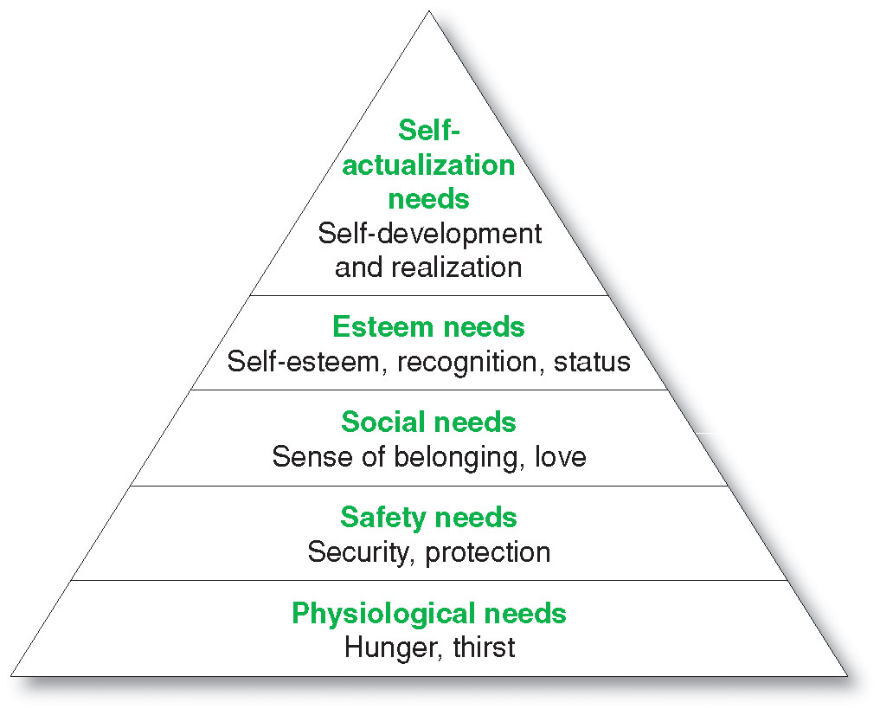
Attitude – person’s consistently fav/unfavourable evaluations, feelings& tendencies toward object/idea

Maslow’s hierarchy of Needs: answers why ppl are driven by particular needs at particular time

Types of Buying Decision Behaviour:
Complex buying behaviour – when consumers are highly involvement in a purchase and perceive significant differences among brands (when product is expensive, risky or purchased infrequently) (consumer has much to learn about product category)

Dissonance-Reducing Buying Behaviour – when consumers are highly involved w/ expensive, infrequent or risky purchase but see little difference among brands (e.g. carpeting)

Habitual Buying Behaviour – low consumer involvement and little significant brand differences (e.g. salt – low cost, frequently purchased products; buy out of habit, not brand loyalty)

Variety-seeking buying behaviour – low consumer involvement but significant perceived brand differences (brand switching is common – e.g. buy cookie brands)

Buyer Decision Process
- Need Recognition – consumer recognize prob/need (triggered by internal/external stimuli)
- Information Search – consumer’s aroused to search for more info; consumer may simply have heightened attention/may go into an active info search; can obtain info from several sources:
  - Personal source – family, friends, neighbours, acquaintances
  - Commercial source – advertising, sales-people, dealer websites, packaging, displays
  - Public source – mass media, consumer rating org, internet searches
  - Experiential source – handling, examining, using the product
- Evaluation of Alternatives – consumer uses info to evaluate alternative brands in choice set
- Purchase Decision – buyer’s decision about which brand to purchase
- 2 factors can come between purchase intention and purchase decision:
  - Attitude of others
  - Unexpected situational factors
- Post-purchase Behaviour – consumers take further action after purchase based on their satisfaction/dissatisfaction (satisfaction= consumer’s expectation& product’s perceived performance)
Cognitive dissonance – buyer discomfort caused by post-purchase conflict (every purchase involves compromise – losing the benefits of the brands not purchased)

Buyer Decision Process for New Products – how consumers learn about products for 1st time& make decisions on whether to adopt them
New product – good, service or idea that’s perceived by some potential customers as new
Adoption process – mental process that an ind passes from 1st hearing about an innovation to final adoption
- 5 stages:
- Awareness – consumer becomes aware of new product but lack info about it
- Interest – consumer seeks info about new product
- Evaluation – consumer considers whether trying new product makes sense
- Trial – consumer tries new product on small scale to improve his/her estimate of its value
- Adoption – consumer decides to make full& regular use of new product
Influence of Product Characteristics on Rate of Adoption

- Relative advantage
- Compatibility
- Complexity
- Divisibility
- Communicability
Individual Differences in adaptation
- Innovators – venturesome, try new ideas at some risk
- Early adopters – opinion leaders in their communities& adopt new ideas early but carefully
- Early majority – they adopt new ideas before the average person
- Late majority – skeptical, adopt only after a majority of ppl have tried it
- Laggards – tradition bound, suspicious of changes, adopt innovation only when it’s become common
CHP 8 – Customer-Driven Marketing Strategy: Creating Value for Target Customers – org can’t target all buyers in marketplace (design customer-driven marking strat: move from mass marking to target marking)
(target specific customers/segments/ w/ unique marketing mix; differentiation – distinct from others)
4 Major Steps in Designing Customer-Driven Marketing Strat: (look@CHP2 for definition)
- Market segmentation
Segment Consumer Markets
1) Geographic segmentation – divide market into dif geo units such as nations, regions, provinces, countries, cities or neighbourhoods
2) Demographic segmentation – divide market into groups based on variables:
Age and life-cycle segmentation – divide market into dif age& family life-cycle groups
Gender segmentation – divide market into dif groups based on gender
Income segmentation – divide market into dif income groups
3) Psychographic segm. – divide market into dif groups based on social class, lifestyle, personality traits
4) Behavioural segm – divide mrkt in2 groups based on consumer knowledge, attitude, use/response2 pdct
Occasion segm – divide market into groups based on occasions when buyers get the idea to buy, actually make their purchase or use purchase item
Benefits segm – divide market into groups based on dif benefits that consumers seek from prdct
User Status – divide market into nonusers, ex-users, potential users, 1st time users, reg users of p
Usage Rate – divide market into light, medium& heavy product users
Loyalty Status – segment based on consumer loyalty
Segment Consumer Markets – segmented into same variables as consumer markets plus:

- Customer operating characteristics
- Purchasing approaches
- Situational factors
- Personal characteristics

Segment International Markets – segment by geo location, economic, political-legal& cultural factors (PESTLE)
Intermarket (cross-market) segm – forming segments of consumers who’ve similar needs&buying behaviour even though they’re located in dif countries
Requirements for Effective Segmentation – to be useful, market segments must be:
- Measurable – size, purchase power& profiles of segments can be measured
- Accessible – the market segments can be effectively reached and served
- Substantial – the market seems large or profitable enough to serve
- Differentiable –segment’s conceptually distinguishable; respond dif2 dif mktg mix elements&programs
- Actionable – effective programs can be designed for attracting& serving the segments

- Market targeting
Evaluating Mrkt segments: segment size& growth; segment structural attractiveness; org objectives& resources
Target Market – set of buyers sharing common needs or characteristics that org decides to serve
- choosing a Target Market depends on: org resources, product variability, product life-cycle stage, market variability, competitor’s marketing strat. It’s carried out at several dif levels:
- Undifferentiated marketing (mass marketing) – market coverage strategy where firm decides to ignore market segment differences and go after the whole market w/ 1 offer
- Differentiated marketing (segmented marketing) – market coverage strategy where firm decides to target several market segments and designs separate offers for each (small share of large market)
- Concentrated marketing (niche marketing) - market coverage strategy where firm goes after a large share of 1 or a few segments or niches (greater knowledge of consumer needs in niche it serves)
- Micromarketing – tailor prdct&mrktg progs to needs& wants of specific ind & local customer groups:
  - Local marketing – tailor brands& promotions to needs& wants of local customer groups (city, neighbourhood, specific stores etc)
  - Ind marketing (one-to-one marketing; mass customization; markets-of-one marketing) – tailor products& marketing programs to needs& preferences of individual customers

- Differentiation and Positioning – (Identity vs. Image) org must choose a value proposition
Product Position – way product’s defined by consumers on important attributes – place product occupies in consumers’ minds relative2 competing products (complex set of perceptions, impressions& feelings consumer have for product) org must plan positions design marketing mix& tools to create these planned positions:
- Perceptual Positioning Map – show consumer perceptions of brands vs. competing products on important buying dimensions
Choosing a Differentiation and Positioning Strategy
- Identify possible value differences& comp adv – profitable relationships w/ target customers = understand customer needs better than competitors do and deliver more customer value
Competitive advantage – adv over competitors gained by offering greater customer value, either through lower prices or by providing more benefits that justify higher prices (distinct& superior (4Ps), not easy to imitate)
Product differentiation – differentiate on features, performance or style and design
Service differentiation – differentiate on speedy, convenient or careful delivery
Channel differentiation – differentiate through way org design its channel’s coverage, expertise& performance
People differentiation – differentiate on hiring and training people better
Image differentiation – differentiate on strong, distinctive image of product’s distinctive benefits& positioning
- Choosing the right competitive advantages – which differences to promote? Must satisfy criteria:
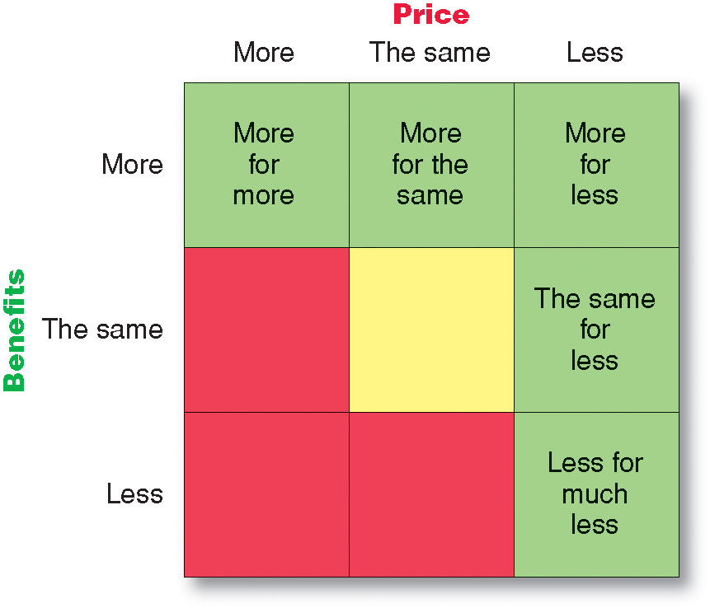
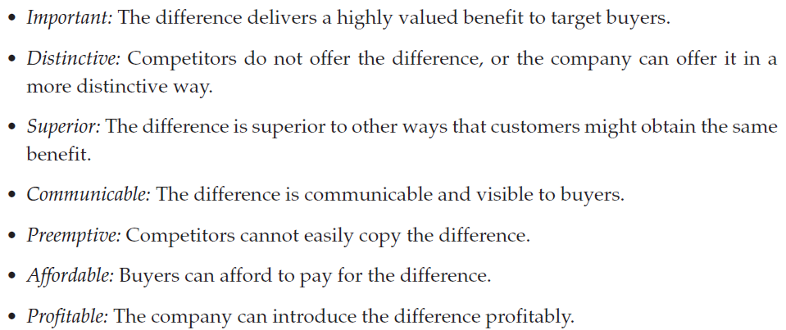

- Selecting an overall positioning strategy
Value proposition – full positioning of a brand – full mix of benefits upon which it’s positioned (bundle of features)
Core Positioning – 1 specific feature in an org
Positioning Statement – summarizes org/brand positioning – To (target segment and need) our (brand) is (concept) that (point of difference)
Points of parody – attributes that every org must have in this specific market (competitive necessity)
e.g. WestJet, Ryanair, EasyJet = basic modes of transport from point A to B

- Effectively communicate and deliver chosen position to market

CHAPTER 9 – Product, Services, and Brands: Building Customer Value
Product – anything that can be offered to a market for attention, acquisition, use or consumption that might satisfy a want or need; consumers see it as complex bundles of benefits that satisfy their needs
- Also include: orgs, person, place (e.g. tourism), ideas & experience
- Social marketing – use of commercial marketing concepts and tools in programs designed to influence ind’s behaviour to improve their well-being& that of society
Service – any activity/benefit that one party can offer to another that’s essentially intangible& doesn’t result in ownership of anything

Product and Service Classifications – P&S fall into 2 classes based on the types of consumers that use them:
    - Consumer Products – product bought by final consumers for personal consumption; include:
- Convenience P – P that customers usually buy frequently, immediately w/ min comparison& buyin effort
- Shopping P – in process of select& purchase, customer usually compares on such bases as price, quality, style and suitability
- Specialty – unique trait/brand id where significant group of buyers’ willing2 make special purchase effort
- Unsought – P that consumer either doesn’t know or knows but doesn’t normally think of buying
    - Business Products – P bought by ind& orgs for further processing or for use in conducting a business

Product and Service Decisions – make decisions at 3 levels:
1. Individual Product and Service Decisions
- Product and Service Attributes:
- Product quality – characteristics of p/s that bear on its ability2 satisfy stated/implied customer needs
- 2 dimensions: quality level (performance quality) and consistency (conformance quality)
Total Quality Management (TQM) – approach where org’s involved in constantly improving quality of product, service & business process
- Product Features
- Product Style and Design
- Branding – name, term, sign, symbol, design/these combo to identify p/s & differentiate from competito
- Packaging – activities of designing and producing the container/wrapper for a product
- Labelling – identifies product or brand, describe product (where, when it’s made etc.), promote brand, support positioning, connect w/ customers etc.
- Product Support Services – survey, follow-up etc.
2. Product Line Decisions
Product Line – group of products that are closely related because they function in similar manner, sold to same customer groups, marketed through same types of outlets or falls w/in given price ranges
- Org can expand its product line in 2 ways:
- Line filling – add more items w/in present range of the line (reason: extra profit etc.)
- Line stretching – org lengthens its product line beyond its current range: downward (lower-end p), upward (higher-end p) or both ways
Product Line Length - # of items in product line
3. Product Mix Decisions
Product mix (product portfolio) – all product lines& items that a particular seller offers for sale
Product mix width – # of dif product lines org carries
Product mix length – total # of items org carries w/in its product lines
Product mix depth – # of versions offered of each product in the line
Consistency – how closely various product lines are in end use, production requirements/distribution channels

Branding Strategy: Building Strong Brands
Brand represents consumer’s perceptions& feelings about product and its performance. It’s org’s promise to deliver a specific set of features, benefits, services& experiences consistently to buyers
- Role: signify quality, create barriers to entry, serve as competitive adv, secure price premium
Brand equity – differential effect that knowing brand name has on customer response to the product& its mrktg
- A measure of brand’s ability to capture consumer preference& loyalty (responsiveness)
- Strength can be measured w/ 4 consumer perception dimensions:
- Differentiation (what makes brand stand out)
- Relevance (how consumers feel it meets their needs)
- Knowledge (how much consumers know about brand)
- Esteem (how highly consumers regard and respect brand)
Major Brand Strategy Decisions involve:
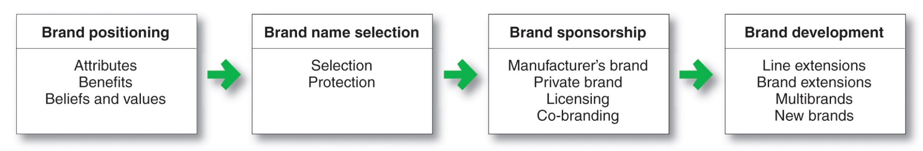
- Brand Positioning – marketers can position brands at any of 3 levels:
  - Product attributes – lowest level (least desirable level – easily copied by competitors)
  - Benefits – associating brand name with desirable benefits
  - Beliefs and values - strongest brand positioning level (deep emotional attachment)
- Brand Name Selection – naming a brand; desirable qualities of a brand name include:
- Should suggest something about product’s benefits and qualities
- Should be easy to pronounce, recognize and remember
- Should be distinctive
- Should be extendable
- Should translate easily into foreign languages
- Should be capable of registration and legal protection
- Brand Sponsorship
National brands (manufacturer’s brands) – created by manufacturer
Store brand (private brand) – brands created and owned by a reseller of a product or service
Licensed brands – uses previously created names or symbols for a fee
Co-branding – practice of using established brand names of 2 dif orgs on same product (e.g. CIBC Visa)
- Brand Development – 4 choices:
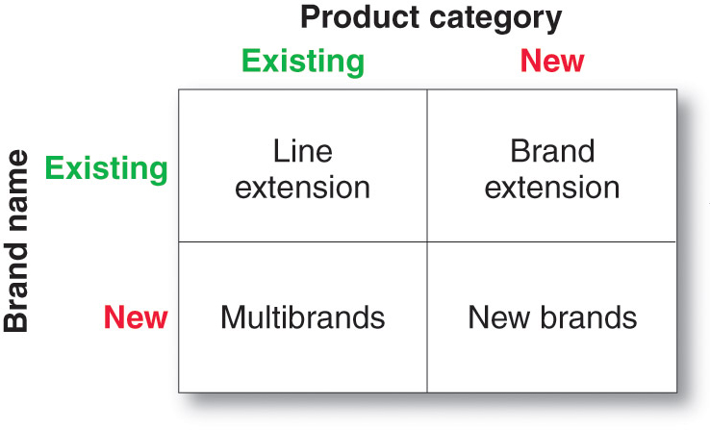
- Line Extension – extending existing brand name to new forms, colours, sizes, ingredients or flavours of an existing product category
- Brand Extension – extending an existing brand name to new product categories
- Multibrands – org introduce many brands in same category; establish dif features& appeal to dif buying motives but may not be very profitable because each brand obtain only a small market share
- New brands

Services Marketing – include: gov, private not-for-profit org, business orgs (e.g. airline, banks, hotel etc.)
4 major characteristics of service:
- Service intangibility – can’t be seen, tasted, felt, heard or smelled before they’re bought
- Service inseparability – produced& consumed at the same time& can’t be separated from its providers
- Variability – its quality may vary greatly, depending on who provides them and when, where and how
- Perishability – can’t be stored for later sale or use

Marketing Strategies for Service Firms
1. The Service-Profit Chain – chain that links service firm profits w/ employee& customer satisfaction. 5 links:
- Internal service quality – superior employee selection and training, results in…
- Satisfied and productive service employees – which results in…
- Greater service value – more effective& efficient customer-value creation& service delivery, results in...
- Satisfied and loyal customers – which results in…
- Healthy service profits and growth – superior service firm perfomrance
Internal marketing – orienting& motivating customer-contact employees& supporting service ppl to work as a team to provide customer satisfaction
Interactive marketing – training service employees in the fine art of interacting w/ customers to satisfy their needs
2. Managing Service Differentiation – develop a differentiated offer, deliver and image
Offer – innovative features that set 1 org’s offer apart from competitors’ offer
Delivery – differentiate by having more able& reliable customer-contact ppl (superior physical env. Where service is delivered or delivery process)
Image – differentiate by symbols and branding
3. Managing Service Quality
4. Managing Service Productivity

