Introduction:

In this laboratory experiment, a telephone switch circuit that allows one of four calling subscribers to connect to one of eight called subscribers was constructed on the Tektron Logic Lab trainer (refer to Figure # in the appendix). This circuit allows only one conversation to take place at any given time. A large-scale application of such a system would typically be used for telephone solicitation, but it would include more telephone switch circuits connected in parallel to allow more than one conversation to take place simultaneously.

Using some of the basic logic gates, a multiplexer gate (MUX) and a demultiplexer gate (DeMUX) were constructed and connected together to form the telephone switch circuit. The MUX is used to select one of several inputs to send to an output, which in this case is the DeMUX. The DeMUX then takes one input and switches it between two or more outputs. The input and output in this case are selected using a signal that deals with binary numbers, which in turn controls the switch that selects the calling and called party. The circuit was tested in steps, after constructing each MUX or DeMUX gate, so that the error could be spotted early on as opposed to when the complete circuit was not functioning properly.

The remainder of this report contains circuit specifications, which includes details of the distinct parts of the system, as well as its limitations. Furthermore, the design process is described in addition to the methods used to meet the specifications. Finally, ways of testing that the design worked are mentioned, along with debugging techniques when problems arose.

Specifications:

Due to limits on the amounts of certain logic gates present on the Tektron Logic Lab trainer, a good amount of thought was put in to the circuit design in order to meet the telephone switch circuit’s requirements, since it was to be constructed with on the Logic trainer. The thought process included narrowing down the number of methods of building our MUX and DeMUX gates due to an insufficient amount of OR and AND gates available, as well as a scarce amount of long wiring accessible.

There are four telephones in the calling party (inputs W, X, Y, Z), and eight telephones in the called party (outputs A, B, C, D, E, F, G, H). The MUX switch allowed us to dial a 2-bit binary number to select the calling party, while the DeMUX switch allowed us to dial a 3-bit binary number to select the called party. This covers the four inputs and the eight outputs. The four inputs were connected to four switch outputs in the bottom right corner of the Logic trainer, and each input had a corresponding switch that would set it to a digital 0 or 1.

Design :

The circuit was designed in two parts: a 4 input MUX and an 8 output DeMUX.

The first part of the circuit is the 4 input MUX. As can be seen in figure 1, a standard MUX has two inputs. In order to build a 4 input MUX, two 2 input MUXs were connected to a third 2 input MUX. Figure 2 shows the design used to build a 4 input MUX.

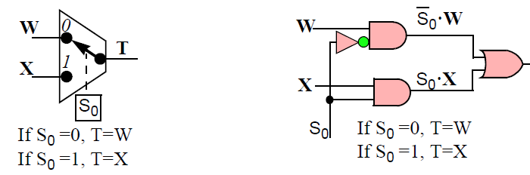
Figure 1: 2 input MUX

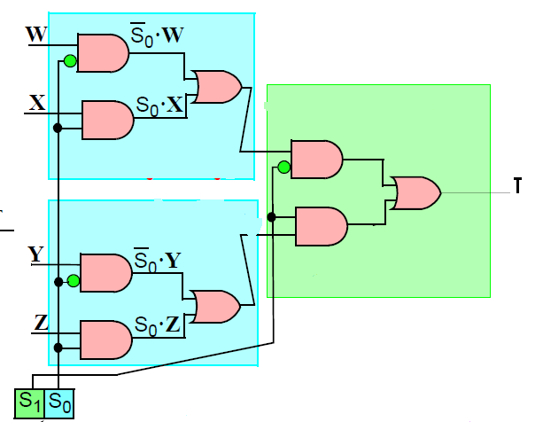
Figure 2: 4 input MUX

Other designs could have been used to build a 4 input MUX e.g. 3 input AND gates and OR gates could also make a 4 input MUX. The design seen in Figure 2 was chosen because it utilizes the dual 2-input AND-NOR gates, which are available on the Tektron Logic Lab. This design is further efficient because a dual – input AND-NOR gate can turned into a MUX by Connecting an inverter to the NOR gate. This saves a lot of wires, which would have been otherwise used to build a MUX from individual AND and OR gates.

The second part of the circuit is an 8 output DeMUX. The DeMUX was designed much in the way as the MUX. Three 2 output DeMUXs (Figure 3) were connected in the order seen in Figure 4 to make a 4 output DeMUX.

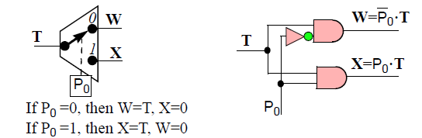
Figure 3: 2 input DeMUX

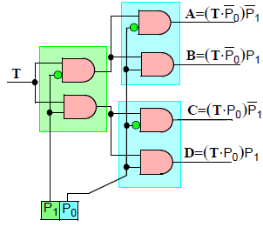
Figure 4: 4 input DeMUX

The design in Figure 4 didn’t work because the number of AND gates (6) required for that design were not available on the Tektron Lab. So, the design was modified to use 2 NAND gates and 4 NOR gates. The modified design can be seen in Figure 5.

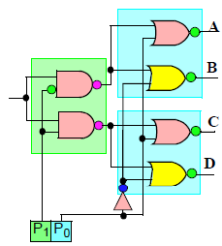
Figure 5: 4 input DeMUX using NAND /NOR gates

To build an 8 output DeMUX, two 4 output DeMUXs were built and connected to the outputs of a 2 output DeMUX. The design can be seen in Figure 6.
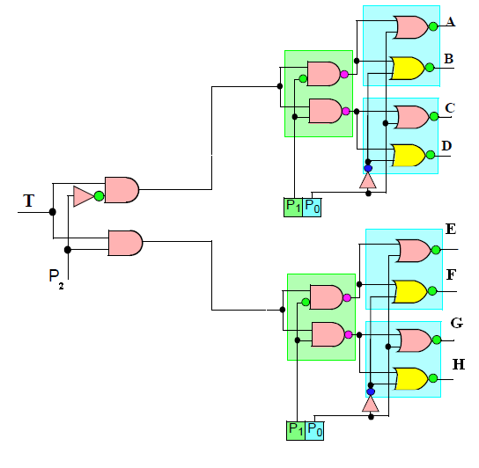
Figure 6 : 8 output DeMUX

The Trunk lines (T) of the MUX and DeMUX were connected together to complete the circuit. The final design for the circuit can be seen in Figure 7.

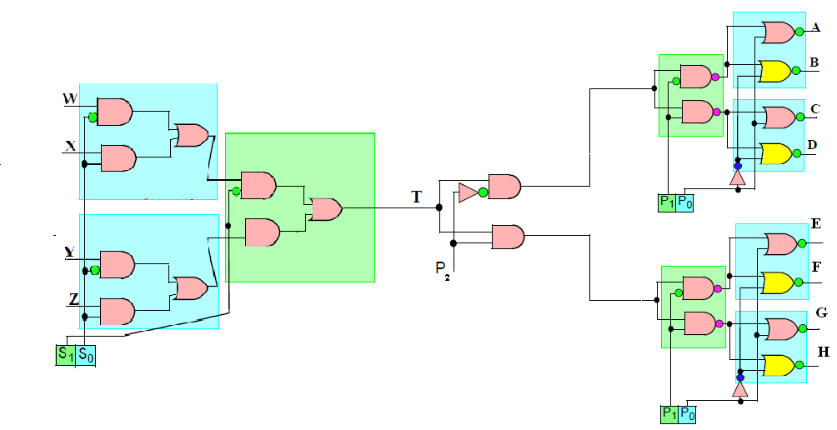
Figure 7 : Phone Switch Circuit

Finally, the design for the pulse dialer circuit was already provided in the lab instructions. The wiring connections for the pulse dialer circuit were made according to the design in provided in the lab instructions (Figure 8).
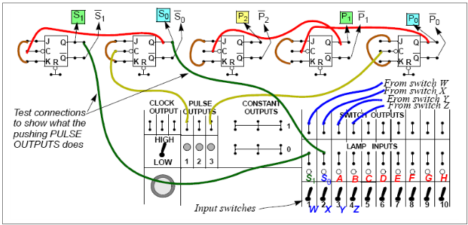
Figure 8 : Pulse dialer circuit

Discussion/Commentary (extra):

Using some of the basic logic gates, a multiplexer gate (MUX) and a demultiplexer gate (DeMUX) were constructed and connected together to form the telephone switch circuit. The MUX is used to select one of several inputs to send to an output, which in this case is the DeMUX. The DeMUX then takes one input and switches it between two or more outputs. The input and output in this case are selected using a signal that deals with binary numbers, which in turn controls the switch that selects the calling and called party. The circuit was tested in steps, after constructing each MUX or DeMUX gate, so that the error could be spotted early on as opposed to when the complete circuit was not functioning properly.

To build a system with 8 calling inputs, the design for an 8 output DeMUX could be followed i.e. Two 4 input MUXs can be created and then connected to a 2 Input MUX. An 8 input MUX cannot be created on the logic because the required gates to built one are not available.

A broadcast call switch can be added by connecting the trunk line of the 4 output DeMUX to an AND gate. The push button broadcast switch should be connected to the other input of the AND gate. The output of the AND gate should be connected to a 5 input OR gate. The outputs A,B,C and D from the DeMUX should be connected to the other four inputs of the 5 input OR gate. The output of the OR gate should then be connected to the lamp inputs A,B,C and D.

Two logic labs can be connected by connecting the MUX from one board to the MUX from the second board.

Implementation and Testing:

The telephone switch circuit was built using a 4-input MUX (made of three 2-input MUXs), an 8-output DeMUX (made of a 2-output DeMUX and two 4-output DeMUXs), and a pulsed dialer to select the desired calling and called party. All of the mentioned parts are found on the Tektron Logic Lab trainer. Below is a breakdown of the individual parts used to construct the MUX and DeMUX.

The 2-input MUX consists of:
- Two 2-input AND gates
- One 2-input NOR gate
- One inverter
- A control signal S₀

The 2-output DeMUX consists of:
- Two 2-input AND gates
- A control signal P₂

The 4-output DeMUX consists of:
- Two 2-input NAND gates
- Four 2-input NOR gates
- Two control signals P₁ and P₀

The abovementioned methods of building the MUX and DeMUX were not the only methods, but rather the most suitable given the limited amount of long wires and AND and OR gates.

To test this circuit, the inputs of the MUX were connected to the switch outputs located at the bottom right of the Logic trainer. The outputs of the DeMUX were connected to the lamp inputs located in the same corner of the board. After dialing the desired calling and called party using the pulse outputs found at the bottom of the Logic trainer, the input switch corresponding to the calling party is set to a digital 1. If the circuit was functioning properly, the lamp input corresponding to the called party would light. This meant that the calling and called parties were successfully connected. If the circuit was not functioning properly, then the lamp would not light, or if the wiring was mixed up, the wrong lamp would light.

While dialing the 2-bit binary number for the MUX, it was noted that the order of binary numbers were switched when the pulse output switch was pushed. Instead of obtaining 00-01-10-11, we obtained 00-10-01-11. To debug this issue, we switched the wiring of S₁ and S₀ at the lamp inputs and tested the order again to find that the problem had been solved.

Conclusion:

The lab was very easy to follow. Some minor problems like the lack of wires were encountered. The logic board got really crowded and messy towards the end which made debugging a little harder. The lack of inputs in some cases caused a little problem, but it was solved with some improvisation. One way to make this lab better in the future would be to provide larger lab boards which would make the wiring neater.

