Child Victims and Witnesses

Today’s Class
- Children’s recall abilities
- Interviewing Techniques with children
- Can children accurately identify suspects in a lineup?
- Children: Testifying in court
- Child abuse

Narrative Elaboration
- Children draw pictures of crime

Udo Undeutsch
- “Statements that are the product of experience will contain characteristics that are generally absent from statements that are the product of imagination.”

Criteria-Based Content Analysis (CBCA)
- General characteristics (3 criteria)
  - logical structure
  - unstructured production
  - quantity of details

CBCA
- Specific content (10 criteria)
  - reproduction of speech
  - unexpected complications
  - accurately reported detail misunderstood
- Motivation-related content (5 criteria)
  - spontaneous correction
  - admitting lack of memory
- Offense-related elements (1 criteria)
  - details characteristics of offense progression

Lab Study:
Yuille, (1988)/Stellar (1989)
- 6 – 9 year olds in BC
- tell true story, given false story to tell
- type of stories
  - directly involved
  - negative emotional state
  - loss of control

Yuille (1988): Results
- 11 of CBCA criteria more often seen in true stories as compared to false stories
- 83 % of true stories identified
- 58 % of false stories identified

Field Study: Lamb et al. (1997)
- 98 alleged victims of child sexual abuse
- ground truth based on independent evidence
- confirmed group (n = 76)
- doubtful group (n = 13)
- questionable (n = 9) - excluded

Results
- 14 of the CBCA criteria scored
- confirmed (M = 6.7)
- doubtful (M = 4.8)

Recognition Memory
- Target-present lineup: Adult and children have same accuracy
- Target-absent lineup: Children are more likely to identify an innocent person as compared to adults

The Elimination Lineup
- All pictures in the lineup are presented to the child and they are asked to select the one that looks most like the culprit (relative judgment)
- The child is then asked to compare his/her memory to the selected photograph and determine if the person is the culprit (absolute judgment)

Simultaneous vs. Elimination
(Figure 6.2; Pozzulo & Lindsay, 1999)

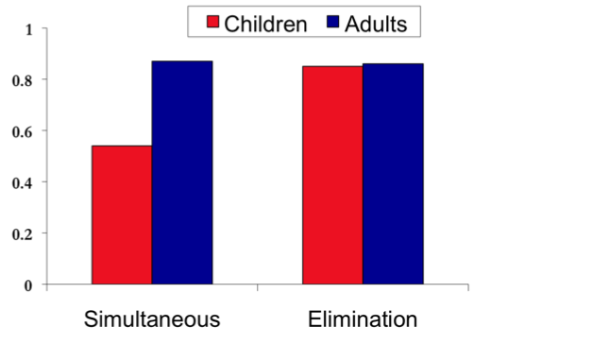

Risks of Testifying
- Potentially traumatizing effects of legal involvement
- Children who experience sexual abuse & testify have more problems during the trial than those who do not
- Express facing accused as biggest fear
- Poorer mental health
  - Especially for repeated testifying in severe cases
  - Worse when younger at time of trial

Court Accommodations
- What accommodations should be made for children testifying in court?

Testifying in Court
- Competency inquiry required for kids under 14 until 2006 in Canada
- Currently:
  - Presume children can testify
  - Simple questions about past events
    - Ability to understand and respond
  - Promise to tell the truth

Behind Closed Doors
- 1998 and 2003 rate of substantiated child abuse increased by 125%
  - 9.6/1000 to 21.7/1000
- Why?

Types of Child Abuse

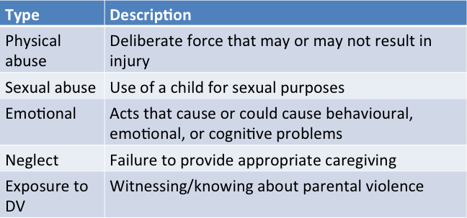

Canadian Survey of Child Abuse
(Trocomé et al., 2005; Figure 6.3)

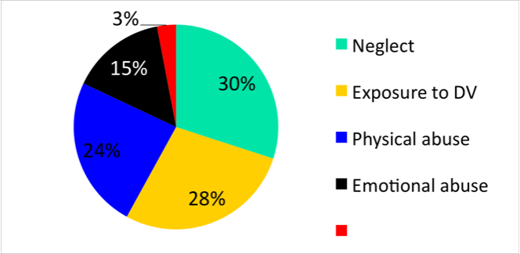

Risk Factors: Child Physical Abuse

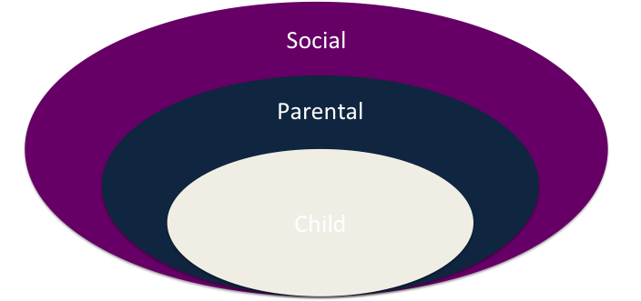

Consequences of physical abuse
- Short-term
  - Guilt, fear
  - Internalizing
  - Externalizing
- Long-term
- Intimate partner violence
- Nonfamilial violence (males)
- Abuse of own children

Consequences of sexual abuse
- Short-term
- Low self-esteem
- Inappropriate sexual behaviours
- PTSD
- Physical problems
- Long-term
- Depression/anxiety
- Victimization
- Alcohol problems
- Drug problems
- Sexual aggression

Against all Odds: Resilience
- Resilience: capacity for children to experience adverse events and not experience negative outcomes
- What factors are related to resilience?
  - Child, family, community

Classic Resiliency Study
(Werner & Smith, 1982, 1992)
- Longitudinal study
- 698 infants born in 1955
- Kaui, Hawaii
- Children followed up
  - 1, 2, 10, 18, 32, & 40
1/3 high risk
- 4 or more risk factors by age 2
- Poverty
- Perinatal health problems
- Congenital handicaps
- Low parent education
- Familial alcoholism
- Violence
- Instability/discord
- Mental Illness

Age 18
- 1/3 of high risk resilient
- Social competent
- High expectations
- Caring relationships
- Problem solving skills

Summary
- Children’s recall abilities
- Interviewing Techniques with children
- Can children accurately identify suspects in a lineup?
- Children: Testifying in court
- Child abuse

Juries

Today’s Class
- How are jurors selected?
- Representativeness and impartiality of juries
- CSI effect
- Variables related to verdicts

Jury Functions
- Apply the law provided by the Judge
- Asses evidence and determine guilt or innocence
- Wisdom of 12 (instead of 1)
- Conscience of the community
- Protect against out-of-date laws
- Increase knowledge about justice system

How is a Jury Selected?
- Juries Act
- Legislation outlining jury selection
- Jury summons
- Court order for jury duty
Selecting a Jury
- Selected from a listpart of jury pool(challenge for cause/peremptory challenges)selected as juror

Characteristics of a Jury
- Representativeness: A jury composition that represents the community where the crime occurred
- Impartiality: A characteristic of jurors who are unbiased
- Increasing Impartiality
- Change of venue: Moving a trial to a community other than the one in which the crime occurred
- Adjournment: Delaying the trial
- Challenge for cause: An option to reject biased jurors
- Unique to Canada

Jury Selection: Case-Specific
- Identify the characteristics of the “ideal” juror to have or to avoid
- Trial-consultants
- O.J. Simpson
- supplemental juror questionnaire (294 questions)

Example Questions: Simpson Trial
- Have you ever had your spouse or significant other call the police on you for any reason, even if you were not arrested?
- Have you ever asked a celebrity for an autograph?
- Have you ever given a blood sample to your doctor for testing?
- Are there any charities or organizations to which you make donations?
- Do you own any special knives (other than for cooking)?"

Jury Nullification
- Ignoring the law and using other criteria for verdict
- May occur when laws are out of date
- Nullification instructions may influence jury decision making producing both socially favourable and socially unfavourable verdicts

Studying Juror/Jury Behaviour
- Field study
  - Post-trial interviews
  - Archival
  - During actual trials
- Lab Study
  - Simulations

Post-Trial Interviews
- Not possible in Canada because jurors are forbidden by law from disclosing content of their deliberations
- Post-trial interviews with jurors from the U.S. can provide a valuable data source
- Limitations:
- Social desirability of responses
- Inaccurate recall

Archival Records
- Use of previously recorded information
- Limitations:
- Inability to establish cause and effect
- Limited in questions that can be researched
- No control over biases that may have influenced record

Simulation
- Mock jurors
- Written, video, or audio format of the trial
- Render verdict and make other judgments
- Factors of interest can be manipulated
- Limitations:
- Generalizability to real world is questionable

Field Studies
- Research conducted within a real trial
- Limitations:
- Permission from the courts may be difficult
- Variables of interest cannot be controlled

Juror Comprehension Aids
- Note-taking
- Meta-analyses suggest positive outcomes
- Asking questions
- Research suggests it’s basically neutral

CSI Effect
- Increased expectations concerning forensic evidence and the level of crime scene investigation
- Changes in the ways in which offenders (and possibly victims) behave
- Increased vocational interest in forensics

Examining the “CSI-effect”
(Kim et al., 2009)
- 1,029 jurors
- Given hypothetical cases with circumstantial evidence only, eyewitness only,
- How often do you watch CSI?
- 5 point scale (1 never, 5 regularly)

Consequences of the CSI effect
- Some defendants not found guilty despite a lot of evidence
- High bar for evidence (financial costs, time, plausibility)
- Ask questions related to TV watching in jury selection
- Tailor opening statements & closing arguments to address issues
- Expert witness to explain types of evidence & their relevancy

Jury Decision-Making Models
- Mathematical models
- Jury decision making is a set of mental calculations
- Explanation models
- Evidence is organized into a coherent whole
Story model
(Pennington & Hastie, 1986)
- Story constructionverdict categorystory classification

Extralegal Factors that may Influence a Verdict
1. Demographics
- Harsher to someone of another race
- If same race:
- Less harsh if weak case
- Harsher if strong case (black sheep effect)
- Can reduce racial bias
2. Personality Traits
- Authoritarianism
- Moderate pro-prosecution bias
- People who have more influence
- Extroversion
- Agreeableness
- Conscientiousness
- Emotional stability
- Openness experience

3. Attitudes
- No group of attitudes or values has received sufficient investigation
- Exception is capital punishment
- Death-qualified jurors more likely than non-death-qualified jurors to vote for conviction
- Case specific attitudes have more predictive power over verdict than general attitudes
4. Defendant Characteristics
- More likely to find someone guilty if know they have previous convictions
- Small relationship between attractiveness of the defendant and jury verdict

5. Victim Characteristics
- Particularly relevant in sexual assault cases
- Rape shield provisions
- May allow some inquiry into a woman’s sexual history at the judge’s discretion
- Onus is on the defendant to demonstrate that the accuser’s sexual history is relevant before it is allowed (R. v. Darrach, 2002)

Fitness to Stand Trial and Criminal Responsibility

Today’s Class
- Fitness to stand trial
- Canada’s insanity standard
- Cases of successful and unsuccessful in using a mental disorder as a defence
- Automatism
- Options for treating mentally ill offenders

Presumptions in Canada’s Legal System
- Elements that must be present for criminal guilt:
- Actus reus: A wrongful deed
- Mens rea: Criminal intent
- Must be found beyond a reasonable doubt for a guilty verdict to be reached

Fitness to Stand Trial
- Unfit to stand trial: An inability to conduct a defence at any stage of the proceedings on account of a mental disorder

Fitness Standard
- Unfit to stand trial if (due to mental disorder) unable to:
- Understand nature or object of proceedings
- Understand possible consequences of the proceedings
- Communicate with counsel
- Time limit on evaluation
- My be raised at various stages of the proceedings

Four Core Elements
- Focus is on defendant’s present ability
- Focus is on capacity not willingness
- Possess a reasonable knowledge
- Emphasis is on cognitive functioning and not on mental disorder

How does Canada determine who is unfit?
- Only medical practitioners
- Psychologists can help with assessment
- Use screening tools
- Then full examinations

Fitness Instruments
- Fitness Interview Test Revised (FIT-R)
- Competency Screening Test (CST)
- Competency to Stand Trial Assessment Instrument (CAI)
- Interdisciplinary Fitness Interview (IFI)
- MacArthur Competence Assessment Tool-Criminal Adjudication (MacCAT-CA)

What happens if someone is unfit?
- Proceedings halted until fit
- Reassessed within 45 days
- Try to get the person fit
- Most commonly medication
- Debate around right for person to refuse medication
- Treatment orders can be imposed
- If unlikely to become fit, court can stay proceedings according (Bill C-10)

What if person doesn’t become fit?
- If continues to be unfit after 90 days, get referred to review board
- Assessed every two years
- Once a year for youth
- Prima facie case
- Every 2 years or on request
- DIAGRAM OF PROCESS ON SLIDE 11

Mental State at Time of Offence
- Insanity: impairment of mental or emotional functioning that affects perceptions, beliefs, & motivations at time of offence
- Legally, insanity removes the responsibility of performing an act because of uncontrollable impulses or delusions
- Brief History

Daniel M’Naughten– 1843
- Tried to shoot Sir Robert Peel, the PM of Great Britain
- 1894: NGRI defence adopted in Canada
- 1992: Bill C-30

Canadian Legislation (Bill C-30)
- Insanity term changed to “not criminally responsible on account of mental disorder” (NCRMD)
- “…rendered the person incapable of appreciating the nature and quality of the act or omission or of knowing that it was wrong”
- Review boards were created

Not Criminally Responsible on Account of Mental Disorder (NCRMD)
- No person is criminally responsible for an act or omission committed while suffering from a mental disorder that rendered that person incapable of:
- Appreciating the nature and quality of the act or omission
- Knowing that it was wrong

Raising the Issue of Insanity
- In Canada, only two situations in which the Crown may raise insanity:
- Following a guilty verdict
- If the defence states the defendant has a mental illness

Assessing Insanity
- Insanity defence requires a psychiatric assessment
- Rogers Criminal Responsibility Assessment Scales (R-CRAS)
- First and only standardized assessment scale for criminal responsibility

Defendants Found NCRMD
- Three dispositions can be made:
- Absolute discharge
- Conditional discharge
- Psychiatric facility
- In Canada, dispositions are made by the court or a review board
- Reviewed yearly
- CHART OF PROCESS ON SLIDE 19

Factors Affecting Dispositions
- Four main criteria considered when deciding a disposition:
- Public safety
- Mental state of the defendant
- Reintegration of defendant into society
- Other needs of the defendant

Comparison of NCRMD and Fitness

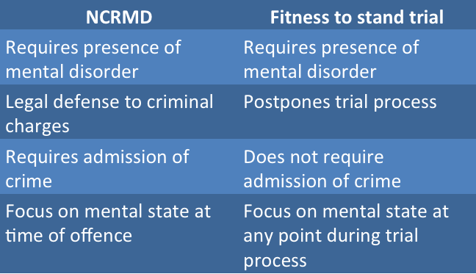

NCRMD: Common Myths
- Large number of defendants use the defence
- Majority of times the plea is successful
- Those found NCRMD are released back in society quickly
- Extreme dangerousness of NCRMD
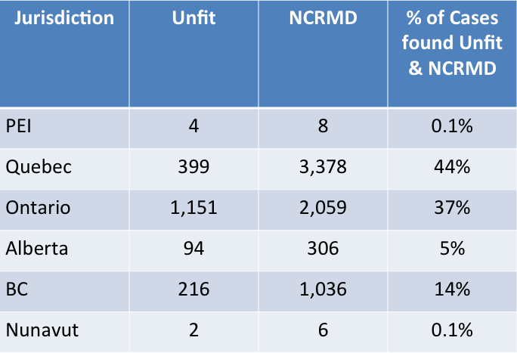

Unsuccessful Attempts
- Jeffrey Dahmer
- John Wayne Gacy
- David Berkowitz
- Mark Chapman

Successful Attempts
- Edward Gein
- John Hinckley
- Francine Hughes
- Lorena Bobbitt
- Jeffrey Arenburg

Tom McClean & Vincent Li
- “I believe that mentality ill or not, people who commit this type of horrific murder need to be held responsible.” (Tim McClean’s mother)
- Anyone who murders should serve life with no parole

High Rates of Mental Illness
- Individuals with a mental illness are arrested more often
- Individuals with a mental illness are more likely to get caught
- Individuals with a mental illness are more likely to plead guilty

Prevalence Rates of Psychiatric Disorders

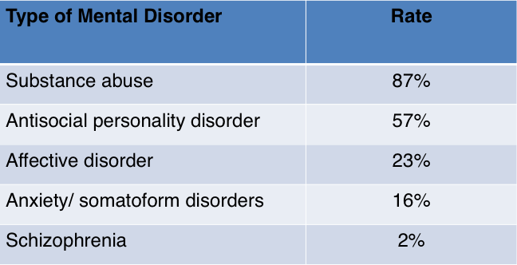

Automatism
- Unconscious, involuntary behaviour
- The person committing the act is not aware of what they are doing
- Premise
- Voluntary conduct is essential to be found guilty of committing an offence

Types of Automatism
- Supreme Court stated there are two forms of automatism:
- Insane
- Noninsane
- To address defences of automatism:
- Judge decides whether evidence exists that behaviour was involuntary
- Judge decides if condition is a mental disorder (insane) or sane automatism

Defences of Noninsane Automatism
- A physical blow (e.g., blow to the head)
- Physical ailments (e.g., stroke)
- Hypoglycemia (e.g., low blood sugar)
- Carbon monoxide poisoning
- Sleepwalking
- Involuntary intoxication
- Psychological blow from extraordinary external event

NCRMD versus Automatism
- Verdict outcome differs:
- Noninsane automatism results in a not guilty verdict
- Insane automatism results in an NCRMD verdict
- NCRMD verdict may result in defendant being sent to mental health facility

Automatism
- Unsuccessful
- R. v. Stone (1999)
- Defence: “exceptionally cruel, psychological sadistic, and profoundly rejecting” attack by wife
- Successful
- R. v. Parks (1992)

Intoxication as a Defense?
- R. v. Daviault (1994)
- In 1995, Bill-C-72 was passed
- Intoxication is not recognized as a defence for violent crimes

Dealing with Mentally Ill Offenders
- Police have two options:
- Mental health system
- Criminal justice system
- Biases may exist in the conditional release of mentally ill offenders
- Likely to be conditionally released as a result of mandatory supervision and to have their release suspended

Treatment Options
- Facilities for treatment include:
- Psychiatric institutions
- Hospitals
- Assisted housing units
- Community treatment orders
- Diversion

Mental Health Courts
- Objectives:
- Divert accused charged with minor to moderately serious criminal offences
- Facilitate a defendant’s fitness to stand trial evaluation
- Ensure treatment for a defendant’s mental disorders
- Decrease likelihood of repeat offences

Offender Treatment and Rehabilitation

Learning Objectives
- Historical background
- What works in offender treatment
- Meta-analysis
- Punishment-based strategies
- Principles of effective correctional treatment
- Risk, need, responsivity
- Specific populations
- Effective correctional workers

Brief historical background
- Extensive debate over “what works” in offender rehabilitation
- Early literature reviews by Bailey (1966) and Logan (1972) did not present favourable conclusions regarding the effectiveness of correctional intervention
- Argued that nothing works, we do not see a lot of gains in terms of reductions in crimes, etc.
- Martinson (1974) presented the “nothing works” conclusion in his paper that evaluated 231 research studies
- Have to be careful about how we define what works
- The answers to what works depends on how you define “working”
- Generally defined as something that reduces crime or recidivism rates
- Anything that doesn’t work is because recidivism stays the same, or goes up.

What works in offender treatment?
- Since Martinson’s time it has become clear that some things do work in offender treatment
- These findings have typically emerged from meta-analytic studies

Why meta-analysis?
- A meta-analysis is the statistical aggregation of the results derived from many independent studies in order to integrate the findings
- Primary unit of analysis is the effect size, which reflects the degree to which a comparison and treatment group differ on a particular measure (e.g., recidivism)

Interpreting effect sizes
- Effect sizes can vary in terms of:
- Magnitude (0.00-1.00)
- Sign (+ or -)
- The magnitude of the effect size tells you how much of an effect there is:
- A large effect size indicates that the intervention had a large effect
- A small effect size indicates that the intervention had a small effect
- 0 = no difference
- Interpret the sign to know in what direction the effect size is in
- The sign of the effect size tells you what type of effect the intervention had:
- A positive effect size indicates that the intervention had its intended effect of reducing recidivism
- A negative effect size indicates that the intervention had its unintended effect of increasing recidivism

Interpreting effect sizes
- Cognitive-behavioural treatment yields an effect size of +0.20
- Around a 50% reoffending rate
- The distance always has to equal the effect size (40 is 10 below 50, and 60 is 10 above 50. 10 + 10 = 20 = effect size)
- CBT is the treatment that is used most commonly for offenders
- What does this mean?
- The treatment group has a recidivism rate of 40% and your comparison group has a recidivism rate of 60%
- Relapse prevention therapy yields an effect size of +0.60
- What does this mean?
- The treatment group has a recidivism rate of 20% and your comparison group has a recidivism rate of 80%
- Divide .60 by 2 = .30
- Add 30 to 50 and subtract 30 from 50
- 20 and 80
- Boot camps yield an effect size of -0.20
- What does this mean?
- The treatment group has a recidivism rate of 60% and your comparison group has a recidivism rate of 40%
- Long prison sentences yield an effect size of -0.60
- What does this mean?
- The treatment group has a recidivism rate of 80% and your comparison group has a recidivism rate of 20%

The effectiveness of punishment-based strategies
- Historically the CJS in North America has used “get tough” strategies to deal with offenders
- This was assumed to be based on a deterrence theory
- People will not commit crime for fear of what will happen to them if they do
- These strategies vary in degree of severity from incarceration to intermediate sanctions (e.g., house arrest, curfews, restitution, Life in prison, death penalty, etc.)
- The objective with these strategies is to reduce recidivism by accomplishing both specific and general deterrence
- Specific to the person
- General by having the public see how the offender is punished
- Researchers have now used meta-analysis to review the evidence for a range of get tough strategies
- The results overwhelmingly support the argument that, if our goal is to reduce recidivism, get tough strategies are not effective

Gendreau et al., 2001
- Huge sample sizes – benefit of meta analyses
The only ways you get small improvements is with fines and restitutions

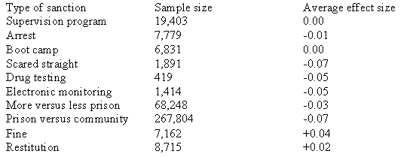

And, yet, still more punishment
- Despite these findings, get tough strategies are still the most common response to crime and new strategies are being proposed on a yearly basis
- Why might this be the case?
- To make the public feel justice was served perhaps
- For example:
- Making male offenders wear women’s clothing (Wilson et al., 1993)
- The use of corporal punishment (e.g., electric shocks) (Newman, 1995)

Why don’t these approaches work?
- Punishment is defined as a negative consequence to a behaviour that decreases the likelihood of the behaviour from re-occurring
- We know that punishment can work to decrease behaviour (e.g., from lab-based studies) so why does it not work to decrease offending behaviour
- All of the reasons that make punishment work are not present in the offender community

6 reasons why punishment doesn’t work (Andrews & Bonta, 2006)
- Reason 1 – Intensity:
- Low levels of punishment will decrease a behaviour but only temporarily
- When the behaviour returns more severe punishment is required to decrease it
- Results in an escalating cycle of punishment as tolerance increases
- In our CJS we do not provide punishment at maximum intensity and it would be unfair to do so
- Reason 2 – Immediacy:
- For punishment to work it must immediately follow the behaviour we are trying to suppress
- If there are delays the target behaviour may be reinforced and some other behaviour is punished
- In our CJS punishment is not delivered immediately and therefore the behaviours that need to be targeted are not
- Reason 3 – Consistency:
- In order for punishment to work it must be delivered every time the target behaviour occurs until there is complete suppression
- This repeated pairing of punishment with behaviour allows the behaviour to become a signal of impending punishment
- In our CJS many instances of crime go unpunished altogether and commonly similar behaviours are punished with differing intensities
- Often based on criminally irrelevant information such as gender of defendant
- Reason 4 – No escape:
- For punishment to work escape routes must be blocked
- In other words, if an individual can get themselves away from the punishment and accomplish their objective by some other means, punishment has not really worked
- In our CJS it is not usually possible to block escape routes (e.g., punishing one criminal behaviour still leaves open the possibility of performing many other criminal behaviours)
- Reason 5 – Person variables:
- Person factors will influence the effectiveness of punishment
- These factors can include biological, cognitive, and state conditions, as well as a range of demographic variables (e.g., consider the psychopath who does not experience fear or anxiety)
- Many offender serving time in our CJS possess characteristics or traits that reduce the potential impact of punishment

So why do we keep punishing?
- People believe in the effect of punishment
- Politicians think that getting tough on crime is what the public wants
- Public is often very misinformed
- Rehabilitation is seen as soft and ineffective
- It takes time and energy to evaluate programs, find they are not working, and initiate new programs
- Eye for an eye mentality

Principles of effective correctional intervention
- If not punishment, then what…
- Psychologists have recently proposed ways of improving the effectiveness of correctional intervention (Andrews et al., 1990)
- The following principles appear to be among those that are most important:
- Risk principle
- Need principle
- Responsivity principle
- These are not the only ones but they are possibly the most important and they are in the textbook

Risk principle
- Consists of two components:
- Risk of re-offending can be predicted
- Higher risk offenders should be provided with more intense (and extensive) interventions
- Recidivism rates will actually increase if we target low risk offenders
- Why?
- We want to target certain things in target treatments if we want to reduce criminal behaviours
- In treatment programs in prisons all participants are combined – but the very things we want to decrease are increased (non-anti social peers, etc.)
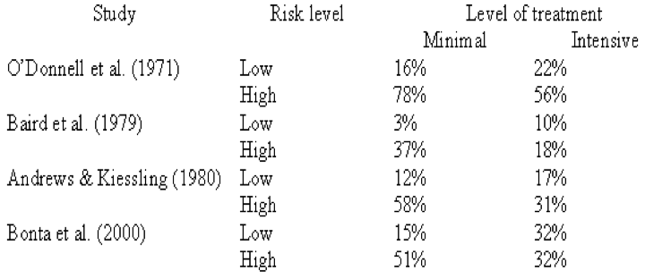

Need principle
- Criminogenic needs must be targeted in order to reduce recidivism
- Criminogenic needs are needs that must be met in order for crime rates to go down
- When these needs are met crime goes down
- These needs represent dynamic risk factors that, when changed, will effect the likelihood of re-offending
- Non-criminogenic needs are also dynamic and changeable but are unrelated (or at least weakly associated) with recidivism
- Seems intuitive to target these non-criminoenic needs, but when they are targetted they have no effect

Examples of criminogenic needs
- Changing antisocial attitudes
- Changing antisocial feelings
- Reducing antisocial peer associations
- Promoting identification with prosocial role models
- Promoting familial affection/communication
- Promoting familial monitoring and supervision
- Increasing self-control, self-management, and problem- solving
- Substance abuse
- Academic and vocational deficits
- Recognition of risky situations

Examples of non-criminogenic needs
- Increasing self-esteem (without reductions in antisocial thinking, feeling, and peers)
- Focusing on vague emotional/personal problems
- Increasing cohesiveness of antisocial peer groups
- Neighborhood-wide improvements without touching the needs of higher risk individuals
- Increasing conventional ambition (work/school) without concrete assistance to achieve them
- Fear of official punishment (i.e. “Scared Straight”)
- Physical training programs
- These are worth while to target for various reasons, however reducing recidivisim is not one of these reasons

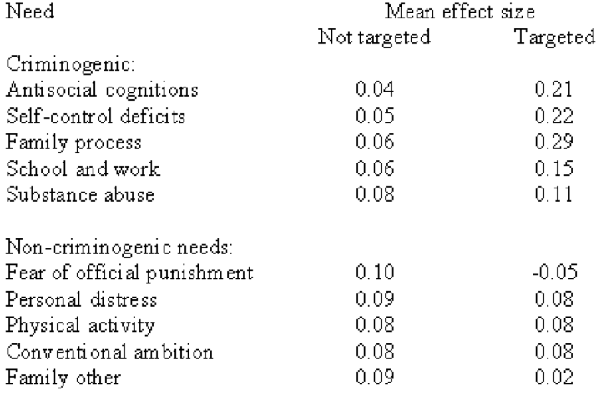

Responsivity principle
- For correctional interventions to be effective they must be delivered in a style and mode that is consistent with the ability and learning style of the offender (general responsivity – subtype 1)
- Generally it is assumed that a cognitive-behavioural approach to treatment will be most effective
- In addition, the intervention should be tailored to be consistent with the specific characteristics of the offender in terms of their motivation to change, personality, and demographic characteristics (specific responsivity – subtype 2)
- Still saying match the treatment to the offender
- But now we’re saying to tailor the treatment to the offender’s personal needs and characteristics
- Example giving independent homework to unmotivated, inarticulate offenders is not good

The effectiveness of programs that abide by these principles
- Intervention programs that take into account these principles are more effective at reducing rates of recidivism
Findings
ON SLIDES 34 – 35 and 37 – 40

Specific populations
- A lot of recent research has explored the extent to which these results generalize to different groups of offenders and different settings
- The results indicate that generalization does occur for women offender, juvenile offenders, violent offenders, sexual offenders, old offenders, young offenders, community samples, etc.
- Women offenders
- More women offenders
- Does age matter?
- Does setting matter?

Effective correctional workers
- For a correctional worker to be effective they must possess certain characteristics:
- They must be able to establish high quality relationships with offenders
- They must effectively demonstrate anticriminal expressions (modeling)
- They must approve of the offender’s anticriminal expressions (reinforcement)
- They must disapprove of the offender’s procriminal expressions (punishment)
- They must make appropriate use of their authority

Are these things really important?

- Staff Characteristics Freq Mean r
- Relationship factors 13 .34***
- Effective modeling 37 .28***
- Rewarded behavior 21 .28***
- Coping model 3 .32*
- Effective approval 15 .31***
- Explains reasons for reward 10 .35***
- Immediate reinforcement 7 .35***
- Client reflection 6 .33**
- Effective disapproval 8 .30***
- Alternatives provided 5 .34**
- Client reflection 5 .27*
- Immediate disapproval 3 .45**
- Problem-solving 45 .25***
- Identify the problem 18 .20**
- Implement a plan 18 .17*
- Clarify goals 17 .28***
- Evaluate the options 16 .31***
- Generate alternatives 16 .29***
- Evaluate the plan 3 .32*

Conclusions
- Human service must be provided not punishment-based sanctions
- Higher risk clients must be targeted
- Criminogenic needs must be included within the treatment targets (the more the better)
- Adherence to general and specific responsivity principles is advised
- Increased adherence to principles of ECT maximize reductions in reoffending
- Non-residential settings are the key if maximum reductions in recidivism are desired
- If these offenders are not too dangerous to have in the community
- Staff must be motivated and well trained

Summary
- Historical background
- What works in offender treatment
- Meta-analysis
- Punishment-based strategies
- Principles of effective correctional treatment
- Risk, need, responsivity
- Specific populations
- Effective correctional workers

Sentencing and Parole

Today’s Class
- Purposes and principles of sentencing
- Sentencing options
- Sentencing disparity
- Parole

Why do we sentence people?
- Specific deterrence
- General deterrence
- Denunciation
- Incapacitation
- Reparation
- Rehabilitation
- Responsibility

The Principles of Sentencing in Canada
- Must be proportionate to the gravity of the offence and the degree of responsibility of the offender
- Consider aggravating and mitigating factors
- Consistency
- Consider aggregate sentence
- Use alternatives to incarceration if at all possible

Sentencing Options in Canada
- Absolute or conditional discharge
- Probation
- Restitution
- Fines and community service
- Conditional sentence
- Imprisonment
- Additional options for high-risk offenders

Dangerous Offenders
- A dangerous offender application can be made for any offender convicted of a serious personal injury offence who constitutes a danger to others
- Requires a determination of dangerousness
- Indeterminate sentence
- Fewer than 500 in Canada
- 1 woman

Long-Term Offenders
- The long term offender designation is relatively new to Canada
- Must meet several criteria:
- Sentence of 2+ years is appropriate
- Risk of re-offending
- Reasonable possibility of eventual control of risk
- Receives a sentence of at least 2 years followed by a period of supervision

Are the Goals of Sentencing Achieved?
- Ongoing debate about deterrence and rehabilitation
- Many researchers do not believe that get-tough strategies reduce crime
- However, certain rehabilitative efforts do appear to reduce re-offending

Crime Rates in Canada

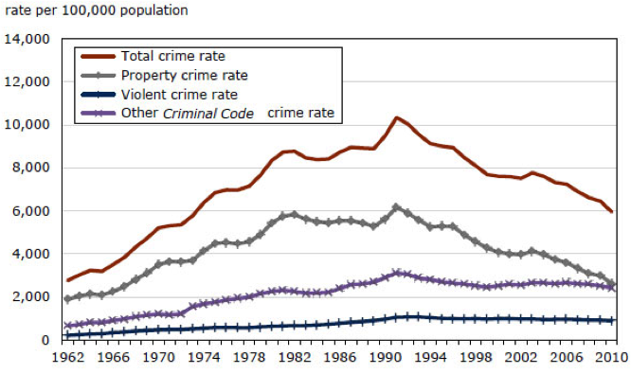

Unwarranted Sentencing Disparity
- Unwarranted sentencing disparity results from a reliance on extra-legal factors
- These factors can be categorized as:
- Systematic factors
- Unsystematic factors

Studying Sentencing Disparity
- Sentencing disparity is typically studied in one of two ways:
- Simulation studies
- Official sentencing statistics
- Using either method it is clear that sentencing disparity exists in Canada

Put in order of severity
(McFatter, 1986)
- Rape and murder of 11-year-old girl.
- Offender stole purse from elderly lady on street.
- Offender talked his way into apartment, raped woman.
- Offender shoplifted $500 camera.
- Offender broke into a home and stole colour TV.
- Fight after minor traffic accident, victim injured.
- Drunk driving caused accident killing one person.
- Offender forged a check for $2000 from former employer.
- Robbery at gunpoint, victim grabbed for gun and killed.
- Robbery at gunpoint, unprovoked killing.
- Theft of tape deck from locked car.
- Robbery at gunpoint, victim handed over wallet.
- Theft of $5 from unlocked car.

Reducing Sentencing Disparity
- Sentencing guidelines
- In Canada, very broad and may not significantly reduce sentencing disparity
Simulation Study
(Palys & Divorski, 1986)
- 206 provincial court judges
- Five cases
- Assault CBH, Impaired Driving, Armed Robbery, B & E, Theft > $200
- Judges asked to
- Impose a sentence
- What sentence would you impose?

Assault Causing Bodily Harm
- Ray is a 21-year old, employed, White male who had no prior record, but who had a reputation for belligerence when drunk. The offence took place in a bar and was unprovoked. The victim lost an eye in the incident. Ray expressed no remorse.

Impaired Driving
- Joe was a 55-year old, highly successful, self-employed business person with no prior record. The incident occurred after a friend’s son’s wedding, where Joe drank profusely. Choosing to drive home despite being drunk, Joe caused a traffic accident with resulted in the death of 2 children.

Armed Robbery
- An elderly couple were tied up, threatened, and held at gunpoint in their home, while 2 people robbed them of several thousand dollars of cash and jewelry. One offender, John, was an 18-year old, Aboriginal from a deprived background. He had a prior juvenile record, but not as an adult. The second offender, Mike, was a 29-year old White male who was both married and employed. He had an alcohol problem, and was drunk at the time of the offence, and had a prior record of 5 convictions, although the most recent was 6 years old.

Parole in Canada
- Parole involves:
- Conditional release into community
- Rehabilitation
- A high degree of supervision
- Return to prison if conditions are breached

Types of Release
- Temporary absences (anytime)
- Day parole (serve 1/6 sentence)
- Full parole (serve 1/3 sentence)
- Statutory release (must be released after 2/3 sentence)
- Doesn’t apply for life or indeterminates
- Automatic unless CSC recommends otherwise

Parole Decision Making
- Decisions are made by members of Parole Board of Canada (PBC)
- A formal hearing takes place between the offender and the PBC
- A formal risk assessment is conducted
- List of things to consider, but little guidance on how

What does a hearing look like?
- Most are held in institutions
- People involved:
- Offender
- 2 board members conduct hearings
- Offender's assistant,
- The offender's parole officer from CSC
- Hearing officer from the PBC
- Elder (if it is an Elder-assisted hearing)
- Victim making a presentation

Conditions of Parole
- All types of parole are supervised by CSC
- Parole officers
- Assistance from community groups
- Various conditions of parole must be met or the offender may go back to prison

Myths Concerning Parole
- Parole reduces sentence time
- Parole is automatically granted when inmates become eligible
- Parole is granted if remorse is shown
- Offenders released on parole frequently recidivate
- Victims do not play a role in parole decisions

Public Perceptions of Parole
- Why are public perceptions important?
- System relies on victim cooperation
- Judges are sensitive to public perceptions
- Government is sensitive to public perceptions

Factors That Influence Public Attitudes
- Discrepancy between attitudes and reality
- Lack of understanding of the criminal justice system
- Effect of media

Public Attitudes Towards the Criminal Justice System
- There are three methods that are commonly used to study public attitudes towards the criminal justice system:
- Simulation studies
- Focus groups
- Public opinion polls (most common)
- Common Attitudes

Results of public opinion polls indicate that Canadians:
- View the criminal justice system in a relatively positive light (especially the police)
- Believe that offenders are treated too leniently (sentencing)
- Support alternatives to sentencing under certain conditions

Summary
- Purposes and principles of sentencing
- Sentencing options
- Sentencing disparity
- Parole

Exciting Crime (added notes done)

Introduction
- When and why do offenders stop committing crimes?
- What does the ex-offender look like? What kind of behaviors, attitudes, etc. to they express?
- At what point would we consider someone an “ex-offender”?

Today’s Objectives
- Do people stop committing crimes?
- Why do they stop committing crimes?
- What is the process of desistance?
- How does this perspective benefit the Criminal Justice System (CJS)?
- Film/Case Study Activity

The Age-Crime Curve
- Research consistently shows:
- Criminal behaviour peaks in late adolescence/early adulthood
- Shows a sharp decline after age 30
- Suggests to us: why aren’t we more optimistic

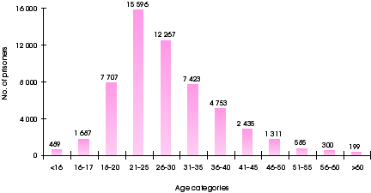

The Age-Crime Curve
- Adult criminal career
  - 6 years
  - 17 years
- Wide variation
  - 4-30 years
- Psychopathic offenders desist later: between the ages of 30 and 40

How does Age affect Crime?
- Decline in physical strength
- Lost contact with antisocial peers
- Don’t see high school friends as much anymore, etc.
- Maturation
- In the early days people said that criminals don’t mature until later on
- Change in social/institutional environment
- A steady job and the right women
- Cognitive changes/changes in subjective interpretation of environment

Other Reasons Behind Age-Crime Curve
- Learning to evade detection
- Maybe they are still committing crimes but they don’t get caught in their 50s and 60s
- Change from illegal to legal antisocial activities
- Maybe they’re not changing, but they’re not getting arrested or in the system anymore
- Ongoing antisocial behavior that does not lead to arrest

Research on the Mechanisms Behind Desistance

Burn Out
- Physical ageing – not a lot of research
- 50% of active offenders believed they were in worse physical condition at time of interview compared to 5 years prior
- Compared active offenders to offenders who hadn’t committed crimes in at least 2 years
- 20% of desisting offenders endorsed this belief
- Ex offenders said they were in better conditions than the offenders – suggests that the people most capable of it were the ones who weren’t committing crimes
- Many ex-offenders felt they were in better condition due to abstinence from drugs

The Genius-Age Link
- Scientific productivity fades rapidly with age
- Most significant contributions occur during the five years around age 30
- Found this for many professions (Jazz Musicians, authors, artists)
- Female curve does not look the same
- Strongest contributions made all over the place – no pattern

An Evolutionary Process?
- Competitive effort
- Leads to productivity of different kinds
- Increases one’s reproductive success
- Males put in all the effort to attract others, etc. around this period of time

But, is it the same for everybody?
- Where are the individual differences?
- Burn out
- Not everyone is burning out, if they are it’s not at the same rate
- Other biological changes
- Unconscious desire for reproduction (evolutionary influences)

Different Trajectories within the Curve
- ON SLIDE 13
- Around 70% of offenders follow curve
- 50% are in the process of desisting
- At any one point they are on their way out of crime
- This is a high number but there are still issues such as below
- Age of onset important predictor in how long career lasts – finish at same age
- Most people finish at the same age but people who started earlier have longer histories of criminal activity
- Initial severity level and number of offences also important
- If you start off with a bang you are going to last longer than if you just started with one crime or a weak crime, etc.
- No smooth lines

But, still, some offenders desist while others persist…why?
For those who desist…how?
RISK FACTORS AND STRENGTHS ON SLIDE 16
- Risk factors told where they were in the beginning, but it was the strength factors that determined where they ended up
- This is just an idea that comes from a depression study
- There must be some strengths that help people desist after time

Desistance ≠ Reverse of Risk
- Desistance cannot occur without history of crime
- Have to be people who are heavily into crime
- Early criminal history variables predict early adult offending, but lose predictive power
- We can’t use info about your early criminal career to predict their desistance
- Variation in criminal career cannot be explained entirely by pre-criminal individual differences
- What keeps them crime free are very different than the things that started them with crime or kept them persistent
- Offenders report different risk/desistance factors

What are the strengths?
- Adult Opportunities/Variables
- Substance recovery
- Employment
- Marriage
- Shifts in thinking/beliefs
- May be others but these are the most heavily researched
Substance Misuse
- Giving up substances often key part of giving up crime
- However, understanding the motivation & effort to become sober is not as clear cut
- Takes a lot of strengths and resources and strong internal willpower to get out of it
- Easier to get into it
- Very different things predicting substance abuse and substance quitting
- Recovery from addiction requires many internal & external resources/strengths

Desistance & Life Factors
- Employment
- Marriage
  - Estimates around 30-35% reduction effect
    - Taking into account 25 variables that predict getting married
    - Twin study using MZ brothers as comparison
- Just getting married helps about 30-35% of people
- Maybe there is something causal about marriage and crime

Marriage & Desistance
- Differential Association
- Disassociation with antisocial peers (Warr, 1998)
- Not actually the marriage itself but that the spouse is taking them away from their peers
- Social Control Theory
- Stakes in conformity (Sampson & Laub, 2005)
- If you get your life going really well, get yourself into a positive relationship you really enjoy you don’t want to mess it up
- I won’t commit another crime because if I do my wife will leave me, etc.
- Quality of Marital Attachment
- Relationship quality (Laub et al., 1998; Maume et al., 2005)
- Only enduring marriages associated with decreases in crime (Theobald & Farrington, 2010)
    - If the marriage dissolved within 5 years the criminals went back to crime and hit the ground running
    - Not just any marriage will do – has to be a high quality marriage
- The other two pale in comparison to this last bullet point
Example: Marriage & Drug Use
- Graph
  - y-axis = cocaine and heroine use, x-axis = treatment sessions
  - steady decline
- However, those who were married were better than those who were living together, who were better than those who were single
  - Even a low satisfaction marriage was better than living together or being single
  - But those who had a low satisfaction marriage and who were separated did less drugs if they were low in satisfaction and stayed with their partner
  - If you have a high quality marriage the person does worse with quitting alcohol – weird situation..

Policy Implications?
- Teach social skills needed to sustain relationships
- From a young age
- Encourage commitment to relationship
- Encourage children to consider benefits of marriage over other forms of partnerships

Policy Implications?
- But, isn’t marriage changing?
  - Social shifts in perception/definition of marriage
  - While cohabiting does not have a desistance, most studies can be criticized for being several decades old
  - What explains: quality, commitment or both?
  - More than just walking down the aisle, they have to invest in the marriage
  - People who are desisting are making loads of good changes in their lives –they are not just getting married
- Reconnecting with their children or prosocial family, getting rid of antisocial peers, getting a job, etc.

Multiple Aspects
- Giving up crime – doesn’t occur in a vacuum
- Often must make strides in multiple life areas
- For example: is family influence an internal or external variable? Arguably its both
- Want to please their family member, etc.
- Internal aspectsexternal aspects
- External aspectsinternal aspects

Expectations/Beliefs
- Expectations change over time
- Estimated payoffs from crime lowers with age
- Individuals who believe a job will pay better than crime = lower risk
- Different expectations related to changes in crime in adolescence

Ongoing Maintenance
- Substance abuse recovery
- Employment
- Marriage
All long-term commitments that require ongoing maintenance
- Not one time things
- Not going to keep your job if you only do a good job on the first day
- Not going to keep your marriage if you are a good husband/wife on the first day and then you suck after that
- Desistence has to be about committing to the long term

Main Desistance Theories
- Social Control Theory
- Bonds give offenders “something to lose”
- Stake in conformity
- Social Learning Theory
- Experience reinforcement for lawful behavior
- Partner could influence you (30-35%) effect on your behavior
- Cognitive Transformation Theory
- Openness to change
- Want to go to AA, want the job, want the marriage, etc.
- External supports
- Re-interpret self
- Life Course Theory
- Integrates all three theories

From Why to How
- The Process of Desistance

Process vs. Event
- Desistance is more than cessation
- Desistance is not defeat
- I tried to be good at crime but I was bad at it and I decided to try something else
- Not the case
- Instead the first time they said “I want to get out of life what I want to get out of it”
- Desistance is not a single event
- Desistance happens over time
- “long-term abstinence from crime among individuals who had previously engaged in persistent patterns of criminal re-offending”
DIAGRAM ON SLIDE 31
Internal change factors
- See yourself as a non-criminal
- Change in beliefs
- The expectations you have
- Beliefs have to sustain your commitment to change
External Change Factors
- World has to work with you in order for it to happen
- Not going to work if your P.O is a jerk
- Have to have positive relationships
- Supportive community, etc.
- Internal and external change factors will work together to help them desist and help them stay committed even when it gets hard

The Change Process
- The optimism of inmates
- 80-95% of inmates upon release stated that they had decided to desist
- Say this is their last time
- 20 months after release, 60% of the sample reported re-offending

Intrapersonal Change
- If offenders are all motivated, what separates those who succeed?
- Is there a threshold of motivation?
- What internal shifts help offenders embrace change & transform themselves to give up crime?

Intrapersonal Change
- What attitude shifts underlie desistance?
- What self-beliefs may stimulate….?
- Establishing new goals
- Adopting new behaviors
- Changing old habits
- Sustaining effort to persevere
- Maintaining new behaviors once established

Agency – can they do it?
- “I’m smart enough to learn skills and anything else I need to learn to help me live a crime-free life.”
- “When I try to stop myself from doing crime, there are too many things that stop me from doing what I’m trying to do.”

Belief = Process (not overnight)
- “When someone tries to stop committing crimes, does it happen all at once, or does it take several steps before they can finally stop committing crimes?”

Crime Expectancies
- Positive
- “You will feel a good thrill or excitement”
- “You will have a better life”
- Do they think positive things will happen if they try really hard vs. negative things after they try really hard
- Negative
- “You will get hurt or killed”
- “You will lose respect from others”

Desistance Expectancies
- Positive
- “You won’t worry about prison or arrest again”
- Negative
- “You won’t achieve your goals”
- “You will live on lower income, at least for a while”
- Effort Expectancies
- “You won’t be able to give up, even when things seem hopeless”

DIAGRAM ON SLIDE 39
Some people seem very ready to desist and others plan to commit another crime
- My life will be better if I continue to commit crimes vs. I don’t want to commit crime anymore
- Crime belief predicted whether they committed another crime
- Desistence expectancies didn’t really do it

Contributions to the Field
- Research interest in desistance is not new
- Rigorous testing/measuring of important psychological constructs
- Measuring with more rigor than any one else in the field
- Fit these into a testable model of offender change

Implications
- Changes in rehabilitation
- Be more positive focused
- Right now we have you need to avoid crime
- Avoid situations or people that will get you involved in crime
- However now we are finding out that criminals are more invested if they have things to work towards and look forward to
- Focus on strengths not weaknesses
- Better risk assessment for older offender populations
- Greater understanding of adult development
- Very difficult time predicting crime for adults over 35 years old
- Don’t know what older offenders are doing
- Maybe if we understand the process more we will be able to do better

Future Directions
- Toward a comprehensive understanding of offender change
- Examine the nature of change & the ability to influence change

Re-integration
- How can we assist offenders’ transitions toward a pro-social identity?

“Does a model of PERMANENT STIGMATIZATION or one of REINTEGRATION best ensure public safety?”

How would a desistance-focused CJS operate?
- View desistance as an ongoing process
- Support offenders in their development
- El vs. SEPTA (2007)
- Risk converges at 7-10 years after first conviction
- Must take into consideration age and # of previous offences
- After about 7-10 years of being crime free their likelihood of committing a crime is the same as anyone else in the population(even after considering age and previous offences)
- Try to make periods of non-offending “stick” (Maruna et al., 2004)
- Take whatever makes them crime free and promote it so that it sticks
- Actively re-integrate offenders via ritual (Maruna, 2007)

Summary
- Do people stop committing crimes?
- Age-crime curve
- Why do they stop committing crimes?
- Burn out, evolution
- What is the process of desistance?
- Individual differences – internal/external
- Would a criminal justice system that focused on desistance processes be a better functioning system of justice?
- Community corrections
- Greater predictive ability
- Fine-tuning what we have now?

Risk Assessment

Learning Objectives:
- What is risk assessment
- Static and dynamic risk factors
- Approaches to risk assessment
- Issues with special populations
- Issues in picking a risk assessment instrument
- Level of predictive accuracy

Why Should We Care?
- The public sure does. Always a hot topic!
- Who wants to live next door to a high-risk sex offender???
- What would you do if someone who was on parole assaulted you?
- Risk assessment informs:
- Sentencing (especially D.O. hearings), classification, treatment needs, treatment intensity, parole decisions, level of supervision, notification decisions, release conditions…

Risk Assessment
- Risk prediction
- Assess the risk that people will commit another offence in the future
- Risk management
- Develop effective intervention strategies to manage that risk

Is This Person at Risk?
- Jack (sex offender):
- 36 years old; Only child
- Frequent contact with both parents who visit often
- Completed university. Worked as engineer for same company for past 10 years
- No criminal record
- Obsessed with pornography
- Regularly utilizes services of prostitutes
- Cannot maintain a relationship with an adult woman
- Believes that young children are mature enough to consent to sexual activity, and having sex with them is okay as long as no violence is used

Origins of Risk Assessment
- Baxstrom Case (1966, U.S. Supreme Court)
- 966 “criminally insane” and “dangerous” patients released or moved to low security
- 98 released patients followed for four years
- 20 rearrested, only 2 for violent offences
Goals of Risk Assessment
- Improve accuracy
- Improve transparency
- Improve consistency
What do we Consider in a Risk Assessment?
- Risk Factors
- A variable that is related to recidivism

Static Risk Factors
- Fixed and unchanging
- Most convenient
- Most frequently used
- Can be reliably measured and are very predictive

Examples of Static Risk Factors
- Demographic variables
- History of criminal behaviour
- Childhood history

Dynamic Risk Factors
- Change with time
- Less convenient, less reliable
- Less frequently used
- BUT: sensitive to change. With intervention, can change level of risk

Examples of Dynamic Risk Factors
- 2 main types:
1) Stable dynamic: persistent and change slowly, if at all.
2) Acute dynamic: rapidly fluctuating

“Central 8” Risk Factors
1) Criminal History
2) Procriminal Personality (impulsive, aggressive)
3) Procriminal Attitudes
4) Procriminal Associates
5) Family/Marital Problems
6) School/Work Problems
7) Inappropriate use of Leisure Time
8) Substance Abuse

NOT risk factors
- These variables are commonly mistaken for risk factors
- Low SES
- Personal distress/psychopathology
- Also includes low self-esteem or depression
- Fear of punishment
- Verbal intelligence
- Remorse/empathy
- Offence severity

Unique Risk Factors
- Domestic Violence
- Jealousy, number of step-children, hostility towards women
- Sexual Offending
- Sexual preoccupations, deviant sexual interests, emotional identification with children, stranger victims

Approaches
1. Unstructured clinical judgment
2. Actuarial tools
3. Structured professional judgment

Unstructured Clinical Judgment
- Subjectively select, analyze, and interpret risk factors
- Unstructured Clinical Judgment
  - Advantages
- Flexible
- Idiographic
- Disadvantages
- Inconsistent
- Low accuracy

Actuarial Tools
- Collect pre-specified risk factors and enter them into a statistical model that combines and weights them

Actuarial
- Advantages
- Consistent
- High accuracy
- Often has recidivism estimates
- Disadvantages
- Nomothetic
- Validity across different samples

Actuarial Example: VRAG
- Quinsey et al. (2001)
- Consists of 12 weighted static risk factors
- Added together to give overall probability of risk
- Developed to assess risk of violence
Actuarial Example: VRAG Items
- 1. PCL-R score (+)
- 2. Elementary school problems (+)
- 3. Personality disorder (+)
- 4. Separated from parents (+)
- 5. Failure on prior release (+)
- 6. Alcohol abuse (+)
- 7. Nonviolent offense history (+)
- 8. Never married (+)
- 9. Schizophrenia (-)
- 10. Victim injury (-)
- 11. Female victim (-)
- 12. Age (-)

Actuarial Example: VRAG Administration
- Code presence of risk factors
- Total the scores
- Assign individual to 1 of 9 bins
- Estimate probability of violence

VRAG Risk Ratings
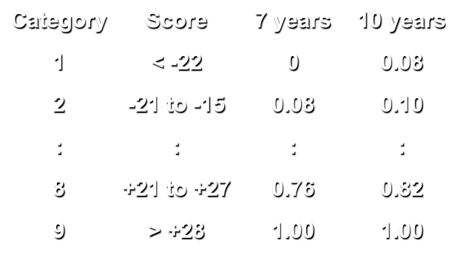

Level of Service Inventory - Revised (LSI-R)
- Andrews & Bonta (1995):
- Developed to assess risk of general recidivism
- 54-items broken down into 10 sub-components (tapping the Central 8)
- Actuarial
- Well-researched; may be one of the best risk scales we have

Structured Professional Judgment
- Collect pre-specified risk factors while adding in any case specific details
- Final assessment of risk is a clinical judgment (informed by empirical risk factors)

Structured Professional Judgment
- Advantages
- Flexible
- Nomothetic-Idiographic
- Disadvantages
- Moderate accuracy (clinical judgment)
- Less consistent than actuarial
- Not conducive to recidivism estimates

HCR-20
- Webster et al. (1997):
- Developed to assess risk for violence
- Consists of 20 items
- Can include any other case-specific information that the assessor feels is important

HCR-20 items
- Historical items:
(1) Previous violence
(2) Young violence
(3) Relationship instability
(4) Employment problems
(5) Substance use problems
(6) Major mental illness
(7) Psychopathy
(8) Early maladjustment
(9) Personality disorder
(10) Prior supervision failure
- Clinical items:
(1) Lack of insight
(2) Negative attitudes
(3) Active symptoms of MI
(4) Impulsivity
(5) Unresponsive to Tx
- Risk management items:
(1) Plans lack feasibility
(2) Exposure to destabilizers
(3) Lack of personal support
(4) Non-compliance
(5) Stress

SPJ Example: HCR-20 Administration
- Code presence of risk factors
- Code case-specific risk factors
- Subjectively decide on level of risk

HCR-20 Risk Ratings
- Low risk - monitor and intervene with low priority and intensity
- Mid risk - monitor and intervene with some priority and intensity
- High risk - monitor and intervene with high priority and intensity

Generations of Risk Assessment
- 1st Generation
- Unstructured professional judgment
- 2nd Generation
- Actuarial, empirical, typically static factors
- 3rd Generation
- Typically actuarial. Static AND dynamic factors
- 4th Generation
- Comprehensive guide from intake to case closure. Assessment, management, treatment progress

Where does SPJ fit?
- Andrews, Bonta, & Wormith (2006)
- Variation of first generation
- Quinsey, Rice, Harris, & Cormier (2006)
- “Actuarial methods are too good and clinical judgment too poor to risk contaminating the former with the latter” (p. 171)
- BUT, qualitatively and empirically different from unstructured judgment
- SPJ likely fits somewhere within the 2nd and 3rd generation

Does it Matter Which One You Pick?
- Absolutely
- Different methods (clinical, actuarial, SPJ)
- Designed for different types of offenders
- Designed to predict different outcomes
- Not all can inform interventions
- Even scales designed for same purposes provide different answers (little consistency across instruments)

Does it matter which one you pick?
- Meta-analyses with sex offender risk assessment
- Measures designed to predict sexual recidivism do best job predicting sexual recidivism
- Measures designed to predict violent recidivism best predict violent recidivism
- Measures designed to predict general recidivism best predict general recidivism

What about Measures for Special Offender Groups?
- Depends – are there truly unique risk factors for the groups?
- Violent and sex offender measures do very well
- Domestic violent measures: not great
- Other possible subgroups?
- Aboriginal offenders, female offenders, juveniles
- Pay attention to similarities and differences

Evaluating Risk Assessment Tools
- Most important: predictive accuracy
- Also: Easy to use, easy to train people on, how much time does it take, construct validity, consistent (inter-rater reliability), does it give us a warm fuzzy

How Do We Evaluate Predictive Accuracy?

Relative vs Absolute Accuracy
- Relative: Compared to other offenders – actual recidivism rates don’t matter
- Do high risk offenders reoffend more than low risk offenders?
- Absolute: Are the recidivism estimates accurate?

Measuring Relative Predictive Accuracy
- Receiver operating characteristic (ROC) analysis
- A technique for measuring the accuracy of risk assessments by examining false positives and true positives across decision thresholds
Decision Outcomes

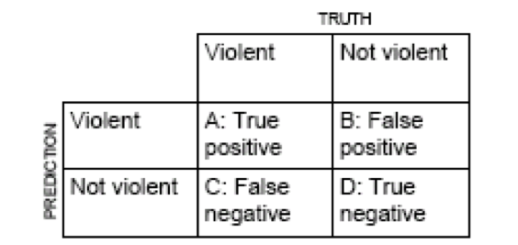

A ROC Graph
- For each possible cutoff value (score), plot false positive rate (x axis) as function of true positive rate (y axis)
- Connect the dots and get a curve
- We can then measure the area under that curve to get an overall measure of predictive accuracy

ROC interpretation
- AUC ranges from 0.50 (chance accuracy) to 1.00 (perfect accuracy)
- In other words, the probability that a randomly selected recidivist will have a higher risk score than a randomly selected non-recidivist
- AUCs of .56, .64, and .71 are roughly comparable to Cohen’s d of .20, .50, and .80

Absolute Accuracy
- Just starting to be examined separately
- Only applicable for actuarial scales with absolute recidivism estimates

Other factors affecting predictive accuracy
- Low base rates
- Poor predictor selection
- Method used
- Quality of criminal records
- Risk assessment tools tend to perform best in U.K., followed by Canada, then the U.S.
- Conscientiousness of evaluator
- Adjusting actuarial scores
- Degrades predictive accuracy

Summary
- What is risk assessment
- Static and dynamic risk factors
- Approaches to risk assessment
- Issues with special populations
- Issues in picking a risk assessment instrument
- Measuring predictive accuracy

Young Offenders

Learning Objectives
- Youth crime rates
- History of juvenile justice
- Youth sentencing
- Juvenile offending trajectories
- Theories of juvenile crime
- Risk and protective factors
- Interventions for young offenders
- Internalizing and externalizing problems
Youth Crime
- How serious a concern is it?

Persons accused of crime, by age, Canada, 2010

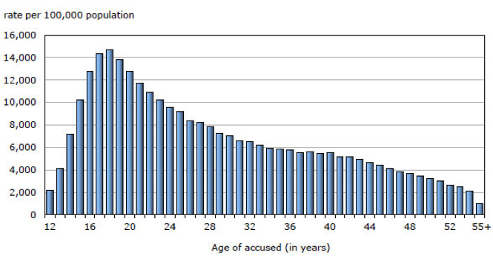

The rate of youth charged has declined since 2001

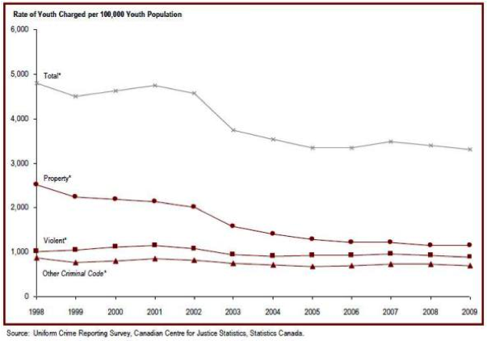

Youth accused of crime in Canada, 2000 to 2010

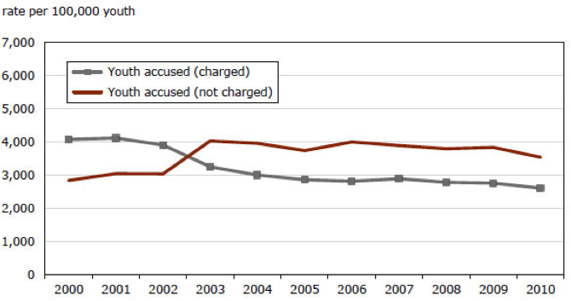
The most common youth court case is theft

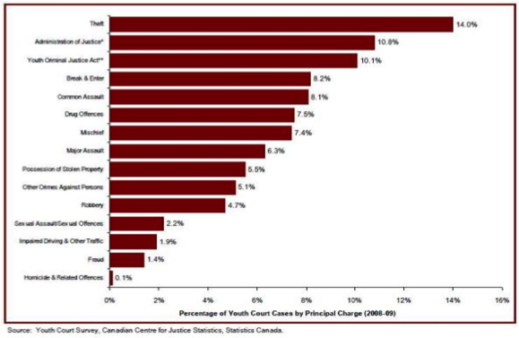

The most common disposition for youth is probation

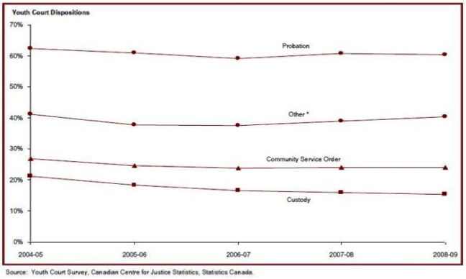
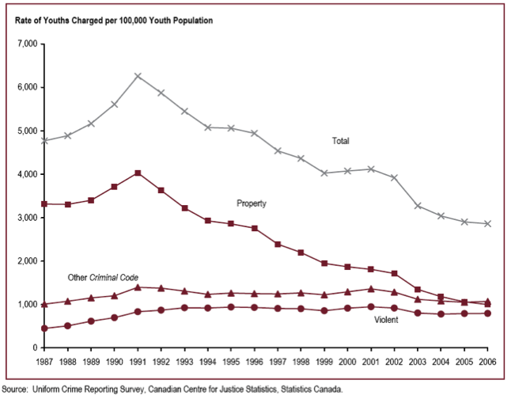

Time of Serious Crime

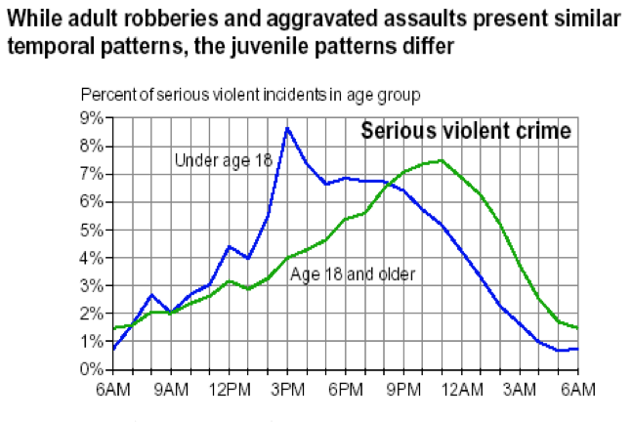

Youth Crime
- 21% of 16-year-olds who had been arrested were first arrested by age 12
- 54% of males and 73% of females who entered the juvenile justice system never returned on a new referral

History of Juvenile Justice

Prior to 19th century
- Children treated as adults
- No provision for developmental stage when it came to charging, sentencing, or incarceration

1908 – Juvenile Delinquents Act (JDA)
- Applied to individuals between 7 and 16 years
- Special circumstances inherent in juvenile offenders
- Separate court designed for delinquents, which were more informal than adult courts (parents encouraged to take part)
- Juveniles committing more serious crimes could be transferred to adult court

1908 – Juvenile Delinquents Act (JDA)
Criticisms:
- Informality of courts denied youths certain rights (legal representation and appeal)
- Judges could impose open sentences; broad definition of delinquency included acts that were not illegal for adults (e.g., truancy)

1984 – Young Offenders Act (YOA)
- Juveniles as cognitively different from adults
- Need for community right to protection against juveniles
- Increase in minimum age at which an individual could be charged (from 7 to 12; and up to 18)
- Youth court remained as did transfer possibility (but youth had to be 14)
- YOA also allowed for diversion

1984 – Young Offenders Act (YOA)
Criticisms:
- Pleading guilty to avoid transfer to adult court
- Getting off light for serious crimes
- Overuse of incarceration
- A number of revisions were made, mostly around transfers to adult courts for serious crime and sentencing lengths

Influence of Legislation
- Youth Criminal Justice Act (YCJA) objectives
- Prevent youth crime
- Provided meaningful consequences
- Encourage responsibility
- Improve rehabilitation and reintegration

2003 – Youth Criminal Justice Act (YCJA)
- Police to consider extrajudicial measures (e.g., warnings or referrals for treatment)
- Charged juveniles can no longer be transferred to adult court, although judges can impose adult sentences when juvenile is at least 14
- Expanded sentencing options are available for judges (e.g., reprimands, attendance orders, supervision orders, rehabilitative custody)
- YCJA also allows victims of crimes to participate in court proceedings and provides them with access to youth court records

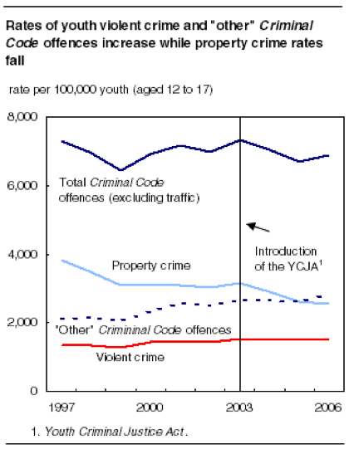

Influence of Legislation
- Before the Youth Criminal Justice Act
- About 80% of custodial sentences were for non-violent offences
- Almost 50% of young persons whose most serious offence was fail to comply were sentenced to custody
- Incarceration rate (age 12-17) was 10.5 per 1000 or 1050 per 100,000 – higher than current adult incarceration rate
- Considerable variability across the provinces
- Rate of imposing custody was lower in the US (approximately 800 vs. 1000)

Youth Sentencing
- The YCJA seeks to keep young offenders out of the court system
- Following the YCJA, in 2006-2007, approximately 17% of guilty offenders received custodial sentences (2002-2003 – 27% of offenders did)
- Other sanctions used in 2006-2007: probation (59%), supervision order (3%), reprimands (2%), intensive support (1%) (7% of total cases used the new sentencing options under the YCJA)

Trajectories of Juvenile Offenders
- Twp types of juvenile offenders (Moffitt, 1983):
- Child onset, life-course persistent
- Adolescent onset, adolescent limited

Trajectories of Juvenile Offenders
- Child onset, life-course persistent:
- Not as common (3-5% of general population)
- Behavioural problems start very early in childhood (sometimes daycare and preschool)
- As babies, difficult to soothe, problematic temperaments, aggressive
- Other challenges, including ADHD, learning disabilities, academic difficulties
- Show more persistent antisocial behaviour later in life

Trajectories of Juvenile Offenders
- Adolescent onset, adolescent limited:
- Approximately 70% of the general population
- Begin to show behavioural problems in teen years
- Acts include truancy, theft, vandalism
- Acts are few and limited
- Generally desist from crime in early adulthood, although a few persist

Theories of Juvenile Crime
- Biological theories:
- A number of genetic and biological differences exist between offenders and non-offenders
- Children who have an antisocial biological father are more likely to engage in antisocial behaviour even when raised apart from the father (Cadoret and Cain, 1980)
- Antisocial youths have slower heart rate (perhaps higher threshold for excitability and emotionality) (Wadsworth, 1976)
- Antisocial youths may have less frontal lobe inhibition (impulsivity is increased) (Moffitt and Henry, 1989)

Theories of Juvenile Crime
- Cognitive theories:
- Cognitive deficits and distortions occurring in social interactions may explain antisocial behaviour (Fontaine, Burks, and Dodge, 2000)
- Limited problem solving in conduct disordered children produce fewer solutions to problems and the solutions are more likely to be aggressive (Coy et al. 2001)

Theories of Juvenile Crime
- Social theories:
- Bandura’s (1965) social learning theory suggests that children learn antisocial behaviour from observing others, especially when they see the behaviour being positively reinforced
- Studies support this, in particular when modeling is combined with a lack of parental supervision and inconsistent discipline (Patterson, 1982)
- Recent studies also show the important role of violence in the media (Bushman and Anderson, 2001)

Risk and Protective Factors
- Criminogenic risk factors are known to exist for young offenders
- They usually have to be present in combination to represent a problem
- Risk factors come from multiple domains: individual, familial, school, peer, and community
- Protective factors are also known to exist
- There are known to be gender differences for both (Fagan et al., 2007)

Risk Factors: Individual
- Prenatal and delivery complications
- Mother’s use of drugs, alcohol, cigarettes
- Child’s temperament (difficult to soothe, hyperactive, attention problems, impulsive, risk taking)
- Substance abuse, especially from an early age
- Low verbal intelligence and delayed language development

Risk Factors: Familial
- Poor parental supervision
- Low parental involvement
- Parental conflict and aggression
- Child abuse, neglect, and maltreatment
- Parental loss and divorce
- Drug and alcohol use
- Parent income

Risk Factors: School
- Poor academic performance, particularly in elementary school
- Low commitment to school
- Low educational aspirations
- Truancy

Risk Factors: Peer
- Perhaps the most important during the adolescent years
- Associating with delinquent peers
- Engaging in delinquent behaviour
- Peer approval of delinquent behaviour
- Gang membership

Risk Factors: Community
- Living in low socioeconomic neighborhood
- Witnessing violence
- Access to weapons

Protective Factors
- Exposure to protective factors = Resiliency
- They can work by:
- Reducing negative outcomes by changing level of exposure to risk factors
- Changing the negative chain reaction following exposure to risk
- Helping develop and maintain self-esteem and self-efficacy
- Avail opportunities to children that they would not otherwise have

Protective Factors
- Individual:
- Intelligence, social skills, values and beliefs, intolerant attitude to antisocial behaviour**, being female, positive temperament, being reflective (i.e., not impulsive)
- Familial:
- Supportive parents, parental supervision, secure parent-child attachment, consistent discipline
- School:
- Commitment to education, extracurricular activities
- Peer:
- Associating with prosocial peers
- Community:
- ?

Intervention Strategies
- Intervention strategies can occur at three levels:
- Primary intervention: implemented prior to any violence occurring, with the goal of decreasing the likelihood that violence will occur later on
- Secondary intervention: attempt to reduce the frequency/severity of violence
- Tertiary intervention: attempt to prevent violence from re-occurring

Primary Intervention Strategies
- Goal:
- Identify groups of children that have numerous risk factors and intervene with these kids to prevent antisocial behaviour
- Family oriented strategies:
- Parent focused: directed at assisting parents to recognize warning signs for later juvenile violence and/or training parents to manage behavioural problems that arise
- Family supportive: connect at risk families to various support services (e.g., child care, counseling, medical)
- Short terms success but attrition is high so usually not stand alone programs

Primary Intervention Strategies
- School oriented strategies:
- Preschool programs such as Project Head Start (nutrition; structured activities; tutoring; medical services)
- Social skills training for children
- Broad based school interventions designed to change school environment (Scared Straight)

Primary Intervention Strategies
- Community wide strategies:
- Provision of structured community activities to increase children’s participation and community cohesion
- Outreach Projects – teaches children self-control, problem solving, child management for parents, provides counseling services, tutoring

Secondary Intervention Strategies
- Goal:
- Provide juveniles who have had contact with the CJS or who have exhibited behavioural problems in school with social and clinical services so that their behaviour does not escalate
- Programs are similar to primary intervention strategies but the target group is different
- Examples: diversion programs, alternative education programs, family therapy, skills training

Secondary Intervention Strategies
- Diversion programs
- Are very popular
- These programs “divert” young offenders from the justice system and into school-based treatment programs
- Belief is that system may cause more harm than good

Secondary Intervention Strategies
- Multisystemic Therapy
- Very popular.
- Examine child across different contexts in which they live – family, peers, school, neighbourhood, community
- Target is family communication, parent management, cognitive-behavioural issues

Tertiary Intervention Strategies
- Goal:
- Minimize the impact of existing risk factors and foster the development of protective factors in order to reduce change of re-offending

Tertiary Intervention Strategies
- Aimed at juveniles who have engaged in criminal acts and who may have already gone through court proceedings
- Strategies are all about treatment rather than prevention
- Examples:
- Inpatient treatment (e.g., institutional)
- Community-based treatment where the approach can be retributive or rehabilitative

Internalizing and Externalizing Problems
- Interventions (in general) with children often focus on emotional and behavioural difficulties
- These difficulties can be divided into two categories:
- Internalizing problems
- Externalizing problems

Internalizing Problems
- Emotional difficulties such as anxiety, depression, obsessions, etc.
- Not usually the target in interventions designed to manage antisocial behaviour
- Reasonably treatable and not particularly predictive of antisocial behaviour

Externalizing Problems
- Behavioural problems (e.g., delinquency, lying, bullying, fighting, and other destructive behaviours
- Psychiatric disorders (e.g., ADHD, CD, ODD)
- Often targeted for intervention in programs designed to reduce antisocial behaviour
- Can develop into more persistent and serious antisocial acts
- Fairly difficult to treat
- Relatively stable over time
- Need to be viewed in a developmental context
- More of a problem for males (10:1)

Summary
- Youth crime rates
- History of juvenile justice
- Youth sentencing
- Juvenile offending trajectories
- Theories of juvenile crime
- Risk and protective factors
- Interventions for young offenders
- Internalizing and externalizing problems

Sexual Offenders

Today you will learn…
- Types of sexual offenders
- Treatment of sexual offenders

Definition of Sexual Assault
- Any nonconsensual sexual act by either a male or female person to either a male or female person, regardless of the relationship between the people involved
- Three levels:
- Simple sexual assault
- Sexual assault with a weapon or causing bodily harm
- Aggravated sexual assault
Extent of Sexual Offending in Canada
- 20,992 sexual assaults in 2008
- 98% were level 1
- Declining since 1993
- Inaccurate official estimates because majority of victims do not report crime
- Victimization surveys indicate high rates of victimization

Classification Sexual Offenders
- Voyeurs
- Exhibitionists
- Rapists
- Pedophiles
- Child Molesters
- Intra-familial (incest offender)
- Extra-familial

Rapist Typologies:
MTC:R3 (Revised Rapist Typology)
- Opportunistic
- Pervasively angry
- Sexual
- Sadistic
- Vindictive

Rapist Typologies
Groth (1979)
- Anger rapist
- Power rapist
- Sadistic rapist

Child Molester Typologies
Groth et al. (1982)
- Fixated child molesters
- Regressed child molesters
- Subdivided into 2 types based on coercion:
- Sex-pressure
- Sex-force: Exploitative type and sadistic type

Adolescent Sex Offenders
- Adolescents commit:
- 20% of rapes
- 30-50% of child sexual abuse
- History of sexual abuse history is common
- Victims tend to be young females (<9 years old)

Female Sex Offenders
- Only 2-5% of incarcerated sex offenders are female
- Four types proposed by Atkinson (1996):
- Teacher/lover
- Male-coerced
- Male-accompanied
- Predisposed

Treatment of sexual offenders
- Most treatment programs focus on:
- Recognizing denial, minimizations, and cognitive distortions
- Empathy
- Social skills
- Substance abuse problems
- Modifying deviant sexual interests
- Relapse prevention

Effectiveness of Treatment with Sex Offenders
- Lack of consensus about whether treatment is effective
- Incarceration is not a deterrent
- Hanson et al. (2002) showed:
- Sexual recidivism rates lower for treated offenders (both adolescent and adult)
- Both institutional and community treatment effective
- Cognitive-behavioral treatment associated with strongest effects

Homicidal Offenders

This Class
- Homicide rate
- Motives for murder
- Murder types
- Types of multiple murder
- Classification of serial murders

Homicide Rates per 100,000: World Homicide Rates – 2010

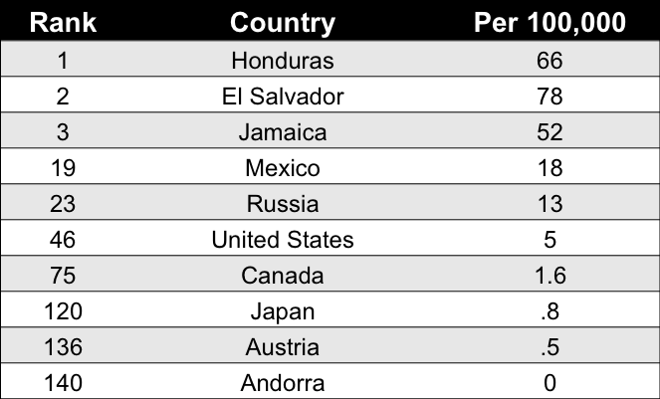

Canada Homicide Rate: 1961 - 2010

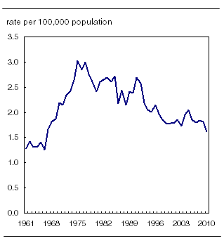

Characteristics of Homicide in Canada in 2010
- More men killed than women
- Females more likely to be killed by an intimate partner than are males
- Gang-related homicides decreasing
- Regional differences (Western vs. Eastern provinces)
- Most likely to be killed by someone you know

Relationship Between Offender & Victim (2010)

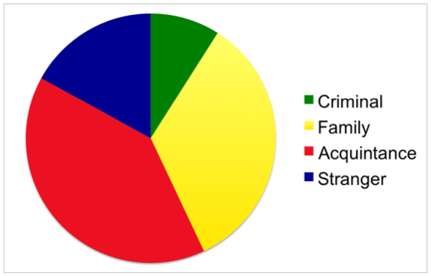

Types of Homicide
- Canadian criminal law recognizes four types:
- First-degree murder
- Second-degree murder
- Manslaughter
- Infanticide

Bimodal Classification of Homicide
- Reactive (affective)
- Impulsive; unplanned; response to perceived provocation
- Victims are most often relatives

Bimodal Classification of Homicide
- Instrumental (predatory)
- Proactive; premeditated; motivated by a goal
- Victims are most often strangers

When Parents Kill
- Filicide
- Killing of children by their biological parents or step-parents
- Includes:
- Neonaticide
- Infanticide

Angela Kuehl
- 25 years old
- Suffocated newborn son with plastic bag in 2007 (Ottawa)
- Tried to revive baby
- Placed body in garbage can

Fathers Who Kill
- Familicide – killing of a spouse and children
- Types:
- Despondent nonhostile killer
- Hostile accusatory killer

John List
- Killed family
- Lived as fugitive for 18 years

Youth who Kill
- 56 youth (12 – 17 yrs) charged with murder in 2010
- Typology of youth murderers (Cornell et al., 1987)
- Psychotic (7%)
- Conflict (42%)
- Crime (51%)

Types of Multiple Murderers
Mass Murderer
- Defining features
  - Kills 3 or more victims
  - No cooling off period
  - In same general area
- Two types
- Classic
- Family

Spree Murderer
- Kills 3 or more victims
- No cooling off period
- Killings occur at two or more locations
- Linked to a single event

Andrew Cunanan
- Murdered at least 5 people including Gianni Versace
- 3 month period in 1997

Serial Murderers
- 3 or more killings
- Different locations
- Cooling off period
- Usually solitary, usually targets strangers

Characteristics of Serial Killers
- Age: 25 – 40
- Sex: Male (83%)
- Race: White (73%)
- Victims: young, female, unrelated, vulnerable
- Killings tend to be within same race
- Tend to act alone

Geographic Variation
- Geographically Transient (35%)
- Geographically Stable (55%)
- Place Specific (10%)

Male vs. Female Serial Killers

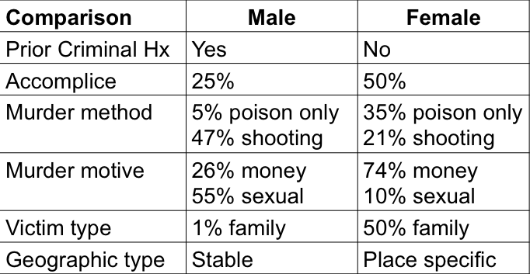

Classification of Serial Killers
(Holmes & Holmes, 1998)
- 6 types
- Developed from reading 110 serial killer case files

Visionary Type
- Rare, mostly men
- Motivation
- Ex: Herbert Mullin – 13 homicides

Mission-Oriented Type
- Rare, mostly men
- Motivation

Lust-Oriented Type
- More common, mostly men
- Motivation
- Ex: John Gacy - 33 homicides

Thrill-Oriented Type
- Most common, mostly men
- Motivation
- Ex: Kenneth Bianchi & Angelo Buono - 12 homicides

Comfort-Oriented Type
- Rare, mostly female
- Motivation
- Ex: Judias Buenoano - 5 homicides

Power/Control Type
- Rare, mostly men
- Motivation
- Ex: Ted Bundy - 36 homicides

Criticisms of Typology
- Overlap of types (thrill, lust, power/control)
- Typologies were generated from case files
- Cannot explain changing motives
- Lack of empirical scrutiny or analyses by external individuals

Testing Holmes & Holmes Typology
(Canter & Wentink, 2004)
- 100 serial killers, coded killing #3
- Two assumptions
- Assumed that crime scene characteristics should cluster together if different types exist
- Each type needs to have characteristics that are clearly distinct from those of other types
- Multi-dimensional scaling used

Results: MDS Plot with Frequency Contours (Fig. 6 from study) ON SLIDE 33

Psychopathy

- What is psychopathy? Defining psychopathic traits and behaviours.
- How do we assess psychopathy?
- What makes them tick (theories; etiology)?
- What kinds of outcomes are associated with psychopathy?

What is Psychopathy?
- A personality disorder characterized by
  - An arrogant, deceitful interpersonal style
  - Deficient affective experiences
  - Impulsive and irresponsible behaviours
  - Early onset and diverse antisocial behaviours

Psychopathy Assessment (3 types)
- Psychopathy
- Self Report Inventories
  - Ask criminal questions like: “How much is this like you from 1-10?”
  - Issues: they can be deceitful
- Informant Rating
  - Someone who knows individual well answers questions for them, similar questions to Self-Report, common for child and youth offenders, often a parent or teacher
- Clinical Rating
  - Trained professional
  - Extensive file of individual including criminal record and psychological examinations by clinical professional, make a judgment of individual’s psychopathic tendencies based on extensive research of individual

The “Gold Standard”
- Psychopathy Checklist-Revised (PCL-R; Hare, 1991, 2003) – Way of testing for psychopathy
  - Semi-structured interview + file review
  - 20 item questionnaire (3 point scale: 0,1,2)
  - Total score of 40 (>30 = psychopathy)
  - Youth version (PCL:YV; Forth et al., 2003)
  - Qualified professional (PhD; appropriate training)

Mean PCL-R Scores
- Between 30-40 = psychopath
- 19 = average female criminal
- 22 = average male criminal
- 5 and less = general population

Psychopathy
- All psychopaths must possess both Factor 1 and Factor 2
- Factor 1 (Interpersonal/Affective)
  - Facet 1 – Interpersonal
  - Facet 2 – Affective
- Factor 2 (Social Deviance)
  - Facet 3 – Lifestyle
  - Facet 4 – Antisocial
Factor 1: Affective-Interpersonal
- Glib and superficial
  - Fake, insincere, surface level connection, not willing to tell of selves
- Egocentric and grandiose
  - Better than others; makes up stories – not worrying about believability of story, believe you are less than them
- Lack of remorse/ guilt/ empathy
  - Don’t feel bad for others; inflict pain – do not feel remorse or guilt for any pain and suffering they inflict on others
- Deceitful and manipulative
  - Tells lies with truth; uses other people for personal gain
- Shallow emotions
  - Don’t experience emotion like others; mimic emotions – no highs and lows, shallow flat-line emotions

Factor 2: Antisocial Behaviour
- Impulsive
  - Don’t think about consequences
- Poor behaviour control
  - Act quickly; risky behaviour
- Need for excitement
  - Need for stimulation (e.g., sky diving) – looking for things to feel excited about
- Lack of responsibility
  - Nothing is their fault; world against them – “you just don’t understand me”
- Early behaviour problems
  - Aggression; problems at school/ with police
- Adult antisocial behaviour
  - Extensive criminal record; aggression

Factor 1 (Affective Interpersonal) – Moral Corruption
- Glib and superficial
- Egocentric and grandiose
- Lack of remorse/ guilt/ empathy
- Deceitful and manipulative
- Shallow emotions

Factor 2 (Antisocial Behaviour) – Antisocial Personality Disorder ASPD
- Impulsive
- Poor behaviour control
- Need for excitement
- Lack of responsibility
- Early behaviour problems
- Adult antisocial behaviour
- 50-80% of offenders have APSD, however, only 15-25% are psychopaths
**APSD is almost solely factor 2 - not all people with ASPD are psychopaths, yet most psychopaths have ASPD, psychopaths are both factor 1 and 2
David Krueger
- Killed three children in the 1950’s, displays psychopathic behaviours including no remorse, egocentricity, very superficial/sly…(used car salesman - esque), says what he is “supposed to say”, not necessarily how he feels

Psychopathy: Theories

- Brain damage, structural anomalies
  - Frontal lobe dysfunction – source of some ASPD, creates social and behavioural problems including psychological disorders such as schizophrenia
- Cognitive processing deficits
  - Response modulation deficits (automatic direction of attention and controlled processing to stimuli or information that are peripheral to ongoing goal-directed behavior or a current response set occurs less readily in psychopathic individuals)
- Cognitive-emotional integration (Cleckley, Hare, Blair)

Psychopathy: Etiology
- Heritability of psychopathic traits
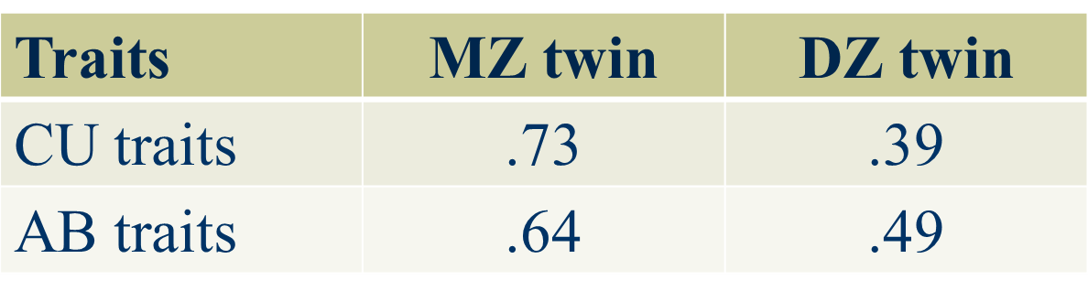
- “Callous-unemotional traits at 7 years, as assessed by teachers at the end of the first year of school, is under strong genetic influence.” (Viding et al., 2004, p.4)
Psychopathy: Affective Deficit
- Startle reflex
  - Reflex occurs when something unexpected occurs
- Magnified if person is in negative emotional state or feeling threatened
- Reduced if person is in positive emotional state
- Mediated by circuits in the amygdal
- Normally people will blink more in the presence of unpleasant images or when unhappy, and less with pleasant images and happiness – psychopaths never change blinking rate
Psychopathy: Affective Deficit
- Psychopathy and Startle Reflex (Patrick et al., 1993): BLINKING TEST**
- Incarcerated offenders
  - Psychopaths vs. nonpsychopaths
- Affective pictures
  - Pleasant (babies, pets, etc.)
  - Unpleasant (snake, mutilations, etc.)
  - Neutral (objects)
- Present startle probes

Psychopathy: Affective Deficit
- Broad conclusions based on years of research into psychopathy and emotional processing:
- Emotions play little role in their thinking, language, and behaviours
- Their approach to the world is predatory
- They put on a good show!
- Non sex-offender psychopathic criminal offenders are more likely to be granted parole than non-psychopathic criminals or sex-offenders

Psychopathy: Correlates

- Criminality/violence/homicide
  - Psychopathic offenders are responsible for a disproportionate amount of crime.
  - Psychopathic offenders engage in more violence which is also more gratuitous, planned, and deliberate.
  - Psychopathic offenders who kill have higher F1 scores than those who don’t kill (Porter et al., 2001)

Psychopathy: Correlates for Murder
- Woodworth & Porter, 2002
- 125 Canadian murderers classified as:
  - Reactive (unplanned, crimes of passion, extreme provocation)
  - Instrumental (planned, settle a score, cold-blooded)
- Treatment (Rice, Harris, & Cormier, 1992):
- Therapeutic community
  - Goal is to foster empathy and responsibility
- Intensive (80 hrs/week)
- Follow-up = 8 years, 4 months
- Psychopaths vs. non-psychopaths
  - 176 treated patients
  - 146 untreated patients
- Limitations of the Rice et al. study:
  - No assessment of treatment change
  - Limited professional staff involvement
  - Limited number of criminogenic needs targeted
  - Treatment integrity not monitored
  - Single source used as outcome measure

Psychopathy: Correlates

- Treatment
- Psychopathic offenders are resistant to traditional treatment modalities
- More likely to drop out of treatment
- Are more disruptive in group therapy
- Lack of empirical studies makes it premature to conclude that they cannot be treated
Psychopathy: Serial Killers

- Serial killers are often described as psychopathic
  - Ted Bundy, Clifford Olsen, John Wayne Gacy, Ken Bianchi, Paul Bernardo
- Many serial killers are psychopaths, however, most psychopaths are not serial killers
- Most offenders who kill are not psychopaths

