Please print out this mock midterm and come to workshops after attempting the questions at home. The exam should take you about 1.5 hours. The solutions will not be posted online. The problems will be taken up during my PASS workshops, but come prepared with specific questions and be ready to participate because there may not be time to write full solutions on the blackboard. My job is to give you the tools to solve problems on your own, not to solve problems for you.

1. Outriggers A and B are used to stabilize the crane from overturning when lifting large loads. If the load to be lifted is 3 Mg, determine the maximum boom angle θ so that the crane does not overturn. The crane has a mass of 5 Mg and centre of mass at G_{C}, whereas the boom has a mass of 0.6 Mg and centre of mass at G_{B}.
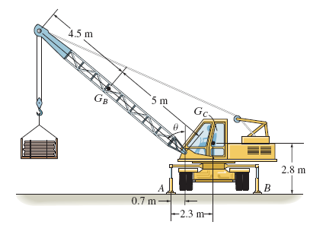

2. The member is supported by a pin at A and a cable BC. If the load at D is 300 lb, determine the x,y,z components of reaction at the pin A and the tension in cable BC.
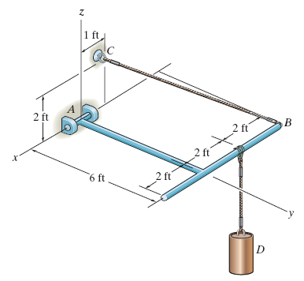

3. The frame is used to support a 50 kg cylinder. Determine the force in the pin at C in member ABC.
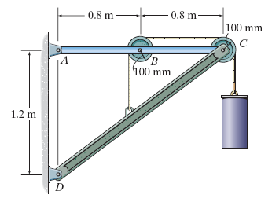

4. Determine the internal normal force, shear force, and moment at point D in the overhang beam. Point D is located just to the left of the roller support at B, where the couple moment acts.


