- In parkinsons disease you see a degeneration of these neurons, if we want to diagnose somebody postmartime, we might section their brain and see if these cell bodies are gone, we have animal models of parkinsons where we might inject them with neuro toxins where we know they kill of these dopamine neurons and we can see if these neurons are gone if we cacrfiice these animals and slice up their brain.
Slide 6
- Left loss of cells turn black in the patient with parkinsons disease
- Nissel Stain
- Golgi Stain
Slide 7
Different techniques stain axons retrograde and anteriorgrade trace where cells come from and where they are going
- Methods in behavioural Neurscience – melding of psycology, biolodym anatomy
- Study of the biological basis of behavior
- Includes study of both human and laboratory animals
- Major challenge is to develop methods for studying both normal and abnormal behavior
- Social neuroscientist
- Interpret test to measure their behavior, tension, depression, parkinsons, challenege trying to develop models and tests of behavior
- Ethology – study of animal behavior niki, carl wins, take the techniques in ethology and apply them to humans
- Morris water mase, special memory in rats, it doesn’t make sense to start them out in loeb to go to uni centre, develop test to measure spacal learning for rats to swim in tank, developed in 1980 Mik morris, kid swimming pools put in lab and put non toxic paint that white, makes water opaque, u hide a platform, learn to navigate to that platform, in the room you have ques, floatation device, window. Divide the pool in the 4 sides of campus, put animal in north, start swimming exterior of maze and shows thegmatastic behavior, its hugging the walls then swim towards the middle and find the platform. Randomize where the starting point of the animal is, over time what your measuring is your dependent variable is the latency to find platform measures spcal learning. It’s a valid way to measure special learning because we know if we destroy parts of the brain that are involded in spcial learning like the hippocampus in humans, the animals will never learn how to do the morris water maze, If u inject them with drugs that block neurotransmitters that are critical in learning and memory the animal wil show dfecit. Its got validaty, and manipulation in humans that destroy spcal learning also happens in morris water mase
Slide 8
Behaviorak analysis of Rats
- Skilled reaching task
- Rats are trained to reach through slot to obtain food
- Movements can be broken down into segments, which are differently affected by different types of neurological perturation which parts of the brain are responsible for which movement
Manipulating and Measuring Branin Behavior Interactions
- We can modify the brain and see how behavior is altered
- Two reasons for doing so:
- 1. Develop hypotheses about how the brain affects behavior
- 2. Test the hypothes
Slide 11
- Brain Lesions
- Lesion or to lesion something means part of your brain is damaged, sore or cut, in Neuroscience we are moving part of the brain or injecting ; chemically or electrically kill of that population of cells
- First techniques used developed by karl lashey (1920)
- Ablation :removal or destruction of tissue,
- getting brain region with a knife: prefronalt lobamies, go through orbits of the eye and little scrap, lose connection between frontal lobe and the back side of your brain, savirng connections between nueros or nuclie. When you cut between the corpus collisuem between the two hamolisphere
- Sterotaxic Apparatus
- Surgical instrument that permists the researcher to target a specific part of the brain
- Not getting as sophisticated behavior
Slide12
Brain Stimulation
- first used by Wilder Penfield (burnt toast) to stimulate the cerebral cortex of human during neurosurgery
- effects are opposite to lesion, usually enhance neural functioning
- when stimulate your artificially causing/producing action potential changing electrical potential of those cells, therefore producing neurotransmitters, when you lesion your remove those cells
- Rats with electrodes in the lateral hypothalamus will eat whenever the stimulation is turned on
- (dopamine neurons going through it, dopamine involved in pleasure and reward and if you implamnt these electrode stereotastically and get an animal in an oprant chamber and get it to bar press and every time they press the bar get a stimulation of those cells it will conitune to do that because it is saying this sensation feels good and I like that) will eat whenever the stimulation is turned on (intercranial self timulation)
- Self stimulation: give the opportunity, rats will press lever to obtain the current
- The stimulation affects a neural circuit involving both eating and pleasure

Slide 13
Transcranial Magnetic Stimulation
- Noninvasive procedure in which a magnetic coli is placed over the skill to stimulate the underlying brain
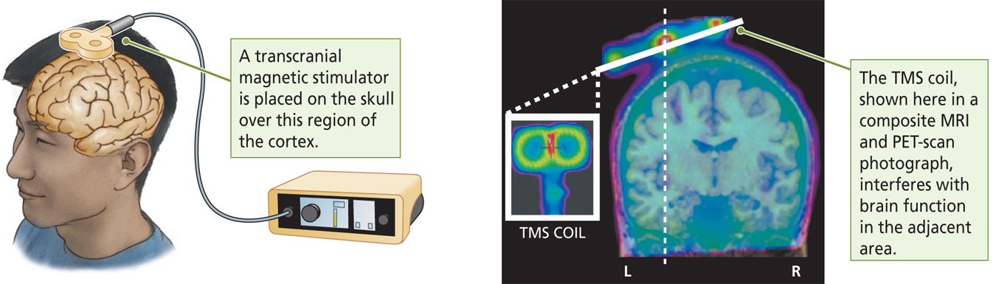
- Used either to induce behavior or to disrupt ingoing behavior, gaining to treat depression control+alt+dlt (large electric current to shock the brain and all those neurotransmitters systems that might have been funky the reset, works great but its invasive and causes seizures and memory defecits. TMS target a population of cells.

Slide 15
Measuring the brains electrical activity –Electroencephalography (EEG)
- Measures the summed graded potentials from many thousands of neurons (field potential)
- Reveals features of the brain’s electrical activity
  - The EEG changes as behavior changes
  - An EEG recorded from the cortex displays an array of patterns, some of which are rhythmical
  - The living brain’s electrical activity is never silent, even when the person is asleep or comatose
Slide 16
- Certain EEG wave forms associated with particular states of consciousness

Slide 17
Event-Related Potentials (ERPs)

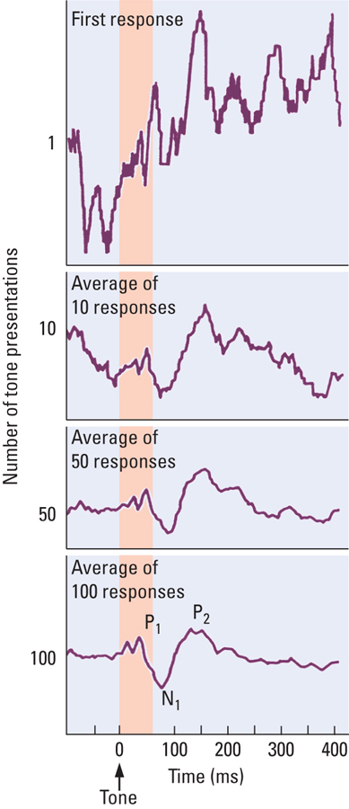
- Complex (used with EEG) (how it changes ot a specifc sense; seeing a picture of an erotic lady or a hamburger) electroencephalographic waveforms related in time to a specific sensory event
- To counter noise effects, the stimulus is presented repeatedly, and the recorded responses are averaged
- Advantages
  - Noninvasive
  - Low cost

Slide 18

Magnetoencephalography
- Magnetoencephalogram (MEG)
  - Magnetic potentials recorded from detectors placed outside the skull
  - Permit a 3-D localization of the cell groups generating the measured field
  - Higher resolution than ERP
  - Disadvantage: high cost
Slide 19

Recording Action Potentials from Single Cells
- Measuring single-neuron action potentials with fine electrodes
  - Electrodes placed next to cells (extracellular recording) or inside them (intracellular recording)
- Place cells
  - Neurons maximally responsive to specific locations
    - i.e., fire if a rat is in a given location
  - Discovered in the hippocampus of rats

Slide 20
Static Imaging Techniques: CT
- Computerized Tomography (CT)
  - X-ray beam projected through head of patient to detector
  - Series of ‘photos’ at each axis yields a 3-D representation
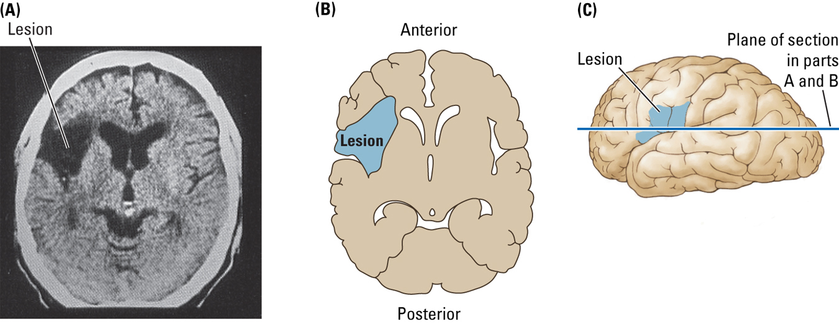

Slide 20
Static Imaging Techniques: MRI
- Magnetic Resonance Imaging (MRI)
  - Technique that produces a static, three-dimensional brain image by passing a strong magnetic field through the brain, followed by a radio wave, then measuring the radiation emitted from hydrogen atoms
  - High SPATIAL resolution
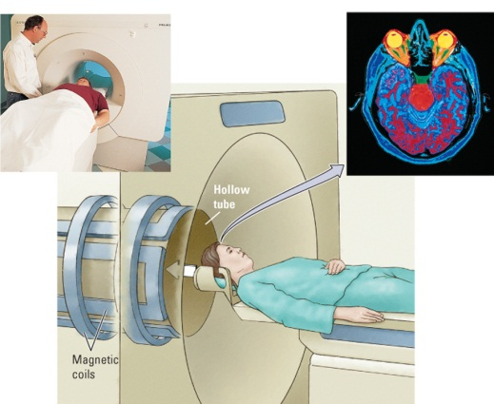

Slide 20
Functional Magnetic Resonance Imaging (fMRI)
- Magnetic resonance imaging in which changes in elements such as iron or oxygen are measured during the performance of a specific behavior
  - Provides both structural and functional information
  - How different brain regions are changing when we are doing a certain task
  - Measuring different elments such as iron and oxygen which are taken up by cells that are active, the more active the brain is the more hot spots we will get
  - Picture horizontal of the brain experimentally and clinically (we can diagnose with MRI and also use this to study what parts of the brain are involved in a given behavior)

Slide 21
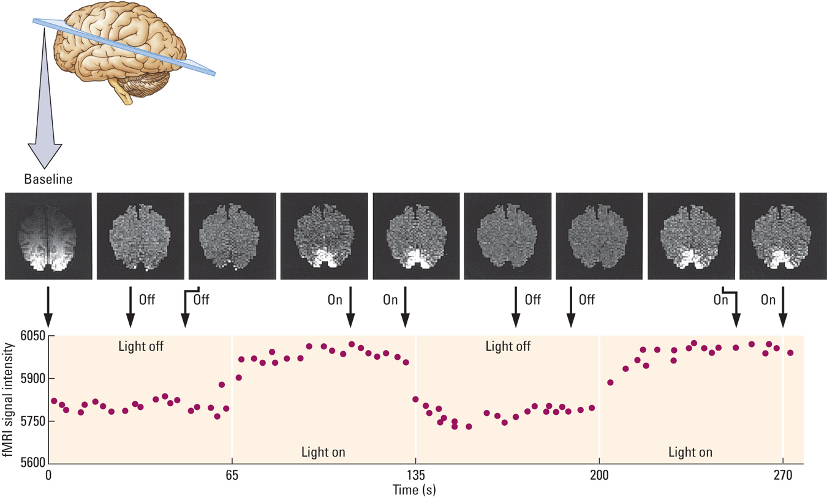
Slide 22
Positron Emission Tomography (PET)
- Imaging technique that detects changes in blood flow by measuring changes in the uptake of compounds such as oxygen or glucose
  - Radioactive molecules are injected into the bloodstream
  - Used to analyze the metabolic activity of neurons
- Very expensive
- Good TEMPORAL resolution
Slide 23
Measuring the Brain’s Chemistry
- Microdialysis
  - Technique used to determine the chemical constituents of extracellular fluid
- Cellular Voltammetry
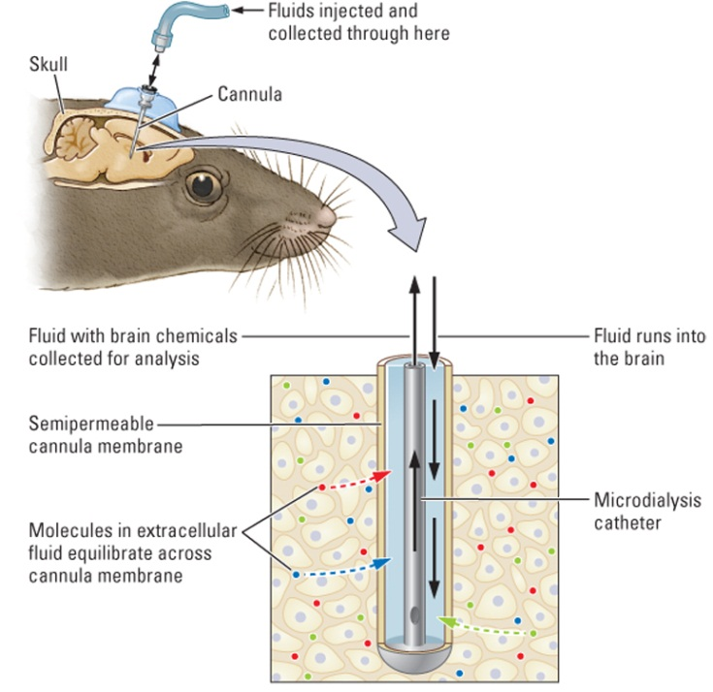
  - Technique used to identify the concentration of specific chemicals in the brain as animals behave freely
  - Does not require chemical analysis, but destroys brain tissue

Slide 24
Measuring Genes in Brain and Behavior
- Variations in gene sequences contribute to brain organization
- Studying twins and adopted children allows us to tease apart environmental and genetic contributions to behavior
- We can also relate the alleles of specific genes to behaviors
Slide 25
Example: Measuring Genes in Brain and Behavior
- Brain-derived neurotrophic factor (BDNF)
  - Plays important role in stimulating neural plasticity
  - Gene related to BDNF has two alleles: Val 66Met and Val 66Val
- Bueller and colleagues (2006)
  - The Met allele is associated with an 11% reduction in hippocampal volume, and poorer memory for specific events
Slide 26
Epigenetics
- Changes in gene expression related to experience
  - Wide range of experiential factors
    - Chronic stress, traumatic events, drugs, culture, disease

- Cumulative experiences affect how genes work

- Fraga and colleagues (2005)
  - Twins have nearly identical patterns of gene expression early in life, but remarkably different by age 50

  - Szyf, Meaney, and colleagues (2008)
  - Amount of maternal attention given to newborn rat pups alters gene expression in their adult hippocampus
  - Licking and grooming behavior to promote normal development, promotes nerve growth factors that develop brain nervous system
  - This environmental input is critical for meditating the later adult behavior (epigenetic phenomen)

Slide 28
Using Animals in Brain-Behavior Research
- Two important issues
  - Do animals actually contract the same neurological diseases that humans do?
  - How ethical is it to use animals in research?

Slide 29
Benefits of Creating Animal Models of Disease

- Some disorders are easy to model (e.g., stroke)
- Behavioral disorders are more difficult
  - Attention-Deficit/Hyperactivity Disorder (ADHD)

    - Developmental disorder characterized by core behavioral symptoms of impulsivity, hyperactivity, and/or inattention

  - Kyoto SHR rat
    - Proposed as a good model for ADHD
Slide30
Kyoto SHR rat

- Known abnormalities in prefrontal dopaminergic innervation that correlate with behavioral abnormalities such as hyperactivity
- Dopamine agonists such as methyphendiate (Ritalin) can reverse behavioral abnormalities, both in children with ADHD and in SHR rats

Slide 31
Animal Welfare and Scientific Experimentation

- Most governments regulate the use of animals in research
- Universities and other research organizations have additional rules governing animal use

Slide 32
Guidelines of the CCAC

- The use of animals in research, teaching, and testing is acceptable only if it contributes to the understanding of environmental principles or issues, fundamental biological principles, or development of knowledge that can reasonably be expected to benefit humans, animals, or the environment
- Optimal standards for animal health can care result in enhance credibility and reproducibility of experimental results
- Acceptance of animal use in science critically depends on maintaining public confidence in the mechanisms and processes used to ensure necessary, human, and justified animal use
- Animals are used only if the researcher’s best efforts to find an alternative have failed
- Researchers who use animals employ the most humane methods on the smallest number of appropriate animals required to obtain valid information

Slide 34
Animal Welfare and Scientific Experimentation

- Considerable controversy remains over using animals in scientific research
- The debate centers on issues of law, morals, custom, and biology
- Because you, as students, encounter many experiments on animals in this course, these issues are important to you as well

