Chapter 2: Perception, Personality, and Emotions
- Perception: the process by which individuals organize and interpret their impressions in order to give meaning to their environment

Factors influencing Perception:

- The situation: the time at which we see an object or event can influence attention, as can location, light, head, or any number of situational factors
- The perceiver- their attitudes, motives, interests, experience and expectations all change the way something is perceived
- The target- novelty, motion, sounds, size, and other characteristics of a target shape the way we see it (loud people are more likely to be noticed in a group than the quite ones)

Perception Errors

- Attribution Theory: the theory that when we observe what seems like atypical behavior by an individual, we attempt to determine whether it is internally or externally caused.
  - Personal control (internal) and something outside the individual caused the behavior (external)
  - Rely on 3 rules: distinctiveness, consensus, and consistency
    - Distinctiveness: considers whether an individual acts similarly across a variety of situations
    - Consensus: considers if everyone faced with a similar situation responds in the same way
    - Consistency: considers whether the individual has been acting in the same way
- Fundamental attribution error: the tendency to underestimate the influence of external factors and overestimate the influence of internal factors when making judgments about the behavior of others
- Self-serving bias: the tendency for individuals to attribute their own successes to internal factors while putting the blame for failures on external factors.
- Selective perception: people’s selective interpretation of what they see based on their interests, background, experience and attitudes.

- Halo Effect: drawing a general impression of an individual on the basis of a single characteristic. General views contaminate our specific ones. (like/dislike Stephan Harper, list 10 things dislike/like about him)

- Contrast effect: the concept that our reaction to one person is often influence by other people we have recently encountered.

- Projection: attributing one’s own characteristics to other people.

- Stereotyping: when we judge someone on the basis of our perception of the group to which he/she belongs

  - We rely on generalizations ever day because they help make quick decisions. Less difficult to deal with unmanageable number of stimuli if we use heuristics (judgment shortcuts in decision making)
  - They are widespread

- Prejudice: an unfound dislike of a person or group based on their belonging to a particular stereotyped group. (individual may dislike people of a particular religion, or state that they do not want to work with someone of a particular ethnicicty.

- Employment Interviews:

  - We form impressions of others within a tenth of a second, based on first glance.
    - If negative impression, it is heavily weighted throughout interview, and most interviewers’ decisions change very little after the first four or five min of the interview

- Performance expectations: people attempt to validate their perceptions of reality even when they are faulty.
  - Self-fulfilling prophecy and Pygmalion Effect describe how an individual’s behavior is determined by others’ expectations. If manager expects big things from her people, they are not likely to let her down.
- Performance Evaluations: depend on the perceptual process. An employee’s future is closely tied to the appraisal – promotion, pay raises, and continuation of employment are among the most obvious outcomes.
  - Appraisal can be objective (salesperson is appraised on how many dollars of sales they generate in territory) many jobs are evaluated in subjective terms (can be problematic – selective perception, contrast effects, halo effect… )

Personality

Personality: the stable patterns of behavior and consistent internal states that determine how an individual reacts to and interacts with others.

Measuring Personality: most common is using self-report measures work well when well constructed, but respondents might lie or practice impression management. Also use observer ratings – provide independent assessments of personality. (co-worker or another observer does the rating

Personality Determinates:

- Heredity: those factors that was determined at conception. Physical, facial attractiveness, gender, temperament, muscle composition and reflexes, energy level, biological rhythms.
  - Twin study, and siblings studies
- Personality Traits: enduring characteristics that describe an individual’s behavior.
  - Myers-Briggs Type Indicator:
    - MBTI is most widely used personality assessment instrument in the world.
    - 100 question personality test that asks people how they usually feel or act in particular situations.
    - Classifies people into 1 to 16 types
    - On basis of answers, classified as:
      - Extraverted or introverted: E outgoing, sociable and assertive, I are quiet and shy. E/I measures where we direct our energy when dealing with people and things
      - Sensing or intuitive: S are practical and prefer routine and order, focus on details. In. rely on unconscious processes and look at the “big picture”. This dimension looks at how we process information.
      - Thinking or feeling: Thinking types are logic, and use reason. Feeling types rely on their personal values and emotions.
      - Judging or perceiving: Judging types want control and prefer their world to be ordered and structured. Perceiving types are flexible and spontaneous.
    - Examples:
      - INTJs are visionaries: usually have original minds and great drive fro their own ideas and purposes. They are skeptical, critical, independent, determined and ofter stubborn.
      - ESTJs are organizers: realistic, logical analytical, decisive and have a natural head for business or mechanics.
      - ENTPs are conceptualizers: innovative, individualistic, versatile and attracted to entrepreneurial ideas.

  - Big Five Personality Model: a personality assessment model that taps five basic dimensions.
    - Extraversion
    - Agreeableness
    - Conscientiousness
    - Emotional stability
    - Openness to experience

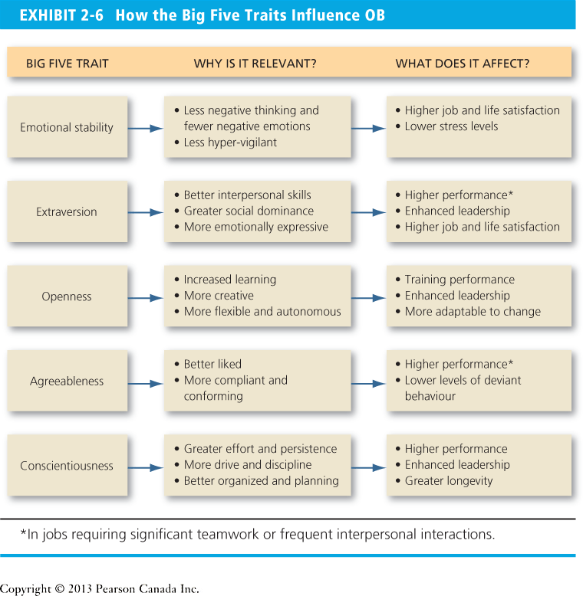

Other Personality Attributes Influencing OB

- Core Self-Evaluation: the degree to which an individual likes or dislikes himself or herself, whether the person sees himself/herself as capable and effective, and whether the person feels in control or his or her environment or powerless over the environment.
- Machiavellianism: the degree to which an individual is pragmatic, maintains emotional distance and believes that ends can justify means. Machs do better when:
  - They interact face to face with others rather than indeirectly
  - The situation has min number of rules and regulations, thus allowing room for improvising
  - Emotional involvement with details irrelevant to winning distracts low machs
  - Bargaining jobs are good for machs
- Narcissism: the tendency to be arrogant, have a grandiose sense of self-importance, require excessive admiration, and have a sense of entitlement. Can have toxic consequences.
- Self Monitoring: a personality trait that measures an individuals’ ability to adjust behavior to external, situational factors.
- Risk Taking: a personality willingness to take chances or risks. High risk managers tend to make more rapid decisions and used less information
- Type A and B: A: a personality with aggressive involvement in a chronic, incessant struggle to achieve more and more in less and less time and if necessary, against the opposing efforts of other things or other people. B: a personality that is described as easy-going, relaxed and patient.
- Proactive Personality: a person who identifies opportunities, shows initiative, takes action, and preservers until meaningful change occurs.

Emotions and Moods:

Affect: a broad range of feelings that people experience.
Emotions: intense feelings that are directed at someone or something.
Moods: feelings that tend to be less intense than emotions and that lack a contextual stimulus.

Choosing Emotions:

Emotional Labor: when an employee expresses organizationally desired emotions during interpersonal interactions. – Service jobs such flight attendants have to be cheerful, we expect funeral directors to be sad.

Emotional dissonance: inconsistencies between the emotions people feel and the emotions they show. (Bottled up feelings)

Felt emotions vs displayed emotions: actual vs emotions organization requires employees to show

Surface acting: hiding one’s inner feelings to display what is expected

Deep acting: trying to modify one’s true inner feelings to math what is expected.

Emotional Intelligence: (EI) an assortment of noncognitive skills, capabilities and competencies that influence a person’s ability to succeed in coping with environmental demands and pressures.

Negative Workplace Emotions:

Employee deviance: voluntary actions that violate established norms and threaten the organization , its members or both.

Effective Events Theory: (AET) the theory that employees react emotionally to things that happen to them at work and that this emotional reaction influences their job performance and satisfaction. The bad or good events happening in the job wil affect the mood and emotions positively or negatively which will effect the job performance and the satisfaction.

