Chapter 5: Motivation in Action
- Intrinsic Rewards: Employee Recognition Programs
  - Recognition on behavior is the key component to motivation
  - Using Reinforcement Theory, providing recognition immediately following positive behavior leads to repetition.

Beware the signals that are sent by rewards:
- Often reward systems do not reflect organizational goals:
  - Individuals are stuck in old patterns of rewards and recognition
  - Organizations don’t look at the big picture
  - Management and shareholders focus on short-term results.

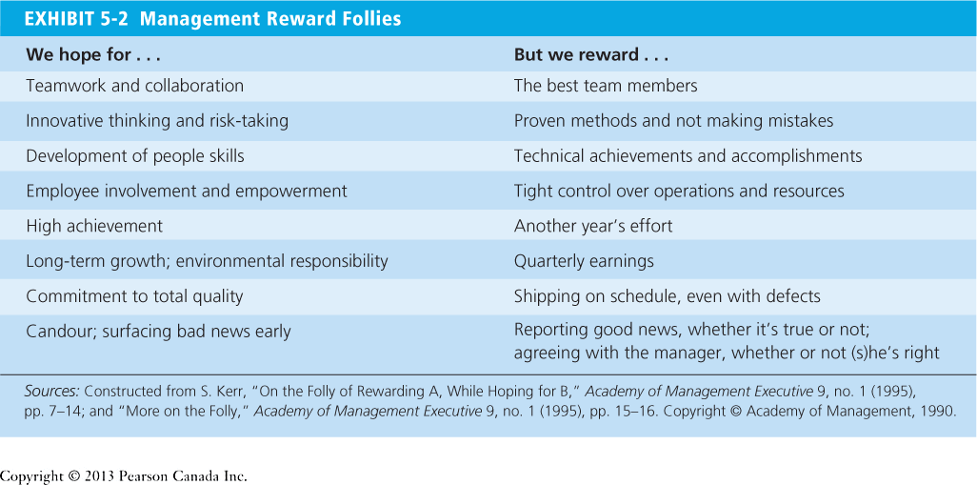

Organizations can create a more supportive, motivating work environment:
- Abolish incentive pay: pay employees generously and fairly so they don’t feel exploited
- Re-evaluate evaluation: instead of making performance evaluation look and feel punitive effort – who gets raises or promoted etc. – structure the performance eval system more like a two way conversation to trade ideas and questions.
- Create the conditions for authentic motivation: help, listen and support employees
- Encourage collaboration: get feedback from one another
- Enhance content: enhancement from learning new skills, provide a variety of tasks and enable them to demonstrate competence.
- Provide choice: more enthusiastic about what we are doing and do it well when we are free to make own decisions

Job Redesign: the way the elements in a job are organized

Job characteristics model (JCM): a model that proposes that any job can be described in terms of five core job dimensions
- Skill variety: job requires a variety of different activities so the employee can use a number of different skills and talents
- Task identity: to which the job requires completion of a whole and identifiable piece of work
- Task significance: to which the job has an impact on the lives or work of other people
- Autonomy: to which the job provides substantial freedom, independence, and discretion to the individual in scheduling the work and determining the procedures to be used in carrying it out
- Feedback: to which carrying out the work activities required by the job results in the individual obtaining direct and clear information about the effectiveness of his/her performance

** To be high on motivating potential, jobs must be high on at least one of the three factors that lead to experience meaningfulness and high on both autonomy and feedback.

How can jobs be redesigned?

- Job rotation: the periodic shifting of an employee from one task to another
  - Creates new challenges
  - Reduces boredom
  - Training cost increase
  - Productivity I reduced by moving an employee into a new position
- Job enrichment: the vertical expansion of jobs, which increases the degree to which the employee controls the planning, execution, and evaluation of work
  - Allows them to do a complete activity
  - Increases freedom and independence and responsibility
  - Provides feedback so individuals can assess and correct their own performance
- Flextime: an arrangement where employees work during a common core period each day but can form their total workday from a flexible set of hours outside the core
  - Not all jobs are able to do it
  - Can lead to longer work hours and multi-tasking. Which can lead to greater work-life conflict and stress

Employee Involvement: a participative process that uses the input of employees and is intended to increase employee commitment to an organizations success.
Examples:
- Participative Management: a process in which subordinates share a significant degree of decision-making power with their immediate superiors.
- Representative participation: a system in which employees participate in organizational decision making through a small group of representatives.

