RYERSON UNIVERSITY
TED ROGERS SCHOOL OF HOSPITALITY AND TOURISM MANAGEMENT

HTL 101

Mid-term
Keys

Student Name: ..............................................................................................................

Student Number: ………………………

Directions:

Time: 90 minutes

Part I: Multiple Choice Questions: 1 to 47

(Circle the letter of one choice only for each question and on the bubble sheet with pencil)
Total marks: 47

Part II: Short Answer Questions: 48 - 53
Total marks: 27

Marks
Part I :

Part II:

Combined: ........../

Part 1: Multiple Choice Questions

  - Which of the following was a feature of the Buffalo Statler Hotel?
- light switches placed just inside the door
- baths shared with only one other person
- newspapers available for a fee to each guest
- fire doors eliminated on all stairways

  - Which of the following pioneers of the lodging industry said that “The customer is always right?”
- Ellsworth M. Statler
- Caesar Ritz
- Kemmons Wilson
- Conrad Hilton
- J.Willard Marriott

  - Which of the following statements about the origins of the European lodging industry is FALSE?
- Most people traveled for pleasure.
- The first innkeepers operated inns on a part-time basis.
- During the late 1700s, English inns were considered the finest in the world.
- Early innkeepers were mainly clergymen, mountain guides, and farmers.

  - Which of the following people took the “grand tour?”
- Rich Saudi Arabian
- Young British from very wealthy and powerful family
- Young French from very wealthy and powerful family
- Leisure travelers

  - Which of the following is NOT a main factor contributing to the establishment of early hotel training school?
- Ever-larger hotels
- Technology development
- Increasing complex administrative problems in managing hotels
- Grand tour

  - Identifying smaller groups within a target market and developing products and services to satisfy these groups is called:
a. franchising.
b. market segmentation.
c. demand marketing.
d. supply marketing.

  - Which of the following pioneers of the lodging industry allegedly first introduced franchising concept into this industry?
- Ellsworth M. Statler
- Caesar Ritz
- Kemmons Wilson
- Conrad Hilton
- J.Willard Marriott

  - The Vacation Resort is a 100-unit property owned by 5,000 individuals, each owning a one-week stay in a specific unit each year. This resort is best described as:
a. a traditional hotel company.
b. a franchisor with a management contract.
c. a condominium operation.
d. a time-share operation.

  - Which of the following early type of European hotels provided economical, clean, efficient overnight accommodation and located in major crossroads.
- English inns
- Vacation hotels
- Grand hotels
- Transit hotels

  - All of the following are benefits enjoyed by hotels affiliated with franchise organizations or referral groups EXCEPT:
a. expanded advertising.
b. centralized purchasing.
c. central reservation systems.
d. rating services.

  - All of the following are benefits for individual hotels entering into franchise agreements with lodging chains except:
- a centralized reservation system.
- a brand image and reputation.
- freedom to design unique standards of operation.
- technical assistance in purchasing.

  - One difference between Diamond rating and Star rating is that:
- Diamond rating is more rigid than star rating
- Star rating is more rigid than Diamond rating
- Diamond rating is more universal
- Star rating is more universal

  - The owner/manager of the University Inn has a great deal of flexibility in responding to changes in local market conditions but cannot afford broad advertising exposure and pays relatively high prices for supplies. The University Inn is probably a(n) ______________ property.
a. chain property
b. franchisee
c. corporate
d. independent

  - Which of the following best describes a mission statement?
a. a description of a company’s target markets and how to reach them
b. a five-year operational plan for increasing revenues
c. a statement of the organization’s unique purpose
d. an explanation of the activities an organization must perform to achieve its defined goals

  - The methods a department or a division uses to achieve to its goals are called:
a. strategies.
b. tactics.
c. goals.
d. responsibilities.

  - On a hotel organization chart, dotted lines indicate relationships that involve:
a. direct accountability.
b. a high degree of communication and cooperation.
c. functional equality.
d. supervisory responsibility.

  - All of the following areas of a hotel are revenue centers EXCEPT:
a. the front office department.
b. the accounting department.
c. the food and beverage department.
d. the hotel operated gift shop.

  - The level of service quality in hotels is determined by:
a. independent rating services.
b. increasing service variability.
c. consistent service delivery.
d. the variety of amenities offered.

  - Judy works in the rooms division of a large hotel. Her primary responsibilities are to register guests, and maintain guest accounts. Judy mostly likely works in the ______________ department.
a. reservations
b. sales
c. front office
d. uniformed services

  - Which of the following departments employs the largest staff in the rooms division?
a. the front office
b. reservations
c. uniformed services
d. housekeeping

  - Which of the following is a primary front office concern during the occupancy stage of the guest cycle?
a. security
b. account settlement
c. room assignment
d. maintaining the guest history record

  - A family of four arrives without reservations at the Cross Hotel. The parents want accommodations that would make it easy for them to supervise their seven- and eight-year-old children. The front desk agent might assign the family any of the following types of rooms EXCEPT:
a. a double-double.
b. connecting rooms.
c. a suite.
d. adjacent rooms.

  - On March 1, a guest checks into room 233 and reserves the room for the next three nights. On March 2, the occupancy report from the front desk would list the status of room 233 as:
a. DNCO (did not check out).
b. a late check-out.
c. a sleeper.
d. a stayover.

  - Which of the following types of front office software enables a hotel to generate forecasting reports
a. general management software
b. guest accounting software
c. rooms management software
d. reservations management software

  - Which of the following system interfaces with a hotel’s property management system allows guest account transactions to be quickly transmitted from remote revenue centers and posted automatically to electronic guest folios?
a. general ledger software
b. financial reporting software
c. a point-of-sale system
d. an inventory control system

  - Which of the following job description best describe the main responsibilities of the guest speaker from Metropolitan Hotel?
- Determining a guest’s reservation status and identifies how long the guest will stay
- Posting revenue center charges to guest accounts, receiving payment from guests at check-out
- Being responsible for the cleanliness and serving guest rooms according to the hotel’s standards
- Being responsible for a hotel operation and representing the hotel to the guest throughout all stages of the guest’s stay

  - The maximum amount set by hotels that guests can charge to their accounts without partial settlement is called the:
a. ceiling limit.
b. credit limit.
c. floor limit.
d. house limit.

  - A hotel’s practice of extending credit to guests by agreeing to bill the guest or the guest’s company for charges is called:
a. direct billing.
b. account billing.
c. transfer settlement.
d. pre-authorized settlement.

  - Which of the following best defines the term "non-group displacement"?
- A reservation error caused by the hotel's failure to update the central reservations system about its room availability.
- A central reservation system error in which a guest is booked into the wrong hotel in the correct destination city.
- A reduction in the size of a group's room block based on previous experience with the group.
- The number of rooms a group occupies that could have been occupied by transient travelers at a higher rate.

  - Which of the following types of guests would spend the most time registering at a hotel?
- guests with non-guaranteed reservations
- guests with credit card guaranteed reservations
- walk-ins
- guests with corporate guaranteed reservations

  - When a guest checks out and settles his or her account, the room’s status changes from occupied to:
a. stayover.
b. on-change.
c. due out.
d. ready for sale.

  - Preregistration activities are most likely to be conducted for all expected arrivals at:
- convention hotels.
- airport hotels.
- a non-automated property.
- a fully automated property.

  - Which of the following types of hotels is most likely to require payment in full prior to a guest's day of arrival?
- airport hotel
- resort hotel
- convention hotel
- commercial hotel

  - The agreed-upon number of rooms set aside for group reservations is called:
- a block.
- a book.
- an overrun situation.
- the wash factor.

Assuming you are using the folio on the right to post guests transactions (from question 35-38):

  - When Mr. Ipslinski complains to the Assistant Manager that his shirt was not folded as he had requested, but was placed on a hanger instead. The Assistant Manager authorizes an allowance of $2.00 off his laundry charge. This should be posted as:
- Cash disbursements
- Transfer credit
- Laundry
DATE | March 3
Opening Balance
Room
Tax
Restaurant
Beverages
Telephone - Local
Telephone - L.D.
Laundry
Valet
Misc. Charges
Cash disbursements
Transfer Debits
TOTAL DEBITS
Cash Received
Allowances
Transfer to City Ledger
Transfer Credit
TOTAL CREDITS
BALANCE FORWARD

- Allowance

  - Mr. Ipslinski, in room 210, pays his account with an American Express credit card, and checks out. This should be posted as:
- Cash received
- Transfer to City ledger
- Transfor Credit
- Balance Forward

  - Flowers from the Daisy Flower Shop arrive for Mr. Leonardo Da Vinci for which the cashier makes a paid-out of $10.50. This should be posted as:
- Misc. Charge
- Allowances
- Cash disbursements
- Cash received

  - Mr. and Mrs. Up have requested that $6.40 of Mr. Russel's bill of yesterday’s restaurant cost be transferred to their account. This should be posted to_____ on their folio.
- Transfer debit
- Misc. Charges
- Transfer to City ledger
- Transfer Credit

  - According to the guest speaker Kevin Makinnon, Four Seasons Hotel Company uses which of the following as the growth strategy?
- Management contract
- Franchising
- Referral
- Investing new hotels around the glob

  - According to the guest speaker, Isabel Carreiro, the first activity in the morning for the housekeeping managers is
- Organizing room attendants singing
- Organizing room attendants dancing
- opening the house
- Giving room attendants instructions of cleaning rooms
- Calling rooms with Do Not Disturb sign

  - The hotel for the front office PMS simulation is called
- ILC
- Ibis
- Pitman
- TRS

  - The name of the PMs is called:
- Marsha
- Fidelio
- Epitome
- Sabre

  - Which of the following types of the rooms in this hotel is not available for reservation?
- BA
- DD
- DS
- QH

  - This hotel has number of rooms in the following range
- Under 150 rooms
- Between 151- 250 rooms
- Between 251-600 rooms
- More than 600 rooms

  - After logging into the PMS in the computer lab, which of the following icons should you click in order to make a reservation or check-in for guests?
a. | 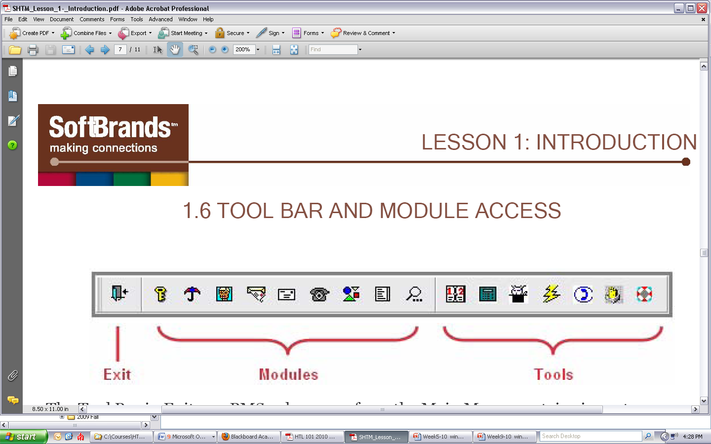 | b. |  | C. |  | 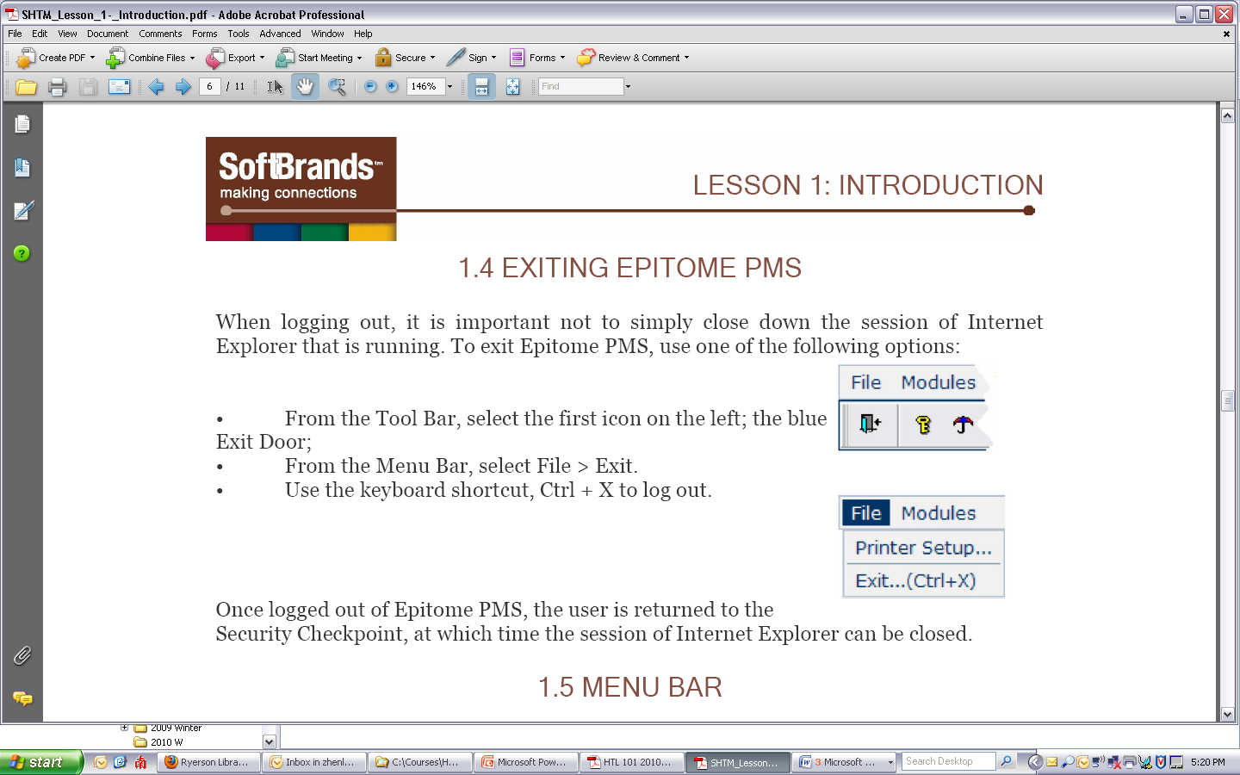  d.

  - Which of the following icons should you click in order to properly exit the Epitome PMS after completing an operation?
a. |  | b. |  | C. |  | d.

  - Which of the following icons should you click in order to view the future room availability report?

a. |  | b. |  | C. |  | d.

Part II. Short Answer ( credits)

  - According to the textbook, what are the four general ways of classifying hotels? (4 credits) describe a hotel (e.g. use your group project hotel) with at least 2 general ways. (2 credits)
- Service, room rate, target market, size, ownership (4 credits);
- For example, Delta Chelsea hotel is a large (size), full service (service), chain hotel (ownership) (2 credits)

  - What is the definition of franchising? (2 credit) What are the pros and cons of using this format for franchisees and franchisors RESPECTIVELY? (4 credits)

Franchising: Franchising refers to the authorization given by one company to another to sell its products and services or use the name of the business, business format. (2 credit)

 | Pros (2 credits) | Cons (2 credits)
Franchisee | taking advantage of CRS, reputation, marketing, central purchasing, training; | Costs  Restricted policies
Franchisor | Expanding company geographically; no financial risk | Difficult to control quality

  - What are the two major types of reservation a hotel normally would accept? List the main responsibilities of the guests and the hotel in each type of reservation? (4 credits)

- Guaranteed reservations
- Non-guaranteed reservation
FOR GUARANTEED RESERVATION:
- The responsibility of the guest is to pay the first night room charge if s/he fails to cancel the reservation before the time required by the hotel. The responsibility of the hotel is to guarantee the room for the guest no matter how late s/he arrives the hotel on the date of arrival.
FOR NON GUARANTEED RESERVATION
- The guest should arrive before the time required by the hotel on the arrival date and the hotel should hold the room for the guest until this time on the arrival date.
(One credit for each point)

  - What are the three main hotel performance indicators discussed in the class? According to the information in the following table, calculate the three indicators respectively (3 credits)

NUF Hotel October,20XX
Rooms Available | 100
Rack Rate | $75
Occupied Rooms | 75
Rooms Sold | 70
Room Revenue | 4200

Occupancy = # Occupied Rooms /Rooms Available= 75%
ADR = Room Revenue/#Rooms Sold = $56
RevPar= Room Revenue/# Rooms Available = $42

  - When a guaranteed guest checks in, the PMS shows that the hotel is fully occupied and there is no room available for this guest to check-in. If you were a front office agent, what actions can you take to avoid walking this guest to another hotel? (4 credits)

- Review all front desk transactions to ensure full occupancy
- Re-take an accurate count of rooms occupied, using all relevant data
- Compare information in the rooms availability report, the housekeeping report for discrepancy in occupancy status
- Contact due-outs
- Verify guest rooms with a status of out of order
- Identify rooms pre-blocked
(Answering each activity closed to the above listed can earn one credit).

  - The following is a report produced by the Epitome PMS, answer the following questions according to this report,:
- What is the name of the report/chart? (1 credit)
Future Room Availability /or room availability
- What does each room type codes mean in this chart. (2 credits)
You can give them two credits, if they can explain 4 room type codes.
BA--- Bachelor
D ---- Double
DD --- Double bed double sofa
DS--- Double bed single sofa
Q --- Queen
QD--- Queen double sofa
QH--- Queen Handicap
QS--- Queen single sofa

- What is the occupancy percent on Tuesday, Oct 28? (1 credits)
2% according to the report.



