Psychology 1001 Midterm Review.
CHAPTER 1
- Applied Psychology: the branch of psychology that is concerned with everyday, practical problems.
- Behaviour: any overt response or activity or an organism.
- Behaviourism: a theoretical orientation based on the premise that scientific psychology should study only observable behaviour
- Clinical psychology: the branch of psychology concerned with the diagnosis and treatment of psychological problems and disorders.
- Cognition: refers to the mental processes involved in acquiring knowledge.
- Critical Thinking: the use of cognitive skills and strategies that increase the probability of a positive outcome.
- Culture: the widely shared customs, beliefs, values, norms, institutions and other products of a community that are transmitted socially across generations.
- Empiricism: the knowledge that is acquired through experience and observation.
- Ethnocentrism: the tendency to view one’s own group as superior to others and as the standard for judging the worth of foreign ways.
- Evolutionary psychology: examines behavioural processes in terms their adaptive value for members of a species over the course of many generations.
- Functionalism: based on the belief that psychology should investigate the function or purpose of consciousness rather than structure.
- Humanism: theoretical orientation that emphasizes the unique qualities of humans, especially their freedom and potential for potential growth.
- Introspection: the careful, systematic self observation of one’s own conscious mind and experience.
- Natural selection: closely linked with Darwin; heritable characteristics that provide a survival or reproductive advantage and is more likely to be passed on to future generations.
- Positive psychology: uses theory and research to better understand the positive, adaptive, creative and fulfilling aspects of human existence.
- Psychiatry: a branch of medicine concerned with the diagnosis and treatment of psychological problems and disorders.
- Psychoanalytic theory: attempts to explain personality, motivation, and mental disorders by focusing unconscious determinants of behaviour.
- Psychology: science that studies behaviour and the psychological and cognitive processes that underlie it, and its the profession that applies the accumulated knowledge of science to practical problems.
- SQ3R: a study system designed to promote effective reading, which includes 5 steps: survey, question, read, recite and review.
- Stimulus: any detectable input from the environment.
- Structuralism: based on the notion that the task of psychology is to analyze consciousness into its basic elements and find out how these elements are related.
- Testwiseness: ability to use the characteristics and format of a cognitive test to maximize ones score.
- Theory: a system of interrelated ideas used to explain a set of observations.
- Unconscious: contains thoughts, memories and desires that are well below the surface of conscious awareness but that nonetheless exert a great influence on behaviour.
Theorists:
- Sigmund Freud: talks about the unconscious mind and mental processes. He is one of the most controversial intellectual figures of modern times. He said humans are not the masters of their own minds as behaviour is influenced by unconscious sexual desires and urges. The main issue with Freudian theory is that it is untestable. You cannot test the unconscious mind.
- Stanley Hall: He was very influential in the psychology movement in America. He established America’s first research lab, he launched America’s first psychological journal and he was the driving force behind the American Psychological Association (APA).
- Donald Hebb: very influential in the development of physiology and neurophysiological practices. He emphasized brain in behaviour. Another pivotal concept was cell assembly (repeated stimulation leads to the development of cell assemblies. These cell assemblies resemble cognitive units that coordinate together facilitate behaviour).
- William James: suggested that we should look at functions of consciousness instead of structure. He was intrigued with natural selection. He believed that the structuralists approach missed the nature of conscious experience. He developed the stream of consciousness (stating that consciousness isn’t divided into elements, it is a stream, in constant flow).
- Brenda Milner: she obtained her Ph.D at McGill university; taught at the university of Montreal and McGill. She has made crucial contributions in memory and neuropsychology.
- Carl Rogers: sometimes called the founder of humanism (theoretical orientation that emphasizes the unique qualities of humans, especially their freedom and potential for potential growth; very optimistic about humans). He maintained that to fully understand peoples behaviour, psychologists must take into account the fundamental human drive towards personal growth. To date, the humanists greatest contribution to the field of psychology is their innovative treatments towards psychological problems and disorders.
- B.F Skinner: founded radical behaviourism. He emphasized how much the environmental factors contribute to overt behaviour. The most fundamental principle for Skinner was that humans tend to repeat the behaviours that lead to positive outcomes and do not repeat behaviours that lead to negative outcomes. His impact is seen in factories, schools, prisons, mental hospitals and many other settings. Skinner was the target of harsh criticism.
- John B Watson: founded behaviourism (a theoretical orientation based on the premise that scientific psychology should study only observable behaviour); this is due to the fact that the scientific method rests solely on verifiability; mental processes were not a proper source for scientific observation as they could not be accurately studied, as they are intangible; he held that behaviour was bases solely on environment. Behaviourism is often called an S-R psychology (stimulus-response psychology).
- Wilhelm Wundt: in 1879 he created the first formal laboratory for research in psychology; 1879 is referred to as psychology’s date of birth; today he is classified as the founder of psychology; primary focus of psychology should be consciousness – the awareness of immediate experience.
CHAPTER 2
- Anecdotal evidence: personal stories about specific incidents and experiences.
- Case study: in depth investigation of an individual subject.
- Confounding of variables: occurs when two variables are linked together in a way that makes it difficult to sort out their specific effects.
- Control group: similar subjects who do not receive the special treatment given to the experimental group.
- Correlation: when two variables are related to each other.
- Correlation coefficient: the numerical index of the degree of relationship between the two variables.
- Data collection techniques: procedures for making empirical observations and measurements.
- Dependent variable: the variable that is thought to be affected by manipulation of the independent variable.
- Descriptive statistics: used to organize and summarize data.
- Double blind procedure: research which neither subjects nor experimenters know which is the experimental group and the control group.
- Experiment: research method in which the investigator manipulates a variable under carefully controlled conditions and observes whether any changes occur in a second variable as a result.
- Experiment group: consists of the subjects who receive some sort of “special” treatment in regard to the independent variable.
- Experimenter bias: when a researcher’s expectations or preferences about the outcome of a study influence the results obtained.
- Extraneous variables: any variables other than the independent variable that may seem likely to influence the dependent variable in a specific study.
- Hypothesis: a tentative statement about the relationship between two or more variables.
- Independent variables: condition or event that an experimenter varies in order to see its impact on other variables.
- Inferential statistics: used to interpret data and draw conclusions
- Internet mediated research: studies in which data collection is done using the web.
- Journal: a periodical that publishes technical and scholarly material, usually in a defined area of inquiry.
- Mean: the arithmetic average of the scores in a distribution.
- Median: the score that falls exactly in the middle of the distribution of scores.
- Mode: the most frequent score in distribution
- Naturalistic observation: researcher engages in careful observation of behaviour without intervening directly with the subjects.
- Operation definition: describes the actions or operations that will be used to measure or control a variable.
- Participants: the persons or animals whose behaviour is systematically observed in a study.
- Placebo effects: occur when a participants expectations lead them to experience some changes even though they receive empty, fake or ineffectual treatment
- Population: much larger collection of animals or people that researchers want to generalize about.
- Random assignment: occurs when all subjects have an equal chance being assigned to any group or condition of the study.
- Replication: the repetition of a study to see whether the earlier results are replicated.
- Research methods: consist of various approaches to the observation measurement, manipulation and control of variables in empirical studies.
- Response set: a tendency to respond to questions in a particular way that is unrelated to the content of the questions.
- Sample: the collection of subjects selected for observation in an empirical study.
- Sampling bias: when a sample is not representative of the population from which it was drawn.
- Social discredibilty bias: tendency to give socially approve answers to questions about oneself.
- Standard deviation: an index of the amount of variability in a set of data.
- Statistical significance: is said to exist when the probability that the observed findings are due to chance is very low.
- Statistics: the use of mathematics to organize, summarize and interpret numerical data.
- Subjects: see participants.
- Survey: researchers use questionnaires or interviews to gather information about specific aspects of participant’s behaviour.
- Theory: system of interrelated ideas used to explain a set of observations
- Variability: refers to how much the scores in a data set vary from each other and from the mean.
- Variables: any measurable conditions, events, characteristics or behaviours that are controlled or observed in a study.
KEY PEOPLE:
- Author Aron and Donald Dutton: they measured sexual attraction in two ways. First: by evaluating the amount of sexual imagery and second: the number or participants in various conditions who called the experiment confederate. (example in the textbook, not all that important).
- Neal Miller: focused on ethical behaviour of psychology. He held that all psychologists should:
- Treated with dignity
- Ensure that their value is no dependent on culture, race, nationality, or other factors.
- Protect the rights, privacy, personal liberty or self determination.
- Vigilant to provide safeguards to protect the vulnerable.
- Freedom of informed consent
- Take all available measures to ensure their research will benefit whom they interact with.
- Emphasize integrity
- Recognize that psychology has a responsibility to provide knowledge to society.
- Robert Rosenthal: suggests that experimenter bias may lead researchers to unintentionally influence the behaviour of their subjects.
- David Wolfe: conducted a study on the effects of the history of abuse and the effect on the proceeding generations.
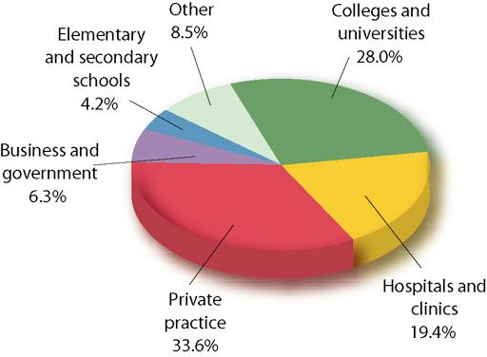
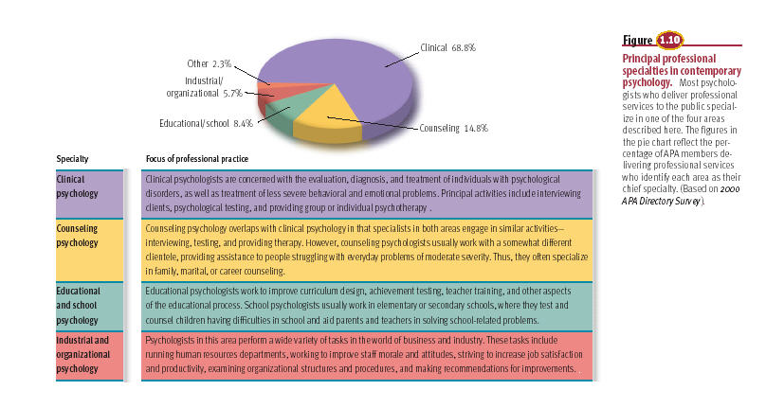
INDEPENDENT AND DEPENDENT VARIABLES
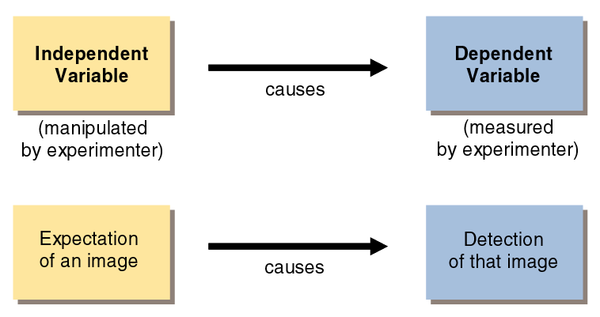
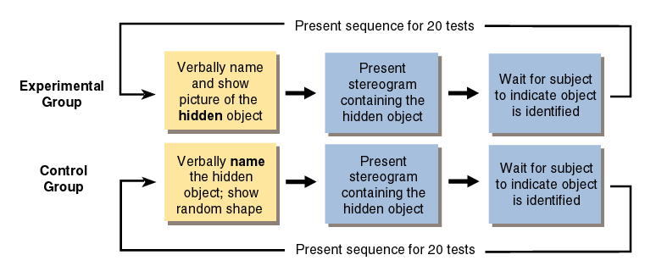
A LINEAR RELATIONSHIP
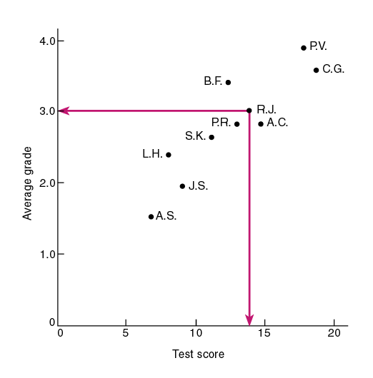
NON LINEAR RELATIONSHIP
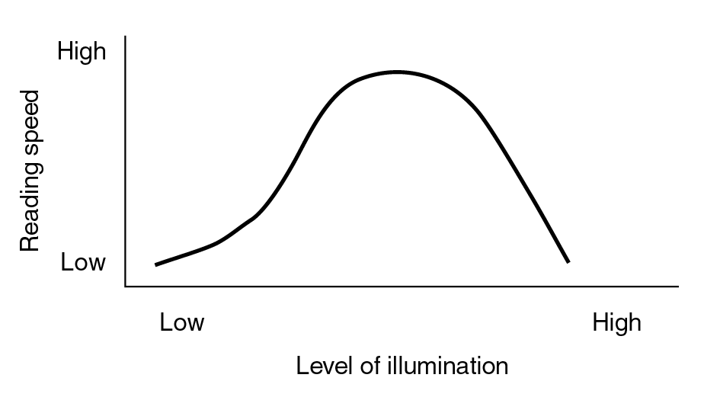

THE AUTONOMIC NERVOUS SYSTEM


