WEEK 1

INTRODUCTION TO BRAIN AND BEHAVIOUR

What is Behaviour?
- Irenaus Eibl-Eibesfeldt
  - “Behaviour consist of patterns in time”
  - Examples: movements, vocalizations, thinking
- Can be
  - Relatively fixed (innate) behaviours
    - Dependent on heredity
  - Relatively flexible behaviours
    - Dependent on learning

Baby rood rat must learn from its mother how to eat pinecones. This behaviour is learned. Whereas a crossbill’s beak is specifically designed to open pinecones, this behaviour is innate.

What is behaviour?
- Complexity of behaviour varies considerably in different species
  - Simple nervous system: narrow range of behaviour; depends on heredity
  - Complex nervous system: wider range of behaviour; depends on learning

Brief History of the Brain
*** Egyptian mummification***
- First written recorded history of the brain was by the Egyptians
- They threw out the brain, because they didn’t need their brains in the afterlife.

Hippocrates (460-379 BC)
- Father of modern medical ethics
- First described effects of head injuries
  - 4 humors
  - Black bile --- depressed
  - Yellow bile --- mood swings
  - Phlegm --- sluggish
  - Sanguine (blood) -- optimistic tendency
- Proven to be wrong

Aristotle
- Brain as a cooling agent for the heart where the spirits circulated
  - No role in producing behaviour
- First use of the term “common sense”
  - Where the spirits come together (sensus communus)
  - Psyche synonym of mind; an entity once proposed to be the sources of human behaviour
- Mentalism: an explanation of behaviour as a function of the non material mind

Galen (131-201 AD)
- Roman physician who worked at a gladiator school
  - Regarded wounds as windows into the body
- Identified 7/12 of the cranial nerves
- First to take the pulse
- Conducted the brain was an organ
- Looked at how trauma effected behaviour

Dark Ages (~1500 AD)
- Period of religious dogmatism
  - No scientific inquiry
- The church ruled. So no science

Renaissance (“Re-Birth”)
- Da Vinci laid the foundation for anatomical drawings
- Corpus collosum: track of fibers that connect both cerebral hemispheres

Rene Decartes (1596-1650)

- Rene Descartes was a philosopher from the 17th C who speculated on the roles of the mind and brain in the control of behaviour. His view of the human body was like that of a machine. He described motor behaviour as a ‘reflex’ that did not require participation of the mind. Much like the other philosophers in this zeitgeist, he was a dualist: he believed that each person possessed a mind separate from the body. However, he was the first to suggest that a link exists between the human mind and the brain. Specifically, he believed that the mind controlled the movements of the body, while the body, through its sense organs, supplied the mind with information about what was happening in the environment.
- Cogito ergo sum:
- However: first to suggest link between mind and body. Mind controlled movements while body supplied mind with information via the sense
- Mind-Body Problem
  - Quandary of explaining a nonmaterial mind in command of a material body
  - Information between the mind and body passes through the brain
  - Mind is located in the pineal gland, which sits beside the brain’s fluid-filled ventricles
  - Mind regulates behaviour by directing the flow of ventricular fluid to appropriate muscles
  - Mind controls rational behavior
  - Body and brain direct all other behavior via mechanical and physical principles
    - Examples: sensation, movement, digestion

- Dualism: mind and brain are separate
  - Both nonmaterial mind and the material body contribute to behaviour
- We are all susceptible to believing that they mind and body are not connected

Mind-Body Problem
- Avandary of explaining a nonmaterial mind in command of a material body
- Information between the mind and body passes through the brain
- Mind is relocated in the pineal gland which sits beside the brains fluid filled ventricles

Problems with Decartes
- Pineal gland is involved in biological rhythms but not in the intelligence or behavioral control
- Fluid is not pumped from the ventricles to control the movement
- Nonmaterial influences on the body would violate the law of conservation of matter and energy

Luigi Galvani (1737-1798)
- Demonstrated that nerves conduct electricity: NOT PIPES
- Frog experience
- Nerves have electrical charges
- Dead frog legs to see if they would jump if he put an electicles charge

Localization of function: hypothetically, the control of each kind

Franz Gall (1758-1828)
- Phrenology
  - Mental and moral faculties- determined by the shape of the skull
  - That’s wrong; first to suggest localization of behaviour

Pierre Flourens (1794-1867)
- Advocate of experimental ablation: remove part of the brain and observe which behaviours remain mostly grey matter
- Came up with the notion that we only use 10% of our brains. Which is not true we use the entire thing. He concluded from research on chickens) that the forebrain was the central functioning of the brain, but we could survive without using the forebrain
- The brain is often being actively inhibited reason why he was wrong

Paul Broca (1824-1880)
- French neuropsychologist
- Localization of function
- He conducted the area the patients brain that he studied, had been effected by stroke and he removed these parts so that he could research these areas that were later called Broca’s area
- Broca’s aphasias: the inability to make comprehendible speech. They make random noises
- Observed stroke patient who had lost the ability to speak
- Autopsy revealed part of the right hemisphere missing
- Concluded area important for speech production: Broca’s area

William James (1842-1910)
- Was one of the first individuals to have a modern approach to biological psychology
- We relate the properties of the mind to the feelings of the nervous system
- Modern approach to biological psychology
- Concepts of consciousness and human experience described as properties of the nervous system

Wilder Penfield (1891-1976)
- There are no pain receptors in the surface of the brain YOU CAN PROBE THE BRAIN WHILE THEY ARE AWAKE!!!!!
- He tried to stimulate the same response that seizure patients experienced when they had a seizure
- Somatosensory cortex: related to the sensation of touch (surface of the brain) mapped out the different areas of the body on this strip of the brain, and could find where the patient felt it in their body
- Somatosensory homunculus
- Neurosurgeon who invented the procedure to treat intractable epilepsy
- Stimulated the brain with electrical probes to observed their responses
- Mapped out “homunculus”

Donald O. Hebb (1904-1985)
- First to describe the process of learning and memory in the brain
- The Hebb rule: when neurons are firing together in time and in space they will become associated together: “ What fires together, wires together.”
- Father of modern behavioral neuroscience

Eric Kandel (1929- )
- Took Hebb’s theory’s: looked at the intercellular cascades that linked learning and memory
- Put Hebb’s theory into practice, and won a Nobel prize: nerve transduction Molecular mechanisms underlying learning and memory

EVOLUTION OF BRAIN BEHAVIOUR

Materialism
- The mind DOES NOT exist
- All higher order behaviours are governed by the nervous systems
- Evolution: they came to the conclusion of evolution by the behaviour of many different species. Thus proving that all other species are related in someway
- Supported evolutionary theories of Alfred Wallace and Charles Darwin
  - Both were struck at the many similarities among species
- Behaviour can be fully explained by the workings of the nervous system, without explanatory recourse to an immaterial mind
- Supported by evolutionary theories of Alfred Wallace and Charles Darwin
  - Both were stuck at the many similarities among species
    - E.g., skeletons, muscles, limbs
  - All living things are related

Theory of Evolution
- New Species evolve:
  - Fossil records
  - Structural similarities
  - Programs of selective breeding
- Natural selection: variations in traits that increase fitness will increase the probability of that species’ survival
- Sexual selection: each sex has anatomical and behavioral features that favour reproductive success
  - E.g. Peacock feathers
- Al species are related, and all species evolve from each other

How are traits selected naturally?
Appearance of new trait (e.g. via mutation) adaptive trait increases chances of survival trait passed to offspring

Implications of Brain and Behaviour
- We as humans have added layers to our brains rather than the brain staying the same and still preforming simple mechanisms
- ***Because all animal species are related, so too must be their brains
  - Rationale for studying simpler animals to understand humans
- ***Because al species of animals are related, so too must be their behaviour
  - Emotional expressions in humans (across cultures) and other animals are similar
- Both the Brian and behaviour changes bit by bit in animals that evolved to greater complexity, as humans obviously did
- Today the evidence that the brain controls the brain controls behaviour is extremely strong: Brain Theory
  - D.O. Hebb

- Common ancestor: a forbearer from which two or more lineages or family groups arise
  - Example: humans and apes are thought to share a common ancestor
- Can trace our lineage by comparing the genes, brains, and behaviours of different animals

Evolution of Brain and Behaviour
- Common Ancestor: a forebearer from which two or more lineages or family groups arise
  - Example: humans and apes are thought to share a common ancestor
- Can trace our lineage by comparing the genes, brains, and behaviours of different animals

Classifications of Life
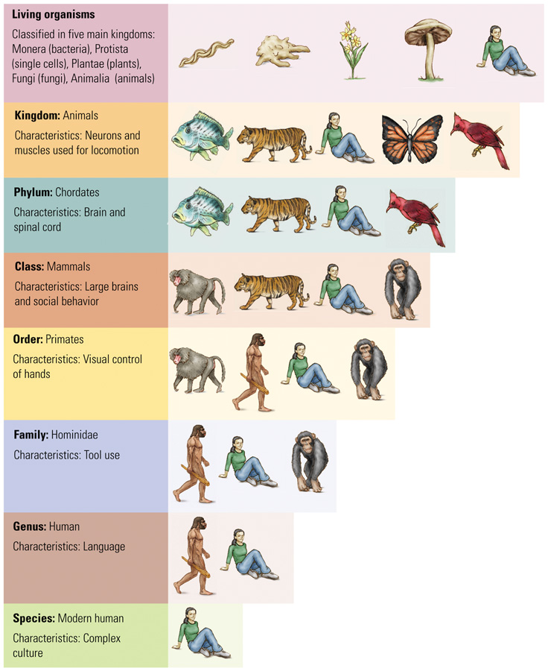
- All living organisms are classified into the 5 kingdoms
- Taxonomy:
  - Branch of biology concerned with naming and classifying species
    - Groups organisms with common characteristics
  - Useful for helping us trace the evolution of brain cells and the brain

Classification of Life
- Cladogram (“branch”)
- Display groups of related organisms as branches on a tree
- Branch order represents how the groups are related evolutionarily, as well as the traits that distinguish them
- Read from left to right; the most recently evolved organism or trait is located farthest to the right

The Chordate Nervous System
- 2 Features distinguish the chordates:
  - Nervous system is crossed
  - Chordate spinal cord lies behind heart and gut
- Crossed nervous system: left side of the brain controls rights side of the body and vise versa

Evolution of the Human Brain
- Australopithecines were hominids that made and used tools
  - Reduced the necessity for large jaws and teeth, and those became steadily smaller
- As H. Habilis evolved, brains became larger and faces got smaller
- H. Erectus made elaborate tools, used fire, and hunted
  - Also expanded their area over three continents
- H. Sapiens: brain volume reaches modern levels
- Mammals share main brain structures
- Humans:
  - Increased in size during course of evolution
  - Most of increase has occurred in the cerebrum
  - Increased cerebrum resulted in increased convolutions
- Difference between human and rat brains are in actual and relative size of regions, such as cerebral cortex and olfactory bulbs
- Human neurons are larger

Relating Brain Size and Behaviour
- Jerison (1973), Principle of Proper Mass:
  - Species exhibiting more complex behaviours will possess relatively larger brains
- Jerison developed an index of brain size to allow comparisons among different species
  - Used body size to predict brain size

Encephalization quotient (EQ)
- Measure of brain size obtained from the ratio of actual brain size to the expected brain size for an animal of a particular body size
- Homo sapiens have the largest EQ

Climate change and the Enlarging Hominid Brain
- Three-fold increase in brain size over last 5 million years appears to have taken place in steps
  - Evidence suggests each new hominid species appeared after new environments appeared due to climate changes
  - Example: spreading grasslands and fewer trees increased the adaptiveness of an upright posture and tool-building skills

Why the Hominid Brain Enlarged
- 1. The Primate Lifestyle
- The foraging behaviour of primates is more complex than other animals
  - Finding fruit is more difficult than eating grass or other vegetation on the ground
    - Need good sensory, spatial, and memory skills
  - Fruit eaters have larger brains
- 2. Changes in hominid physiology
- Radiator Hypothesis (Falk, 1990)
  - To increase the sixe of a car’s engine must increase size of radiator to cool it.
  - The more active the brain is, the more heat it generates
  - Homo species’ skulls had more widely dispersed blood flow, which allowed for increased brain size.
Increased blood circulation improved brain cooling enabled size of hominid brains to increase

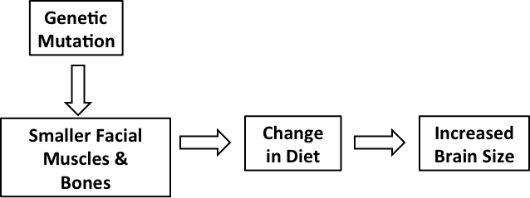

- 3. Neoteny (“juvenilization”): juvenile stages of predecessors become the adult features of descendants
- Rate of maturation is slowed
  - Allows more brain cells to be produced
- Adults retain some infants characteristics
- Newly evolved species resemble the young of their common ancestors

Modern human Brain Size and intelligence
- Evolutionary Approach
  - Make brain-behaviour comparisons between different species
- CAUTION:
  - Difficult to make brain behaviour comparisons between members within the same species
    - Example brain size and intelligence

Are people with larger brains more intelligent?
- Problems:
- How does one measure brain size?
  - Control for skull thickness
  - Volume versus weight
    - Can fluctuate within an individual over time
  - Effect of age, physical health, brain damage?
- Problem: how does one measure intelligence?
  - People vary enormously in their individual abilities, depending on the task
Person A: excellent math abilities, but poor spatial abilities
Person B: poor math abilities, but excellent spatial abilities

Fallacies of Human Brain-Size Comparisons
- Brain size and intelligence do not seem to be particularly related
  - Research has shown that many smart people (e.g., Einstein) have average size brains
  - Women’s brains weigh about 10% less then men, but the two sexes do not differ in measures of average intelligence

Culture and Evolution
- Our large brains have allowed us to develop a rich culture:
  - Complex learned behaviours that are passes on from one generation to the next through teaching and learning
- The brain is highly flexible
  - We preform many tasks today that our brains were not originally selected for early during evolution
    - Example: programming computers

Is Bigger Better?
- Costs:
  - Long gestation period
  - Prolonged dependence on parents
  - Metabolically costly
  - Complex genes are vulnerable to mutation

Smarter is better!
- Benefits:
  - Increases survival and ability for group interaction
  - Innovative behaviour, use of tools and social learning
  - Predicts success in a novel environment
  - Sexual selection pressures for ability to attract attention, artistry and creativity may lead to increased brain size.
Chapter 1

Neuroscience I the 21st century
- Understanding the link between brain and behaviour how the brain is organized to create behaviour
- Evidence comes from studying to create behaviour
  - 1. The evolution of the brain and behaviour in diverse animal species
  - 2. How the brain is related to behaviour in normal people
  - 3. How the brain changes in people who suffer brain damage or other brain abnormalities

Why study the Brain and Behaviour
- 3 reasons for linking the study of the brain and behaviour
  - 1. A growing list of behavioral disorders can be explained and cured by understanding the brain
  - 2. The brain is the most complex living organ on Earth and is found in many different groups of animals
  - 3. How the brain produces both behaviour and human consciousness is a major unanswered scientific question

- The brainstem is responsible for most of our unconscious behaviours
- The forebrain has nearly 2 symmetrical halves called hemispheres
- Cerebral cortex: the entire outer layer of the forebrain that consists of a thin, folded layer of nerve tissues
- The forebrain pointing temporal lobe is located at the side of the brain. The temporal lobe functions as a connection with hearing and language and musical abilities
- Above the temporal lobe is the frontal lobe often characterized as preforming the brains “executive” functions such as decision making
- The parietal lobe is located at the top of the skull, behind the frontal lobe and above the temporal lobe parietal functions include directing our movements toward a goal or to preform a task, such as grasping on object
- The area at the back of each hemisphere constitutes the occipital lobe where visual processing begins

Gross anatomy of Nervous system
- The nervous system is composed of cells; as is the rest of the body and these nerve cells or neurons, most directly control behaviour. Neurons communicate with one another with sensory receptors on the body, with muscles and with internal body organs
- Connections throughout the body are made through the spinal cord
- Together the brain and spinal cord make up the central nervous system (CNS). The CNS is central because it is physically located to be the core of the nervous system and because it is the core structure in mediating behaviour.
- All the processes radiating out beyond the brain and spinal cord as well as all the neurons outside the brain and spinal cord constitute the peripheral nervous system (PNS). Neurons in the somatic division of the PNS connect to receptors and to convey information from the CNS to move muscles of the face, body, and limbs. Similarly, the autonomic division of the ONS enables the CONS to govern the workings of your body’s internal organs- such as the beating of your heat, the contractions of your stomach, and the movement of your diaphragm to inflate and deflate your lungs.
- Embodied consciousness: proposed that the movements that we make and those that we perceive in others are listening to words but also with overt gestures and body language

What is Behaviour?
- Irenaus Eibl-Eibesfeldt: “Behaviour consists of patterns in time”. These patterns can be made up of movements, vocalizations, or changes in appearance, such as the facial movements associated with smiling. The expression “patterns in time” includes thinking
- The behavioral patterns of some animals are relatively fixed: most of their behaviours are inherited ways of responding. The behavioral patterns of other animals are both inherited and learned
- THINK THE BIRD AND RAT EXAMPLE
- Complexity emerges in part because new nervous-system structures are added to old ones

Perspectives on Brain and Behaviour
Aristotle & Mentalism:
- The Psyche: Aristotle argued, is responsible for life and its departure from the body results in death
- Aristotle’s account of behaviour had no role for the brain, which Aristotle thought existed to cool the blood. To him, the nonmaterial psyche was responsible for human thoughts, perceptions, and emotions and for such processes as imagination, opinion, desire, pleasure, pain, memory, and reason. The psyche was an entity independent of the body.
- Mind is an Anglo-Saxon word for memory and when “psyche” was translated into English, it became mind. The philosophical position that a person’s mind or psyche, is responsible for behaviour is called Mentalism, meaning “of the mind”
- Because the mind is nonmaterial it cannot be studies with scientific method. Just the same, Mentalism has influenced modern behavioral science because many terms remain in use for patterns of behaviour today and matters related to these behaviours are the focus of contemporary research in psychology

Descartes & Dualism
- Proposed a new explanation of behaviour in which the brain played in important role. Descartes places the seat of the mind in the brain and linked the mind to the body.
- He stated that the mind and body “must be joined and united to constitute people…”
- He thought that most of the functions of the brain could be explained by mechanical and physical principles. The nonmaterial mind, on the other hand, is responsible for rational behaviour.
- The philosophical position that behaviour is controlled by two entities, a mind and body is called dualism
- The problem of how a nonmaterial mind and a physical brain might interact and it has come to be called the mind-body problem.
- The mind receives information from the body through the brain
- He developed a mechanical explanation of how the mind produces movement. He suggested that the mind resides in a small structure in the center of the brain, the pineal body (now the pineal gland), which is located beside fluid-filled cavities called ventricles. He thought that the pineal body directs fluid from the ventricles through nerves and into muscles. When the fluid expands those muscles, the body moves.
- People who damages their pineal glands or had no pineal gland showed to have no reduced function of their intelligent behaviour
- TODAY WE UNDERSTAND THAT THE PINEAL GLAND PLAYS ROLE IN BEHAVIOUR RELATED TO BIOLOGICAL RHYTHMS, BUT IT DOES NOT GOVERN HUMAN BEHAVIOUR.

DARWIN & MATERIALISM
- Materialism is the theory that the idea that rational behaviour can be fully explained by the workings of the brain and the rest of the nervous system with, with out any need to refer to an immaterial mind.
- Darwin further elaborated on the theory of evolution by publishing the book On the Origin of Species by Means of Natural Selection, published in 1859. This book presented a wealth of supporting detail, which is why Darwin is regarded as the founder of modern evolutionary theory.
- Both Darwin and Wallace looked closely at the structure of animals and at animal behaviour. Although the diversity between most creatures the two noticed that there is similarities between most animals.
- Darwin proposed that animals have traits in common because these traits are passed from parents to their offspring.

Evolution of Brain and Behaviour
- The study of living organisms shows that nervous systems or brains are not common to all and that nervous systems and behaviour built up and changed bit by as animals evolved.
- We trace evolution of the human brain and behaviour by describing (1) those animals that first developed a nervous system and muscles with which to move and (2) how the nervous system became more complex as the brain evolved to mediate complex behaviour.
- The popular interpretation of human evolution is that we are descended from apes. Actually apes are not our ancestors, although we are related to them through a common ancestor, a forbearer from which two or more lineages or family groups arise.

The Chordate Nervous System
- All chordates have a brainstem, but only the birds and mammals have a large forebrain. Two additional features distinguish the chordates
- 1. The nervous system is crossed: that is one hemisphere of the brain receives most sensory signals from the opposite side of the body and sends motor commands mainly to the opposite side of the body (left hemisphere controls right body, and vise versa. In prechordate animals, the nervous system does not cross over
- 2. The chordate spinal cord lies behind the heart and gut: the prechordate nervous system lies in front of these structures. Some anatomists speculate that in an ancestral animal, the head twisted in relation to the body producing key adaptations of a crossed nervous system, the shift toward the back also allowed the chordate nervous system to grow larger

Humans: Members of the primate Order
- The human relationship to apes and monkeys places us in the primate order a subcategory of mammals that includes apes and monkeys but lemurs, tarsiers and marmosets as well. In fact we humans are but 1 of the 275 species in the primate order. Primates have excellent color vision, with the eyes positioned at the front of the face to enhance depth perception and they use this highly developed sense to deftly guide their hand movements
- Among the apes, we are most closely related to the chimpanzee, having had a common ancestor between 5 million and 10 million years ago. In the past 5 million years many hominids, primates that walk upright, evolve in our lineage. For most of the hominid past, a number of hominid species coexisted. At present, we are the only surviving hominid species.

Australopithecus: Our Distant Ancestor
- From the Latin word austral meaning “southern” and the Greek word pithekos, meaning ape.

Psyche: synonym for mind, an entity once proposed to be the source of human behaviour
Mind: proposed nonmaterial entity responsible for intelligence, attention, awareness, and consciousness
Mentalism: Of the mind: an explanation of behaviour as a function of the nonmaterial mind
Dualism: philosophical position that holds that both a nonmaterial mind and the material body contribute to behaviour
Mind-body Problem: Quandary of explaining a nonmaterial mind in command of a material body
Materialism: philosophical position that holds that behaviour can be explained as a function of the nervous system without explanatory recourse to the mind.
Natural Selection: Darwin’s theory for existing species change over time differential success in the reproduction of different characteristics (phenotypes) results from the interaction of organisms with their environment
Species: Group of organisms that can inbreed
Cladogram: phylogenic tree that branches repeatedly, suggesting taxonomy of organisms based on the time sequence in which evolutionary branches arise
Nerve net: simple nervous system that has no brain or spinal cord but consist of neurons that receive sensory information and connect directly to other neurons that move muscles
Bilateral symmetry: body plan in which organs or parts present on both side of the body are mirror images in appearances. For example the hands are bilaterally symmetrical whereas the heart is not.
Segmentation: division into a number of parts that are similar; refers to the idea that many animals, including vertebrates are composed of similarly organized body segments
Ganglia: collection of nerve cells that function somewhat like a brain and a spinal cord.
Chordate: animal that has both a brain and a spinal cord
Cerebellum: major structure of the brainstem specialized for coordinating and learning skilled movements. In large brained animals, it may also have a role in the coordination of other mental processes
Hominid: General term referring to primates that walks upright, including all forms of humans, living and extinct.
Encephalization quotient (EQ): Jerison’s quantitative measure of the brain sixe obtained from the ratio of actual brain size to expected brain size according to the principal of proper mass, for an animal of particular body sizes
Radiator Hypothesis: idea that selection for improved brain cooling through increased blood circulation in the brain of early hominids enabled the brain to grow larger.
Neoteny: process in which maturation is delayed, ad so an adult retains infant characteristics: idea derived from the observation that newly evolved species resembled the young of their common ancestors
Species-typical behaviour: behaviour that is characteristic of all members of a species
Culture: learned behaviours that are passed on from one generation to the next through teaching and experience

