Chapter 2: How Dos the Nervous System Function?

Overview
- The brains primary function is to produce behaviour or movement. To produce behaviour as we search, explore, and manipulate our environments, the brain must get information about the world-about the objects around us: their sizes, shapes, and locations. Without such stimulation, the brain cannot orient and direct the body to produce an appropriate.
- The nervous system’s function is to produce movement within a perceptual world created by the brain
- The brain is plastic: neural tissue has the capacity to adapt to the world by changing how its functions are organized.
- From an anatomical standpoint, the brain and spinal cord together make up the central nervous system, and all the nerve fibers radiating out beyond the brain and spinal cord as well as all the neurons outside the brain and spinal cord from the peripheral nervous system.
- The CNS includes the brain and the spinal cord, the structures at the core of the nervous system that mediate behaviour
- The somatic nervous system (SNS), all spinal and cranial nerves carrying sensory information to the CNS from the muscles, joint , and skin, also transmits outgoing motor instructions that promote movement
- The autonomic nervous system (ANS) balances the body’s internal organs to “rest and digest” through the parasympathetic (calming) nerves or to “fight and flee” or engage in vigorous activity through the sympathetic (arousing) nerves.

The Brain’s Surface Features
- Meninges: Three layers of protective tissue
  - Dura mater:
    - “Hard mother”; tough outer layer of fibrous tissue
  - Arachnoid layer:
    - “Like a spider’s web”; thin sheet of delicate connective tissue
  - Pia mater:
    - “Soft mother”; moderately tough inner layer that clings to the brain’s surface
  - Between arachnoid and pia is the cerebrospinal fluid

Views of the Brain
- Dorsal: looking down
- Ventral: looking from the underside up
- Lateral: side (fully intact)
- Medial: side (cut in half)
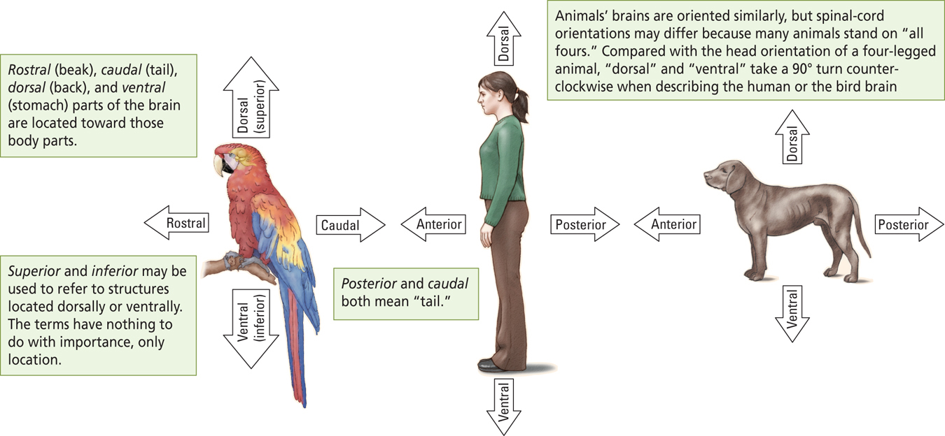

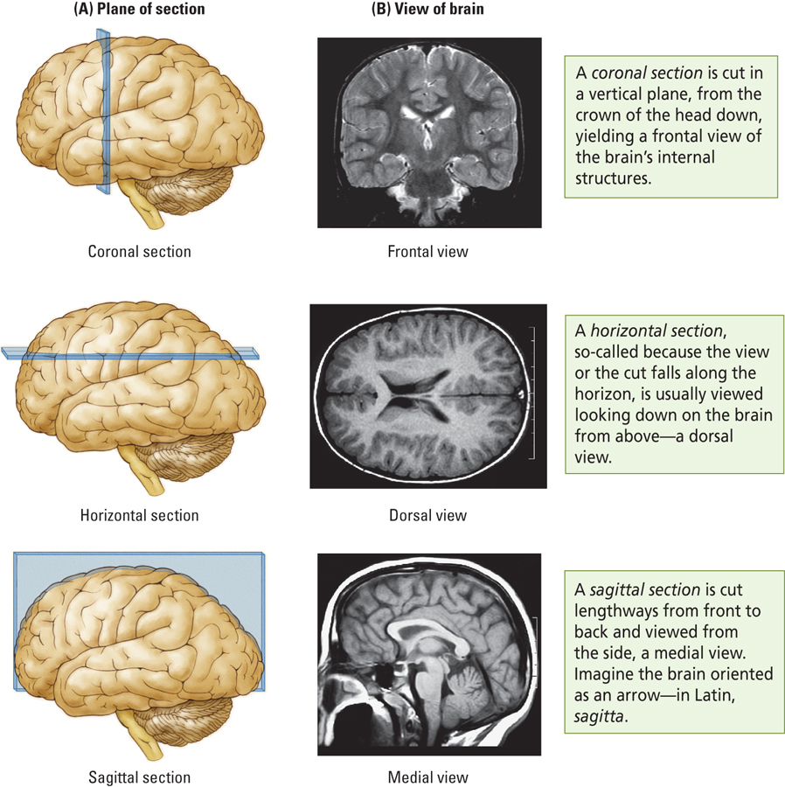

Meningitis: Infection of the meninges and CSF

The Brain’s surface features
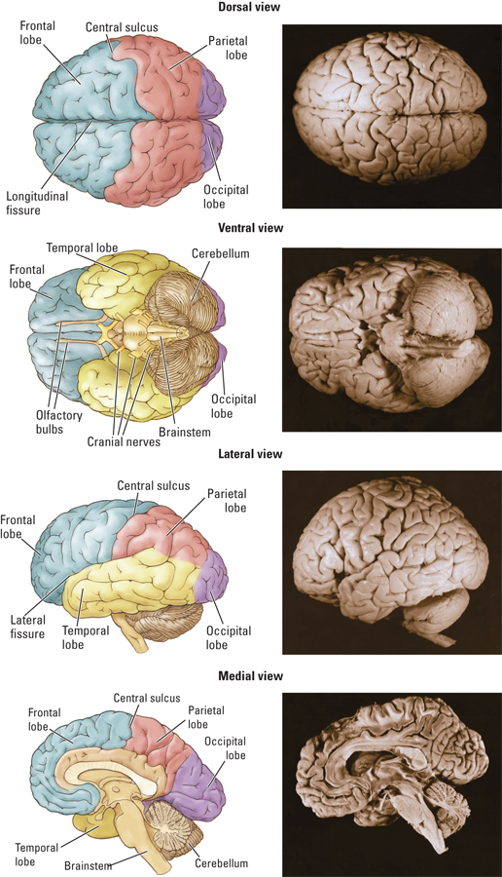

- Gyrus (pl. gyri)
  - A small protrusion or bump formed by the folding of the cerebral cortex
- Sulcus (pl. sulci)
  - A groove in brain matter, usually found in the neocortex or cerebellum
- Fissure
  - A very deep sulcus

- The brain’s surface appears to be covered in blood vessels. Like the rest of the body, the brain receives blood through arteries and sends it back through the veins to the kidneys and lungs for cleaning and oxygenation. The cerebral arteries emerge from the neck to wrap around the cerebellum, finally piercing the brain’s surface to nourish the inner regions
- Thee major arteries send blood to the cerebrum-namely, the anterior, middle, and posterior cerebral arteries. Because the brain is very sensitive to los of blood, a blockage or break in a cerebral artery is likely to lead to the death of the affected region, a condition known as a stroke, the sudden appearance of neurological symptoms as a result of severe interruption of blood flow. Because the 3 arteries service different parts of the brain, stokes disrupt different brain functions depending on the artery affected.

The Brain’s Internal Features
- The interior of the brain is not homogeneous. Both light and dark regions of tissue are visible and through these regions may not be distinctive as the parts of a car’s engine, they nevertheless represent different components
- The darker regions, called gray matter, are largely composed of cell bodies and capillary blood vessels. The cells of the gray matter function either to collect and modify information or to support this activity. The lighter regions called white matter are mostly nerve fibers with fatty coverings that produce the white appearance, much as fat droplets in milk make it appear white. The fibers of the white matter form the connections between the cells
- A second feature at the middle of our frontal view consists of two wing-shaped cavities, the ventricles that contain cerebrospinal fluid. The brain contains four. Cells that have the ventricles make the cerebrospinal fluid fill them. The ventricles are connected to the CSF flows from the two lateral ventricles to the third and fourth ventricles that lie on the brain’s midline and into the cerebral aqueduct, a canal that runs the length of the spinal cord.
- The ventricles are thought to play an important role in maintaining brain metabolism. The CSF may allow certain compounds access to the brain, and its probably helps the brain excrete metabolic wastes, in the event of head or spinal trauma.
- One feature of the brain is a line of white matter that runs much of the length of the cerebral hemispheres. This band, the corpus collosum, contains about 200 million nerve fibers that join the two hemispheres and allow communication between them.
- The cortex covers the cerebral hemispheres above the corpus callosum whereas below it is various internal subcortical structures that generally controls basic physiological functions. Many subcortical regions are forebrain structures intimately related to the cortical areas that process motor, sensory, perceptual, and cognitive functions. This cortical- subcortical relation alerts s to the concept that there is redundancy of function at different levels of the nervous system’s organization.
- Of you were to compare the left and right hemispheres in sagittal section, you would be struck by their symmetry.
- The fundamental units of the brain are its cells. They are so small that they can be viewed only by microscope. By using a microscope, we quickly discover that they brain has two main types of cells. Neurons carry out the brain’s major functions where as glial cells aid and modulate the neurons’ activities- for example by insulating neurons. Both neurons and glia come in many forms, each determined by the work that they do.
- We se that the distribution of cells within the gray matter of the cerebral cortex is not homogeneous but rather forms layers revealed by the bands of tissue. Subcortical regions are seen to be composed of clusters, or nuclei, of similar cells.
- Neruons
  - Carry our the brain’s major functions
  - Approximately 80 billion
- Glial cells
  - Aid and modulate neurons’ activities
  - Approximately 100 billion
- Although layers and nuclei are very different in appearance, both form functional units within the brain. Whether a particular brain region has layers or nuclei is largely an accident of evolution.
- A key feature of the neurons is that they are connected to one another by fibers known as axons. When axons run along together, much like the wires that run from a car engine to the dashboard, they form a nerve or a tract. By convention, the term tract is usually used to refer to collections of nerve fibers focused within the brain and spinal cord, whereas bundles of fibers located outside these CNS structures are typically referred to simply as nerves. Thus the pathway from the eye to the brain is known as the optic nerve, whereas the pathway from the cerebral cortex to the spinal cord is known as the conticospinal tract
- Nucleus (pl. nuclei)
  - A group of cells forming a cluster that can be identified with special stains to form a functional grouping
- Nerve
  - Large collection of axons coursing together outside the central nervous system
- Tract
  - Large collection of axons coursing together within the central nervous system

Evolutionary Development of the Nervous System
- Human brain is a complex mammalian brain, yet it still retains most of the features of other less complex mammalian brains
- Most behaviour are not the product of a single locus in the brain, but rather of many brain areas and levels.

The Spinal cord
- Controls most body movements
- Can act independently of the brain
- Spinal reflex:
  - Automatic movement
  - Hard to prevent (brain cannot inhibit)
  - Ex. Knee-jerk reflex (patellar tendon)

The Brainstem
- Begins where spinal cord enters the skull
- Produces movement and creates a sensory world
- Three regions:
  - Hindbrain
  - Midbrain
  - Diencephalon
The brainstem receives afferent nerves from all of the body’s sense sand it send efferent nerves to the spinal cord to control virtually all of the body’s movemtns except the most complex movements of the fingers and toes
- Hindbrain
- Evolutionarily the oldest part of the brain
- Contains:
  - Cerebellum
    - Controls complex movements and has a role in a variety of cognitive functions
    - Size of cerebellum increases with the physical speed and dexterity of species
  - Reticular formation
    - Netlike mixture of neurons (gray matter) and nerve fibers (white matter)
    - Stimulates the forebrain
      - Regulation of sleep-wake behaviour and behavioral arousal
  - Pons
    - Connects cerebellum to the rest of the brain
    - Controls important movements of the body
  - Medulla
    - Rostral tip of spinal cord
    - Vital functions
      - Control of breathing and heart rate
- Control of movement

- Brainstem (Midbrain)
- Tectum (roof of midbrain)
  - Sensory processing (visual and auditory)
  - Produces orienting movements
- Tegmentum (floor of midbrain)
  - Eye and limb movements
  - Species-specific behaviours
  - Perception of pain
- Brainstem (Diencephalon)
- Hypothalamus (maintaining homeostasis: the body wants to maintain a constant bodily environment)
  - Hormone function
    - Through connections in the pituitary gland
  - Feeding
  - Sexual behaviour
  - Temperature regulation
  - Emotional behaviour

Diencephalon
Thalamus (bi-lobed (2sides) important role: integration center for all sensory information)
- Gateway for channeling sensory information to the cortex
- Primary role is sensory processing
- Motor processing

The forebrain (most recently evolved portion of the brain)
The principle structures:
- Neocortex (“new bark”)(outer most layer of gray matter):
  - Regulates various mental activities
    - Consists of 6 layers of gray matter
THE CORTEX
-New layers add to the cortex as the brain develops
- Losing cortical tissue in the fusiform facial area you get: prosopagnosia: when you lose the ability to remember peoples faces

    - Creates and responds to a perceptual world
- Limbic cortex
  - Evolutionarily older
  - 3 or 4 layers of gray matter
  - Controlling motivational states

- Basal Ganglia (ganglia: a group of neural structures that are associated in function):
  - Control of voluntary movement
    - Collection of nuclei just below the white matter of the cortex
      - 3 principle structures: caudate nucleus putamen, and Globus Pallidus
    - Controls voluntary movement
    - Related disorders
      - Parkinson’s disease (degeneration of the neural structures; loss of cells in the substantial nigra) and Tourette’s syndrome (considered a psychiatric disorder when people who can’t control ticks)

- Limbic system (principle structures: involved in motivation and emotion):
  - Regulates emotions behaviours that create and require memory
    - Group of structures between the neocortex and brain stem
      - Principle structures: amygdala,(almond) hippocampus (“seahorse”), and cingulate cortex ( older tissue that would have been the cortex) (sub-cortical structures: subconsciously)
    - Regulation of:
      - Emotional and sexual behaviours
      - Memory (multiple memory systems)
      - Spatial navigation

Cortical Layers
- Different layers have different cell types
- Density of cells in each layer varies
- Differences in appearance relate to function
- Cytoarchitectonic distinct: the density of the cells, and the type of the cells that can be found are distinct
- Cytoarchitectonic map
  - Map of neocortex based on the organization, structure, and distribution of cells
- Form follows function

The Cortical Lobes
- Frontal: Motor and executive function (damage to the frontal lobe; have personality changes; you lose the ability to plan, organization of behaviour)
- Occipital: Vision
- Parietal: Tactile functions (sensory cortex located here; gives you a sense of where you are in space; ego and exo centric spatial functions)
- Temporal: Visual, auditory, and gustatory (taste) functions (memory processing, language centers, main cortical region for taste)

The Somatic Nervous System (the two branches are autonomic (out of your control) and somatic (within your control): Transmitting Information
- The SNS is monitored and controlled by the CNS
  - The cranial nerves by the brain
  - The spinal nerves by the spinal cord segments

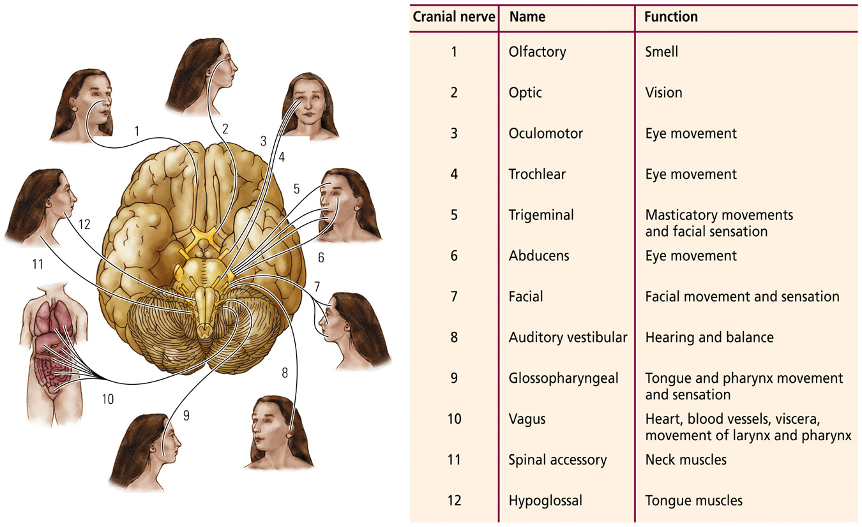

Only One Option To Taste A Fricken Good Vino S Hellmens
- Olfactory: bundles of the axons coming out of the olfactory bulbs; when you smell they come into the olfactory nerve; Afferent nerve (only a sensory nerve)
- Bundles of the ganglia cells (sensory nerve)
- Ocular nerve (sensory and motor nerve (where our eyes have moved too, and where to then move our eyes)
- ….
- Branches out sensory and motor (chewing motions) sends information about temperature. Somewhat sensory information
- Visual
- …
- hearing and balance
- …
- wacky, wandering nerve; goes throughout the whole body other then the face.
- …

The spinal Nerves
Connections of the Somatic Nervous System
- Dorsal fibers are afferent: they carry information form the body’s sensory receptors. There is gray and white matter.
- Ventral fibers are efferent: they carry information from the spinal cord to the muscles
- Law of bell and magendie: the general principle that sensory fibers are located dorsally and motor fibers are located ventrally
Dermatome
- Area of the skin supplied with afferent nerve fibers by a single spinal-cord dorsal root
Spinal-cord segments are interconnected so adjacent segments can operate together to direct complex coordinated movements

The Automatic Nervous System: Balancing internal functions
Two divisions working in opposition
- Sympathetic nervous system
  - Arouses the body for action (e.g., increase heart rate and blood pressure)
  - Mediates the “flight or flight “ response
  - When nerves are activated they send signals using nerve fluid telling certain parts of the body to react in an excited way. So that we can deal with potential or perceived stressors
- Parasympathetic nervous system
  - Opposite of sympathetic: prepares the body to “rest and digest”
  - Reverses the “fight or flight” responses

What are the units of Nervous systems Function?
- Cells of the Nervous system
- Internal structure of a cell
- Genes, cells, and behaviours
  - Genomics:
    - Field of study directed toward understanding how genes produce proteins
    - Genome size and chromosomes number seem unrelated to organismal complexity
  - Proteomics:
    - Field of study directed at understanding what all the proteins do

Neurons: the basis of information processing
- 3 Basic subdivisions
  - Dendrites
    - Gather information from other neurons
  - Cell body or Soma
    - Core region; contains the nucleus
    - Integrates the information
  - Axon
    - Carries information to be passed on to other cells
Basic Structure and Function
- Dendritic spines
  - Protrusion from a dendrite that greatly increase its surface area and is the usual point of contact with axons of other cells
- Axon Hillock
  - Juncture of soma and axon where the action potential begins
- Axon Collaterals
  - Branch of axon
- Teleodendria
  - End branches of axon
- Terminal button
  - Knob at the tip of an axon that conveys information to other neurons; also called an end foot
- Synapse
  - Gap between one neuron and another neuron
  - Usually between an end foot of the axon of one neuron and a dendritic spine of another neuron

Different types of Neurons
- Sensory Neurons
  - Bring information to the central nervous system
- Interneurons
  - Associate sensory and motor activity within the central nervous system
- Motor neurons
  - Send signals from the brain and spinal cord muscles

5 Types of glial cells
- Ependymal Cells
  - Small, ovoid; found In the walls of the ventricles
  - Make and secrete CSF
- Hydrocephalus
  - Build-up of pressure in the brain and swelling of the head cause if the flow of CSF is blocked
  - Can result in retardation
- Astrocyte
  - Star shaped, symmetrical
  - Structural support for neurons
  - Transports substances between neurons and capillaries
    - But also protects the brain: blood-brain barrier
  - Scar tissue formation
  - Enhance brain activity by providing fuel to active brain regions
- Microglia
  - Originate in the blood as offshoot of immune system
  - Phagocytosis: scavenge debris (e.g., dead cells)
- Oligodendroglia Cell
  - Glial cell in the central nervous system that myelinates axons
  - Myelin
    - Glial coating that surrounds axons

- Schwann Cell
  - Glial cells in the peripheral nervous system that myelinates axons
- Multiple sclerosis (MS)
  - Nervous system disorder that results from the result from the loss of myelin around the axon

Damage to Cells
- Paralysis
  - Loss of sensation and movement due nervous system injury
- Central nervous system
  - Repair does not take place, regrowth may even be inhibited
- Peripheral nervous system
  - Microglia and Schwann cells help repair neurons

Genes, cells, and behaviours
- Genomics:
  - Field of study directed toward understanding how genes produce proteins
  - Genome size and chromosomes number seem unrelated to organismal complexity
- Proteomics:
  - Field of study directed at understanding what all the proteins do

Chromosomes and Genes
- Human somatic cells have 23 pairs of chromosomes
  - One copy from the mother (X) and one copy of the father (Y)
  - Autosomes: Pairs 1-22
  - Sex chromosomes: Pair 23
- Allele
  - Alternate form of a gene; a gene pair contains two alleles
- Homozygous
  - Having two identical alleles for a trait
- Heterozygous
  - Having two different alleles for the same trait
- Wildtype
  - Refers to a normal (most common in a population) phenotype of genotype
- Mutation
  - Alteration of an allele that yields a different version of that allele
- Genotype
  - The full set of all the genes that an organism possesses
- Phenotype
  - The appearance of an organism that results from the interaction of genes with one another and with the environment

Dominant and Recessive Alleles
- Dominant Allele
  - The member of the gene pair that is routinely expressed
- Recessive Allele
  - The member of the gene pair that is routinely unexpressed
- Complete dominance
  - Only the dominant allele’s trait is expressed in the phenotype
- Incomplete dominance
  - The phenotypic expression of the dominant allele’s trait is only partial
    - E.g. wavy hair
- Dominance
  - The traits of both alleles of a gene pair are expressed completely in the phenotype
    - E.g. roan cows

Genetic Mutations:
- Can have a positive effects, neutral effects, or negative effects
  - Most have negative effects
- Effects may be specific or widespread

Tay-Sachs Disease
- Inherited birth defect caused by the loss of genes that encode the enzymes necessary for breaking down certain fatty substances
- Appears 4-6 months after birth and results in retardation, physical changes and death by about 5
- Causes by recessive allele

Huntington’s Chorea
- Autosomal disorder that results in motor and cognitive disturbances
- Caused by an increase in the number of CAG (cytosine-adenine-guanine) repeats on chromosome 4.

Chromosome Abnormalities
- Genetic disorders involve aberrations in part of a chromosome (or the entire chromosome) rather than a single defective allele
- Down syndrome
  - Chromosomal abnormality resulting in mental retardation and other abnormalities, usually caused by an extra copy of chromosome 21 (trisomy)

Genetic Engineering
- Adding or removing genes from a genome, or modification of a gene
- Approaches
  - Selective breeding
  - Maintaining spontaneous mutations
  - Directly manipulating genetic expression
  - Cloning
    - Producing an offspring that is nearly genetically identical with another animal

Approaches
- Chimeric Animals
  - Have genes from two different species
- Transgenic animals
  - A gene is added to the genome and is passed along and expressed in subsequent generations
- Knockout technology
  - Method used to inactivate a gene so that it is not expressed
  - Potential application to human genetic disorders

Neuroplasticity: the nervous system’s potential for physical or chemical change that enhances its adaptability to environmental change and its ability to compensate for injury.
Somatic nervous system (SNS): part of the PNS that includes the cranial and spinal nerves to and from the muscles, joints, and skin that produce movement, transmit incoming sensory input, and inform the CNS about the position and movement of body parts.
Autonomic nervous system (ANS): Part of the PNS that regulates the functioning of internal organs and glands.
Afferent: Conducting away from a central nervous system structure
Meninges: Three layers of protective tissue –Dura mater, arachnoid, and Pia mater that encases the brain and spinal cord
Brain-Body Orientation: describes brain-structure location from the frame of reference of the face
Spatial Orientation: describes brain structure location in relation to other bod parts.
Anatomical orientation: describes the direction of a cut, or section through the brain from the perspective of the viewer
Cerebrospinal fluid (CSF): clear solution of sodium chloride and other salts that fills the ventricles inside the brain and circulates around the brain and spinal cord beneath the arachnoid layer of the subarachnoid space.
Parkinson’s disease: disorder of the motor system correlated with the loss of dopamine in the brain and characterized by tremors, muscular rigidity, and reduction in voluntary movement.
Hemispherectomy: surgical removal of a cerebral hemisphere
Cerebrum: Major structure of the forebrain, consisting of two virtually identical hemispheres (left to right) and responsible for most conscious behaviour
Gyrus (pl. gyri): a small protrusion or bump formed by the folding of the cerebral cortex
Sulcus (pl. sulci): a groove in the brain matter, usually a groove found in the neocortex or cerebellum.
Brainstem: Central structures of the brain, including the hindbrain, midbrain, thalamus, and hypothalamus, responsible for most unconscious behaviour.
Stroke: sudden appearance of neurological symptoms as a result of severe interruption to blood flow
Gray matter: areas of the nervous system composed predominantly of cell bodies and blood vessels that function either to collect and modify information or to support this activity
White matter: areas of the nervous system rich in fat-sheathed neural axons that form the connections between brain cells
Ventricle: one of four cavities in the brain that contain cerebrospinal fluid that cushions the brain and may play a role in maintaining brain metabolism
Corpus collosum: Fiber system connecting the two cerebral hemispheres to provide a route for direct communication between them.
Hindbrain: evolutionarily the oldest part of the brain; contain the pons, medulla, reticular formation and cerebellum structures that coordinate and control most voluntary and involuntary movements
Reticular formation: midbrain area in which nuclei and fiber pathways are mixed producing a netlike appearance: associated with sleep-wake behaviour and behavioral arousal
Midbrain: Central part of the brain that contains neural circuits for hearing and seeing as well as orienting movements.
Tectum: roof (area above the ventricle) of the midbrain; its functions are sensory processing, particularly visual and auditory and the production of orienting movements
Tegmentum: Floor (area below the ventricle) of the midbrain; a collection of nuclei with movement-related, species- specific, and pain-perception functions
Orienting movement: movement related to sensory inputs, such as turning the head to see the source of sound
Diencephalon: the “between brain” that integrates sensory and motor information on its way to the cerebral cortex
Hypothalamus: diencephalon structure that contains many nuclei associated with temperature regulation, eating, drinking, and sexual behaviour
Thalamus: diencephalon structure through which information all sensory systems is integrated and protected into the appropriate region of the neocortex
Forebrain: evolutionarily the newest part of the brain; coordinates advanced cognitive functions such as thinking, planning, and language contains; contains the limbic system, basal ganglia and the neocortex
Neocortex (cerebral cortex): Newest outer layer (new bark) of the forebrain and composed of about six layers of gray matter that creates our reality
Cytoarchitectionic map: map of the neocortex based on the organization structure, and distribution of the cells
Basal ganglia: subcortical forebrain nuclei that coordinate voluntary movements of the limbs and body; connected to the thalamus and to the midbrain
Tourette’s syndrome: disorder of the basal ganglia characterized by tics; involuntary vocalizations (including curse words and animals sounds); and odd involuntary movements of the body, especially of the face and head
Limbic system: disparate forebrain structures lying between the neocortex and the brainstem that form a functional system controlling affective and motivated behaviours and certain forms of memory: includes cingulate cortex amygdala, hippocampus, among other structures
Cranial nerve: one of the set of 12 nerve pairs that control sensory and motor functions of the head, neck and internal organs
Vertebrae (sing. Vertebra): the bones or segments that form the spinal column
Dermatome: area of the skin supplied with afferent nerve fibers by a single spinal-cord dorsal root
Law of Bell and Magendie: general principle that sensory fibers are located dorsally and motor fibers are located vertically
Sympathetic division: part of the autonomic nervous system; arouses the body for action, such as mediating the involuntary fight- or –flight response to alarm by increasing heart rate and blood pressure
Parasympathetic division: part of the autonomic nervous system; act is in apposition to the sympathetic division- for example, preparing the body to rest and digest by reversing the alarm response or stimulating digestion

