Mid term review: politics

Lecture 1
Politics

- The activity in which conflicting interests struggle for advantage or dominance in making and implementation of public policies.

Elements of the definition of politics

- Power to govern
  - Public policies, binding decisions, authoritative allocation
- Conflict
  - Conflicting interests, struggle, rival claims
    - Different parities or groups with different ideas
- Distribution
  - Who gets what, allocate values or resources
    - Which group gets what and what resources they get
- Interaction
  - Activity, interaction between citizens and public authority
Power
- The ability of one actor to impose its will on another, to get its own way, or do or get what it wants
- The ability to get what you want.
Three forms of power
- Influence
- The ability to persuade some to do the will of another, to convince others to desire the same objective

- Coercion
- The use of force and the threat
- The deliberate subjection of one will to another through fear or harm or threats of harm
- “Power based on authorized physical force, including police, armed forces, and jails, on which government has a near monopoly”

- Authority
- Is a form of power in which obedience is based on the recognition that the person or organization issuing a command has the right to do so and should be obeyed.
- Legitimate power, based on consent.

Constitutional Monarchy
- Constitutional monarchy is the official title of Canadian form of government, characterized by
  - A monarch who is head state
    - Queen Elizabeth
  - But who rules according to the constitution, which confides almost all-governmental power into other hands.
What is a constitution?
- A body of fundamental rules and principles according to which a state is governed.
- Canada’s constitution provides for the basic institutions of government and the relations between them, relations between national and provincial governments, and relations between governments and citizens
Constitution, as defined by the constitution
- “The constitution of Canada is the supreme law of Canada, and any law that is inconsistent with the provisions of the constitution is, to the extend of the inconsistency, of no force or effect” (the constitution act, 1982, s.52)
Seven components of the Canadian constitution
- Constitution act, 1867 (BNA act)
- Constitutional amendments
- British statutes and orders-in-council
- Canadian statutes
- Constitution act, 1982 (charter of rights and freedoms)
- Judicial decisions
- Constitutional conventions
- Unwritten rules of constitutional behavior that are considered to be binding by and upon those who operate the constitution but that are not enforceable by the courts
- Not written down but supposed to follow
- Unwritten practices that emerge over time and are generally accepted as binding rules of the political system
  - Responsible government
  - Dominant position of prime minster and cabinet
  - Subordinate role of governor general
Government
- People effectively using executive authority that is elected to power.
  - Government of the day
    - Harper government (prime minster and cabinet)
    - McGuinty government (premier and cabinet)
  - Government is a component part of the state.

Three components of the definition of the state
- Territorial boundaries
- Set of institutions that uses public authority or sovereignty (rule)
- Sovereignty is a sate’s “right to be self-governing” in which “it has the final say over its own territory and people”
- Sovereignty is the ultimate or superior authority to make binding laws
- Monopoly over the legitimate use of force
Six institutions of the state
- Executive, government, political executive
- Bureaucracy, administration, public service
- Legislature
- Judiciary, courts.
- Military
- Sub-national units
- Provinces, states, lander (Germany), cantons (Switzerland)
Three powers/branches/functions of Canadian political institutions
- Executive
- To put laws enacted by the legislature into effect
- To carry out or execute acts of parliament
- Legislative
- To pass statue laws
- Judicial/adjudicative
- To interpret law
- To resolve legal conflicts
- I.e. courts.

Canadian political institutions
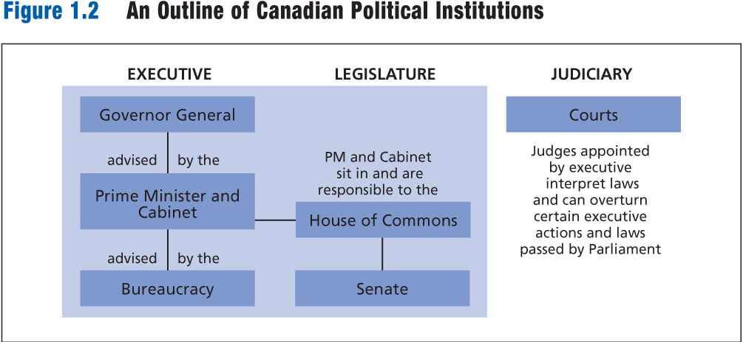

The executive

- The three parts of the executive are sometimes called:
  - Symbolic executive (crown/ governor general)
  - Political executive (prime minster and cabinet)
  - Permanent executive (bureaucracy)

The legislature is bi-cameral (having two branches, chambers, or houses, as a legislative body)

- Elected house of commons: 308 members
- Appointed senate: 105 members, normally
30 additional seats will be added to the House of Commons before the next scheduled federal election in 2015, to bring the total number of seats from 308 to 338:
- Ontario +15
- British Columbia +6
- Alberta +6
- Quebec +3

Parliament of Canada

- Formally, parliament is made up of:
  - The queen
  - The senate
  - The house of commons
- Functioning collectively as in the approval of legislation
- In practice, the term parliament is often used to refer to:
  - House of commons alone
  - House of commons and senate together

Parliamentary government (or the Westminster model of government)

- Two components to the definition of parliamentary government:
  - Fusion of powers
    - Because the prime minster and cabinet ministers have seats in the legislative branch, the system is often described as involving a “fusion of powers” that is a combination of legislative and executive powers.
    - The executive and legislative functions are combined in one institution, called parliament.
  - Responsible government
    - The prime minster and cabinet (the government) “retain their position and powers only so long as they are supported by a majority in the house of commons”
Parliamentary government lacking/losing confidence

- If the house of commons declares a lack of confidence in the prime minister and cabinet, they must either
  - Resign and make way for another group to take their place or
  - Call election
- What is lack of confidence
  - Not written down but its historically representative
  - A motion of non-confidence in the government is passed in the house
    - 2005 (martin) and 2011 (harper)
  - The senate doesn’t not mean anything if loss of votes
  - Motions that government declares to be questions of confidence
  - Government losses a vote on major legislation:
    - Budgetary bills and supply bills
      - Budget bills if you owe money
    - Speech from the throne
      - If rejects speech from the throne
Fusion of powers
- Fusion of powers is the “most outstanding feature of Canadian parliamentary democracy”

Fusion of powers versus separation of powers
- Fusion of powers “most clearly sets Canadian national institutions apart from those in the united states”
  - Prime minster has more power than in the united states
- Fusion of powers in Canada gives the executive enhanced powers
- Separation of powers in the US weakens the executive
- The prime minster and cabinet sit in the legislature as well as the executive when the president does not.

Parliamentary terms 1
- Parliament
  - Parliaments are labeled by consecutive numbers, overlapping with each general election
  - The federal election on 2 may 2011 was the 41st general election
  - We are in the 41st parliament
  - Normally, no house of commons and no legislative assembly shall continue for longer than 5 years form the date fixed for the return of the writs at general election of its members. (Charter, section 4.1)
- Session (parliamentary session) beginning of a election and the end of election”
  - Number and length of sessions are determined by the government
  - Typically, there are two or three sessions in each parliament
  - The average length of a parliamentary session in each parliament
  - The average length of a parliamentary session is 13-14 months
  - Each session begins with a speech from the throne that outlines the government’s legislative agenda for the session.

Parliamentary terms 2
- Adjournment (the prime minster or senate are going on holiday basically)
  - Temporarily suspends the business of a parliamentary session
  - Adjournments typically take place during the summer and winter holiday periods
  - After adjournments, parliament picks up where it left off.
- Prorogation
  - Ends a parliamentary session
  - Terminates the business of parliament
  - Bills under consideration die
  - Parliamentary committees do not meet
- Dissolution
  - Ends the parliament
  - General election follows
Representative government
- Canada is a representative democracy in which every 4 or 5 years, we choose certain individuals (members of parliament) to act on our behalf. We empower them to act as our behalf. We empower them to act on our behalf. We empower them to act as our agents and to represent our interests in the national decision-making process.

Party government
Three components
- Candidates are elected as part of a party team
- Government is structured along party lines
- The prime minster and cabinet misters are members of the “governing party”, the party that won the most seats in the house
- The “official opposition” is made up of members of the second largest party in the house
- Governmental decisions and polices are made along party lines
- Party discipline: in the legislature, members act as a united party and vote the same way, as established by the party leadership
  - That is, legislators vote along party lines

Majority government
- One party wins the majority of seats in the house of commons
  - Number of seats needed for majority government = 155
  - Majority government can easily pass legislation in the house

Minority government
- No single party wins a majority of seats
  - Party with the largest number of seats forms the government
  - Recent minority governments:
    - Martin 2004: 135 seats
    - Harper 2006: 124
    - Harper 2008: 143 seats
  - Minority governments must negotiate with or otherwise rely on other parities to ensure major legislation passes.

Federalism
- Two levels of government- central and provincial- and a division of powers between them characterize Federalism.
- A system of government characterized by two levels of authority- federal and provincial and a division of powers between them, such that neither subordinate to the other.

Two defining elements of federalism
- Power to make laws is divided between two levels of government
- Divided sovereignty
- Citizens are members of two political communities
- Two levels are co-ordinate and independent
- Neither level is subordinate to the other
- Neither level can unilaterally alter the powers of the other
- Each level can make final decisions on certain matters

A typology of political rule
 | Rule in the interest of:
Number of rulers: | All | Rulers
One | Monarchy | Tyranny
Few | Aristocracy | Oligarchy
Many | Polity | Democracy

Democracy
- A political system characterized by popular sovereignty, political equality, political freedom and majority rule

Lecture 2
- Recent federal and provincial elections have witnessed a significant drop n the number of Canadians who vote. This decline is most evident among young voters.
- What does this drop in electoral turnout mean?
  - An electoral system translates votes into seats.
Political participation
- Voluntary activates by citizen intended to”
  - Influence the selection of government leaders
  - Or influence the decisions they make
- Electoral participation
  - Occurs in and around election campaigns
    - Voting in election
    - Putting a campaign sign on lawn
    - Volunteered for a political party
- Non-electoral participation
  - Occurs outside of the electoral calendar, is not determined by electoral needs.
  - Signed a petition
  - Boycotted/chose a product for ethical reasons

Voting turnout (voter turnout)

- Voting turnout is usually expressed as the percentage of eligible voters who actually turn out to vote in a given election
- %Voting turnout= ($\frac{number of people voting}{number of people eligible to vote}$) 100

Evolution of the federal franchise

- 1918= woman
- 1948= Asian Canadians
- 1953= Inuit
- 1960= registered Indians
- 1970= persons 18 years of age
- 1988= judges and people with mental disabilities
- 1999= returning officers
- 2002= all prisoners
Turnout in recent federal elections
- 2011 voter turnout is 61.1% and in 1984 it was 75%

Proposed explanations for lower federal turnout among Canadian youth

- Political inattentiveness
  - Less knowledgeable about and pay less attention to politics
    - Decline of civic education in schools
    - Less knowledge than 30 or 40 years ago
      - Less knowledge the less your likely to vote
  - Lower levels of political interest
  - Lower levels of new media consumption

- Weakening social integration
  - Weak attachment to province and nation
    - Underdeveloped sense of civic duty
      - How strongly attached you feel to Canada and Ontario
      - Many people have underdeveloped civic duty.
      - Civic duty: your duty to get involved politically.
  - Weak attachment to political parties
    - Parties don’t really focus on young people because they don’t vote
    - But it could be see, as they aren’t trying hard enough to get them involved.
  - Growth of individualism
    - Decline of respect
    - Influence of neo-liberal ideology

- Less likely to be contacted by political parties
  - Parties not engaging issues important to young people
  - Parties electoral strategies do not target the marginal vote
  - Youth feel distanced from politics and the political system
  - By they are not more skeptical or less happy

- Permanent voters’ list: national register of electors
  - Door-to-door listing encouraged people to vote
  - Permanent list is less accurate, especially for young people
  - Responsibility is on non-registered person to register

- Mobility of youth, too busies, and lack of time.

Elections and the electoral system

The electoral system

- In an election, parties receive a certain number of votes from electors
- Parties also receive a certain number of seats in the legislature
- The question is: how do we translate the number of votes parties receive in an election into the number of seats they receive in the legislature?

Single-member plurality electoral system (SMP)

- Representation is by area or riding
  - 308 areas or electoral districts
  - 30 new seats are being added to bring the total to 338
- A single member is elected in each electoral district
  - 308 districts➔308 MPs in the house of commons
- The representative is elected by plurality
  - Winning candidate gets the most votes (i.e., more votes than any other candidate)
  - Majority not necessary
  - First past the post (FPTP)

Disproportionalities: the distortions of the single-member plurality (SMP) system

- SMP rewards the strongest party (receiving the most votes)
- Strongest party usually receives a higher percentage of seats than votes.
- SMP punishes the second strongest party
- Second strongest party tends to receive a lower percentage of seats than votes
- SMP rewards “third” parties with regional or provincial attentions of support
- SMP punishes third parties with drawn-out national support
- SMP’s regional distortions worsen regional divisions.

