- Personality: defined as a dynamic, organized, and relatively enduring set of psychological traits possessed by a person that distinctively influences the person’s cognitions, motivations, and behaviors; and consequently influences the person’s interactions with, and adaptation to the social environment.

- The concept of personality is used to explain:
- 1. The stability in a person's behavior over time and across situations (consistency)
- 2. The behavioral differences among people reacting to the same situation (distinctiveness)

- Influential theories in the study of personality

- 1. Freud’s Psychoanalytic Theory:
- Explains personality by focusing on the influences of early childhood experiences and the presence of unconscious motives and conflicts. How unconscious forces can influence behavior and personality development.

- The id: Primitive, instinctive. Ruled by the pleasure principle. Illogical, irrational, fantasy oriented.
- The ego: The decision-making component. Ruled by the reality principle. Rational, realistic, problem solving oriented.
- The Superego: The moral component that incorporates social standards about what represents right and wrong.

- Conscious: Whatever one is aware of at a particular point in time. It houses one's current thoughts
- Preconscious: It contains material just beneath the surface of awareness that can easily be retrieved.
- Unconscious: It contains difficult-to-retrieve feelings, memories, and desires that are well below the surface of conscious awareness but that exert great influence on behavior

- Defense Mechanisms: Largely unconscious reactions that protect a person from unpleasant emotions, such as anxiety and guilt.
- 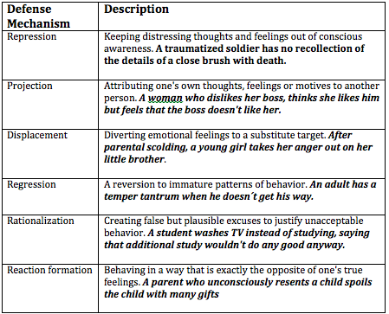

- 2. B.F. Skinner’s Behavioral perspectives:
- Skinner’s ideas applied to personality focus on how external environment molds overt behavior.
- Personality is viewed as an individual's collection of response tendencies.
- Skinner emphasizes the importance of what happens after behavior occurs.
- Environmental consequences determine people's patterns of responding.
- Personality development is viewed as a continuous lifelong journey.

- What happens after a behavior occurs?
- Reinforcement: The response is strengthened as a consequence of favorable outcomes.
- Punishment and extinction: The response gradually weakens and eventually disappears.

- 3. Bandura’s Social Cognitive Theory
- People are self-organizing, proactive, self-reflecting and self-regulating. Personality is shaped through observational learning.
- 1. Observational learning occurs when the person's response is influenced by the observation of others.
- 2. People's characteristics pattern of behaviors are shaped by the models they are exposed to. Many response tendencies are the product of imitation.
- - Reciprocal determinism

- 4. Humanistic Perspectives
- Three basic assumptions:
- 1. People can control their biological urges.
- 2. People are conscious and rational beings who are not dominated by unconscious, irrational needs and conflicts.
- 3. A person's subjective view of the world is more important than objective reality.

- 5. Rogers’ person-centred Theory
- Personality structure in terms of self-concept: A collection of beliefs about one´s own nature, unique qualities, and typical behavior.
- The relevance of others for our own views of self
- The implications of incongruence (disparity between self-concept and actual experience) in the self system for dysfunctional emotions

- Maslow’s theory of Self Actualization:

- Trait Taxonomies Perspectives
- A personality trait is a durable disposition to behave in a particular way in a variety of situations.
- Personality traits are enduring patterns of perceiving, relating to, and thinking about the environment and oneself that are exhibited in a wide range of social and personal contexts.
- 1. Traits are relatively stable over time and across situations.
- 2. Traits differ among individuals.
- 3. Traits influence behavior.

- Psychological traits are useful for at least 3 reasons:
- 1. They help us describe people.
- 2. They help us explain behavior.
- 3. They help us predict future behavior.

- Cattell’s 16 Personality Factors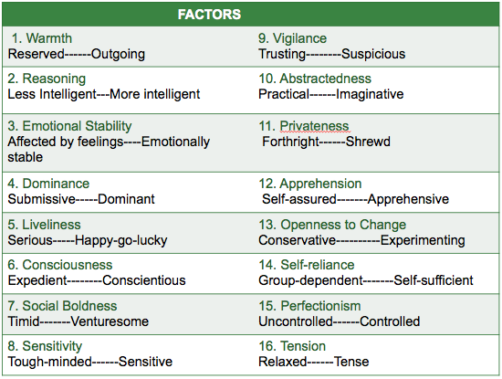

- Eysenck’s personality theory
- Personality is largely determined by the person's genes. Individuals differences in personality are determined by genetic factors. Personality traits are inherited.
- There are properties in the brain and the central nervous system that corresponds to specific personality traits.

- All aspects of personality emerge from 3 higher-order traits.
- 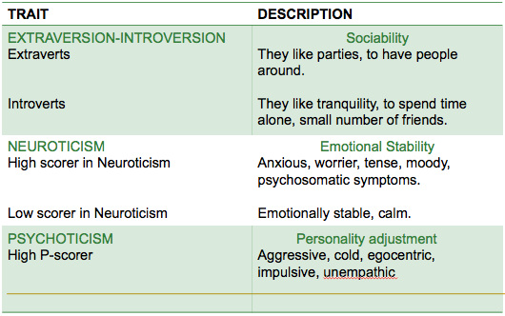

- Levels in Eysenck’s hierarchical structure of traits:
- Super trait: Extroverted-- Narrower Trait: Sociable--Habitual response: Party going--Specific Act: Dancing wildly at a party

- Modern behavioral genetics research suggests that personality is shaped to a considerable degree by hereditary factors.
- The effects of nature and nurture are twisted together in complicated interactions that can't be separated clearly.

- The Five-Factor model of personality traits (Costa and McCrae)

- Most Personality traits are derived from 5 higher order traits
- 1. Openness to experience: The tendency to be imaginative, independent and interested in variety VS the tendency to be practical, conforming, interested in routine.
- 2. Conscientiousness: The tendency to be organized, careful, and disciplined VS the tendency to be impulsive, careless, disorganized.
- 3. Extraversion: The tendency to be sociable, fun-loving VS the tendency to be shy, somber, reserved, suspicious.
- 4. Agreeableness: The tendency to be trusting and helpful VS the tendency to be suspicious and uncooperative.
- 5. Neuroticism: The tendency to be calm, secure, and self-satisfied VS anxious, insecure and self-pitying.

- **Trait theories do not address how or why individual differences in personality develop or emerge. Trait models often underestimate the effect of specific situation on people's behavior.**

- Culture and Personality (Markus and Kitayama):
- 1. American culture fosters an independent view of the self. They define themselves in term of their personal attributes. A sense of uniqueness.
- 2. Asian cultures foster a more interdependent view of the self. People in these cultures view themselves as part of a larger social matrix. They define themselves as part of the group the belong to. Their pride in group achievements is the basis for their sense of self-worth

